Date: 26th March 2026
Name: Fariza Begum Suleman
Programme: BSc Health and Social Care
Module: Changemakers: Building your personal Brand
Module Code: BMHP15
Lecturer: Tswani Khumalo
Assignment Title: Component 2: Report

Employability Skills Development Report; Health Care Support worker -Women`s Health

Table of Contents
1.Introduction
2.job Description
3.Employability skills Analysis
4.Self-Evaluation and Reflection
5.Experience and Qualifications
6.Personal Brand and Identity
7.Network and Career Development
8.Unique Selling point
9. Action Plan and Timeline
10.Communicatating Skills to Employers
11. Conclusion
12.References
13. Appendices

1.Introduction
The role of a Health Care Support Worker (HCSW) is not only essential to the functioning of healthcare systems but it also fundamental to the delivery of compassionate patient-centred care ,within the Women’s Health Outpatients Department at NHS Trust ,this role require both clinical awareness and emotional sensitivity as patients may experience vulnerability, anxiety or discomfort during consultations and procedures (NHS,2025).
My motivation to pursue this role is deeply rooted in my current experience working with children with Special Educational Needs and Disabilities (SEND). This role has allowed me to develop patience, empathy and adapting -qualities thar are essential when supporting individuals with complex emotional and physical needs. Through this experience I have developed a strong desire to transition into healthcare environment where I can continue to support individuals in a meaningful and impactful way.
This report critically evaluates the employability skills required for the HCSW role, reflects on my current abilities and outlines a structured action plan for future development it also demonstrates how my qualifications, experience and personal attributes align with the expectations of the role,

2.Job Description
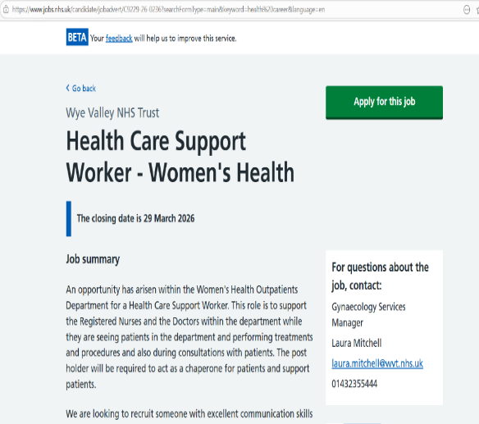
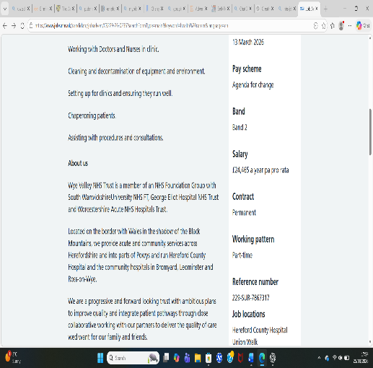
(NHS,2025)

The HCSW role Wye valley Trust involves supporting clinical staff in delivering high quality patient care, key responsibilities include assisting with procedures, preparing clinical environments, chaperoning patients, and ensuring cleanliness and infection control standards are maintained (NHS,2025).
The person specifications highlight essential skills such as effective communication teamwork, and knowledge of personal care in addition, organisational skills, IT literacy, and prior experience in care setting are considered desirable. The role requires a balanced of technical skills and interpersonal abilities. According to Godin et al, (2008), healthcare professionals must integrate knowledge, behaviour, and communication to provide effective care. Therefore, employability within this role is not solely based on qualifications but also on ability to interact professionally and compassionately with patients.

3. Employability Skills Analysis
Employability Skills are critical in ensuring both personal success and high-quality patients care (Pang,2024). The following section analyses key skill require for the HCSW role.
- Communication skills
Communication is fundamental in healthcare particularly in sensitive environments such as a women`s Health, patients may feel anxious or vulnerable requiring clear, respectful, and empathetic communication. My experience working with SEND children has strengthened my ability to adapt communication styles, including the use of non-verbal cues and reassurance techniques (Grimani et al.,2021).
- Teamwork
Teamwork is essential in healthcare settings where professionals must collaborate to deliver coordinated care, HCSW work closely with nurses, doctors, and other staff to ensure smooth clinic operations.
Though my current role I have developed the ability to work collaboratively, support colleagues and contribute to a positive working environment, teamwork enhances efficiency and improves patients care (Bariyyah,2021).
- Problem -Solving
Problem -solving skills enable healthcare professionals to respond to challenges and adapt to changing situations (Bariyyah,2021). I have developed this through managing unpredictable situations in my current role.

- Empathy and Emotional Intelligence
Empathy is central to patient-centred care, it allows healthcare workers to understand and respond to patient’s emotional needs. Working with SEND children has significantly enhanced my empathy and emotional intelligence, according to Arnold (2017), emotional support plays a key role in wellbeing making empathy a vital skill in healthcare.
- Organisation and Time management
Strong organisational skills ensure efficiency and patient safety, self-regulations are important in managing workload (Hamilton & Bradley,1999). I have developed these skills through balancing work, study and training commitments demonstrating my ability to prioritise tasks effectively.

- Professionalism and Ethical Practice
Professional behaviour, confidentiality adherence to ethical standards, are vital HCSWs. Are always expected to model professionalism, contributing to patient trust and safe practice, establishing a professional identity requires a balance between ethical practice and self-promotion, ensuring that personal branding aligns with standards of care and professional integrity (Heymann,2011). My training in safeguarding and child protection has strengthened my understanding of ethical responsibilities and professional conduct. (Seyferth et al.,2022).
- Learning Through Observation
Bandura (1977), Highlights the importance of learning through observation, imitation, and modelling, HCSWs acquire many practical skills by observing experienced nurses and doctors, this learning method supports safe and confident practice, helping new workers to integrate knowledge and behaviours into their daily roles (Kuts,2013).

4.Self-Evaluation and Reflection
Reflective practice is essential for continuous improvement (Bennet-levy &Lee,2012).
I have developed strong communication, empathy and adaptability through my work with SEND children, these skills enable me to provide effective support to individuals with diverse needs.
Areas for Development
While I have strong interpersonal skills, I recognise that my clinical experience within a hospital environment is currently limited, this means that I need to further develop my practical understanding of clinical procedures, infection control protocols, and the day -to -day responsibilities associated with a health care support worker role.
In addition, I aim to build greater confidence when in fast-paced clinical settings although I remain calm and adaptable, I acknowledge that exposure to more complex healthcare environments will allow me to strengthen my decision-making skills and abilities to respond effectively under pressure.
Furthermore, I recognise the importance of developing my technical and administrative skills particularly in relation to healthcare IT systems and record -keeping, improving these skills will enable me to work more effectively within multidisciplinary teams and contribute to the overall efficiency of the department,
To address these areas, I am committed to engaging in continuous professional development, gaining hands-on experience, and applying reflective practice to monitor my progress, this proactive approach will ensure that I am fully prepared to meet demands of the Health Care Support Worker role.

Gibbs` Reflective Cycle
I have chosen to use Gibbs ‘Reflective Cycle as a structured framework to support my personal and professional development within healthcare practice reflection is a key skill in healthcare practice, as it allows individuals to critically evaluate their experiences, identify strengths and areas of improvement and apply learning to future situations (Bennett-Levy &Lee,201;Kuts,2013). Gibbs` model is particularly effective because it provides a clear step-by -step process that encourage deeper thinking rather than simple descriptions.
By following the stages of description, feeling, evaluation, analysis, conclusion, and action plan, I can fully explore my experience when working with SEND children and understand how these experiences have shaped my skills. This structured approach allows me to identify both strengths and areas of development, supporting continuous improvement and self-regulation within professional practice (Hamilton & Bradley1999).
Furthermore, reflective practice is essential in healthcare environments where continuous learning is required to maintain high standards of patient care using Gibbs ‘Reflective Cycle enables me to link theory to practice, ensuring that my actions are informed by both experience and academic knowledge (Bennett-Levy& Lee,2012). This is particularly important as transition into a clinical role, where reflection contributes to improved decision-making and professional competence.
In addition, reflection enhances self-awareness which is a key attribute for healthcare professionals, understanding my own behaviours and responses allows me to improve how I interact with patients and colleagues, particularly in sensitive areas such as women’s health. This aligns with the importance of emotional awareness and wellbeing in professional environments (Arnold,2017).
Overall, Gibbs ‘Reflective Cycle provides a reliable framework that supports my ongoing development as a reflective practitioner, it enables me to evaluate experiences critically apply learning effectively and continuously improve my skill in preparation for a healthcare career.

5. Experience and Qualifications
My academic and professional journey reflects a strong commitment to developing a career in health and social care, I have completed:
- NVQ level 1
- NVQ level 2
- NVQ level 3
- University level 4
- Currently in progress level 5& 6
In addition, I have undertaken essential training including, safeguarding, disability awareness, first aid and child protection. these qualifications are particularly relevant when working with vulnerable individuals and ensure that I can provide safe and ethical care.
My current experience working with SEND children has been instrumental in shaping my professional identity, it has allowed me to develop patience, resilience, and a deep understanding of individualised care this experience has not only strengthened my practical skills but also reinforced my passion for supporting others in a healthcare setting.

6.Personal Brand and Professional Identity
Developing a strong personal brand and professional identity is essential within healthcare, as it reflects how I present myself, interact with others and uphold professional standards in practice a personal brand is not only about appearance but also about the value, behaviours and attitudes that define me as a future healthcare professional, in the context of working within Wye Vally NHS Trust ,it is particularly important that my personal brand aligns with core values such as care ,respect ,accountability and excellence.
My professional identity is strong shaped by my current experience working with children with Special Educational Needs and Disabilities (SEND), through this role I have developed a compassionate and patient-centred approach ,ensuring that individuals feel supported ,valued and understood .These qualities are essential in healthcare ,particularly insensitive areas such as women’s health where patients may feel vulnerable ,research highlights that emotional connections and trust are key components in building effective relationships within healthcare services(kemp et al.,2014; Seyferth et al.,2022).
I am also committed to continuous professional development, as shown through my ongoing qualifications, lifelong learning is essential in healthcare to maintain skills and adapt to change (Kuts,2013). Furthermore, professionalism in central to my identity, including maintaining confidentiality showing respect and following ethical standards, these qualities are important for building trust and credibility in healthcare settings (Heymann,2011).
Overall, my personal brand reflects compassion, professionalism, and strong commitment to providing high quality care, communicating value and authenticity, where creativity plays a significant role in how individuals present their professional identity to others(O`barr,2011).

7.Network and Career Development

Networking and career development are essential for progressing with the health and social care sector ,building professional relationships with colleagues ,mentors and healthcare professionals can provide valuable guidance ,support and access to job opportunities engaging with others in clinical settings will allow me to learn from experience staff and develop my confidence within a healthcare environment ,additionally ,networking can enhance my understanding of career pathways and expectations within organisations such as Wye Valley NHS Trust by actively seeking opportunities ,attending training and maintaining professional connections ,I can strengthen my employability and successfully work towards achieving my career goals.

8. unique Selling Points

My unique selling point is my ability to combine practical experience with strong interpersonal skills and a commitment to continuous development, through my work with SEND children I have developed empathy, adaptability and effective communication, enabling me to support individuals with diverse needs, in addition my ongoing qualifications demonstrate motivation and readiness to progress within healthcare these qualities allow me to provide person-centred care and build positive relationships with patients and colleagues ,developing a strong personal brand further strengthens my professional value and employability within organisations such as Wye Valley NHS Trust (Pang,2024:Kemp et al.,2014).

9.Action Plan and Timeline

My action plan is designed to support my progression into a Health Care Support Worker role within a three-year timeframe in the short term I will continue developing my knowledge by completing my level 5-6 qualifications and enhancing my practical experience in care settings ,in the medium term I aim to gain clinical exposure through volunteering or shadowing opportunities ,while improving my organisations such as Wye Valley NHS Trust. By maintaining motivation when pursuing long-term career goals can be challenging however, adopting an approach -focused mindset enhances engagement and persistence compared to avoidance-based goals (Hennecke,2019).
This structured timeline ensures continuous development aligning my skills with professional healthcare standards and career goals, a comprehensive Gantt chart I developed to visually present my planned progression and key development milestone over the next three years. (Gantt chart appendix fig 1).

10.Communicatating Skills to Employers

Effectively communicating my skills to employer is essential for securing a role within health and social care, I will present my abilities through a professional CV, tailored applications and by developing an online presence on platforms such as LinkedIn, these tools will allow me to highlight my qualifications, experiences and key competencies in a clear and professional manner. Additionally, demonstrating strong personal communication and confidence during interview will be crucial building a strong personal brand will further support how I present to organisations such as NHS Trust enhancing employability and creating positive professional impressions (Pang, 2024; kemp et al.,2014), (CV appendix fig 2).

11. Conclusion
This report demonstrates that becoming a Health Care Support Worker within the NHS Trust requires a combination of employability skills, reflective practice, and continuous professional development. While Pang (2024) emphasises the importance of skills for employability, Arnold (2017) highlights the role of emotional intelligence in effective practice, showing that both are essential, reflection, supported by Bannett-Levy & Lee (2012), further strengthens professional growth. My experience, qualifications, and structured action plan position me well for this role by continuing to develop and communicate my skills, I will successfully progress within the healthcare sector, highlighting the importance of self-awareness and continuous reflection in improving healthcare practice (Godin et al.,2008).

12 References
Arnold, K.A. (2017). Transformational leadership and employee psychological well-being: A review and directions for future research. Journal of Occupational Health Psychology, 22(3), pp.381–393.
Bandura, A. (1977). Social Learning Theory. Englewood Cliffs, N.J. : Prentice Hall.
Bariyyah, K. (2021). Problem solving skills: essential skills challenges for the 21st century graduates. Jurnal EDUCATIO: Jurnal Pendidikan Indonesia, 7(1), p.71. doi:https://doi.org/10.29210/120212843.
Bennett-Levy, J. and Lee, N.K. (2012). Self-Practice and Self-Reflection in Cognitive Behaviour Therapy Training: What Factors Influence Trainees’ Engagement and Experience of Benefit? Behavioural and Cognitive Psychotherapy, 42(1), pp.48–64. doi:https://doi.org/10.1017/s1352465812000781.
Gibbs, G., and Andrew, C. (1988). Learning by Doing. Oxford Polytechnic.
Godin, G., Bélanger-Gravel, A., Eccles, M. and Grimshaw, J. (2008). Healthcare professionals’ intentions and behaviours: A systematic review of studies based on social cognitive theories. Implementation Science, [online] 3(1). doi:https://doi.org/10.1186/1748-5908-3-36.
Grimani, A., Goffe, L., Tang, M.Y., Beyer, F., Sniehotta, F.F. and Vlaev, I. (2021). Effectiveness of personal letters to healthcare professionals in changing professional behaviours: a systematic review protocol. Systematic Reviews, 10(1). doi:https://doi.org/10.1186/s13643-021-01650-4.
Hamilton, W., and Bradley, N. (1999). Self regulation at work: a case study. BMJ, 319(7209), pp.585–585. doi:https://doi.org/10.1136/bmj.319.7209.585.
Hennecke, M. (2019). What doesn’t kill you . . .: Means for avoidance goal pursuit are less enjoyable than means for approach goal pursuit. Motivation Science, 5(1), pp.1–13. doi:https://doi.org/10.1037/mot0000104.
Heymann, H.O. (2011). ‘Branding’ Your Practice: Ethics and Excellence. Journal of Esthetic and Restorative Dentistry, 23(6), pp.353–353. doi:https://doi.org/10.1111/j.1708-8240.2011.00489.x.
Kemp, E., Jillapalli, R. and Becerra, E. (2014). Healthcare branding: developing emotionally based consumer brand relationships. Journal of Services Marketing, 28(2), pp.126–137. doi:https://doi.org/10.1108/jsm-08-2012-0157.
Kuts, V.A. (2013). Lifelong education: the experience of self-reflection. Lifelong education: the XXI century, 4(4), pp.44–57. doi:https://doi.org/10.15393/j5.art.2013.2164.
NHS (2025). NHS Jobs. [online] www.jobs.nhs.uk. Available at: https://www.jobs.nhs.uk/candidate [Accessed 26 Mar. 2026].
O’Barr, W.M. (2011). Creativity in Advertising. Advertising & Society Review, 11(4). doi:https://doi.org/10.1353/asr.2011.0006.
Pang, M. (2024). Employability skills, employability readiness, and skills building: Basis for student workforce employability framework. International Journal of Research Studies in Education, 13(3). doi:https://doi.org/10.5861/ijrse.2024.24613.
Parker, G., Shahid, N., Rappon, T., Kastner, M., Born, K. and Berta, W. (2022). Using theories and frameworks to understand how to reduce low-value healthcare: a scoping review. Implementation Science, [online] 17(1). doi:https://doi.org/10.1186/s13012-021-01177-1.
Seyferth, A.V., Egan, J.M. and Chung, K.C. (2022). Branding in Health Care. Plastic and Reconstructive Surgery, [online] 150(3), pp.481–485. doi:https://doi.org/10.1097/PRS.0000000000009387.

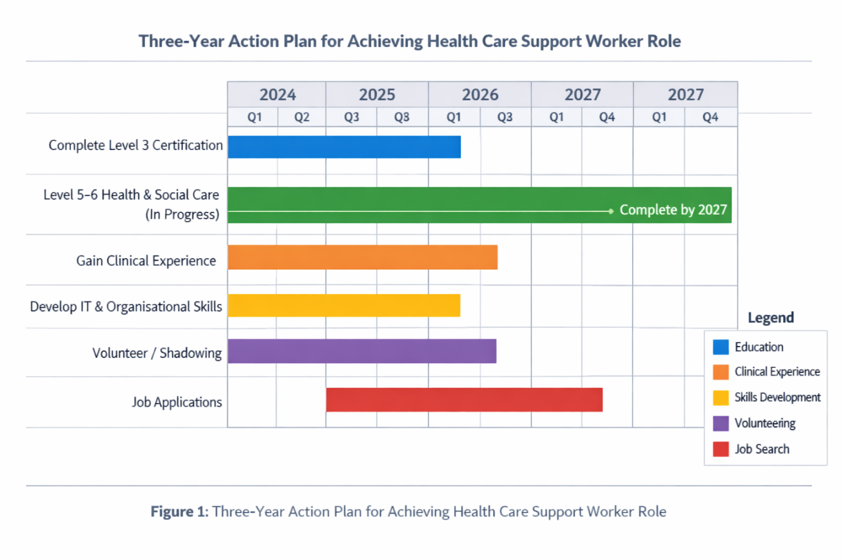
13.Appendices

Fig 2 CV

