

An Investigation into the Security of a Typical Home Network

Dan Wadham
(1704227)

Supervisor: Dr John Rees
Second Marker: Dr Kapilan Radhakrishnan

Project submitted as part of the requirements for the award of BSc (Hons) Computing (Computer Networks & Cybersecurity)

April 2020

Declaration of Originality

I, Dan Wadham declare that I am the sole author of this Project; that all references cited have been consulted; that I have conducted all work of which this is a record, and that the finished work lies within the prescribed word limits.
This work has not previously been accepted as part of any other degree submission.

Form of Consent

I, Dan Wadham, hereby consent that my Project, submitted in candidature for the B.Sc. (Hons) Computing (Computer Networks and Cyber Security) degree, if successful, may be made available for inter-library loan or photocopying (subject to the law of copyright), and that the title and abstract may be made available to outside organizations.

Copyright Acknowledgement

I acknowledge that the copyright of this project report, and any product developed as part of the project, belong to University of Wales Trinity Saint David, Swansea.

Abstract

The following report will be investigating the usage and security of a typical home network, specifically investigating how the average home network can be attacked and utilized to acquire sensitive information from the network users as well as utilizing the most popular attacks used today such as DDoS ‘deauthentication’ attacks to cause disruptions amongst other attacks to a targeted network. The project attempted to utilize a device known as a ‘deauther’, an Arduino board capable of wireless networking loaded with various tools to attempt to gain access to a targeted network. With the help of supporting tools such as Kali Linux [1], the attack proved to outline how even the most modern network setups are still to this day vulnerable to certain forms of attacks. Following the investigation, it is clear that a deauthentication attack is near unavoidable however, certain measures can be put in place to make the attack useless in the larger scope other than simply causing disruption to a network. These measures include creating a longer and more complex password for the network resulting in a brute force attempt to identify a password would be near impossible within a reasonable amount of time for the attacker as well as upgrading home network hardware to be capable of utilizing the 802.11w protocol that has eliminated the issue of spoofing deauthorization frames by reinforcing the security on the management frames. This however is not an achievable approach for most common households is it would require more expensive and specialist equipment.

Table of contents:

Declaration of Originality…………………………………………………..…......i
Form of Consent…………………………………………………………………...i
Copyrights acknowledgments………………………………………….………...i
Abstract…………………………………………………………………….……....ii
Chapter 1 - Introduction
Introduction………………………………………………………………………...4
Aim………………………………………………………………………………….5
Objectives……………………………………………………………………….....6
Project Structure………………………………………………………………......7
Chapter 2 - Field Research
Introduction……………………………………………………………….…….....8
Background Research…………………………………………….……………...9
Conclusion………………………………………………………………………..13
Chapter 3 - Experiment Overview
Introduction……………………………………………………………………….14
Research & Philosophies……………………………………………………….14
Experimental Hypothesis………………………………………………...……..16
Hardware Used……..……………………………………………………..….….17
Software Used………………………………………………..………………….18
Validity & Reliability………………………………………………………..…….19
Conduction……………………………………………………………….……....19
Chapter 4 - Design & Implementation
Introduction……………………………………………………………………….23
Hardware Choices……………………………………………………………….23
Software Choices………………………………………………………………..25
Implementation…………………………………………………………………..25
Conclusion………………………………………………………………………..26
Chapter 5 - Evaluation
Introduction………………………………………………………………….……27
Results Evaluation…………..…………………………………………….…….27
Chapter 6 - Conclusion
Chapter 7- Reflection
Chapter 8 - References
Appendices

Chapter 1 - Introduction

1.1 Introduction

As the online world continues to grow and evolve, the reliance on personal home networks grows stronger alongside. As home networks become faster and more available with reportedly 93% of all UK households in 2019 having access to the internet in some shape or form [2], the importance of securing these networks has continued to become a more important and pressing issue. With the speed and reliability of home networks in the modern day, the amount of data transferred through a typical home network can contain large amounts of various sensitive data such as usernames, passwords and even bank details from purchases made online or through online banking. With the availability of tools online such as online banking and even online shopping through services such as Amazon [3] or Just Eat [4], it has become very common to have a user’s bank and account details saved on various devices and used daily.

While this type of data is typically encrypted as it passes through the internet, there are various other ways of tracking and logging this information for an attacker to access before the data hits the outgoing traffic. With this information a hacker can not only access all of the user’s accounts and emails but even make purchases through the user own bank accounts or even sell the data onwards. Another threat increasing in popularity is known as ransomware. This is a type of malicious software that is designed to take the users files and programs and encrypt everything. Once the file system has been encrypted, the software provides a link to deposit money, typically bitcoin, in order to get the key to decrypt the files or risk losing them all. Because of this, it is important to understand how this can happen and how to spot and potentially prevent this from becoming an issue should an attacker choose to target your very own network for their attack. With so many people connected to the online world, there is never a shortage of potential targets for a hacker to choose to attempt an attack on. By utilizing a device known as a ‘deauther’, an attacker can disrupt a network and its connected devices allowing them a window to utilize different methods to access or take down the network.

The typical home network setup across the UK consists of a home class router issued by the ISP such as Virgin Media [5] and their ‘Super hub 3’. This is a router that combines the abilities of a modem and wireless router into one small package to reduce the complexity of the network setup for their customers. The typical devices then connected to these routers mainly consist of laptops, smartphones and even smart TV’s and voice assistants with the rapid growth and adoption of IoT Devices.

As technology continues to advance in the field of IoT devices, many of the devices are making their way into people’s homes and are rapidly increasing in popularity. This is clearly indicated as the amount of IoT devices has skyrocketed from 8.7 billion in 2012, which at first seems like a lot, to an outstanding 50.1 billion in 2020 proving that more and more people are introducing many of these IoT devices into their own homes in devices such as the Google Home [6] or Amazon’s Alexa smart speaker [7]. While many of these devices have been around for a while, there are many more devices that are brand new being accepted into the homes of many creating more possible threats and entry points for attackers to target making them an increased security risk for the average home network. By default, almost all of these devices will attempt to rejoin a known network immediately after being disconnected making them a perfect target for a deauthorization attack from someone looking to gain access.

1.2 Aims

In order to conduct a successful project, there must be a concise set for targets for the project to achieve. Not only will this help the project stay on track but can also help in time management throughout the project. The aims for a project must be realistic and achievable whilst also progressing the project forward.
The target for this project will be to identify and highlight potential weaknesses in the typical home network setup used in homes across the globe. By utilizing a small Arduino device alongside a Kali Linux device, the main aim will be to demonstrate how simple and effective a small DDoS attack on a targeted network can be by utilizing weaknesses found within the 802.11 protocol. From this, further attacks can be carried out such as creating what is known as an ‘evil twin access point’ as well as a brute force password attack following the ‘sniffing’ of a 4-way handshake. These are just some of the possibilities of potential attacks from the device combination. By demonstrating how these attacks are carried out and highlighting how to spot a potential attack, the odds of the attack being successful can be drastically reduced with the aim to attempt to identify a method to completely prevent these attacks from being possible in the first place.

1.3 Objectives

The key objectives that will be aimed to be achieved are as follows:
- Identify the most popular attacks for 2020
- Create a small Arduino device capable of hosting a number of attacks
- Using the Arduino, carry out basic attacks to prove the devices capability
- Utilize a device running Kali Linux to compliment the Arduino’s attacks
- Identify any possible tells to identify when a network is being targeted
- Attempt to put measures in place to prevent a number of attacks being possible on the network

In order to identify the most popular attacks for 2020, background research will need to be conducted into what attacks are likely to be used, how effective the attacks are and how these attacks can be spotted or even prevented before the attacker has a chance to capture any sensitive data or deploy any malicious software.

Using the data from the background research on popular attacks, a small Arduino based device can be constructed that is capable of hosting some of these attacks. The Arduino board offers many benefits that an equivalent device such as a laptop could not offer including the ability to be very discrete as it is very small in size as well as the increased portability again thanks to its size but also its power requirements. The chosen board will be able to run off a simple 5v power source whether that be from a USB device such as a laptop or smartphone or even a battery bank. The device will also be able to be deployed at a location and left for numerous days to run off a battery bank as the power drain will be very small for such a small device further increasing the device's versatility.

While the Arduino device will be capable of a number of attacks, a device running Kali Linux, such as a laptop, will be able to compliment the Arduino’s abilities and attacks by working in some other attacks that require more hands on action therefore the next objective will be to acquire a device capable of running Kali Linux with the appropriate tools installed in order to carry out a successful attack and gain access to the network.

Following these attacks, the next objective will be to monitor the network and attempt to identify when the attacks are taking place to be able to spot and prevent further action being taken on the network by an unauthorized attacker.

Following the attack, the final objective will be to attempt to put measures in place to prevent access to the network from being possible for an unauthorized attacker keeping the house network safe from any further attacks.

1.4 Project Structure

This project will be broken down to 3 key parts that will need to be carried out. The first being an investigation into the background of the subject researching and identifying where the weaknesses are in the typical home network and how they are managed in today's world. This includes any past attacks, improvements made to the structure of a network and its protocols and how they've been overcome to help aid in the prevention or detection of any attacks carried out today.
The second part will cover the practical and experimentation side of the project. This will involve creating and utilizing the various tools to attack a chosen and approved home network to use as a testing ground. This section will involve most of the hands-on work as an experiment into these security flaws will be carried out in real time on a targeted network with the appropriate permissions for safe and legal experimentation.
Following the research and attempted attacks will come the third and final part of the project, the data collection, analysis and conclusion. This will involve collecting any and all data from the conducted experiments as well as any relevant information from the research carried out and analyzing them to come to a conclusion on the efforts of attacking and attempting to prevent attacks on a chosen home network. The sections can be broken down into chapters as follows:
- Part 1 - Chapter 2
- Part 2 - Chapter 3, 4
- Part 3 - Chapter 5, 6

Chapter 2 - Research

2.1 Introduction

When it comes to wireless networks, there have been numerous investigations into the strength of the security on the 802.11 standard for the wireless platform. While the security of the standard has been continually increasing and improving over the years as it continues to develop, there are still vulnerabilities that have been exposed many years ago that to this day still remain. Some of these attacks are possible due to weaknesses in the protocols used however not all attacks depend on this. Many of the most popular attacks come from the online world and only occur due to user error either through accidentally clicking on a bad link or even social engineering to manipulate the user into handing over the information themselves. It is important to understand the nature of the attacks to be able to understand how they work and how they can be avoided

2.2 Background Research

Social Engineering

Social engineering is defined by Webroot as “the art of manipulating people so they give up confidential information” [8]. Social engineering comes in many different forms such as a phone call from a mystery person claiming to be from a business or company that the target would be familiar with and even have accounts with such as a bank helpdesk with the intent to make it seem to the target that the call is legitimate with the aim to get them to hand over personal details such as account numbers or bank card details. Another form social engineering can come in is a simple email from a trusted source such as a friend, family member or company. The email will be made to look as accurate as possible to fool the target user into thinking it's a real email, however within the email could be a link to malicious programs and malware. Even a simple image being downloaded could contain a malicious payload. Many of these forms of social engineering are often known as ‘phishing’ attacks however phishing attacks are usually conducted digitally such as in emails and texts. These attacks can also be carried out in bulk as they don’t require an individual person to operate making them a much more prominent threat in the online world especially for home users who may not be fully informed of these forms of attacks. Luckily, most anti-virus programs, including the ones built in to the OS and browsers, have become very good at detecting a large majority of these attacks and can inform a victim of the potential threat or even remove the email/file before it has a chance to impact the victim.

Man-in-the-middle Attack

A man-in-the-middle attack is one of the most popular attacks that happen online in today’s world. The man-in-the-middle attack on a user is where the attacker intercepts the data transmitted to its intended source allowing the attacker to see and log all data being transmitted meanwhile the target would be completely unaware of any form of attack currently happening. Many of these attacks often include some form of social engineering such as phishing to get the user to install software or simply input details on a fake webpage.
Alternatively, an attacker can target a public or home network with weak or even no security to implement their tools to intercept any transmitted data without the target's knowledge. Once the data has been captured the attacker can then take the data away to be decrypted where they can find any data transmitted during that session such as bank details, usernames and passwords.
HTTP spoofing is another form of attack under this category that aims to trick a target user’s browser into believing that a website that handles sensitive data such as credentials, is secure. An example of this could be an online store uses the HTTPS protocol when handling user login credentials or bank details however, an attacker has tricked the browser into believing the site is using HTTPS making the user feel safe knowing that their data is secured when it is in fact only using the standard HTTP protocol which is not secure and can easily be intercepted. While the attacker is monitoring and possibly logging all the interactions the user has with that website, the user themselves are completely unaware as the browser will continue to show the HTTPS indication to show secure connection is active.
Another form of man-in-the-middle attack is known as ‘SSL hijacking’. This type of attack targets a user’s device and, more specifically, the secure sockets layer (SSL) protocol that establishes a secure link between the user’s device and website or server that uses a secure connection through HTTPS. By hijacking the layer protocol, an attacker is able to intercept all sensitive data transmitted across the connection between the user and the server which could contain a variety of sensitive information.

Evil Twin Access Point

The evil twin access point, while seemingly simple in nature, can often be hard to spot and cause just as much harm as any other form of attack. As stated by Yimin Song Et al. “An attacker typically launches evil twin attacks near free hotspots, such as airports, cafes, hotels and libraries” [9]. While this is true, an attacker can just as easily decide to target a generic household network to allow them to intercept potentially sensitive data should the victim accidentally join the rogue access point (AP). While these types of attack can be prevented in public areas or workplaces with expensive equipment and software solutions, the typical home environment has no protection or safeguards against this form of attack. The only way to prevent these forms of attack without supporting hardware/software is to educate the individual on how and when to suspect an evil twin access point. The success rate of the evil twin attack can be increased by positioning the rogue AP closer to the victim as most modern operating systems will opt to display the network with the best signal strength when the SSIDs of both networks match as they are both expected to be access points to the same network. To further enhance the possibility of a victim joining the rogue AP as stated by Y. H. Hsneh Et al., the attacker can “force victim users to connect to evil twin is launching de-authentication attack at the same time.”[10] By pairing the two attacks, the attacker can deny access to the legit AP forcing the user to connect over to the evil twin AP granting the attacker access to intercept data transmitted.

The 802.11 standard

The 802.11 standard for wireless communications is defined as “an evolving family of specifications for wireless local area networks (WLANs) developed by a working group of the Institute of Electrical and Electronics Engineers (IEEE)” [11]. These protocols enable communication across devices wirelessly and over the years have continued to improve with relation to speed, reliability and most importantly for some, security. In order to secure the data transmission across a wireless network, various other protocols have been implemented into the standard with varying levels of success. The first of which was the Wired Equivalent Privacy (WEP) in 1999 however this was shortly proven to not be as secure as expected as Scott Fluhrer, Itsik Mantin and Adi Shamir later published their “Weaknesses in the Key Scheduling Algorithm of RC4” [12] which exploited the RC4 cypher and as such, granted them access in under a minute. This resulted in a new protocol needed to replace the current system.
Following the downfall of WEP, the Wi-Fi Alliance [13] introduced ‘Wi-Fi Protected Access’ (WPA). While WPA solved the shortcomings of WEP, it was known to be insecure in other ways and as such was not designed to be implemented as a permanent solution. This led to the development of ‘Wi-Fi Protected Access 2’ (WPA2). WPA2 utilizes what is known as a ‘4-way handshake’ to ensure the mutual authentication between network access point and end devices. It is this action that can allow an attacker to attempt to gain access to a network as the key shared between devices during the handshake is not intended to be shared to a 3rd party but can be identified through network sniffing. While the key is only able to be retrieved during a device attempting to connect to the network, an attacker can force this event to happen through a deauthentication attack. This attack forcibly removes all or targeted users from a network making them attempt to reconnect either automatically or manually depending on each device’s preferences. This attack is possible as the header of a frame is always shown to the network regardless of if the device is currently connected to the network or not allowing a specifically configured device to send out deauthentication frames to a target network.
With the exploits of the 802.11 protocol being around since the protocol has existed, there are many papers and reports covering this issue such as the paper titled, “Channel switch and quiet attack: New DoS attacks exploiting the 802.11 standard” from 2009 [14], that shows how a core weakness in the 802.11 standard is being exploited to create a DDoS attack with more potential than the previous deauthentication attacks proving that the issue of a simple deauthentication attack has been prevalent since the very beginning of the standard and has not been addressed in widespread home network setups.
While the issue has persisted, there have been various attempts into reducing the effectiveness of an attack including one by Johnson Et al. [15] who proposed a ‘one-bit identity authentication protocol’. While this protocol helped reduce the effectiveness of a simple deauthentication attack, it could not prevent it. Following the work of Johnson et al., many other investigations were conducted including that from Nyugen Et al. [16]. This approach proposed using a ‘hard function based approach’ that operated in only one-way however, this attempt was only able to prevent low frequency attacks meaning an attacker that was sending deauth packets at a very high rate would still prove successful.
Whilst there have been many attempts to prevent and solve the deauthentication issue present in 802.11, to this day the issue still persists. In the present day, creating a dedicated deauther device has never been easier thanks to Stefan Kremser also known online as ‘Spacehuhn’ [17] with his work on his ‘esp8266_deauther’ project. This project can take a regular NodeMCU esp8266 board [18] and load onto it a pre-built set of code that will transform the board into a fully capable de-authenticator device that can be controlled through any Wi-Fi enabled device such as a laptop, tablet or smartphone. Not only is the device very easy to acquire and use, but it is also highly portable being a small Arduino board that requires very little power resulting in the board itself being capable to be powered through a smartphone or battery pack.

802.11w Protocol

While the core 802.11 protocol is still susceptible to death attacks, the IEEE [19] have released a new and updated version of this protocol known as the 802.11w protocol. With this new revision of the protocol, the security on the management frames has been put in place to prevent any spoof deauthentication frames causing disconnects across the network. However, although the new protocol prevents deauthentication attacks, the new protocol has to be implemented into both the access point as well as the end device which to this day, is very uncommon. As such, most households will still find themselves vulnerable to these kinds of deauthentication attacks resulting in the issue still being prevalent in today's technological climate.

2.3 Conclusion

When it comes to potential exploits and attacks someone with malicious intentions can carry out, there is no shortage of available options which makes it more important than ever to understand as many of these attacks as possible to prevent falling for any and handing over sensitive data to an attacker.

Chapter 3 - Experiment Overview

3.1 Introduction

In order to conduct the experiment into attacking a home network through deauthentication, a variety of research will need to be carried out which in turn will require a select choice of research methods and philosophies as well as a select set of hardware will be required ranging from various physical devices such as a development Arduino board, a PC/Virtual machine running Kali Linux, an operational target network as well as some end devices connected to said network. Alongside the physical hardware, various software will also be required to carry out the investigation such as the Arduino Integrated Development Environment, Kali Linux installed with its various tools as well as Cisco Packet Tracer should there be any need of a simulated network environment as a backup strategy. With the selected range of hardware and software, the experiment should be able to highlight the flaws and weaknesses that to this day persist in the 802.11 wireless standard that is used in home networks.

3.2 Research Philosophies & Approaches

When it comes to researching for a project, there are many different methods and philosophies used to conduct different research on different topics. Many different methods and philosophies however are better suited to different kinds of work. The two main philosophies used for projects such as this one are broken down into two forms. The positivist philosophy and the phenomenological philosophy. The positivist philosophy is the idea that any knowledge we gain from conducting the research and investigation will come from the observation as well as the experience of the project. Phenomenology on the other hand is the idea that the project is based around human experience and perception. This philosophy requires that the results need to be understood by the individual rather than recording facts. This can be described as gaining knowledge from the world as the user sees it. The philosophy followed for the following project follows the positivism philosophy as the knowledge that will be gained will come from the observations and results gathered at the end as well as during the experiment itself. Data collected from the experiment will be quantitative data further cementing the idea that the experiment follows the positivist philosophy.

When it comes to the approach of research being conducted, there are two main approaches widely used. The ‘inductive’ approach and the ‘deductive’ approach. The inductive approach focuses on the generation of new theories through the project as the data is collected whereas the deductive approach is focused on testing a particular theory or hypothesis based on an existing prior theory. The approach used for the project follows the deductive approach as there has been a lot of background research conducted on the topic at hand. The experiment can also be completed in one take with a single method which also follows this approach however the experiment could be carried out various times, the results should all remain the same making the endeavor pointless.

A project can be carried out using various strategies. The most common strategies used include, but are not limited to, experimental, research, development and survey. The experimental strategy focuses on conducting an experiment and testing theories or hypotheses or testing prior research to verify it. The research strategy on the other hand focuses more on the learning and researching of theories to possibly create a new theory and develop it throughout the project. A survey strategy is used to conduct surveys to willing participants and gather data based on their results and feedback to develop a theory or hypothesis. The strategy used for the project will be following the experimental strategy as the project will be carried out in real-time with the suitable hardware and software required for the experiment.

When it comes to the research choices on a project, there are 3 choices typically made to decide this: mono, mixed and multi method. The mono method is seen as a single method choice, suitable for projects where data collection should not differ through various other methods whereas multi-method is suitable for projects where there is more than one method used to collect data or research. As for the choices, this project will be a mono method choice as there is no need to repeat the experiment with various other methods such as conducting all attacks from a single source such as the PC as the results theoretically should not be affected making the repeat experiment not worthwhile as it presents no beneficial data to provide to the project. This data collected from the project will be quantitative and as such mono-method is the suitable approach.

The time horizon must also be considered when undertaking research on a project. This includes two methods known as ‘cross-sectional’ and ‘longitudinal’. While the longitudinal method analyses one subject across a period of time, the cross-sectional method analyses many subjects with the same theory gathering results from different groups. For this project, the method best suited is the cross-sectional method as the attacks have been carried out across various networks in the past and can be compared to other results rather than rely only on the results gathered from the one single experiment.

The final decision that must be made covers the data collection and analysis portion of the project. There are two main forms of data that can be collected from the project. These are known as ‘primary’ data and ‘secondary’ data. Primary data is the data that is collected from the project itself and is not outsourced through research or surveys. Outsourced data is known as secondary data. While most the data for the project will be collected firsthand there are also elements of data that have been outsourced resulting in the project consisting mainly of primary data with some secondary data included.

3.3 Experimental Hypothesis

The project will target a home network in an effort to prove that current security standards on a typical home setup are not sufficient in preventing attacks and granting an attacker access to a user’s own network allowing the attacker to conduct any further attacks they desire. To achieve this, various hardware and software will be required and used together to form an experiment where the attacks can be performed in real-time and documented to prove their success on a specific target network.

3.4 Hardware Used

The following hardware will be required to carry out this investigation into accessing a home network.

Arduino Board

For the experiment, a select set of hardware is required. The first of which will be the Arduino development board, notably the NodeMCU esp2866 model. The development board is not only very popular amongst the Arduino family but is also cheap to acquire. Additionally, the device is very small in size making it a great fit for an attacker looking to keep their tools very inconspicuous. The board is also capable of running at full capacity from any 5v power source such as a battery bank making the device fully portable however most importantly, the device has built-in wireless networking utilizing both Wi-Fi and Bluetooth making it a very useful tool for an attacker as they can remotely connect to the device from a reasonable distance. These features allow the device to be set up at a targeted location and hidden from the targeted users while the device continues to operate independently running off a battery bank and accessed whenever the attacker returns to the area making it a very versatile device.

PC

For the deauthentication attack to be fully utilized, a device running Kali Linux should be used to not only monitor the network but also launch its own attacks through the window the Arduino device has granted such as sniffing the 4-way handshake when a disconnected device attempts to reconnect. In order to carry out these attacks the device will need to be equipped with the appropriate hardware such as a wireless network adapter and possibly a Bluetooth adapter. The PC will also be required to flash the required deauther software onto the Arduino board in order to create the device. This will require a simple USB port and suitable cable to connect the two devices for the initial setup process.

Target Network

The target network for the experiment will need to as accurately as possible represent a typical home network topology in order for the experiment to accurately show how this attack can be an issue for the everyday household. This includes a home router that acts as both the modem and wireless access point, possible range extenders as well as a variety of end devices both wired and wireless to best cover all bases including devices ranging from smartphones and tablets, to wireless printers and IoT voice assistants.

3.5 Software Used

The following software will be used in tandem with the hardware in order to achieve the attacks desired to penetrate a network.

Arduino IDE
In order for the NodeMCU board to be programmed to carry out the various attacks, a development environment capable of writing code to the device is required. The Arduino IDE can not only write code directly to the board but is also fully supported on the NodeMCU platform with all the various libraries required for successfully creating the deauther device and verifying the integrity of the device following the injection of code.

Kali Linux
Kali Linux is a very popular and widely used operating system using Linux designed as a penetration and ethical hacking tool. The OS can come fully loaded with an arsenal of tools specifically designed for various different tasks and attacks which can very nicely compliment the Arduino board in carrying out various other attacks and information gathering attempts.

3.6 Validity & Reliability

The validity of the project should be ensured as the amount of variables within the experiment are very low and controllable. By being able to control all variables and devices including the target network, the results from the experiment should be highly repeatable with identical results. Given that the equipment used in the experiment is based on a typical home network and basic level devices, the results should also be reliable across various hardware variants where the experiment is being conducted on.

3.7 Conduction

In order to conduct the experiment, a network was required with permission to carry out the chosen attacks as this type of attack is considered illegal to try on any unwilling or unknowing users making this a crucial requirement for the experiment to go forward. Once a network suitable was obtained the experiment could begin. To begin the project, the deauther device needed to be configured in order to be able to carry out the deauthentication attacks when requested from the attacker. This requires a PC running Arduino IDE and the required code set to be connected to the Arduino board so that the code may be exported onto the device correctly. The device must then be tested to ensure the upload of the code was completed successfully and the device was operating as expected. To test the device, the board was powered on through external power and initialized. Using a smartphone to connect to the board through Wi-Fi, the device's web interface was shown by navigating to the local webpage “deauth.me” on the phone’s browser. From here the device can perform AP scans, station scans, target specific networks and choose the desired attack as seen in figure 1.
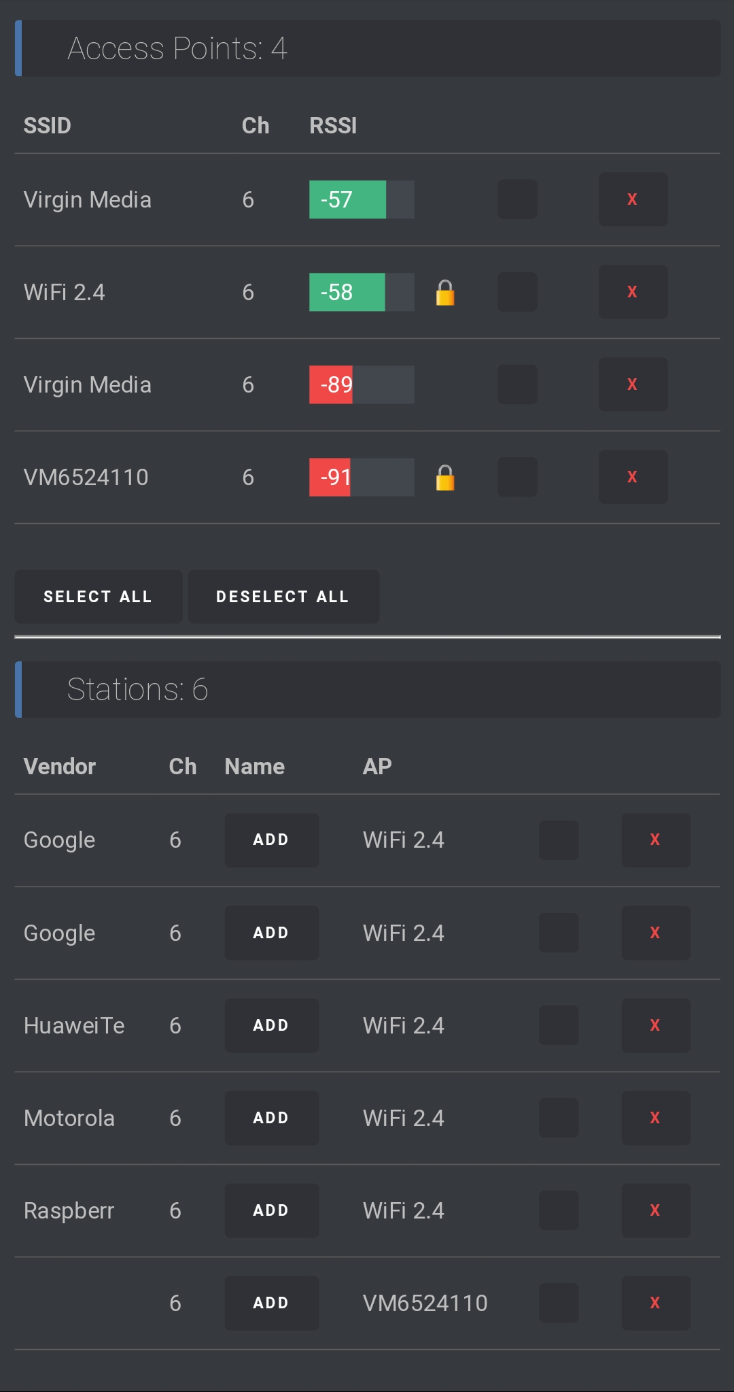
[Figure 1]
To test the device, the targeted network was chosen and the deauth attack was launched from the web interface through the smartphone. Moments later any device connected to the network was removed and failed to reconnect while the attack was ongoing. This confirmed the device was capable of hosting a deauthorization attack on its own remotely controlled through a web interface. During testing it was also identified that the deauthorization attack managed to prevent the DNS server running on another development board from being able to reconnect effectively preventing even wired devices on the network from accessing the web without the knowledge to check on or reset the DNS however once reset, the network returned to normal following the disabling of the attack. For the main attack for the experiment, the device will be positioned within range of the network as well as the attacker in order to execute the attack on command. Once positioned, the PC, now running Kali Linux on a live USB, can begin monitoring the active networks and stations in order to identify the target device’s BSSID as well as the channel the device is operating on shown in figure 2.
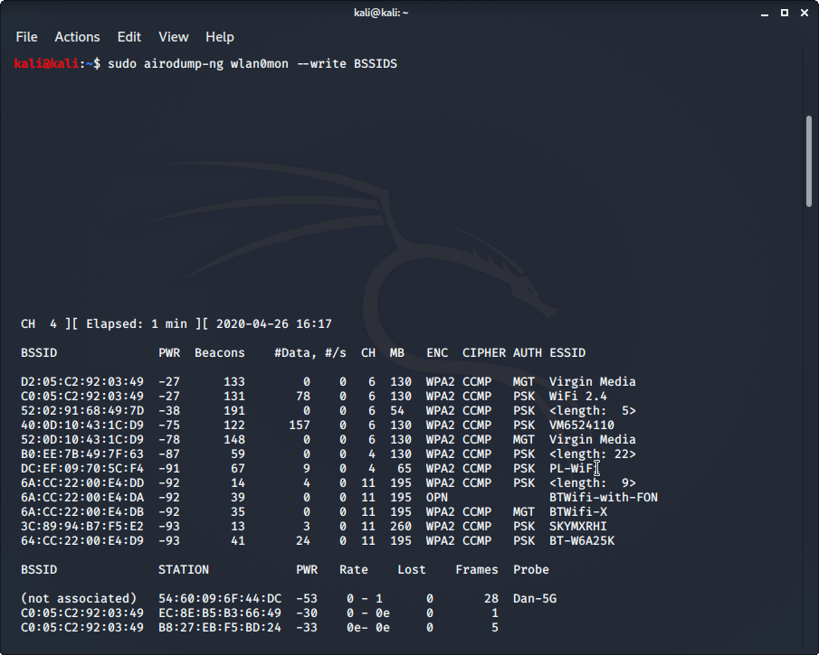
[Figure 2]
Following the exposing of SSIDs in the area, the SSID broadcast was disabled in an attempt to prevent the network being visible on scans. This did little to prevent the scans from obtaining network BSSIDs as the hidden network was still exposed by the station probe. Once identified and noted, Kali was now ready to sniff the WPA 4-way handshake, required to attempt to break into the network, by loading the tool ‘airplay-ng’. Once prepped the deauth attack was begun while aireplay-ng attempted to sniff the WPA 4-way handshake from a device attempting to reconnect to the network. This device could range from any of the connected smartphones to any of the smart assistants throughout the household resulting in a single target device being removed from the network without the target victims’ knowledge.
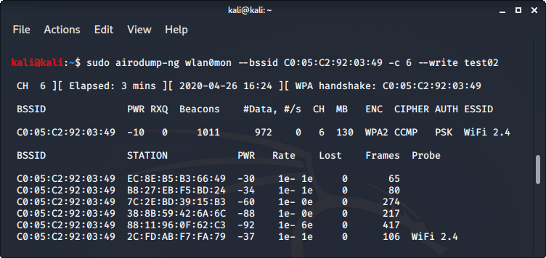
[Figure 3]
Once captured, the deauth attack was halted as the attacker now had the required information from the handshake. Alternatively, the attack could be continued to cause further disruption to the network in a DDoS styled attack. The handshake could then be verified through another tool called ‘aircrack-ng’ to ensure the captured handshake was valid, visible in figure 4.
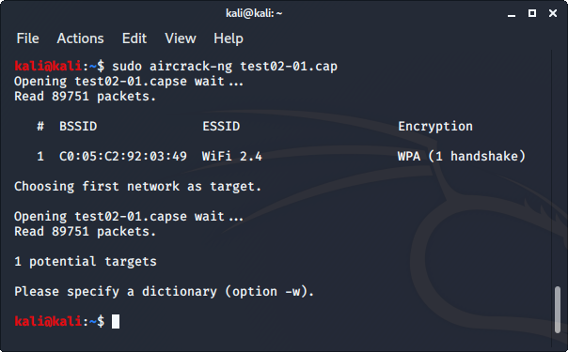
[Figure 4]
Following the capture of the handshake and verification, the attacker can begin an offline attack on the network by attempting a brute force password attack using aircrack-ng utilizing the handshake information however this can take a very long time depending on the passphrases complexity. Alternatively, the capture file could be converted through various tools available online such as HashCats [20] online converter tool ‘cap2hccapx’ where the file can be cracked through Hashcat to reveal the password for the targeted network granting the attacker access. Furthermore, the attacker could also set up an ‘Evil twin access point’ as an alternative way of gathering information from a target victim now that the device's SSID and BSSID amongst other details has been revealed. Once inside the network, the hacker is free to deploy whatever further attacks they desire such as malware, ransomware or even a logger program to run in the background and capture users inputting any sensitive information into various sites and/or programs.

Chapter 4 - Design & Implementation

4.1 Introduction

In order to verify the attacks work in today's typical home network setups, the experiment must be fully carried out in a live environment. In order to carry out a successful investigation, certain design decisions must be made to ensure the aims and objectives of the experiment are met. To achieve this, the project must be designed beforehand to meet specification. This includes any hardware choices, software choices as well as methods used to achieve the goal.

4.2 Hardware Choices

To begin the attack, a device capable of launching a targeted deauthentication attack was required. In order to meet these specifications, an Arduino development board, NodeMCU esp8266 was chosen as the device is very small and cheap whilst also having built in capabilities of wireless networking. The board comes programmable through Arduino software therefore, using SpaceHuhn’s pre-coded program, the board could become a very small, compact deauther device that is also inexpensive and can be bought in bulk. The power requirements for the device are also very low allowing an attacker to attach a small battery pack to the device and leave it running for multiple days at a time before the battery would need replacing/recharging making the device a very versatile device in comparison to a laptop capable of the same attacks while also remaining much more inconspicuous. This would allow an attacker to deploy many of these devices across an area allowing them to target multiple targets at once as long as the attacker is within range of each device.

Initially, a Microsoft Surface Laptop 2 [21] was chosen to conduct the experiment as the host for the penetration testing suite. This was later revealed however to not be possible as the system would not allow a Linux [22] based operating system to run on it without extensive work as the hardware was specifically designed to function on Windows [23]. It was then decided that the specialist OS could be loaded using a virtual machine software from Oracle [24]. This however would not allow the guest OS to utilize the wireless networking card resulting in the laptop of choice being incompatible for the project. This led to a HP laptop being used as a host machine for a live USB setup that would allow access to the networking card to the OS.

In regard to the chosen network setup, the design requirements needed a simple network setup that would be very common in most households with internet access. This would include a network that consisted of a wireless router as well as many end devices currently connected with an active internet connection from the ISP. The obvious choice for acquiring this setup was to use my own home setup with the permissions from everyone currently connected and using the network to begin the experiment. This was the design decision as it was a network that was familiar and fully customizable and available to use without the need for any new hardware being acquired.

4.3 Software Choices

While the Arduino deauther was capable of a few attacks, a more robust arsenal of tools was required to compliment the tools available to the Arduino in order to carry out the desired attack. This problem led to the decision to use a penetration testing OS alongside the deauther to aid the attack and allow the experiment to succeed. From conducting research into the various penetration testing operating systems the decision was to use Kali Linux and its suite of tools for the project.
The decision to use Kali Linux was a clear choice over other penetration tool suites such as ParrotOS [25] or Caine [26] as the popularity and support for Kali is a major factor to its success. The availability of tools and guides to accompany them helps Kali become a very useful but also powerful operating system for penetration testing needs. Kali Linux was chosen also for its excellent support of their ‘Live USB’ feature which can give a host pc full access to Kali’s suite of tools whilst not impacting the host storage. The feature can run the full suite of Kali’s tools on the USB as a bootable drive while ignoring the host PC’s internal drive. It was due to this fact that when conducting the experiment, the live USB feature was used on a donor laptop that was required for its wireless networking card allowing Kali to perform network scans and execute its sniff tools effectively. It was thanks to this feature that the experiment was able to go ahead making this design choice a crucial factor in the success for the project.

4.4 Implementation

From using the deauther Arduino device in the experiment, the deauther completed its task as expected. The device immediately began deauthorizing the selected device once the command was given and remained to keep the device attempting to connect until the Kali tools were able to retrieve the handshake. The device then immediately allowed the targeted device to continue as normal once the command was dismissed. This is very important as an attacker would not want to cause disruption for too long as to not raise any suspicion of a potential ongoing attack. The device was operated just as suggested in the literature review of SpaceHuhn’s support documentation making the process of setting up and using the device very straight forward.

Once the obstacles of selecting a suitable host laptop were overcome, the laptop chosen performed well, having a slightly older networking card and older processor, the laptop was still able to perform various network scans and sniffs through the tools the OS provided thanks to the operating systems speed and efficiency. Had the chosen OS not supported the live USB feature, the project would not have been able to go forward as the planned hardware resulted in unexpected conflicts with the chosen software.

During the experiment, the results of the home network setup met the expectations for the experiment as set by the prior research into the topic. The router was unable to establish a connection between devices whilst the deauthentication attack was ongoing and eventually revealed the WPA 4-way handshake to the Kali tools allowing the rest of the attack to continue to take place.

From using Kali Linux in the experiment, the tools provided were able to successfully carry out all required tasks successfully as expected as well as provide a backup deauther should there be an issue with the Arduino device. All results acquired from the tools used were received as expected allowing the experiment to continue onwards very smoothly.

4.5 Conclusion

By using the appropriate collection of hardware and software, the attack was able to go ahead as planned, after collecting the results it was clear to see that each stage of the experiment returned successfully however the attempt to crack the password was met with a very long expected time before a successful match would be made therefor the attempt on breaking the password was cancelled is it would have taken too long. While the password could have been matched had the tool had enough time to run, it was decided to halt the efforts to instead focus on other areas of the project.

Chapter 5 - Evaluation

5.1 Introduction

Once the data has been captured from the experiment it is then important to correctly evaluate the result in order to draw a conclusion and attempt to complete the aims and objectives of the project.

5.2 Results Evaluation

The data collected from the results of the experiment showed that even in a modern home network setup with software firewalls in the router, WPA2 secured Wi-Fi and hidden SSIDs, the attempts to break into the network were met with little to no resistance. The hidden SSID was immediately exposed with the full name of the network shown in text, the connected devices BSSIDs were immediately shown including the access point they were currently connected to as well as the signal strength and channel they were all operating on.

Any attempt to prevent the deauthentication attack was met with the same failed result as the core weakness in the 802.11 protocol has not been addressed and cannot be prevented until devices begin to utilize the 802.11w revised protocol that has built in measures to prevent deauth attempts. However, in today’s world, very few devices use this protocol and as a result cannot prevent a deauthentication attack, household equipment even less so making home network targets still very much exposed to simple deauthentication attacks as proven by the experiment.
Although the deauthentication attacks are still very easy to conduct, their usefulness is mitigated due to the fact that the time taken to brute force a password can be very large with some passwords being virtually impossible to crack for a typical attacker looking to cause malicious intent. This is simply due to the complexity that passwords can incorporate. By using various characters and even symbols, the time required to brute force the password by trying every possible combination until the attack succeeds is increased massively. However, this is only the case if the network password is indeed complex, a simple string of characters would not take long to reveal. While there are other alternatives to the traditional brute force attack, these can still take an incredible amount of time to crack making the attempted attack impossible to complete within any reasonable amount of time for an average attacker.

While the attacks can be unavoidable by any means of prevention, there have been areas a victim can identify to help halt any further attempts at cracking into their network. An example of this includes when a device mysteriously disconnects from the network and fails to reconnect. A quick investigation into the status of the network can help identify if this is a network fault or an unknown device fault. Should the victim suspect anything malicious, they can simply turn off the suspected device, preventing the 2 devices exchanging a 4-way handshake and preventing the attacker from being able to identify it. Should the issue then begin to reoccur with a new device, the victim should suspend or shutdown the network to prevent the attacker repeatedly attempting to attack the network. The only other means of defense is to ensure each home network comes from the ISP with a very strong password that can only be replaced by another suitably strong password to prevent any brute force or cracking attempts from only taking a small amount of time making it not worthwhile for the attacker to stay around that long.

On a whole, these results were in line with that of the research conducted into this topic in the past proving that the security in this sector still remains a potential threat to any network that does not use complex passwords and is not running the 802.11w protocol.

Were this experiment to be conducted again, there would be a comparison made between two separate networks where one would use a complex password that the average person would create themselves against a password issued by an ISP. These two passwords would then be used to compare the time taken to crack the passwords, as well as a third test network with a very simple string password to prove the method's success in a reasonable time frame. Another form of attack such as the evil twin access point could also be conducted to show the abilities of another form of attack as well as a man-in-the-middle attack to show how effective these can be against a home network and an unsuspecting victim.

While this experiment met many of the target aims and objectives the aim to completely prevent these attacks from happening is not possible with the current widely used protocol for home networks being the 802.11 protocol. Should this protocol become replaced by the 802.11w protocol by using specialist hardware, the aim would be met but for the average household, this is not a viable option therefore the issue cannot be fully prevented as of yet.

Chapter 6 - Project Conclusion

To conclude the project, the aims and goals for the experiment was to use suitable hardware and software tools to highlight an area in the home network that has been insecure for many years and attempt to reduce the impact of this weakness while also attempting to prevent it all together. Following the background research into the topic, it was clear that the potential threats that could arise from this exploit were substantial and could cause a lot of damage to an unsuspecting victim. While there were advances being made in the prevention of these attacks, the 802.11w protocol responsible for this is not yet widespread in the home network market as a result, home networks across the globe are still to this day in a vulnerable state to these forms of deauthentication attacks.
From conducting the experiment on a controlled network that has been made as secure as reasonably possible for a typical home network setup, it was clear to see there is no way to prevent this issue for any typical household however after attempting the final crack of the network password it was very clear that the ability to brute force a password takes a lot of time. The more complex the password the more time the crack would take which can easily lead to passwords being impossible to crack should the password being complex enough which leads to the conclusion that the passwords set on the router should need to be highly complex from the ISP with the ability to change the password only to another very complex password to ensure the average home network remains as secure as possible.

Chapter 7 - Reflection

Throughout the project, I personally learned to become much more familiar with the Arduino development platform and the capabilities a single device can be capable of through the use of IoT and other emerging technologies. I have also developed a familiarity with the Linux operating system through the use of Kali Linux to help expand my knowledge base of different system setups and how to use them for more technical use cases.
Throughout the development of this project as a whole, a key skill I have learnt is the effectiveness of correct time management and how it can alleviate pressure from such a large task. This should continue to help me throughout the future of my studies/careers as I apply this to large tasks.

Chapter 8 - References

[1] Kali Linux - Operating System – [Online] - Available: https://www.kali.org/
[2] Statista – Company – [Online] Available: https://www.statista.com/statistics/275999/household-internet-penetration-in-great-britain/
[3] Amazon - Company - [Online] - Available: https://www.amazon.co.uk/
[4] Just Eat - Company - [Online] - Available: https://www.just-eat.co.uk/
[5] Virgin Media - Company - [Online] - Available: https://www.virginmedia.com/
[6] Google Home - Product - [Online] - Available: https://store.google.com/gb/product/google_home
[7] Amazon Alexa - Product - [Online] - Available: https://www.amazon.com/Amazon-Echo-And-Alexa-Devices/b?ie=UTF8&node=9818047011
[8] Webroot - Article - [Online] - Available: https://www.webroot.com/ie/en/resources/tips-articles/what-is-social-engineering
[9] Y. Song, C. Yang and G. Gu, "Who is peeping at your passwords at Starbucks? — To catch an evil twin access point," 2010 IEEE/IFIP International Conference on Dependable Systems & Networks (DSN), Chicago, IL, 2010, pp. 323-332.
[10] Y. H. Hsneh et al, "ET Detector: A Client-Based Solution to Detect an Evil Twin Access Point," Applied Mechanics and Materials, vol. 764-765, pp. 900-904, 2015. Available: https://search.proquest.com/docview/1684015754?accountid=130472. DOI: http://dx.doi.org/10.4028/www.scientific.net/AMM.764-765.900.
[11] Search Mobile Computing - Article - [Online] - Available: https://searchmobilecomputing.techtarget.com/definition/80211
[12] Scott R. Fluhrer, Itsik Mantin, and Adi Shamir. 2001. Weaknesses in the Key Scheduling Algorithm of RC4. In Revised Papers from the 8th Annual International Workshop on Selected Areas in Cryptography (SAC ’01). Springer-Verlag, Berlin, Heidelberg, 1–24.
[13] Wi-Fi Alliance - Organization - [Online] - Available: https://www.wi-fi.org/
[14] B. Könings, F. Schaub, F. Kargl and S. Dietzel, "Channel switch and quiet attack: New DoS attacks exploiting the 802.11 standard," 2009 IEEE 34th Conference on Local Computer Networks, Zurich, 2009, pp. 14-21.
[15] Johnson, H., Nilsson, A., Fu, J., Wu, S. F., Chen, A. & Huang, H. (2002). SOLA: A one-bit identity authentication protocol for access control. In Proceedings of IEEE global telecommunications conference, Taipei, Taiwan (pp. 768–772), November 17–21, 2002.
[16] Nguyen, T. D., Nguyen, D., Tran, B. N., Vu, H. & Mittal, N. (2008). A lightweight solution for defending against deauthentication/disassociation attacks on 802.11 networks. In Proceedings of 17th international conference on computer communications and networks (ICCCN ‘08), St. Thomas, US Virgin Islands (pp. 1–6), August 3–7, 2008.
[17] SpaceHuhn - Developer - [Online] - Available: https://spacehuhn.io/#about
[18] NodeMCU eps2866 - Product - [Online] - Available: https://www.nodemcu.com/index_en.html
[19] IEEE – Organization – [Online] Available: https://www.ieee.org/
[20] HashCat – Service – [Online] Available: https://hashcat.net/hashcat/
[21] Microsoft Surface Laptop 2 - Product - [Online] - Available: https://www.microsoft.com/en-gb/p/surface-laptop-2/8xqjkk3dd91b?activetab=pivot%3aoverviewtab
[22] Linux - Operating System - [Online] - Available: https://www.linux.org/
[23] Windows - Operating System - [Online] - Available: https://www.microsoft.com/en-gb/windows
[24] Oracle - Company - [Online] - Available: https://www.oracle.com/uk/index.html
[25] ParrotOS - Operating System - [Online] - Available: https://parrotlinux.org/
[26] Caine - Operating System - [Online] - Available: https://www.caine-live.net/

Appendices

- SpaceHuhn’s esp8266 deauther project - https://github.com/spacehuhn/esp8266_deauther

