Project Planning and Management in the Workplace

Student Name: Salema Khanum
Student ID: 1713343
Module: Project Planning and Management in the Workplace
Module Code: BMSW5104
Lecturer: Paul Ranson

The Organisation

The organisation, “Vintners” is a family-run antiques store situated in Shirley. The main co-ordinator of the business is Doreen Vintner. Doreen is an accountant who has been running the store for many years. She makes sure to obey the rules and is a strict individual. The team member responsible for finding antique collectables and vintage furniture is Denis Vintner. Denis holds a passion for rare antiques; therefore, he travels around the country to find a wide range of rare furniture to be repaired and sold at the store. Customer service is handled at the store by Suha. Suha Madani has the responsibility of ensuring that customers leave the store satisfied with their experience and she must deal with complaints and enquires. She has worked at the store for 3 consecutive years, proving that she is liked by customers and carries her duties out exceptionally. The final member of the business is Omar King. Omar’s responsibilities include managing and organising the warehouse, and repairing the antique goods that Denis collects. He has the responsibility of ensuring that the warehouse is operating well and that antiques are refurbished to a high standard- resulting in satisfied customers and increased sales. Omar’s many skills, including carpentry, help him to carry out his responsibilities.
The Vintners warehouse, which contains all the stock and the repair station, is based in Sparkhill. The company requires a Project Manager to assist them with converting their store into an online-based business from their warehouse. This is because they have received an offer from Tesco, who would like to buy their property off them. One of the things that they need to do is relocate all their in-store stock into their warehouse. However, before they do this, the warehouse will need to be repaired so that it is fit enough to store the antiques and electric equipment, and so that it is safe and comfortable enough for workers.




Doreen Vintner
Denis Vintner
Suha Madani
Omar King

Risk Assessment- Risks in the Project

As with opening a brick and mortar store- there are risks with opening an online store. The internet has quickly become a way for small businesses and large to sell their products and advertise to a larger market audience. “Whether it is an information website or personal blog monetized by advertising or an ecommerce store, the Web has become a critical business medium for small entrepreneurs.” However, transitioning a business from a brick and mortar includes additional risks that will need to be considered. Online Businesses all face the risk of not having sufficient online security. This would pose risks such as phishing, data errors, unprotected online services, and hacking. It could put any customers who use the site at risk of having their personal data, such as email addresses and credit card details/billing information, stolen. Cybercrime like hacking is so common today, statistics prove that “There is a hacker attack every 39 seconds.”. To avoid the chances of having the website hacked into and data stolen, all the transactions, from ordering to the delivery should be monitored. Additionally, when creating an account- customers should be asked to create strong passwords.
Another risk that could affect the company is e-commerce Intellectual Property. Copyright is one of the most important key factors when opening an online retail business. Any images and logo which Vintners own and use on the website will need to be safeguarded by their own intellectual property. This is so that anyone else who would like to use their logo or images will need to request permission to do so first. Likewise, permission will need to be attained to use someone else’s images.
Furthermore, customer disputes are issues which are a main concern to any business. With an online business, there can be complaints such as the product never arrived, the purchase was made with a stolen credit card, the product didn’t meet expectations or match website description, the wrong product was shipped or a clerical error like the order was billed twice. A solution to this can be to only charge customers once the items they ordered are shipped and including a clear refund policy on the website.
Finally, damaging the antique products when relocating them to the warehouse poses as a major risk. There are problems such as having the store stock badly damaged or delivered to the wrong location. Therefore, it is necessary to ensure that the antiques are properly wrapped and packed to avoid scratches or cracks appearing on them.

Project Management Tools and Techniques

User Stories
User stories are used in agile software, it is a tool used “to articulate how a piece of work will deliver a particular value back to the customer.” The user story describes the who the user is, their requirements, and why they want certain things. The User Story can be recorded on post-it notes or a notebook, and the authors can be users, clients, the development team, or managers- who are all the stakeholders of a project. For example, the type of user can be an online shopper- who wants to be able to add an item into their cart (the feature), so that they can purchase it (the reason). A User Story should be short and concise- so that it does not overcomplicate anything. Also, it should be written as a team, this is so that each member of the team can contribute- creating a diverse and larger amount of ideas. Therefore, User Stories help the team to concentrate on the needs of the customers, which “eliminates various potential risks such as - lack of communication risk, technical risk, financial risk, business risk, etc.”

Chevron
“A goal in itself is not a problem. It is when there are obstacles that make it difficult to reach the goal that one has a problem.” To find the obstacles needed to overcome to achieve a goal, the goals will need to be categorised according to importance and the overall mission will need to be recognised. To do this, I will be using the project management tool- Chevron.
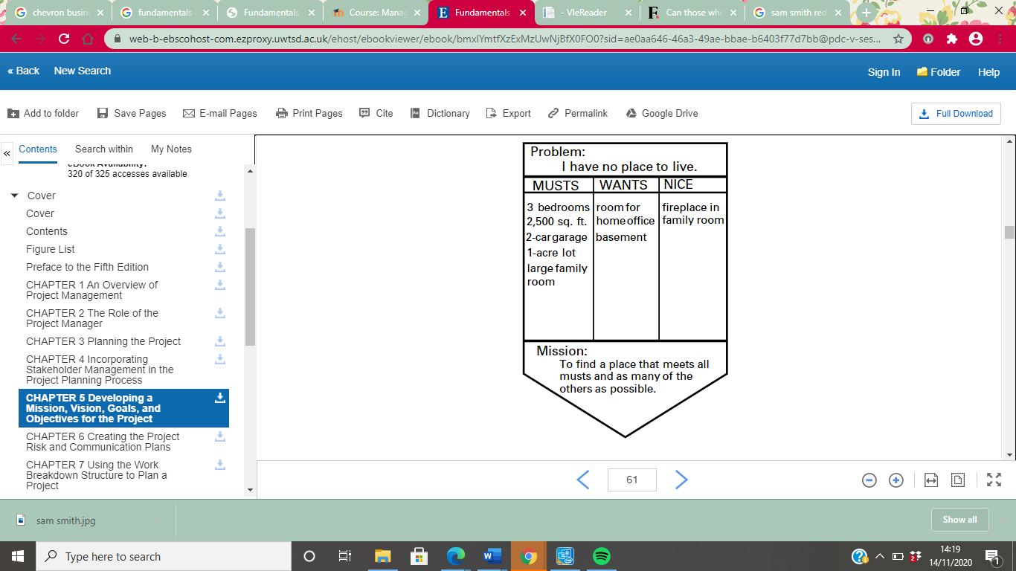
Joseph Heagney (2016) Fundamentals of Project Management. New York: AMACOM
This diagram shows the “Problem”, the “Musts”, the “Wants”, the “Nice” and the overall “Mission”. The “Problem” is the main issue. In this case, the persona has nowhere to live. First, the “Must” needs to be recognised. These are the things that the persona must have, the main priorities for the solution. Next, “Wants” should be recognised, which are the non-compulsory features, but features that are still important. Finally, the “Nice” is things that she does not require but she would like to have, although this is the least important. There is also the overall “Mission”, which is to find a place that meets as many of the “Musts” first, then as many of the others, as possible. The Chevron tool is a very useful way to organise what is needed and what is not as necessary- allowing a more organised and neater approach to achieve the overall mission.

Trello Board
“Collaboration tools, by default, enable a group of two or more people to collaborate and move towards a common goal or objective.” There are many different collaboration techniques which can be used in this case study. A popular technical application, the Trello board, is like normal non-technical options (flip charts, paper, post-it notes and whiteboards). The Trello board is a very easy-to-use and popular method used to plan and organise projects and tasks in them. The board allows you to easily find who is working on what, when they are working on it, and the progress made on the project. An advantage of the Trello Board is that adding any new members is easy to do so, as well as creating new issues and assignments. The board is also mobile-friendly. This is beneficial because it means that the Trello board can be used whilst travelling, easily. However, a downside of using a Trello board is that it is not as complex as a full-featured project management, “Project teams need features such as time-tracking and expense tracking to make sure projects are on-time and within budgets.”. Therefore, a Trello may be more suited to a smaller project. Also, a Trello board does not show task dependencies. “Task dependencies are needed to obtain the critical path information.” Whereas a Gantt Chart does show task dependencies.

Gantt Chart
A useful project management tool is the Gantt Chart. The Gantt chart shows the timeline and owner of tasks and the date at which they start and end. Also, the completion of each task at a stage, deadlines, scheduling, and dependencies. Therefore, the Gantt chart is reliable to a large team of multiple stakeholders, as it gives “managers visibility into team workloads, as well as current and future availability, which allows for more accurate scheduling”. However, a successful Gantt Chart must be simple and clear. Link to the Gantt Chart

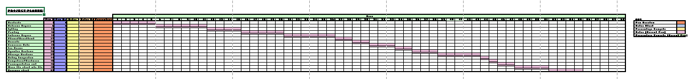
(Gantt Chart- Full View)

Communication of Project Plans

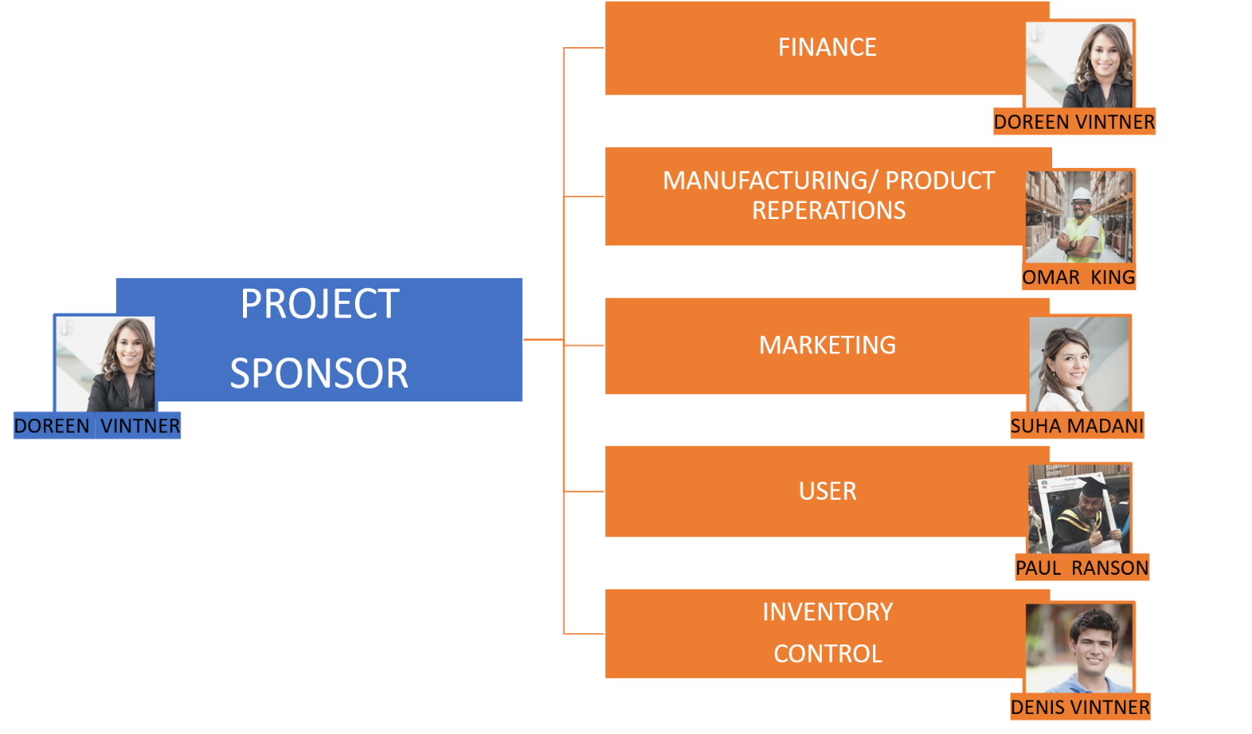
The Steering Group
The Internal Stakeholders of this project are the Sponsor, the Financier, the User, the Product Manufacturer, the business Marketer, and Inventory Control.

Project Sponsor:
The Project Sponsor for this project is Doreen Vintner. Doreen would make an excellent Project Sponsor because she follows rules and is accustomed to running on a tight schedule. The Project Sponsor is the individual who has been invested in the business and the project since the beginning. They have the responsibility of attaining any financial recourses and works very closely with the Project Manager- assisting with decision-making and risk assessments. “organizations that undervalue project management report an average of 50% more of their projects failing outright.” Therefore, a Sponsor is so essential in a project, without one, the project would undoubtedly fail.
Financier:
Doreen Vintner will also be the Financier in the Steering Group. As an Accountant, she attains all the necessary experience and qualifications to ensure that the Financial side of the project is overlooked. Therefore, Doreen will be in-charge of any loans, insurances and recording the expenses. Doreen will also play a large role in planning out the financial aspects of the project.
Manufacturing/ Project Reparations:
Omar King will oversee the project reparations. The antique business regularly collects unique products which are second-hand, as they are vintage. Therefore, any minor faults or damages will need to be repaired and the products, such as furniture, will need to be upcycled to make them appealing to customers. Omar has worked within the business since he was very young, and he already has the responsibility of repairing the antique goods that Denis collects. Omar is also fit for this role because he has excellent carpentry skills

Marketing:
For the marketing of the Vintner company, Suha Madani would make a suitable candidate. Suha already manages customer service within the business, and the customers do like her. Therefore, this proves that she is good at what she does. Suha will be in charge of advertising products and dealing with customer enquiries.
User:
The User of the project is any customers of the business. Paul Ranson is a friend of the family who owns the business. This makes him a potential customer or user of their products.
Inventory Control:
Denis Vintner, who finds different, unique products to sell, will be the Inventory Controller. An Inventory Controller must make sure the correct quantity of items is in stock and oversee the inventory (stock). Denis would be perfect for this role because he already has experience in finding antiques for the store and has a passion for antiques.

Waterfall Methodology
The Waterfall Methodology is a way the project plan can be communicated to the Stakeholders. This method is a “linear project management approach”. The requirements of the Stakeholders and the customers are sorted at the start, and then the plan is tailored to these requirements. With five to seven phases, the next phase cannot be started until the one before it is fully completed. The first phase to the Waterfall Methodology is that the requirements of the client must be gathered. This is a crucial starting point to any project. The ‘wants’, the ‘needs’ and the ‘nice to haves’ of the Stakeholders (the Vintner steering group) must be recognised. This would be the Chevron method, which would prioritise the requirements of the client by importance and determine the end mission. The next phase is the design of the project. Here, the steps to complete the project and how to complete the steps are brainstormed and evaluated. To do this, the Gantt Chart should be used to make the steps organised and clear. After this, it is the third phase, which is Implementation, which is the actual implementation of the project takes place. The end-result then needs to be checked and looked over by the Project Manager and the Stakeholders, to ensure that it is meeting customer expectations, which is the Verification phase. Finally, the last phase is the Maintenance of the project. This final step is crucial because it is when the customer is using the final product in real-time. By seeing the result of the project being utilised, any issues and dilemmas will be clearer. Therefore, changes to the way the things are working can be made at this time

Personal Reflection, Future Recommendation and Self-Development

To improve my own performance, I will consider my own personal goals and do as much as I can to ensure my own success, as well has the success of the project. During this project, I intend to develop my Project Management Skills, as it is something I wish to pursue further in the future. I also intend to use this project as a staple in my experience in the field, whilst taking away valuable skills from it. This is because I believe that the more lessons I learn from experience in the field- the better Project Manager I will become. By 2022, I hope to secure a full-time career as a Project Manager, I will do so after completing the Prince-2 certificate to widen my qualifications and to give me a higher chance of finding the dream Project Managing career.

Reference List

Whether it is an information website or personal blog monetized by advertising or an ecommerce store, the Web has become a critical business medium for small entrepreneurs.
https://www.powerhomebiz.com/blog/2013/12/24/10-risks-starting-online-business/

There is a hacker attack every 39 seconds.
https://hostingtribunal.com/blog/hacking-statistics/

“Collaboration tools, by default, enable a group of two or more people to collaborate and move towards a common goal or objective.”
https://www.simplilearn.com/tutorials/project-management-tutorial/what-is-trello

Project teams need features such as time-tracking and expense tracking to make sure projects are on-time and within budgets.”.
https://projectmanagers.net/top-8-disadvantages-of-using-trello/#:~:text=%20Disadvantages%20and%20Cons%20of%20Trello%20%201,inability%20to%20show%20task%20dependencies.%20Many...%20More%20

“Task dependencies are needed to obtain the critical path information.”
https://projectmanagers.net/top-8-disadvantages-of-using-trello/#:~:text=%20Disadvantages%20and%20Cons%20of%20Trello%20%201,inability%20to%20show%20task%20dependencies.%20Many...%20More%20

managers visibility into team workloads, as well as current and future availability, which allows for more accurate scheduling
https://www.apm.org.uk/resources/find-a-resource/gantt-chart/

https://www.atlassian.com/agile/project-management/user-stories
used “to articulate how a piece of work will deliver a particular value back to the customer.”

“eliminates various potential risks such as - lack of communication risk, technical risk, financial risk, business risk, etc.”
https://agileforgrowth.com/blog/userstory-benefits/#:~:text=%20Good%20User%20Story%20Benefits%3A%20%201%20Highest,Story%2C%20the%20product%20is%20built%20incrementally.%20More%20

“A goal in itself is not a problem. It is when there are obstacles that make it difficult to reach the goal that one has a problem.”
Joseph Heagney (2016) Fundamentals of Project Management. New York: AMACOM. Available at: https://search-ebscohost-com.ezproxy.uwtsd.ac.uk/login.aspx?direct=true&db=nlebk&AN=1135060&site=ehost-live (Accessed: 14 November 2020).

organizations that undervalue project management report an average of 50% more of their projects failing outright.
https://www.lucidchart.com/blog/why-is-project-management-important#:~:text=A%20good%20project%20manager%20is%20the%20glue%20that,more%20of%20their%20projects%20failing%20outright.%20Fifty%20percent.

linear project management approach
https://www.projectmanager.com/waterfall-methodology#:~:text=Waterfall%20methodology%20is%20a%20linear%20project%20management%20approach%2C,project%20plan%20is%20created%20to%20accommodate%20those%20requirements.

