Dissertation (Proposal)

Title: The impact of democratic leadership style on employee motivation in the UK restaurant sector within the London region.

LCBB6000

Name: Anca Ghizela Hotca (2021006)
Supervisor: Dr. Anupam Mazumdar

Contents
CHAPTER 1 4
1.1 Introduction 4
1.2 Origin of the study 4
1.3 Background of the study 5
1.4 Problem statement 6
1.5 Aim of the study 6
1.6 Objectives of the study 6
1.7 Research question(s) 7
1.8 Significance of the study 7
1.9 Rationale of the study 8
1.10 Outline of the study 8
1.11 Conclusion 8
CHAPTER 2: Literature Review 9
2.1. Typology of Leadership Style 9
2.2. Characteristics of a Democratic Leader 10
2.3. Democratic Leadership and Employee Motivation 11
CHAPTER 3: Research Methodology 13
3.1. Research Philosophy 13
3.2. Research Paradigm 13
3.3. Research Approach 13
3.4. Research Methodology 14
3.5. Research Strategy 14
3.6. Sampling Method 14
3.7. Data Collection Method 15
3.8. Data Interpretation Technique 15
3.9. Time Prospect 15
3.10. Ethical Considerations 16
List of References 17

CHAPTER 1

1.1 Introduction
Democratic leadership could be defined as leadership style according to which a leader adopts participative approach for involving followers in decision making process as a holistic team. This kind of leadership style promotes team based decision making approach so that a leader could involve entire follower team for making decisions in business through considering the diversity of views. The purpose of the following research is to evaluate the effectiveness of democratic leadership style for contributing in employee motivation. In the below Figure 1 represent the market size of the full sevice restaurant section in the United Kingdom.

1.2 Origin of the study
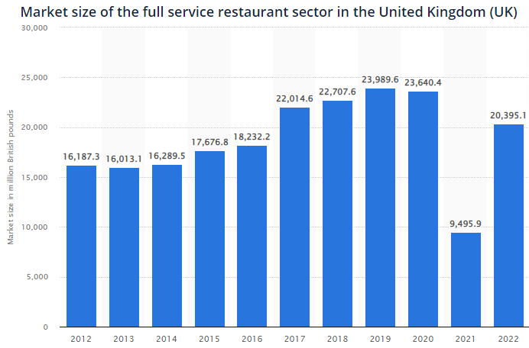
Fig 1: Market size of the full service restaurant sector in the UK(Source: Statista, 2023)
The above provided figure shows that market size of restaurant industry in the UK faced a drastic fall in the post pandemic operational scenario in 2021 and it is projected to remain lower than 2019 even in 2022 as well (Hilton et al., 2021). It shows that recent operational hazards for restaurant industry in the UK have also affected overall market productivity and revenue generation capacity as well (Dastane, 2020). Hence, this research tries to evaluate the extent to which demographic leadership style could be useful for restaurant sector businesses in the UK to trigger staff motivation level in the present adverse operational conditions.

1.3 Background of the study
The target scenario based on which this research will evaluate the importance and effectiveness of democratic leadership towards staff motivation is the restaurant industry in the UK. By the end of 2021, restaurant industry in the UK involves more than 101,000 businesses across the nation (Hilton et al., 2021). It is evident that the current operational scenario of the British restaurant industry is highly competitive in nature. In the below figure 2 represents the scenario of number of restaurants and mobile food businesses in the UK during 2008-2021.
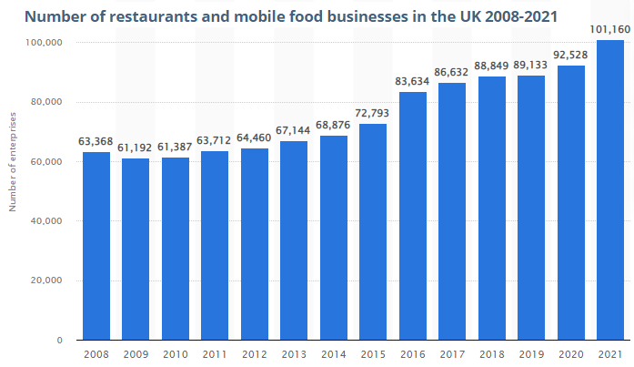
Fig 2: Number of restaurants and mobile food businesses in the UK (Source: Statista, 2023)
The UK restaurant industry employs a huge workforce of more than 450,000 employees (Caillier, 2020). Many restaurant brands in the UK operate multiple outlets across the nation which generates the need for decentralised leadership approaches (Putra et al., 2017). This study will try to evaluate employee motivational impacts of democratic leadership with respect to this contemporary context of British restaurant industry.

1.4 Problem statement
In recent years, the restaurant industry in the UK has gone through range of ups and downs. Huge number of restaurant industry employees lost their jobs during and after Covid19 pandemic due to heavy losses incurred by their employer during lockdown and post-pandemic operational restrictions (Caillier, 2020). Growing market trend of online food delivery is also responsible for diversifying technical skill requirements from restaurant industry workforce in the UK and subsequently it could also affect their work motivation through triggering job insecurities among employees (Kotera et al., 2018).

1.5 Aim of the study
Aim – The aim of this research is to evaluate the importance of demographic leadership style for contributing in employee motivational level in the UK restaurant industry within the London region.

1.6 Objectives of the study
Objectives – Research objectives to be accomplished from this study are –
- To understand the concept of democratic leadership style and its applications by Restaurant businesses in London.
- To identify the issues/challenges of associated with employee motivation management of British restaurant industry in London.
- To evaluate the relevance and impacts of democratic leadership style on employee motivation level in restaurant sector businesses within London.
- To recommend strategies for more effective application of democratic leadership style in British restaurant businesses for boosting up staff motivation.

1.7 Research question(s)
Research Questions
- How democratic leadership style could contribute in employee motivational level in restaurant businesses within London?
- How restaurant sector businesses in London could make more effective use of democratic leadership style to trigger staff motivation in the present operational conditions?

1.8 Significance of the study
People face a variety of obstacles in today's professional world. Employees nowadays make every effort to provide a result-oriented performance during their work because it is the work that defines a person's worth in both the organisation and society. The value of an organisation is determined by the quality of its workforce (Dastane, 2020). Complete utilisation of employee competency is a management skill that demands its staff to be in sync with their place of employment. Considering the demanding work schedule of restaurant industry, it is very much required for the leaders to motivate the employees and boost their morale to overcome the tiring work schedule and execute their work with ease. Thus, this study would dig into the relevance of democratic leadership style with respect to managing employee motivation within the work place.

1.9 Rationale of the study
Numerous studies on the nature of employment in the restaurant industry indicate that that restaurant industry is demanding and hectic. These positions are typically described as having low compensation, part-time employment, few opportunities for advancement, and a restricted work environment. Throughout the restaurant industry and operational system sometimes chaotic workday, especially during peak hours, employees are required to be prompt and pleasant to ensure customer satisfaction with service quality (Putra, et al., 2017). Thus, there are ample strategies employed by leaders to ensure employee motivation, however, apart from such strategies the attitude of a leader towards the employee’s also leads to motivation. Hence, the role of democratic leader in employee motivation would be the primary factor to be evaluated in the course of this study.

1.10 Outline of the study
The main study would be formatted into five main chapters the 1st chapter would detail on the introduction part of the research following to that would be a vivid discussion on literature to be conducted in 2nd chapter. Then 3rd chapter would define the research methods to be followed and their relevance to the study.

1.11 Conclusion
This research will be following secondary data collection methodology for gathering information from a wide range of online journals, articles and reports shedding light on the employee motivational impacts of democratic leadership in the British restaurant industry (Newman & Gough, 2020). The research will be using interpretivism philosophy for extracting facts from online secondary data sources depending on subjective interpretations.

CHAPTER 2: Literature Review

2.1. Typology of Leadership Style
According to Dastane, (2020) a leader in business could be defined as an individual with ample visionary characteristics and motivational qualities for providing directions to the future of a business and gaining motivated cooperation from the follower workforce. One of the most effective theoretical concepts for categorising leadership styles in business is the Lewin’s Leadership Style Model.
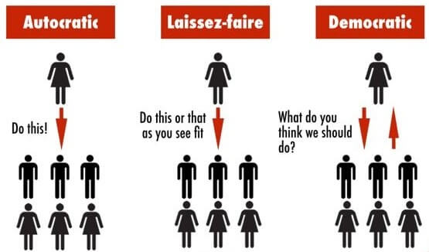
Source: Kotera et al., (2018)
According to Kotera et al., (2018) Lewin’s leadership style sheds light on three types of leadership behaviour which include autocratic, democratic and laissez-faire. Hilton et al., (2021) stated that autocratic leadership is a control oriented leadership style for limiting decision making power to self and controlling follower workforce with strict orders and instructions.
Dastane, (2020) opined that laissez-faire leaders also keeps the final decision making power in business to self but considers views and opinions of employees as well. Caillier, (2020) argued that democratic leaders show least directive behaviour for allowing employees to contribute in the decision making process depending on their individual views and opinions.

2.2. Characteristics of a Democratic Leader
According to Putra et al., (2017) democratic leadership could be defined as leadership style in which a leader adopts participative behaviour for involving follower workforce in the decision making process. Kotera et al., (2018) argued that democratic leaders usually believe in team based decision making process where individual views of follower employees get equal importance in the decision making process.
Gandolfi & Stone, (2017) opined that democratic leadership strongly encourages creativity and collaboration among follower workforce to foster conflict free decision making process. Hilton et al., (2021) also stated that democratic leaders usually work like a guide and mentor to a follower team so that they could reach their full performance potential depending on own creative thinking.
According to Mohiuddin, (2017) democratic leaders are more focused on frequent feedback collection and exchange so that performance progress could be tracked and employees could be provided with justified guidance. Putra et al., (2017) also stated that democratic leaders foster flexibility at workplace so that employees could be empowered to meet their responsibilities in their own creative way.

2.3. Democratic Leadership and Employee Motivation
According to Gandolfi & Stone, (2017) Maslow’s Hierarchy of Needs is one of the most effective theoretical concepts for outlining motivational needs of people in five distinct categories including physiological, security, belongingness, esteem and self-actualisation.
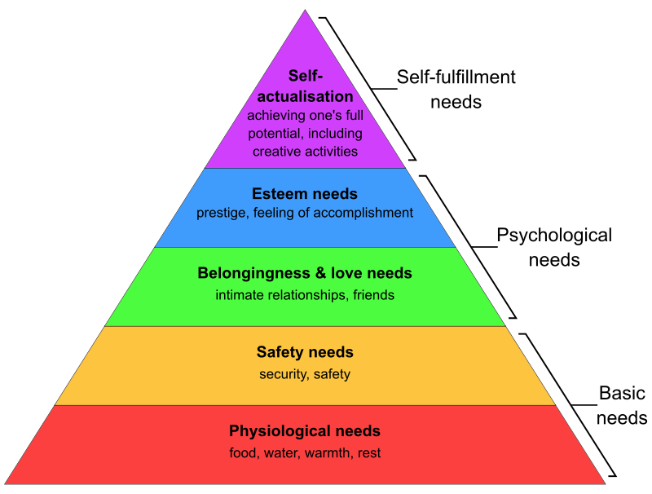
Source: Gandolfi & Stone, (2017)
Kotera et al., (2018) argued that democratic leadership could deeply contribute in employee motivation through meeting their self-actualisation motivational needs. Mohiuddin, (2017) also opined that democratic leadership empowers employees to meet their responsibilities depending on their own creative ideas and it could contribute in positive motivation level through better sense of self-actualisation. Putra et al., (2017) contradicted that democratic leadership could also contribute in employee motivation through triggering their esteem needs. Hilton et al., (2021) stated that democratic leaders ensure equal inclusion employees in the decision making process without directive behaviour and it could improve their sense of self-esteem.
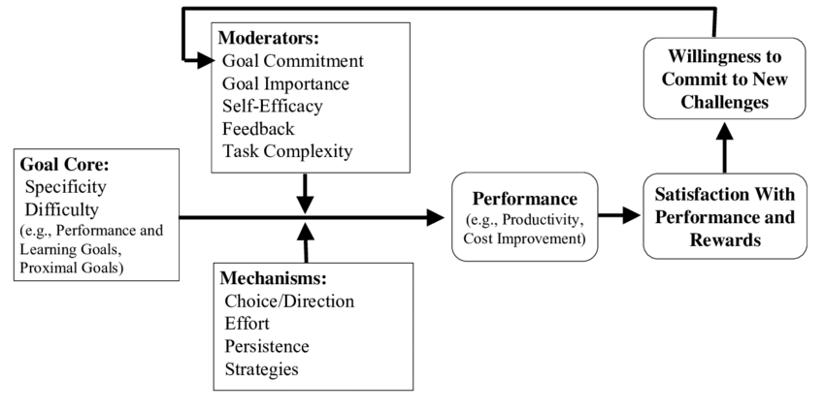
Source: Dyczkowska & Dyczkowski, (2018)
Locke’s Goal Setting theory shows that employee motivation in goal oriented work context is influenced by five key moderators including task complexity, feedback, self-efficacy, goal commitment and importance. Mohiuddin, (2017) stated that democratic leaders put additional efforts in feedback exchange with follower workforce which could boost their motivation with better goal orientation. Dyczkowska & Dyczkowski, (2018) contradicted that democratic leadership could also trigger staff motivation through facilitating their self-efficacy to utilise their own creative thinking at work.

CHAPTER 3: Research Methodology

3.1. Research Philosophy
There are different types of research philosophy to connect a research topic to its practical scenario and some of the most common types of research philosophies are positivism, interpretivism, realism, pragmatism, etc (Mohajan, 2018). This research will be using interpretivism philosophy for extracting accurate facts from range of secondary data sources depending on subjective interpretations (Newman & Gough, 2020).

3.2. Research Paradigm
Research paradigm has several different types including explanatory, exploratory and descriptive. This research will be using explanatory design as it is effective for finding justifications between a cause and effect. Explanatory design will enable this study to consider democratic leadership as a cause and find its motivational impacts on restaurant sector employees in London (Ruggiano & Perry, 2019).

3.3. Research Approach
There are two main types of research approaches to determine the direction of a study which are deductive and inductive. This research will be using deductive approach that flows from assessment of a generalised scenario for drawing conclusions to a specific hypothesis or context (Mohajan, 2018). Deductive approach will be useful for assessing data from wider diversity of online journals for drawing conclusions to employee motivational impacts of democratic leadership (Newman & Gough, 2020).

3.4. Research Methodology
In terms of methodology, this research will be secondary in nature. The main reason for adopting secondary research methodology is to consider diverse views of different researchers about motivational impacts of democratic leadership style (Snyder, 2019). Secondary methodology will enable the researcher to evaluate employee motivation impacts of democratic leadership in London based restaurant industry from diverse strategic viewpoint of different researchers (Ruggiano & Perry, 2019).

3.5. Research Strategy
Strategically this research tries to evaluate motivational impacts of democratic leadership in light of restaurant sector in London. The study gathers data from different online articles shedding light on different aspects of democratic leadership style and its relevance with employee motivational needs in restaurant industry (Mohajan, 2018). Evaluation of gathered facts in light of relevant motivational theories is the main approach for this research to reach meaningful findings (Snyder, 2019).

3.6. Sampling Method
There two types of sampling methods to foster accurate selection of information sources in a research study which include probability and non-probability. This research will be using non-probability purposive sampling for selection of online secondary data sources that are relevant and valid to the targeted topic and contemporary London based restaurant industry scenario (Newman & Gough, 2020).

3.7. Data Collection Method
Data collection method has two different types which are primary and secondary. As mentioned earlier, this research will following secondary data collection method for gathering data from different online journals, articles and reports shedding light on employee motivational impacts of democratic leadership specifically in London based restaurant sector (Snyder, 2019).

3.8. Data Interpretation Technique
For extracting findings from collected form of secondary research data, this study will be using thematic analysis method. Thematic analysis method is effective for analysing facts from descriptive form of data without modification depending on subjective and theoretical interpretation (Ruggiano & Perry, 2019). Hence, it will be more effective for protecting data authenticity and research reliability.

3.9. Time Prospect
Activities | WK 1 | WK 2 | WK 3 | WK 4 | WK 5 | WK 6 | WK 7 | WK 8 | WK 9 | WK 10
Selection of topic and scenario
Formulation of aim and objectives
Planning of methodology
Development of literature review
Online collection of research data
Data analysis and interpretation
Development of project report

3.10. Ethical Considerations
Data from selected secondary data sources will be used without any kind of tampering of facts and information (Newman & Gough, 2020). Authors and researchers associated with the selected secondary data sources will be provided with justified credit through citation of their name alongside taken facts and information from their studies (Mohajan, 2018). Clear information of secondary data sources will also be provided at the end of project report for better ethical viability. Websites having data privacy policies will not be used as secondary data sources (Ruggiano & Perry, 2019).

List of References
Caillier, J. G. (2020). Testing the influence of autocratic leadership, democratic leadership, and public service motivation on citizen ratings of an agency head’s performance. Public Performance & Management Review, 43(4), 918-941.
Dastane, D. O. (2020). Impact of leadership styles on employee performance: A moderating role of gender. Australian Journal of Business and Management Research, 5(12), 27-52.
Dyczkowska, J., & Dyczkowski, T. (2018). Democratic or autocratic leadership style? Participative management and its links to rewarding strategies and job satisfaction in SMEs. Athens Journal of Business & Economics, 4(2), 193-218.
Gandolfi, F., & Stone, S. (2017). The emergence of leadership styles: A clarified categorization. Revista De Management Comparat International, 18(1), 18.
Hilton, S. K., Arkorful, H., & Martins, A. (2021). Democratic leadership and organizational performance: the moderating effect of contingent reward. Management Research Review, 44(7), 1042-1058.
Kotera, Y., Adhikari, P., & Van Gordon, W. (2018). Motivation types and mental health of UK hospitality workers. International journal of mental health and addiction, 16, 751-763.
Mohajan, H. K. (2018). Qualitative research methodology in social sciences and related subjects. Journal of economic development, environment and people, 7(1), 23-48.
Mohiuddin, Z. A. (2017). Influence of leadership style on employees performance: Evidence from literatures. Journal of Marketing and Management, 8(1), 18.
Newman, M., & Gough, D. (2020). Systematic reviews in educational research: Methodology, perspectives and application. Systematic reviews in educational research: Methodology, perspectives and application, 3-22.
Putra, E. D., Cho, S., & Liu, J. (2017). Extrinsic and intrinsic motivation on work engagement in the hospitality industry: Test of motivation crowding theory. Tourism and Hospitality Research, 17(2), 228-241.
Ruggiano, N., & Perry, T. E. (2019). Conducting secondary analysis of qualitative data: Should we, can we, and how?. Qualitative Social Work, 18(1), 81-97.
Snyder, H. (2019). Literature review as a research methodology: An overview and guidelines. Journal of business research, 104, 333-339.

