

LEVEL 7 ASSESSMENT SPECIFICATION
Student name: | LEUNG Hon To | Student ID number: | 2133985
Programme: | MBA
Module: | Change & Stability Management
Module code: | HKBM7015 | Contribution to Overall Module Assessment (%): | 75%
Lecturer: | Dr. Joe Leung | Internal Verifier: | Dr. Poon Che Cheong
Assignment Title: | Assessment 2 Report | Word count (or equivalent): | 3,000 words (maximum)
Submission deadline: | 8 May 2023 | Return date of provisional marks & written feedback: | Within 20 days after submission
Submission method: | All written assessments, where practical and possible, must be submitted via Turnitin unless otherwise instructed by the Lecturer. (Please DO NOT put this assessment specification into Turnitin or it will match many similarities with other students’ submissions.)  Alternative submission method (if applicable):  Late submission of the assessment will result in a late penalty mark. Penalties for late submission: Up to one week late, maximum mark of 50%. Over one week late, 0%. Only the Extenuating Circumstances Panel may approve a change to submission dates.
Academic honesty/ referencing: | Academic honesty is required. In the main body of your submission you must give credit to authors on whose research and ideas your work is based. Append to your submission a reference list that indicates the books, articles, etc. that you have used, cited or quoted in order to complete this assessment.

Table of contents
1. Introduction of 759 Store 2
2. Current situation of 759 Store and the major drivers for the change 4
2.1 Crisis 4
2.2 New technology 5
2.3 External pressure from competitors 6
3. Evaluation the favorable and the unfavorable factors of the organizational change 8
3.1 Favorable factors of the organizational change 8
3.2 Unfavorable factors of the organizational change 9
4. Stability in the modern business environment 11
4.1 If without adapting to the online store 12
4.2 If continue on closing low-profit stores and reducing staff 13
5. Change Approach: Kotter's Eight-Step Plan for 759 store 15
5.1 Create urgency 15
5.2 Form a powerful coalition 15
5.3 Create a vision for change 16
5.4 Communicate the vision 16
5.5 Empower action 17
5.6 Create quick wins 17
5.7 Build on change 17
5.8 Make it part of the culture 18
6. Conclusion 19
References 20

Introduction of 759 Store
759 Store is a Hong Kong-based chain of convenience stores that was founded in 2010. The store offers a wide range of products, including snacks, drinks, and household items, and has 166 stores across Hong Kong. The name 759 Store comes from the HKEx stock code of its parent company, CEC International Holdings Limited, which has been listed on the Main Board of the HK Stock Exchange since 1999 (759 Store Limited, 2023).

Before COVID-19, 759 Store expanded excessively and affecting the cash flow. During COVID-19, they closed low-profit stores and reduced manpower to maintain profitability (CEC-COILS, 2022).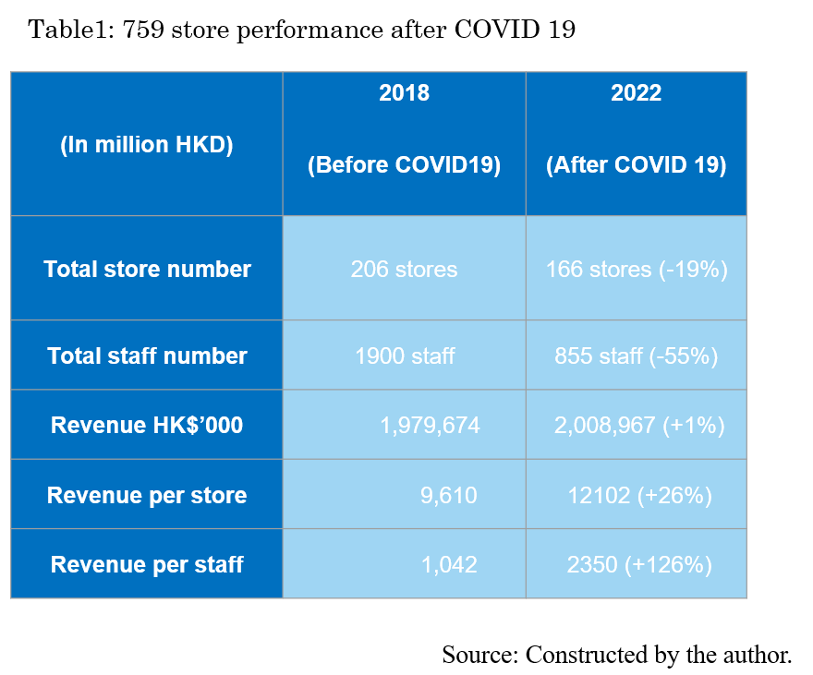
"The Death Spiral" is a term used to describe a situation where a company experiences declining revenue and profit, which leads to cost-cutting measures such as reducing staff and store closures, which in turn leads to further decline in revenue and profit. This creates a vicious cycle that can ultimately lead to the company's demise (Christensen, 2013). In the case of 759 store, the company had expanded aggressively before the COVID-19 pandemic, but was forced to close low-profit stores during the pandemic and reduce staff to maintain profitability. This has resulted in declining revenue and profit in 2022, which could potentially lead to a death spiral if the company is unable to turn things around (CEC-COILS, 2022).

Current situation of 759 Store and the major drivers for the change
The current situation for 759 Store has been significantly impacted by three major drivers of change, including the COVID-19 pandemic, new technology, and reaction to external pressure from competitors.

2.1 Crisis

The COVID-19 pandemic has had a significant impact on the retail industry, and 759 Store is no exception.

In Hong Kong, the retail industry has been significantly impacted by the COVID-19 pandemic. The Bread, Pastry, Confectionery and Biscuits sales volume in February 2023 decreased by 5.5% year-on-year (Census and Statistics Department, 2023).

The pandemic has also accelerated the shift towards online shopping in Hong Kong. According to a survey conducted by Statista, 31% of respondents in Hong Kong stated that they were shopping more frequently online since the outbreak of COVID-19 (Statista, 2021).

As a result, 759 Store has had to adapt to changing consumer behavior, such as increased demand for online shopping and home delivery services. To respond to these challenges, 759 Store has had to implement new business strategies, such as online store and home delivery services, to meet the changing needs of their customers.

2.2 New technology

New technology is also a significant driver of change for 759 Store. The rise of e-commerce platforms and online retail has disrupted the traditional brick-and-mortar retail model. Consumers are now able to shop online from the comfort of their own homes, with greater convenience and competitive pricing (AbouThai, 2023) (Best Mart 360˚, 2023).
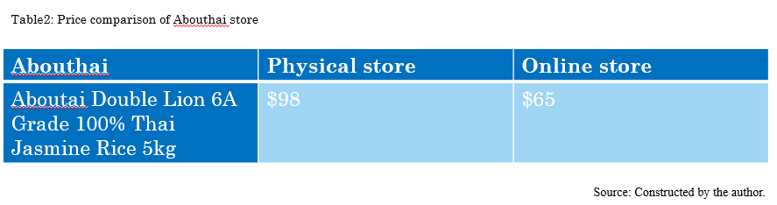
The rapid digitalization and changing consumer behavior have also posted significant challenges to the company. With the rise of e-commerce and online shopping, consumers have more options to purchase products at competitive prices. Moreover, the COVID-19 pandemic has accelerated the shift towards online shopping, resulting in a decline in foot traffic for physical stores (Statista, 2023).

To stay relevant, 759 Store needs to adapt to this changing landscape by implementing new technology in their operations. This includes developing an online store website, creating an omnichannel shopping experience for customers, and utilizing data analytics to improve inventory management and customer insights. Omnichannel shopping experience is a retail strategy that aims to provide customers with a seamless and integrated shopping experience across all available channels. This includes brick-and-mortar stores, online marketplaces, social media, mobile apps, and other touchpoints that consumers use to interact with a brand (Mosquera, Pascual and Ayensa, 2017).

2.3 External pressure from competitors

External pressures from competitors also play a critical role in driving change for 759 Store. The convenience store industry is highly competitive, with many players vying for market share. To remain competitive, 759 Store must differentiate itself from its competitors included BestMart 360˚and AbouThai to find innovative ways to attract and retain customers. This could include offering new product lines, expanding store locations, and improving the customer experience through enhanced service delivery.

Best Mart 360˚ is a retail chain that specializes in leisure food and was founded in 2013. The store offers a variety of products, including snacks, confectioneries, frozen and chilled food, personal care, groceries, and household items (Best Mart 360˚, 2023).

AbouThai is another competitor that has witnessed significant growth in recent years, having been established in 2015. Their product offerings mainly comprise imported goods from Thailand, ranging from frozen foods, snacks, and beverages to household products, herbal oils, and cosmetics. As of February 2022, the company operates 25 stores (AbouThai, 2023). To attract customers, AbouThai has also been known to hold an annual "Songkran Festival" discount event in April, where prices are lowered for a limited period (HKET, 2019).

Evaluation the favorable and the unfavorable factors of the organizational change
In the case of 759 Store, the shift to online sales and the implementation of a change program may have been a response to external challenges, such as the growth of e-commerce and the COVID-19 effect. By implementing a change program and moving towards online sales, 759 Store may able to break free from this potential death spiral and regain its footing in the market. This change program likely included efforts to improve the company’s online presence, optimize its supply chain and logistics, and develop new marketing strategies such as online shop to reach a wider customer base and offer a seamless shopping experience to its customers. These efforts may help the company stay competitive in the face of new challenges and avoid a decline that could have ultimately led to its demise.

3.1 Favorable factors of the organizational change

3.1.1 Improved customer experience
By moving online, 759 Store was able to provide customers with a more convenient and accessible shopping experience. Customers could shop anytime and anywhere without having to physically visit a store. Additionally, online shopping allows customers to easily compare prices, access customer reviews, and receive personalized recommendations. This could lead to increased customer satisfaction and loyalty (Briedis et al. 2020).

3.1.2 Increased agility:
By successfully adapting to the changing business environment, 759 Store has shown that it can be agile and responsive to new challenges, which is essential for long-term success. An agile organization can pivot quickly to changing market conditions, customer needs, and emerging technologies, enabling it to stay ahead of competitors and capitalize on new opportunities (Lee, 2004).

3.1.3 Improved operational efficiency
Moving online may have also allowed 759 Store to improve its operational efficiency, such as through automated processes or reduced overhead costs (Hwangbo, Kim and Cha, 2017). This can lead to reduced costs, increased productivity, and improved customer service.

3.2 Unfavorable factors of the organizational change

3.21 Conflict with physical store
Moving online may lead to a conflict with physical stores, as online sales could potentially cannibalize sales from brick-and-mortar stores. Revenue per store may be decreased, leading to a loss of commission for physical store staff. To successfully implement change, 759 Store must ensure that the success of the online store is shared with physical store staff, for example, by providing them with training to handle online orders or incentives to promote both the online and physical stores (Kalyanam and Tsay, 2013).

3.2.2 Resource requirements
Moving online can require significant resources, including investments in technology, marketing, and logistics (Schu, Morschett, and Swoboda, 2016). If the company did not allocate sufficient resources to the change program, it may not have been able to achieve its intended goals. Additionally, changes can be disruptive, requiring time and effort to train employees, redesign processes, and integrate new systems. This can lead to temporary decreases in productivity and morale.

4. Stability in the modern business environment
The concept of stability in business refers to the maintenance of a consistent, predictable, and unchanging status quo in the organization. Stability may be desirable in some cases where a business has established a successful business model that has been proven over time. In such cases, stability provides a sense of security, predictability, and reliability for both the organization and its stakeholders (Fogel, Morck and Yeung, 2008).

However, in the current business environment characterized by rapid technological advances, disruptive innovations, and evolving consumer needs and preferences, stability is becoming less attainable and less desirable. The COVID-19 pandemic has exposed the vulnerabilities of businesses that rely on traditional models and the need for adaptation to changing circumstances (Roggeveen and Sethuraman, 2020).

On the other hand, organizational change, which refers to any significant modification in an organization's processes, structure, and culture, is becoming increasingly relevant in modern business environments. Organizational change allows businesses to adjust to the changing business environment and meet the evolving needs and expectations of customers. For example, online shopping has become a significant trend during the COVID-19 pandemic, and businesses that have adapted to this trend by offering online shopping options have been able to thrive.

If 759 Store fails to adapt to the changing business environment and does not embrace organizational change, it is unlikely to achieve stability or long-term success in the modern business environment. The COVID-19 pandemic has demonstrated that businesses that were unable to adapt to the changing landscape were severely impacted and some even went bankrupt.

4.1 If without adapting to the online store
In the case of 759 Store, without adapting to the online store, the company may not have been able to survive during the pandemic. The pandemic led to a shift in consumer behavior, with more people preferring to shop online rather than in-store to minimize the risk of infection. Failure to respond to this shift in consumer behavior could have resulted in a significant loss of sales and customers, and ultimately could have led to the company's demise.

Furthermore, the pandemic has accelerated the trend towards online shopping, with many consumers now preferring the convenience and accessibility of online shopping. This trend is likely to continue even after the pandemic subsides. Therefore, failure to embrace online shopping may result in 759 Store becoming increasingly irrelevant in the marketplace, as consumers opt for competitors that offer a more comprehensive omnichannel shopping experience.

In addition, not adapting to changing consumer trends may result in 759 Store becoming stagnant and losing touch with the needs and preferences of its customers. This can lead to a decline in sales and profitability over time, as consumers seek out companies that are more responsive and adaptable to their needs.

4.2 If continue on closing low-profit stores and reducing staff
In the case of 759 Store, continues its strategy of closing low-profit stores and reducing staff to maintain profitability means retrenchment, it may achieve short-term stability in the face of the exceptional event of the COVID-19 pandemic (Robbins and Pearce, 1992). However, in the long run, this strategy may not be desirable in the modern business environment.

Reducing staff can negatively impact morale and productivity among remaining employees. When employees feel uncertain about their job security, they may become less engaged and less committed to the company's goals. This could lead to decreased productivity and customer satisfaction, which could ultimately harm the company's bottom line.

By closing low-profit stores, 759 Store is limiting its potential for growth. Although some stores may not be profitable in the short term, they could become profitable in the future if market conditions change. Additionally, closing stores reduces the company's physical footprint, which could limit its ability to reach customers in certain areas.

Closing stores and reducing staff could negatively impact 759 Store's reputation, particularly among customers who value corporate social responsibility. If the public perceives that the company is prioritizing profitability over the well-being of its employees, it could lead to a loss of trust and brand loyalty.

The COVID-19 pandemic has accelerated the shift toward online shopping and digital payments. By focusing on physical stores and reducing staff, 759 Store may be missing out on opportunities to invest in new technology and expand its digital offerings. This could limit its ability to compete with other retailers in the future.

Overall, while stability may seem desirable in the short term, it is unlikely to be attainable or desirable in the modern business environment without embracing change and adapting to the needs of consumers. Companies that fail to adapt are at risk of becoming irrelevant and ultimately failing in the marketplace. Therefore, 759 Store must continue to be adaptable to changing consumer trends and embrace organizational change to remain competitive in the modern business environment.

5. Change Approach: Kotter's Eight-Step Plan for 759 store
To manage the external challenges and adapt to the changing business environment, 759 Store can consider using Kotter's Eight-Step Plan for Implementing Change and provides insights into why change efforts often fail and how the framework can help address common pitfalls. (Kotter, 2007).

5.1 Create urgency
The initial step is to establish a sense of urgency among stakeholders by effectively communicating the necessity for change and the negative consequences of not taking action. Kotter highlights that neglecting to create a sense of urgency is the most significant mistake organizations make when attempting to implement change (Kotter, 2008). To apply this step to 759 Store, the urgency could be conveyed by emphasizing the impact of the COVID-19 pandemic and the rising trend of online shopping on the Hong Kong retail industry.

5.2 Form a powerful coalition
The next step involves creating a coalition of important stakeholders, with a particular focus on executive director such as Ms. TANG Fung Kwan (Chairman and Managing Director) and Mr. HO Man Lee, who are responsible for the Group's IT development and implementation (CEC-COILS, 2022). To committed to the change initiative and can provide the necessary leadership and resources. This coalition also include top management, department heads, and key employees who can drive the change initiative.

5.3 Create a vision for change
The third step in the change process involves establishing a well-defined and persuasive vision that is consistent with the strategic objectives and values of 759 Store. This may involve outlining the company's digital transformation objectives and determining the specific measures that must be taken to achieve these goals. Creating a vision and receiving support for projects was not particularly contentious. This is due to the widespread recognition of the need for change (Cao, Clarke, and Lehaney, 2004). Offering additional choices of snacks, food groceries, household and personal care products to customers online and offline. This vision should be communicated to all stakeholders to ensure alignment and buy-in.

5.4 Communicate the vision
The fourth step in the change process is to communicate the vision and the importance of change to all stakeholders through various channels such as town hall meetings, emails, and other forms of internal communication. This will facilitate understanding and ensure that everyone in the organization, including 759 Store, is aware of the vision and the reasoning behind the change program. This step is one of the most critical stages in Kotter's process is the need to effectively communicate the change to all stakeholders (Ansari and Bell, 2009).

5.5 Empower action
The fifth step involves enabling employees to act on the vision by eliminating barriers, providing the required resources and training, and appointing a coach. In 759 case could be providing online store training to front-line staff to promote the online store, as well as ensuring that the success of the online store is shared with physical store staff. This step is critical in empowering employees to take ownership of the change initiative and ensuring its success. Attending training sessions by all coaches is crucial to ensure their performance and to build momentum towards effective implementation of the change initiative (Lubit, 2001).

5.6 Create quick wins
The next step involves creating short-term successes that showcase the progress of the change initiative and encourage employees to remain committed. For instance, this could involve launching the online store or app and meeting sales goals within the first few months, as well as sharing commission with physical store staff as a way of incentivizing them to promote the online store.

5.7 Build on change
The seventh step is to consolidate the gains achieved through the change initiative and build on them by producing more change. This could include expanding the product offerings or optimizing the supply chain to improve efficiency.

5.8 Make it part of the culture
The last step is to integrate the new approaches into the company's culture by incorporating them into the organization's values, policies, and procedures. To ensure the sustainability of the change initiative in the long run. However, it should be noted that evaluating stages 7 and 8 are hard to evaluate (Appelbaum et al. 2012).

6. Conclusion
In conclusion, it is evident that 759 Store needs to adapt to the changing business environment in order to sustain growth and remain competitive. With the rapid shift towards online shopping and the COVID-19 pandemic accelerating this trend, launching an online store is a viable option for the company to reach a wider customer base and improve customer experience.

To effectively carry out the proposed change, 759 Store could utilize Kotter's Eight-Step Plan. This plan includes creating a sense of urgency, forming a guiding coalition, developing a vision and strategy, communicating the vision for change, empowering others to act on the vision, achieving short-term successes, consolidating gains and creating additional changes, and establishing new approaches as part of the organization's culture.

While this change program can bring significant benefits to 759 Store, such as improved customer experience, agility, and operational efficiency, it will also require a shift in resources, investment, and creating a new company image. However, the potential rewards outweigh the risks, and implementing this change is crucial for the long-term success of 759 Store in the modern business environment.

References
- AbouThai (2023) All Products Available at: https://www.abouthai.com/search?zserialid=NAV202201120016&caption=%25E5%2585%25A8%25E9%2583%25A8%25E5%2595%2586%25E5%2593%2581 (Accessed: 20 April 2023).

- Ansari, S. and Bell, J. (2009) Five easy pieces: a case study of cost management as organizational change. Journal of Accounting & Organizational Change.

- Appelbaum, S. H., Habashy, S., Malo, J. L., and Shafiq, H. (2012). Back to the future: revisiting Kotter's 1996 change model. Journal of Management development, 31(8), 764-782. Available at: https://www.researchgate.net/profile/Steven-Appelbaum/publication/242339672_Back_to_the_future_Revisiting_Kotter's_1996_change_model/links/0f31752f14502e718d000000/Back-to-the-future-Revisiting-Kotters-1996-change-model.pdf (Accessed: 20 April 2023).

- Best Mart 360˚ (2023) All Products Available at: https://www.bestmart360.com/index.php?route=product/category (Accessed: 25 April 2023).

- Briedis, H., Kronschnabl, A., Rodriguez, A., and Ungerman, K. (2020). Adapting to the next normal in retail: The customer experience imperative. Available at: http://dln.jaipuria.ac.in:8080/jspui/bitstream/123456789/1510/1/Adapting-to-the-next-normal-in-retail-the-customer-experience-imperative.pdf (Accessed: 25 April 2023).

- Cao, G., Clarke, S. and Lehaney, B. (2004) The Need for a Systemic Approach to Change Management - A Case Study. Systemic Practice and Action Research 17:103-126.

- CEC-COILS (2022) 2021/2022 Anual Report Available at: http://www.0759.com/doc/art/finance/2022082201/202208220001.pdf (Accessed: 20 April 2023).

- Census and Statistics Department (2023) Report on Monthly Survey of Retail Sales Available at: https://www.censtatd.gov.hk/en/data/stat_report/product/B1080003/att/B10800032023MM02B0100.pdf (Accessed: 20 April 2023).

- Christensen, C. M. (2013) The innovator's dilemma: when new technologies cause great firms to fail Harvard Business Review Press. Available at: http://dspace.vnbrims.org:13000/jspui/bitstream/123456789/4699/1/The%20Innovator%27s%20Dilemma%20When%20New%20Technologies%20Cause%20Great%20Firms%20to%20Fail%20%28Management%20of%20Innovation%20and%20Change%20Series%29.pdf (Accessed: 20 April 2023).

- Fogel, K., Morck, R., and Yeung, B. (2008). Big business stability and economic growth: Is what's good for General Motors good for America?. Journal of Financial Economics, 89(1), 83-108. Available at: https://www.nber.org/system/files/working_papers/w12394/w12394.pdf (Accessed: 25 April 2023).

- HKET (2019) 【歡迎香港人轉載】AbouThai 3年開12店 泰國老闆娘：物色大舖想大到似超市咁Available at: https://ps.hket.com/article/2368243 (Accessed: 20 June 2022).

- Hwangbo, H., Kim, Y. S., and Cha, K. J. (2017). Use of the smart store for persuasive marketing and immersive customer experiences: A case study of Korean apparel enterprise. Mobile Information Systems, 2017. Available at: https://www.hindawi.com/journals/misy/2017/4738340/ (Accessed: 25 April 2023).

- Kalyanam, K., and Tsay, A. A. (2013). Free riding and conflict in hybrid shopping environments: Implications for retailers, manufacturers, and regulators. The antitrust bulletin, 58(1), 19-68.

- Kotter, J. P. (2007). Leading change: Why transformation efforts fail. In Museum management and marketing (pp. 20-29). Routledge. Available at: https://www.scinapse.io/papers/2134648895 (Accessed: 25 April 2023).

- Kotter, J. P. (2008) A sense of urgency. Harvard Business Press Available at: https://kingdomwayministries.net/wp-content/uploads/2016/12/A_Sense_Of_Urgency_Change_Final.pdf (Accessed: 25 April 2023).

- Lee, H. L. (2004). The triple-A supply chain. Harvard business review, 82(10), 102-113. Available at: https://www.academia.edu/download/37053129/The_Triple_-_A_Supply_Chain.pdf (Accessed: 25 April 2023).

- Lubit, R. (2001). Tacit knowledge and knowledge management: The keys to sustainable competitive advantage. Organizational dynamics.

- Mosquera, A., Pascual, C. O., and Ayensa, E. J. (2017). Understanding the customer experience in the age of omni-channel shopping. Icono14, 15(2), 4. Available at: file:///D:/download/Dialnet-UnderstandingTheCustomerExperienceInTheAgeOfOmnich-6054345.pdf (Accessed: 26 April 2023).

- Robbins, D. K., & Pearce, J. A. (1992). Turnaround: Retrenchment and recovery. Strategic management journal, 13(4), 287-309. Available at: https://www.researchgate.net/profile/John-Pearce-10/publication/227814093_Turnaround_Retrenchment_and_Recovery/links/5a0dae490f7e9b7d4dba3671/Turnaround-Retrenchment-and-Recovery.pdf (Accessed: 26 April 2023).

- Roggeveen, A. L., and Sethuraman, R. (2020). How the COVID-19 pandemic may change the world of retailing. Journal of retailing, 96(2), 169. Available at: https://www.ncbi.nlm.nih.gov/pmc/articles/PMC7183942/ (Accessed: 26 April 2023).

- Schu, M., Morschett, D., and Swoboda, B. (2016). Internationalization speed of online retailers: A resource-based perspective on the influence factors. Management International Review, 56, 733-757. Available at: https://www.researchgate.net/profile/Matthias-Schu/publication/298907960_Internationalization_Speed_of_Online_Retailers_A_Resource-Based_Perspective_on_the_Influence_Factors/links/5c7e701f458515831f854c2a/Internationalization-Speed-of-Online-Retailers-A-Resource-Based-Perspective-on-the-Influence-Factors.pdf (Accessed: 26 April 2023).

- Statista (2021) Share of consumers who increased their online shopping frequency and amount during coronavirus COVID-19 in Hong Kong in 2020, by category Available at: https://www.statista.com/statistics/1222612/hong-kong-change-in-frequency-and-amount-of-online-shopping-during-covid/ (Accessed: 20 April 2023).

- Statista (2023) eCommerce - Hong Kong Available at: https://www.statista.com/outlook/dmo/ecommerce/hong-kong (Accessed: 20 April 2023).

- 759 Store Limited (2023) About Us Available at: https://www.759store.com/aboutus.php (Accessed: 20 April 2023).

