1.Of course, my theme is to use the form of Gothic games in the world of VR to build a game that can bring the experience of death games. At the same time, I explore some connections between virtual neutrality and real death. Therefore, here I introduce a concept of what kind of impact will virtual death have on the concept of reality. Therefore, it will bring several subsets of questions. Does virtual death have an effective impact (because players know that they are in the virtual world), can the Gothic style bring the interpretation of death, or do you need to combine with other design techniques and concepts?

- The main variables in the study are 1.ue5 Whether the scene design effect brought by this software can bring players an immersive experience 2. Can the design of game scenes and the design of ambient light bring adaptive visual effects? 3. Can the interactive elements in the game be well connected with the reality of life and bring some emotional resonance 4. Can the design of the plot connect life and death well, and at the same time trigger people's consideration of reality? 5. The degree of horror affects the visual sense of the whole game. At the same time, too scary atmosphere may cause people's discomfort, so it is necessary to find the boundary of horror.

- Of course, many of the variables are about the experience of game design. Among them, the boundary line of the degree of horror is that the game Silent Hill is the highest level of horror. Once it is higher than its level, it will bring an uncomfortable reaction. At the same time, as a veteran gamer, I prefer to convey my idea in the way of story narrative, that is, living to die.

- Yes, past game experience and some philosophical thinking have basically determined the direction of my game design. For example, in the design of the whole scene, I learned some design styles of Dark Soul 3 in the design of architecture and atmosphere. In terms of interactive elements and interactive elements, I used the Silent Hill method. Both of them have very successful performances in Gothic games. At the same time, I introduced the concept of "life to death" with Heidegger's concept, combined with the TMT horror theory to bring some theoretical research. My goal of the whole vr game experience is very clear.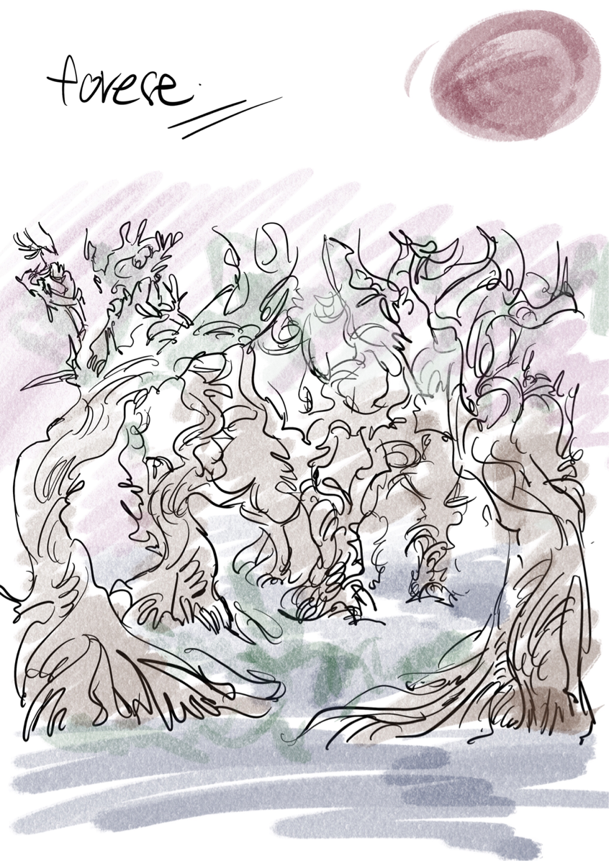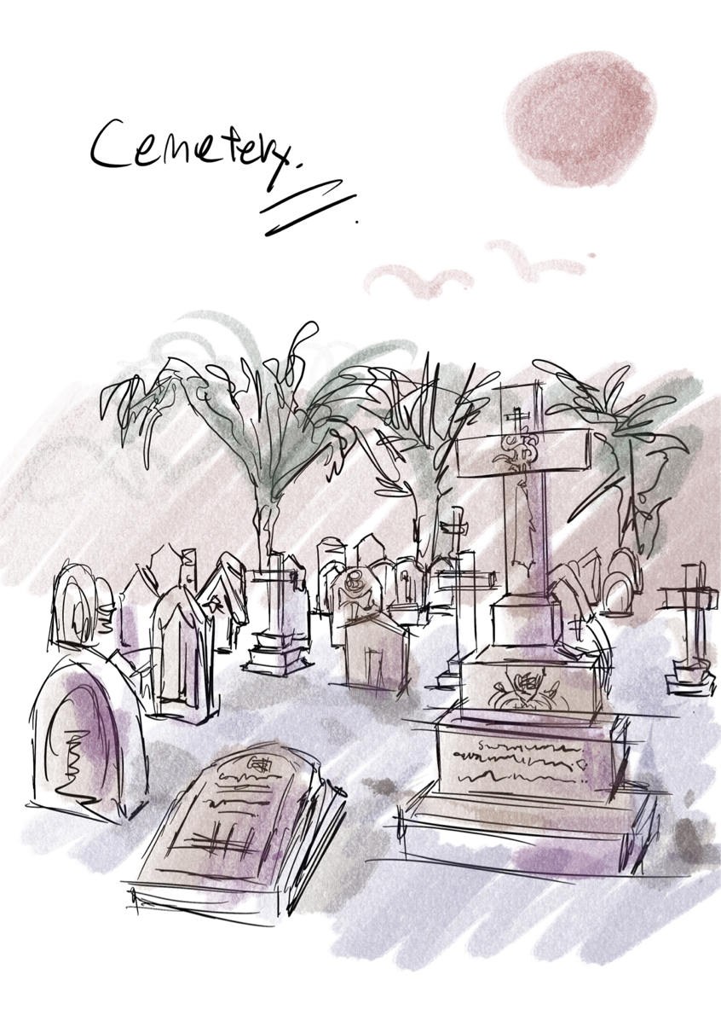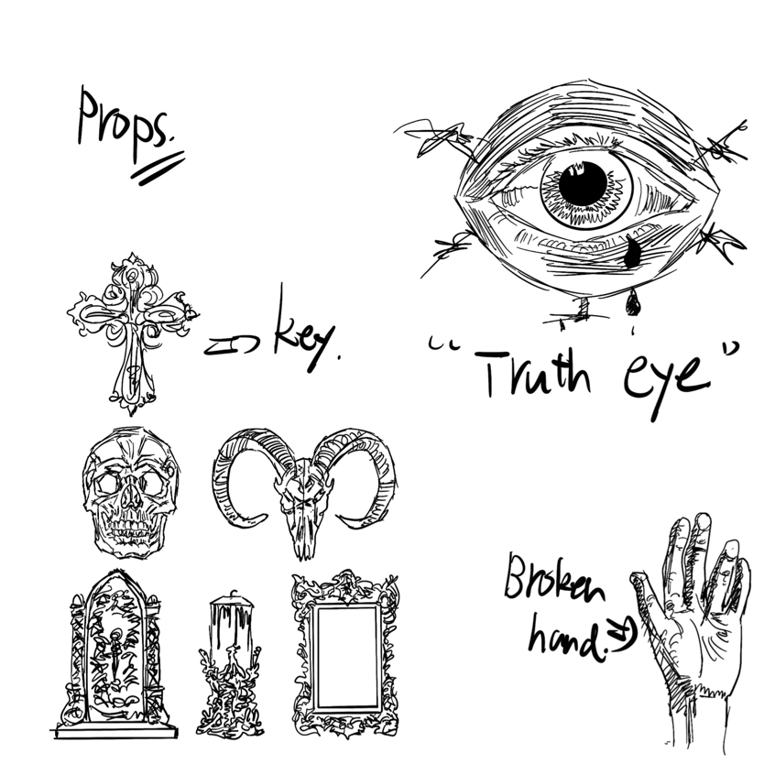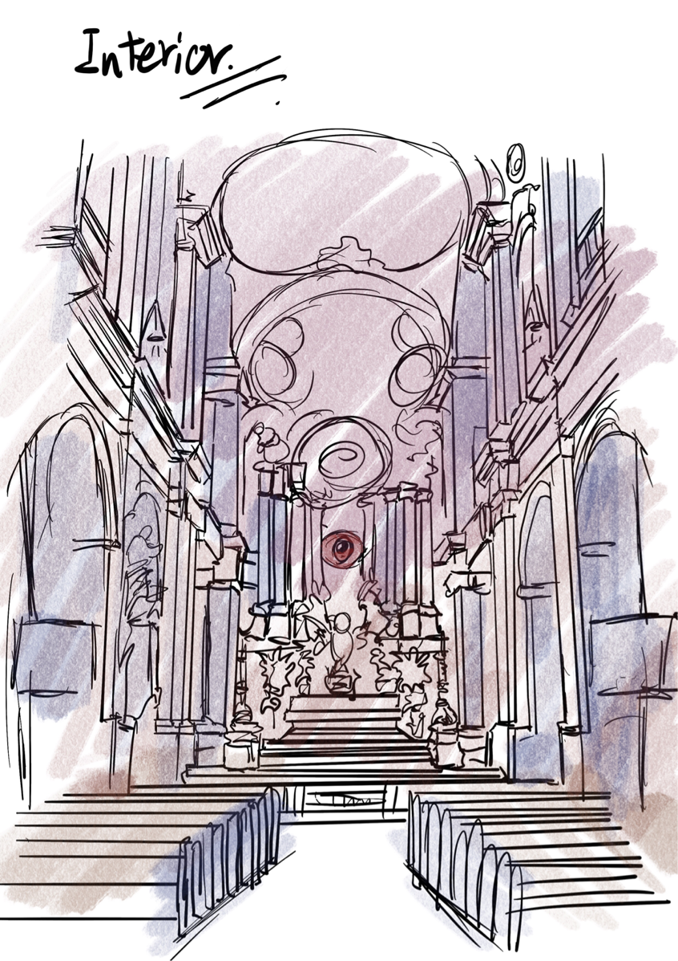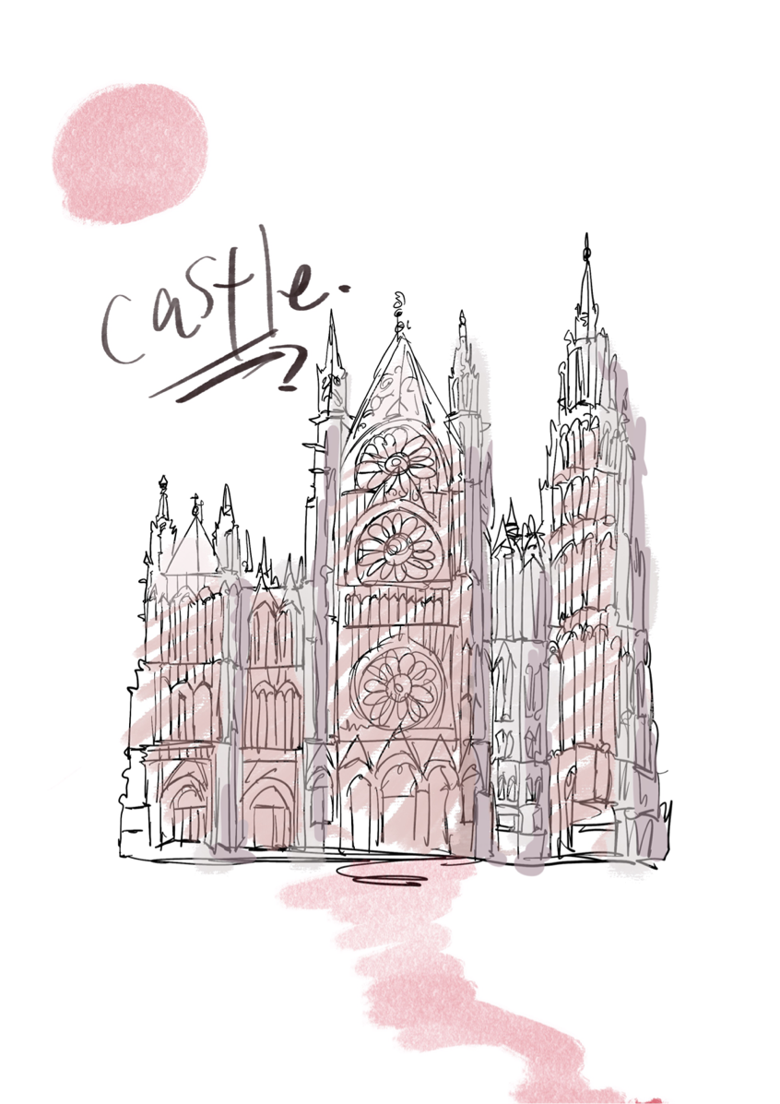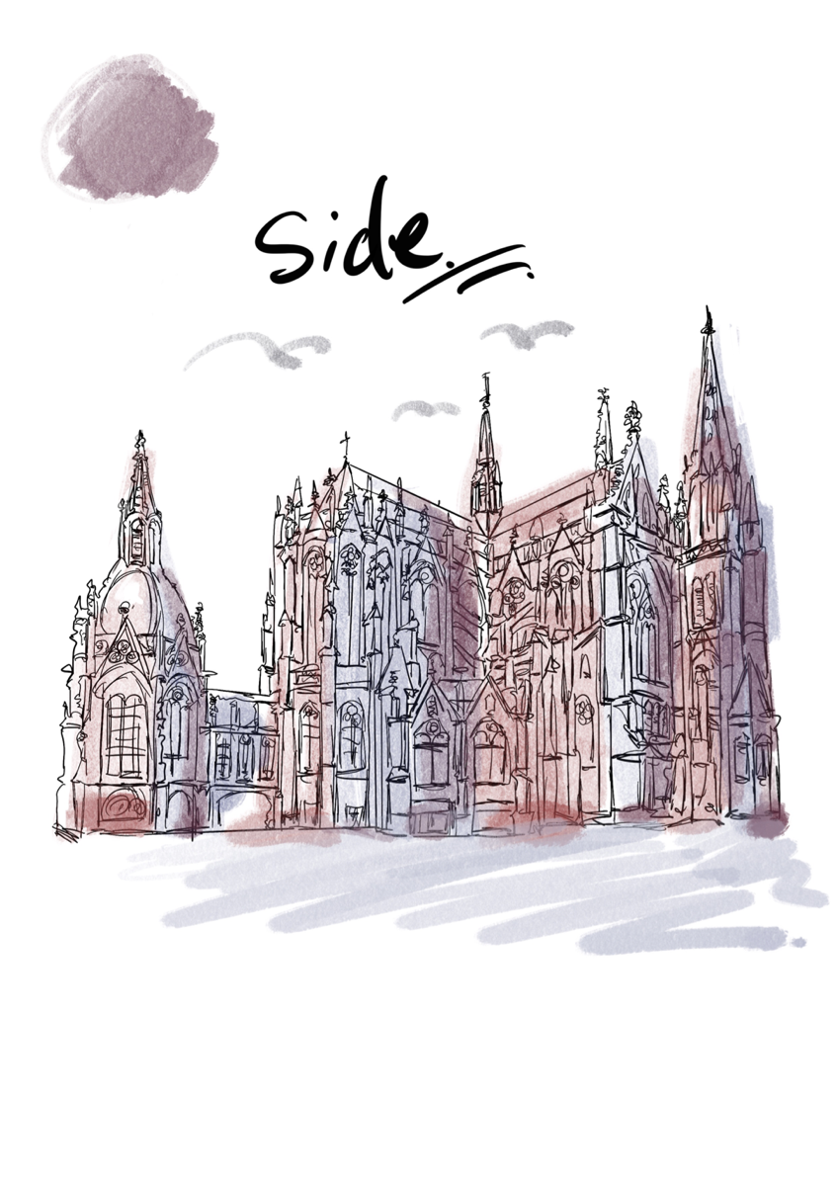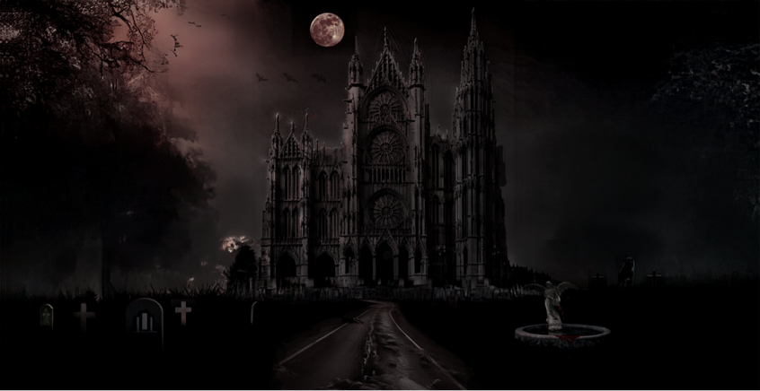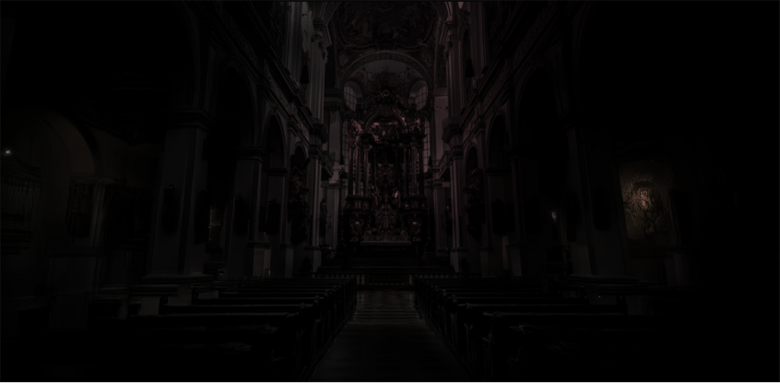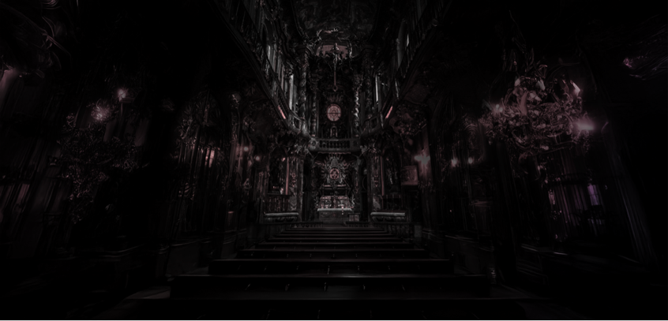
- In fact, in the early stage of the whole game design, I used to design concept drawings and made a lot of modifications. However, in terms of visual modeling, because this game needs to be displayed in 3D form, there are many differences in the concept design in the whole game. Therefore, some designs will be appropriately modified to maintain the tone of the whole design style as much as possible while ensuring the experience of the game.
- Yes, as a vr game, the most important thing is the player's playing experience. I will record the player's evaluation of the game in the form of a questionnaire, and draw on the player's guidance on the game. The question will start from three perspectives. First, from a technical perspective, whether the design of this game brings an immersive experience, and also Do you mean that there is a difference? The second is whether it brings some physiological discomfort or insufficient horror elements on the game screen, resulting in insufficient game experience. At the same time, the mechanism of the game can bring connection and influence to reality. The third is whether the narrative angle of the game can be connected with my research, or if there is a new experience in the game. This is the information I want to collect, so as to add richer content on the basis of the original design.

