

Student name: Golam Mahabub Evan
Student ID: 2514987

Module name: Introduction to Health and Social Care
Module code: LCHS4003
Lecturer name : Eleni
Content page

Element 1 …………………………………………………………….. page
Care Quality Commission (2023) Regulation of health and social care services. Available at: https://www.cqc.org.uk (Accessed:14 March 2026).
NICE (National Institute for Health and Care Excellence) (2018) Care and Support of people growing older with learning disabilities. Available at: https://www.mencap.org.uk.

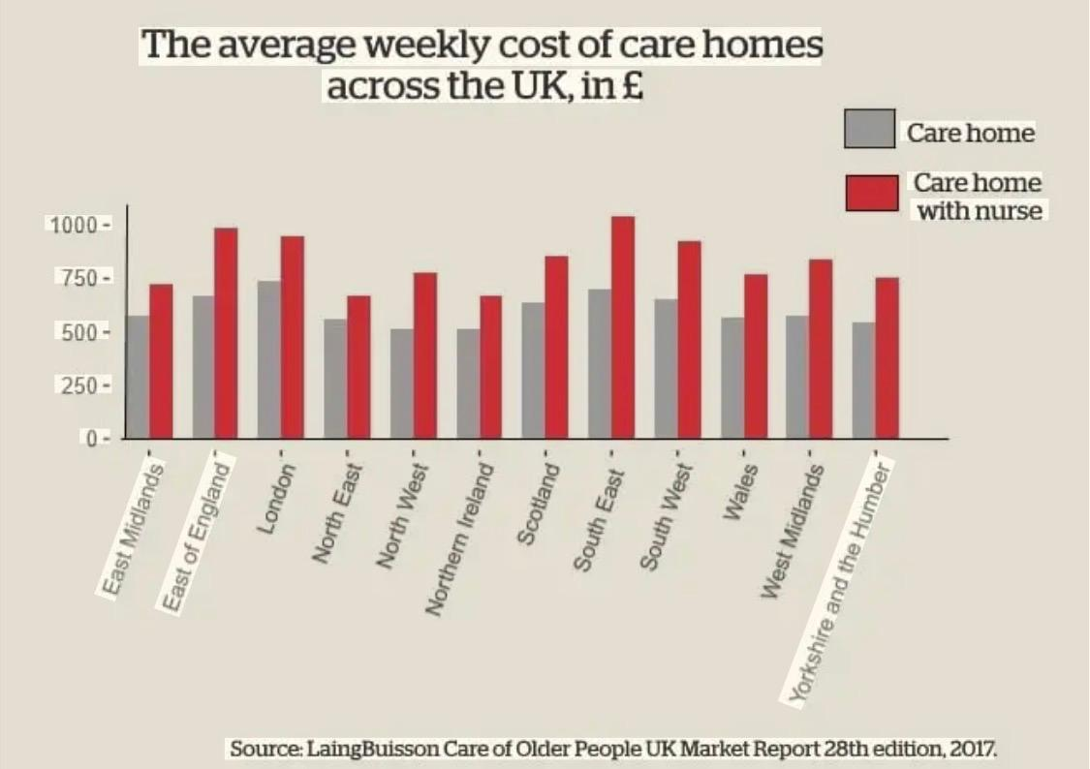
History: Over time, residential care facilities have undergone substantial change. In the past, families or charitable and religious organisations were the primary providers of care for the elderly. However, the need for formal care services grew as societies evolved and life expectancy rose.
In nations like the United Kingdom, establishments like workhouses proliferated during the 18th and 19th centuries. Although conditions were frequently subpar and the emphasis was more on poverty alleviation than well-being, these offered vulnerable people basic shelter and care.
After World War II, a significant change took place with the establishment of the welfare state. Residential care services became more organised and regulated as governments started to assume more responsibility for social care. With a greater focus on professional staffing and safety, standards of care progressively improved.

Two challenges: The first and most pressing issue is the growing disparity between the amount of money needed to support high-quality care and its cost. Increased Employer National Insurance contributions and the April 2026 increase in the National Living Wage to £12.71 per hour have caused many care providers' overheads to rise at a rate that significantly exceeds inflation.
A fragmented market has resulted from this financial strain. While smaller, independent homes, which are frequently the cornerstone of local communities, are facing closure or forced mergers, larger corporate providers are surviving by utilising economies of scale. The "cross-subsidy" model, in which private residents pay higher fees to make up for underfunded local authority placements, is at a breaking point as average weekly costs for self-funders now surpass £1,300. There are more "care deserts" in lower-income areas as a result of families' growing inability to close the gap.
The second issue is a severe and ongoing staffing shortage that technology has not yet been able to completely address. The core of residential care is still a "high-touch" human endeavour, even with the introduction of AI to handle administrative tasks. But at the moment, the sector's vacancy rate is almost three times higher than the overall economy. The social care infrastructure is at systemic risk due to the combination of these two issues.

Current functioning: Residential care facilities became more specialised and regulated starting in the late 20th century, with regulations aimed at safeguarding residents' rights and raising the standard of care. The person-centred approach that underpins residential care today guarantees that each person's needs, preferences, and dignity are respected.
A transition from traditional, reactive care models to a proactive, technologically integrated, and highly regulated ecosystem characterises the residential care industry in 2026. A data-driven regulatory environment, the mainstreaming of "Agentic AI," and ongoing economic pressures are the three main forces that have changed the operational reality of the modern care home, even though the fundamental goal is still to provide the elderly with dignity and safety.
The complete switch to the Care Quality Commission's (CQC) Single Assessment Framework is the biggest change in how contemporary care facilities operate. The "big bang" inspection era, in which a house was evaluated on a single, crucial visit every few years, is essentially over. It is replaced by a continuous monitoring model. Providers must now use digital portals to submit continuous streams of data and evidence (NHS, 2020).

For those who are unable to live independently, especially older adults or people with disabilities, residential care services offer housing and personal care. Instead of providing extensive medical care, these services concentrate on assisting with day-to-day living. Residents are assisted with:
Personal hygiene (eating, dressing, and washing)
Support for medication
Social interaction and everyday activities
Promoting safety, dignity, independence, and general well-being in a nurturing setting is the primary goal.
The residential care industry is tightly regulated to protect vulnerable adults' safety and well-being. The independent regulator in England is the Care Quality Commission (CQC,2023). Every facility is inspected on a regular basis based on five main questions: Is the service well-led, safe, efficient, compassionate, and responsive to people's needs? Families and local authorities use these ratings—which range from "Inadequate" to "Outstanding"—as their main criterion when selecting a provider.
In contrast to the NHS, residential care is not "free at the point of use" in the UK. It is means-tested instead. As of 2026, people must "self-fund" their care if their assets exceed a certain threshold (currently £23,250 in England) (NHS, 2019). If the person is entering long-term care, this frequently entails selling their primary residence. Although residents are still required to contribute a portion of their income, such as their state pension, local authorities offer financial assistance to those whose assets fall below the threshold.
In an ageing society, residential care homes are an essential safety net. These facilities offer a compromise between complete independence and clinical hospitalisation by fusing a round-the-clock support system with social interaction and expert personal care. The structured setting of a care home is intended to enhance the quality of life for individuals who find the difficulties of living alone intolerable, even though the financial and emotional transition to such a facility can be substantial.

Residential Care Home
Golam Mahabub Evan. Introduction to Health and Social Care. 2514987@student.uwtsd.ac.uk

Pharmacy Services:

Pharmacy services guaranteeing safe access to medications, offering expert advice, and assisting in the treatment and prevention of illness are essential to contemporary healthcare. Over centuries, the field has undergone tremendous change due to advancements in science, shifts in society, and the need for healthcare (Royal Pharmaceutical Society, 2026). Ancient societies used natural materials like plants, minerals, and animal products to make medicines, which is where pharmacy got its start. Early healers in Mesopotamia and Egypt documented medicinal formulas and cures for ailments. The development of pharmacy as a profession was made possible by these early practices (WHO 2019).

Physicians started studying medicine more methodically in ancient Greece and Rome. Hippocrates and other scholars placed a strong emphasis on observation and the use of natural remedies, while Galen created techniques for making medicines by mixing various ingredients. For many centuries, these methods had an impact on how medicines were prepared and compounded (American Society of Health-System Pharmacists, 2021). Pharmacy developed further in the Islamic world during the Middle Ages, when scholars like Avicenna made substantial contributions to pharmaceutical practices and medical knowledge (Porter, 1997). In Europe, the apothecary profession emerged concurrently. Preparing and selling medications was the responsibility of apothecaries, who eventually separated from doctors. The scientific revolution and the Renaissance saw a rapid advancement in pharmacy. The development of pharmacopoeias contributed to the standardisation of medications and their preparation. With the founding of professional organisations like the Royal Pharmaceutical Society in the UK during the nineteenth century, the field became more structured (Royal Pharmaceutical Society, 2026). Chemistry also advanced during this time, enabling researchers to more successfully extract active components from plants and create medications.

Pharmacy services now encompass much more than just dispensing medications. These days, pharmacists are important medical professionals who support disease prevention, offer guidance on medication use, and participate in public health campaigns (NHS, 2023). To guarantee that patients receive safe and efficient treatments, community pharmacies, hospital pharmacies, and clinical pharmacy services collaborate. Pharmacists in the UK are able to provide services like medication reviews, immunisation programs, and assistance with long-term condition management thanks to the National Health Service. To enhance patient outcomes, pharmacists also work in conjunction with physicians, nurses, and other medical specialists.

Pharmacy services do face some difficulties in spite of these advantages. The availability and effectiveness of pharmacy services may be impacted by rising healthcare demand, a lack of workers, and financial constraints. Additionally, because new medications and technologies are developed so quickly, pharmacists need to keep up with the latest developments (International Pharmaceutical Federation, 2020). However, in order to guarantee safe medication use and lessen the strain on other healthcare services, contemporary pharmacy services are still crucial.

By guaranteeing safe and efficient medication management, pharmacy services greatly enhance service users' quality of life. By teaching patients how to take their medications correctly, pharmacists lower the chance of medication errors and enhance treatment results (NHS 2023). Additionally, pharmacists are crucial to illness prevention and health education. They offer guidance on immunizations, leading a healthy lifestyle, and treating common illnesses. This assistance aids people in preserving their health and preventing complications from long-term illnesses like diabetes or high blood pressure. Furthermore, pharmacy services make healthcare more accessible. Community pharmacies can offer prompt advice and treatment for minor ailments and are frequently easier to reach than other medical facilities. This convenience eases the burden on hospitals and general practitioners while assisting service users in receiving timely care (International Pharmaceutical Federation, 2020).

Over thousands of years, pharmacy services have evolved from basic herbal remedies to a highly specialized field of medicine (Sonnedecker,1976). Modern pharmacy practice has been influenced by historical advancements in science, medicine, and professional regulation. These days, pharmacists are essential to maintaining healthcare systems, guaranteeing the safe use of medications, and enhancing patient outcomes. Pharmacy services continue to improve service users' quality of life and are a crucial part of contemporary healthcare through education, prevention, and easily accessible care.

References

NHS (2021) Improving communication between Healthcare professionals. Available at: https://www.england.nhs.uk/publication/improving-communication-between-health-care-professionals-and-patients-in-the-nhs-in-england/ (Accessed: 18th July 2023).

National Health Service (2023) Pharmacy services. Available at: https://www.nhs.uk/nhs-services/pharmacies/(Accessed: 10 March 2026).

Porter, R. (1997) The Greatest Benefit to Mankind: A Medical History of Humanity. London: HarperCollins.

Royal Pharmaceutical Society (2022) The history of pharmacy. Available at: https://www.rpharms.com(Accessed: 10 March 2026).

Sonnedecker, G. (1976) Kremers and Urdang’s History of Pharmacy. 4th edition. Philadelphia: J.B. Lippincott.

World Health Organization (2019) Medication Safety in Polypharmacy. Geneva: WHO.
International Pharmaceutical Federation (2020) FIP Global Vision for Pharmacy Workforce. The Hague: FIP.

World Health Organization (2023) The role of the pharmacist in the health care system. Available at: https://www.who.int (Accessed: 10 March 2026).

