Digital Marketing Channel Critical Review

MTour Tourism and Events Management
Digital Marketing and Social Media in Tourism
M7X02122
By Billie Morgan
P144065

Executive Summary

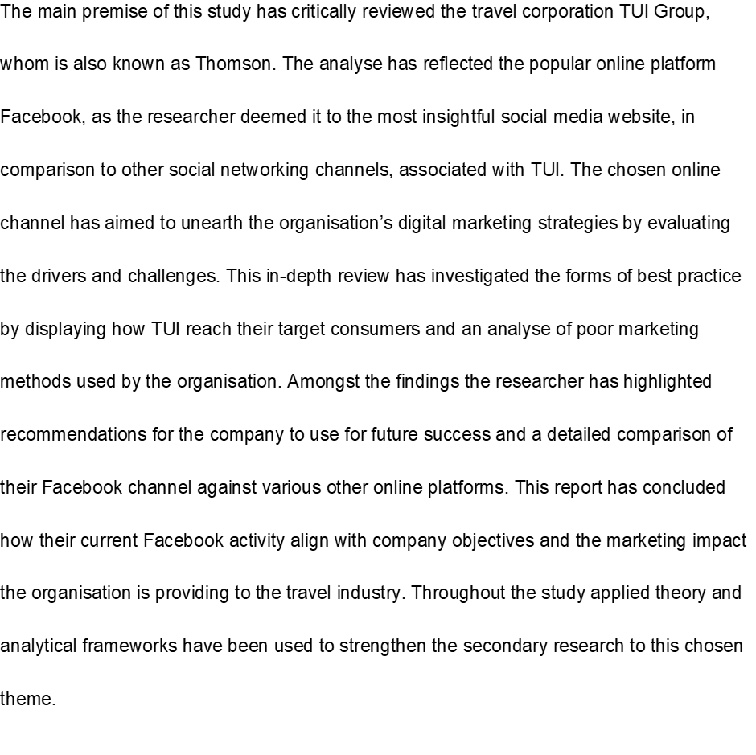In conclusion the researcher believed that Facebook was the best channel in achieving with company goals and to market their target audience however, the limitations reveal that the Facebook of TUI is undeveloped, thus recommendations have been suggested such as utilization of features and keep up with Facebook trends have been put forward, which will obtain future enhancement of this social media site and gain increasing followers and potential consumers to further sales and profit with the company.

Contents
- The Introduction to Social Media Marketing………………………………………………………………………….3, 5
    - Online Social Media Platforms………………………………………………………………………………………..5, 7
  - The organisation of TUI………………………………………………………………………………………………………7, 8
  - The Social Media Channel, Facebook…………………………………………………………………………………….8
  - Introduction analyse of TUI’s Facebook………………………………………………………………………………9, 13
    - A comparison of Facebook to other social media channels…………………………………………...13, 17
    - The best practices TUI’s Facebook…………………………………………………………………………………18, 22
    - Limitations of TUI’s Facebook and Poor Marketing Methods……………………………………….23, 26
    - TUI’s Facebook activity align with company objectives………………………………………………..27, 29
  - An Overview of Recommendations for the Future……………………………………………………………….30
  - Conclusion…………………………………………………………………………………………………………………………….31
  - References…………………………………………………………………………………………………………………………32,35

1.0 The Introduction to Social Media Marketing
- Provides a board reach to consumers and mass publicity
- Social media delivers organisations to benefit from cost-free strategies
- Provides the availability of operations and 24-hour control
- Audience, the option the appeal to specific groups and target markets
- Provides instant services and live publicity to a range of consumers
Social Media is defined by Peter, Scott & Jacka (2011, p.5) as ‘the set of web-based broadcast technologies that enable the democratization of content, giving people the ability to emerge from consumers of content to publishers’. Social media empowers people to connect each other through conversation and collaboration (Stephenson, 2010). Amongst this form of digital marketing, global organisations have become aware of the potential social media can achieved to marketing objectives, thus online platforms have been used to promote a product or service and advertise to a global audience.
Social Media is situated at the pinnacle of the ‘current trends in consumer to consumer conversation and marketing effort amplification’, Evans (2012 p.49) This technique of digital marketing has been proven to become the most effective of modern method to be performed globally by organisations, in the gain to excel marketing strategies. The popularity of social media has spawned a new age in expanded capabilities, consumer relations and has enlarged the possibilities of company goals to be achieved.
The importance of social media used in marketing strategies has strengthened throughout the century due to the shear impact in can produce for a company and the magnitude of reach it can deliver to potential consumers. In 2019, it is estimated that globally social media will claim ‘2.77 billion users’ and a further growth shall be gained in 2021 of ‘3.02 billion’ active social media users and increase from 2017 of ‘2.46 billion’ (Statista 2017). Social media accounts can be accessed through many devices, which is a possible reason for the intensive growth, according to We Are Social Global Report (2017) there are an existing 2.549 billion’ active mobile social users. These statistics and objectives for the future is justification of why social media marketing is the most effective form of digital marketing.
In association with the travel and tourism industry, social media has transformed tourism marketing. Carnoy (2017) reveals the influence that social media can have over consumers, “over 97% of millennials share photos and videos of their travels online, building an influential web of peer-to-peer content that serves to inspire potential guests” therefore this shows the importance of social media as it can deliver significant impacts to many tourism organisations. The Millennial generation is proven to provide the industry self-marketing due to the, ‘89% of millennials plan travel activities based on content posted by their peers online’ Carnoy (2017), this online activity by the consumer market will increase growth in the future and be strong advantage for travel organisations. The most profound effect that social media has brought to consumers, in relation to the travel industry is availability. From browsing the internet for travel inspiration, consumers have instant results in what they are looking for. This can be done from other traveller’s photos, online travel videos, check-ins and ratings. This viewpoint serves from a real experience by a person and which is great opportunity for many destinations and companies as most social media content is tremendously influential and accessible.
1.0.1 Online Social Media Platforms
Sociality manifests in a variety of ways on a variety of different online platforms, for users (Bucher, 2015). Globally, there are many different types of social media platforms that available to the public. However, the most popular channels amongst this expanding communication systems are considered to be Instagram, Facebook, Twitter, LinkedIn, Snapchat and YouTube. There are many different comparisons and contrasts between each of these popular channels as each supply various alterative features and services that are different to one another. To disclose the magnitude these social media sites in statistics, it was reported in 2017, Facebook receives a total number of monthly active users of ‘2.07 billion’ (We Are Social 2017). Facebook is the largest social media site due to the shear volume of users this platform holds, in comparison the alterative option that’s has experience mass growth in recent years, is the video-sharing site and community of YouTube has ‘1.5 billion users monthly. (Matney 2017). The uniqueness of this channel is the ability to create content and share to a world-wide audience or observing popular YouTube Channels that supply regular entertainment for public display.
Instagram main service in communication is the function of photo-sharing and the reason in which it has captured a monthly number of ‘700 million users’ (Statista 2017). The popularity has spawned for this platform is the ability to access celebrity accounts and following their latest actions. Twitter is similar to this aspect and it is another popular social networking with a large based number of users, this global site is relevantly new compared to sites such as Facebook and Myspace. It’s diffraction to other social media is the service of sending instant interactive messages, known as ‘Tweets’ and the news feed of chosen ‘follow’ profiles have gathered around ‘330 monthly active users’ (Statista 2017).
Snapchat is an application-based networking site, this is the most unique form of social media. It services supply photo and video sharing capabilities set by a timer when open and received by a person’s contact and an option to observe a variety of news feed stories and personal messaging. The recent function of applying ‘filters’ has delivered a vast number of ‘300 million’ monthly users, thus making Snapchat a significant establishment within this industry (S. Aslam 2018). The final monthly statistic is by LinkedIn with a number of ‘106 million’ users each month (LinkedIn 2017). LinkedIn is for business profile network for the ability for users to display their academic achievements and credentials to further their professional image and gain possible opportunities from other users.
Amongst the proclaimed social media websites mentioned above, are many additional social online platforms in the public of the global internet, that attract a number of online users. However, it was important to reference the select few as these six are the most influential and popular sites to use in current society.
1.1 The organisation of TUI
Headquartered in Hannover, Germany the TUI Group is the largest multinational leisure, travel and tourism organisation in the world. This current giant in the travel and tourism industry has allowed them to obtain a strong reputation. Their company profile is vast as operations includes the six European airlines owned, which operate both scheduled and charter flights in 150 countries in 60 airports. A fleet of five current functioning cruise lines, 18,000 travel agencies and 300 hotels and resorts and a workforce of 67,000 employees (TUI Group 2018), thus making this company to be one of the most significant in modern day tourism and a justification in the analyse of their marketing strategies, due to the importance and magnitude of this organisation. The offered products and services by TUI has equipped them to receive an annual of ‘20 million’ globally customers which has resulted in the organisation gaining a successful financial year in 2017. The produced turnover was ’18.5 billion euros’ and a operating result of ‘1.002 billion euros’ (TUI, 2018) fundamentally achieving an effective overall profit.
TUI’s current marketing strength is brand awareness, on a global scale this brand has mass recognition due to the large scale of operations and has the reputation of Thomson and First Choice of providing consumers providing differentiated and flexible options to meet changes in demand. The success of social media marketing and the possibilities it can award to a company if utilized correctly are great, especially is terms of growth and gain. Therefore, the opportunity being TUI can further excel in their implementation of marketing as trends and features of social media change often. The force has analysed the Facebook of TUI, @TUIUnitedKingdom due to the organisation and owing many regional social media accounts it was best performed to review the region of the UK.
1.2 The Social Media Channel, Facebook
Founded by the famous Mark Zuckerberg and lunched in 2004, Facebook is the largest social networking website that is available to online users globally. Due to modern technology since the lunched of the popular social media channel, Facebook has had the opportunity to expand its audience by improving features and supplying a range of services. The connection of communication via this platform can be met in many different options, users have the ability to exchange messages, share videos, photos and links, post status updates, create events, join group chats, interactive features (like buttons and profile stories) receive notifications of activity and use various software applications. The vastness of features has been effective in upholding relevance and gaining support by users, to exploit this success from (Facebook DUA 2018) ‘1.37 billion people on average log onto Facebook daily and are considered daily active users’ this is sixty-six per cent of Facebook’s audience and rising. The consistency of Facebook’s activity and growth has resulted into a promising audience for marketing efforts led by organisation around the world.
It is stated that ‘42% of marketers report that Facebook is critical or important to their business’ and ‘16 Million local business pages have been created as of May 2013 which is a 100 percent increase from 8 million in June 2012.’ (Zephoria, 218) Facebook marketing is key and it is transforming due to many organisations recognising the potential of social media marketing and its awards, thus it is important that marketing implementations stand out and are effective to gain competitor advantage.
1.3 Introduction analyse of TUI’s Facebook
TUI recent overall marketing strategy was a revamp campaign, the basis on this strategy was slowly dropping the name of Thomson and instead making TUI under a single brand name. It was the biggest rebrand marketing strategy ever in TUI history. (Faull, 2017). It was a long-term strategy in improving brand awareness and operations.
It is important to TUI to be successful via digital marketing due to ‘Over 60% of bookings are now made digitally and over 50% of its web traffic comes from SEO’. Included within this statistic social media marketing has increased bookings online and engagement for the TUI organisation. (Faull, 2017). For example, since the first branding campaign of Facebook it has increased their ‘purchase intent by 5%’, ‘6.6% of brand awareness increase’ reached ‘77% of core target group’ and gained a larger user following. (Facebook Business, 2018).
The verified Facebook page of TUI, @TUIUnitedKingdom has a well-established community of 5,168,129, whom has liked the page and 5,146,071 people follow this social media account (TUI Facebook, 2018). This is a large scale of likes upon one page, the opportunity for TUI is Facebook fans potentially turning into paying customers (Strauss & Raymond, 2016). In contrast when a user likes a company’s Facebook page they have certain expectations, as they gain access to exclusive content, events, sales and promotions, thus it is hugely important to keep engaging users.
TUI’s Facebook as first observation is simple and easy to navigate. The profile image is TUI’s famous logo, which is the smile that spells the company’s name within. This is good as users of visiting the page first time will recognise this brand and be similar with the organisation. The cover photo has aligned with company messaging by displaying the current television advertisement of TUI, a useful strategy to build brand awareness.
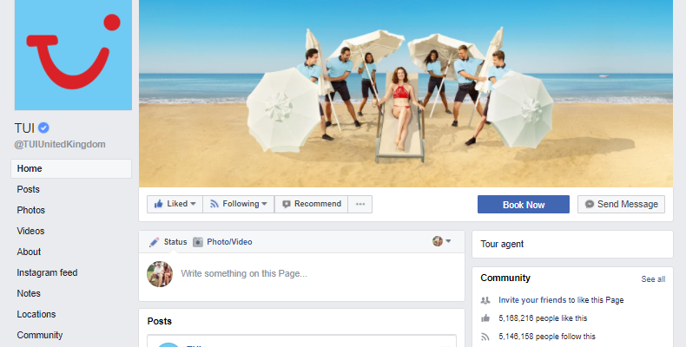
Fig 1. Facebook Profile of TUI.
The Facebook profile of TUI consists of clear sections that users can visit on the account. The following sections of the site are, the home page, posts, videos, about, Instagram feed, notes, locations and community. These sections are updated regularly by TUI, this is important as without content updated on a regular basis the page will be lifeless for consumers. Therefore, the possibly outcome being a dislike on the page making that user unconnected to TUI which could result in a possible loss in business and marketing strategies are no longer successful due to the lack of interaction made by the company. (Treadaway & Smith, 2012).
Setup on the home page is a ‘Book Now’ where users to the site can instantly be directed to the official TUI website in which the products and services offered by TUI can be brought and booked. As the Facebook page consists of many advertisement posts of destinations, holiday and cruises that are available to the visitor of the site. Thus, the marketing strategy in appealing to a visitor and attracting them to TUI’s products, is a good strategy to utilise on this social media account due to the mass audience obtained by this channel. When briefly analysing the overall services on TUI’s Facebook there was customer services available to improve satisfaction and develop future facilities on the profile. One service was an option of instant message, users of the site can send a message to the organisation where a reply would be met shortly answering there needs and supplying with possible solutions and helpful service. Another was situated on the home page that was a ‘Recommend’ button, a user could comment a recommendation to improve the sites facilities via this service. This marketing technique can develop future service and advance on what people are wanting from a social media site.
When reviewing a social media platform of an organisation, it is important to be mindful of Chaffery’s 6cs customer motivation. As if an organisation supplies these six C’s to this existing social media channel it will be beneficial for the marketing methods.
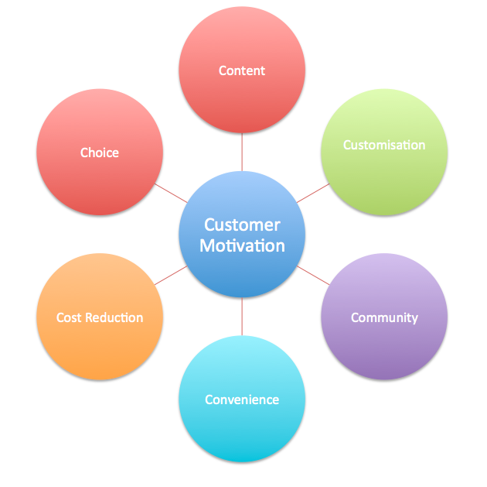
Fig 2. Chaffey’s Six C’s.
- Content, this is the most important as without good content customers will be interested in the products. TUI has delivered posts in which advertise their products by sharing photos and videos on the destination and services that are offered by the company, this can be appealing to visitors of the site, however increase in interactive tools, services and engagement would improve the content of TUI Facebook.
- Customisation, by personalising posts to TUI’s target market can increase the appeal of that demographic.
- Community, TUI’s community section on Facebook is a good utilisation to receive interaction from consumers. By displaying their own photos and posts it allows further customer engagement.
- Convenience social media is available 24/7 it operations of the site as constant therefore users have convenience in contacting this organisation.
- Cost Reduction, discount promotions are often produced on social media sites
- Choice, by promoting various products via TUI’s Facebook it can supply choice for consumers and advertise to range of demographics whilst attracting to their target market.
1.3.1 A comparison of Facebook to other social media channels
An overall analyse of TUI’s social media accounts to market to users, is important as by evaluating the success of each social networking site, by comparing and contrasting TUI’s other social media channels in terms of popularity, features, services and setup has given the review exploitations in limitations and advantages to the Facebook of TUI. It has determined a conclusion in what platform is best for TUI to market to consumers on.
There are two other dominant social channels that TUI operate on, Instagram and Twitter. Both are different to one another; however, each have similar services in comparison with Facebook facilities, if combined.
TUI UK, is the name and verified account of TUI’s Instagram. They have attained a current audience of ‘79,100’ following their page, TUI themselves follow ‘437’ other Instagram accounts and they have posted ‘1,199’ times (TUI’s Instagram, 2018) . There current BIO states ‘Say hello to TUI. We put U in the middle with travel inspo and deals’ thus this social site is to inspire users to book and TUI holiday as promotional deals are given to users on this platform. The content of this page is visual impressive, there are many professional photos taken to market this company. Each video and image supply a description of the destination and what is offered, which is appealing customer temptation of purchase. The Instagram profile also include a link to the official TUI site and ‘Call’ button that automatedly connects to a TUI operator and a section where TUI customers can pot and share their photos and videos. These features designed to improve user experience and have been ultised well as there are constant updated posts by the organisation.
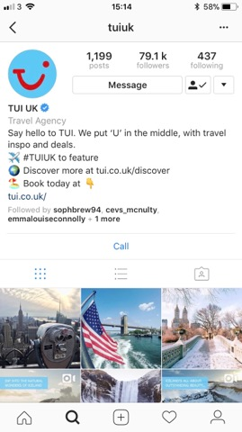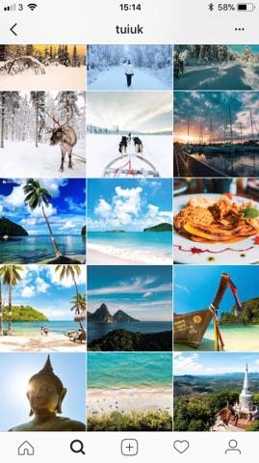
Fig 3. TUI’s Instagram Account.
In comparison to Instagram, TUI twitter @tuiuk has a greater audience. This verified social media account has obtained ‘149,000 followers’, ‘2,458 likes’ has tweeted ‘94,700 times’ and follows ‘613’ accounts. From analysing this twitter account, it is much more communication from company to customer, TUI replies to customer tweet regularly and marketing is more obvious due to tweets being more descriptive on deals, pricing and holiday packages. The Bio is the same as Facebook and Instagram as well as profile image and cover photo, which is good as it a form of building brand awareness. However, the difference of this account being they recommend customers visiting another Twitter page named @tuiukcares this is an account dedicated in responding the customer questions, feedback and problems. It is 24/7 and replies are quick.
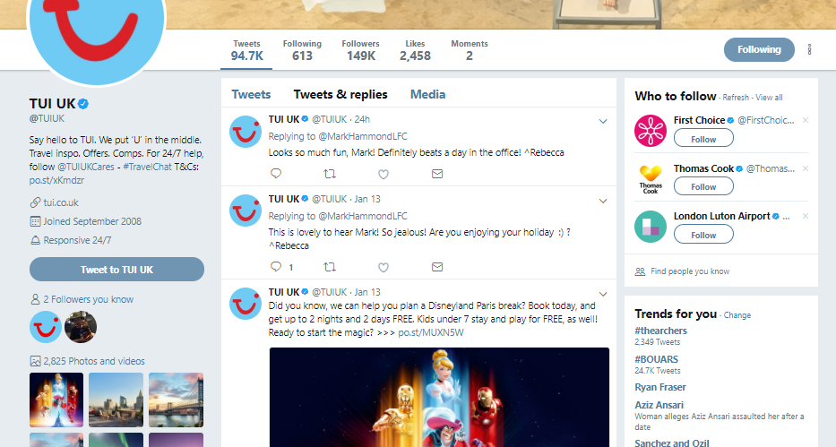
Fig 4. TUI’s Twitter UK.
Although each social media site between is different in operations however, there marketing method is fairly similar as it is often posting a photo or video along with a caption enticing a user to TUI packages and destinations offered. Therefore, each account is visually pleasing for a user. However, the main difference is TUI’s Facebook as a larger audience of Instagram and Twitter numbers combined. It is clear that marketing via Facebook can gain the most rewards due to the magnitude of users that are currently following this page, which is concluded that this channel is the best to TUI social media marketing in comparison to other platforms.

Allowed content, this is a significant when analysing differences and benefit within social media channels. It is the number of words that is allowed to be posted at one time. Twitter allowed characters that users can use is ‘280’ per tweet (official Twitter, 2018). Instagram holds a limit of a greater number of characters allowed of ‘2200’ maximin words (Herman, 2014). Thus, in comparison Facebook number of characters has a maximum limit that users are able to post of’63,206’ (Buck, 2012) therefore by this number to can see why as a marketing perspective that using Facebook will be constrict content when being made. It is a great advantage as having a small limit could narrow a company’s message to the public and supply a constriction of content.
Another advantage to Facebook is that this site supplies greater number of features and services in comparison to Twitter and Instagram, therefore opportunities in how TUI’s Facebook can improve and ultised such features has been mentioned in 1.3.3 where their limitations and recommendations have been suggested.
1.3.1.1 Target Market
One major difference when comparing Facebook to Instagram and Twitter is the audience. The target market of Instagram tends to be the younger generation, Instagram receives ‘200 million active users, 53% are between the ages of 18 to 29’ (Walton, 2015). Twitter is of similar demographics as this social network also tends to attract younger users to the site, ‘over 271 active users 35% of in the age range of between 18 to 29’ (Walton, 2015). Thus, revealing significant difference to Facebook due to the site’s majority of audience is captured by mainly adults ‘47% of its users over the age of 35’ this suggests that due to the lower following of TUI’s Instagram and Twitter accounts compared to the higher following of Facebook to be in the millions mark that this channel the best channel to market potentially consumers on. Consequently, Facebook due to the reach it holds, marketing strategies can work more effectively as user’s access Facebook from all range of groups and ages, whereas Instagram and Twitter have limited capabilities in target markets and due to higher percentage of Facebook, retaining mostly adults it is more likely that marketing to this audience will gain more profit as adults have more financial resources compared to millennials and young generations. (Leibowitz, 2017)
Another advantage of Facebook audience being older is that TUI’s target market often Adult client based, there products, services and pricing is targeted to the older market segments. First Choice a TUI brand targets ‘family orientated population’ and Thomson market is ‘wealthier, older empty-nester customers’ (Travel Weekly, 2008) Therefore, as Facebook is best to be utilized is marketing this audience compared to Instagram and Twitter to market to TUI customers.
In conclusion the benefit of Facebook compared to other channels is that Facebook dominates social media by both audience reach and engagement. The advantages from the social site is Facebook ads, capability to build brand awareness, features and allowed content. By companies using Facebook it can improve marketing results and potentially profit.

1.3.2 The best practices TUI’s Facebook
Supplying good Facebook marketing practices will deliver a company many advantages, however it is important perform online social marketing correctly and manage marketing methods through online trends and features.
There are six fundamental Facebook best practices that a company should consider in general terms to market to users (York, 2016).
Using these elements in marketing efforts will achieve to meet company goals and produce a successful marketing strategy on social media.
When reviewing TUI’s Facebook there are many advantages in their current marketing efforts performed to further achieve company goals. One advantage being the utilisation of Facebook videos, they are regularly uploaded to TUI’s account and the content supplies appealing professional footage of holidays that are packaged by a company. ‘Facebook videos receive 4 billion views a day and 70% of them are uploaded directly to the social media site’ (Statista, 2017) The advantages of video marketing a has a significant visual impact as users are more prone to click on a video than read a post, thus video advertising has a greater impact to compared to other features. Facebook videos also encourages social shares, this benefit is that the more views a video receives the more exposure the brand gains. TUI receives views in the thousands on each video uploaded, and each has shares within the hundreds, therefore it is recommended to add humour to video content as by supplying humour are often more successful and it will maximise TUI’s ratings on videos.
From a primary source interviewed by the researcher when what asked the benefits of marketing via Facebook? A. Lushnikov TUI’s social media and live chat advisor responded by stating “Facebook allows customers to direct message social media agents, meaning they can ask simple questions and get an answer without calling or waiting, this benefits us as we receive higher customer satisfaction and receive feedback and criticism which enables to improve services”. This service allows a company to further engage to customers and increase communication, it is a highly important tool by TUI replying to messages from users they then build a sense of reliability. TUI benefits from collecting information and recommendations that can further the brand itself and their Facebook activity, therefore this is an advantage and good practice performed by TUI suppling this Facebook service.
Another advantage and is a part of the six fundamental of good practice via Facebook mentioned above is, posting frequently and timely. When critically analyse TUI is evident that they achieve this. Posts are every day, sometimes a couple with often a photo shared or video. The gain more this is achieving customer attention daily and showcasing their products often will attract a variety of people to the organisation.
TUI has posted ‘2,314 photos’ on Facebook. ‘37% of marketers said visual marketing was the most important form of content for their business’ (Mawhinney, 2017) by giving audiences a visual to what TUI is promoting it is more beneficial in terms of advertising a product. Recently TUI has caught on trend with the 360 photos. Released by Facebook in 2016 the 360 photo features providers users an interaction rotating/tilting their phone to experience a panoramic view of the shot taken, these photos are directed by the display of the globe icon. It is the latest feature regarding photos and it is a trend in which engages consumers.
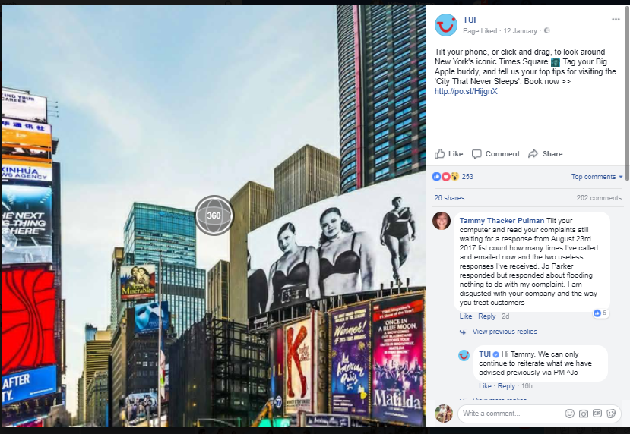
Fig 5. TUI’s 360 of Time Square.
On 12th January 2018, TUI upload a 360 of time square, it received over 200 likes and gave a link to book with them online. This is good practice of marketing due to the online feature being on trend and popular with users, thus a chance for TUI followers to interact with their latest post, as this feature furthers customer engagement it is recommended to upload more 360 photos on Facebook of the destinations that TUI package.
From reviewing York’s six best practices of Facebook marketing, it was analysed that TUI succeed in producing these elements, as they post are engaging, interactive and frequent. Although, the activity via the profile timeline is important there is another opportunity to market to users of Facebook that haven’t liked the existing page of TUI UK. Facebook Ads, the growth of Facebook in recent years has spawned a whole new opportunity for organisations to gain competitor advantage and consumer marketing. Facebook ads come in many forms such as video ads, messaging, virtual reality ad ads powered by artificial intelligence, thus the benefits of ad marketing on Facebook are increasing and in TUI is fruitful in developing these ads to increase success in operations. ‘Discover your smile’ was persuasive Facebook brand campaign that TUI performed, Masuch head of social media in TUI stated “The Facebook campaign, which was focused clearly on our target audience, provided long-term support in helping us introduce our new “Discover your smile” brand slogan”. The campaign was shown on Facebook news feeds both on desktop and mobile. The success of these ads was due to having a non-ad feel for example, the campaign was of happy people smiling in selfie which fitted naturally in Facebook News feeds. The result of this “TUI reached 3.6 million people with the “Discover your smile” campaign on Facebook, which ran from
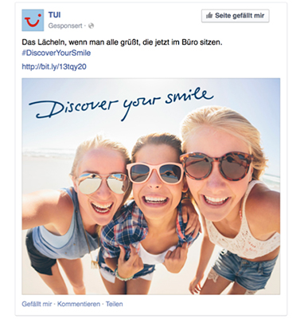

Fig 6. TUI Facebook Ad.
1.3.3 Limitations of TUI’s Facebook and Poor Marketing Methods
Upon reviewing TUI’s Facebook there were clear limitations of their marketing methods. Therefore, this section of the review has highlighted the key limitations of TUI’s Facebook and how they could improve their existing page and services. Thus, recommendations have been suggested in order to increase visitors to the company’s profile page.
Overall Facebook activity is marketing users well, however there are features that could further improve marketing efforts. When reviewing the structure/layout of TUI’s profile it was important to find links to other social media accounts, this would maximise digital marketing methods overall, as it encourage Facebook users to view TUI’s other forms of social media that would contain different information of products and services that Facebook has. It is a tactic in which increases marketing results and further engages consumers. The limitation being that TUI’s Facebook only had an Instagram link and page section. Although Twitter being TUI’s second biggest social media site, the Facebook page did not have a link to this channel. It is recommended that they supply a page on their Facebook profile in where the Twitter news feed is there for access to users like the active Instagram feed and to further this supply a clear link to Twitter.
When reviewing an organisation’s social media page, it is important to observe their competition. The best company that the researcher found to compared TUI’s Facebook and outline the disadvantages, was to make a comparison to a company that is performing on trend features and successful Facebook marketing methods. It was important to have the company also be in the Travel and Tourism industry. The chosen organisation that was found and performing good practices was STA travel. Although STA Travel has a different target market to TUI their structure of their Facebook featured much more than TUI’s therefore it is recommended that TUI supply some of these feature to their Facebook.
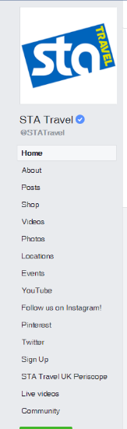

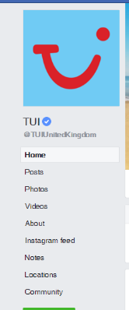

Fig 7. TUI Facebook Features. Fig 8. STA Travel Features.
It is highly recommended that TUI supply links to YouTube, Twitter and Pinterest to boost following of all social accounts. In addition, create a sign up, as STA Travel as done in where users of Facebook and sign up to receive brochures on TUI package holidays as this could significant increase sales. These added features to the profile of TUI can further increase attraction, sales and customer engagement.
Live Video, this was the biggest trend in 2017 in social media. By a click on a button a user can go live of Facebook and record an instant stream of their current actions and real time surroundings. This feature allows to further interact with viewers and users of Facebook and broadcasting in direct and easy. In terms of marketing it is the latest trend due to the rewards it brings, for example consumers can ten times more likely to click on a video, however it is believed live video increases a brand favourability by 63% (Waldron, 2018). TUI limitation is that they have not utilise this feature therefore it is recommended that they supply live videos of world events and holiday destinations by a professional cinemaphotographer to capture an appealing yet live video of desirable destinations. STA travel on their Facebook profile went live in total on ‘12’ videos (STA Travel Facebook, 2018) containing a range of events, destinations and staff interaction videos. It is important therefore that TUI obtain this feature and keep on with latest trends on social media to enhance these social profiles.
STA Travel from instant observation the profile is interactive straight away for the user compared to TUI. The cover photo is of a video, which engages a user instantly to the site. There photos supply humour and descriptions are persuasive. Videos are often and interesting rather than a television advert therefore making them exclusive. In conclusion with this comparison it reveals the poor marketing methods of TUI due to them missing important features that could further enhance the profile page, the exploitation of these mentioned limitations and highlight how TUI can improve future operations on online platforms and increase social communication and supply.
Negative communication, this is throughout on the profile page of TUI. Especially on the community page users are using negative comments about the organisation and their past experiences of their TUI holidays, this is a huge limitation when marketing is considered as first time users of the page will be discouraged to further their involvement of the profile and have negative perceptions about the products and services that are offered. Therefore, it is suggested that negative comments are filtered and TUI maintain a positive atmosphere via the page and respond to users a good manner.

1.3.4 TUI’s Facebook activity align with company objectives
It was important to analyse their vision for the company and its objectives to further this study during the review of their marketing strategies in social media.
This is best illustrated from the official TUI website (2018) and it shows their current belief in engaging employees and customers:
Fig 9. Vision of TUI
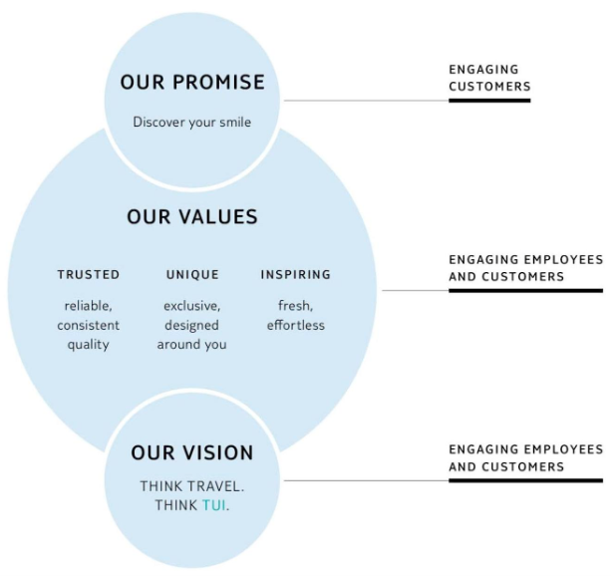

In relation to this diagram, to achieve the values and vision set in engaging employees and customers this is done by their overall company strategies gathered from TUI Website (2018):
- Capitalising on the strength of the TUI brand on a global scale: to attain this the company aim to build consistency of customer experience, digital presence, operational efficiency and competitive strength
- Increasing direct and online sales, building a direct relationship with customers to give them a personal experience and retaining a competitive advantage
- Leveraging direct relationship with the customer using TUI’s global IT platforms
- Driving operational efficiency improvements
- Enhancing top line growth by adding further flexibility
The majority of this company strategies can be achieved through marketing implementations, thus this needs to be considered when an evaluating their social media marketing and how these company goals align with Facebook activity.
TUI’s objectives in the overall company are about building growth and enhancing customer relationships and maximising sales. All of these goals can be achieved through Facebook marketing. By the discussed limitations and recommendations TUI’s Facebook can further achieve these set company goals by improving services and adding to the advantages of their current account as they are already attaining these objectives.
TUI’s Facebook activity align with company goals as it can be explained through the framework of R.A.C.E (Chaffey, 2013 p.226)
Reach- Social media can provide amplification and mass audience to reach new prospects, this is already seen due to the millions that follow the TUI account and their continuing strength in gaining more users. Therefore, TUI goals was digital presence this is met by Facebook activity, shares and mentions can deliver the reach that TUI can further gain.
Act- Encourage interaction leading to increased leads. By TUI suppling Facebook videos direct message service and 360 photos it has given customer interaction and engagement, which is building a direct relationship to TUI customers therefore benefiting a company goal.
Covert- increasing conversion to sale. Social media can vastly increase TUI’s bookings, Facebook has given the company a whole new audience to market to therefore by continuously advertising product and services it will complete the goal in increasing online sales.
Engage- Developing a long-term relationship with first time buyers to build customer loyalty and to gain repeat purchases using communication on the social site. This element encourages customers to act as advocates for the business through sharing, interaction and recommendations. TUI’s Facebook has many facilities that engages customers which have been explained, this has therefore achieved the goal in Leveraging direct relationship with the customer using TUI’s global IT platforms.
A quote from a primary source by Jeremy Ellis TUI marketing director said “one of our ambition is to have a global brand. In a world that is driven by digital and the internet, global brands are more powerful than local ones” therefore due to Facebook being well established, TUI has achieved a global brand as users can access this social account anywhere and furthering online activities can provide TUI future for growth in customers and interaction through marketing techniques.
1.4 An Overview of Recommendations for the Future
This is an overview of the recommendations that was included within the report and advised strategies to improve the future of TUI’s Facebook Marketing

- Filter negative comments as it discourages first time visitors to the page

  - Conclusion

