

Student name: Krisztina Szegvari
Student number: 1908223
Lecture: Dr. Diola Bijlhout
Moodle name and code: Population Health and Digital Health Promotion (LCHS7005_LON)
Assignment title: Component 1
Part A – Blogs
Part B – Poster design
Submission Date: 2023.07.31

Table of content

Introduction.............................................................................................................................3
Part 1 Blog Type 1 Diabetes in the United Kingdom Background............................................................................................................................3
Downloading options..............................................................................................................3
Digital Health Promotion.........................................................................................................4
Advantages and disadvantages.........................................................................................................................5
Recommendations..................................................................................................................6
Part 2 Blog Teenage Pregnancy in the United Kingdom Background.....................................7
Baby Buddy App......................................................................................................................7
Digital Health Promotion..........................................................................................................8
Advantages and disadvantages..........................................................................................................................8
Recommendations...................................................................................................................9
Part 2 Poster Desing – Type 1 Diabetes in the United Kingdom............................................10
Reference List..........................................................................................................................................11

Component Assignment

Part 1

Blog 1 - Adolescents with Type 1 Diabetes in the United Kingdom

- Blog
Introduction:
This assignment will discuss 2 different blogs with public health concerns and how digital health technology can help and improve their issues. After will choose one of the blogs and from that make a poster design.

  - Background:
Diabetes affects the quality of life who is living with that long-term conditions and is a main problem in public health. Diabetes in adolescents has now become a common disease in the world. Many people have inherited the disease either due to stress, trauma and genetic(Whicher et al., 2020).
In the United Kingdom, by 2030, every tenth person may have diabetes, unfortunately, the government does not pay more attention to prevention services. Almost 4.1 million people have type 1 or type 2 diabetes(Whicher et al., 2020).
The T1D population in the United Kingdom is 30% use the FreeStyle Libre system(NICE, 2017).
The FreeStyle Libre 2 is provided by Abbott. The data is interstitial fluid glucose levels made. The system is a sensor and a reader at the same time. They got a new upgrade about the patient being able to scan the insulin pen with the mobile phone to see how many units given to the patient and the now they do not need to scan the sensor they just need to open the app and is showing the data the glucose mmol without even scanning the sensor(Abbott, 2023).

  - Downloading options:
Available the app from any platform free. The company LibreLink app can download from Google Play or the Apple Store as well. The patient just needs to scan the sensor with their phone and they can see the actual glucose level. They can share the data with the diabetes team. When they scan the sensor it will be activated in 60 minutes(NICE, 2017).
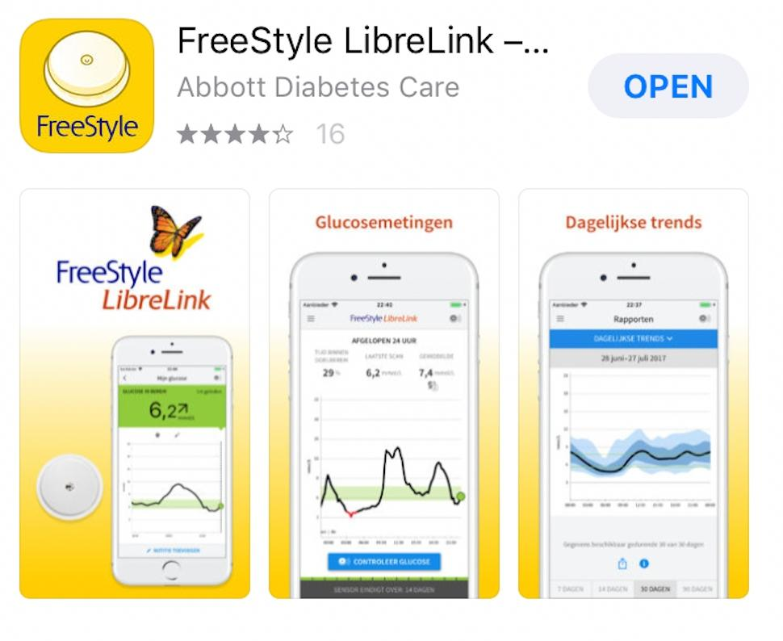
Freestyle Libre App: (Abbott, 2023).
The sensor can stay until 14 days after has an expire need to be removed because after not sending any more data. Giving alarm high or blood sugar(NICE, 2017).

Only available in the United Kingdom on prescription with the National Health Services offer for type 1 diabetes patients(NHS ENGLAND, 2022).

1.2 Digital Health Promotion:
Digital technology is promoting the user's health because they can check anytime their glucose anytime without any pain. 24 hours the blood sugar level is monitored. Promoting health with digital technology such as self-care, nutrition how many carbohydrates the patient needs to take and how many units of insulin need to be taken for that portions and physical health to avoid any high blood sugar which can cause a lot of different health problems in the future, eyes, foot, teeth, nerve(NICE, 2017).
Improve the patient quality of life and quality of care. Because the diabetes team as well can be monitor the patient with the sensor. With digital health technology such as CGM sensor the patient can better manage their diabetes.Educate the patient and empower them to make sure they know how they are using that technology to knows the positive and negative sides as well(Pintus, 2019).
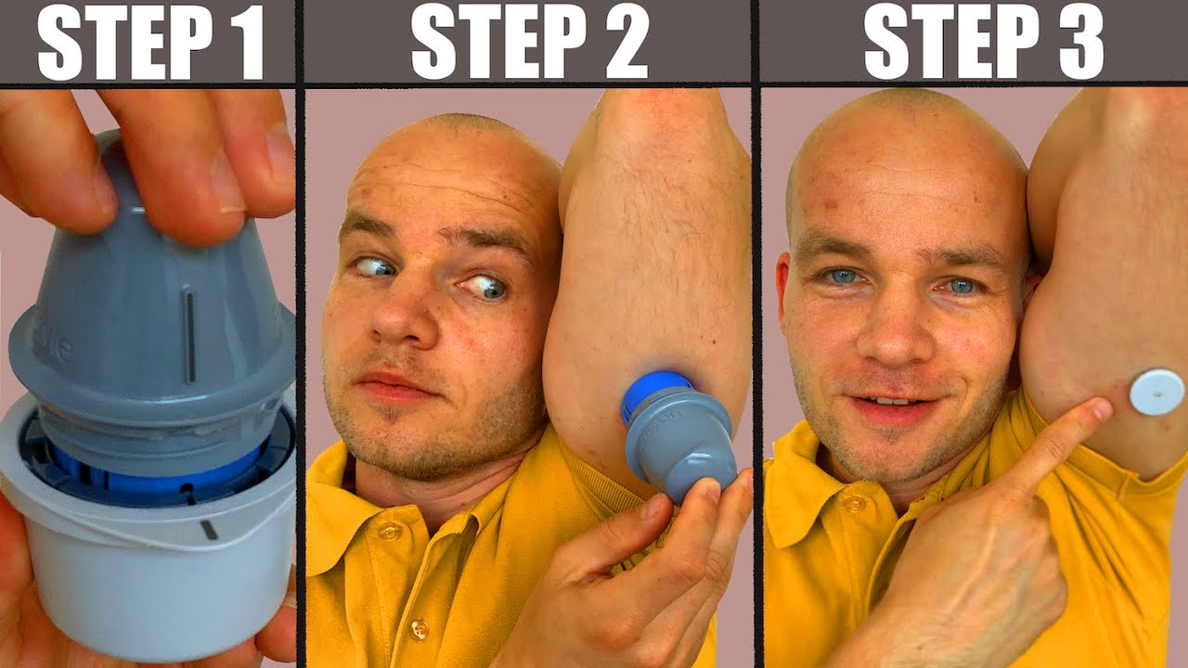
How to apply step by step. Attached the link.

(Mercado, 2021).
Source: https://www.youtube.com/watch?v=DnQydBN_TLQ

1.3 Freestyle Libre sensor websites they are on all of the social media platforms, such as Facebook and Instagram and they have their own website.
Links:
- https://www.instagram.com/freestylediabetes/
- https://www.facebook.com/FreeStyleMeters/?brand_redir=954298964703081
- https://www.freestyle.abbott/uk-en/home.html

  - Advantage:

Anytime can the user see the actual glucose level and with graphs can see and understand how meals can affect the sugar level or any physical activities. No need finger picks checks. Share data with the diabetes team anytime. Insured by NHS and they approve all the data from the sensor(Chapple, 2023).

- Disadvantage:

Mental health issues for the user because they can know the glucose level any time and if the person was working really hard it can make anxiety. No data protection to share the data, low confidence. Not always accurate because results do not come from blood. Sensor, when a person has, can make irritations or not feel the confidence to show to other people(Chapple, 2023).

  - Recommendations:

This digital health technology CGM sensor already exists but would give to add a few elements to develop digital health promotion. Need to be available to access everyone to only Type 1 Diabetes patients it should not depend on the health conditions. They have to upgrade the connection because many times losing the signal from bloothoot(Abbott, 2023).

Blog 2 - Teenage Pregnancy in the United Kingdom

- Background:

In the World around 16 million teenage pregnancies per year, most of the time coming from low-income countries. The complications from pregnancy are one of the biggest problem causes of death in girls between 15 -19 years old(WHO, 2023).

In the United Kingdom, teenage pregnancy has an adverse effect, they are most likely to live in poverty, are orphans, are unemployed, have not received adequate education, or may be living in a foster family(McCarthy et al., 2014).

The UK has the highest rate of teenage pregnancy between the ages of 13 and 19, whether planned or unplanned. About 3 million girls undergo abortions each year. The pregnancy of high teenage shows poor sexual health, and not having safe sex so it is quite a big public health problem. Adequate education, financial and social situation, and support for teenage people are important(Taylor, 2023).

A lot of studies are shows they girls are not getting pregnant because they do not know about the safe sex that was thought became in the mother for the full part of their life(Evans, 2022).

1.1 Baby Buddy App

Baby Buddy App, digital health technology presented by the United Kingdom Charity Best Beginnings and supported by National Health Services, /NHS/ has a lot of advantages for the new pregnant patient in the United Kingdom.is a free pregnancy app that helps improve health outcomes, support parents, and reduce various inequalities. It helps parents to develop their knowledge in the child's life, to have a stable foundation(Rhodes et al., 2020).

Personalized data give support day by day for the pregnant patient until the baby's first birthday. Helps with a lot of videos such as nappy changes and breastfeeding to mental health. They can update the growth, vaccines, appointments any important information. All the registers can be anonymous for data protection. They can use with smartphones and downloaded from different platforms for free such as Google Play and Apple Store(Deave et al., 2019).

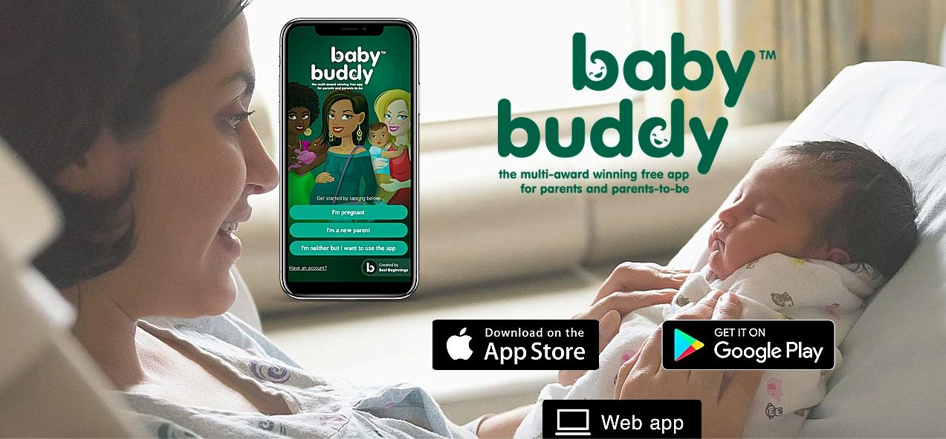
(Baby Week UK, 2021).
Links to access to download.
https://www.babybuddyapp.co.uk/
https://www.facebook.com/babybuddyappofficial/
https://www.instagram.com/babybuddyapp/

1.2 Advantage:
Available for free. Support male and female teenage pregnancy. Step by step all the support available such as breastfeeding, nappy change, and weights. Develop their knowledge of how they can be better parents to support their children in the growing period(Hughson et al., 2018).
Disadvantage:
Disadvantage can be the app can not replace the human some of the patients are feeling more confident talking with the specialist face to face. Some of the apps have unfriendly user face which can ignore complex systems. Low rates of the app where the people have low income and non-English speaking girls. The user does not ensure the data and information are valid(Hughson et al., 2018).

1.3 Digital Health Promotion:
Using health promotion the app helps teenage pregnant to build self-efficacy and promote good parental infants. Support from the beginning not only the pregnant teenager same but the teenage dad as well they can register on the app. Can develop more confidence and knowledge for the user about the pregnancy to support their baby after the birth and during the pregnancy period(Musgrave et al., 2021).
1.4 Recommendations:

This digital health technology has already existed would suggest adding new elements which can develop the app and help teenage pregnancy. They need to give access to all over the World not only in the United Kingdom to help the different countries to reduce teenage pregnancy(Musgrave et al., 2021).

They need to help teenage pregnant to be accessible by the app anywhere and anytime when they need it. They need to educate to have safe sex, to make sure to plan a baby and support low-income parents. The people who have non-English language need support with free language courses from the local community to be able to understand the app and help them how to use it(Hughson et al., 2018).

Poster Design Part 2 - Type 1 Diabetes in the United Kingdom
Concept, Values and Principles:
Value: Non-judgemental, and respect their diseases and themselves as well. Keep their glucose level within range before and after meals. When the patient wakes up 5 to 7 mmol/L and before meals 4 to 7 mmol/L and after meals 90 minutes later 5 to 9 mmol/L(Seery, 2022).
Principles:Thinking like a pancreas to find out what is needed and to understand how it is working with the timeline.Achieve a normal glucose level to reduce the risk of any sickness or any other long-term conditions which can cause the not controlled blood sugar level. Patients can check with the digital health technology their blood sugar levels with no need to use finger pricks.Normal glucose level between 4 to 7 mmol after the meals 2 hours later around 9 mmol.Other principles not going lower than 4 mmol. Because it can be a risk of having hypo events.Lowering carbs to make sure the glucose level is in the right numbers.Anything can affect and raise the blood sugar level, sickness, work, and stress.Educating the patient about their diseases is really easier to manage and reduces misunderstanding and confusion(Cavan, 2018).
Concept: Type 1 Diabetes mellitus is an autoimmune disease that can cause genetic or environmental combinations and is a long-term disease. Living with the T1D disease is very difficult for the patient, and family members as well(Cavan, 2019).
Health promotion values and principles.
Determinants of diabetes: The patient's life can have psychological and biological factors such as genetics. Different social, and economic environments such as poverty, violence, inequality, and environmental deprivation also the risk of abuse or unhealthy lifestyle can cause(NICE, 2015).
Empowerment: Respectful and not judgemental, open relationship and feel confident to discuss their feeling their thoughts, focus on strengths and skills, decision making together, holistic approaches with person-centred care.Educate the patient to build their confidence(NICE, 2015).
Quality of life:Learn to manage their diseases, change their lifestyle, be more physically active and support their mental health and well-being(NICE, 2015).
Conclusion: Still one of the biggest public health problems in the United Kingdom the type 1 diabetes. Each year the number and increasing. No specific reason why is happening that can be inactivity, family history, or trauma.The digital health technology Freestyle Libre is very helpful for that patient and makes their life much easier by not using it all the time the finger pricks. More advantages than disadvantages the digital health technology. But unfortunately still only available free for type 1 diabetes patients in the United Kingdom. The biggest challenge to keep their glucose level within range and counting the carbs. The health belief model helps the patient how the behaviour change can improve their health and encourage them to see the changes that are needed. The outcome is the patient is more confident with their data because they can handle them and keep an on eye their changes and the diabetes team as well can see everything in real-time when they need it.
Background.
Around 400.000 patients are living with type 1 diabetes and from that group 29.000 are children in the United Kingdom(NHS, 2021).
FreeStyle Libre is started in the United Kingdom in 2017.More than 30% of type 1 diabetes patients are using the Freestyle Libre sensor in England.The numbers each year increase the number of T1D patients by around 4% in England.The United Kingdom has the highest rates of T1D patients in the World(Watts, 2022).
Type 1 diabetes causes when the blood sugar level became too high and when your body does not produce enough insulin anymore to control the blood sugar level(Diabetes UK, 2019).
The treatment patient has to take insulin to have the right glucose level in the range. Type 1 diabetes no links between overweight is linked between family history or autoimmune diseases(Blissett et al., 2022).
Reference List : Adejoh, S.O. (2014) Diabetes knowledge, health belief, and diabetes ... - sage journals, Diabetes Knowledge, Health Belief, and Diabetes Management Among the Igala, Nigeria. Available at: https://journals.sagepub.com/doi/10.1177/2158244014539966
Blissett, R. et al. (2022) Freestyle Libre flash glucose monitoring system for people with type 1 diabetes in the UK: A budget impact analysis, BMJ Open Diabetes Research &amp; Care. Available at: https://drc.bmj.com/content/10/2/e002580#:~:text=In%202017%2C%20the%20FreeStyle%20Libre%20system%20was%20listed,England%20%28unpublished%20internal%20market%20report%20provided%20by%20IQVIA%29
Cavan, D.D. (2018) Six principles of managing type 1 diabetes (part 1/2), Top Doctors. Available at: https://www.topdoctors.co.uk/medical-articles/six-principles-of-managing-type-1-diabetes-part-one#:~:text=Six%20principles%20of%20managing%20type%201%20diabetes%20%28Part,levels%20...%203%20Four%20is%20the%20floor%20
Cavan, D.D. (2019) Six principles of managing type 1 diabetes (part 2), Top Doctors. Available at: https://www.topdoctors.co.uk/medical-articles/six-principles-of-managing-type-1-diabetes-part-2#:~:text=Six%20principles%20of%20managing%20type%201%20diabetes%20%28part,of%20adjustment.%20...%203%20Education%20is%20essential%20
Khosravizadeh, O. et al. (2021) Applying the health belief model and behavior of diabetic patients: A systematic review and meta-analysis, Clinical Diabetology. Available at: https://journals.viamedica.pl/clinical_diabetology/article/view/72300
Medscape UK (2021) Concerns raised over inequitable access to Freestyle Libre, Medscape UK. Available at: https://www.medscape.co.uk/viewarticle/concerns-raised-over-inequitable-access-freestyle-libre-2021a1001qrv
Expected outcome
Studies are showing the expected outcomes from the Freestyle Libre app it was very positive. With that opportunity, the depression and anxiety symptoms were reduced. More confidence for the patient to easily check the glucose level anywhere and anytime. The cost is free for the Type 1 diabetes patients. Feel more safer because they can see the haemoglobin A1C and diagrams, high and low blood sugar events and that app can make an alarm for the patients when low or high the glucose level(NICE, 2017).
Behaviour Change Theory: Health Belief Model: The Health Belief Model posits that people who experience health problems are more likely to engage in behaviours that are consistent with or reduce the occurrence of the health problem. It emphasizes that the patient's belief in the personal threat of the disease, as well as the belief in the effectiveness of the recommended behaviour and action, can help the person to accept the new behaviour(Khosravizadeh et al., 2021).
Perceived Severity Type 1 diabetes in the United Kingdom affects a lot of people very high rate. Can be different risk factors that can cause diabetes such as unhealthy, stressful lifestyles, genetic causes and trauma.
Perceived SusceptibilityThe person will not change with their behaviour if they do not believe they are in danger. They need to believe to reduce the risk to develop diabetes if they change their behaviour. For example, if they have a family history of diabetes and having a healthy lifestyle can reduce the risk. Perceived Benefits: People need to convince if they change their behaviour and agree with the treatment and lifestyle change it can help with their diseases. Such as regular physical activities, carbohydrate counting, monitoring glucose levels closely and attending appointments with the diabetes team(Khosravizadeh et al., 2021).
Perceived Barriers:Discrimination and stigma because of illnesses. The different difficulties and long-term consequences are eyes problems, foot issues, tooth problems, and really weak all the time and if the glucose is high all the time the immune system is at very low risk of catching any illnesses(Khosravizadeh et al., 2021). Cues to Action: The action can be internal or external. Internal is physical, pain, symptoms. External, social media, health care providers, the promotion which related to health behaviour. Educate the patient on how they can cope with their diseases and how they can live with them, to mention the risk and how they can prevent that(Adejoh, 2014). Self-Efficacy The patient's ability to make a change in their life and to build the patient's belief and confidence in their diseases. More control over their data and monitor themselves as well with the sensor to see the changes anytime(Adejoh, 2014).
Digital Health Intervention
The Freestyle Libre CGM sensor monitors the glucose level in 24 hours. The sensor is contaminated with fluids not blood. The sensor can stay on the patient for 14 days after will be expired. If someone is unwell better to do finger pricks to make sure the data are valid. The provider is Abbott and is insured and approved all the data by the National Health Services it was published the first sensor in 2017(Medscape UK, 2021).
The patient can apple under the upper arm only other space on the body is not insured.The patient can see 24-hour data and diagram low and high sugar level events. They can see haemoglobin A1C without a blood test. If the sensor is fall off before 14 days or when the patient is applied on the arm and is failed scanned they can contact Abbott services and they will replace and send a new sensor the next three working days for free and the patient can send back the failed sensor to them. If someone wants to have a sensor but they do not have a prescription they can buy it online for around 59 pounds.Health inequality access to digital health technology because only available free for T1D patients. Older patients can not access that, social economic status can be an issue as well. Education because the patient needs to have training on how they can use the technology to raise the awareness of pros and cons as well as to inform them. Poverty patients can not afford to buy a sensor if they not having for prescriptions(Medscape UK, 2021).

Seery, C. (2022) Normal blood sugar ranges and blood sugar ranges for adults and children with type 1 diabetes, type 2 diabetes and blood sugar ranges to determine people with diabetes., Diabetes. Available at: https://www.diabetes.co.uk/diabetes_care/blood-sugar-level-ranges.html
Watts, M. (2022) The abbott freestyle libre has come as an entirely new concept in glucose monitoring by providing much greater data than blood glucose testing whilst being more affordable than continuous glucose monitors (CGM)., Diabetes. Available at: https://www.diabetes.co.uk/blood-glucose-meters/abbott-freestyle-libre.html
NICE (2015) Overview: Type 1 diabetes in adults: Diagnosis and management: Guidance, NICE. Available at: https://www.nice.org.uk/guidance/ng17
NICE (2017) Clinical and technical evidence: Freestyle Libre for glucose monitoring: Advice, NICE. Available at: https://www.nice.org.uk/advice/mib110/chapter/Clinical-and-technical-evidence

Reference List

Abbott (2023) Welcome: Myfreestyle, Abbott. Available at: https://www.freestyle.abbott/uk-en/welcome.html
Adejoh, S.O. (2014) Diabetes knowledge, health belief, and diabetes ... - sage journals, Diabetes Knowledge, Health Belief, and Diabetes Management Among the Igala, Nigeria. Available at: https://journals.sagepub.com/doi/10.1177/2158244014539966
Baby Week UK (2021) Best beginnings guidance for pregnancy, birth and beyond, Baby Week UK. Available at: https://babyweek.co.uk/resources/best-beginnings-guidance-for-pregnancy-birth-and-beyond/
Bidonde , J. et al. (2017) Freestyle Libre flash glucose self-monitoring system: A single-technology assessment [internet], National Center for Biotechnology Information. Available at: https://pubmed.ncbi.nlm.nih.gov/29553668/
Blissett, R. et al. (2022) Freestyle Libre flash glucose monitoring system for people with type 1 diabetes in the UK: A budget impact analysis, BMJ Open Diabetes Research &amp; Care. Available at: https://drc.bmj.com/content/10/2/e002580#:~:text=In%202017%2C%20the%20FreeStyle%20Libre%20system%20was%20listed,England%20%28unpublished%20internal%20market%20report%20provided%20by%20IQVIA%29
Cavan, D.D. (2018) Six principles of managing type 1 diabetes (part 1/2), Top Doctors. Available at: https://www.topdoctors.co.uk/medical-articles/six-principles-of-managing-type-1-diabetes-part-one#:~:text=Six%20principles%20of%20managing%20type%201%20diabetes%20%28Part,levels%20...%203%20Four%20is%20the%20floor%20
Cavan, D.D. (2019) Six principles of managing type 1 diabetes (part 2), Top Doctors. Available at: https://www.topdoctors.co.uk/medical-articles/six-principles-of-managing-type-1-diabetes-part-2#:~:text=Six%20principles%20of%20managing%20type%201%20diabetes%20%28part,of%20adjustment.%20...%203%20Education%20is%20essential%20
Chapple, B. (2023) Flash glucose monitors (freestyle libre) and continuous glucose monitors (CGM), Diabetes UK. Available at: https://www.diabetes.org.uk/guide-to-diabetes/diabetes-technology/flash-glucose-monitors-and-continuous-glucose-monitors#Getting%20Insurance%20For%20Your%20CGM%20Or%20Freestyle%20Libre
Deave, T. et al. (2019) A study to evaluate the effectiveness of best beginnings’ Baby buddy phone app in England: A protocol paper, Primary health care research & development. Available at: https://www.ncbi.nlm.nih.gov/pmc/articles/PMC6476387/
Diabetes UK (2019) Us, diabetes and a lot of facts and stats. Diabetes UK. http://www.diabetes.org.uk
Evans, S. (2022) Teenage pregnancy: Will public health cuts negate previous policy success?, The Health Policy Partnership. Available at: https://www.healthpolicypartnership.com/teenage-pregnancy-will-public-health-cuts-negate-previous-policy-success/
Hughson, J.-A.P. et al. (2018) The rise of pregnancy apps and the implications for culturally and linguistically diverse women: Narrative review, JMIR mHealth and uHealth. Available at: https://www.ncbi.nlm.nih.gov/pmc/articles/PMC6269626/
Khosravizadeh, O. et al. (2021) Applying the health belief model and behaviour of diabetic patients: A systematic review and meta-analysis, Clinical Diabetology. Available at: https://journals.viamedica.pl/clinical_diabetology/article/view/72300
Medscape UK (2021) Concerns raised over inequitable access to Freestyle Libre, Medscape UK. Available at: https://www.medscape.co.uk/viewarticle/concerns-raised-over-inequitable-access-freestyle-libre-2021a1001qrv
Mercado, R. (2021) How to download YouTube thumbnail images, MUO. Available at: https://www.makeuseof.com/download-youtube-thumbnail-images/
McCarthy, F.P., O’Brien, U. and Kenny, L.C. (2014) The management of teenage pregnancy, The BMJ. Available at: https://www.bmj.com/content/349/bmj.g5887
Musgrave, L.M. et al. (2021) Baby buddy app for breastfeeding and behavior change: Retrospective study of the app using the Behavior Change Wheel, JMIR mHealth and uHealth. Available at: https://www.ncbi.nlm.nih.gov/pmc/articles/PMC8085747/
NHS (2021) Dorset Medicines Advisory Group - nhsdorset.nhs.uk, COMMISSIONING STATEMENT ON THE USE OF FREESTYLE LIBRE® SENSORS. Available at: https://www.nhsdorset.nhs.uk/Downloads/aboutus/medicines-management/Other%20Guidelines/SGLT2s%20commissioning%20statement%20July%202021.pdf
NICE (2015) Overview: Type 1 diabetes in adults: Diagnosis and management: Guidance, NICE. Available at: https://www.nice.org.uk/guidance/ng17
NICE (2017) Clinical and technical evidence: Freestyle Libre for glucose monitoring: Advice, NICE. Available at: https://www.nice.org.uk/advice/mib110/chapter/Clinical-and-technical-evidence
NICE (2017) The technology: Freestyle Libre for glucose monitoring: Advice, NICE. Available at: https://www.nice.org.uk/advice/mib110/chapter/The-technology
NSV Health (2022) Principles for effective support - what is empowerment?, What is empowerment? - Principles for effective support. Available at: https://www.health.nsw.gov.au/mentalhealth/psychosocial/principles/Pages/empowerment.aspx#:~:text=Empowerment%20is%20%E2%80%9Cthe%20level%20of%20choice%2C%20influence%20and,to%20discuss%20their%20feelings%20and%20what%20they%20want
NHS ENGLAND (2022) Lifechanging technology to be rolled out to all type 1 diabetes patients, NHS choices. Available at: https://www.england.nhs.uk/2022/03/lifechanging-technology-to-be-rolled-out-to-all-type-1-diabetes-patients/
Pintus, P. (2019) Freestyle libre flash glucose monitoring improves patient quality of life measures in children with type 1 diabetes mellitus (T1DM) with appropriate provision of education and support by Healthcare professionals, Diabetes & metabolic syndrome. Available at: https://pubmed.ncbi.nlm.nih.gov/31425957/
Public Health England (2018) Teenage pregnancy prevention framework - gov.uk, Teenage Pregnancy Prevention Framework. Available at: https://assets.publishing.service.gov.uk/government/uploads/system/uploads/attachment_data/file/836597/Teenage_Pregnancy_Prevention_Framework.pdf
Rhodes , A., Kheireddine, S. and Smith, A.D. (2020) Experiences, attitudes, and needs of users of a pregnancy and parenting app (Baby Buddy) during the covid-19 pandemic: Mixed Methods Study, JMIR mHealth and uHealth. Available at: https://pubmed.ncbi.nlm.nih.gov/33264100/
Seery, C. (2022) Normal blood sugar ranges and blood sugar ranges for adults and children with type 1 diabetes, type 2 diabetes and blood sugar ranges to determine people with diabetes., Diabetes. Available at: https://www.diabetes.co.uk/diabetes_care/blood-sugar-level-ranges.html
Taylor, A. (2023) Teenage pregnancy is a public health problem, The BMJ. Available at: https://www.bmj.com/rapid-response/2011/10/28/teenage-pregnancy-public-health-problem
Watts, M. (2022) The abbott freestyle libre has come as an entirely new concept in glucose monitoring by providing much greater data than blood glucose testing whilst being more affordable than continuous glucose monitors (CGM)., Diabetes. Available at: https://www.diabetes.co.uk/blood-glucose-meters/abbott-freestyle-libre.html
Whicher, C.A., O’Neill, S. and Holt, R.I. (2020) ‘Diabetes in the UK: 2019’, Diabetic Medicine, 37(2), pp. 242–247. doi:10.1111/dme.14225.
WHO (2023) Adolescent pregnancy - world health organization. Available at: https://apps.who.int/iris/bitstream/handle/10665/112320/WHO_RHR_14.08_eng.pdf

