  - ACBA6003

Ground Investigation
By
Tim Rees
1807470

Table of contents –

- – Introduction – Page 3
- – Proposed Site- Page 3
- – Topography – Page 4
- – Geology -Pages 5-6
- – Contamination – Pages 6-7
- – Nearby landfill site – Page 7

1.0 Introduction-

The following desk study is an assessment of readily available site information, including topographic, geological data. The objectives of the ground investigation study are to:
• Determine whether the ground conditions in the area are suitable for the proposed development.
• Evaluate risks associated with potential land contamination.

This ground investigation has been primarily carried out as a desk top study due to the restricted access to the proposed site.

2.0 The proposed site –

The proposed site is situated on a parcel of land situated south of the prince of wales dock and just north of King’s dock within the section marked “E9” in the image below. The proposed site is approximately 9380m2 in size.

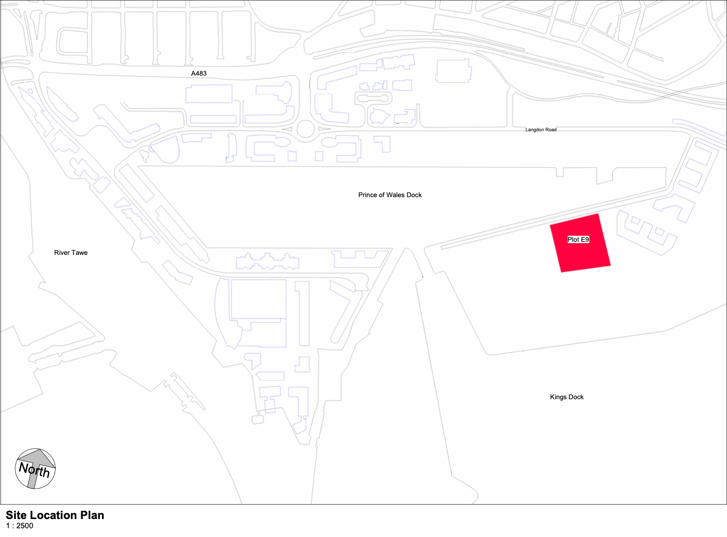
Image 1 showing site location (Brown, 22)

3.- Topography -

During my desk top study, I have carried out a brief topographical survey. From this survey, it can be seen that the ground level of the proposed site is considerably even and does not show any significant difference in regard to height variation of the ground level.
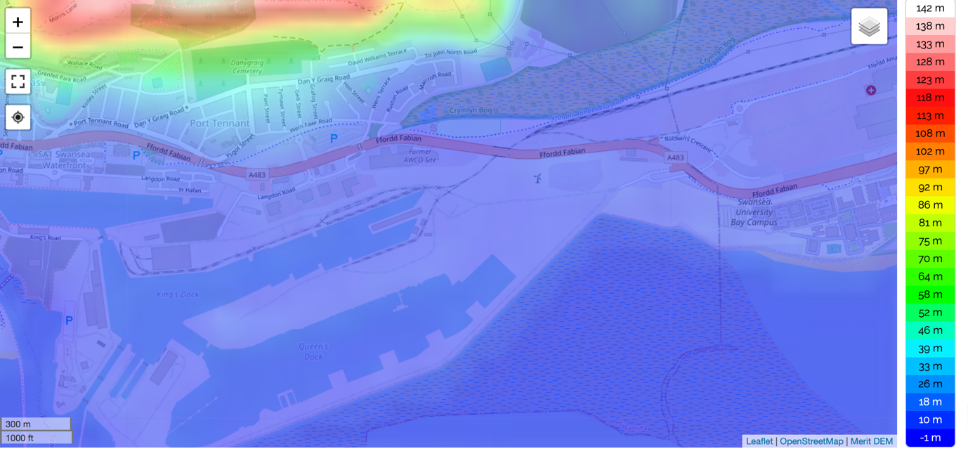
(maps, T 2022)

Need for a further topographical survey –

Although a desk top based topographical survey has been used to establish the ground level variation, a further topographical survey in which a team will visit the site in order to set up stations, reflective prism and GPS units on metal nails hammered into the ground at the control stations. This can be used to accurately measure the topography of the land one point at a time. These stations once established, can then be used to check the accuracy of measurements alongside other survey works, as well as providing accuracy for the setting out process. The completion of this further survey can provide assistance to several tasks during the varying phases of the project. Some of these tasks might include route planning for buried services, designing new access and any potential realignments to existing highways and to satisfy the requirements of the local planning authority.

4.0 Geology-

The assessment of the geology of the site and the ground conditions has been
inferred from available information such as the information available from previous ground investigations on neighbouring sites such as UWTSD, Swansea university and the PBSA building currently under construction on Kings’ Road.
During my desk top study I contacted the planning and building control department in Swansea council and was advised that the soil types in the area were assumed to be comparable to that of the new Swansea University on Fabian way. (Swansea university 2022) Using the information provided by the ground investigation report for the Swansea university, which contained data for another 3 neighboring sites, I was able to produce a table (Appendix 1) that that describes the soil types we may find on our site at various depths.

Strata. | Depth to range of top of stratum(m) | Depth to base of stratum (m) | Description.
Made Ground | Ground Level | 2.5-3.2 | Fine to medium sand with boulder of Quarzitic sandstone.
Aeolian Sand | 2.5-3 | 10.9-15.5 | Medium to dense light brown and yellowish fine to medium sand with calcareous fragments.
Fluvio-Glacial Till | 10.9-15.5 | 20.30-23 | Stiff, dark brown and greyish sandy clay with lots of subrounded cobbles.
Lower Coal measures | 20.30-23 | unknown | Extremely weak grey mudstone.

During my desktop study I also carried out a survey of the Geological Survey of England and Wales 1:63,360/1:50,000 geological map series, New Series which also showed that the typical ground types in the area conform with results shown in the ground investigations carried out on neighbouring sites. This also allowed us to not only identify the soil types and bedrock geology of the area but also to find out if the area has been subject to any past mining activities. Past mining activities can affect the land by causing heavy metal contamination that can be harmful to humans and the local environment, but it can also affect the structural integrity of the ground which will have important implications for construction work.

5.0 land contamination-

(Swansea Council, 2022) It is well known from multiple previous planning applications in the area surrounding the proposed site including that for UWTSD, show constraints for historically contaminated land. It is also known that the area in which the proposed site sits contains was heavily bombed during the Second World War. Due to this there is a risk of contamination within proximity of the site.
A previous Ordnance Threat Assessment was carried out in respect of the areas covering the Swansea docks and Crymlyn burrows in 2014. This assessment was carried out in accordance with CIRIA (Construction Industry Research and Information Association) guidelines. This assessment was carried out by creating a series of trial pits and windowless sample holes to depths typically between 4m to 6m bgl, with some of the deeper bore holes going as deep as 25m bgl.
Following completion of these tests some risk mitigation measures were recommended to support any future proposed works. These measures provided guidance for both low risk zones and high-risk zones.
These measures included:
Measures that cover both high risk and low risk zones-
Explosive ordnance safety and awareness briefings to all personnel who may be required to carry out potentially intrusive works.
Provision of Unexploded Ordnance Site Safety Instructions.
Measures to cover high risk zones only (previously mentioned measures to be included-
Non-intrusive magnetometer survey and target investigation ahead of any potentially intrusive works.
Where the use of a non-intrusive magnetometer is not possible an Explosive Ordnance Disposal (EOD) engineer is required to be present to site to allow for the supervision of all open excavations.
An intrusive magnetometer survey of any proposed pile/borehole locations.
As the proposed site for our project is within reasonable proximity to that of the tested areas, I would make recommendations to carry out similar risk mitigation measures for our proposed site.

6.0 Contamination from Landfill –

When considering proximity to previous and current landfill sites it is noted that the Swansea Councils planning guidance literature and Part C of the Building Regulations 2010 and the latest edition of Approved Document C: Site Preparation and Resistance to Contaminants and Moisture, both advise of a 250m zone of concern which should be given to buildings and proposals within proximity of former and current landfill sites. The intention of this zone is to protect buildings from the potential of gas migration from the landfill through the ground.

As seen in image 4 (below) there are no landfill sites within the 250m zone of concern to our site according to the Environment Agency website. Appendix x below shows a map of historic landfill sites within proximity of our proposed site. As you can see from this map there are/have been previous land fill sites on the other side of Fabian way. This shows that the proposed site is outside of the 250m restriction set out in Swansea Councils planning guidance literature.

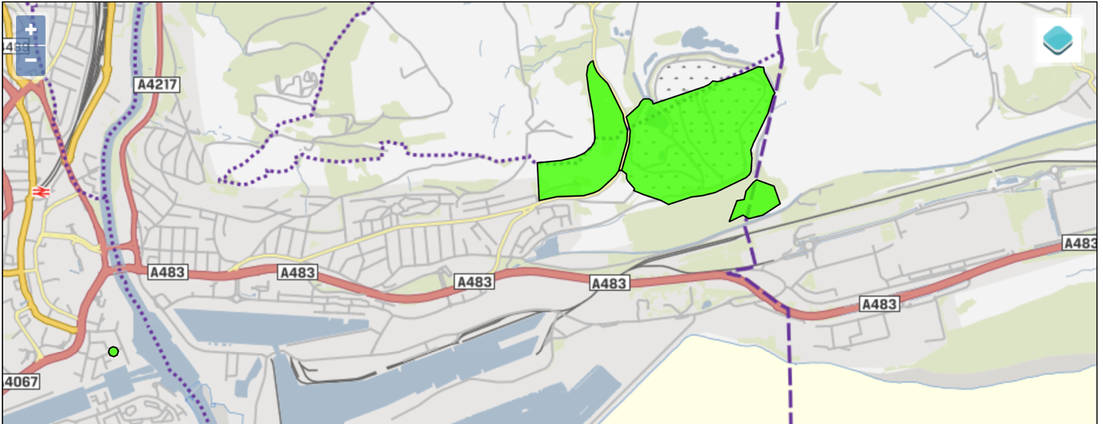
http://lle.gov.wales/catalogue/item/HistoricLandfillSites/?lang=en

References –

maps, T., 2022. Wales topographic map, elevation, relief. [online] topographic-map.com. Available at: <https://en-gb.topographic-map.com/maps/c4/Wales/>

2022. [online] Available at: <https://www.swansea.ac.uk/media/CISM---Ground-Conditions.pdf)>.

Council, S., 2022. [online] Available at: <https://property.swansea.gov.uk/online-applications/simpleSearchResults.do?action=firstPage>.

Webapps.bgs.ac.uk. n.d. Geological Survey of England and Wales 1:63,360/1:50,000 geological map series, New Series| BGS maps portal | OpenGeoscience | Our data | British Geological Survey (BGS). [online] Available at: <https://webapps.bgs.ac.uk/data/maps/maps.cfc?method=listResults&MapName=&series=E50k&scale=&getLatest=Y&pageSize=100>.

CIRIA, n.d. A. [online] CIRIA (Construction Industry Research and Information Association) guidelines. Available at: <http://CIRIA (Construction Industry Research and Information Association) guidelines.>.

Labc.co.uk. n.d. Wales Approved Document Part C: Site preparation and resistance to contaminants and moisture | LABC. [online] Available at: <https://www.labc.co.uk/professionals/building-regulations-guidance-documents/approved-documents-and-technical-guidance-wales/wales-approved-document-part-c-site-preparation-and-resistance-contaminants-and-moisture>.

Lle.gov.wales. n.d. Lle - Historic Landfill Sites. [online] Available at: <http://lle.gov.wales/catalogue/item/HistoricLandfillSites/?lang=en>.

