Task One; Semiotic Analysis
Semiotics can be many different things, words, symbols, images, sounds, smells; Semiotics are everything. There are many different interpretations about semiotics, but the main one would be what do they make you do? Using semiotics, I will show some of the main features of this poster and why it might have been made the way it is.
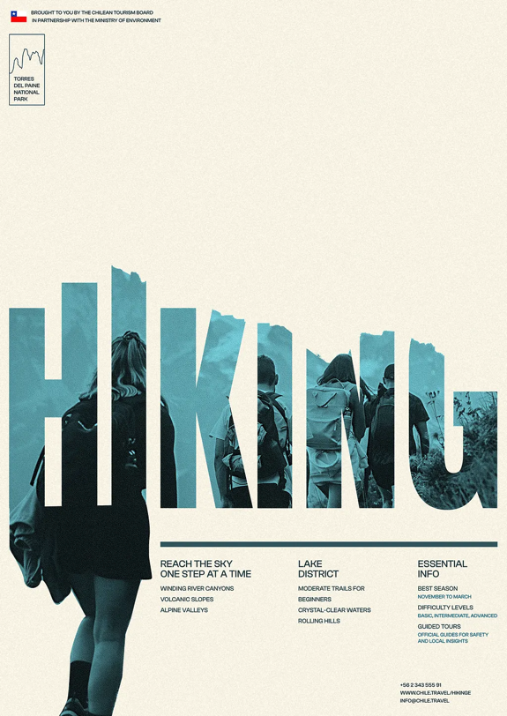

Figure 1, (Bumazhnov, Posters in Swiss Style)
The first thing you might notice about this poster is the visual communication in the poster, more specifically the hierarchy. The main title ‘Hiking’ is central in the poster in a bold all capitals sans serif typeface. ‘Many sans serif typefaces are geometric in their construction’ (Carter, 2014, p.39) As this poster is in a Swiss style which is known for being geometric and using grids, it works perfectly. The next part of the poster the eye would go to is below the main title to the secondary information. This information has been colour matched to the darkest blue in the main title which works great. The visual chromatic signs of this poster work well with the topic as blue is often seen as a cold colour. ‘Blue belongs to the cooling end of the spectrum…it should be the colour of truth, which is a calm reflection and never of a heated argument.’ (Conroy, 1921, p.27) This works well with the outdoors theme of the poster and adds to how hiking can be calming. As this book is from the 1900s, it shows that colours and their meanings are still true and relevant to this day. The background colour is a creamy colour which contrasts great with all of the blue tones that have been used. It brings a warmer tone in, if there was a white background instead it would be more assertive and have a cooler atmosphere.

The final semiotic that plays a large part in this poster would be the visual flow of it. As we have already discovered this poster shows the calmness of hiking by using the colours we also want the poster to flow well. This has been done by the people who have been masked into the main title facing the right. This then looks like they are moving with the word. Another way of creating visual flow in this poster is by keeping the top right corner open. The information works in the left corner as nothing is facing it whereas if this was in the right corner the poster would feel more closed off. ‘separate components that are to be arranged on the page…to form a seamless presentation.’ (Ambrose and Harris, 2005, p.82) This means that when the layout is correct and is good, it will make the poster. The layout really is a make or break aspect of the poster. The white space around the poster lets it breathe and lets the views eye see what is important.

Bibliography
Carter, R. (2014) Typographic design: form and communication. Wiley-Blackwell. Available at:
https://r3-vlebooks-com.ezproxy.uwtsd.ac.uk/Reader?ean=9781118715819
Conroy, E. (1921) The Symbolism of Colour. William Rider & Son, Limited. Available at:
https://gutenberg.org/cache/epub/76422/pg76422-images.html#CHAPTER_V
Ambrose, G. and Harris, P. (2005) Layout: n. an arrangement of parts etc. according to plan. Bloomsbury Academic. Available at:
https://r4-vlebooks-com.ezproxy.uwtsd.ac.uk/Reader?ean=9782940439096
Figures
Figure One; Bumazhnov, S. Posters in Swiss Style. Available at: https://dribbble.com/shots/25531977-Posters-in-Swiss-style

Task Two: Manifesto
- Whatever it is, go for it.
- You only live once, if you do it right, once is enough.
- Keep things organised and neat.
- Design is subjective, do what you want to do.
- Keep it simple, don’t overthink.
- Treat animals like humans.
- Take a second to think about what you have done.
- All humans are the same.

