Destination Management: Dubai

Student Name: Apurba Das
Student ID: 2107164
Module Title: Sustainable Hospitality & Tourism Management
Module Code: BMIH5006
Lecturer’s Name: Ruth Taylor-Davies

Table of Contents
Introduction 3
Sustainable Tourism Principles for Dubai 3
Environmental Sustainability 3
Economic and Social Sustainability 4
Travelling Sustainability 5
Butler’s life cycle model for Dubai 5
Doxey’s Irridex model for Dubai 7
Recommendations 9
Conclusion 9
References 10

Introduction
Tourism is the movement of individuals from one environment to another for both personal and travel purposes (Harris et al., 2012). It is a major source of income for all the countries around the world and is responsible for over 8.2% of global GDP (Ritchie and Crouch, 2021). However, the operations and activities of tourism can have devastating impacts on the country’s economy, social sustainability and the natural environment if it isn’t managed accordingly. Therefore, the concept of sustainable tourism arrives which takes into consideration the social, economic, and natural environment while also providing a comprehensive tourism experience to customers (Harris et al., 2012). The main goal of this report is to critically analyse and evaluate to what extent the principles of sustainable tourism are present in the chosen tourism destination which is Dubai. Butler’s life cycle model and Doxey’s Irridex model are applied and some recommendations for the future development of the destination.

Sustainable Tourism Principles for Dubai
The sustainable development of a tourism destination is made up of three factors which are derived from the principles of sustainable tourism (George, 2021). The three principles are social, economic and environmental sustainability of a destination (Liu, 2019). Dubai is one of the most popular tourism destinations in the world which will receive over 14.23 million tourists in 2022 (Hvidt, 2023). The tourist numbers are increasing and many new tourist spots are also being developed. Therefore, achieving sustainability is vital to maintaining the long-term viability of the destination.

Environmental Sustainability
The practice of sustainable development has been a key part of the development plan of Dubai. The city has always made efforts in conserving the environment while also providing an exceptional tourism experience to customers. Currently, there are over 2000 electric public buses in the city which were introduced to reduce carbon emissions from people travelling within the city to arrive at the various tourist spots (Henderson, 2021). Moreover, fossil fuel is being switched with solar, wind energy and other sources of renewable energy under the Dubai Urban Master Plan 2040 (Maxim, 2022). Dubai also has an environmental index which measures the conservation efforts of the city in maintaining biodiversity and ecological balance. The development plan is outlined in line with the index to further improve biodiversity within the city limit. The land area in Dubai is also protected under city laws which directly oversee the conservation of over 15.5% of the land area. (Alhosani and Zaidan, 2022) Under this initiative, Rub' al Khali, Badayer Desert, Liwa Oasis etc are protected under environmental conservation. The revenue from tourism is being used to oversee environmental conservation efforts.

Economic and Social Sustainability
Dubai has included in its development plan to switch from its oil-dependent economy to a green and sustainable economy. The city has made huge investments in tourism to improve the tourism infrastructure and make it more attractive to tourists. Under the UAE Tourism Strategy 2031, it plans to attract over 40 million visitors annually (U.ae, 2023). It wants to increase the GDP contribution of the tourism sector to $122.52 billion with an annual increase of $7.35 billion (U.ae, 2023). The UAE Tourism Strategy 2031 has 25 policies in place to ensure the sustainable development of the tourism sector in Dubai. Currently, over 2.9 million of the city’s residents are connected to the tourism sector and it generated over $49.2 billion in revenue in 2022 (Hvidt, 2023). The investments in tourism development, clean energy and technology have played a key role in achieving Dubai’s long-term objective of becoming a sustainable tourism economy.

Dubai has a rich and vibrant history which has been preserved in designing & building its tourism infrastructure. The city receives on average 15 million visitors annually who come to visit and observe the unique culture of the city (Henderson, 2023). The destination plan is developed in a way to promote cultural understanding and tolerance. It wants to attract over $27 billion as additional tourism investments to increase competitiveness. The development of the tourism infrastructure and the practice of sustainable tourism has been critical in building a sustainable economy while also preserving the cultural heritage, traditional practices, environmental sustainability and ways of life.

Travelling Sustainability
The operations of tourism are connected with severe cases of environmental pollution and the transportation issue is a major concern. Dubai is witnessing increases in carbon emissions from the travelling aspect of tourism as people move from one tourist spot to another. The city’s primary airport will host over 7,80,000 people in 2022 (Maxim, 2022). Port Rashid, which is the major destination for cruise ships in the city, is causing havoc in the already strained waste management system of the city. To counter the issue, Dubai has introduced 2000 electric buses as part of the UAE Tourism Strategy 2031 its to help tourists move around the city. It has also introduced a metro system which can carry up to 600,000 people an hour (Alhosani and Zaidan, 2022). The city is incentivising the use of bike lanes and promoting e-bike use among tourists to travel around the city.

Butler’s life cycle model for Dubai
Butler’s life cycle model is a popular framework which is used to study the evolution of a particular tourist spot. It helps in analysing how a tourist destination develops over time through the six different stages outlined in the model (Butler, 2018). The model is applied to analyse how the tourism destination Dubai evolved over time.
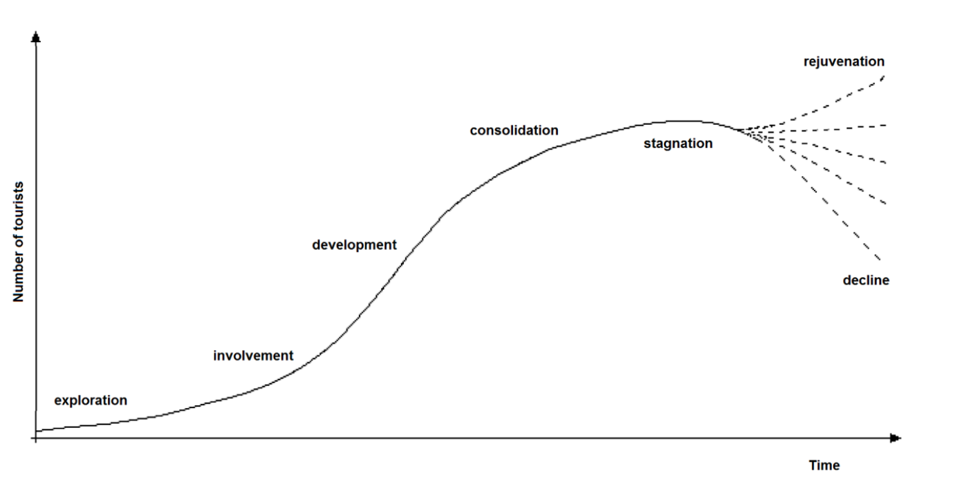
Figure 1: Butler’s life cycle model, Source: (Butler, 2018)
Discovery
Dubai wasn’t a major city until 1996 when major oil mines were located in the outskirts of the city (Yas et al., 2020). The discovery of the oil wells led to the foundation of the city and contributed to its growing popularity. Before this, the Bani Yas community populated the area and it transformed into a popular destination with people using its ports to conduct commerce and trade by the sea. By the 20th century, the city inhabited almost 100,000 residents and it turned into a popular destination with 300 ports welcoming traders and tourists (Yas et al., 2020).

Involvement
In this stage, the destination gains attention from a wide range of tourists, including early adopters. The revenue earned from the tourism sector during the era of Sheikh Rashid helped to pave the way for development in Dubai. It led to the improvement of Dubai’s schools, roads, transportation and the build-up of other infrastructures. This helped to transform Dubai into a modern with various attractions such as Dubai Creek, traditional souks, and the establishment of Emirates Airlines. A major turning point in Dubai's participation phase, the construction of the Jebel Ali Free Zone in the 1980s attracted international investment and facilitated commerce (Yas et al., 2020).

Consolidation
In the consolidation stage, the destination is well-established, with a thriving tourism industry and a variety of attractions. This was achieved in the 2000s when Dubai established itself as a major tourist hub (Henderson, 2021). The construction of the Dubai Marina, the Dubai Miracle Garden, and the opening of the Dubai Opera are examples of Dubai's consolidation stage. Dubai transformed its focus from a luxury destination to focusing on family-friendly entertainment, theme parks, and cultural attractions.

Development
Because of its abundance of high-end shopping malls, five-star restaurants, and other attractions, Dubai has become known as a top-tier holiday resort. It is home to the Burj Khalifa, the world's tallest building at 830 metres. It also has some of the highest ratings for five-star hotels anywhere in the globe. Dubai is also seeing an increase in sports tourism as a result of the city's hosting of major sporting events like the Formula One and Indian Premier League. Tourists flock to the country because of its developed tourism infrastructure, including large hotels, international cooperation, beautiful resorts, and beach villas.

Stagnation
Many people worried about Dubai's future as the economy started to collapse in 2009. The downturn in Dubai's main markets had a devastating effect on the city. Dubai hotels had the greatest income per room of any city in the world. Occupancy dropped from 70% in May 2008 to 18% in June 2009 as the dollar lost value against the dirham and many stayed home out of fear for their employment (Hvidt, 2023). While not all hotels were affected, such as coastal hotels, which did well in contrast, a 36.5 percent loss in revenue per available room was the outcome of hotels lowering expenditures to cope with this slump. Shorter average stays and less spending were seen among tourists. During this time, the number of tourists visiting Dubai flatlined for the first time in a decade.

Rejuvenation
The period of decline which occurred in 2009 was quickly overcome by investing in technology, facilities, advertising and liberalising its legal policies. Dubai regained its position as the most popular tourist destination in the world. The 2020 pandemic has been a curse for the destination as it saw a record decline in tourist numbers to receiving only 5.51 million tourists (Maxim, 2022). However, this was also quickly overcome as the pandemic receded and the city received over ver 14.23 million tourists in 2022. The tourist forecasts look positive for the future and the Dubai government expects to receive a record 25 million tourists in the year 2025 (Alhosani and Zaidan, 2022).

Doxey’s Irridex model for Dubai
Doxey's Irridex model is a conceptual framework that attempts to explain the potential negative impacts of tourism on a destination and its residents (Hannam et al., 2014). The model explains the four different stages of irritation that residents of a tourist destination experience as it develops.
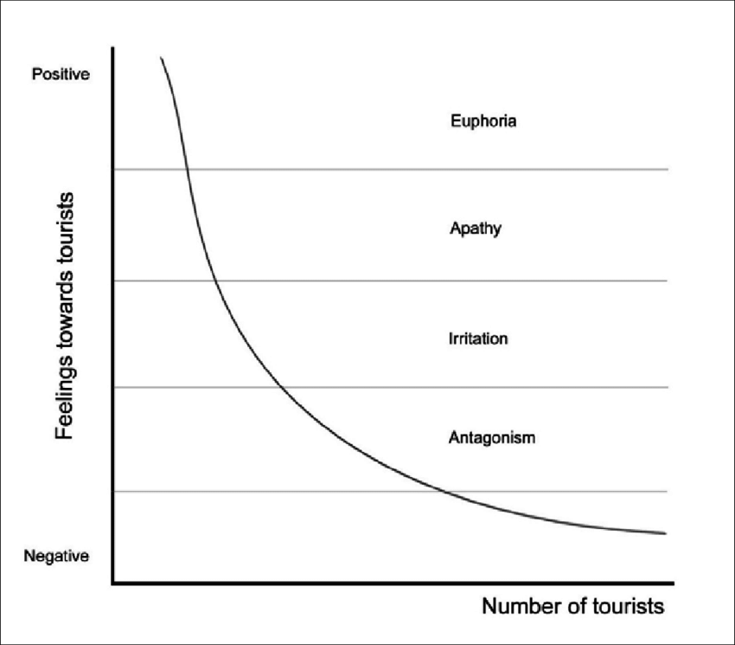
Figure 2: Doxey’s irridex model, Source: (Hannam et al., 2014)
Dubai has become a major tourist destination in the world since the 1990s with tourists flocking in high numbers from all parts of Asia, Europe and America. Initially, most of the tourists in the city were from neighbouring gulf countries which represented 55% of the total number of tourists visiting Dubai. However, as the popularity of the destination grew, tourists started coming from all around the world and it took over the original population of Dubai by number when it received over 3.13 million people (Alhosani and Zaidan, 2022). The residents of the city were happy as tourism revenue led to the development in building new schools, roads, infrastructure and increasing facilities for citizens. This turned into apathy when the number of tourists exceeded the original Dubai population by count. The government recognized that resident apathy was a major problem and began rewarding citizens with a portion of the revenue generated by tourists (Zaidan and Kovacs, 2021). This swayed them considerably and maintained the influx of tourists into the city. There were 14 million tourists in Dubai this year, or five times as many as the city's permanent residents. The population's current level of annoyance has been kept under control by the increase in infrastructure. The Dubai Urban Master Plan 2040 has been crafted to secure the city's long-term viability. This has prevented the population's displeasure from growing to the point of hostility as a result of the overabundance of tourists (Zaidan, 2018).

Recommendations
- The United Arab Emirates may do more to fight the negative effects of tourism by promoting responsible tourism rather than encouraging high-end urban travel, without giving up the economic benefits that tourism presents. The UAE is home to a variety of beautiful natural environments, including stunning beach landscapes and spectacular mountainous areas (Stephenson and Ali-Knight, 2020). Tourists can be encouraged to visit the Rub' al Khali and Liwa Oasis in Dubai to have a better understanding of the Emirati people and their culture. Spending the day shopping and skiing at the Dubai city mall has a considerably greater impact on the environment than spending the day exploring the vast expanse of natural sand dunes in Dubai or learning about the local culture.

- A greater focus on ecotourism and historical tourism might help spread out the current concentration of visitors in the city's coastal metropolises. Responsible travel may help mitigate some of the negative impacts that tourism has on Dubai's environment and society.

- The tourism sector is especially vulnerable to climate change impacts, and it also contributes to the release of greenhouse gases. To protect the tourism sector for the future, it is essential to hasten the pace at which greenhouse gas emissions are reduced. To lower its CO2 emissions and other pollutants, Dubai's municipal government must hasten the city's entire transition to renewable energy sources and increase its investment in green technologies.

Conclusion
The report has successfully evaluated the principles of sustainable tourism through a case study of a globally popular tourist destination Dubai. The tourism development of Dubai and its life cycle stage has been evaluated through two strategic models which are the Butler’s life cycle model and Doxey's Irridex model. Dubai is at its growth stage as the number of tourists is increasing and it is important to follow sustainable tourism practices to ensure the long-term viability of the destination. The report has also successfully made some recommendations for future tourism development in Dubai.

References
ALHOSANI, N. and ZAIDAN, E. 2022. Shopping tourism and destination development: Dubai as a case study. The Arab World Geographer, 17, pp.66-81.
BUTLER, R. W. 2018. Sustainable tourism: A state‐of‐the‐art review. Tourism geographies, 1, pp.7-25.
FARZANEGAN, M. R., GHOLIPOUR, H. F., FEIZI, M., NUNKOO, R. and ANDARGOLI, A. E. 2021. International tourism and outbreak of coronavirus (COVID-19): A cross-country analysis. Journal of Travel Research, 60, pp.687-692.
GEORGE, R. 2021. Tourism and Hospitality Marketing Principles. Marketing Tourism and Hospitality. Springer.
HANNAM, K., BUTLER, G. and PARIS, C. M. 2014. Developments and key issues in tourism mobilities. Annals of tourism research, 44, pp.171-185.
HARRIS, R., WILLIAMS, P. and GRIFFIN, T. 2012. Sustainable tourism, Routledge.
HENDERSON, J. C. 2021. Destination development: Dubai. Journal of travel & tourism marketing, 20, pp.33-45.
HENDERSON, J. C. 2023. Global Gulf cities and tourism: A review of Abu Dhabi, Doha and Dubai. Tourism Recreation Research, 39, pp.107-114.
HVIDT, M. 2023. The Dubai model: An outline of key development-process elements in Dubai. International Journal of Middle East Studies, 41, pp.397-418.
LIU, Z. 2019. Sustainable tourism development: A critique. Journal of sustainable tourism, 11, pp.459-475.
MAXIM, C. 2022. Challenges of world tourism cities: London, Singapore and Dubai.
RITCHIE, J. B. and CROUCH, G. I. 2021. The competitive destination: A sustainable tourism perspective, Cabi.
STEPHENSON, M. L. and ALI-KNIGHT, J. 2020. Dubai's tourism industry and its societal impact: social implications and sustainable challenges. Journal of Tourism and Cultural Change, 8, pp.278-292.
U.ae. 2023. UAE Tourism Strategy 2031. [Online]. Available: https://u.ae/en/about-the-uae/strategies-initiatives-and-awards/strategies-plans-and-visions/tourism/uae-tourism-strategy-2031#:~:text=The%20UAE%20Tourism%20Strategy%202031,increase%20of%20AED%2027%20billion [Accessed 8 June 2023].
YAS, H., MARDANI, A., ALBAYATI, Y. K., LOOTAH, S. E. and STREIMIKIENE, D. 2020. The Positive Role of the Tourism Industry for Dubai City in the United Arab Emirates. Contemporary Economics, 14, pp.601-617.
ZAIDAN, E. 2018. The impact of cultural distance on local residents perception of tourism development: The case of Dubai in UAE. Tourism: An International Interdisciplinary Journal, 64, pp.109-126.
ZAIDAN, E. and KOVACS, J. F. 2021. Resident attitudes towards tourists and tourism growth: A case study from the Middle East, Dubai in United Arab Emirates. European Journal of Sustainable Development, 6, pp.291-291.

