University of Wales Trinity Saint David
School of Engineering
Aerodynamic Vehicle Testing & Analysis



Krishna Katwa
P150652
05/01/2019
Motorsport Engineering (M6X00415)
Contents
1 Introduction 1
1.1 Aims 1
1.2 Objectives 1
2 Background Research 2
2.1 Simulators 2
2.2 Track Testing 2
2.3 Centre of Pressure 2
2.4 Rake 4
2.5 Straight Line Testing 4
3 Methodology 5
3.1 Test Plan 5
3.2 Track Testing 5
3.2.1 Track Selection 6
3.2.2 Calculating Front & Rear Downforce from Track Data 7
3.3 Skid-Pan Testing 9
3.3.1 Calculating Downforce and Drag From Coast Down Test 9
3.3.2 Steady State Cornering 12
4 Results 13
4.1 Coast Down 13
4.1.1 Efficiency 15
4.1.2 Change of Lift and Drag During A Lap 16
4.1.3 Speed X-Y Plots 19
4.2 Axle Loads 21
4.2.1 Centre of Pressure (CoP) 21
4.3 Ride Height & Rake Angle 23
4.4 Driver Feedback 25
5 Conclusion 27
6 Recommended Further Work 28
7 References 29
8 Appendix 31

Figure 1-1 - Dallara GP2 Car. (Web Car Story, 2012) 1
Figure 2-1 - Centre of Pressure. (Glenn Research Centre , 2015) 3
Figure 2-2 - Aero Balance. (Formula 1 Dictionary, n.d.) 3
Figure 2-3 - Rake Examples. (Piola, 2017) 4
Figure 3-1 - Pembrey Track Map. (Independent, 2018) 6
Figure 3-2 - Snetterton Track Map. (BTCC, 2018) 6
Figure 3-3 - Static Loads 7
Figure 3-4 - Weight Transfer Channel 8
Figure 3-5 - Static Load Capture Point 9
Figure 3-6 - Static Loads 9
Figure 3-7 - Coast Down Velocity Graph 10
Figure 3-8 - Rolling Resistance 10
Figure 3-9 - Total Resistance 11
Figure 3-10 – Drag Values 11
Figure 3-11 - Drag Coefficient Values 12
Figure 3-12 - Coast Down & Steady State Tests 12
Figure 4-1 - Coast Down Results 13
Figure 4-2 - Lift & Drag Lap Traces 16
Figure 4-3 - Track Map, End of Straight 16
Figure 4-4 - Aero Load Comparison 17
Figure 4-5 - Track Map, Turn 1 17
Figure 4-6 - Downforce & Drag Lap Comparison 18
Figure 4-7 - Lift vs Speed Plot 19
Figure 4-8 - Lateral G vs Speed Plot 20
Figure 4-9 - Track Map, Turn 2 20
Figure 4-10 - Axle Loads 21
Figure 4-11 - Centre of Pressure Comparison 21
Figure 4-12 - Suspension Setups 23
Figure 4-13 - Rake Angle Comparison 23
Figure 4-14 - Lift Comparison 24
Figure 4-15 - Track Map, Turn 11 24
Figure 4-16 - Understeer Comparison 24
Figure 8-1 - Equations & Constants Used 31

Equation 1 - Aero Load Equation. (Tudor, 2018) 7
Equation 2 - Weight Transfer Equation 7
Equation 3 - Coast Down Lift Equation 9
Equation 4 - Cd Equation. (Glenn Research Centre NASA, 2015) 11

Graph 1 - Cd & Cl vs Wing Setup 13
Graph 2 - Drag & Downforce Produced 14
Graph 3 - Efficiency 15

Table 1 - Test Configurations 5

Introduction

Aims
The aim of this report is to cover the analysis of the results of simulator testing in order to characterise the aerodynamic and handling performance of a GP2 car. The simulator that UWTSD possesses was used for the testing, it is a Base Performance GT Simulator, using a Dallara GP2 car with the following specification taken from the simulator programme;
- Engine – 4.0L V8
- Power – 612 HP
- Weight – 780.63 (Inc full tank of fuel)

Objectives
In order to fully analyse the performance of the car, the following objectives will need to be met;
- All testing needs to be conducted within 2 hours
- Coefficients of drag (Cd) and lift (Cl) will need to be calculated for different aero configurations
- Produce x-y plots to show differences in aero setups
- Calculate axle aero loads and centre of pressure
- Examine suspension changes and their influence on performance, making particular note of driver feedback
In order to analyse the data, Motec data analysis software will be used. This will allow the outputted data from the sim to be read and worked with. Motec software is used heavily within the motorsport industry so is the preferred choice for this report.
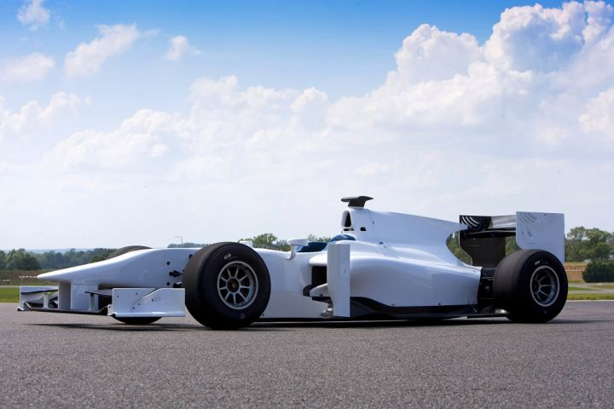
Figure 1-1 - Dallara GP2 Car. (Web Car Story, 2012)

Background Research

Simulators
In racing, time saving is important be it out on track or in the design offices, a professional driving simulator can be used to reduce the traditional lengthy process that precedes a new cars introduction. A simulator can allow the race drivers to carry out testing working with handling, aero, structural and engine engineers long before the real car has even started to be manufactured. This can lead to feedback that can improve upon the base car in a much shorter time than has been possible before. (Toso & Moroni, 2014)
It is also important to note the distinction between a commercial simulator, which is mainly used as a training tool for new tracks and young drivers and a professional simulator that support the engineering teams’ decisions early into the design of a new race car. (Toso & Moroni, 2014)
However, despite the benefits that a simulator can bring, there can be a slight disconnect between the real-world track and the simulated track a driver will see before them. A driver can be great in real life but not as great in the simulator and the opposite can also be true. This could be down to the fact that there is no danger in a simulator if your go off track and crash, therefore you can be relaxed when pushing the car to its limits. (Kilbey, 2016)

Track Testing
In Tune To Win, (Smith, 1978), it is noted that the conservation of track time is one of the most important aspects of going racing. Smith even goes as far as to state that ‘the operation that goes to the test track without a plan… …will accomplish nothing worthwhile.’ Therefore, it is of upmost importance to ensure that whenever a test session is carried out, there is a thorough plan in place. Smith goes on to say that any changes that are made should be carried out in a logical manner so as to not waste valuable time.

Centre of Pressure
Pressure around an object will often vary, and this is caused by the velocity of the fluid varying around the surface of the object. With the aerodynamic force on the object known, it is assumed that this single force acts through the average location of the pressure on the surface of the object. This is what is known as the centre of pressure. (Glenn Research Centre , 2015)
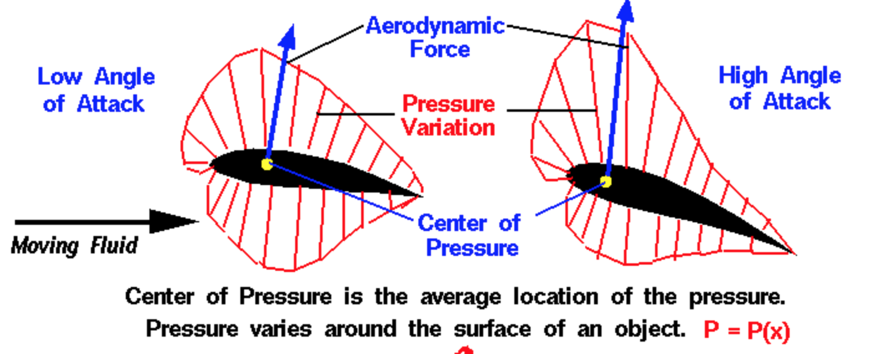
Figure 2-1 - Centre of Pressure. (Glenn Research Centre , 2015)
This is important to understand as it can influence the cars behaviour when on track. The position of the centre of pressure allows the engineer to understand which axle will have the greater aerodynamic loads placed upon it. This then leads to a related term known as aero balance. Aero balance can be explained as the portion of downforce acting on the front wheels with respect to the overall downforce acting on the car. Aero balance is usually denoted with a % and tells the engineer which axle should have the most grip as speed and therefore aero load increases. (Quintarelli, 2018)
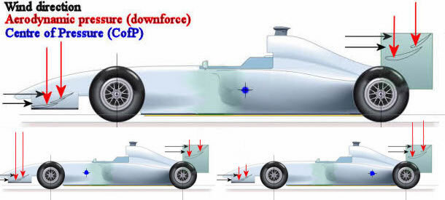
Figure 2-2 - Aero Balance. (Formula 1 Dictionary, n.d.)

Rake
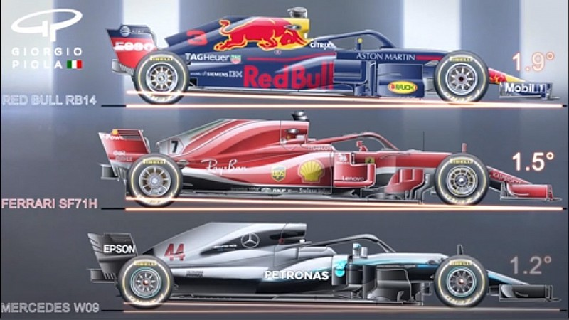
This term is used to describe the difference between the front and rear ride heights. Usually the rear of the car is raised higher than the front leading to an up-ward slope front to rear. The benefit of rake is that the aerodynamics generate more downforce without a big drag penalty, on a formula car, the front wing will be closer to the ground and therefore be operating closer to ground effect. This also has the benefit of increasing the diffuser angle, however if the rake angle is too high then it becomes harder to seal the edge and the floor of the car leading to air spilling in around the sides of the diffuser and preventing it from performing at its optimum. (Mclaren, n.d.)
Figure 2-3 - Rake Examples. (Piola, 2017)

Straight Line Testing
In order to measure vehicle drag, there are two established tests that can be performed, these are a coast down test and a steady state test. This measures the total vehicle drag which includes the sum of aero drag along with rolling resistances and mechanical losses. These two techniques have been researched and it was found by (Passmore & Jenkins, 1988) that the coast down method was the method of choice due to it’s repeatability. (Le Good, et al., 1995)
Therefore for this analysis, the coast down test is the preferred data collection method to enable the calculation of the vehicle drag.

Methodology

Test Plan
As the key to characterising the performance of the GP2 car is the quality of the data obtained, a sufficient and in-depth test plan is needed. The test plan needs to be thorough enough to cover all areas of interest whilst also allowing the tests to be carried out within the allocated 2-hour simulator time.
Each of the tests would test aerodynamic or suspension changes. One of the advantages of simulator testing over real world testing is the ability to carry out more tests in the same amount of time as setup changes just need a few clicks in the simulator program rather than the need of a full race team at circuit to carry out testing and changes on the car.
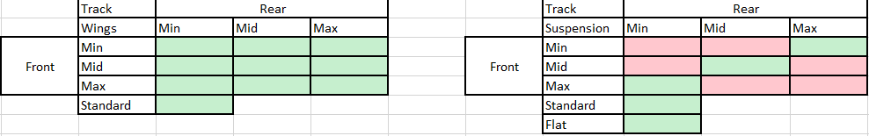
To this end, a number of different aerodynamic and suspension configurations would be tested on track, they were arranged in a grid like pattern so that each test could be marked off once carried out and allowed for 15 potential tests and are detailed below;
Table 1 - Test Configurations
The tests carried out are highlighted in green. It was agreed in the working group that came up with the test plan that these were the ideal tests that would help capture the required data.
The aerodynamic configurations were also tested on a skid-pan, using a coast down test to allow the coefficients of cd and cl to be calculated for different aerodynamic configurations. This is explored more in section 3.3.

Track Testing
For the tests, each configuration would be applied to the car and then ran on track, the track time would consist of 3 laps, and this would allow enough time for each configuration to be tested. The out-lap would be used to heat the tyres and allow the driver to become familiar with the setup of the car. Outright lap times although useful to show how well the car was performing with a given setup were not the goal of the testing, consistent clean laps were of greater interest as they would provide clean and comparative data. When carrying out track testing, it is recommended to advise the driver of any extreme setup changes before they take to the track, such as going from a high downforce setup to a low downforce setup. This is so that the driver knows what to expect and doesn’t get caught out by the setup change. This advice was followed during the simulator session, although the driver was not informed of the nature of the change so that the driving style did not change. At the start of each session the driver was asked to leave the pit box then stop in the pit lane to allow the static car loads to be recorded by the data acquisition system.

Track Selection
A number of tracks were considered for the location of the test. These included Silverstone, Brands Hatch, Oulton Park, Pembrey, Snetterton and Donnington Park.
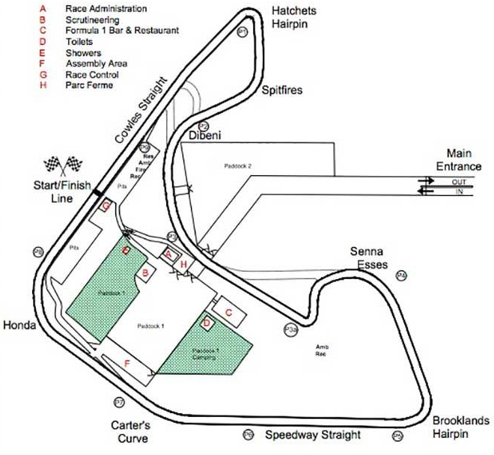
As time was limited, Silverstone was dismissed as the long lap, over 3.6miles, would eat into the number of configurations that could be run. Oulton and Donnington Park were not chosen due to their undulating nature as only ride height was being tested not settings such as bump and rebound. Brands Hatch wasn’t chosen as compared to Snetterton and Pembrey, the drivers experience was not as great meaning more laps would be need for familiarisation of the circuit. This left a choice of Pembrey or Snetterton, it was decided that although both have merits, Snetterton would be the track of choice for the testing, this is because despite the longer lap, 3miles vs 1.46miles, Snetterton was felt to offer more varied corners with regards to speed and it was thought would better show up differences between the tested configurations. A track layout of both Pembrey and Snetterton can be seen below.
Figure 3-1 - Pembrey Track Map. (Independent, 2018)

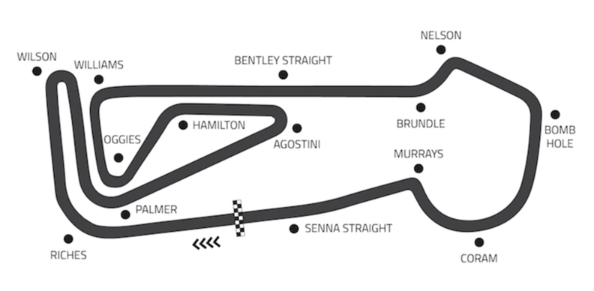
Figure 3-2 - Snetterton Track Map. (BTCC, 2018)

Once the track had been decided on, the driver was given 8 laps, 7 plus an out-lap to get used to the car and the track before any setup changes were made. A brake balance change was made to make the car more stable on the brakes before the start of the testing, this would allow a baseline time for comparative purposes and allow the drive to feel confident and comfortable before the start of the test. Driver feedback was collected in-between sessions and comments made whilst driving were also noted during the test.

Calculating Front & Rear Downforce from Track Data
The downforce would need to be calculated from the track data to give an indication of the aerodynamic load on each axle and how the changes to the wings would affect this. The aerodynamic centre of pressure could also then be calculated to show how this is influenced by the wing configuration.
In order to calculate the downforce on each axle, the following equations were used;
Equation 1 - Aero Load Equation. (Tudor, 2018)

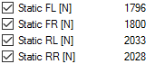
The tyre loads were taken from the data and to obtain a value for the static loads, the driver was asked to stop at the end of the pit lane for 2-3 seconds to allow the car to settle and for the static loads to be recorded in the data. These loads were then added as constants as the wing angle change would not alter the static load each tyre had and can be seen below.
Figure 3-3 - Static Loads

Longitudinal weight transfer was taken into account as during the lap when the car would be accelerating or decelerating there would be a weight transfer taking place. The sensitivity to pitch as a result of the aero load could only be seen once the effects of weight transfer had been taken into account, this aerodynamic sensitivity would only become apparent when looking at the centre of pressure of the car for different aerodynamic configurations.

Weight Transfer Calculation
The formula for weight transfer is as follows;
Equation 2 - Weight Transfer Equation

Where:
- G = Gravity = 9.81m/s²
- CoG = Centre of Gravity Height = 0.22m
- Wheelbase = 3.1m
- G Force Longitudinal is a live value from track data
- Sprung Mass = 663.53
The weight transfer was plotted on as a separate data trace and an example of this can be seen below;
Figure 3-4 - Weight Transfer Channel
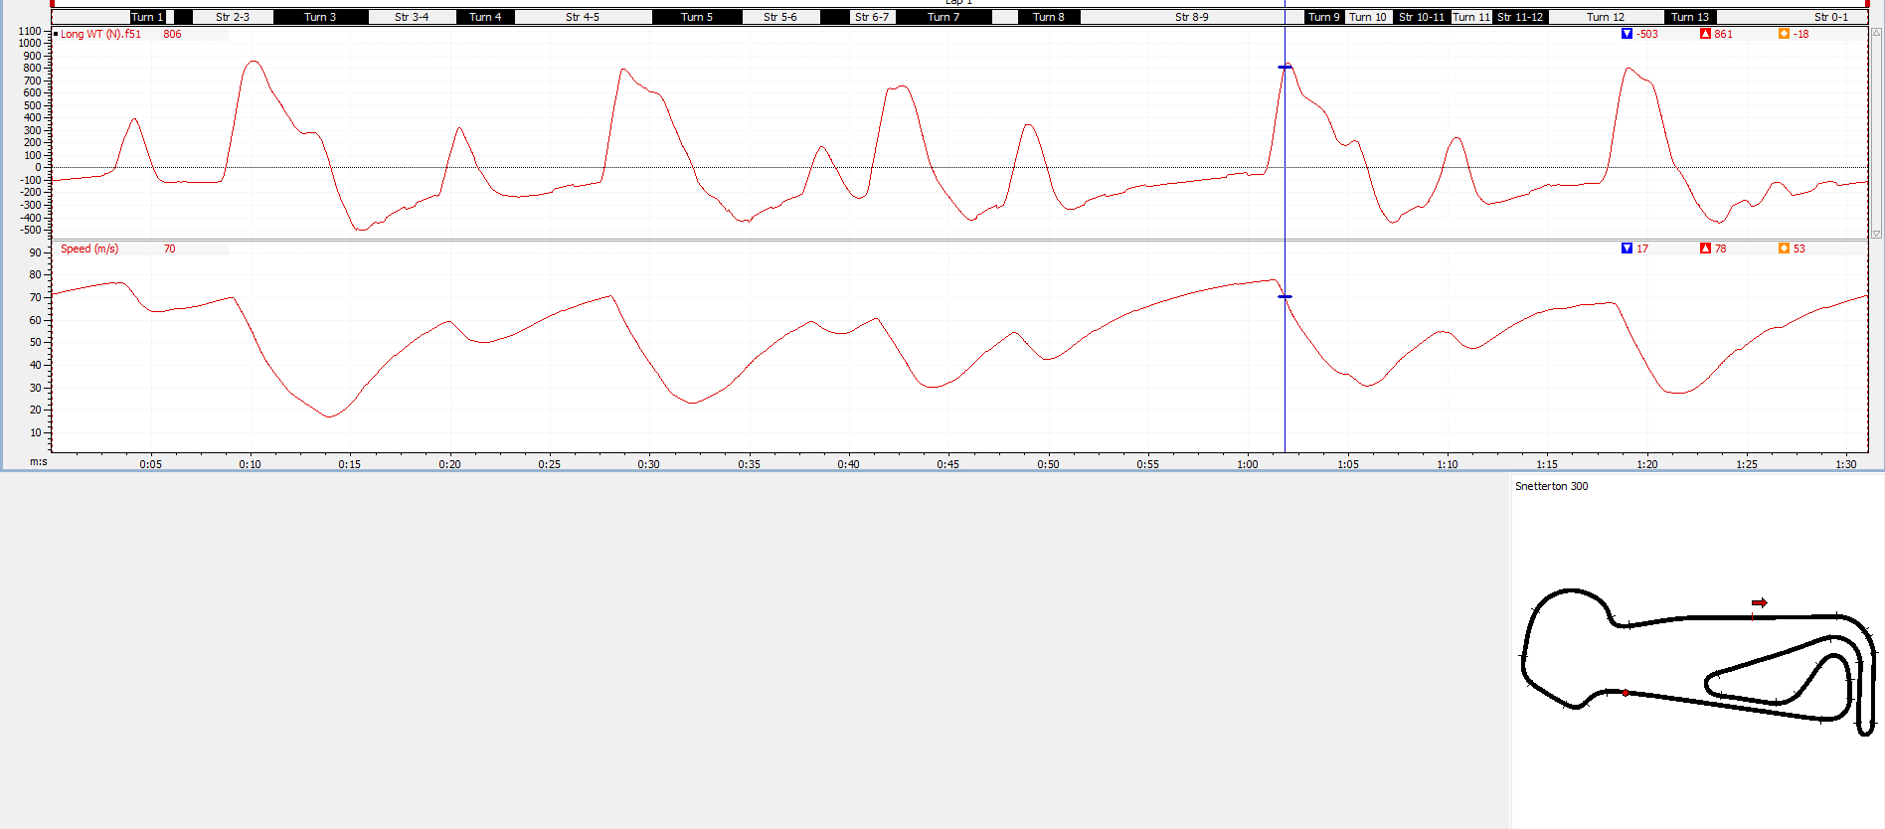

Skid-Pan Testing
Skid-pan testing is useful as the pan is marked out with makers for straight line testing and for constant radius cornering. This would allow testing that would provide data to allow the calculation of cd and cl which is one of the objectives for characterising the performance of the GP2 car. The test method chosen was the coast-down test. This is a test where the vehicle is taken up-to a chosen speed, and then held at that speed for a few seconds before engaging neutral and allowing the car to come to a complete stop or a pre-determined slow speed. This was carried out 9 times, once for each aerodynamic configuration.

Calculating Downforce and Drag From Coast Down Test
The downforce was calculated in Motec by simply adding the tyre loads together for each axle while the car was traveling at the steady state speed of 57m/s which was the top of 3rd gear. However this is not a true reflection of the downforce acting on the car as it includes the static loads acting on the car, therefore these were subtracted from the tyre loads. The maths channel used can be seen below along with the static loads and the period during which they were taken when the car was stationary;
Equation 3 - Coast Down Lift Equation

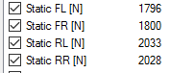

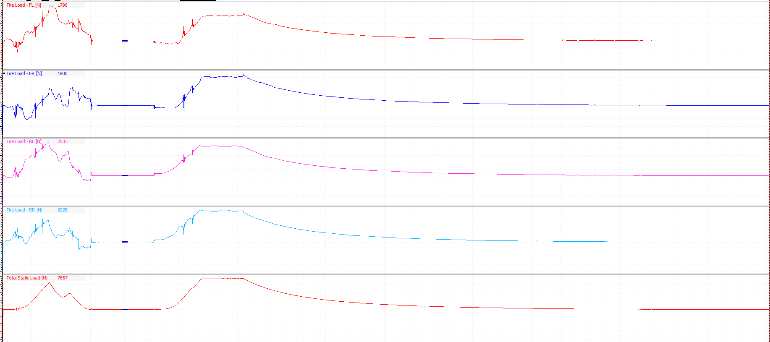
Figure 3-5 - Static Load Capture Point
Figure 3-6 - Static Loads

It is assumed that the static loads are constant as the mass of the car did not change between tests.
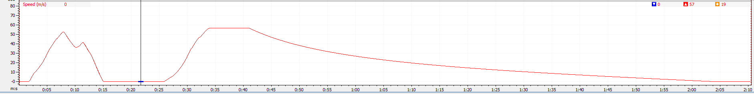
The drag was calculated in excel using data from the coast down velocity graph, an example of which can be seen below;
Figure 3-7 - Coast Down Velocity Graph
As drag is a resistance, the total resistance can be split into aerodynamic resistance (drag) and mechanical resistance from the drivetrain and wheels. First, the mechanical drag was calculated, this was done by calculating the acceleration at low speed. This is because it can be assumed that aerodynamic forces are negligible below speeds of 40km/h. (OptimumG, 2018) or 11m/s.
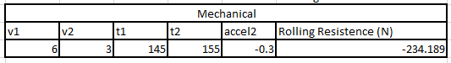
This can be seen below;
Figure 3-8 - Rolling Resistance

The first velocity was picked at random, then the second velocity was taken after 10seconds, as this would allow a wide enough time period for the car to decelerate. From this the acceleration was calculated. As the mechanical resistance or rolling resistance is a force, it could be calculated by simply using F=ma. Given the mass of the car is 780.63kg and the acceleration was -0.3m/s/s, the rolling resistance was -234.189N. the mechanical resistance can be assumed to be the same for each configuration tested as only the angle of the wing was being changed so that would be expected to have no mechanical impact.
Next the Total resistance was calculated. The same method was used to calculate the resistance except that the initial velocity selected was higher. Looking at the data it was decided to calculate the acceleration just after neutral had been engaged as this is where the drag and therefore deceleration would be greatest. A time period of 3 seconds was chosen. As the wing angle would affect the drag, the total resistance for each aerodynamic configuration was calculated. This is displayed below;
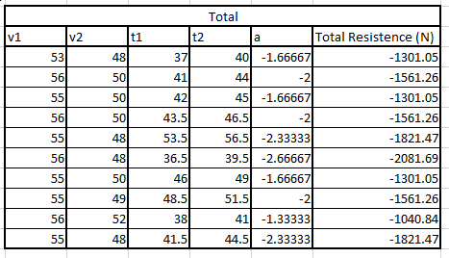

Figure 3-9 - Total Resistance
The aerodynamic drag force could then be simply calculated by subtracting the rolling resistance from the total resistance. This is shown below;
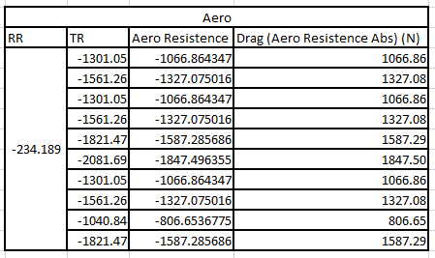

Figure 3-10 – Drag Values
In order to convert the drag force into the drag coefficient, Cd, the following equation was used:
Equation 4 - Cd Equation. (Glenn Research Centre NASA, 2015)
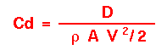

Where:
- D = Drag Force
- Ρ = Density
- A = Frontal Area
- V = Velocity
Average velocity was used as the car was decelerating, the velocity’s used were the same used for the total resistance calculation. The table can be seen below showing the drag coefficient.
The lift coefficient, Cl was calculated in the same manner with the exception of drag force being lift force.
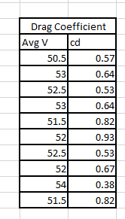

Figure 3-11 - Drag Coefficient Values

Steady State Cornering
The constant radius corners allow the measurement of slip during steady state cornering. This test is carried out at a low speed, where the car will not be under or oversteering and means the data captured can be used to help create channels in the data analysis software that show how the car behaves at speed when on track. From the steady state cornering data, theoretical steer and under/oversteer channels can be calculated and used to describe the handling balance of the car. The equations of these can be found in the appendix.
The table of tests that were to be carried out can be seen below;
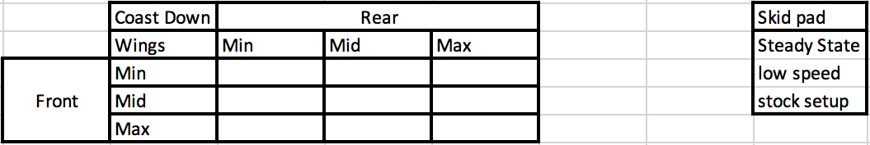
Figure 3-12 - Coast Down & Steady State Tests

Results

Coast Down
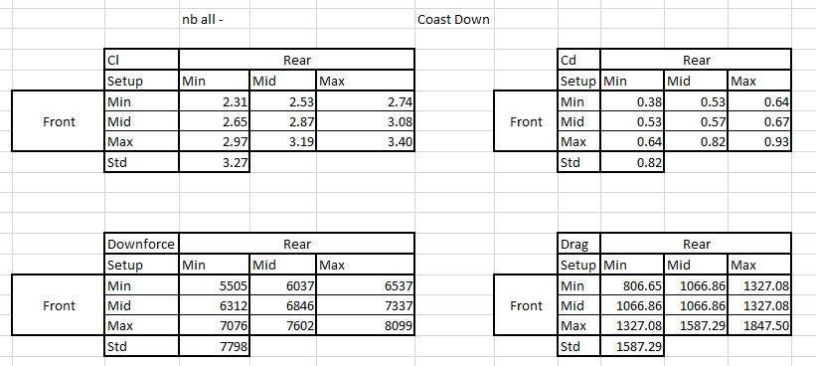
The results of the coast down test can be seen below, drag force and downforce along with the coefficients, were calculated and tabulated.
Figure 4-1 - Coast Down Results
In order to provide a meaningful comparison, the standard wing setup used by the sim model was included. The cl and downforce values are negative as the car produces downforce. Graphs were produced to better display the results of the testing. These can be seen below;
Graph 1 - Cd & Cl vs Wing Setup

Graph 2 - Drag & Downforce ProducedGraph 1 - Cd & Cl vs Wing Setup

As to be expected, the cd is greatest when the cl is greatest, the range of cd is from 0.93 when the wings are at the highest angle and 0.38 at the lowest setting. The cl values at the corresponding wing settings are -3.40 and -2.31 respectively.
Compared to the standard sim model results of 0.82 cd and -3.27 cl it can be assumed that the standard car model runs with a high amount of downforce. This was proven true by looking in the setup of the car. It was found the wings could be adjusted within a range of 1-40. 1 being a low wing angle and 40 being a high angle. The standard setup for the GP2 car was both wings at 35.
Graph 2 - Drag & Downforce Produced

Graph 3 - EfficiencyGraph 2 - Drag & Downforce Produced
The above graph shows the values in Newtons for drag and downforce. It can be seen that for both forces there is a general downward trend from max wing angle to minimum wing angle. From the data it can be calculated that the front wing has a bigger influence on the downforce produced by roughly 500N. The change in downforce from the rear wing angle with a constant front wing angle is 1023N whereas the change in downforce from the front wing with a constant rear wing angle is 1562N. This could be down to the front wing being in ground effect thus producing more downforce or could be down to the rear wing design not needing to produce as much downforce because the rear of the car would also have a diffuser. However the effect on of the rear wing angle on drag is clear to see, with a difference of roughly 520N.

Efficiency
Aerodynamic efficiency can be simply described, it is the ratio of lift to drag. The goals is to have an efficient design. This is where the drag is kept to a minimum for a given amount of lift. (Katz, 2006). The efficiency of the GP2 car design at different wing configurations can be seen below;

Graph 3 - Efficiency

From the graph, it can be seen that the aerodynamic efficiency increases from max wing angle where the lift and drag are greatest to minimum wing angle where the drag produced is at its least.

Change of Lift and Drag During A Lap
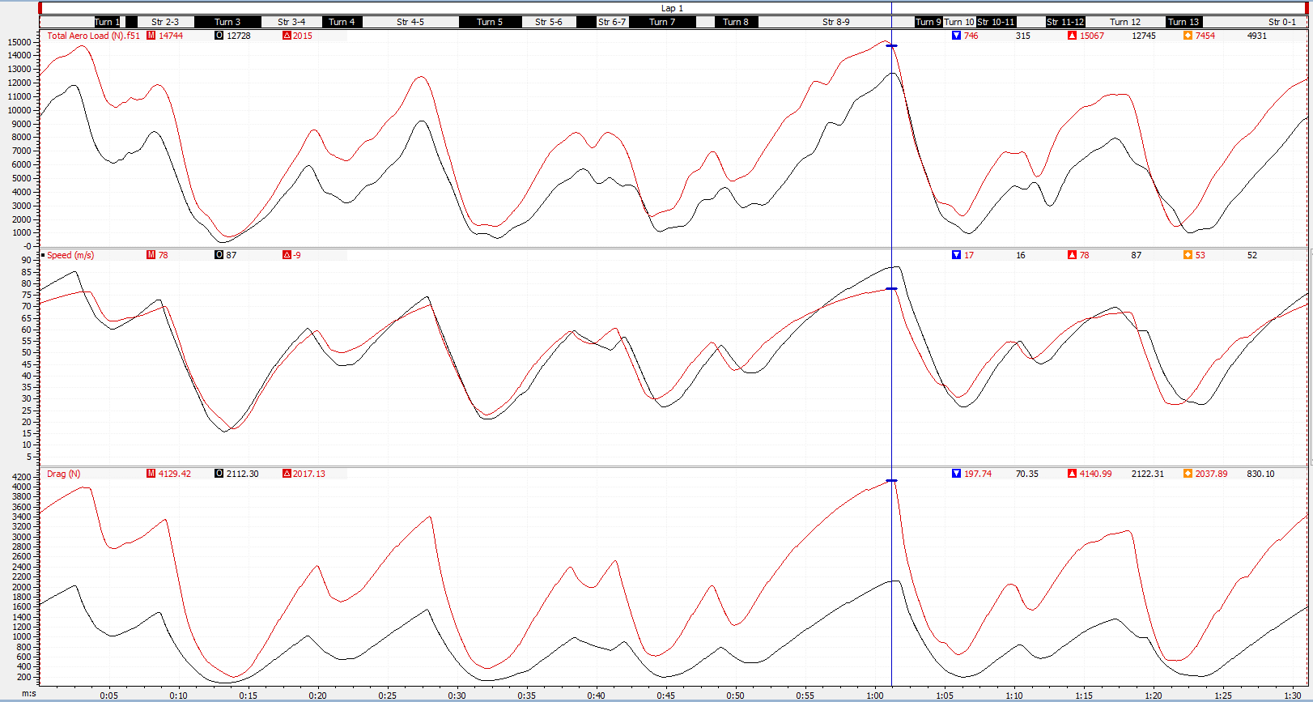
In order to show the difference that the downforce and drag levels make to the car, the data traces from the fastest lap of both minimum wing angles and maximum wing angles were plotted against each other in Motec. This can be seen below;
Figure 4-2 - Lift & Drag Lap Traces
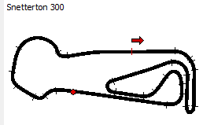

Figure 4-3 - Track Map, End of Straight

The red data trace is the max wings lap and the black data trace the minimum wings lap. Although not being used as definitive criteria as to the cars performance it is noted that the lap time of the minimum wings lap is 9 tenths slower, (0.9s). From the data above it can be seen how the lift (total aero load) and drag vary during the lap. Particular points of interest are towards the end on the back straight where it can be seen from the data that the minimum wing angle is only producing a peak of roughly 12,000N of downforce compared to the 15,000N of the max wing angle. The difference in drag force at the end of the straight is roughly 2000N, this difference is demonstrated nicely by the speed difference, with the minimum wing setup reaching 87m/s compared to 78m/s with maximum wing angle.
Whilst it can clearly be seen that the speed in general over the lap is similar, the average drag force produced over the lap for the minimum wing angle is 830N compared to 2037N when at max. The difference in average downforce during the lap is also substantial between the two setups, with the max setup producing 7454N and the minimum producing an average of 4931N.
This leads to more grip and quicker apex and corner exit speeds helping to negate the speed difference along the straights. This is most apparent through the sweeping right hander of turn one, (where the red dot is located), where despite the lower entry speed, the max wing angle setup carries a higher speed through the corner thanks to roughly 4000N more downforce at the apex of the corner.
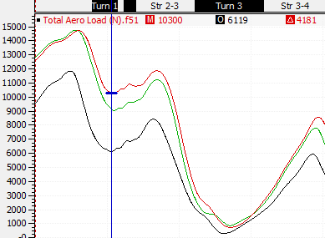

Figure 4-4 - Aero Load Comparison

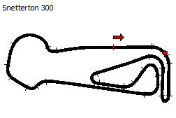

Figure 4-5 - Track Map, Turn 1

Figure 4-6 - Downforce & Drag Lap Comparison
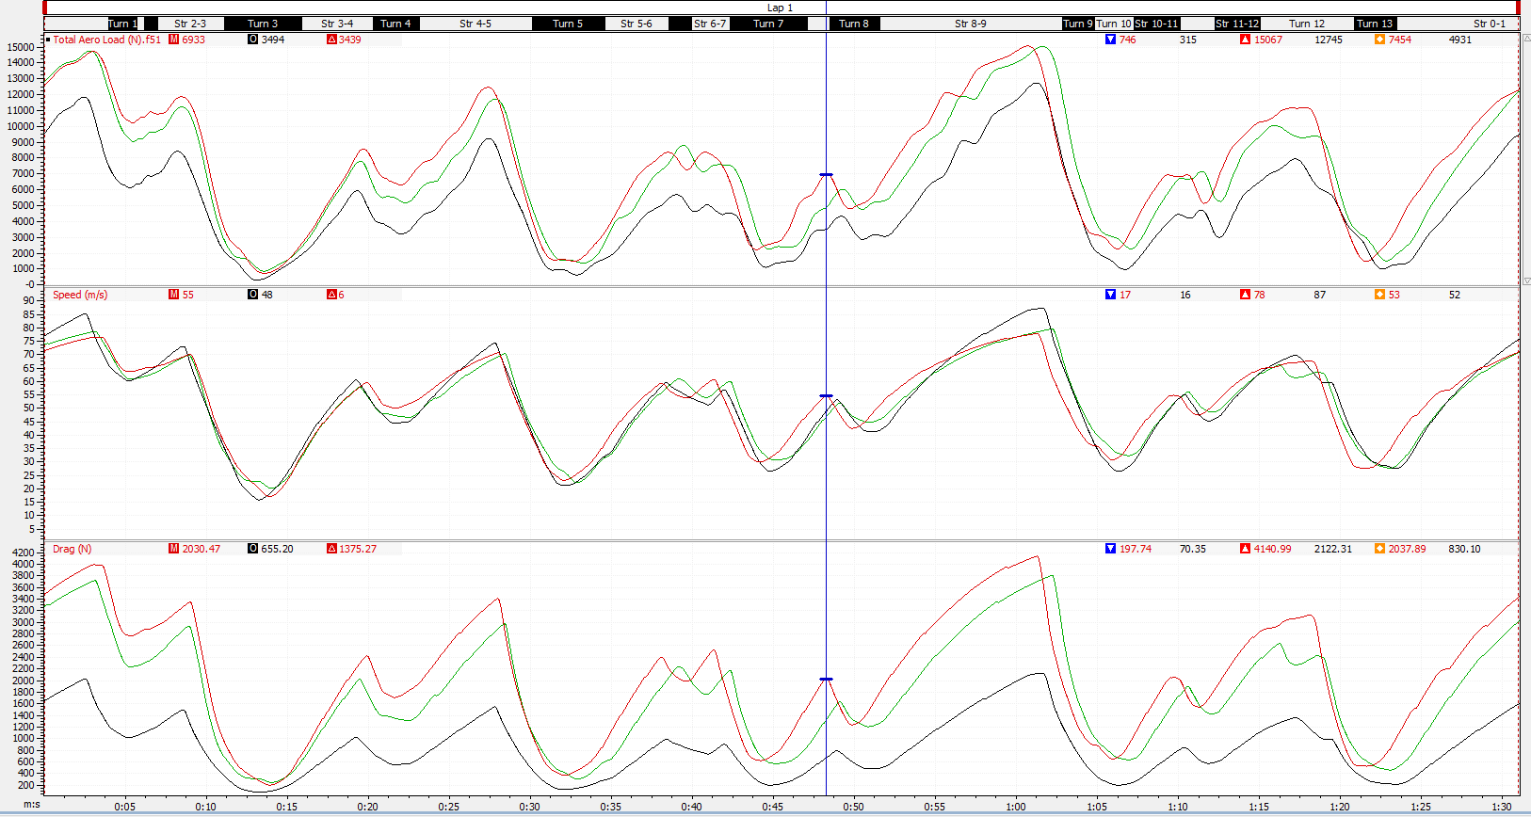
Above, another data trace of downforce and drag across a lap can be seen, the standard setup for the car (green trace) was compared to maximum (red) and minimum (black) wing setups. As expected after discovering it is close to the max wing setup, the standard setup is producing slightly less downforce and drag whilst on the back straight reaching a higher top speed.

Speed X-Y Plots
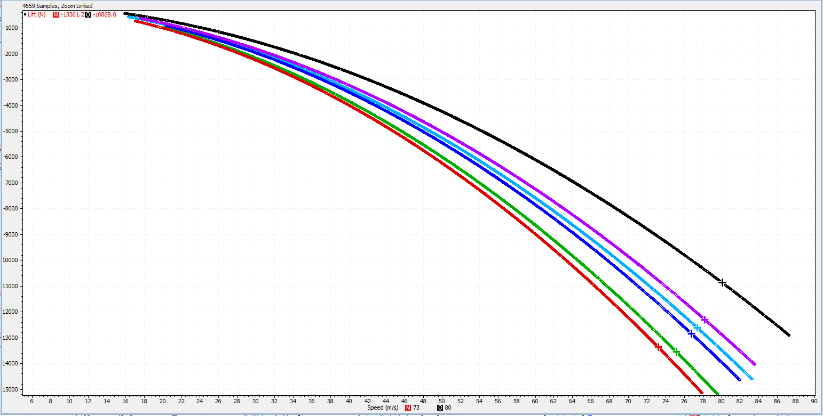
To demonstrate the difference between lift created by the different wing setups tested on track, a lift versus speed x-y plot was made. This shows that as the speed increases the lift produced also increases. The plot shows that there is a significant loss of downforce when using minimum wing angle and that a good range of configurations was tested. The lift is in negative values denoting that the car is producing downforce. Each of the 6 wing configurations tested have been plotted and can be seen below;
Figure 4-7 - Lift vs Speed Plot
The coloured lines each represent the following configuration in both the above and below plots:
- Red – Max wings
- Green – Standard Setup
- Dark Blue – Max Front Min Rear
- Light Blue – Mid
- Purple – Min Front Max Rear
- Black – Min

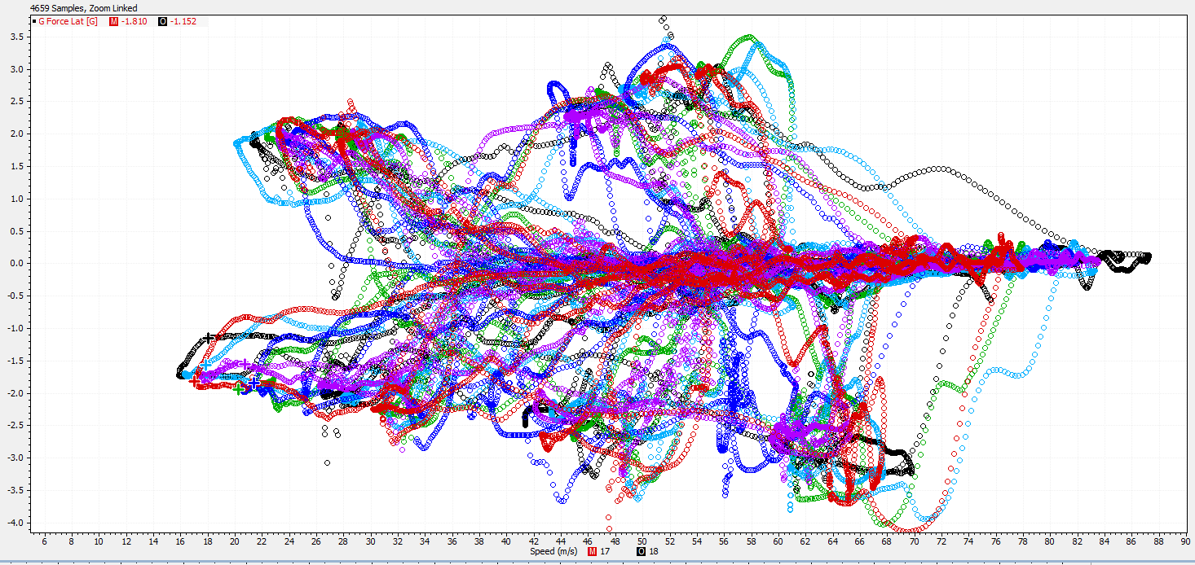
The below plot shows the change in lateral g force produced by the car during the lap, it can be seen that at high speeds there is higher values g values for each setup. The markers circled show the car going round the turn 2 hairpin, it can be seen that despite the lower speed, the max wing setup nearly produces the most g showing the grip available to the driver due to the higher downforce pushing down on the car increasing the contact patch of the tyre.
Figure 4-8 - Lateral G vs Speed Plot

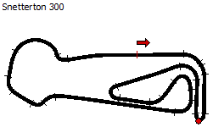

Figure 4-9 - Track Map, Turn 2

Axle Loads
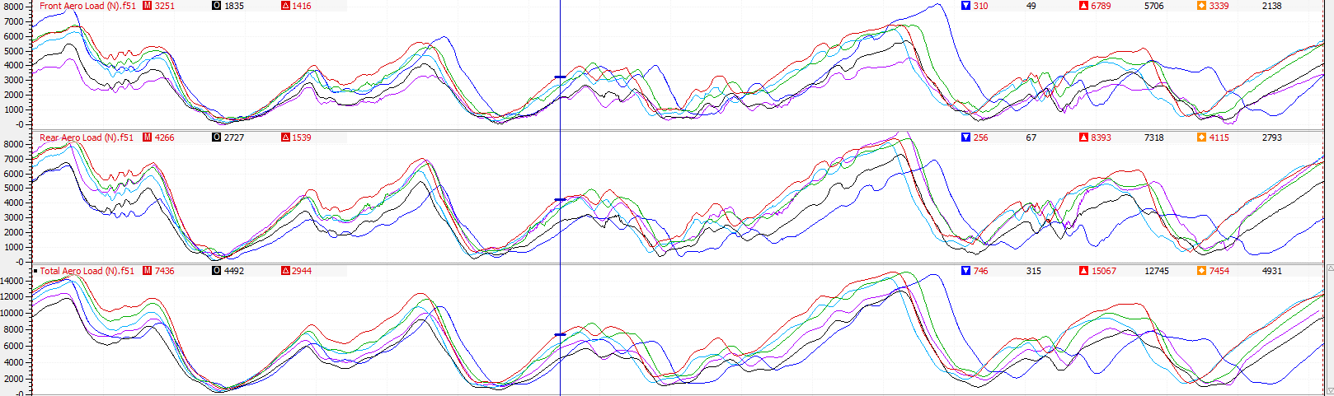
The downforce on each axle was calculated and plotted in Motec, the results of which can be seen below for each of the wing configurations tested. The front and rear loads were added together for the total load.
Figure 4-10 - Axle Loads
Each wing configuration is represented by the same colours as before. It is clear to see from the data that the downforce loads were highest with the max configuration, shown by the red trace. It is also interesting to note that when the rear wing is at its lowest setting, the rear aero load is at its lowest but as the front wing is at max the total aero load at the end of the start finish straight is still greater than the black, purple and light blue traces.

Centre of Pressure (CoP)
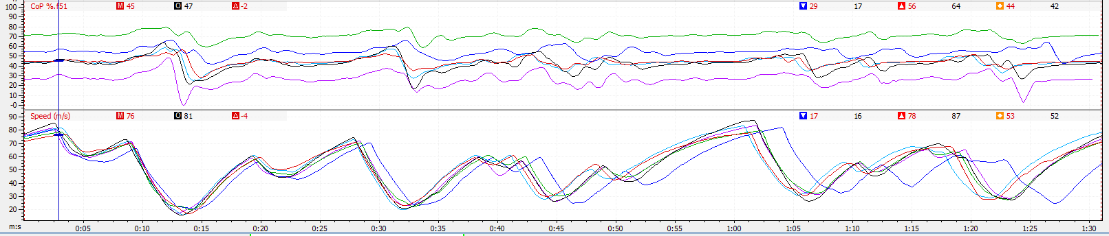
The centre of pressure was discussed in section 2.3 and this was plotted for the duration of a lap, each configuration can be compared and the differences between the configurations can be seen over a lap below;
Figure 4-11 - Centre of Pressure Comparison
Based on how the CoP was calculated, the lower the %, the closer the CoP is to the rear of the car. This is obvious when noticing the purple trace, (min front and max rear), throughout the lap it is the lowest value, meaning the CoP was heavily rear biased. In contrast to this, the standard setup, green trace, has a CoP towards the front of the car. When the front wing is at its highest and the rear wing is at its lowest, dark blue, the centre of pressure is generally towards the front of the car but not to the same extent as when the wings are at the opposite to this setup. The fact that when the wings are at max, min and mid, (red, black and light blue) respectively, the CoP is slightly towards the back of the car for each setup showing that the aero balance of the car is inherently slightly rear biased.

Ride Height & Rake Angle
The rake angle was calculated and plotted against the setup used along with the ride height. This is shown in the table below;
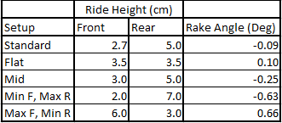

Figure 4-12 - Suspension Setups

It can be seen from the table, that running minimum front ride height and maximum rear gives the biggest rake angle -0.63 degrees. With that suspension setup switched front to back, the rake angle was 0.66 degrees. The minus sign denotes that the rear of the car is higher than the front, giving the ‘traditional’ rake angle appearance seen on race cars. When the number is positive the front of the car is higher than the rear leading to a ‘negative’ rake.
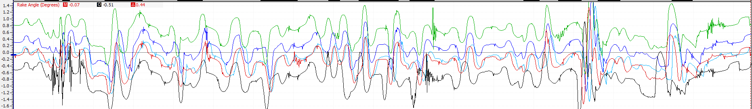
Comparing how the rake angle changes across a lap will provide an insight into how sensitive that configuration is to pitch changes. This can be seen below;
Figure 4-13 - Rake Angle Comparison
Each setup is represented by the following colours:
- Standard = Red
- Min Front, Max Rear = Black
- Max Front, Min Rear = Green
- Mid = Light Blue
- Flat = Dark Blue
It is clear to see from the data where the rake angle average is on each setup throughout the lap, the standard and mid setups, red and light blue respectively, are very similar throughout the lap, this is not surprising as there is only a 0.3mm difference in front ride height between the setups.
With the ride height set to flat, it is apparent that the front of the car rests slightly higher than the back, this leads to a setup that throughout the lap is constantly changing rake angle between the ‘negative’ and ‘traditional’ rake angle values.
With the suspension set to extremes, green and black traces, it can be seen that the rake angle for the majority of the lap stays either positive, green trace, or negative, black trace.
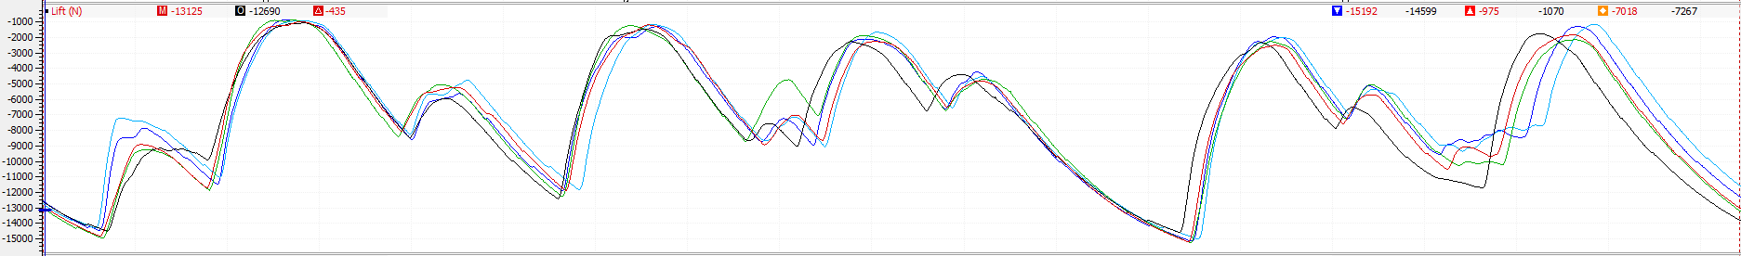
The lift produced from each suspension setup was compared between each setup, it was found that throughout the lap there was very little difference between each configuration. This can be seen in the figure below;
Figure 4-14 - Lift Comparison

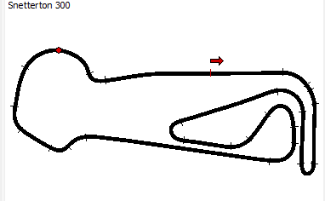
However, upon further examination, it was found that the setup with the biggest ‘traditional’ rake angle, did produce significantly more downforce round the long turn 11, circled. This could be a result of the rake angle not only allowing the front wing to work closer to ground effect but also increase the power of the diffuser due to the increased diffuser angle.

Figure 4-15 - Track Map, Turn 11
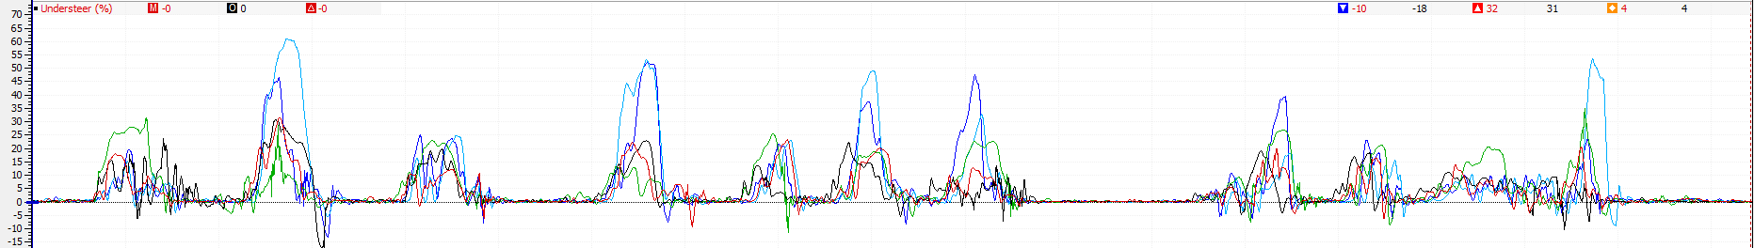
Another way of analysing the effect of ride height and rake angle changes is to look at the understeer of the car throughout a lap. This was plotted and is displayed below;
Figure 4-16 - Understeer Comparison
It can be seen that two traces in particular show the car experiencing more understeer, these are the light and dark blue traces which correspond to the mid ride height and flat ride heights respectively. With rake angles of -0.25 and 0.10. Under these suspension setups and therefore rake angles, the car understeers significantly more that with the other setups, this could be due to the fact the car is fairly flat so the front wing is not in ground effect and the floor of the car is fairly flat front to back meaning that the diffuser is not working as hard. This leads to less aerodynamic grip being available to the driver meaning that the mechanical grip of the car is exceed leading to understeer. It is no surprise to lean then that these two configurations produced the slowest lap times, 1:33.428 with the mid setup and a 1:32.707 with the flat setup. Compared to the quickest of 1:30.797 for the min front max rear ride height setup.

Driver Feedback
As data can only show the numeric behaviour of the car, it is important to ask the driver for feedback when testing setups. It can often be irrelevant if the data shows a certain setup is working better than a previous one if the driver does not like the way the car ‘feels’ with the new setup. This is because the driver will not have the confidence or trust in the car to push the car to its limits. Therefore it is important to setup a car with the drivers driving style in mind, it can lead to better outright lap time if the driver feels confident in the car rather than asking the driver to adapt to the car.
The driver’s feedback was collected after the sessions whilst the new setup was being loaded. This also had the benefit of distracting the driver of what setup changes were happening to avoid and preconceived ideas in the driver’s head of how the car would behave next time out on track.
The feedback of the driver was as follows:
Aerodynamic
Default aero: Understeering in slow corners, good grip in high speed corners
Max Wings: Similar balance to default aero setup, good traction, good high speed stability
Mid Wings: Tending to understeer more, worse braking stability
Min Wings: Understeer through medium to high speed corners, hard braking stability poor with locking fronts, good high end speed, no signs of oversteer
Max Front / Min Rear: Good turning, braking improved, very responsive, mid corner oversteer is severe especially through high speed corners, traction reasonably poor, hard to drive
Min Front / Max Rear: Initial turning poor, understeer throughout, low braking grip, traction really good

Ride Height Feedback
Min Front Ride Height / Max Rear: Lots of grip, good turning
Max Front / Min Rear: Less braking grip/stability, mid corner understeer through high speed corners, cornering not as good
Mid Suspension: Poor traction out of corners, Initial turn in good, Mid corner the rear steps out
Flat suspension: High speed good balance, Low speed understeer, Good initial bite

Conclusion
This report set out to accurately analyse and characterise the performance of a GP2 car. In order to this different aerodynamic and ride height configurations were tested. The data from these runs was collected and analysed in Motec data analysis software.
From the data and driver feedback it was clear to see the effect of wing changes on the car, the changes in lift and drag respectively between aerodynamic setups can be seen in the driver’s feedback and then backed up in the data when looked at.
The suspension ride height changes led to different rake angles. The difference in rake angle not only effects how the car feels to the driver but also the performance of the front wing and floor / diffuser of the car. This was most apparent when looking at how the car understeered more with little rake angles.
Overall, the data from the test sessions was fully analysed and this allowed insight into how wing angle and ride height would impact on car performance and how the driver responds to different setups.

Recommended Further Work
Further ride height testing could be carried out to fully exhaust the combinations possible. This could then also be combined with further aerodynamic work, the wing angles could be altered together with the ride height rather than using standard wings when changing ride height as has been the case with this testing.
Using the driver feedback alongside the data would lead to an ideal aerodynamic and ride height setup for the car and circuit based on the testing carried out. Of course there are then further setup parameters that would lead to more testing, such as spring rates and bump and rebound settings. Smaller tweaks could also be made to things like tyre pressures and brake balance and force. This would lead to a fully optimised car setup.
Lastly the influence of fuel could be taken into account for the setup, usually one would optimise the car for qualifying on low fuel and then high fuel for the race during testing. After testing a compromised setup based on expected weather conditions or championship position would be put on the car to maximise performance for both qualifying and race.

References
BTCC, 2018. Snetterton. [Online]
Available at: http://www.btcc.net/calendar/snetterton/
[Accessed 29 December 2018].
Formula 1 Dictionary, n.d. Aerodynamic balance or Centre of Pressure (CofP). [Online]
Available at: http://www.formula1-dictionary.net/aerodynamic_balance.html
[Accessed 28 December 2018].
Glenn Research Centre , 2015. Centre of Pressure. [Online]
Available at: https://www.grc.nasa.gov/www/k-12/airplane/cp.html
[Accessed 28 Dec 2018].
Glenn Research Centre NASA, 2015. The Drag Coefficient. [Online]
Available at: https://www.grc.nasa.gov/www/k-12/airplane/dragco.html
[Accessed 30 December 2018].
Independent, 2018. Rodren Vella racing at Pembrey Circuit in Wales with his Honda Civic. [Online]
Available at: http://www.independent.com.mt/articles/2018-07-01/f1/Rodren-Vella-racing-at-Pembrey-Circuit-in-Wales-with-his-Honda-Civic-6736192772
[Accessed 29 December 2018].
Katz, J., 2006. Aeroydynamics of Race Cars. California: San Diego State University .
Kilbey, S., 2016. A Day of Training at Base Performance Simulators. [Online]
Available at: www.dailysportscar.com/2016/05/26/a-day-of-training-at-base-performance-simulators.html
[Accessed 27 Dec 2018].
Le Good, G., Howell, J., Passmore, M. & Garry, K., 1995. On-Road Aerodynamic Drag Measurements Compared with Wind Tunnel Data, s.l.: SAE Technical Papers.
Mclaren, n.d. F1 Playbook. [Online]
Available at: https://www.mclaren.com/formula1/f1-playbook/rake/
[Accessed 28 Dec 2018].
OptimumG, 2018. Aerodynamic Analysis, s.l.: Optimum G.
Passmore, M. & Jenkins, E., 1988. A Comparison of the Coastdown and Steady State Torque Methods of Estimating Vehicle Drag Forces, s.l.: SAE Technical Paper.
Piola, G., 2017. How wheelbase/rake of F1's top teams compare. [Online]
Available at: https://www.motorsport.com/f1/news/revealed-how-wheelbase-rake-of-f1s-top-teams-compare/3174238/
[Accessed 28 December 2018].
Quintarelli, A., 2018. Aerodynamic efficiency, balance and center of pressure. [Online]
Available at: http://theracingline.net/2018/race-car-tech/race-tech-explained/aerodynamic-efficiency-balance-and-center-of-pressure/
[Accessed 28 Dec 2018].
Smith, C., 1978. Tune To Win. Fallbrook: Aero Publishers.
Toso, A. & Moroni, A., 2014. Professional Driving Simulator to Design First-Time-Right Race Cars, s.l.: SAE.
Tudor, T., 2018. Aero Load Calculations. Swansea: UWTSD.
Web Car Story, 2012. 2011-2017 Dallara GP2/11 Mecachrome. [Online]
Available at: http://www.webcarstory.com/voiture.php?id=942&width=1920
[Accessed 05 January 2019].

Appendix
In order to help analysis the data produced from the simulator, a number of maths channels and constants were needed. These can be seen below and show the equations used.
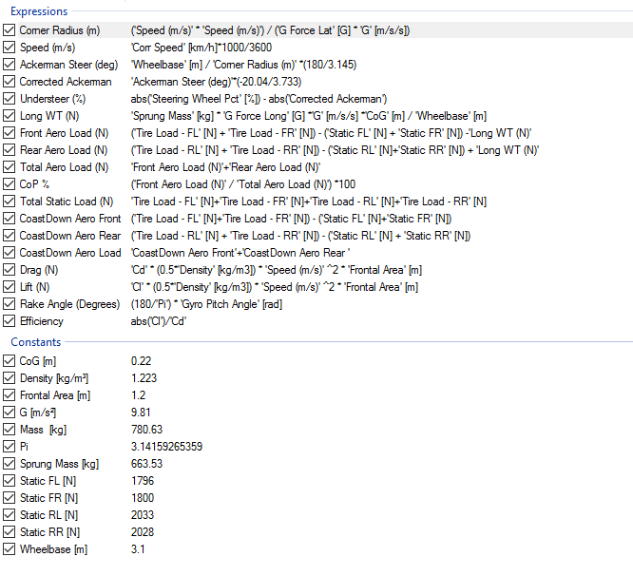
Figure 8-1 - Equations & Constants Used

