Huawei POT LX1 P Smart
Huawei POT LX1 P Smart IS EMMA PHON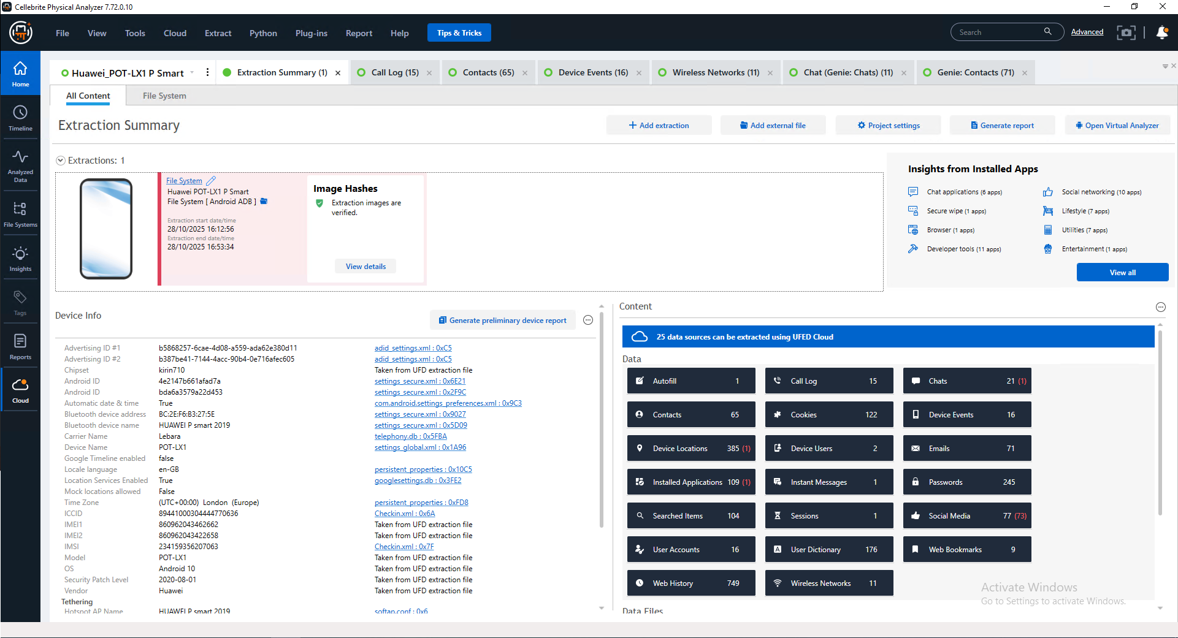

Cellebrite report page 1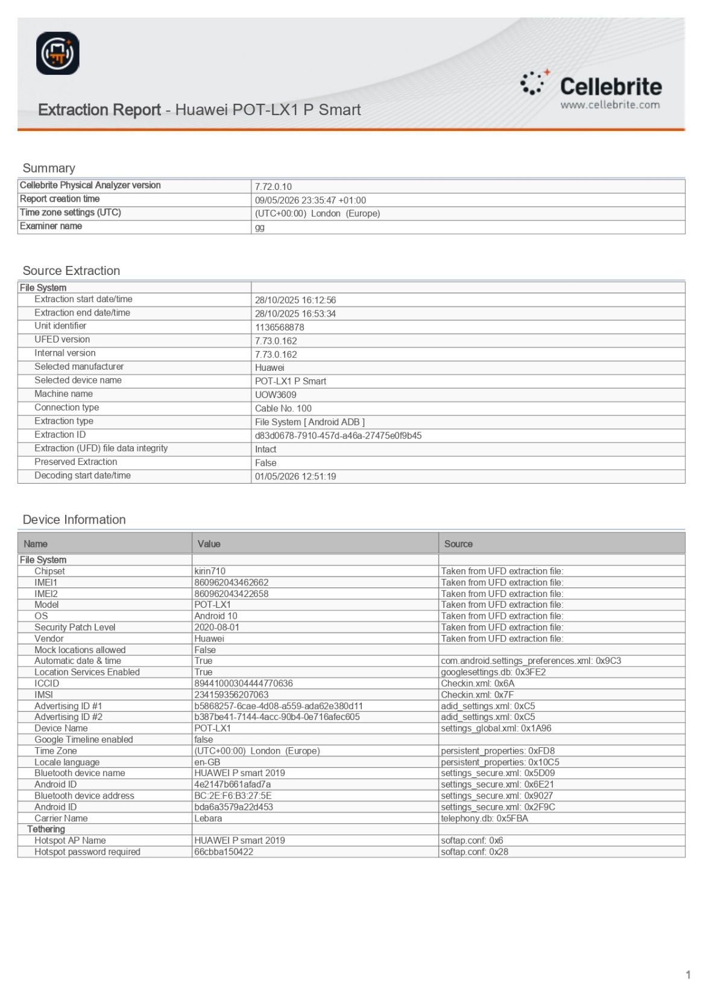
Cellebrite report page 2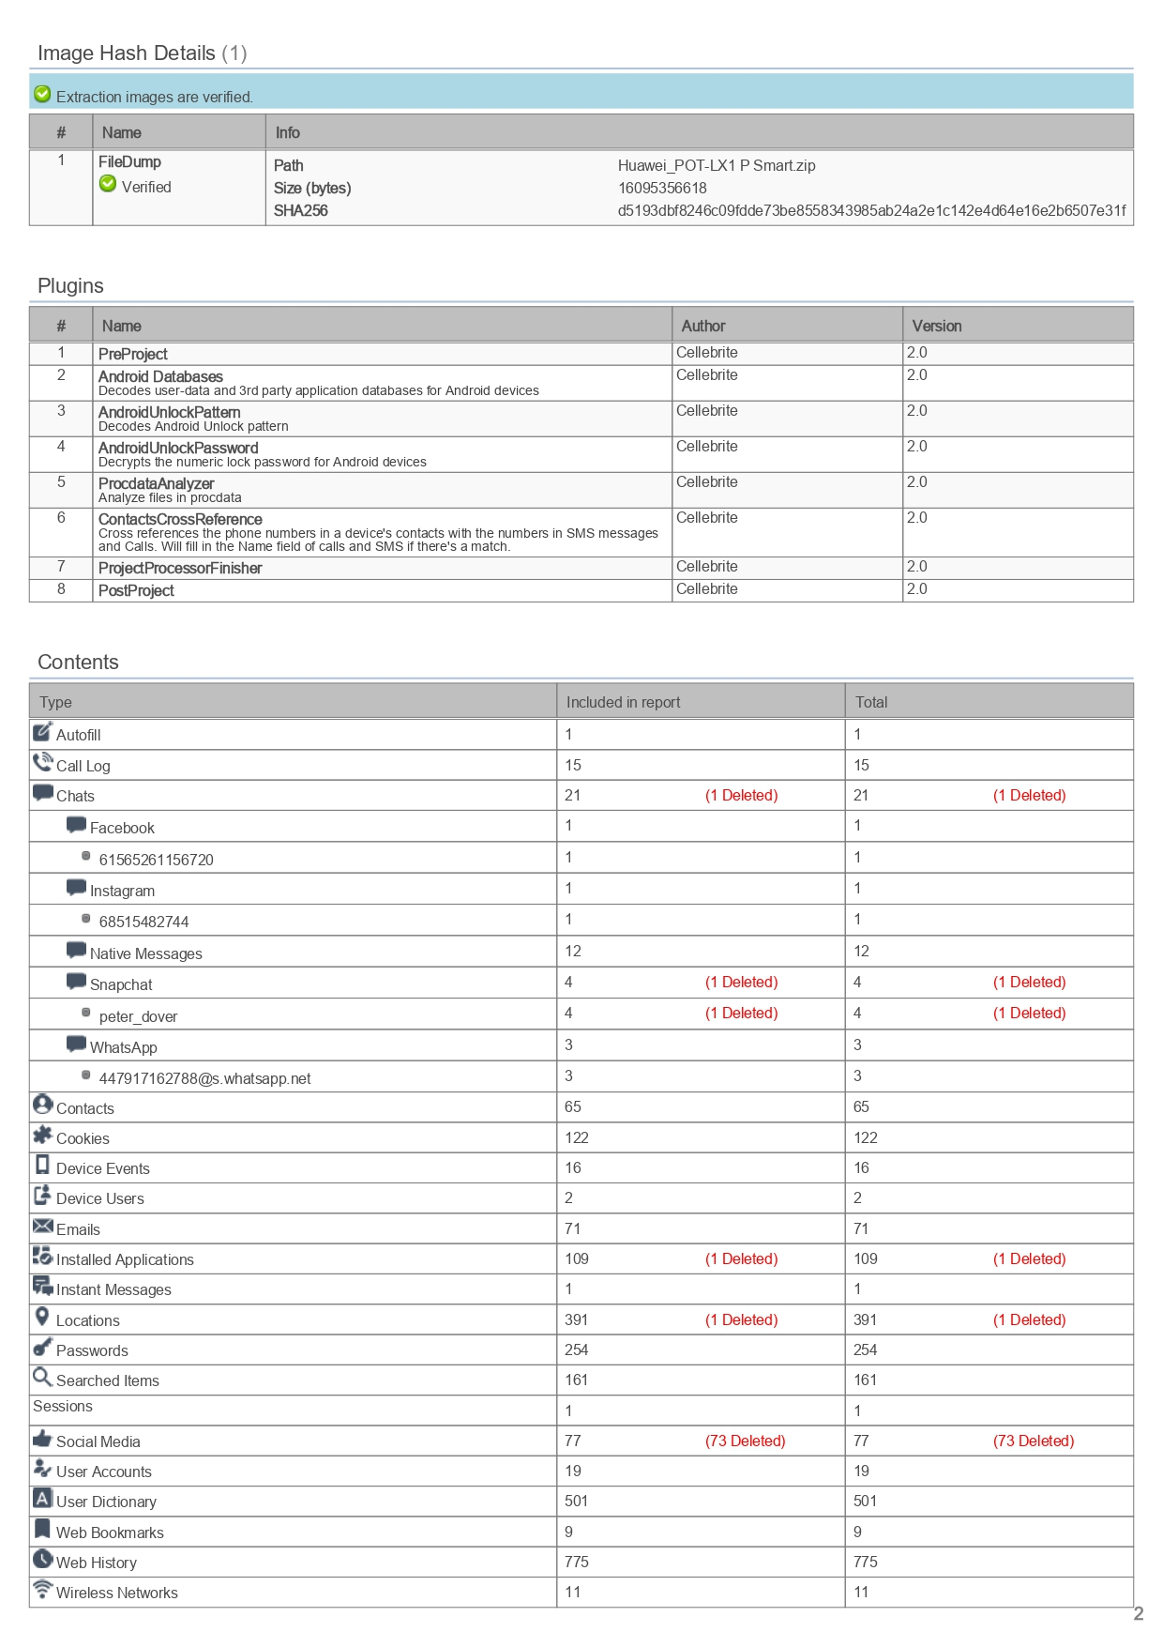
Cellebrite report page 3
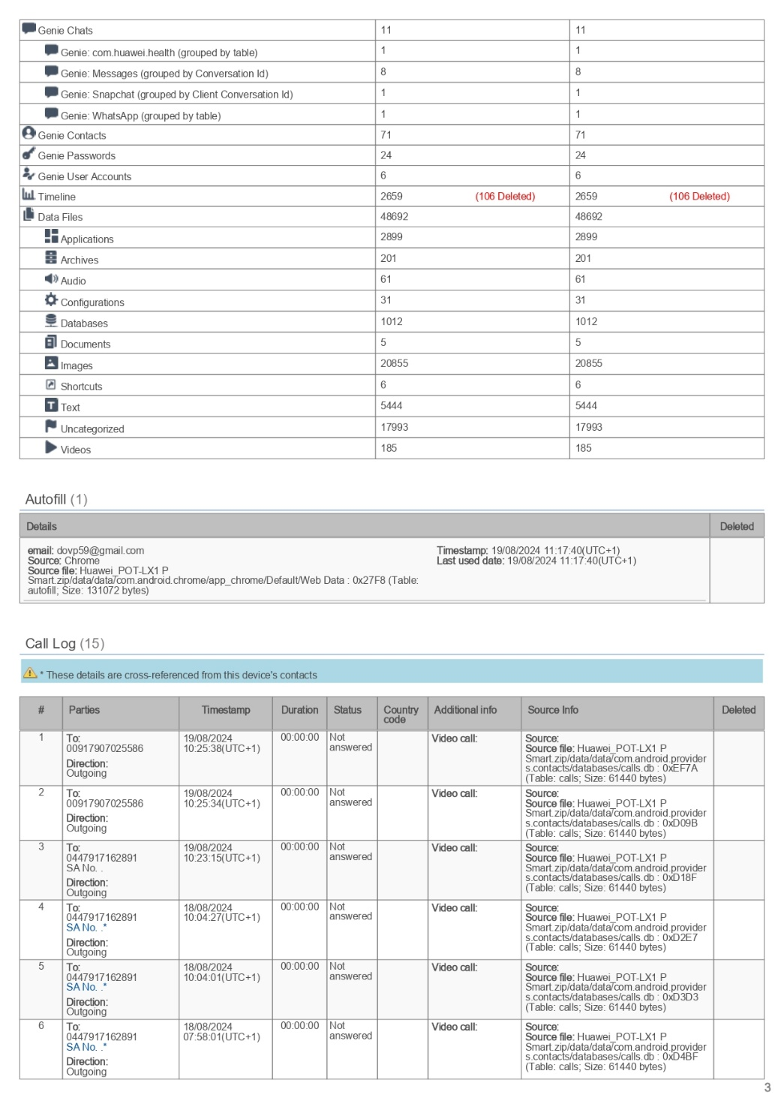
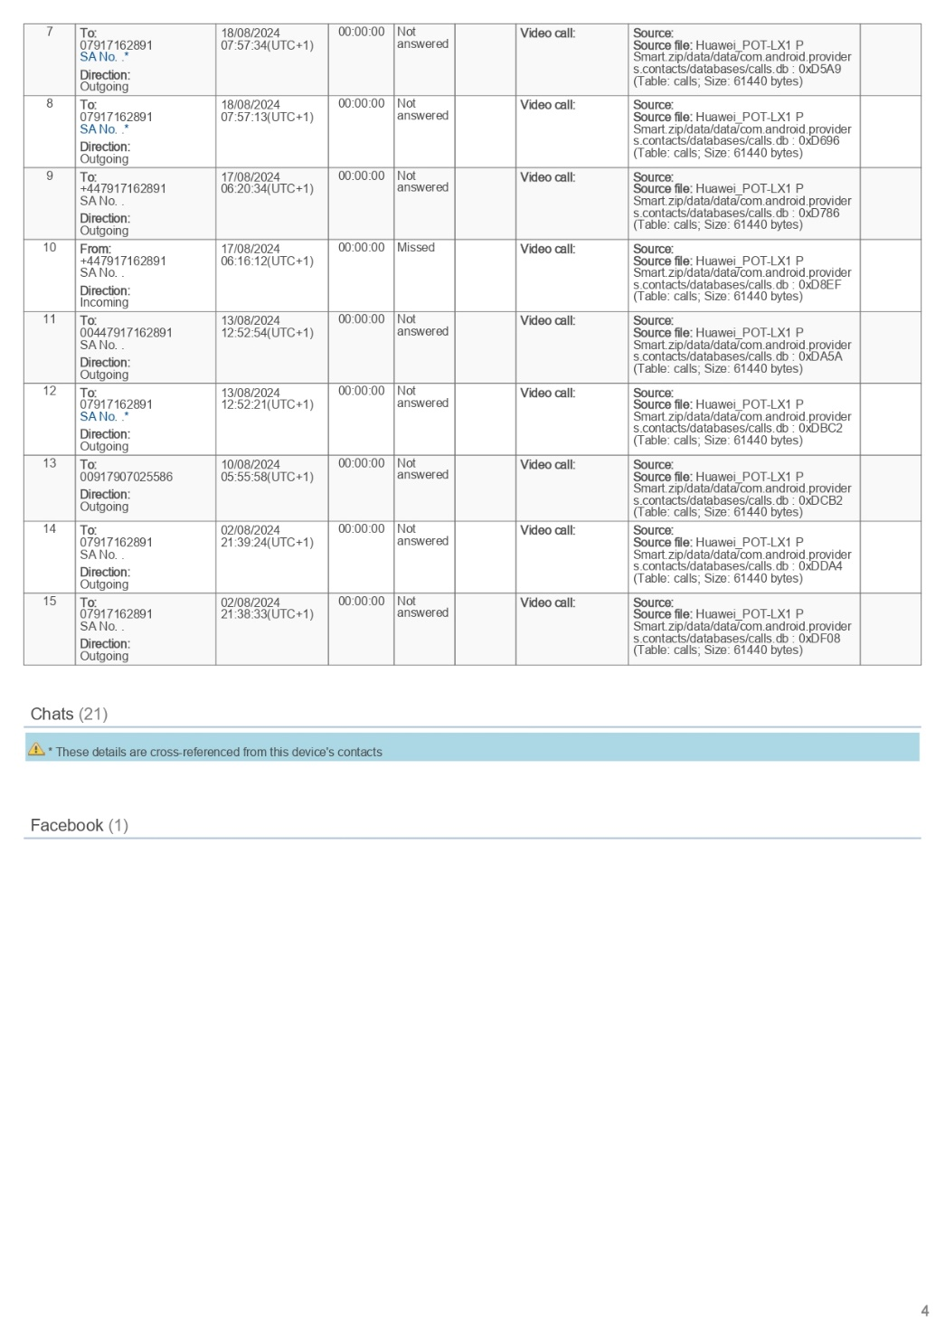
Cellebrite report page 3
thouse r WhatsApp text
Emma & joe conversation 1
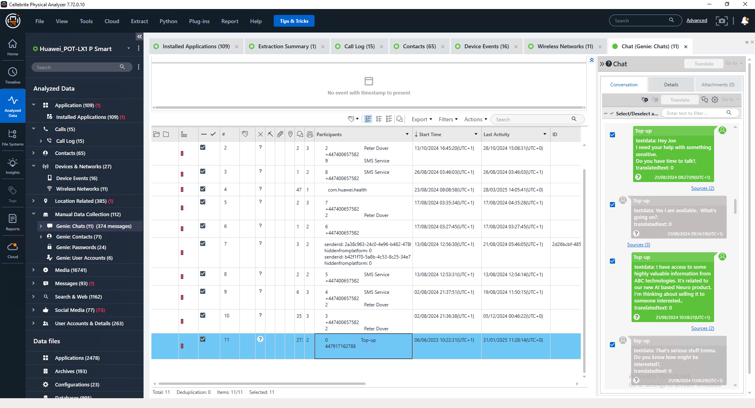

Emma & joe conversation 2
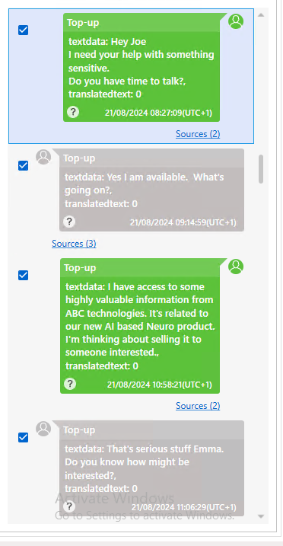

Emma & joe conversation 3
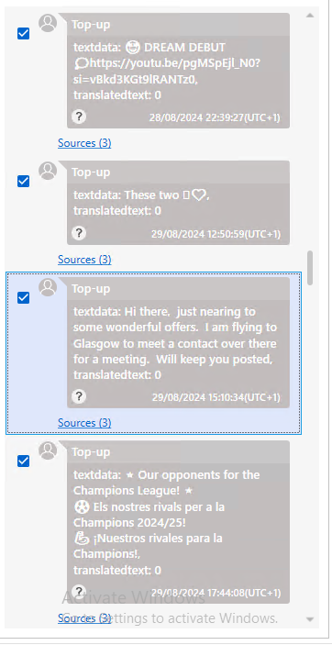

Emma & joe conversation 4

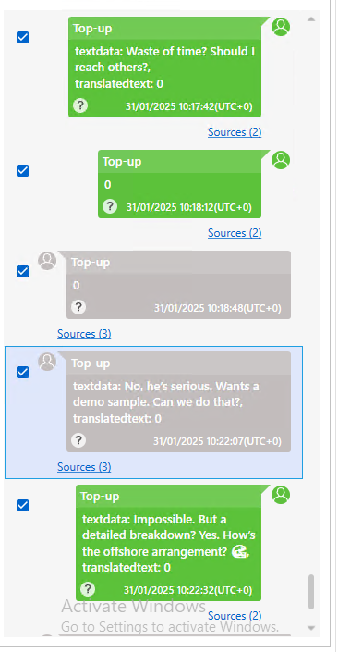

Emma & joe conversation 5

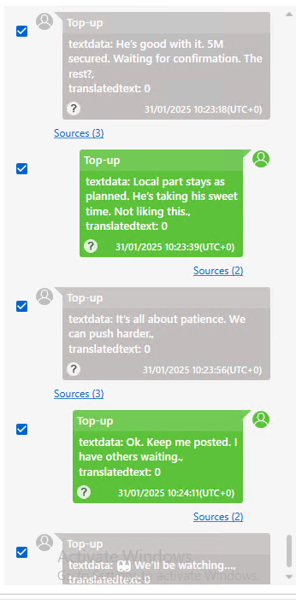

Those are Phone text
Emma & Norman conversation 1
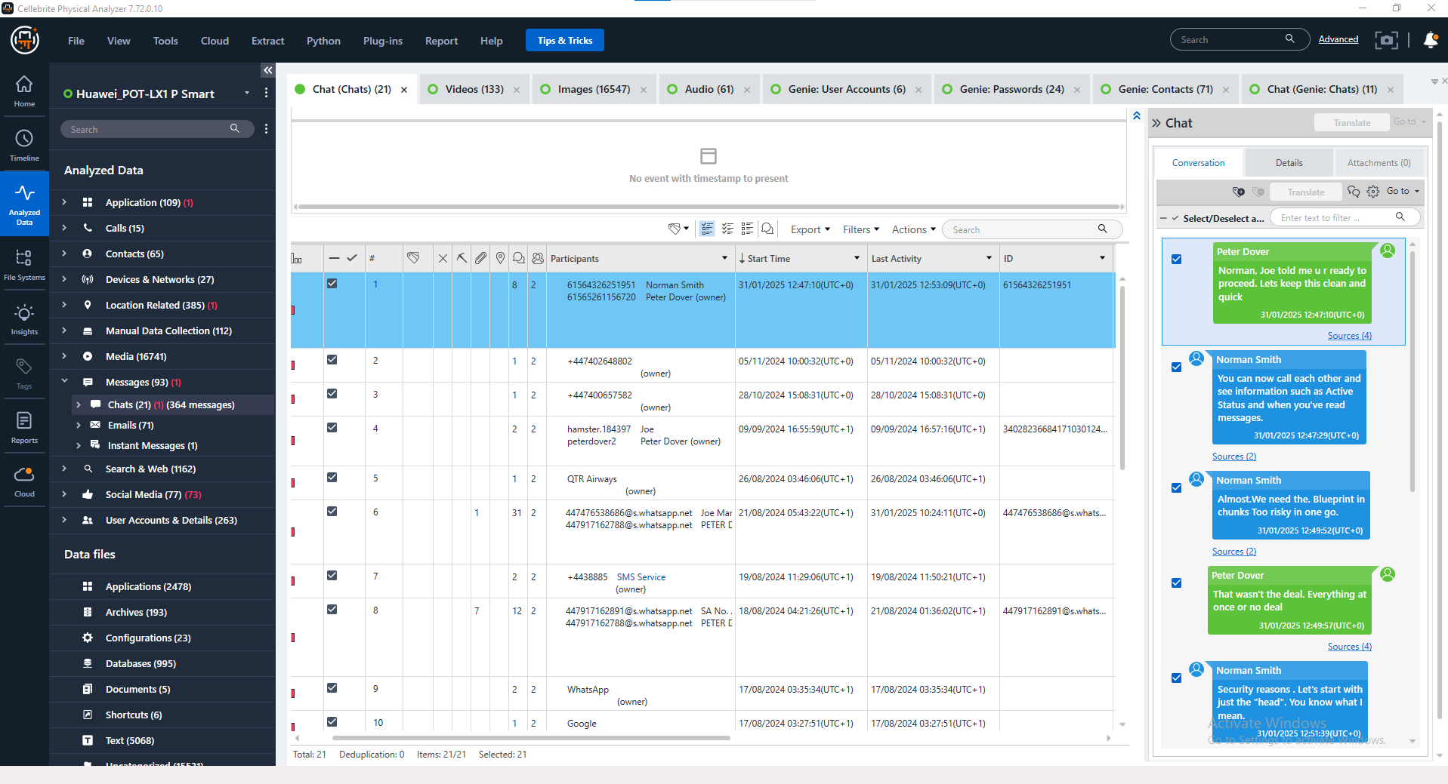

Emma & Norman conversation 2
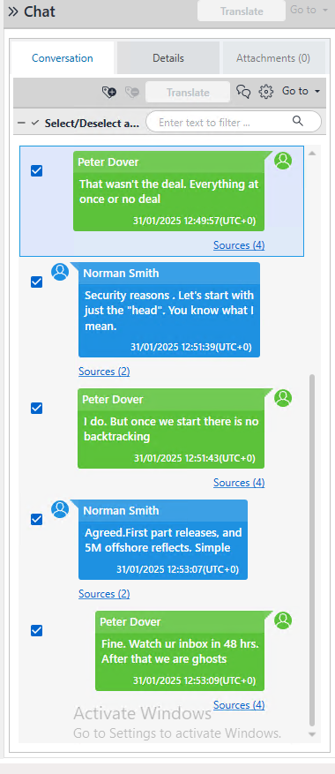
Emma & Norman conversation 3
THOSE ARE FACEBOOK conversation

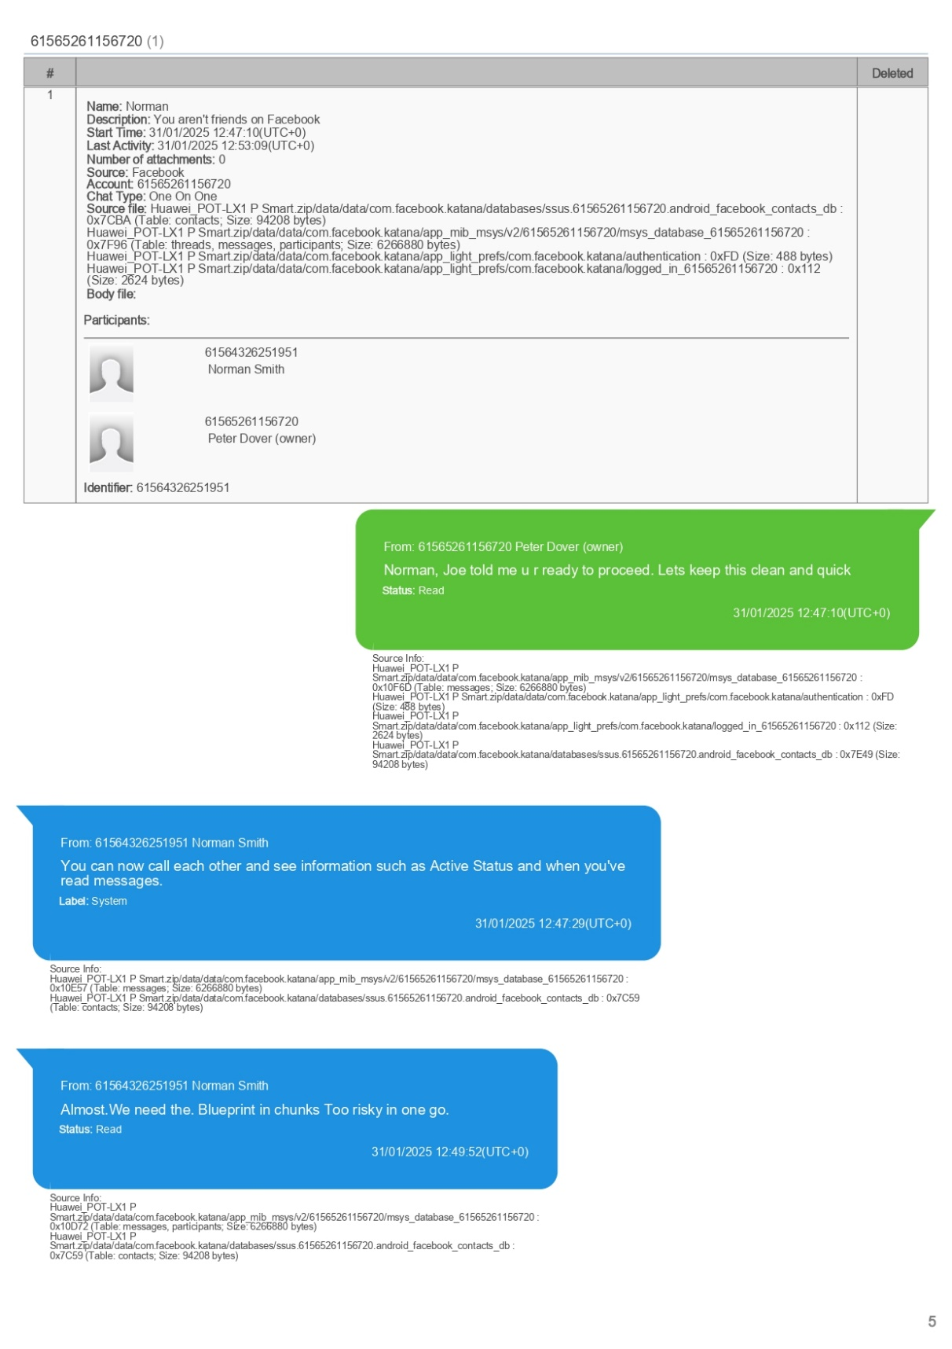
Emma & Norman conversation 4
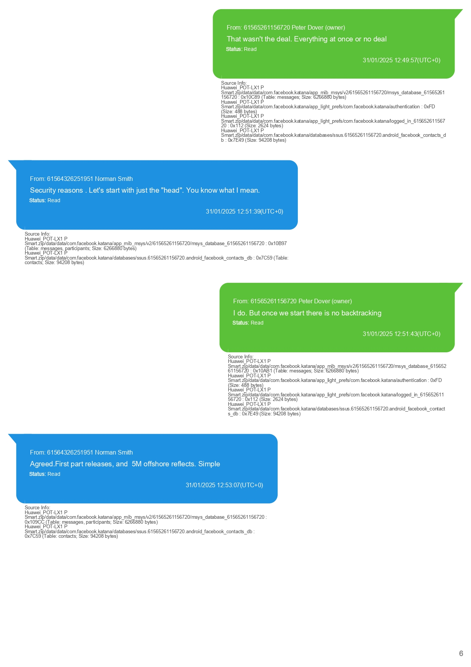
Those are Phone text
Emma & joe conversation 1
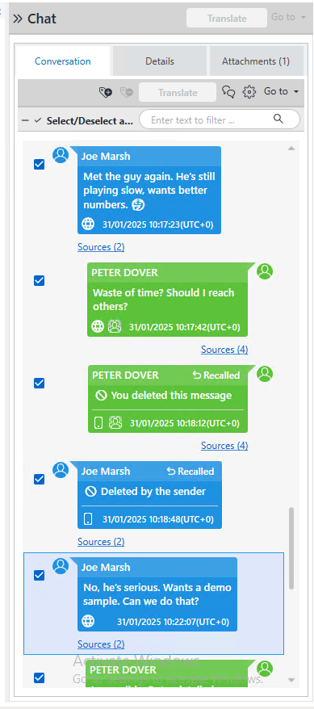
Emma & joe conversation 2
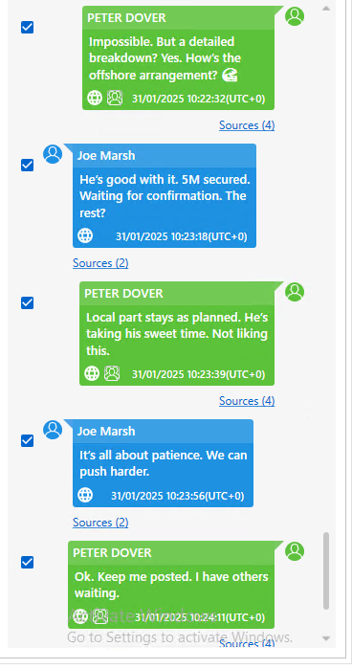

Emma & joe conversation 3
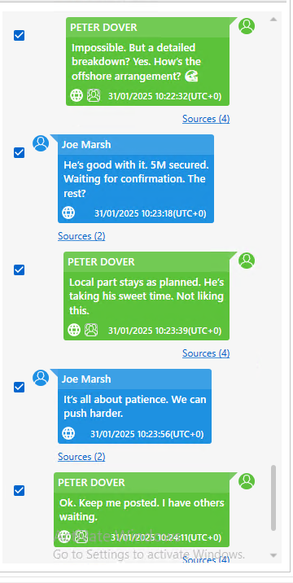

meeting point set Jeo text to emma
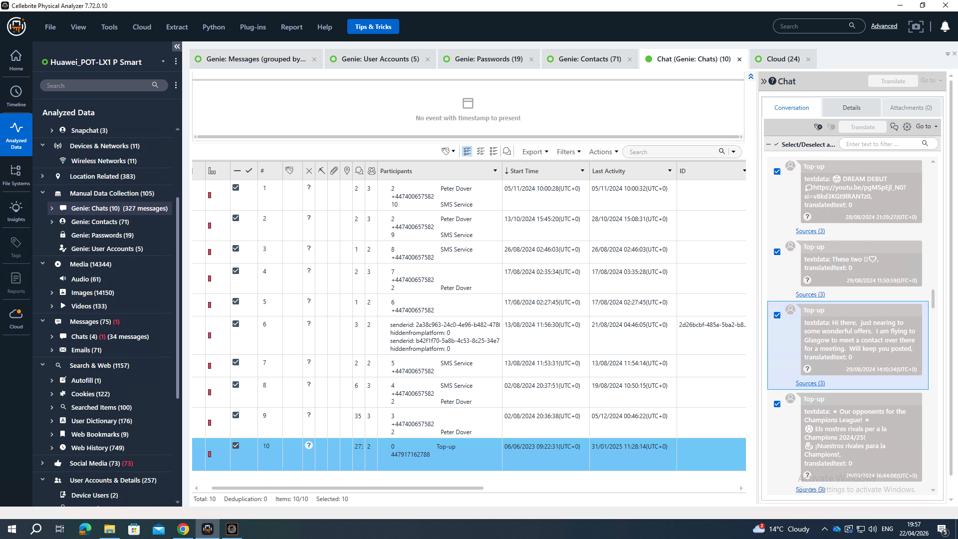

Model Nokia C2 2nd Edition
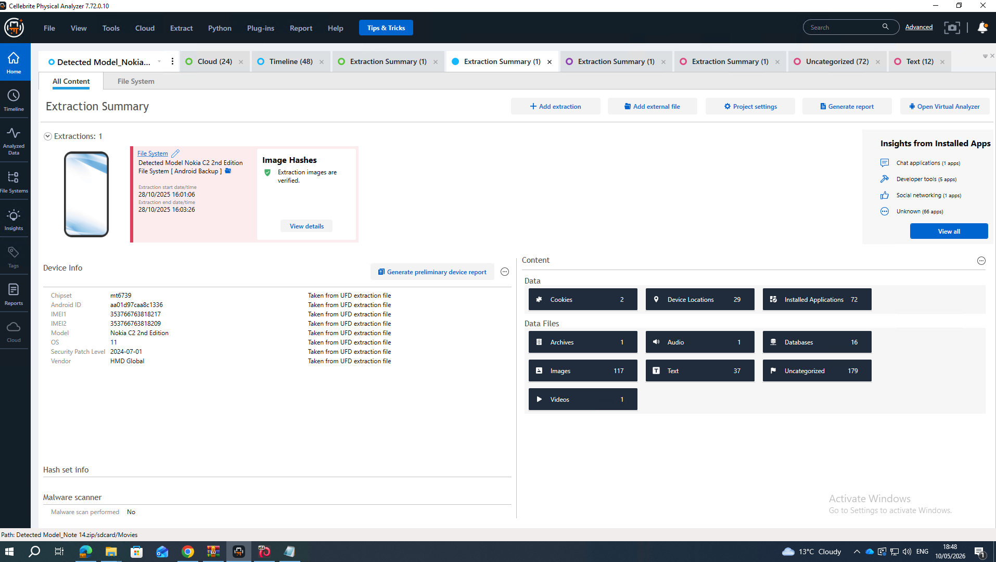

Cellebrite report page 1
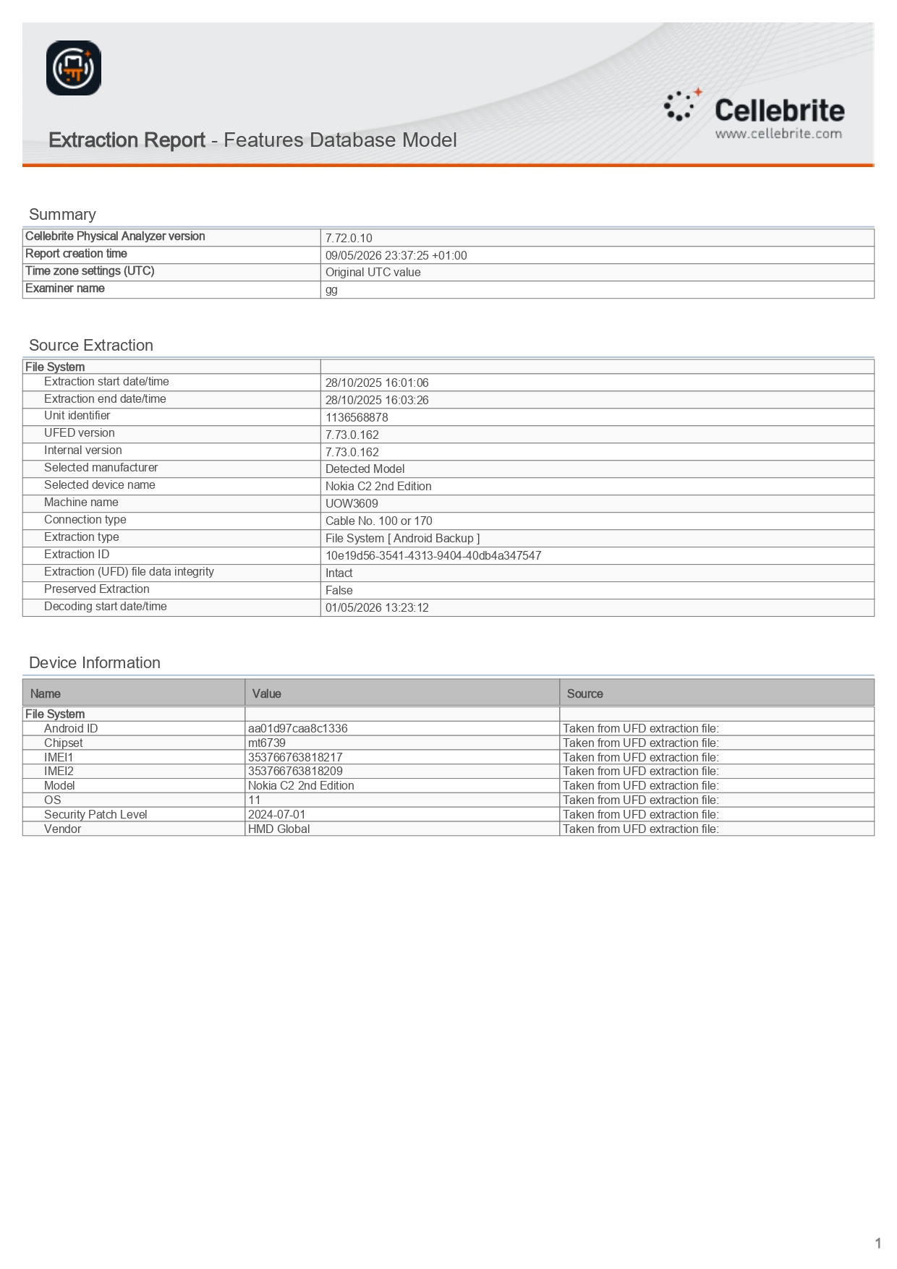
Cellebrite report page 2
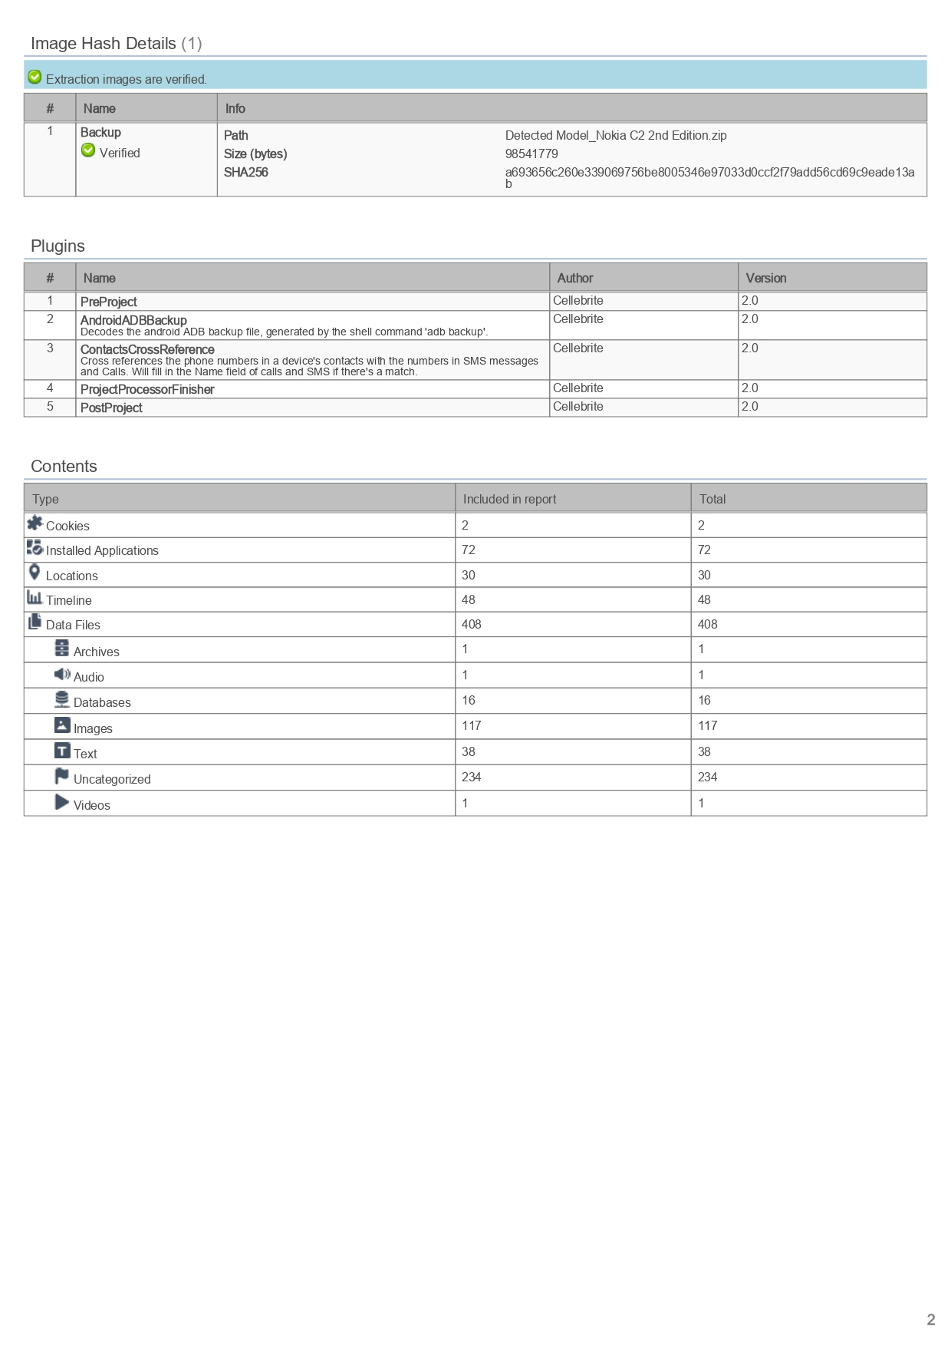
Cellebrite report page 3
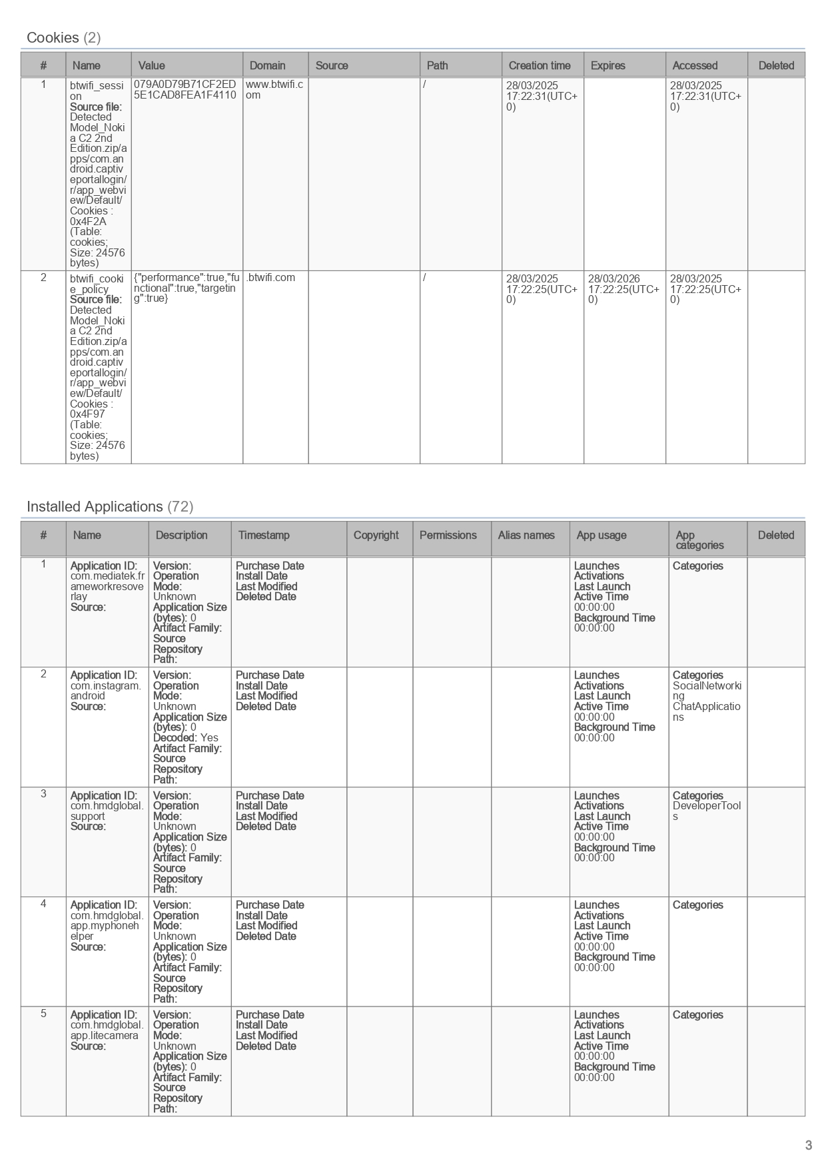
Find a open7z file which is password protected
under 7z file I found a open.doc which is password protected
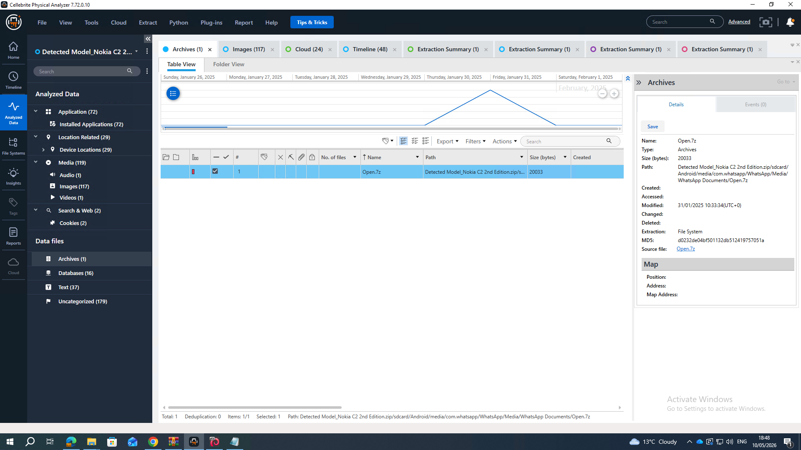

Samsung A13 is joe phone
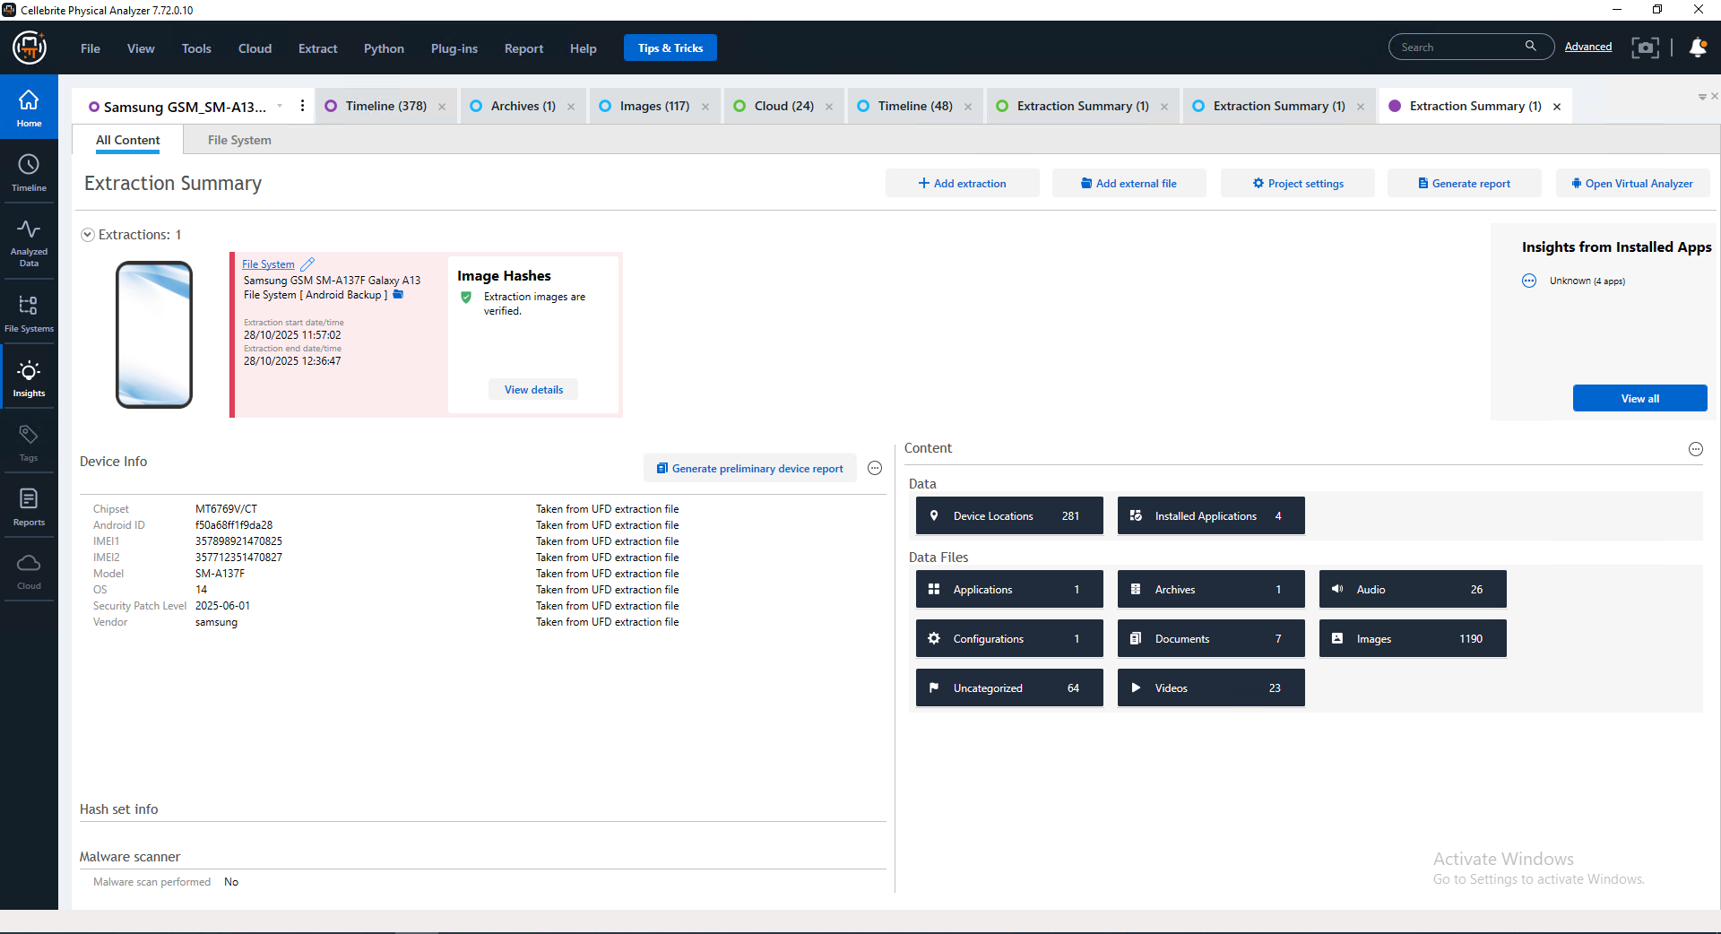

Cellebrite report page 1
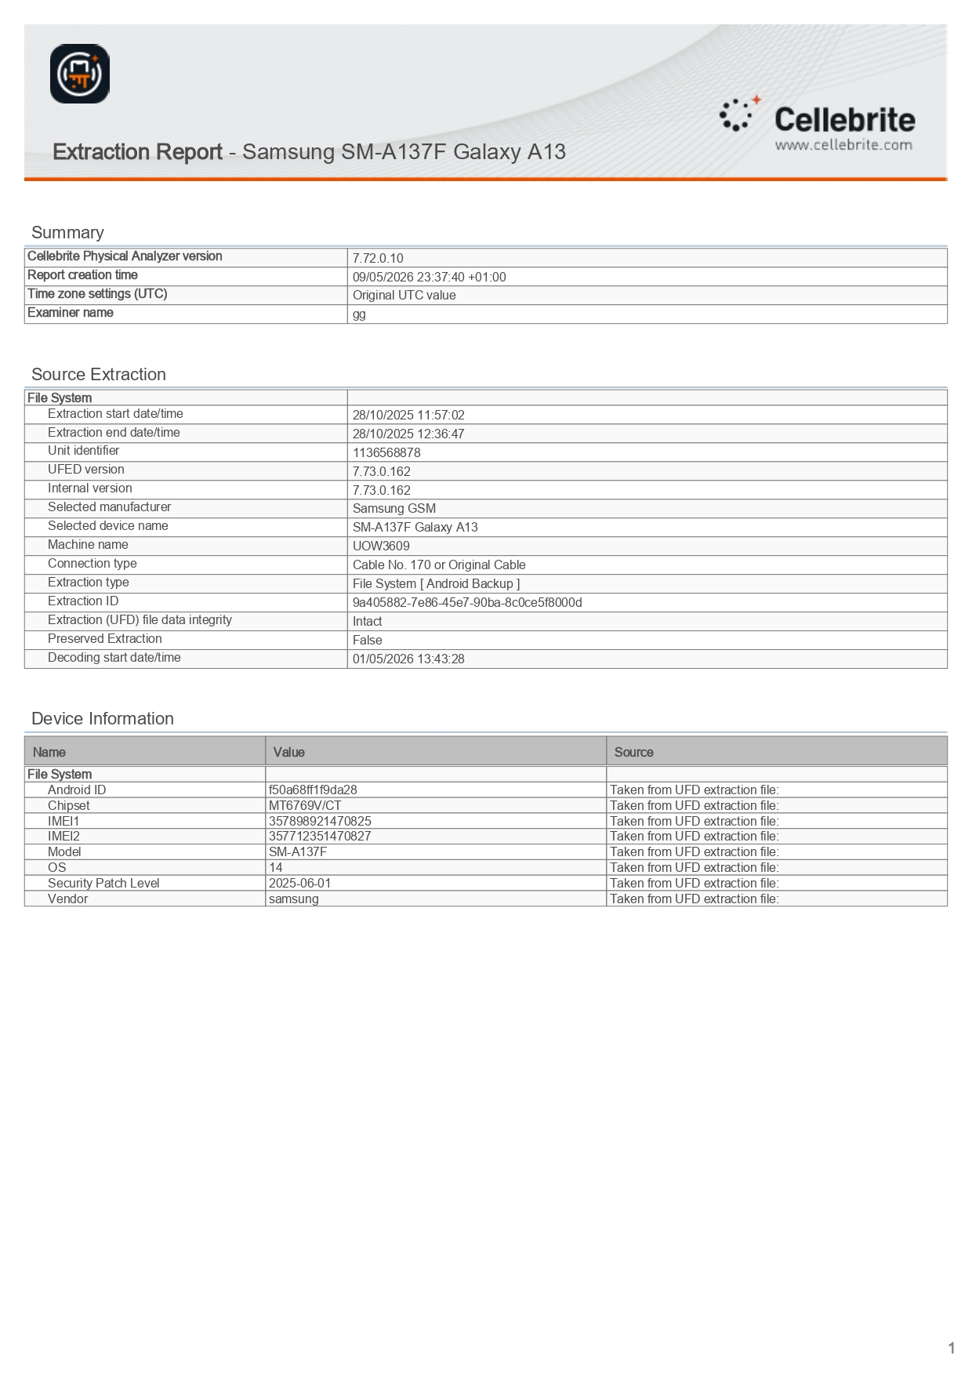
Cellebrite report page 2
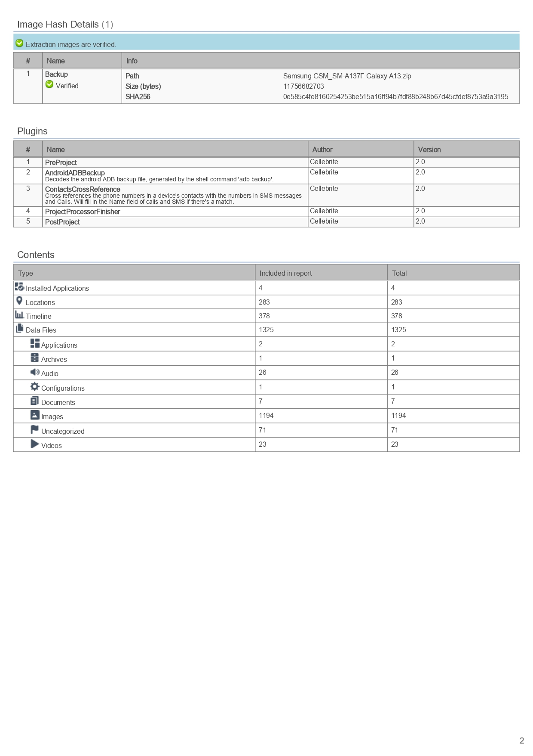
Find as tickets in joe phone
which is glasgow tickets
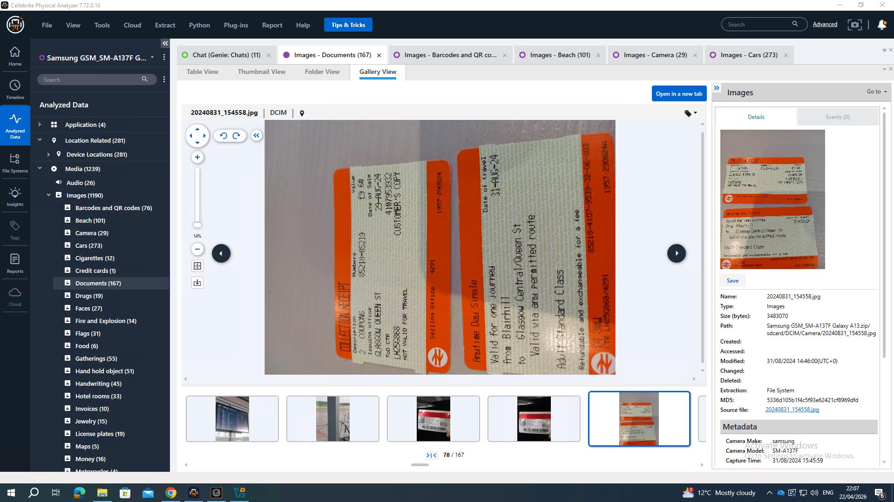

Insurging his live location sharing with Emma txt time & date
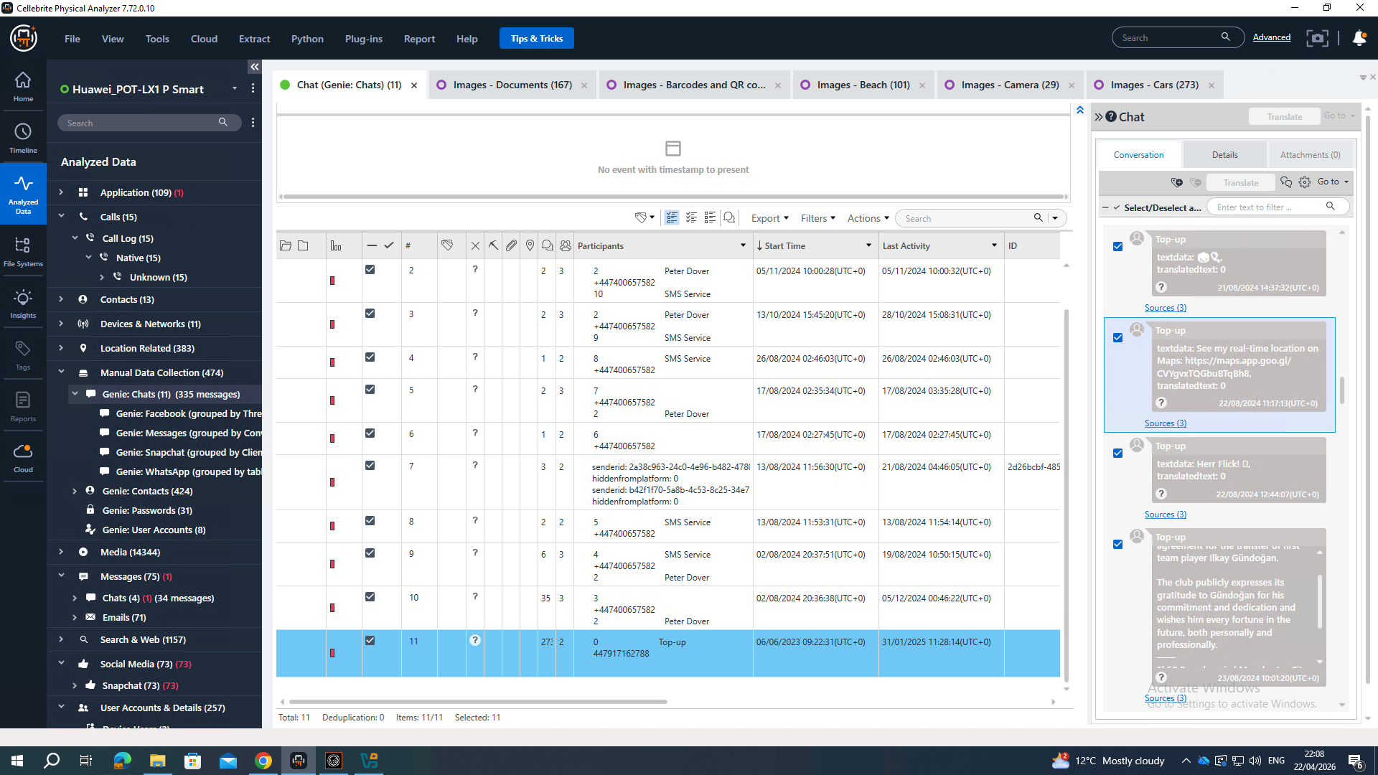
I found some pictures in his phone in between 08.08.24 -15.10.24 Their location was in Glasgow.
This image further proves that the device belonged to Joe, as he was located in Glasgow on 22/08/2024 and shared his live location with Emma during that time.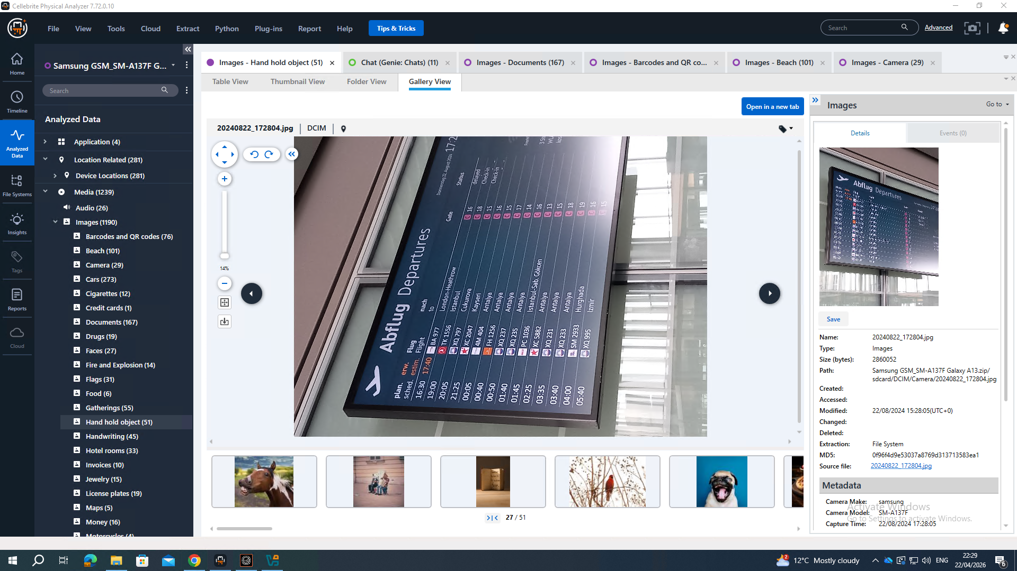
evidance 1&2 aging i found in Samsung phone
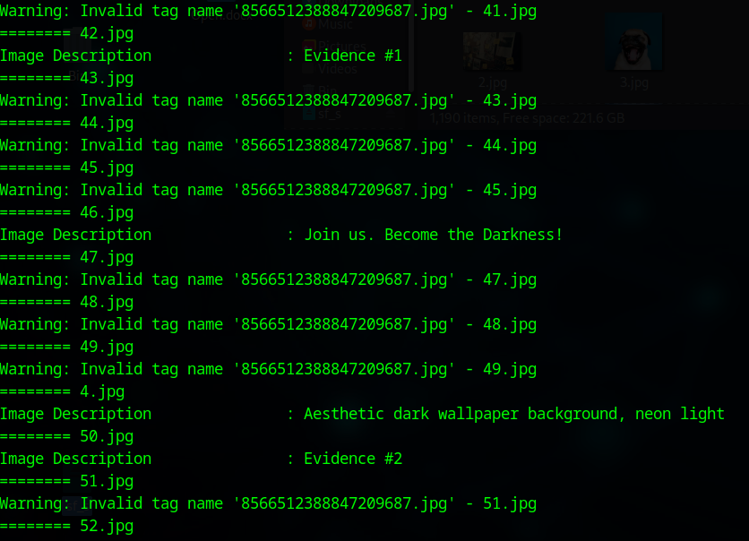
evidance 1  evidance 2

Note 14
Note 14 phone IS Norman PHONE
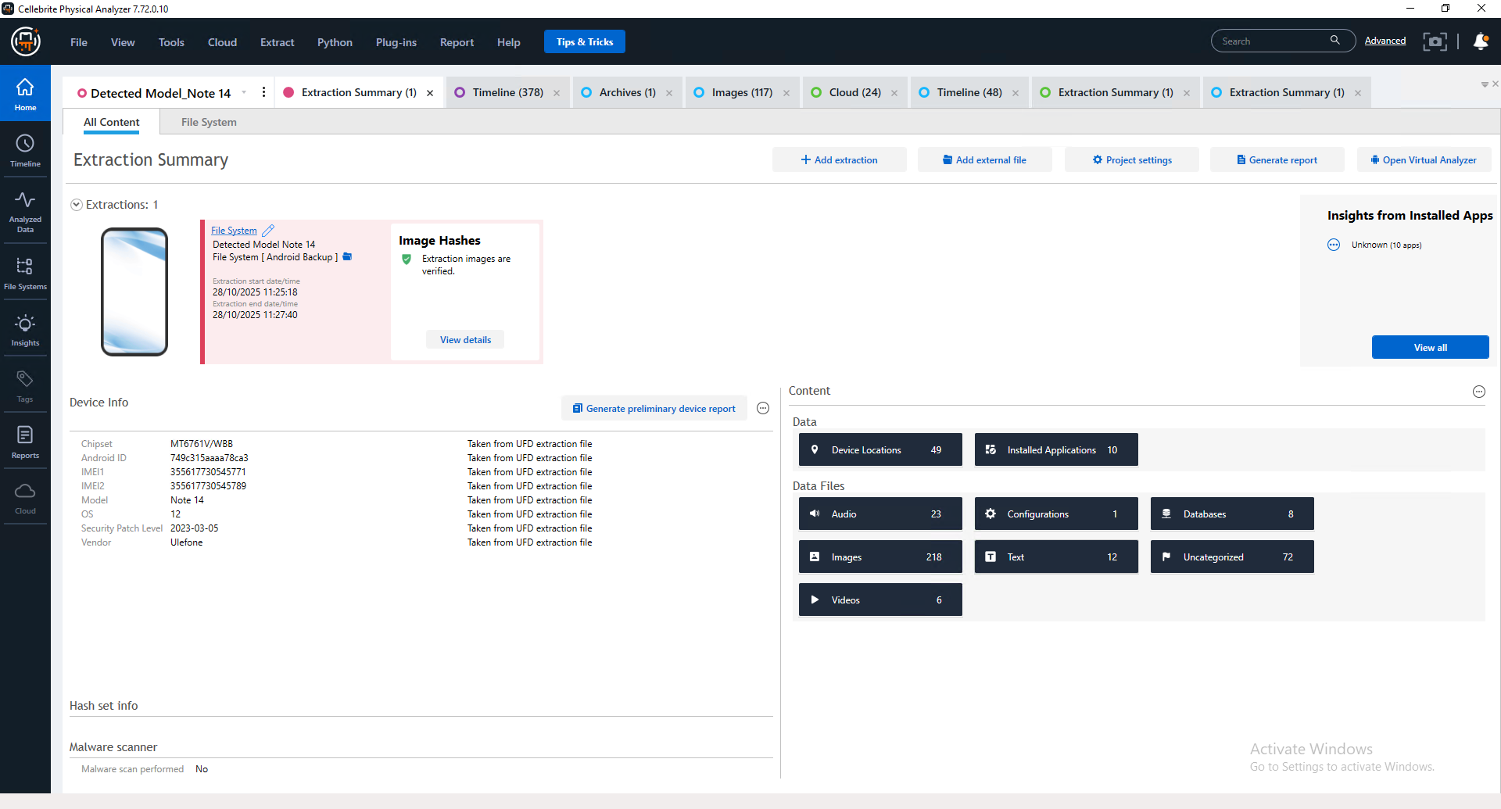

Cellebrite report page 1
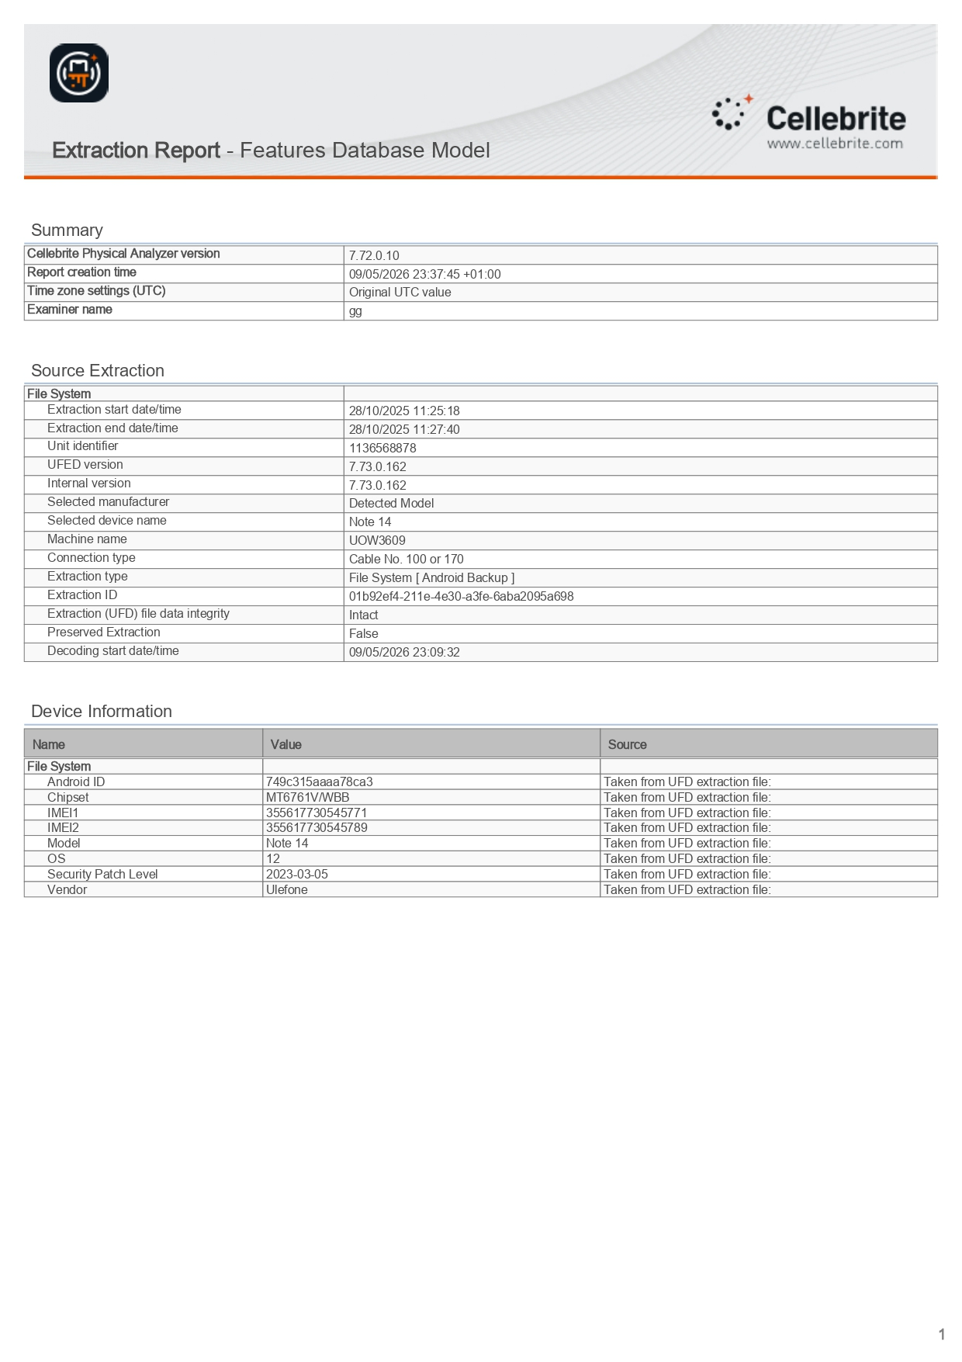

Cellebrite report page 2
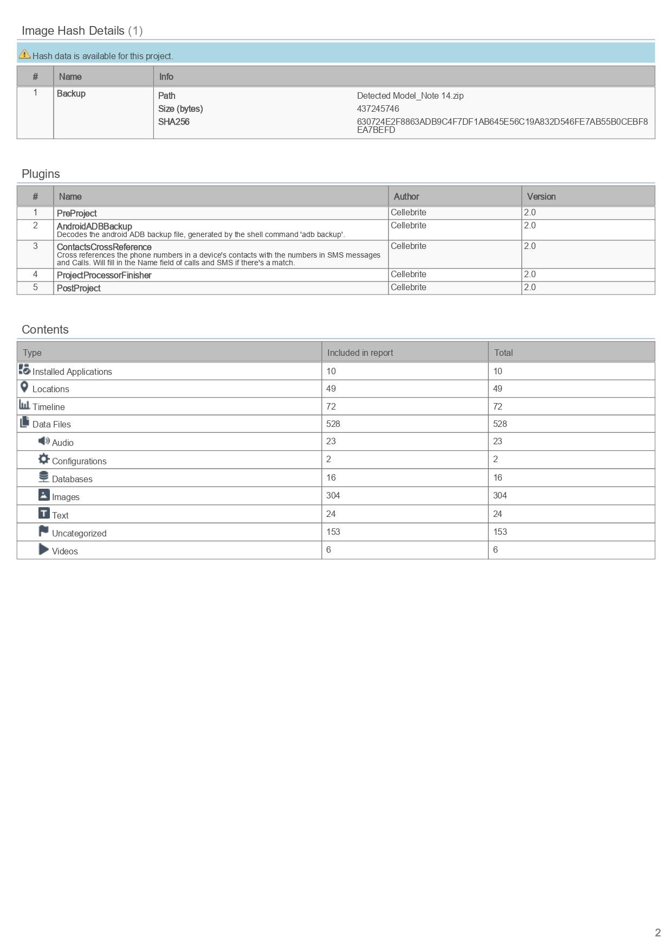
all image meta data I find 2 image with is evidance 1 & 2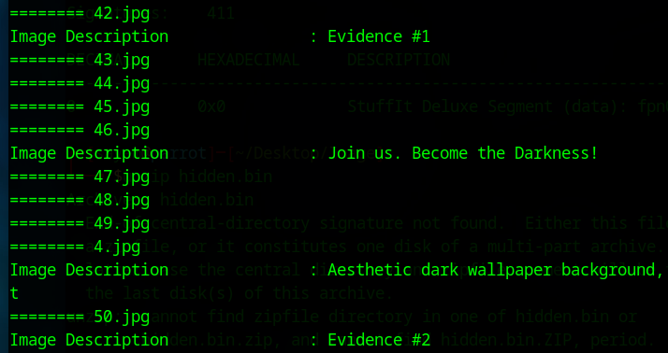
evidance 1 evidance 2
Emma USB meta data
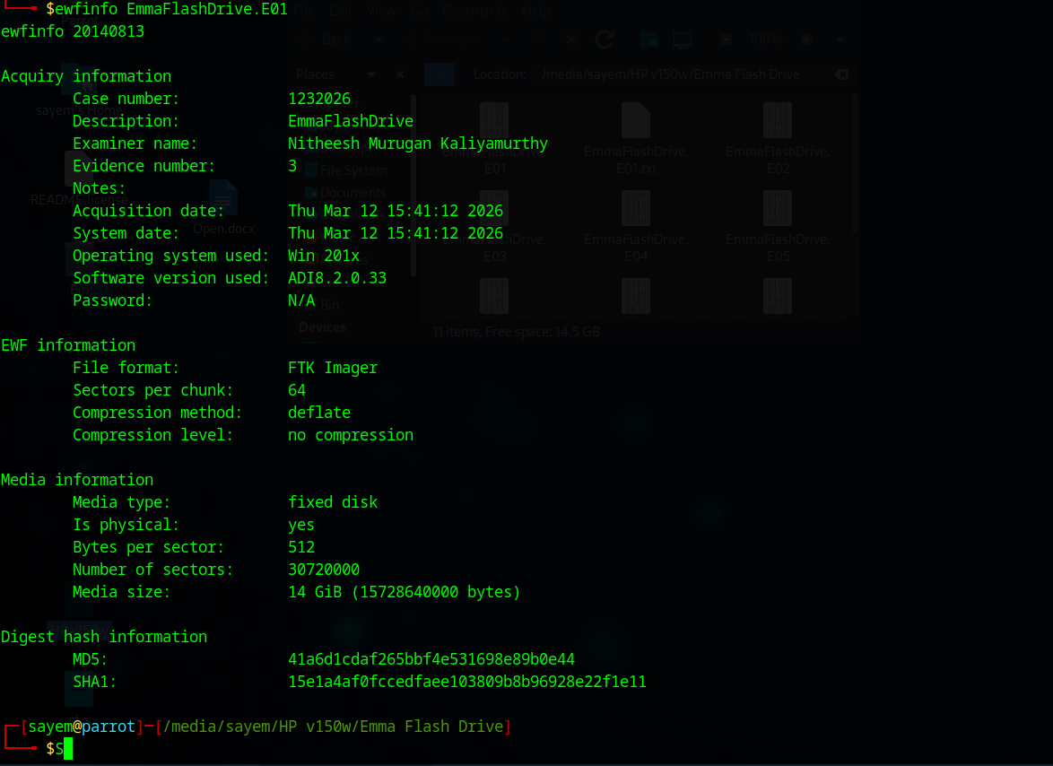
Emma usb all file analysis
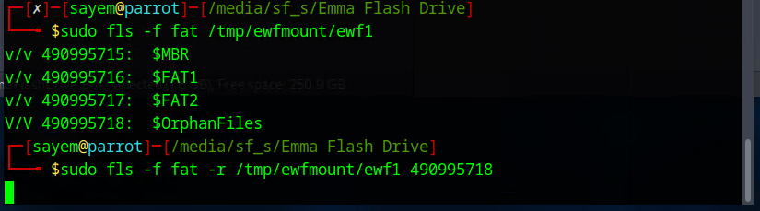

in OrphanaFiles
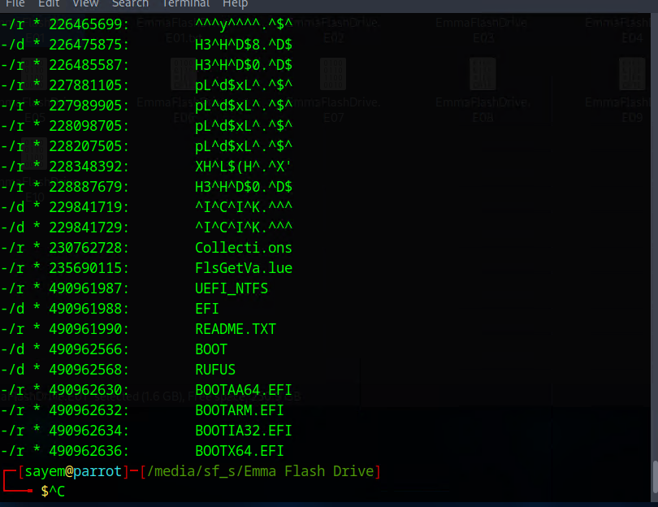
open readme txt there is nothing
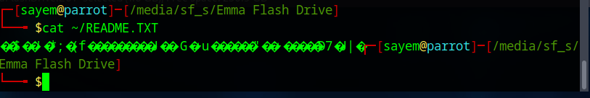
Emma usb autopsy report


