University of Wales trinity saint David

Wales institute of science and art

Vehicle performance optimisation using simulation software

Introduction to automotive Engineering
ACHA4035

Cade Gibbons
2516743
12/25

Table of Contents
1. Introduction 3
2. Baseline Vehicle model and initial performance 3
3. Optimisation strategy and points allocation 4
4. Traction and gearing analysis 4
5. Results, discussion and conclusion 5
6. References 6
7. Optimum Lap photos 7

Introduction

This assignment tasked me to used Optimum lap (a vehicle simulation software). I was given a base vehicle model and six race circuits lay outs to use. I attempted to modify the car in a way that it would perform best across various race circuits. This proved difficult as the circuits differed a lot. The task involved upgrading the car to increase the speed whilst sticking to a fixed points-based budget. To achieve the fastest possible lap, performance upgrades needed to be carefully selected. I was able to modify aspects of the car such as vehicle mass, engine performance, gearing, aerodynamics and tyre characteristics, all these modifications made it possible to improve the lap time of the car around these circuits.

This report will show how I’ve used my understanding and knowledge of vehicle dynamics theory, and how it can be applied to improve lap time performance. Better lap times were achieved through analysis and testing of the base line vehicles behaviour. From analysing traction models, predicted lap times and powertrain characteristics I was able to target specific aspects of the race car, improving the cars performance and efficiency around six tracks.

Baseline Vehicle model and initial performance

The baseline vehicle was a rear wheeled high performance car. The initial car set up had a total mass of 975kg, a gasoline engine with a strong mid-range torque reaching 550hp and a top speed of 194 mph. The car had moderate aerodynamic performance with the drag being 422 newtons at 62mph.

The original tyre set up provided a middling longitudinal and lateral grip, this limited both the acceleration and cornering performance. Through testing the different tyre maps and analysing the driveline model, as well at the traction model, I was able to find that the engine output was sufficient for a high-end top speed but its acceleration at low speeds was constrained. This was because the tractive force exceeded the tyre traction limit.

The original gearing was set up in a way that it prioritised tops speed rather than acceleration meaning that the first two gear ratios were prolonged. Though the long gear ratio allowed the car to reach maximum speed when on long straights, it reduced acceleration, meaning the car’s speed decreased when exiting tight corners (RaceSport, 2021). The Base aerodynamic map had a good drag coefficient and down force making the car sturdy at high speeds but negatively affected the car when it came to high-speed corning.

The baseline vehicle was well balanced and had a good base to make improvements. When experimenting with the car on optimum lap I found that the cars main limitations where it’s mass, tyre grip and its gearing which showed the focus points of improving the cars performance.

Optimisation strategy and points allocation

After evaluating the baseline model, I aimed to develop the car to improve its lap time performance while sticking to the points-based budget. With the various circuits; some being low-speed streets and others being high-speed tracks, there were challenges modifying the car to best suit the diversity of the circuits. I aimed to ensure that the car was well-balanced in order to perform well across all circuits instead of maximising its performance for a single circuit.

From prior investigations, I found that the vehicle’s mass, tyre grip and gearing were the main limitations of the car’s performance. Due to this, upgrades to these areas were prioritised; changing these factors would improve acceleration, traction and cornering across all circuits (Varsani, 2024; Campbell-Brennan, 2023). The main improvement to the car was mass reduction as I found it had the greatest effect on the car’s performance. This also improved the acceleration, breaking and cornering as well as reducing the tyre load sensitivity, meaning the tyres ran more efficiently. This helped to determine that mass reduction was a good investment of points.

The next priority were the tyres, as the grip directly limits both longitudinal and lateral performance. I found that by increasing the longitudinal and lateral friction coefficients, the cars cornering capabilities increased. I later found that this was due to the traction being heightened during acceleration. This improvement is important because the baseline configuration had traction limited behaviour at low speeds.

To improve acceleration and top speed along straights, the engine’s performance was increased. Although, due to the increase of power, the traction limitations decreased meaning improvements to the tyre grip and gearing were necessary.

To better suit the engines new torque and power characteristics, the gears needed to be modified. The lower gear ratios were shortened to improve acceleration at lower speeds; which also improved the exiting speed on corners. The higher gear ratios were also adjusted to improve the cars top speed capabilities on fast tracks. The change in gear ratios ensured that the engine operates as close as possible to its optimal speed range during acceleration.

Finally, the increased downforce from the aerodynamic map created an acceptable level of drag, helping to improve the stability and cornering performance without significantly reducing straight-line speed. This was done with all circuits in mind, with the aim to maximise lap times.

Traction and gearing analysis

A key part of the process involved analysing the traction because the original car showed traction limited behaviour at low speeds. By using the traction model, I was able see the relationship between the tractive force at the wheels, the aerodynamic drag and the tyre traction limit. This showed me where there were limited vehicle acceleration and the effectiveness of the tyre grip (Groote, 2002).

The traction model also showed that at low speeds, the tractive force made by the power chain surpassed the maximum force that could be transmitted onto the tyres. This mean that the wheels slipped during acceleration, specifically in the first two gears. When the cars speed increased, the tractive force decreased, meaning the aerodynamic drag was also heightened; which made the car change from a traction limited state to a power and drag limited state. Typical high-performance cars show this behaviour, which displays that traction limitation at low speeds are unavoidable.

Improvements to the longitudinal friction, increases the maximum transferable force; this helps form a better percentage of the engines output, which is then converted into acceleration. This increases the cars cornering performance and reduces excessive wheel slip (Gheorghe and Soica, 2025).

The gearing changes further improved the overall traction of the car, especially at low speeds. This was done by shortening the lower gears which increased the torque multiplication at the wheels, leading to improve the acceleration. This set up prioritised acceleration rather than top speed. The higher gears were adjusted so the car could still reach an improved top speed for the fast circuits. Through doing this, it ensures the engine is running efficiently and producing optimal torque and power.

Behaviours of specific tracks were also accounted for. On tracks such is Monte Carlo, a low-speed track, improvements of the low-speed traction and changing the gearing improved the car’s performance gains. Tracks such as spa are high speed, so the car benefited more from the changes to the higher gears and the aerodynamic efficiency. This set up was selected to ensure the car had a consistent performance across all 5 tracks.

Overall, the gearing and traction changes improved the acceleration, power utilisation and stability all helping to reduce the lap time across all the circuits.

Results, discussion and conclusion

Using optimum lap, I have recorded lap times for both the baseline and optimised vehicle across all six circuits. From the lap times it is evident that there was a great improvement across all six tracks showing the effectiveness of the upgrades that I have selected within the point-based budget.

The best lap time reductions were seen on low speed and technical circuits like Monaco and Portugal. Changes to the car such as tyre grip (with both the longitudinal and lateral friction changing from 1.8 to 1.825), reduced vehicle mass (which went from 975 Kg down to 925Kg), and shorter/lower gear ratios increased traction and corner exit acceleration. This solved the traction limited issue that the baseline model had. The changes have vastly improved the cars drivability and has reduced lap times in sections dominated by tight corners and frequent use of brakes.

Lap time changes on high-speed tracks such as Silverstone, le mans and Spa-Francorchamps were smaller but still evident. For these tracks the aerodynamic efficiency and power is key for the best lap times. Whilst the vehicle wasn’t optimised for straight-line speed, all rounded aerodynamics and gearing configuration still make it competitive on tracks such as le mans, while not compromising the cars performance on slower tracks.

From the results it’s evident that a balanced optimisation strategy was effective when the car had to deal with various circuits, all varying in characteristics. By reducing the mass of the car and improving the tyre grip and gearing, the car can achieve near perfect stability, power utilisation and acceleration. In this assignment I have demonstrated how vehicle dynamics theory should be applied when using simulation software and have made informed engineering decisions to improve lap times performance within the budget.

References

Campbell-Brennan, J. (2023). Racecar Performance Development: The 5 Key Factors (Le Mans Feature). [online]

Gheorghe, C. and Soica, A. (2025). Tire–Road Interaction: A Comprehensive Review of Friction Mechanisms, Influencing Factors, and Future Challenges. Machines, 13(11), p.1005. doi:https://doi.org/10.3390/machines13111005.

Groote, S.D. (2002). The vehicle performance envelope. [online] F1Technical. Available at: https://www.f1technical.net/features/10697? [Accessed 14 Dec. 2025].

RaceSport (2021). A Guide to Track and Race Car Chassis Setup – including Setup Tips - Racesport. [online] Racesport. Available at: https://racesport.uk/a-guide-to-track-and-race-car-chassis-setup-including-setup-tips/?utm_source=chatgpt.com [Accessed 14 Dec. 2025].

Varsani , D. (2024). Vehicle Dynamics in Automotive and Motorsport – Motorsport Engineer. [online] Motorsportengineer.net. Available at: https://motorsportengineer.net/vehicle-dynamics-in-automotive-and-motorsport/? [Accessed 14 Dec. 2025].

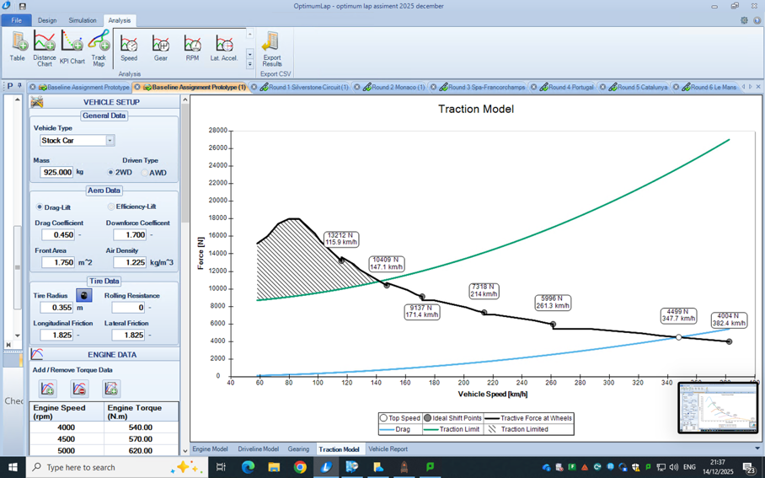
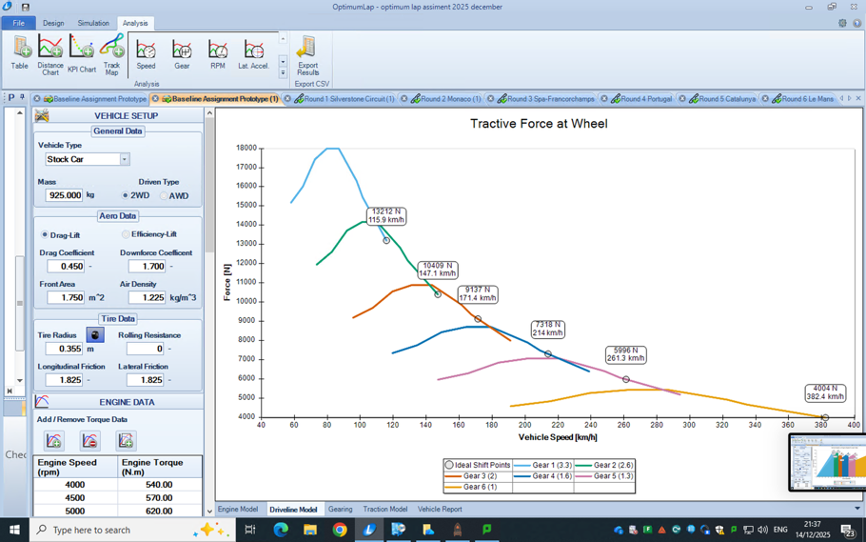
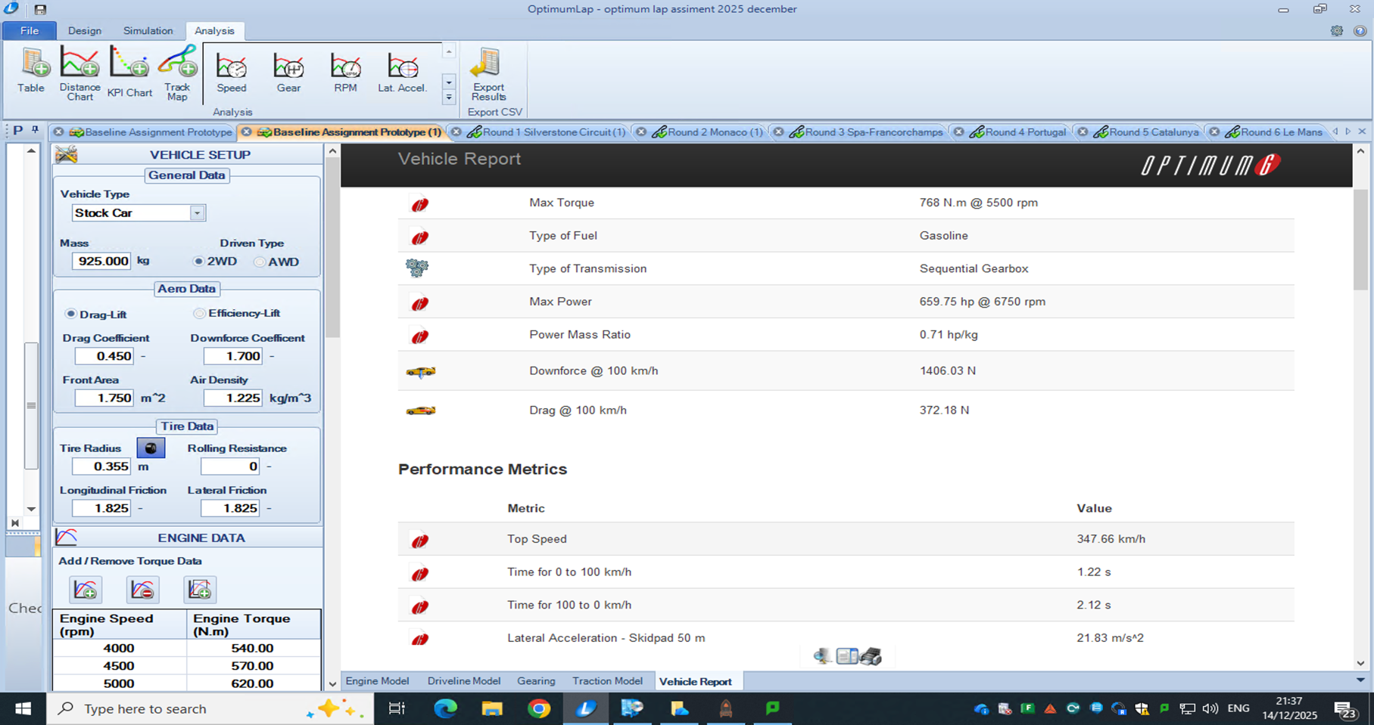
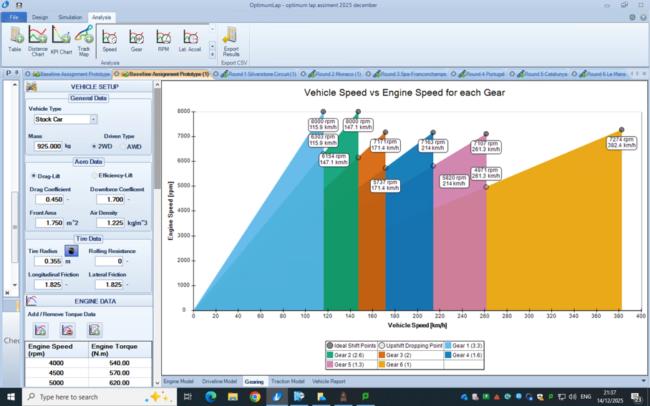
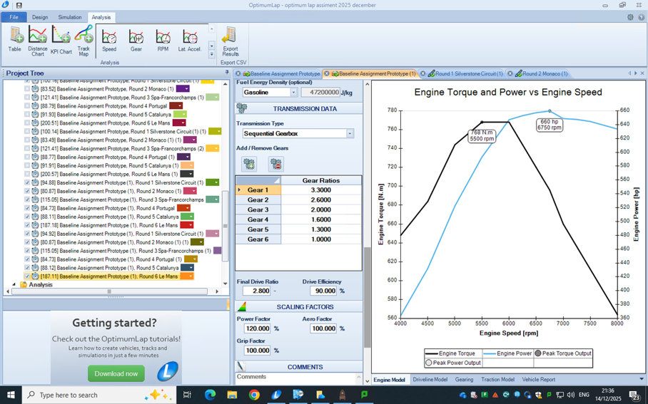
7. Optimum Lap photos

