Student Name: Mustafa Dzhamal Mustafa

Assignment Title: Google Background

Module Title: Introducing the Modern Workplace

ID Number:1920425

Lecturer’s Name: Rula Alousi

Introduction
The existence, practice and significance of management has been there since the very inception of business itself (Koreimann, 2015). Business is the process of creating value using resources and then selling it for a profit. One of the essential resources that generate value for a business is the people (Hodgetts and Kuratko, 2012). Management is mostly concerned with the people that contribute to the business, how they behave, how they need to be treated, what kind of culture they should find themselves in. More importantly, what is the right way to be leading the people. This report attempts to answer such questions by exploring a real world case. Which is Google LLC.

Company Profile: Google
Google is one of the most well-known technology companies on earth. 86% of all searches on the internet happen through Google’s search engine. Google is also the largest technology company on the planet. They have a plethora of software solutions. They have a monopoly on many cornerstones of modern technology like satellite maps, web search, app development, email and so on. On top of its gigantic search engine infrastructure, Google has also developed and owns a host of other services and apps. Their entire infrastructure spans over 1.5 billion users (Reference for Business, 2020). They handle a 150 million searches every single day.

Background Literature
It’s a long established fact that management is essential to business. Certo and Certo (2019), states that management has been around as long as business has. Yet management still has never been more important than it is now. Management used to be about how to control people and how to enforce pressure on them to get the most out of them with the least amount of input possible (Koreimann, 2015). But the world has come forward from that. While exploitation by no means is dealt with, it is considerably less of a problem than it used to be. This has changed the entire dynamic of workplace management, People have rights, they cannot just be forced or coerced into working long hours (Minkes and Nuttall, 2015). But, they can be motivated, they can be inspired. It is possible to instill a certain level of trust and respect for the organization in their minds. This is where modern management is born. It deals with people, treating them like people. People are complex and in it lies the beauty of modern management. The subject navigates both farther spectrums of psychology as well as business economics to make sure that management can eek out the best from the workforce while ensuring their rights and their immunity from exploitation.

Background of the Project
Google is by far one of the most successful companies in the world. Therefore, it makes sense to study their management, their style of leadership, how they like to build and employ teams and how their teams work together (Minkes and Nuttall, 2015). Since management is such an important facet of business, it can do no harm to learn from the best. This report explores the inner workings of the giant that is Google, breaks it down into a digestible set of principles based on an analysis of established management theories and concepts (Hodgetts and Kuratko, 2012). To explore the management and leadership styles that Google follows to boast the kind of success they do. When companies have exemplary success, there are usually things that they do differently to other companies. This report is focused around finding the things that Google does differently.

Aims and Objectives:
This section and conclusion are too large and necessary parts are missing
The report works with the management, leadership and team building experience at Google. It investigates the managerial structure that Google follows, the kind of leadership style they promote and how they structure and utilize teams. Below are the objectives of this paper:
- Create an understanding of the value chain in the world’s largest technology company. Technology companies seldom ever generate any tangible output. But they’re serially pumping out billions of dollars of services and digital resources every year. Their value chain does not function like that of a normal company. Therefore, it is important to gain an understanding of how the value chain at Google functions.
- Understanding management in a modern setting. Management in the modern world can be far different to the one found in textbooks. Google has been a longstanding leader in revolutionary management practices. They’re the ones that incepted the laid back, startup management culture that technology companies these days love to emulate. (Certo and Certo, 2019).
- Understanding the structure and function of teams. Teams are one of the biggest tools modern managers have at their disposal. Teams allow managers to assign specific people with well suited skills to specific tasks that require particular sets of skills. Google might be one of the best demonstrations out there of how this system works
- Take stock of how the value chain, Google’s management philosophy and teams work together to make Google itself function. (Minkes and Nuttall, 2015).
- Leadership was not regarded as an important facet in business in days past because management was rigid and systematic. But times have changed and leadership is much more important because an empowered workforce is much more productive than an enforced workforce (Daft and Lane, 2015). Therefore, we need to understand in depth the leadership philosophies that Google follows to create the conglomerate they have.
- Learn how to motivate highly educated, tech savvy, young individuals. It’s widely accepted that people of this generation are very different from those before, what with the technology, information and education they have access to, their minds are set up very differently. Google is a masterclass in how to motivate these minds.

Milestones
Milestones are significant events or indicators that will imply the achievement of an objective. Detailed below are the milestones for this project:
- Whether Google generally follows a hierarchical, horizontal or matrix structure.
- Apply Maslow’s need hierarchy theory. Herzberg’s two factor theory, lean management theory, systems theory and more to learn about the management style and set up of Google.
- Define Google team structure.
- Define and analyse Google’s supply chain.
- Find leadership principles declared by Google
- Find how Google Motivates employees.

Work Breakdown Structure
Person 1 will be doing research regarding the management style that Google follows using the necessary frameworks and theories needed. Person 2 will analyse the team structures and the motivation style. Person 3 will map out the value chain and how Google functions. Person 4 will find the management structure that Google follows. Person 5 will decipher the leadership style relating to Google’s success.
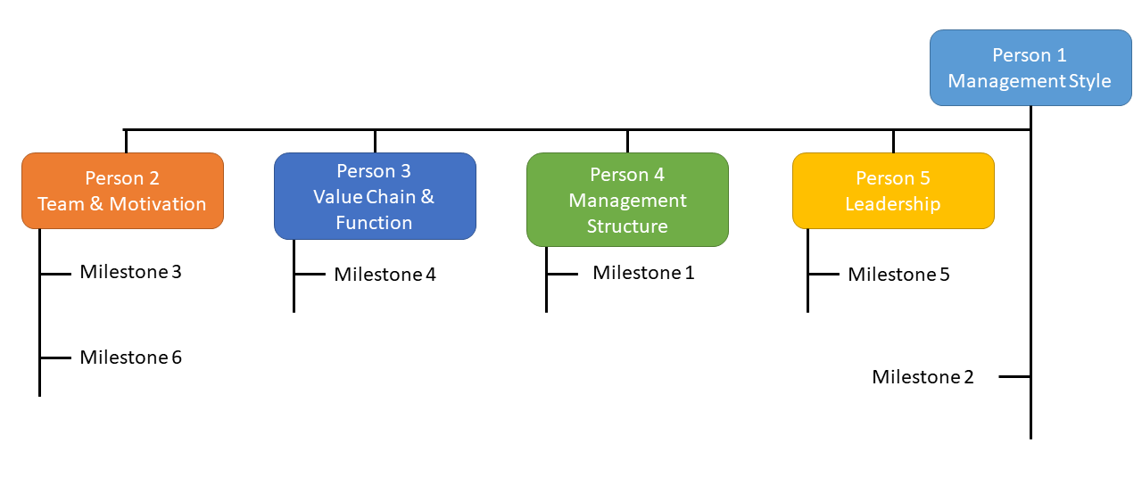

References
Certo, S. and Certo, S., 2019. Modern Management. Harlow, United Kingdom: Pearson Education Canada.
Daft, R. and Lane, P., 2015. Leadership. Stamford: Cengage Learning.
Hodgetts, R. and Kuratko, D., 2012. Effective Small Business Management. New York: John Wiley & Sons.
Koreimann, D., 2015. Management. Berlin/Boston: Walter de Gruyter GmbH.
Minkes, A. and Nuttall, C., 2015. Business Behaviour & Management Structure. New York: St. Martin's Press.
Reference for Business, 2020. Google, Inc. - Company Profile, Information, Business Description, History, Background Information On Google, Inc.. [online] Referenceforbusiness.com. Available at: <https://www.referenceforbusiness.com/history2/9/Google-Inc.html> [Accessed 19 August 2020].

