ORGANISATIONAL CONSULTANCYCAESARS PALACE

Student name-Parbes Ali
Student ID- 2127517
BMIH 6005
CAESARS PALACE
(Las Vegas, USA)

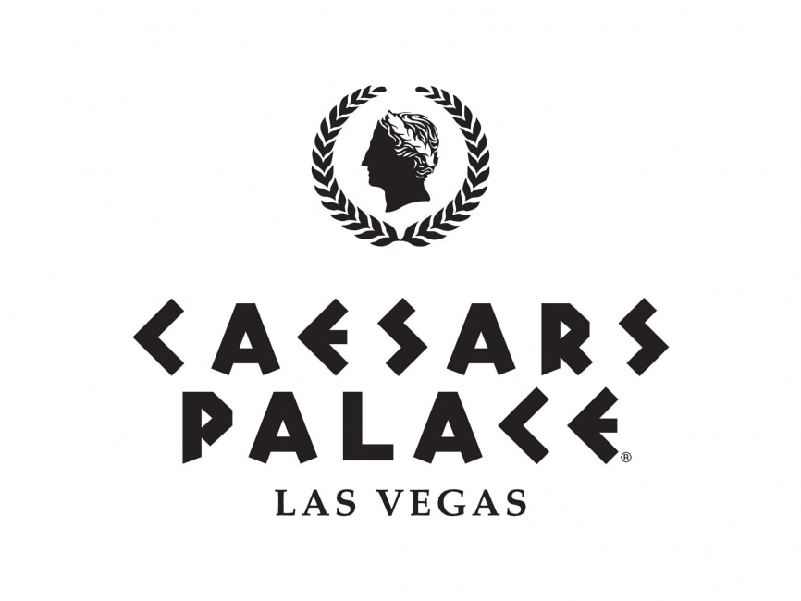
Table of Contents
Introduction 5
Analysis 6
Identified issue for the hotel 6
Causes behind the issue 7
Impact of the issue on the hotel 8
PESTLE analysis 9
SWOT analysis 11
TOWS analysis 13
Recommendations and Change Management 15
Mitigating the Negative Feedback 15
Diminishing the impact of Cyberattack 15
Improving the Quality of Services 16
Eradicating the System Errors 16
Removal of Technological Threats 17
Change management strategies 17
Expected outcomes of the recommendations 19
Associated costs to implement the recommendations 19
Action Plan 20
Conclusion 23
Reference List 25

Executive summary
Caesars Palace is a luxury hotel in Las Vegas which includes services such as a casino, stripping club, gaming zone, and so on. The hotel has attracted customers throughout the world through its services and fine dining options by incorporating the services of famous celebrity chefs like Gordon Ramsay. The hotel has engaged customers in an effective manner by providing 24-hour room service options along with various other services like spas and massages. This report has considered the services of Caesars Palace and has made a consultancy report for the management of the hotel which will help them to overcome any issues that have been bothering the growth of the organisation. In this context, it can be said that the first and foremost important activity performed in the report is to identify issues faced by Caesars Palace and critically analyse them to understand the reasons behind them as well as the impact of the issues.
Caesars Palace has been struggling with the issue of negative feedback from customers due to its poor quality of services which has caused reputational damage for the hotel. Various feedback on websites like TripAdvisor has showcased that customers wrote about their different experiences while staying in the same category room. This created a sense of dissatisfaction among customers which impacted the reputation of the hotel negatively and reduced the rating of Caesars Palace. Along with this, it has also been examined in this report that the hotel faced a cyber-attack in the last year which stopped several operations of the organisation. This created a sense of urgency in the hotel as well as a sense of tension among customers which is a major drawback of the hotel. Through keen speculations, it has been critically examined in this report that due to the existing vulnerabilities of the existing system, Caesars Palace has faced the challenge of cyber-attacks.
Apart from this, it has also been identified that Caesars Palace has failed to maintain the quality of its services as it did not fulfil the demands of customers. Due to this reason, customers posted negative feedback regarding the hotel which reduced the long-built reputation of Caesars Palace. This consultancy report has examined the impact of these issues faced by Caesars Palace which has shown that the inaccessible services due to cyber-attacks left customers with an unpleasant experience. To identify the issues and evaluate those in an effective manner, this report has considered various models and frameworks such as PESTLE analysis, SWOT analysis, and TOWS analysis. Among these, the PESTLE analysis has helped to analyse the macro environment of the hotel through which it has been evaluated that only social, technological, and legal factors are creating issues for the hotel. On the other hand, the SWOT analysis and TOWS analysis have critically examined the microenvironment of the hotel. These models allowed to identify and understand the internal strengths and weaknesses of Caesars Palace as well as external opportunities and threats of the hotel.
The analysis of the framework helped to understand that the lack of training and understanding of the needs of customers are hampering the service quality of Caesars Palace and is impacting its reputation negatively. The report has identified potential recommendations for the client as well through which the identified issues can be resolved. In this context, the report includes strategies such as improving internal service quality, providing necessary training and support to employees, introducing technological advancements, and removing technological threats which are helpful for the hotel. Along with this, the report has also included change management strategies for the organisation which will allow the management to implement the new changes in an effective manner. In this respect, various strategies for change management along with theories of change management have been discussed elaborately here. Lewin’s change management model can be utilised in this context which will help employees of Caesars Palace to welcome the new changes for the betterment of the hotel.
The change management strategies and the necessary actions for Caesars Palace can be implemented through the application of an action plan which is provided in this consultancy report. The issue of service quality at Caesars Palace needs to be improved to attend and attract more customers globally. That is why the action plan needs to be implemented in the hotel which will help the organisation to achieve the mission and vision in an effective manner. This shows that Caesars Palace can improve its quality of services by executing several activities based on the importance of priorities of the organisation. The consultancy report shows that the main issue of negative feedback from customers can be overcome through the improvement of services which includes providing employee training, introducing personalised services, and fulfilling the needs of customers efficiently. This will ensure that the hotel is able to have engaged customers and is also building customer trust which is vital for the hospitality industry. The need for technological advancements has also been identified here which will not only ensure that the risks of cyberattacks are reduced but also make sure that employee performance is improved.

Introduction
In the rapidly changing business dynamics, organisations often struggle to provide the best services to their customers and stay ahead in the industry. This causes reputational damage for the organisation which is why consulting a firm for possible solutions can be a strategic way to deal with the ongoing problems. This report will focus on the hotel “Caesars Palace” which is located in Las Vegas in the United States. The hotel was established in the year 1966 and has been running its services for a really long time which is why it has become one of the most renowned hotels in Las Vegas. The iconic Caesars Palace is a tribute to the richness of Rome which offers a large empire full of entertainment, fine dining facilities, a gaming zone, and a happening nightlife with a central Strip location (Caesars.com, 2024a).
Caesars Palace has a grand offering of 4000 guest rooms which are distributed in six distinct towers which have also been renovated in recent times. The palace is home to renowned celebrity chefs like Gordon Ramsay and Bobby Flay which gives a lifetime experience to the diners. In this context, it is also seen that the hotel provided luxurious hotel rooms which have multiple facilities such as climate control, in-room massages, 24-hour room service, a minibar, and so on (Caesars.com, 2024b). Apart from this, the hotel also provides various spa services for customers which makes their stay even more luxurious which is why the hotel is preferred by a lot of guests. Although it might seem that all is good in the Caesars palace it still faces some issues which is making it hard for the hotel to attract more customers in an effective manner. As a consultant from Campbell Tickle, the problems faced by the hotel will be solved by first analysing the situation of the hotel through the microenvironment and macro environment analysis. After the analysis, the hotel will be provided with some recommendations and strategies to implement change management which is important for better outcomes in the future.
Campbell Tickle is a renowned consultancy firm in the UK which has been established for over 20 years and has been working with more than 1000 organisations all across the UK, Ireland, and beyond (Campbelltickell.com, 2024). Not only this the firm has also provided its services to central and local government, commercial organisations, charities, and whatnot. The services of the firm include strategy and governance, finance and business planning, risk and assurance, regulation and troubleshooting, human resources and recruiting, and so on. The diverse range of services will be helpful for the consultant to attend to the issues that have been faced by Caesars Palace and help the hotel overcome those in an effective manner.
Through this consultancy report, the hotel’s issues will be identified based on some important frameworks such as SWOT, PESTLE, and TOWS analysis. Along with this, the report will include various recommendations and change management strategies which will also follow some theoretical frameworks. This will help the organisation to implement new working patterns in an effective manner which will be beneficial for the future. An action plan for the organisation will also be presented in this report which will be useful for the hotel to plan its operations accordingly as per importance. The hotel will be able to understand the causes behind the issues faced through this report which is impacting the reputation negatively. Thus, it can be said that the consultancy report will bring positive changes to the operations of Caesars Palace and it will be able to stay at the top of its game again.

Analysis

Identified issue for the hotel
Negative customer feedback and reputational damage
Customer feedback is one of the most vital components in building a positive brand value in the industry. Studies have argued that the provision of feedback is directly linked to the customer and brand in an evaluative process. Feedback behaviour is considered an intimate behaviour which leads to expectations of improvement. Thus, it can be said that feedback is expected to increase perceptions of the quality value of an organisation (France et al., 2020). However, it is seen that the customer feedback for Caesars Palace is not positive in recent times. Many customers have complained on various websites that the service of Caesars Palace has left them disappointed which is why they have given negative feedback about the hotel. This is one of the most critical issues that has been bothering Caesars Palace and is also causing reputational damage for the brand. Various feedback on websites such as TripAdvisor shows that the quality of services by the hotel is not up to the mark for customers. Customers received different types of services while staying in the same charging rooms (Tripadvisor.com, 2024). The issue of negative customer feedback is causing reputational damage for the hotel which is a major challenge to staying relevant in the industry.
Cyberattack
Another major issue that has been faced by Caesars Palace is the issue of cyberattack. It is seen that in current times, the Internet allows companies of various sizes to conduct business in the global context which makes them vulnerable to the threat of cyber-attacks at the same time. Cyber-attacks are unauthorised interceptions of data by hackers who have the intention to obtain or manipulate data for harmful purposes (Udofot and Topchyan, 2020). Caesars Entertainment which is the patron organisation of Caesars Palace faced cyber-attacks on September 2023 which created a huge issue of information safety for the hotel. Reports said that the hackers were able to access some customer information such as driver’s license information, social security numbers, and so on. Not only this but due to the cyberattack reservation services, casino operations, and some booking operations were inaccessible (Collier, 2023). This created a huge issue for the hotel as customers were concerned about their professional information being hacked by outsiders.

Causes behind the issue
Service quality
Another issue that has been identified in this case is the issue of service quality which is faced by multiple customers. In this regard, it can be said that service quality impacts the satisfaction of a guest through the service and performance of the organisation. It is considered an approach to increase the effectiveness, competitiveness, and flexibility of the hotel (Ali et al., 2021). However, Caesars Palace is unable to provide effective service to each guest which is why the first issue of negative feedback is caused. In this context, it is seen that studies have argued that the firms operating in the hospitality industry need to meet the needs and expectations of customers by providing excellent quality services (Mouzaek et al., 2021). This helps organisations to meet their performance objectives and improve financial performance as well. However, the performance of the hotel Caesars has deteriorated recently which has caused negative feedback and reputational damage for the hotel. It also reduced customer satisfaction which is a huge drawback for the firm.
Vulnerabilities of Existing System Errors
One of the main reasons behind the cyberattack faced by the hotel is the vulnerability of the structure of computer systems and communication networks. It is seen that the misconfigurations and deficiencies in hardware, software, and computer networks reveal the systems to hackers. Due to these increasing deficiencies, the system is becoming powerless against cyberattacks (Aslan et al., 2023) which have also caused cyberattacks in Caesars. Apart from this, it is also seen that the skills gap in the knowledge of cybersecurity is another reason that causes cyberattacks in organisations. Studies have shown that most employees of an organisation have a skills gap in cybersecurity knowledge which makes the company vulnerable to cyber-attacks (Catal et al., 2023). A similar situation has been seen in the case of Caesars Palace as the company faced a cyber-attack which stopped its multiple operations.

Impact of the issue on the hotel
The issues that have been identified in the previous section have caused a negative impact on the hotel as negative feedback and reputational damage can reduce the financial performance of the hotel. The figure presented below shows that the hotel business of Caesars Entertainment which is the Caesars Palace is not able to generate enough revenue. Although the Entertainment company was able to generate 6 billion US dollars in 2022 from the casino business (Statista.com, 2023) it still failed to generate enough revenue from the hotel.
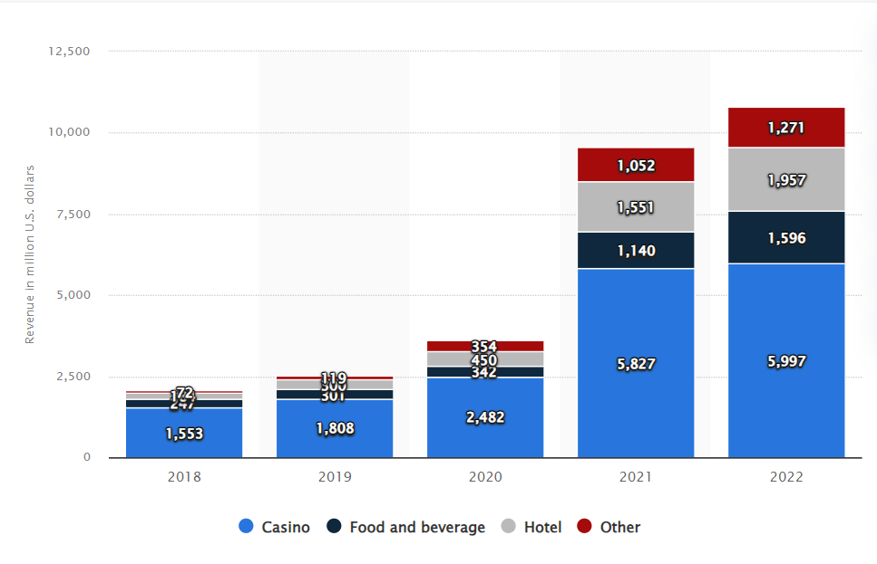
Figure: Revenue growth of Caesars Entertainment segment wise globally from 2018 to 2022
(Source: Statista.com, 2023)
By critically reviewing the statistics, it can be said that the negative feedback from guests has impacted the revenue of Caesars Palace negatively. In this context, it is seen that negative reviews can lead to a decrease in sales, customer trust and eventually the profitability of the organisation. A study by BrightLocal stated that 94% of consumers have reported that they avoid businesses with negative reviews whereas 57% of consumers only trust businesses that have 4 stars or more ratings (Kumar, 2023). This shows that the impact of negative feedback can have a negative consequence on the profitability of Caesars Palace. Along with this, it has also been examined from various studies that the quality of service is important for customers which promotes customer satisfaction (Supriyanto et al., 2021). Unfortunately, it has been explored that the hotel is struggling to provide customer satisfaction through its services which is why the reputation of the hotel is damaged.
On the other hand, it has also been evaluated that the issue of cyberattacks is detrimental to the reputation of a hotel and destroys the trust of customers (Florido-Benítez, 2024). This can even lead to financial, legal, and regulatory implications and guests might receive a negative experience due to this. As it is already discussed, due to the cyberattack, various services of the hotel were inaccessible it can be said that this left the guests with an unpleasant experience. This impacts the hotel’s reputation negatively and might reduce the number of customers as well.

PESTLE analysis
Political | - Political factors include aspects like government regulations and policies, political stability and instability, taxation policies, and so on (Serdyuk, 2023).  - These factors might impact the business of Caesars Palace negatively but currently, the issues faced by the hotel are not caused by any of these.  - This shows that the hotel is not bothered by external political factors as of now.
Economical | - Studies have argued that economic factors involve economic growth, exchange rates, inflation rates, unemployment, income of consumers, and so on (Juhola, 2020).  - In this context, it can be said that the hotel is operating in a decent economy and also has customers who are economically stable.  - That is why this is not an external threat factor for the hotel.
Social | - Social factors consist of demographic and cultural aspects of the macro environment which also includes the behaviour of customers (Susilo, 2020).  - In this context, it is seen that the customers visiting the hotel expect high-quality services which are not provided by Caesars.  - That is why this is impacting the hotel’s reputation negatively as social factors are not working for the advantage of the company.
Technological | - Technological advancements have acted as both a boon and a bane for the hospitality and tourism industry.  - New technologies have increased the risk factors for the industry (Puškar and Sprčić, 2021) which is seen in the case of Caesars Palace.  - The organisation is vulnerable to technological threats which have impacted the organisation’s reputation negatively.
Legal | - Legal factors include laws and regulations related to consumer rights, employee protection laws, and so on.  - In this context, it is seen that hotels are subjected to a huge number of laws and regulations in terms of local laws as well as international laws (Codo, 2018).  - The need to accumulate all these laws and follow them puts excessive pressure on the hospitality industry.  - Caesars Palace also faces this pressure as it needs to maintain consumer rights laws so that it is not accused of any negative behaviours.
Environmental | - Studies have argued that the hospitality industry is hugely affected by environmental uncertainties (Darvishmotevali et al., 2020).  - In this context, it can be said that the Caesars Palace is an eco-friendly hotel which shows that it is aware of the condition of the environment.  - Thus, it can be evaluated that the external factor of the environment is harmless for the hotel and is not a threat as well.  - The hotel considers the betterment of the environment which is a positive side of Caesars Palace.

SWOT analysis
Strengths  - Caesars Palace is a well-known hotel in the USA which is preferred by customers due to the various strengths of the hotel.  - In this context, it is seen that the location of the place is one of the major strengths of the hotel which is easily accessible to tourists.  - Along with this, the hotel has various parts which include a casino, luxury rooms, parking areas, and so on which are attractive to customers (Sagar, 2020). | Weaknesses  - Although there are various strengths of the hotel it still has some weaknesses which are faced by customers.  - It is seen from various feedback from customers that the check-in options of the hotel are not ideal for customers as they have to wait for a long time (Tripadvisor.com, 2024).  - Along with this, the services of the hotel are also pretty expensive which is another weakness of the organisation.
Opportunities  - Caesars Palace has a lot of opportunities that can help the organisation to reach a wider audience.  - With the help of digital marketing opportunities, the hotel can have two-way communication with customers which attracts more customers effectively (Dimitrios et al., 2023). | Threats  - The company faced many threats among which the cyber-attack is one of the main threats that hampered the reputation of the company.  - Apart from this, changing customer interests can also be a threat to the hotel.

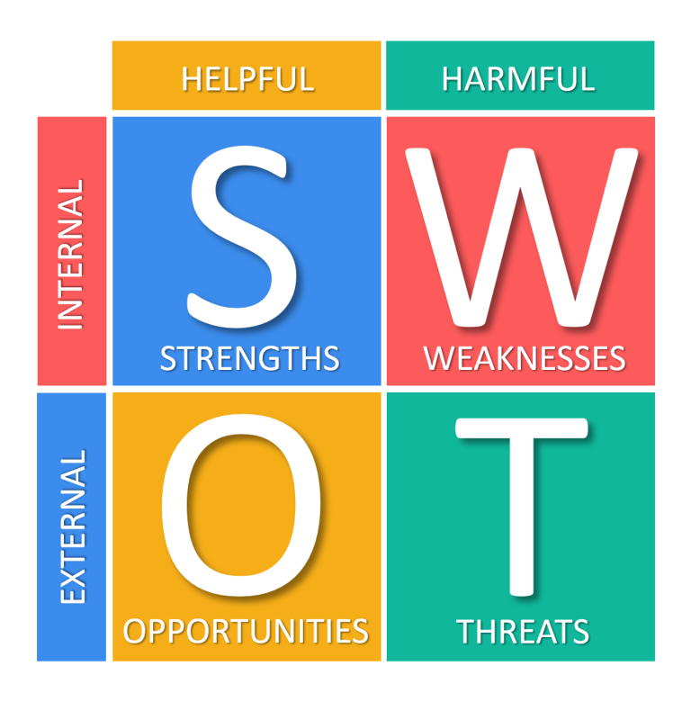
Figure: SWOT analysis
(Source: Self-made)

TOWS analysis
The TOWS analysis is a tool which helps to identify and analyse threats, opportunities, weaknesses, and strengths of an organisation. Although it has the same components as the SWOT analysis it still has a different approach to analyse a company’s situation in the market (Indeed.com, 2023).
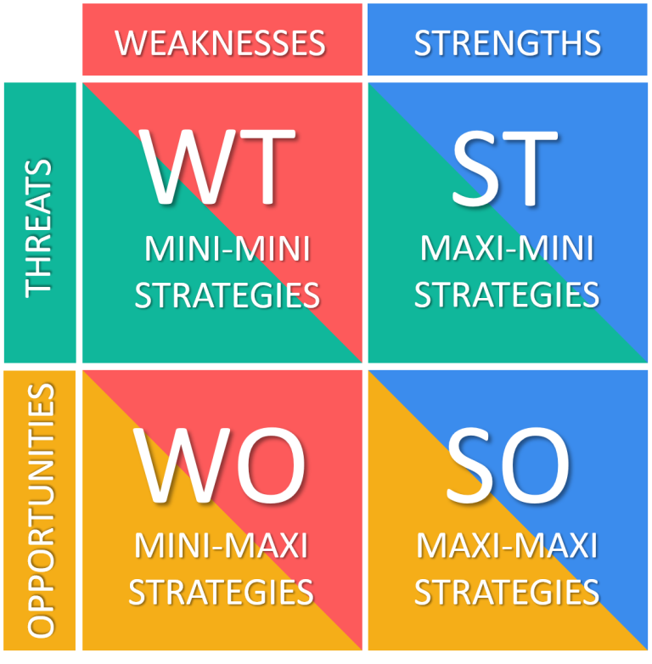
Figure: TOWS matrix
(Source: Self-made)
Strengths-opportunities (SO)  - The hotel can use its internal strengths to utilise the external opportunities for the growth of the company.  - In this context, it can be said that the location of the place can be utilised through digital marketing to attract more customers. | Weaknesses-opportunities (WO)  - Through the opportunities, the hotel can overcome its weaknesses in an effective manner.  - Utilising the opportunity of digital marketing to promote the services of the hotel will help Caesars to overcome its weaknesses.
Strengths-threats (ST)  - The strengths of the hotel can be utilised to eliminate the threats.  - In this context, it can be said that using the various services of the hotel can be helpful in adjusting to the threat of changing consumer behaviour. | Weaknesses-threats (WT)  - The strategy in this context requires to have effective ways that will help to reduce weaknesses and threats to the hotel.  - Thus, it can be said that Caesars need to focus on reducing cyber-attack threats and long waiting times at the lounge area during check-in.

Recommendations and Change Management

Mitigating the Negative Feedback
From the discussion made earlier in this assignment, it can be stated that negative reviews are found from the visitors who have gained services from this organisation. The reviews from TripAdvisor have depicted that the services offered by this hotel brought to the fore some reputational damage in the industry (Tripadvisor.com, 2024). This is the reason why business leaders of Caesars Palace have perceived the significance of the quality of food and other areas in the current scenario (Demirciftci et al., 2023). Along with that, marketing strategies need to be implemented so that sustainable and profitable services can be provided to consumers in the upcoming days.
In support of that, numerous researchers are of the opinion that internal service quality must be enhanced to attain better customer feedback because the quality of service can be impactful in multiplying the number of consumers in the near future (Wu et al., 2021). Apart from that, appropriate training and guidance should be given to the personnel who can be able to perform their duties in a coherent manner. In addition to this, the employees must be empowered to become purpose-driven so that any kind of adverse situation can be resolved and opportunities can be availed of (Solomon, 2021).

Diminishing the impact of Cyberattack
The usage of digital tools in the management of the Caesars Palace is crucial. In this regard, for keeping the guest information, technical equipment is helping the employees. However, the regulation of technical tools has also brought forth some indecent activities such as the loss of essential data as well as data breaches that have stirred the trust and faith of visitors in the contemporary scenario (Shabani and Munir, 2020). In this respect, Caesars Palace should implement resources and expertise to eradicate the instances of cyberattacks so that the operation of the business can be administered in the near future (Appiah et al., 2020).
The incorporation of Artificial Intelligence and Machine Learning algorithms can be useful in order to detect unusual patterns (Karagiannis, 2024). Thus, the powerful risks can be thwarted from attacking the systems of the hospitality industry. Additionally, encryption must be included so that the sensitive data can be preserved from the cybercriminals. Apart from that, an open-system communication protocol should be included to maintain the safety and security of the information gathered from the visitors in order to operate the hotel (Süzen, 2020). Therefore, by the application of these protocols and infrastructure, the instances of cyberattacks can be reduced.

Improving the Quality of Services
By going through several research studies, it is identified that customer satisfaction and service quality can go hand in hand and this is the reason why poor quality of service can lead towards the destruction of the reputation of organisations in the hospitality sector (PJ et al., 2023). In this context, self-audits have been crucial with the objective of highlighting the transformations that could be imperative for increasing the quality of services. With the help of this activity, the performance of the workers can be measured and improvement can be taken into account. In this connection, it can be mentioned that the utilisation of RAISA (Robots, Artificial Intelligence and Service Automation) can be vehemently significant with the objective of tackling the issues related to food and process innovation (Naumov, 2019).
Along with that, several types of Inspection Apps can be helpful in monitoring the services that have been offered in the hospitality sector.
In support of that, innumerable researchers have illustrated that the implementation of smart technologies can be another factor that can elevate the quality of services and the visitors can be gratified since they would be gaining a positive impact from the administration of services in a technologically advanced manner (Yang et al., 2021). Apart from that, the experience of the guests must be personalised so that their services can be provided in accordance with the requirements and problems of the consumers in times to come.

Eradicating the System Errors
The business leaders of Caesars Palace must act by keeping in mind the changing preferences of the consumers so that the business can be expanded in the near future. In this respect, error management training must be essential with the objective of bringing forth developmental approaches to attain the beneficial aspects in the upcoming times (Yao et al., 2019). The Corporate Social Responsibilities (CSR) need to be maintained by the business leaders of this hotel. However, the implementation of these practices can be expensive (Boulhaga et al., 2023). Due to this, a huge amount of investment has been necessary to support the hotel and remove the barriers from the systems of regulation of this hotel.
In addition to that, financial resources have been mandatory so that any kind of poor facilities can be annihilated and the business can be regulated in the market by developing the competition (Crespí-Cladera et al., 2021). Along with that, the application of an Automated Property Management System (PMS) can be inevitable with the objective of offering an error-free amenity to the visitors. In this way, reservations and cancellations can be nurtured in the near future. In this connection, the communication and other skill gaps must be bridged (Mnyakin, 2023). Thus, data security can be maintained with the help of multiple software systems in the current scenario.

Removal of Technological Threats
In order to develop the technical tools and remove the technological threats, digital transformation is of utmost importance. In this regard, anti-virus and anti-malware must be installed so that malware and viruses can be easily detected and the hospitality industry can be administered in a safe and healthy as well as sound manner (Moses et al., 2020). Simultaneously, multi-factor authentication is inevitable for handling the services that are offered through the implementation of the technical tools or equipment. Along with that, different policies need to be applied for utilising renewable energies so that facilities such as “green hotels” can be maintained by Caesars Palace in times to come (Navratil et al., 2019). Business owners must perceive that consumers are generally attracted towards hotels that develop sustainability in the hospitality industry and can maintain environmental impacts in a strong manner. Thus, differentiation can be maintained in the distribution of the services in the hospitality sector.

Change management strategies
Removing barriers through effective leadership
During the implementation of various changes in the hotel, it can be seen that the organisation is facing various barriers that can hamper the process of change management. That is why removing the barriers faced by the organisation is necessary which can be achieved through the implementation of effective leadership. Leadership is an influence leadership between leaders and followers who have the intention to bring real changes in the organisation (Ciulla and Ciulla, 2020). In this context, taking the approach of transformational leadership will be helpful for the hotel. Transformational leadership has a great impact on creating organisational value by motivating employees to perform better (Demirtaş et al., 2020). This will help Caesars Palace to implement change management efficiently.
Involving employees in the process
Studies have argued that employee involvement and commitment are strongly connected to the success of constant improvement of the company (van Assen, 2021). That is why it is important to involve employees in the process of change management. This will engage employees in the entire process of change management. In this context, it can also be identified that employees who are actually involved in their respective jobs have the ability to suggest and implement improvements for the organisation (Tortorella et al., 2021). This is a great advantage for the decision-making process of the organisation which will help Caesars Palace to make important decisions regarding the change management process.
Providing training and support
The change management process often requires to possess new skills so that employees are able to adapt to new processes. That is why providing employees with adequate training and support can be helpful for the organisation to ensure that employees are able to handle the change (McCreery, 2023). In this context, it is argued that training is not only considered to train workers physically and mentally for the organisation’s improvement but it also helps to improve the current status of skills and information of employees (Burhan Ismael et al., 2021). Through this, employees can change their ways of thinking and performing any tasks which will be beneficial for the Caesars Palace.
Lewin’s change management model
Through the use of Kurt Lewin’s change management model, Caesars Palace can implement change management strategies and the processes of change in an effective manner. The model compiles three stages which are unfreezing, moving, and refreezing which help to adapt to the new change accordingly (Burnes, B., 2020). The first step of unfreezing involves the destabilising process of the status quo by creating the need for the upcoming change (Errida and Lotfi, 2021). This will prepare Caesars Palace and its employees for the approaching change. After this, the step of moving involves the process of approaching a new state through the participation and involvement of employees (Bekmukhambetova, 2021). Planned actions in the organisation take place to change the behaviour of employees which will help Caesars Palace to influence employees’ behaviour positively. Lastly, the stage of refreezing or freezing is a new level for the organisation which seeks to have a new balanced state to ensure the safety of the company (Tran and Gandolfi, 2020). Through policy setting, rewards, and so on, Caesars Palace can stabilise the new changes in the organisation in an effective manner.
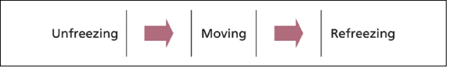
Figure: Stages of Lewin’s change management model
(Source: Self-made)

Expected outcomes of the recommendations
The recommendations that have been provided in the previous section will have positive outcomes for the organisation. Studies have argued that the quality of services provided by an organisation satisfies the needs of customers (Mahsyar and Surapati, 2020). Thus, it is critically evaluated that by improving the service quality, customers will be satisfied and the overflow of negative feedback will also reduce significantly. In addition to this, it is seen that cybersecurity protocols enhance the privacy and security of consumers which prevents cyber threats (Florido-Benítez, 2024). That is why the approach of reducing cyber-attacks and building cyber-security will positively impact Caesars Palace. Along with this, other recommendations related to reducing systems errors and technological threats also have the potential to improve the technological efficiency of the organisation which is a positive aspect for the hotel.
In accordance with this, it can be said that the recommendations will bring various benefits as well. The very first benefit experienced by the hotel will be improved customer satisfaction which is the outcome of improved service quality. It is also seen that customers evaluate the percentage of customer satisfaction provided by an organisation (Nunkoo et al., 2020). That is why it can be said that improving service quality will not only improve customer satisfaction but will also attract more customers to the hotel.

Associated costs to implement the recommendations
The recommendations that have been mentioned in the above section include cost amounts which mostly include training costs for Caesars Palace. It is argued that most companies spend 2% of the employee’s total cost-to-company on training which shows that training costs are huge for companies (Linkedin.com, 2024). This is also dependent on the size of the company and for a company like Caesars Palace, the estimated cost of training will be around 1.28 billion US dollars in a year based on the yearly estimate of 1280 dollars for each employee. Apart from this, it is seen that most hotels spend 2% of their net room revenue on technological advancements which is also around 1 billion for Caesars Palace. During the implementation of better technology to reduce the threat of cyberattacks, Caesars Palace will need to spend around 1 billion US dollars. However, it is seen that technological advancements lead hotel operations to improved efficiency and reduced labour costs (Linkedin.com, 2023). Thus, it can be said that the increased cost of technology can be balanced by reducing labour costs which will be beneficial for Caesars Palace.

Action Plan
An action plan is a very useful tool for an organisation which helps the business to prioritise the goals as per importance. This helps to map out the strategies to achieve the long-term goals of a business (Tait, 2020) which will help the hotel to utilise its energy and resources on important business objectives. The following table will include the issues faced by Caesars Palace which can be resolved with effective solutions.

Number | Problem | Solution | Desired outcome | Time scale | Completion date | Planned budget
 | Negative customer feedback | To improve the quality of services by impacting the attitudes and behaviours of employees positively. An attitudinal commitment of employees is related to service quality (Lee et al., 2020) which is why improving the attitudes of employees is necessary. | Improved service quality not only improves customer satisfaction but also builds customer loyalty (Anabila et al., 20220. This will reduce negative feedback from customers effectively as well. | 2 months | 01.07.2024 | 50,000 US dollars
 | Issue of cyber-attack | To implement cybersecurity by investing in cybersecurity. | Cybersecurity allows an organisation to have a flexible framework to deal with the current challenges faced during a digital era (Safitra et al., 2023). It will reduce the threats of cyber-attacks from Caesars Palace. | 3 months | 01.08.2024 | 60,000 US dollars
 | Poor quality of service | To provide training on a regular basis with the help of new technologies will ensure that service quality is improved (Fernandez, 2021).  Along with this, providing personalised services to customers through voice assistance can improve the quality of services (Buhalis and Moldavska, 2022). | Providing training to employees regularly improves employee motivation (Al-kharabsheh et al., 2022) which is beneficial for Caesars Palace to achieve better quality of services. | 3 months | 10.08.2024 | 1.28 billion US dollars yearly
 | Unfulfilled customer needs | To listen and analyse customer feedback through social media pages or other websites.  In addition to this, solving the problems faced by customers as soon as possible is necessary (Indeed.com, 2022). | Taking customer feedback seriously will make sure that the company is introducing activities according to the needs of customers which will engage customers effectively. | 3- 4 months | 10.09.2024 | 30,000 US dollars.

Conclusion
The consultancy report has focused on the hotel Caesars Palace and has provided an in-depth analysis of the business and the challenges faced by it which is hampering the business of the hotel. Caesars Palace is a renowned hotel which has been present in Las Vegas providing various types of services to worldwide tourists. In this consultancy report, the overview of the organisation has been presented through an in-depth analysis which has helped to identify the issue that has been faced by the hotel currently. The issue identified in this report includes negative feedback from customers along with the outbreak of cyber-attacks which stopped the operations of the hotel. Through the consultancy report, the causes behind these issues as well as the negative impact of the issues have been mentioned. This has helped to understand that the service quality of the hotel is not up to the mark which is why customers have provided negative feedback on various websites.
After this, the consultancy report has provided an analysis of the microenvironment and macro environment of the hotel through the PESTLE, SWOT, and TOWS framework. This will help the management of the hotel to identify its strengths, weaknesses, opportunities, and potential threats. Through this, Caesars Palace will be able to improve its future actions which will engage customers in an effective manner. After critically assessing the issues faced by Caesars Palace, the report has presented some recommendations which are very beneficial for the hotel to improve its current situation in the hospitality industry. The section of recommendations includes improving customer service quality to mitigate the challenge of negative feedback along with overcoming technological barriers in an effective manner. The recommendations will have certain outcomes which are expected to be positive for the hotel’s future which has also been discussed in a detailed manner in this report.
After listing the possible solutions for Caesars Palace, the report has presented a detailed action plan that will help the hotel to identify its future actions based on the importance of the activities. The actions have been mentioned as per their seriousness in the context of Caesars Palace which will be beneficial for the hotel’s future. It has been identified that improving the quality of service by training employees is one of the main findings of the report. This report shows that working for organisations like Caesars Palace is a great opportunity for collaboration which helps to identify the important factors to be considered while identifying any issues of an organisation. It has helped to improve the knowledge of an individual which can be beneficial for them in the future. After the completion of this consultancy report, it can be said that Caesars Palace needs to identify the preferences and needs of customers so that it can improve its quality of services to stay relevant in the industry.

Reference List
Ali, B.J., Gardi, B., Jabbar Othman, B., Ali Ahmed, S., Burhan Ismael, N., Abdalla Hamza, P., Mahmood Aziz, H., Sabir, B.Y., Sorguli, S. and Anwar, G., 2021. Hotel service quality: The impact of service quality on customer satisfaction in hospitality. Ali, BJ, Gardi, B., Othman, BJ, Ahmed, SA, Ismael, NB, Hamza, PA, Aziz, HM, Sabir, BY, Anwar, G.(2021). Hotel Service Quality: The Impact of Service Quality on Customer Satisfaction in Hospitality. International Journal of Engineering, Business and Management, 5(3), pp.14-28. (Accessed: 27 April 2024).
Al-kharabsheh, S.A., Attiany, M.S., Alshawabkeh, R.O.K., Hamadneh, S. and Alshurideh, M.T., 2022. The impact of digital HRM on employee performance through employee motivation. International Journal of Data and Network Science, 7(1), pp.275-282.
Anabila, P., Ameyibor, L.E.K., Allan, M.M. and Alomenu, C., 2022. Service quality and customer loyalty in Ghana’s hotel industry: The mediation effects of satisfaction and delight. Journal of Quality Assurance in Hospitality & Tourism, 23(3), pp.748-770.
Appiah, G., Amankwah-Amoah, J. and Liu, Y.L., 2020. Organizational architecture, resilience, and cyberattacks. IEEE Transactions on Engineering Management, 69(5), pp.2218-2233. (Accessed: 25 April 2024).
Aslan, Ö., Aktuğ, S.S., Ozkan-Okay, M., Yilmaz, A.A. and Akin, E., 2023. A comprehensive review of cyber security vulnerabilities, threats, attacks, and solutions. Electronics, 12(6), p.1333.
Bekmukhambetova, A., 2021. Comparative analysis of change management models based on an exploratory literature review.
Boulhaga, M., Bouri, A., Elamer, A.A. and Ibrahim, B.A., 2023. Environmental, social and governance ratings and firm performance: The moderating role of internal control quality. Corporate Social Responsibility and Environmental Management, 30(1), pp.134-145. (Accessed: 25 April 2024).
Buhalis, D. and Moldavska, I., 2022. Voice assistants in hospitality: using artificial intelligence for customer service. Journal of Hospitality and Tourism Technology, 13(3), pp.386-403.
Burhan Ismael, N., Jabbar Othman, B., Gardi, B., Abdalla Hamza, P., Sorguli, S., Mahmood Aziz, H., Ali Ahmed, S., Sabir, B.Y., Ali, B.J. and Anwar, G., 2021. The role of training and development on organizational effectiveness. Ismael, NB, Othman, BJ, Gardi, B., Hamza, PA, Sorguli, S., Aziz, HM, Ahmed, SA, Sabir, BY, Ali, BJ, Anwar, G.(2021). The Role of Training and Development on Organizational effectiveness. International Journal of Engineering, Business and Management, 5(3), pp.15-24.
Burnes, B., 2020. The origins of Lewin’s three-step model of change. The Journal of Applied Behavioral Science, 56(1), pp.32-59. (Accessed: 19 April 2024).
Caesars.com, 2024a. Las Vegas hotels on the Strip, See Hotels Around The Strip. Available at: https://www.caesars.com/las-vegas/hotels/on-the-strip#:~:text=The%20iconic%20Caesars%20Palace%20is,which%20have%20been%20recently%20renovated.
Caesars.com, 2024b. Secure and fast hotel reservations: Caesars Entertainment, Secure and fast hotel reservations | Caesars Entertainment. Available at: https://www.caesars.com/book/hotel-calendar?dateSearchFormat=flexible-dates&flexibleMonth=May&propCode=clv (Accessed: 27 April 2024).
Campbelltickell.com, 2024. About Us: Campbell Tickell: Consultancy & Recruitment For the charitable, not-for-profit & public sectors, Campbell Tickell | Consultancy & recruitment for the charitable, not-for-profit & public sectors. Available at: https://www.campbelltickell.com/about-us/ (Accessed: 22 April 2024).
Catal, C., Ozcan, A., Donmez, E. and Kasif, A., 2023. Analysis of cyber security knowledge gaps based on cyber security body of knowledge. Education and Information Technologies, 28(2), pp.1809-1831.
Ciulla, J.B. and Ciulla, J.B., 2020. The importance of leadership in shaping business values. The search for ethics in leadership, business, and beyond, pp.153-163.
Codo, X., 2018. How does regulation affect the hospitality industry?, LinkedIn. Available at: https://www.linkedin.com/pulse/how-does-regulation-affect-hospitality-industry-xavier-codo/ (Accessed: 28 April 2024).
Collier, K., 2023. Caesars Entertainment says it was also a victim of a cyberattack, NBCNews.com. Available at: https://www.nbcnews.com/tech/security/caesars-entertainment-says-was-also-victim-cyberattack-rcna105050 (Accessed: 21 April 2024).
Crespí-Cladera, R., Martín-Oliver, A. and Pascual-Fuster, B., 2021. Financial distress in the hospitality industry during the Covid-19 disaster. Tourism Management, 85, p.104301. (Accessed: 25 April 2024).
Darvishmotevali, M., Altinay, L. and Köseoglu, M.A., 2020. The link between environmental uncertainty, organizational agility, and organizational creativity in the hotel industry. International journal of hospitality management, 87, p.102499.
Demirciftci, T., Belarmino, A. and Raab, C., 2023. An application of choice-based conjoint analysis to measure willingness to pay for casino buffets. International Hospitality Review. (Accessed: 24 April 2024)
Demirtaş, Ö., Bıckes, D.M., Yener, S. and Karaca, M., 2020. The influence of transformational leadership in organizations: The mediating role of meaningful work. Journal of Economy Culture and Society, (61), pp.153-172.
Dimitrios, B., Ioannis, R., Angelos, N. and Nikolaos, T., 2023. Digital marketing: The case of digital marketing strategies on luxurious hotels. Procedia Computer Science, 219, pp.688-696.
Errida, A. and Lotfi, B., 2021. The determinants of organizational change management success: Literature review and case study. International Journal of Engineering Business Management, 13, p.18479790211016273. (Accessed: 17 April 2024).
Fernandez, J., 2021. Tips to improve service quality at your hotel in the post pandemic era, LinkedIn. Available at: https://www.linkedin.com/pulse/tips-improve-service-quality-your-hotel-post-pandemic-juan/ (Accessed: 22 April 2024).
Florido-Benítez, L., 2024. The Cybersecurity Applied by Online Travel Agencies and Hotels to Protect Users’ Private Data in Smart Cities. Smart Cities, 7(1), pp.475-495. (Accessed: 17 April 2024).
Florido-Benítez, L., 2024. The Cybersecurity Applied by Online Travel Agencies and Hotels to Protect Users’ Private Data in Smart Cities. Smart Cities, 7(1), pp.475-495.
France, C., Grace, D., Lo Iacono, J. and Carlini, J., 2020. Exploring the interplay between customer perceived brand value and customer brand co-creation behaviour dimensions. Journal of brand Management, 27, pp.466-480. (Accessed: 16 April 2024).
Indeed.com, 2022. 16 tips to meet customer needs | indeed.com. Available at: https://www.indeed.com/career-advice/career-development/meet-customers (Accessed: 19 April 2024).
Indeed.com, 2023. What is a tows analysis? (definition and how to conduct it). Available at: https://uk.indeed.com/career-advice/career-development/what-is-tows-analysis (Accessed: 28 April 2024).
Juhola, J., 2020. Business Plan to Utilize the Ahjola Premises Located in Kainuu.
Karagiannis, M. (2024) Combatting cybersecurity threats in the hospitality industry, Medium. Available at: https://medium.com/hotel-tech/combatting-cybersecurity-threats-in-the-hospitality-industry-6b7a843e489c (Accessed: 25 April 2024).
Kumar, A., 2023. The impact of negative reviews on businesses and how to mitigate it, LinkedIn. Available at: https://www.linkedin.com/pulse/impact-negative-reviews-businesses-how-mitigate-anupam-kumar/ (Accessed: 25 April 2024).
Lee, S., Park, J., Back, K.J., Hyun, H. and Lee, S.H., 2020. The role of personality traits toward organizational commitments and service quality commitments. Frontiers in psychology, 11, p.631. (Accessed: 19 April 2024).
Linkedin.com, 2023. How technology reduces costs in hotel business, LinkedIn. Available at: https://www.linkedin.com/pulse/how-technology-reduces-costs-hotel-business-mugna-tech/ (Accessed: 20 April 2024).
Linkedin.com, 2024. The real cost of training, LinkedIn. Available at: https://www.linkedin.com/pulse/real-cost-training-courseplay-bug5c/ (Accessed: 23 April 2024).
Mahsyar, S. and Surapati, U., 2020. Effect of service quality and product quality on customer satisfaction and loyalty. International Journal of Economics, Business and Accounting Research (IJEBAR), 4(01).
McCreery, D., 2023. The Top 10 Change Management Strategies for successful organizational transformation, LinkedIn. Available at: https://www.linkedin.com/pulse/top-10-change-management-strategies-successful-david-mccreery/ (Accessed: 30 April 2024).
Mnyakin, M., 2023. Big Data in the Hospitality Industry: Prospects, Obstacles, and Strategies. International Journal of Business Intelligence and Big Data Analytics, 6(1), pp.12-22. (Accessed: 25 April 2024).
Moses, N.D., Victor, W.O., Abdulhamid, S.I.M. and Obada, S.L., 2020, April. Comparative Performance Analysis of Anti-virus Software. Information and Communication Technology and Applications: Third International Conference, ICTA 2020. (Accessed: 25 April 2024).
Mouzaek, E.L.E.N.A., Al Marzouqi, A.M.I.N.A., Alaali, N.A.D.E.R., Salloum, S.A., Aburayya, A.H.M.A.D. and Suson, R.O.B.E.R.T.O., 2021. An empirical investigation of the impact of service quality dimensions on guests satisfaction: A case study of Dubai Hotels. Journal of Contemporary Issues in Business and Government, 27(3), pp.1187-1199.
Naumov, N., 2019. The impact of robots, artificial intelligence, and service automation on service quality and service experience in hospitality. In Robots, artificial intelligence, and service automation in travel, tourism and hospitality (pp. 123-133). emerald publishing limited. (Accessed: 25 April 2024).
Navratil, J., Picha, K., Buchecker, M., Martinat, S., Svec, R., Brezinova, M. and Knotek, J., 2019. Visitors’ preferences of renewable energy options in “green” hotels. Renewable energy, 138, pp.1065-1077. (Accessed: 27 April 2024).
Nunkoo, R., Teeroovengadum, V., Ringle, C.M. and Sunnassee, V., 2020. Service quality and customer satisfaction: The moderating effects of hotel star rating. International Journal of Hospitality Management, 91, p.102414.
PJ, S., Singh, K., Kokkranikal, J., Bharadwaj, R., Rai, S. and Antony, J., 2023. Service quality and customer satisfaction in hospitality, leisure, sport and tourism: an assessment of research in Web of Science. Journal of Quality Assurance in Hospitality & Tourism, 24(1), pp.24-50. (Accessed: 29 April 2024).
Puškar, J. and Sprčić, D.M., 2021. APPLICATION OF CASH-FLOW-AT-RISK METHOD IN RISK ANALYSIS–CASE OF ARENA HOSPITALITY GROUP. COMPANY ANALYSIS, p.1. (Accessed: 19 April 2024).
Safitra, M.F., Lubis, M. and Fakhrurroja, H., 2023. Counterattacking cyber threats: A framework for the future of cybersecurity. Sustainability, 15(18), p.13369.
Sagar, A.D., 2020. Casino-A Punter's Paradise.
Serdyuk, A., 2023. Main factors of the external environment of the organisation and evaluated of environmental factors (based on practical aspects at the hotel" Time" enterprise case) (Doctoral dissertation, Private Higher Educational Establishment-Institute “Ukrainian-American Concordia University").
Shabani, N. and Munir, A., 2020. A review of cyber security issues in hospitality industry. In Intelligent Computing: Proceedings of the 2020 Computing Conference, Volume 3 (pp. 482-493). Springer International Publishing. (Accessed: 25 April 2024).
Solomon, M. (2021) Five hospitality principles to uplift customer service in any industry, Forbes. Available at: https://www.forbes.com/sites/micahsolomon/2021/03/09/five-hospitality-principles-to-uplift-customer-service-in-any-industry/?sh=3ab4f04122a2 (Accessed: 25 April 2024).
Statista.com, 2023. Caesars Entertainment: Revenue by segment worldwide 2022, Statista. Available at: https://www.statista.com/statistics/257624/revenue-of-caesars-entertainment-worldwide/ (Accessed: 26 April 2024).
Supriyanto, A., Wiyono, B.B. and Burhanuddin, B., 2021. Effects of service quality and customer satisfaction on loyalty of bank customers. Cogent Business & Management, 8(1), p.1937847.
Susilo, D., 2020. Macro-Regional Analysis of Tourism Entrepreneurship Environment in Bali: A Descriptive Study. International Journal of Economics, Business, and Entrepreneurship, 3(1), pp.1-13.
Süzen, A.A., 2020. A risk-assessment of cyber attacks and defense strategies in industry 4.0 ecosystem. International Journal of Computer Network and Information Security, 14(1), p.1. (Accessed: 25 April 2024).
Tait, B., 2020. How important is an action plan for your business?, LinkedIn. Available at: https://www.linkedin.com/pulse/how-important-action-plan-your-business-brian-tait-pcc/ (Accessed: 29 April 2024).
Tortorella, G., Miorando, R., Caiado, R., Nascimento, D. and Portioli Staudacher, A., 2021. The mediating effect of employees’ involvement on the relationship between Industry 4.0 and operational performance improvement. Total Quality Management & Business Excellence, 32(1-2), pp.119-133.
Tran, T.T. and Gandolfi, F., 2020. Implementing Lewin's change theory for institutional improvements: A Vietnamese case study. Journal of Management Research, 20(4), pp.199-210.
Tripadvisor.com (2024) Caesars Palace - updated 2024 prices & resort reviews (Las Vegas, NV). Available at: https://www.tripadvisor.com/Hotel_Review-g45963-d91762-Reviews-Caesars_Palace-Las_Vegas_Nevada.html (Accessed: 24 April 2024).
Tripadvisor.com, 2024. Beautiful resort, but lousy check-in and understaffed - review of Caesars Palace, Las Vegas, NV - Tripadvisor. Available at: https://www.tripadvisor.com/ShowUserReviews-g45963-d91762-r791623429-Caesars_Palace-Las_Vegas_Nevada.html (Accessed: 29 April 2024).
Udofot, M. and Topchyan, R., 2020. Factors related to small business cyber-attack protection in the United States. International Journal of Cyber-Security and Digital Forensics, 9(1), pp.12-25.
van Assen, M.F., 2021. Training, employee involvement and continuous improvement–the moderating effect of a common improvement method. Production planning & control, 32(2), pp.132-144.
Wu, X., Wang, J. and Ling, Q., 2021. Managing internal service quality in hotels: Determinants and implications. Tourism Management, 86, p.104329. (Accessed: 25 April 2024)
Yang, H., Song, H., Cheung, C. and Guan, J., 2021. How to enhance hotel guests’ acceptance and experience of smart hotel technology: An examination of visiting intentions. International journal of hospitality management, 97, p.103000. (Accessed: 24 April 2024).
Yao, S., Wang, X., Yu, H. and Guchait, P., 2019. Effectiveness of error management training in the hospitality industry: Impact on perceived fairness and service recovery performance. International Journal of Hospitality Management, 79, pp.78-88. (Accessed: 25 April 2024).

