BMSW4003 - Digital Skills and Research Methods Liviu Topala
Task II – Questionnaire & Graphics Explained - 1905828 -
(Taxi Service Questionnaire)
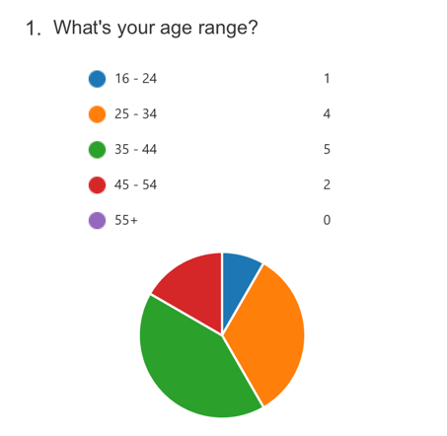
Taking into consideration the purpose of the business, the graph indicates that the majority of the people that answered the questionnaire are in between 25 and 44 years old. The form is sent online this also give us the information that answers are due to the fast connectivity to mobile devices and laptops, which encourages us to keep the initial plan of the business that our taxi company will operate the most in online and via mobile applications. This is also important to know the age range of the people accepting and fills the questionnaire as we will know where to invest and how to use our resources effectively, in order to touch every age range. (Eg: if the online is dedicated to people in between 25 and 44, we know this the offline services will be addressed to people from 45 and onwards.

Airport Expert is a business that is mostly focusing into airport transfers, ports and international train stations, dedicated to the people that are willing to travel long distances. We can observe that for the question “Is the taxi your best option to travel to the airport or port?” the audience answers that 50% from they will definitely consider a taxi service to travel with and 50% are undecided. Taking into consideration this, the undecided audience will be needed to be informed and convinced that the taxi services are the easiest, safest and surest way to go to the airport or port. The most efficient and effective approach will be advertising on different platforms, including social media and online search engines. There were not negative answers into an questionnaire answered by 12 people, which is understanding that in some point everyone will need a taxi service.
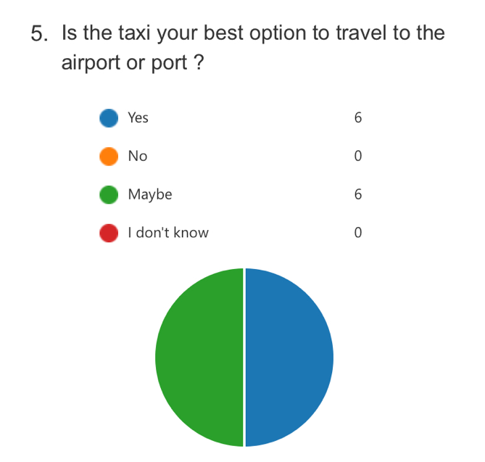

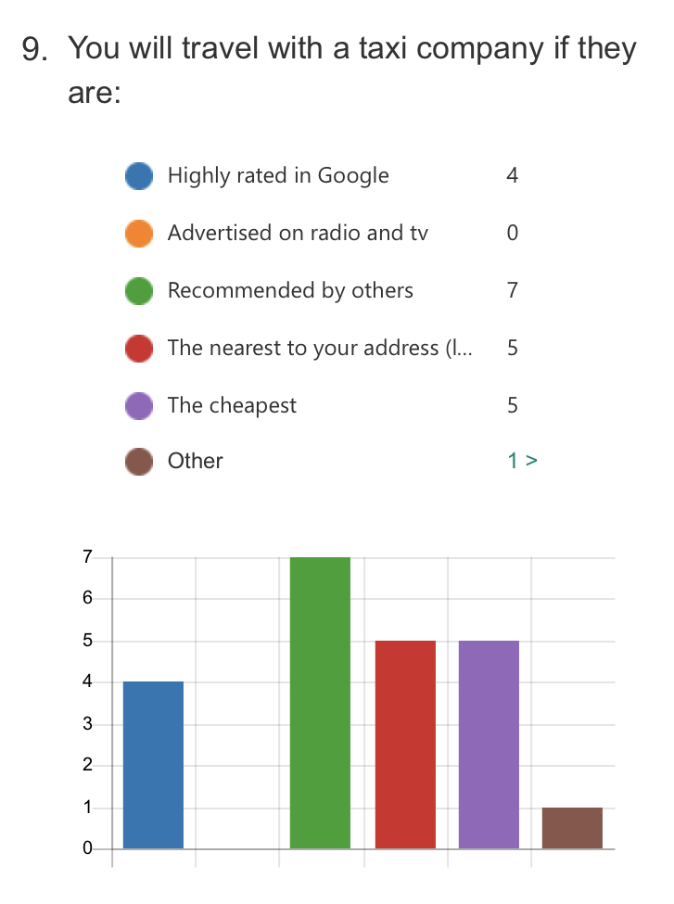
Looking at the graph on the left (Q9) we analyse the situation by punctuation:

- The most of the people will use a business that is recommended by others (friends and family)
- On the second position will be a company that is local or will be a neighbourhood business, also the same amount of people they will use the cheapest company around
- Reviews in the most busiest online search engine (google) plays a important role in the decision of a lot of people according to the number answered
- A few people answered that they will use the taxi if this is “appropriate for the purpose of travelling” (eg: they will hire a taxi as a wedding car or to travel to a special event)
- None of the audience don’t relay on the classic advertising (offline) as radio or television advertising anymore
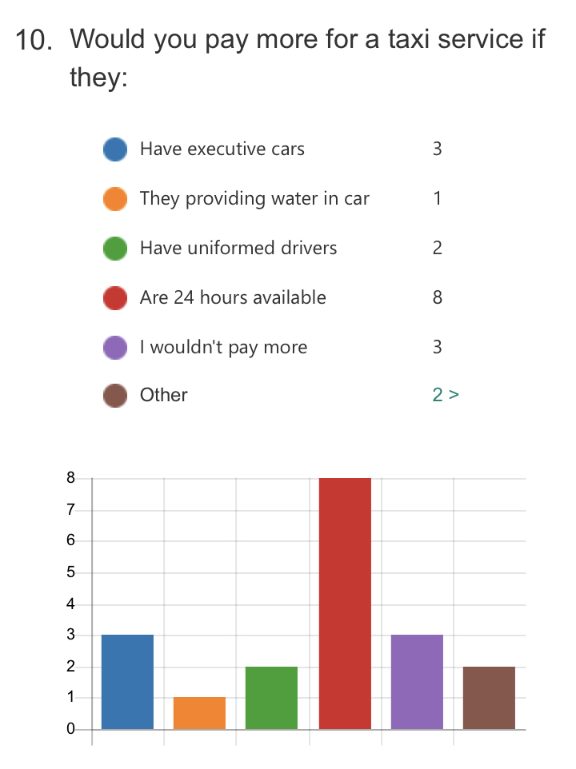
The company is a medium price range (average towards slightly expensive) company due the quality of the services the are provided.

Despite the high quality of the services offering, the audience that completed the questionnaire is the most interested in the availability and the efficiency of the services, 8 from 12 people questioned answering that they will pay more for a taxi service that is available 24 hours; at the other end with only 1 answer is that the extra services in the car as water or refreshments are not decisive in rising the price. An company that implement a specific uniform for its drivers is more likely to be taking into consideration despite the price may be higher than a regular taxi service that haven’t a uniform policy. Some of the people filling the questionnaire mentioned that they will be paying more for a taxi service if the cars are ecological, clean and tidy and are on time and punctual.

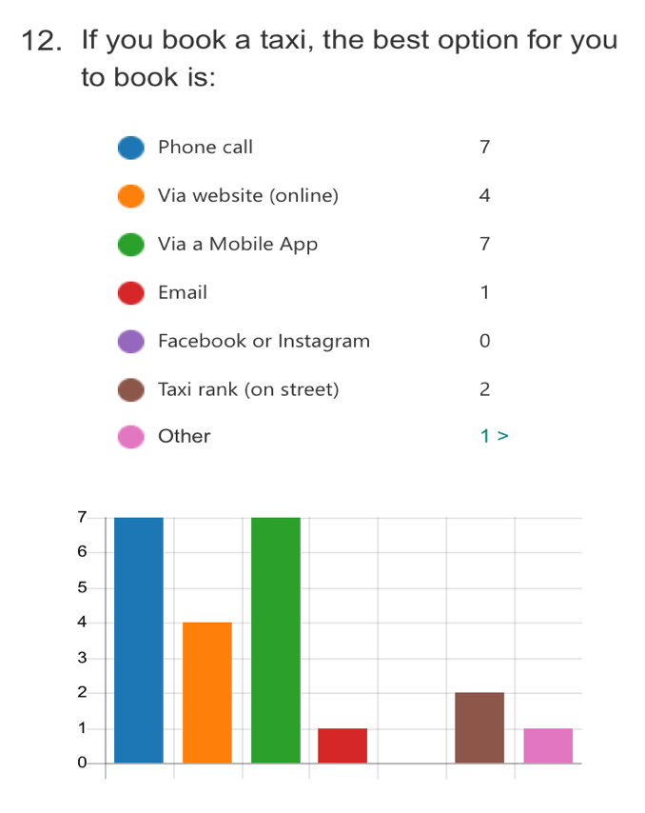
Starting to the premise of the technology is the new normal, Airport Expert is investing into online the most of its resources (time, education, money).
For the question 12 that is asking “What will be the best option to book a taxi services?” the majority of the audience questioned is still relayed to phone calls (not a robot) but also the same amount found easier to book via an mobile application where will be able to order a taxi pressing few buttons. The company website is also a trusted and interactive way to book a taxi services, but only 4 people from 12 will use this option. There are still people that will trust the local services and will consider the taxi rank (Hackney Carriage) the option to book, possible the tourists or visitors into a city that are not familiar with the local taxi companies. Only 1 person from 12 will ask someone else to book for them (eg: hotel or restaurant reception)

SUMMARY

The above graphics are illustrative only and was applied to a number of 12 people responding the taxi services related questions in order to understand better the public needs and what can apply to interact better with people, what services to add and what to take off.

Majority of the audience answered the questionnaire is situated into an age’s range of 24 and 45 years old, but taking into consideration the online environment that the questionnaire was sent, the ages range is understandable, as they are the most that using a mobile device or a laptop and also are the ones that are mostly connected to an online network able to receive and sent the information faster and concise.

From our questionnaire, we noticed that the people that will use a taxi service for a long-distance journey is the same as the people that will use it only for a local journey. The quality of the services is important and essential, as people will have a look on what other people says about the company online, despite better feedback in the online advertising or reviewing websites, the audience questioned answered that they will make their decisions to use a certain business if the advice is coming from a trusted person (friends or family).

A company that has a price range a bit expensive than others companies is still likely to be chosen by the public as an option to travel if they are available 24 hours and also is available to be booked this services online on the classic phone number but on the new ways as a mobile application for example.

