History and theory
The building I have decided to write about is the national library of Wales, with is located in Aberystwyth. This building is located half way up a hill, which is next to the university and a sports center. After sitting in this area and observing the area. I realized that where this building is placed and the buildings that surround it, they’ve been constructed to work well together and have contrast with each other. After, seeing how this building accommodates to their particular context, I believe they have done this well with t aspects that they use. The national library of Wales was established by royal charter on the 19th of March 1907 and then officially opened on the 1st of January 1909 (NLW, 2024). The architect that drew plans for the construction of the national library of wales was Sidney K Greenslade (NLW, 2024) and he built this building In the classical revival style (NLW, 2024).
I found an original pan of the national library of Wales floor plan. This original plan shows what it was meant to loo like before any new builds were built inside of the areas that don’t have anything inside them. This plan also shows that the structure of the library hasn’t changed rom when this plan was drawn to now. This means that although new tings have been added the structural soundness of the original plan is still standing now and still used the way it was intended. Although I was unable to find a section I found some pictures of the inside of the national library and the way that it looks from the inside in different areas.
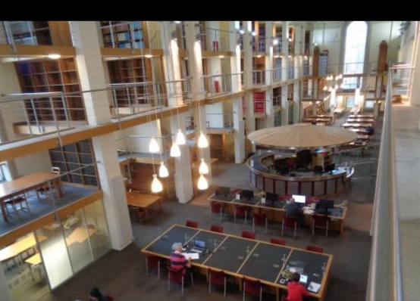
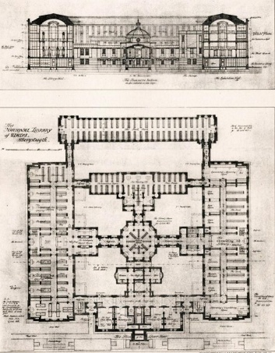
(Ceredigion county council) (Trip advisor)
The architect that designed the national library of wales was Sidney K Greenslade, he designed this building in the revival style. The foundation stone was laid in 1911, which were then followed on by the construction of the reading rooms which were built and opened in 1916 (NLW, 2024). After the reading rooms the next buildings, to be built were the administrative block in 1937 and the technical block in1955 (NLW, 2024). There was then two more additions that were constructed to the building these were the center of Wales and Celtic studies and the dictionary of the Welsh language, which opened in 1993, and the Drwm which opened in 2005 (NLW, 2024). The buildings were constructed out of concrete frame and then the front of the building was also made out of concrete and stone. The inside of the building that I have visited had the original stone wall and timber throughout the design of the building. There are also spot lights inside the building and windows throughout to give the inside of the building natural light and added light.
Inside the national library of Wales after being there a few times and observing the space I found there are quite and loud areas. These areas include the library which is a quiet place, the canteen which is a loud space and the shop which is sometimes could be loud or quiet, depending on the days. I believe that the layout of the building is successful because as you enter the national library of wales you are greeted with a reception desk, which once you have passed on your left-hand side is how you get to some of the exhibits and the shop. Whereas on your right-hand side it leads to a hallway that takes you to the canteen. Inside the canteen there is a door that leads to a hallway that only staff are able to walk down and need access too, I think this layout works well because you are keeping the public away from the work that goes on and the noisiness of the work that goes on. Although the other way if you were to go right on entry takes you through public exhibits and a shop where you can buy souvenirs about the national library of wales. You then go down the corridor into exhibits and then up a flight of stairs, where there is more exhibits. Then you turn right and the library is there with double doors separating it. I believe this works well because the nosier places of the library are located on the ground floor and then the quieter areas are on the first floor in order to separate the noise.
In this conclusion I have learnt numerous things, these things include how to interpret buildings differently and look at the style and materials that are used to make different buildings. This has also meant I was able to learn why certain materials were used to create different buildings and why they have been used. I have also learnt how to research a building more thoroughly, which gives me a better understanding of the building and how to implement this in every building I need to research for future projects. I have also learnt that the use of a building matter more than I thought and the amount of light inside the building ensures that it’s a nice place to be in. If I was to do this task again, I would ask people in space and see what their opinion is of the buildings layout and the materials that are used. I could also do a questioner to understand the publics opinions and the workers opinions on the topics I have to write about. I could also sit in the space for longer to get a better feel for the site and whether the materials used, are the right materials for the building or whether there are other materials that would improve the materials better.
Bibliography
Https://www.library.wales/ - National Library of Wales (NLW).
Https://www.library.wales/ - National Library of Wales (NLW).
Https://www.library.wales/ - National Library of Wales (NLW).
Https://www.library.wales/ - National Library of Wales (NLW).
Https://www.lbrary.wales/ - National Library of Wales (NLW).
Https://www.library.wales/ - National Library of Wales (NLW).
Https://archifdy-ceredigin.org.uk/Sched/LIB05.html
Https://www.tripadvisor

