Name: Andreea Catalina Paun
Student Number: 1919504
Module Code and Title: BMHP5014 Changemakers: Creativity and Value Creation
Assignment Title: Component 2: Written Assignment (Report)

Table of Contents

Title Page 1
Table of Contents 2
Poster CareLink AI: Helping you feel safe when returning home 3
Title and Innovation Overview 4
The Issue/Gaps in Health & Social Care 4
Target Audience and Impact 4
Implementation and Timeline 5
Development, Regulations, and Technology Integration 5
Dissemination: How the Innovation will be promoted 6
Conclusion 6
Reference List 7

CareLink AI Poster: Helping you feel safe when returning home
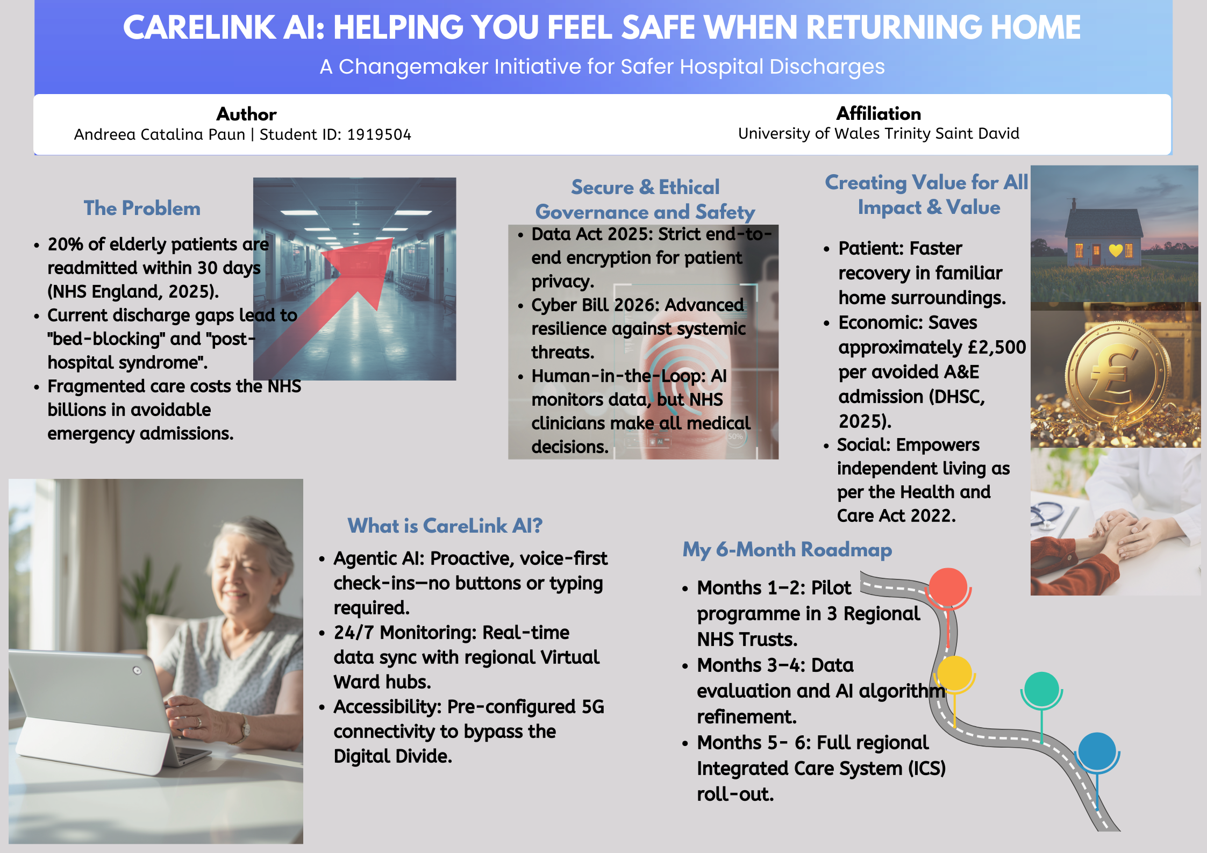
A Changemaker Initiative for Safer Hospital Discharges

- Title and Innovation Overview:
The post-discharge care pathway for elderly people in the UK health and social care sector will undergo a radical change because of the planned breakthrough, CareLink AI. In order to solve the "revolving door" crisis, a systemic failure in which patients are released from acute care only to be readmitted soon after due to a lack of coordinated support, this venture is a proactive digital service. CareLink AI makes use of "Agentic AI," a sophisticated type of artificial intelligence that actively establishes contact rather than just responding to user input. The service serves as an ongoing safety net and is delivered via a voice-first tablet with 5G integration. It records medicine adherence, uses Bluetooth-enabled peripherals to monitor clinical vital signs, and uses sentiment analysis to assess the patient's mental health. CareLink AI effectively expands the hospital's reach into the community by establishing a real-time data bridge between the patient's home and NHS Virtual Ward hubs, ensuring that recovery is tracked with clinical precision.

- The Issue/Gaps in Health & Social Care
NHS England's (2025) alarming data, which show that 20% of senior patients experience an emergency readmission within 30 days of release, serve as the foundation for the need for CareLink AI. This gap in the care continuum is frequently characterised by "post-hospital syndrome," a time of acquired vulnerability during which the patient is unable to independently manage their health due to the physiological and psychological stress of hospitalisation. The overcrowding in today's community social care programs sometimes results in fragmented monitoring and delayed interventions. This systemic "gap" leads to "bed-blocking," in which patients stay in hospital beds because a safe home-care setting cannot be guaranteed, rather than because they need urgent medical attention. This is addressed by CareLink AI, which offers proactive monitoring around-the-clock, fills the clinical gap between community nurses' home visits, and makes sure that mild health declines are detected before they become serious enough to necessitate A&E attendance.

- Target Audience and Impact
Patients 75 years of age and older, who have been found to be at the highest risk of readmission and social isolation, make up the main population for CareLink AI. This group is affected in a variety of ways. It primarily improves health and wellness by encouraging "Hospital at Home," which enables people to recuperate in comfortable environments and has been shown to lower the risk of delirium and hospital-acquired infections. CareLink AI promotes independence and dignity, which benefits society beyond therapeutic results. Additionally, the innovation adds significant value to the larger healthcare ecosystem. The Department of Health and Social Care (DHSC, 2025) has emphasised that reducing needless readmissions is essential to the NHS's long-term viability. CareLink AI creates economic value that can be put back into primary care by saving an estimated £2,500 for each avoided hospitalisation. It also lessens the "carer burden" on unpaid family members, giving them the assurance that professional-grade AI connected to clinical professionals is keeping an eye on their loved ones.

- Implementation and Timeline
CareLink AI is intended to be easily incorporated into the Health and Care Act of 2022's current architecture, particularly through regional Integrated Care Boards (ICBs). The pre-configured device is given to the patient as part of their recovery pack by hospital staff at the time of discharge. To guarantee safety and effectiveness, the roadmap for this innovation is organised over a specified six-month timeframe. A pilot program to measure user engagement and technological reliability is implemented in three different NHS Trusts throughout the first two months. The assessment of pilot data and the improvement of AI algorithms based on actual clinical input are the focus of months three and four. The project moves into a complete regional rollout of the Integrated Care System (ICS) by months five and six. This tiered approach enables the iterative application of the "Changemaker" mindset, guaranteeing that the solution is strong enough for widespread acceptance while satisfying the exacting requirements of the UK healthcare industry.

- Development, Regulations, and Technology Integration
The foundation of CareLink AI's efficacy is technological integration. In order to avoid the "Digital Divide" noted by Age UK (2024), the hardware is a specially constructed, 5G-ready tablet that doesn't require Wi-Fi setup. This guarantees that care is not impeded by socioeconomic level or a lack of digital literacy. In terms of development and legislation, the invention is designed to adhere to the strictest UK regulations, such as the Cyber Security and Resilience Bill 2026 and the Data (Use and Access) Act 2025. These rules guarantee that the system is safe against systemic cyberattacks and that all patient data is secured from beginning to end. Importantly, a "Human-in-the-loop" ethical framework is incorporated into the AI's programming. The AI cannot diagnose illnesses on its own, but it does track data and spot patterns of decline. Rather, it ensures that the final medical decision is always guided by human expertise by flagging hazards to qualified physicians inside NHS Virtual Ward hubs (NHS England, 2026).

- Dissemination: How the Innovation will be promoted

A thorough distribution and promotion plan is necessary to guarantee CareLink AI's effective adoption. The public, patients, and healthcare professionals are the three main groups that need to be involved. Internal Trust messaging and training sessions for discharge coordinators, which highlight how the tool lessens their long-term workload, will be used to promote professionals. A "Safe Home, Smart Care" marketing campaign will be introduced for the general public through local community hubs and internet platforms. By emphasising how AI may be used as a force for good in maintaining the independence of the elderly, this campaign will inspire the general public to support the innovation. Additionally, I'll make use of "Social Prescribing" channels, which allow general practitioners to suggest the service to patients who are at risk before they even enter the hospital system. We hope to increase public confidence in AI and obtain the social licence required for extensive NHS integration by encouraging a culture of "digital-first" care.

- Conclusion
In conclusion, CareLink AI is an essential innovative answer to one of the NHS's most enduring problems. We go from a reactive sickness-based model to a proactive, preventative health strategy by identifying the crucial gaps in post-discharge care and implementing "Agentic AI" technology. This innovation promotes the common good by preserving the independence and dignity of our senior population while also generating quantifiable economic benefit by saving the NHS millions in unnecessary readmission expenses. The UK's dedication to offering top-notch, inclusive, and compassionate care to everyone is evolving, and the incorporation of CareLink AI into regular clinical routes is not only a technological advancement. In order to guarantee that "going home" from the hospital always entails a secure and assisted return to health, we implore stakeholders and the general public to support this effort.

Reference List

Age UK (2024) Offline and Overlooked: Digital exclusion in later life. London: Age UK.
Department of Health and Social Care (2025) Better Care Fund Policy Framework 2025-26. London: HMSO.
Health and Care Act 2022, c. 31. Available at: https://www.legislation.gov.uk (Accessed: 20 March 2026).
NHS England (2025) The NHS 10-Year Health Plan: Digital-First Healthcare. London: NHS England.
NHS England (2026) National Framework for Virtual Wards. London: NHS England.
UK Government (2025) Data (Use and Access) Act 2025. London: The Stationery Office.
UK Government (2026) Cyber Security and Resilience Bill 2026. London: The Stationery Office.

