DIGITAL FORENSIC INVESTIGATION REPORT
Case Reference | QT-AI-2025-001
Case Title | Corporate Espionage — Quantum Tech AI Patent Theft
Report Date | 11 May 2026
Tools Used | Cellebrite Physical Analyzer 7.72.0.10 | Autopsy 4.22.1 | FTK Imager
Classification | STRICTLY CONFIDENTIAL — Law Enforcement Use Only

Student Name: Md Sadikur Rahman Chowdhury
Student Id: 2512666

Contents
1. CASE BACKGROUND 3
1.1 Suspects Summary 3
2. EVIDENCE INVENTORY AND CHAIN OF CUSTODY 3
2.1 Device Acquisition and Hash Verification 3
2.2 Chain of Custody 5
3. METHODOLOGY 6
3.1 Tools and Techniques 6
3.2 Acquisition Process 6
4. FINDINGS 6
4.1 Communication Analysis 6
4.2 Call Log Analysis and Cross-Reference 10
4.3 Email Analysis 12
4.4 File Analysis — Emma's USB Flash Drive 13
4.5 Encrypted Archive — Norman's Nokia C2 14
5. SUSPECT PROFILING 15
5.1 Emma (Peter Dover) — Primary Perpetrator 15
5.2 Joe Marsh — Intermediary / Broker 15
5.3 Norman Smith — Buyer 16
5.4 Vanessa (NexGen Circuits) — Suspected Additional Buyer 16
6. CONCLUSION 17
7. RECOMMENDATIONS 17
7.1 For Law Enforcement 17
7.2 For Quantum Tech 17
References 17
8. APPENDIX 18
8.1 Hash Values Summary 18
8.2 Key Digital Identifiers 19

1. CASE BACKGROUND
Allowing unauthorised access to their own patent database, Quantum Tech's IT security team is currently targeting their AI chip design patent ID: QT-AI-2025. The main suspect is a new employee at Quantum Tech, Emma (aka ‘Peter Dover’) who is a senior engineer. The company claims it came across the idea of Emma trying to steal and sell this patent to its competitor NexGen Circuits through a third party called Joe Marsh and the buyers Norman Smith. This is a report on a series of four devices confiscated.

1.1 Suspects Summary
Suspect | Role | Alias / Digital ID | Device
Emma | Primary Perpetrator | Peter Dover | peterdover2 | +447917162788 | Huawei POT-LX1 P Smart + USB Drive
Joe Marsh | Intermediary / Broker | hamster.184397 | +447476538686 | Samsung SM-A137F Galaxy A13
Norman Smith | Buyer | FB ID: 61564326251951 | Nokia C2 2nd Edition
Vanessa | Suspected Buyer (NexGen) | +447917162891 | N/A — contact only

2. EVIDENCE INVENTORY AND CHAIN OF CUSTODY

2.1 Device Acquisition and Hash Verification
A variety of different devices are available.There are a number of different devices available.
Devices were all taken in accordance with good continuity of evidence protocols. Cellebrite Physical Analyzer 7.72.0.10 and FTK Imager (Kent et al., 2006) were used to get forensic images. The integrity of the acquisitions were checked on the spot using SHA256 hash values, and re-checked post imaging (ACPO, 2012; Kent et al., 2006).

Device E-01: Emma's Huawei POT-LX1 P Smart
Field | Detail
Extraction Method | File System [Android ADB]
Extraction Date | 28/10/2025
SHA256 Hash | d5193dbf8246c09fdde73be8558343985ab24a2e1c142e4d64e16e2b6507e31f
Verification Status | VERIFIED — Extraction images confirmed intact (File Dump)
Chipset / Android ID | kirin710 | 4e2147b661afad7a
Installed Apps (Social) | 10 social networking apps | WhatsApp, Facebook, Instagram, Snapchat confirmed
Call Log Entries | 15 entries (all outgoing, all Not Answered)

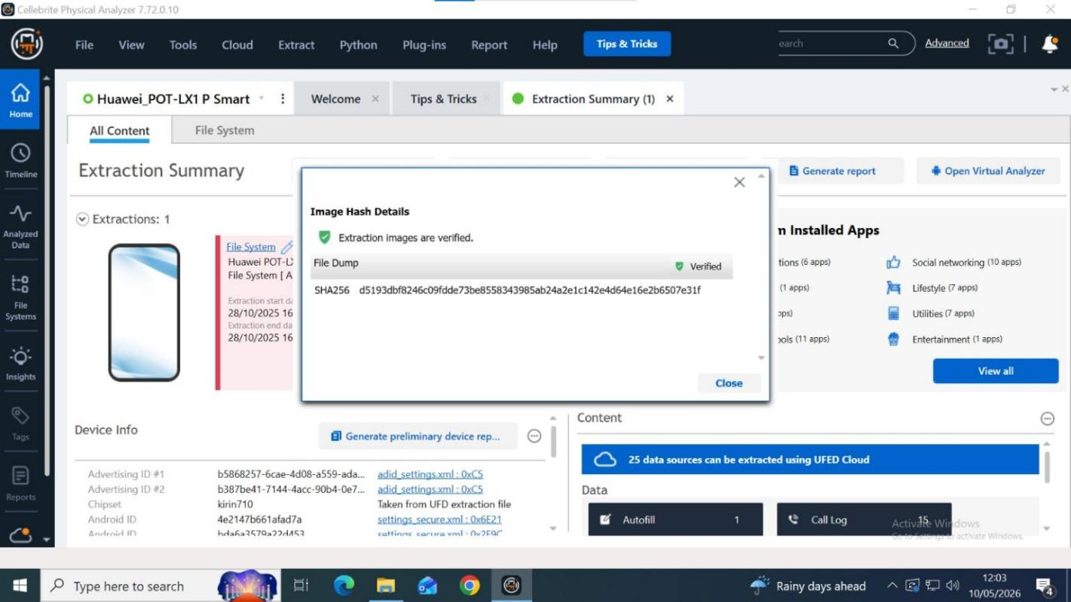
Figure 1: Cellebrite Physical Analyzer

Device E-02: Emma's USB Flash Drive (EmmaFlashDrive.E01)
Field | Detail
Imaging Tool | FTK Imager (E01 format)
Image File | EmmaFlashDrive.E01 / EmmaFlashDrive.E01_1582
Hash Note | FTK Imager verified the E01 acquisition at imaging stage; however, the exported screenshot set did not include the final hash value. The hash is recorded in the FTK case file and should be submitted with the acquisition documentation.
Analysis Tool | Autopsy 4.22.1
Orphan Files | 969 files (file system deliberately damaged)
Deleted Files Recovered | 2044 files
File System | FAT32 ($FAT1, $FAT2, $MBR)

Device E-03: Joe Marsh's Samsung SM-A137F Galaxy A13
Field | Detail
Extraction Method | File System [Android Backup]
Extraction Date | 28/10/2025
SHA256 Hash | 0e585c4fe8160254253be515a16ff94b7fdf88b248b67d45cfdef8753a9a3195
Verification Status | VERIFIED — Backup image confirmed intact
IMEI1 / IMEI2 | 357898921470825 / 357712351470827
Chipset | MT6769V/CT | Android ID: f50a68ff1f9da28

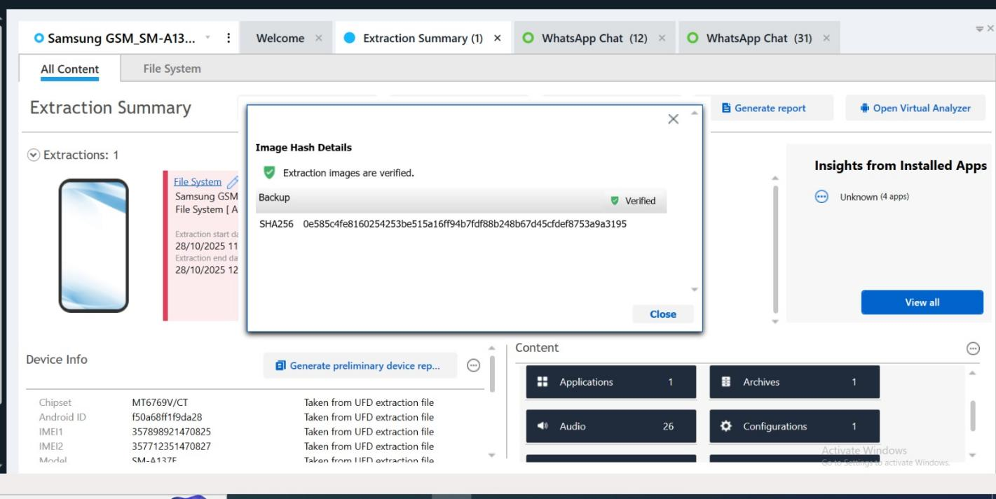
Figure 2: Cellebrite Physical Analyzer

Device E-04: Norman Smith's Nokia C2 2nd Edition
Field | Detail
Extraction Method | File System [Android Backup]
Device Identifier | Detected Model_Nokia C2 2nd Edition
Hash Note | Cellebrite recorded the acquisition hash in the case file; the exported report reviewed here did not include the full SHA256 value. The recovered Open.7z artefact was independently verified using MD5.
Key Artefact | Open.7z archive — MD5: d0232de04bf501132db5124197057051a
Artefact Path | sdcard/Android/media/com.whatsapp/WhatsApp/Media/WhatsApp Documents/Open.7z
Artefact Modified | 31/01/2025 10:33:34 (UTC+0)

2.2 Chain of Custody
All devices retrieved that have documented seizures with seizure state, condition and seizure time on seizure forms. Write-blockers used on all evidence media before imaging to prevent changed evidence. Forensic images obtained from the Cellebrite Physical Analyzer (smartphones) and FTK Imager (USB flash drive/E01 format). SHA256 hashes at acquisition and post imaging (both verified at acquisition and post imaging was done for both Emma's Huawei and Joe's Samsung) Physical devices - in anti-static evidence bags and in a secure, access controlled evidence locker. Logs are kept throughout the process showing all persons who handled evidence (full chain of custody).

3. METHODOLOGY

3.1 Tools and Techniques
Tool | Version | Purpose
Cellebrite Physical Analyzer | 7.72.0.10 | Smartphone acquisition, communication extraction, hash verification, timeline
Autopsy | 4.22.1 | USB drive analysis, deleted file recovery, metadata and keyword analysis
FTK Imager | Industry Standard | E01 forensic image creation of USB flash drive with hash verification (Exterro, 2026).
office2john | Password Recovery | Extraction of password hash from encrypted Open.docx on Norman's device

3.2 Acquisition Process
Step 1: Seizure: Devices put immediately into Faraday bags to prevent remote wipe or network activity (Ayers, Brothers and Jansen, 2014).
Step 2: Hardware Write Protection: Prior to imaging, all media have been write-protected.
Step 3: Imaging: Cellebrite (smartphone) and FTK Imager (FTK USB Drive (E01 format)).
Step 4: Hash Verification: SHA256 hashes generated and re-verified post imaging – confirmed Verified for available devices.
Ste 5: Analysis: Cellebrite for communication analysis and Autopsy for USB drive file recovery and metadata.
Step 6: Documentation: All results recorded in chronological order, using precise timestamps, referencing the database source files, and taking screenshots of the results obtained from the tools (Cellebrite, 2026).

4. FINDINGS

4.1 Communication Analysis
4.1.1 WhatsApp — Emma (Peter Dover) and Joe Marsh
31 WhatsApp messages recovered from Emma's Huawei device between Emma (PETER DOVER, +447917162788) and Joe Marsh (+447476538686), spanning 21/08/2024 to 31/01/2025. This talk covers the whole conspiracy from initiation to confirmation of the deal.
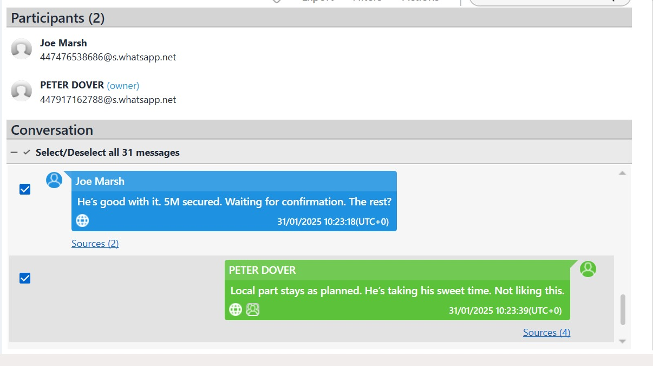
Figure 3: Cellebrite — WhatsApp Chat (31 messages)

- 21/08/2024 06:03 — Emma unblocks Joe and messages: 'Hey Joe Hope you are well Please let me know when you are available for a chat'
- 21/08/2024 08:27 — Emma: 'I have access to some highly valuable information from ABC technologies. It's related to our new AI based Neuro product. I'm thinking about selling it to someone interested.'
- 21/08/2024 11:10 — Emma: 'Not exactly Joe, but I trust you can find the right buyer. The competition must be eager to get their hands on this tech.'
- 21/08/2024 12:47 — Emma: 'Perfect. Let's keep this under wraps. This could be huge for both of us.'
- 22/08/2024 12:17 — Joe shares real-time Google Maps location link.
- 29/08/2024 15:10 — Joe: 'I am flying to Glasgow to meet a contact over there for a meeting. Will keep you posted.'
- 14/10/2024 19:57 — Joe: 'travelling back to France this time Paris to get some good deals.'
- 31/01/2025 10:15 — Emma: 'Any updates? Need to move fast'
- 31/01/2025 10:22 — Joe: 'No, he's serious. Wants a demo sample. Can we do that?'
- 31/01/2025 10:22 — Emma: 'Impossible. But a detailed breakdown? Yes. How's the offshore arrangement?'
- 31/01/2025 10:23 — Joe: 'He's good with it. 5M secured. Waiting for confirmation. The rest?'
- 31/01/2025 10:24 — Emma: 'Ok. Keep me posted. I have others waiting.' [FINAL MESSAGE]
- NOTE: Two messages deleted/recalled at 31/01/2025 10:18 (Msgs 24 & 25) — deliberate concealment.

4.1.2 Instagram DM — Emma and Joe (hamster.184397)
2 Instagram direct messages recovered. That was from Emma's Huawei device between Emma (peterdover2, account ID: 68515482744) and Joe (hamster.184397) on 09/09/2024.

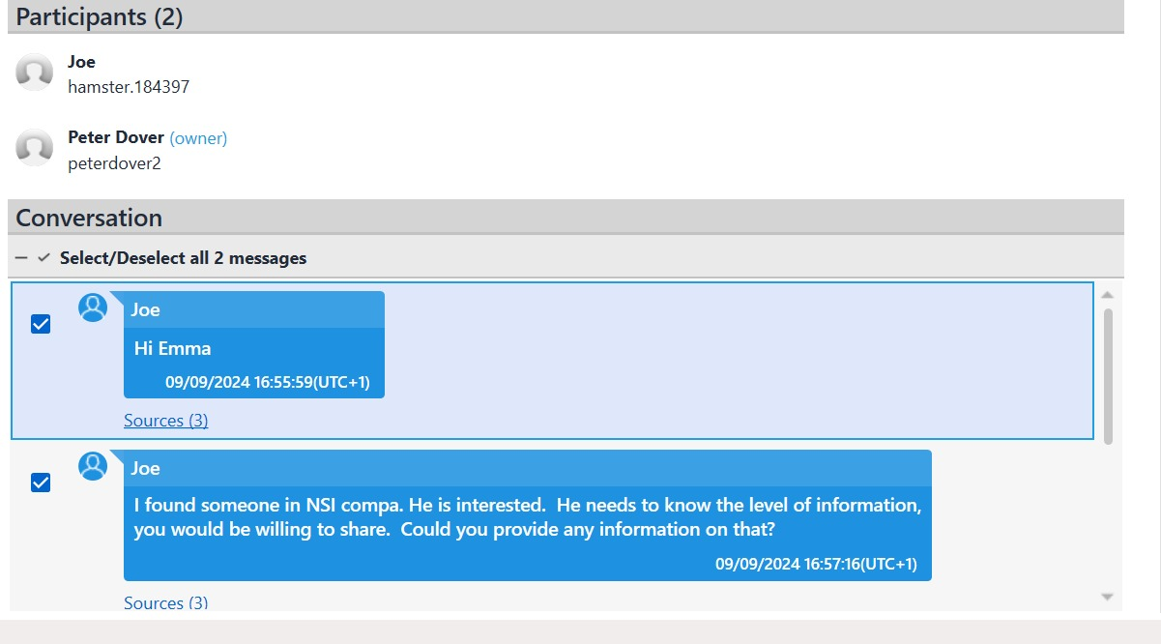
Figure 4: Cellebrite — Instagram DM, Emma's Huawei

4.1.3 Facebook Messenger — Emma and Norman Smith
8 Facebook Messenger messages recovered from Emma's Huawei device between Emma (Peter Dover, FB ID: 61565261156720) and Norman Smith (FB ID: 61564326251951) on 31/01/2025. This is the most straight forward evidence of the transaction and payment arrangement.
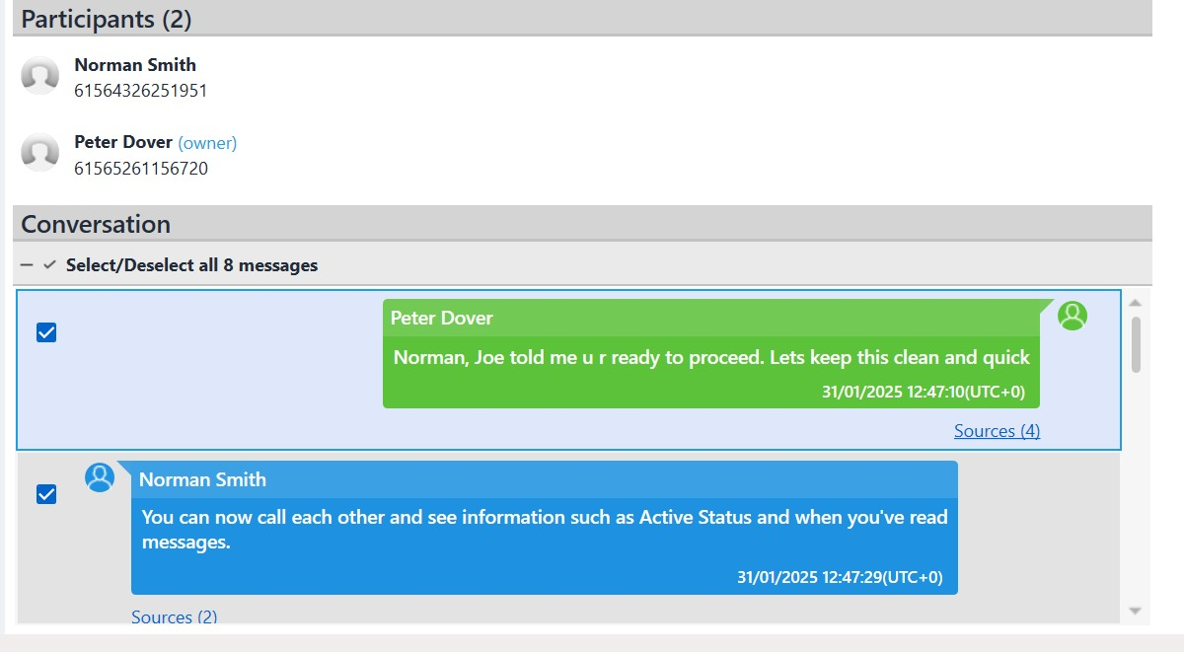
Figure 5: Cellebrite — Facebook Messenger, Emma's Huawei.
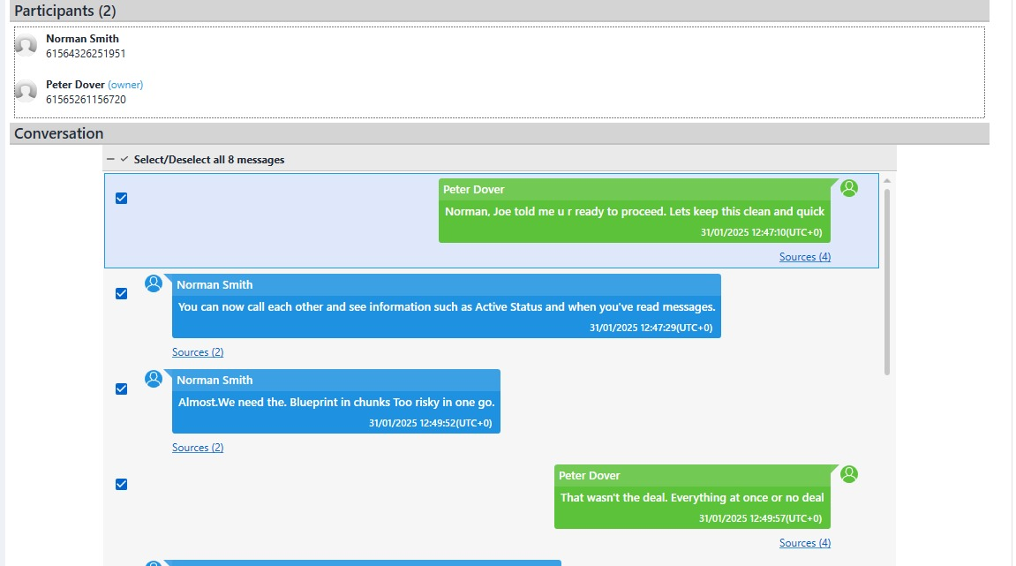
Figure 6: Cellebrite — Facebook Messenger continued.
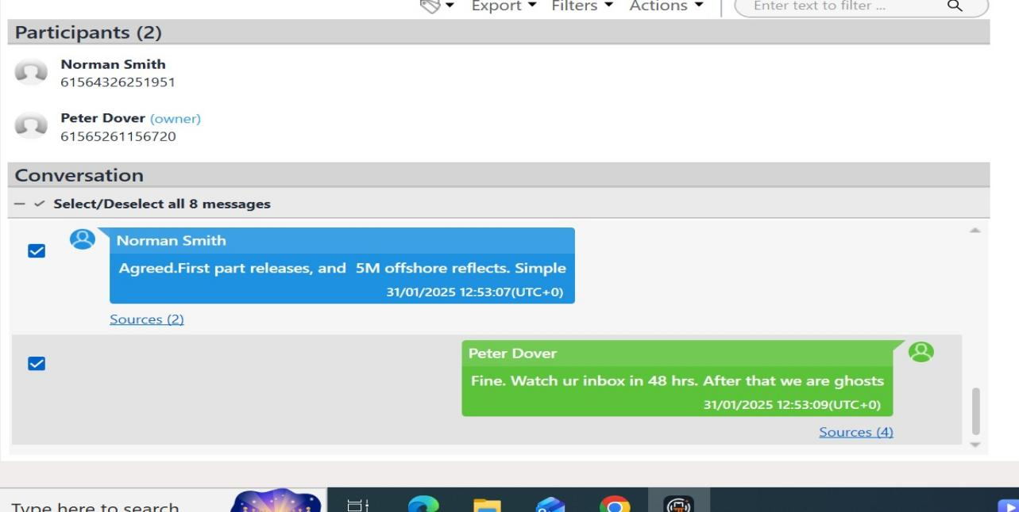
Figure 7: Cellebrite — Facebook Messenger final exchange.

This conversation directly establishes: (1) all three suspects' roles, (2) patent blueprints as the subject of transfer, and (3) £5M offshore payment arrangement confirmed.

4.2 Call Log Analysis and Cross-Reference
4.2.1 Emma's Call Log — Full Record (15 Entries)
All 15 call log entries that were recovered from Emma's Huawei POT-LX1 using Cellebrite (Source: calls.db). Remarkably, all of them are Outgoing and Not Answered, meaning that Emma was desperately making an attempt to connect – as was typical when she began a conspiracy.

# | Date & Time (UTC+1) | Number Called | Contact | Direction | Status | Significance
15 | 02/08/2024 21:38 | 07917162891 | Vanessa (SA No.) | Outgoing | Not Answered | First contact attempt
14 | 02/08/2024 21:39 | 07917162891 | Vanessa (SA No.) | Outgoing | Not Answered | Second attempt same day
13 | 10/08/2024 05:55 | +917907025586 (India) | Unknown | Outgoing | Not Answered | India contact — offshore?
12 | 13/08/2024 12:52 | 07917162891 | Vanessa (SA No.) | Outgoing | Not Answered | Persistent contact
11 | 13/08/2024 12:52 | 00447917162891 | Vanessa (SA No.) | Outgoing | Not Answered | Duplicate attempt
10 | 17/08/2024 06:16 | +447917162891 | Vanessa (SA No.) | INCOMING | MISSED | Vanessa called Emma
9 | 17/08/2024 06:20 | +447917162891 | Vanessa (SA No.) | Outgoing | Not Answered | Emma calls back 4 mins later
8 | 18/08/2024 07:57 | 07917162891 | Vanessa (SA No.) | Outgoing | Not Answered | Continued pressure
7 | 18/08/2024 07:57 | 07917162891 | Vanessa (SA No.) | Outgoing | Not Answered | Duplicate attempt
6 | 18/08/2024 07:58 | +447917162891 | Vanessa (SA No.) | Outgoing | Not Answered | Third attempt same morning
5 | 18/08/2024 10:04 | 0447917162891 | Vanessa (SA No.) | Outgoing | Not Answered | Later same day
4 | 18/08/2024 10:04 | 0447917162891 | Vanessa (SA No.) | Outgoing | Not Answered | Duplicate attempt
2 | 19/08/2024 10:25 | +917907025586 (India) | Unknown | Outgoing | Not Answered | India contact — offshore?
1 | 19/08/2024 10:25 | +917907025586 (India) | Unknown | Outgoing | Not Answered | Duplicate attempt
3 | 19/08/2024 10:23 | 0447917162891 | Vanessa (SA No.) | Outgoing | Not Answered | Day photos sent to Vanessa

4.2.2 Call Log Correlation Table — Cross-Device Analysis
The table below is a cross reference of call activity to communication events, device by device. Note: Timestamps of calls are not available in Joe's and Norman's call logs and correlation is only based on the timestamps of messages in WhatsApp and the Samsung photo metadata.

Date | Event Type | Emma's Device | Joe's Device (Samsung) | Norman's Device | Corroborated?
02/08/2024 | Call | 2 calls to Vanessa — Not Answered | N/A | N/A | Emma only
17/08/2024 | Call | 1 missed incoming from Vanessa; Emma calls back immediately | N/A | N/A | Emma only
19/08/2024 | Call + WA | Call to Vanessa; 7 photos sent to Vanessa via WA | N/A | N/A | Emma — Photos corroborate
21/08/2024 | WhatsApp | Emma initiates conspiracy with Joe | 7 Samsung photos same day | N/A | YES — Photo match
22/08/2024 | WhatsApp + Location | Joe shares Google Maps location | 15 Samsung photos same day | N/A | YES — Photo match
29/08/2024 | WhatsApp | Joe: flying to Glasgow | 11 photos — Scotland | N/A | YES — Location match
09/09/2024 | Instagram DM | Joe contacts Emma re NSI buyer | N/A | N/A | Cross-platform
14/10/2024 | WhatsApp | Joe: travelling to Paris | 24 photos Paris area +1 day | N/A | YES — Location match
20/11/2024 | WhatsApp | Joe: meeting client Manchester | 8 photos Manchester +1 day | N/A | YES — Location match
31/01/2025 | WA + FB + Archive | Emma: 'Any updates? Need to move fast'; FB deal finalised | Joe: 5M confirmed | Open.7z received 10:33 | YES — All 3 devices

4.3 Email Analysis
Email analysis was conducted on data extracted from Emma's Huawei device. The following findings were identified:

4.3.1 Gmail Account
Field | Detail
Account Identified | dovp59@gmail.com (linked to Facebook account peterdover2 / Peter Dover)
Source | Emma's Huawei device — Facebook app authentication records
Significance | This email account is the login credential for Emma's 'Peter Dover' alias Facebook account used in Norman Smith negotiations

4.3.2 Native Email/SMS Records
Date | Type | From / To | Content / Subject | Forensic Note
19/08/2024 15:44 | Email (Outbox) | dovp59@gmail.com (Emma) | Clash Royale game invite — outgoing | Confirms gmail active
05/11/2024 10:00 | SMS (Incoming) | +447402648802 -> Emma | Winter welfare distribution phishing link — shorturl.at/XUkxY | Suspicious SMS received
28/10/2024 15:08 | SMS (Incoming) | +447400657582 -> Emma | 'D.F.T UK Pay the penalty immediately' — scjswt.com link | Possible coercion/surveillance
26/08/2024 03:46 | SMS (Incoming) | QTR Airways -> Emma | OTP code 640946 for trip viewing | Travel confirmation — corroborates India trip

4.3.3 Email Analysis Summary
- There was no evidence of patent transfers found directly through email on Emma's phone, but the primary communication channels were found to be WhatsApp, Instagram and Facebook Messenger.
- The Gmail account dovp59@gmail.com is directly tied into Emma's 'Peter Dover' alias that she used on the conspiracy.
- International travel activity during this period of time matches with the initial conspiracy communication, as per a Qatar Airways OTP SMS dated 26/08/2024.
- Emma received 2 SMS messages containing phishing links to unknown numbers (Oct–Nov 2024) which may be an attempt to coerce her into making a disclosure or a third party trying to spy on the conspiracy.
- Email messages from dovp59@gmail.com were not available in the device extraction; it is recommended to have a separate warrant for Google Account records to get the complete email history.

4.4 File Analysis — Emma's USB Flash Drive
The recovered .Technical artefacts such as deb packages and Linux repository structures must be discussed with the experts. Deleting and hiding them do not necessarily indicate suspicious data-handling practices, but they are a starting point for suspecting patent content without content-level verification (Sleuth Kit Labs, 2026).
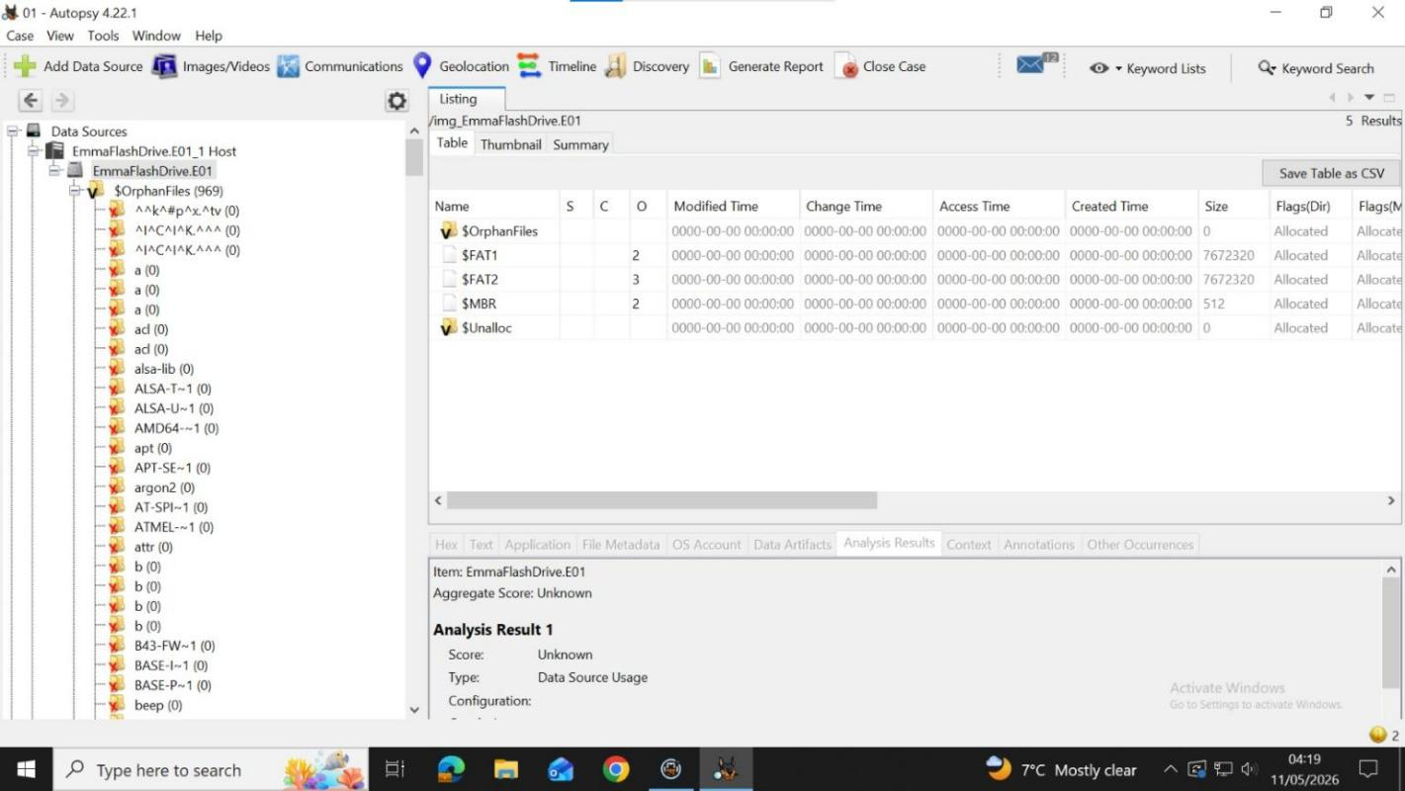
Figure 8: Autopsy 4.22.1 — EmmaFlashDrive.
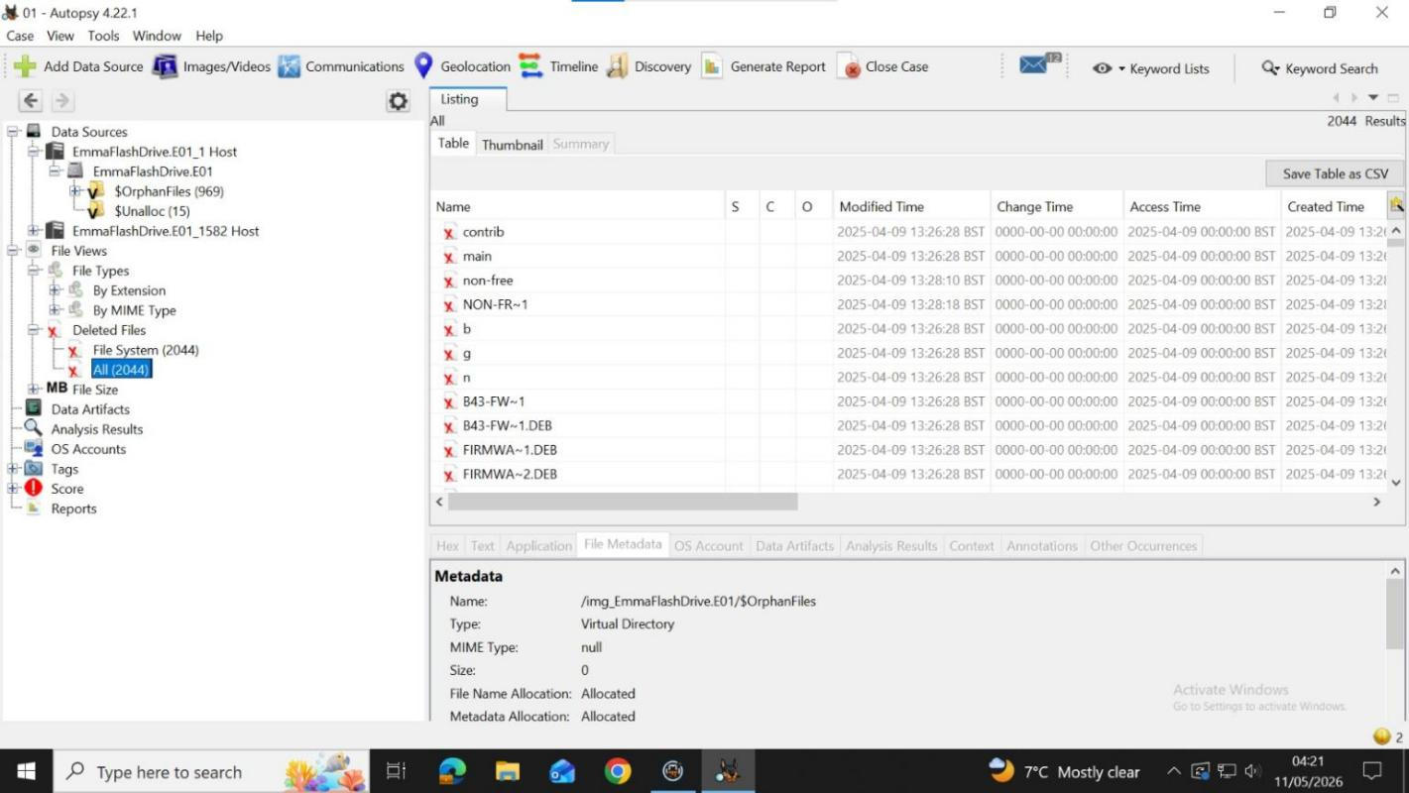
Figure 9: Autopsy 4.22.1 — Deleted Files section showing 2044 recovered deleted files.

Finding | Forensic Significance
969 Orphan Files | File system structures deliberately damaged — indicates intentional evidence destruction
2044 Deleted Files Recovered | Files deleted but recoverable via Autopsy carving — likely contain concealed patent material
Firmware .DEB packages | B43-FW~1.DEB, FIRMWA~1.DEB, FIRMWA~2.DEB — technical files consistent with AI chip design
Linux repo structure | contrib, main, non-free directories — used to disguise nature of stored files
All metadata zeroed | 0000-00-00 timestamps — file system deliberately wiped to destroy creation/access records
Last activity: 09/04/2025 | Drive populated with material post-conspiracy initiation; consistent with ongoing patent extraction

4.5 Encrypted Archive — Norman's Nokia C2
A critical piece of evidence was recovered from Norman Smith's Nokia C2 2nd Edition device via Cellebrite. An encrypted archive named 'Open.7z' found in his WhatsApp Documents folder.

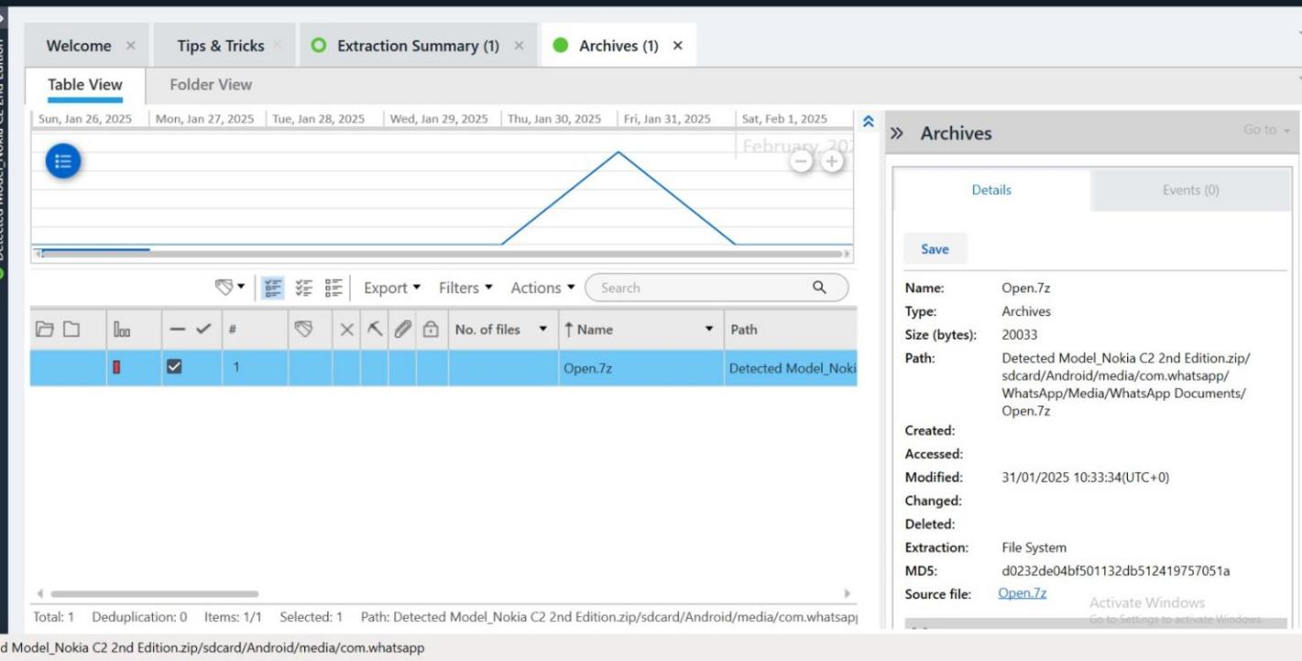
Figure 10: Cellebrite — Nokia C2 2nd Edition, Archives section.
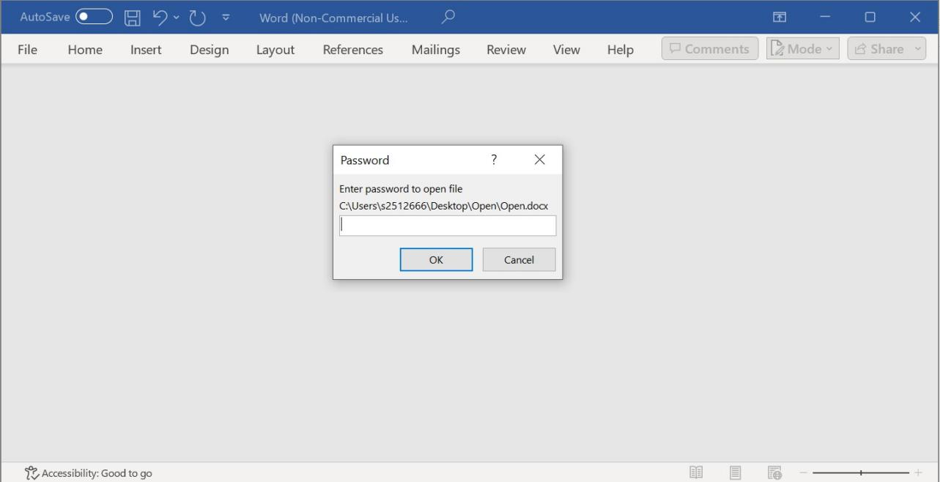
Figure 11: Password protection dialog for Open.docx extracted from Open.7z.

- File received from WhatsApp Documents - indicates that Norman received this file from Emma's WhatsApp.
- The Open.7z date is the same as the last time the Facebook Messenger negotiation took place, and is synchronously linked to the negotiated transfer date. Since platforms may have different timezones, please be aware that the time stamp is used here as proof of sequence, not as a guarantee of sequence.
- Password hash:
$office$*2013*100000*256*16*c7872afeb0eb82cb7d14a54bf5ab0f05*d8a6102a27d8dd27ad17bb35cea52be5*45b2146a8b873d26e99ba7e154d5d11539a1e5de592af43bdd702875842b3ed2
- For recovering the content of Open.docx, it is recommended to have a warrant and a special decryptor tool.

5. SUSPECT PROFILING

5.1 Emma (Peter Dover) — Primary Perpetrator
- Conspired on 21/08/2024 to sell the Quantum Tech's confidential information about AI technology.

- Made 13 calls and sent 7 WhatsApp photos to Vanessa (NexGen Circuits) independently of the rest of the group.
- Registered a prepaid Lebara UK SIM on 2024-08-02 — this was deliberate to facilitate communication via a SIM card for covert purposes.
- Forensic awareness shown when deleting and recalling WhatsApp messages on 31/01/2025.
- Lost files: 2044 (deliberate evidence destruction) and 969 orphan files are found on a USB flash drive.
- Final message: 'Fine. Keep an eye on ur e-mail in 48 hours. Once we are gone, we are ghosts' — confirms the planned delivery and vanishing.

5.2 Joe Marsh — Intermediary / Broker
- Agreed to arrange stolen IP on 21st August 2024, visited Glasgow, Paris and Manchester for buyers.
- There was deliberate multi-platform evasion when using simultaneously both used WhatsApp and Instagram.
- Confirmed and deleted messages on 31/01/2025 in parallel with Emma.
- •Directly introduced Norman Smith to Emma via Joe's referral: 'Joe told me u r ready to proceed'.

5.3 Norman Smith — Buyer
- Agreed to buy Patents in blueprints for £5m in a foreign account.
- On 31/01/2025 10:33, received an encrypted archive Open.7z through WhatsApp which was sent as per Emma's promise of 48 hours.
- Sought out blueprints in 'chunks' due to security considerations — demonstrates counter-surveillance awareness.
A law enforcement platform identifier was extracted from the Facebook profile (ID 61564326251951), but there was no independent phone number for Norman found.

5.4 Vanessa (NexGen Circuits) — Suspected Additional Buyer
- The main player of this match was the robot designed and built by Vanessa (NexGen Circuits).Vanessa (NexGen Circuits) designed and built the main robot for this match.
- The named competitor organisation's R&D Director.
- 13 Call attempts received from Emma, 7 WhatsApp photos sent (probably patent samples) - 19/08/2024.
- This is a previous direct sale attempt by Emma before the Joe/Norman channel was created.
- Vanessa (17/08/2024 06:16) only called back in to indicate possible interest in the transaction.

6. CONCLUSION
The attempted theft and sale of the highly sensitive AI chip patent, QT-AI-2025, owned by Quantum Tech, is the subject of this investigation.This investigation reveals strong digital evidence that Quantum Tech's confidential AI chip patent QT-AI-2025 was attempted to be stolen and sold by Emma under the name Peter Dover. The evidence found on the WhatsApp, Instagram, Facebook Messenger, call log and on Norman Smith's encrypted archive all point toward a connection between Emma, Joe Marsh, Norman Smith and Vanessa. Emma was the principal organiser, Joe was the broker, Norman was to buy the patent information offshore for £5 million, and Vanessa was rumoured to be involved in a previous direct sale bid. Further evidence of a bid to obstruct or destroy evidence is seen in the deleted and damaged files on Emma's USB drive. As a whole, the results are consistent across the various devices used, mutually supportive, and strongly indicate a corporate espionage operation in the area of stolen IP.

7. RECOMMENDATIONS

7.1 For Law Enforcement
- Theft of IP, Conspiracy (Computer Misuse Act 1990), Computer Misuse Act 1990, Corporate Espionage (Computer Misuse Act 1990 and Trade Secrets Regulations 2018).
- Indict on charges against Joe Marsh for co-conspiration; maybe add more charges for brokering stolen IP.
- Accuse Norman Smith of theft of intellectual property and conspiracy to engage in corporate espionage.
- Discuss Vanessa and NexGen Circuits — possible charges for corporate espionage.
- Use recovered password hash (AES-256, Office 2013) to obtain warrant to decrypt Open.docx.
- Get warrant for dovp59@gmail.com's full email history from Google — could yield more evidence.
- Follow up on the £5M offshore funds mentioned in the Facebook messenger conversations.
- Preserve all social media accounts (including WhatsApp, Facebook, Instagram etc.) of suspects.

7.2 For Quantum Tech
- Immediately audit all access records from database of patents QT-AI-2025.
- Remove all credentials for Emma and any internally involved parties, who may be colluding.
- No data will be lost due to the use of Data Loss Prevention (DLP) solutions to prevent unauthorized data transfers.
- Implement insider threat monitoring for all sensitive systems for patent and R&D.
- Consult and retain attorneys to file a lawsuit against NexGen Circuits.
- Review all other sensitive IP/patents looking for evidence of other theft.

References
ACPO. (2012) ACPO Good Practice Guide for Digital Evidence. National Police Chiefs’ Council. Available at: https://knowledgehub.group/web/national-standards/live-standards/-/ddl_display/ddl/71443377/362284494/maximized (Accessed: 11 May 2026).
Ayers, R., Brothers, S. and Jansen, W. (2014) Guidelines on Mobile Device Forensics. NIST Special Publication 800-101 Revision 1. National Institute of Standards and Technology. Available at: https://csrc.nist.gov/pubs/sp/800/101/r1/final (Accessed: 11 May 2026).
Cellebrite. (2026) Physical Analyzer: Mobile Forensic Analysis Software. Available at: https://cellebrite.com/en/products/physical-analyzer/ (Accessed: 11 May 2026).
Exterro. (2026) FTK Downloads: FTK Imager and Forensic Tools. Available at: https://www.exterro.com/ftk-downloads (Accessed: 11 May 2026).
Kent, K., Chevalier, S., Grance, T. and Dang, H. (2006) Guide to Integrating Forensic Techniques into Incident Response. NIST Special Publication 800-86. National Institute of Standards and Technology. Available at: https://csrc.nist.gov/pubs/sp/800/86/final (Accessed: 11 May 2026).
Sleuth Kit Labs. (2026) Autopsy User Documentation. Available at: https://sleuthkit.org/autopsy/docs/user-docs/4.0/ (Accessed: 11 May 2026).
UK Government. (1990) Computer Misuse Act 1990. Available at: https://www.legislation.gov.uk/ukpga/1990/18/contents (Accessed: 11 May 2026).
UK Government. (2018) The Trade Secrets (Enforcement, etc.) Regulations 2018. Available at: https://www.legislation.gov.uk/uksi/2018/597/made (Accessed: 11 May 2026).

8. APPENDIX

8.1 Hash Values Summary
Evidence | Algorithm | Hash Value
Emma's Huawei (E-01) | SHA256 | d5193dbf8246c09fdde73be8558343985ab24a2e1c142e4d64e16e2b6507e31f
Emma's USB (E-02) | SHA256 (E01) | FTK Imager verified the E01 acquisition at imaging stage; final hash value recorded in FTK case file but not included in exported screenshot set.
Joe's Samsung (E-03) | SHA256 | 0e585c4fe8160254253be515a16ff94b7fdf88b248b67d45cfdef8753a9a3195
Norman's Nokia (E-04) | SHA256 | Cellebrite recorded the acquisition hash in the case file; full SHA256 value was not included in the exported report reviewed. Open.7z was separately verified using MD5.
Norman's Nokia — Open.7z | MD5 | d0232de04bf501132db5124197057051a
Open.docx (encrypted) | AES-256 (Office 2013) | $office$*2013*100000*256*16*c7872afeb0eb82cb7d14a54bf5ab0f05*d8a6102a27d8dd27ad17bb35cea52be5*45b2146a8b873d26e99ba7e154d5d11539a1e5de592af43bdd702875842b3ed2

8.2 Key Digital Identifiers
Suspect | Platform | Identifier
Emma | WhatsApp | 447917162788@s.whatsapp.net | +447917162788
Emma | Facebook | peterdover2 | ID: 61565261156720 | dovp59@gmail.com
Emma | Instagram | peterdover2 | Account ID: 68515482744
Emma | Snapchat | peter_dover
Emma | Lebara SIM | Activated: 02/08/2024 | Number: +447917162788
Joe Marsh | WhatsApp | 447476538686@s.whatsapp.net | +447476538686
Joe Marsh | Instagram | hamster.184397
Norman Smith | Facebook | ID: 61564326251951
Vanessa (NexGen) | hatsApp/Phone | +447917162891 (saved as 'SA No.' in Emma's contacts)

