Content
Introduction 1
Failover Cluster 1
Applicable environment editor 1
How it works 2
Basic conditions 2
Attention points 2
Create Failover Cluster 3
Windows server 2012 failover cluster features 3
Create a domain contains all nodes computers 3
Setting up a shared disk 7
Create iSCSI target 8
Configure DHCP 10
Add a DHCP Role 11
Add failover cluster to each node 13
Test failover 13
Bibliography 15

Introduction
A computer cluster refers to a group of connected computers that work together as a computer for the outside world. Clusters are generally connected by LAN, but there are exceptions. Clusters are generally used for high-performance computing that cannot be completed by a single computer and have a high price/performance ratio.
Google's background server is a cluster.
Cluster technology has developed for many years, but in fact there is not a very accurate definition and classification, different people have different understanding.
In fact, it doesn't matter what it is called, as long as it can be beneficial to users.
There are several types of clusters, of course, as mentioned earlier, different people have different understandings, and we can fully discuss them. My classifications are more about engineering than technicality[1].
Failover is a backup mode of operation in which the functionality of system components (such as processors, servers, networks, or databases) in this model is passed when the primary component fails due to a failure or scheduled shutdown time. To secondary system components. For those wishing to make the system more fault-tolerant, failover is a major part of the emergency mission system that must be used regularly. This program includes automatic unloading tasks to spare system components so that programs can be as trouble-free as possible for the end user. Failover can be applied to many aspects of the system: For example, within a personal computer, failover may be a mechanism to protect the failed processor; inside the network, failover can be applied to many network components or system components, such as Connect access, storage devices, or Web servers[2].

Failover Cluster
Failover clustering is a highly available infrastructure layer consisting of multiple computers. Each computer is equivalent to a redundant node. The entire cluster system allows certain nodes to be dropped, faulty or damaged without affecting the normal operation of the entire system. The process of a server taking over a failed server is often referred to as "failover."
If one server becomes unavailable, the other server automatically takes over the failed server and continues processing tasks. Each server in the cluster has at least one other server in the cluster identified as its standby server.
Failover clusters can be deployed in operating systems such as Windows server 2003, Windows server 2008, and Windows 2012 server.

Failover Cluster is an important component of cloud computing
Benz put forward in his article that they are interested in improving the failover software used in cloud systems to meet "high availability" requirements. They asked how to make Pacemaker software faster and described the "recovery time test" as a process to find the process that led to slow recovery. They investigated the Pacemaker configuration - how the "Cluster Information Base" (CIB) affects pacemaker resuscitation. The result shows that pacemaker recovery time can be reduced by 7.5 times using CIB[3].

Applicable environment editor
Failure of a hardware component, application, or service causes the program or service to become unusable or affecting work; for example, a server power supply fails, if the server and power supply are all unique, there is a single point of failure, and the server-supplied application will unavailable.
Scheduled server downtime or maintenance affects the availability of applications; for example, to update a database server without a standby server
On the operating system, you may need to restart or stop the application service to install the update patch;
Monitoring and maintaining multiple server tiers increases the requirements for system and network resources. For example, if you need multiple servers to provide multiple application services, independent servers are not conducive to monitoring and maintenance.

How it works
Failover clusters must be deployed in a domain-based management model to monitor the health of each node with a "heartbeat mechanism." The standby server uses the heartbeat signal to determine if the active server is healthy. To make the standby server an active server, it must determine the active server. No longer working properly.

Basic conditions
Two computers with domain management mode and windows server 2003 or above;
Devices that can be shared storage volumes act as quorum disks; (for example, NAS or software that supports iscsi protocol)
Each computer has an independent network card that transmits heartbeat signals;

Attention points
Pay attention to the binding order of the network card to the domain network first.
Disable heartbeat network NETBIOS; and some unrelated protocols and services;
Each node can communicate with each other through the domain host name (intradomain DNS role);
Shared disks and quorum disks can be used in multiple links;
Strictly enforce cluster testing requirements;
The system patch and version of each node are the same.
Failover clusters cannot be co-located on a logical machine with NLB load balancing (can be shared by virtual machines);
The firewall blocks the cluster traffic and needs to be configured to allow cluster and domain related services to pass;
Installing a virtual network card may cause the MAC address to fail to establish a cluster.
Domain controllers are not recommended for installation on cluster nodes.

Create Failover Cluster

Windows server 2012 failover cluster features
1. Create a cluster of up to 64 nodes to expand your environment, while older versions can only contain 16 nodes.
2. By expanding the infrastructure, each cluster can run up to 4,000 virtual machines and each node can run up to 1024 virtual machines.
3. It has the ability to control virtual machine cluster management and other cluster roles.
4. Supports Cluster Awareness Update (CAU), an automated feature that allows updates to be automatically applied to host operating systems in a clustered server with minimal loss of availability during the update process.
5. In a cluster running Windows Server 2012, administrators can configure the monitoring of services on cluster virtual machines running Windows Server 2012 simultaneously.
6. The Microsoft iSCSI Software Target is an integrated feature in Windows Server 2012. It can provide storage from the server over TCP/IP, including applications and shared storage hosted in failover clusters. In Windows Server 2012, you can use Failover Cluster Manager or Windows PowerShell cmdlets to configure highly available iSCSI target servers as cluster roles[4].

Create a domain contains all nodes computers
1. Set the IP address of the domain server as follows
2. Run add/remove windows components in the control panel, select network service, select DNS
3. After the installation is complete, select DNS Management in the management tool. Right-click in the forward query area and click New Zone.
4. Create a new zone name SQLCluster.com
5Select Allow Non-Security and Security Dynamic Updates
6. Right-click on the new area in the reverse lookup area
7. Enter the corresponding network segment, set to 192.168.0
8. Choose to allow non-security and security updates
9. Select the Configure Your Server Wizard in the Administrative Tools and select the Domain Controller
10. Click Next
11. Select the controller for the new domain
12. Select the domain in the new forest
13. Enter the full DNS name of the new domain: SQLCluster.com, the name of the zone that was configured in the forward lookup zone in DNS.
14. The default is OK, this example is SQLCluster
15. The default is can
16. The default is yes, click it.
17. The default can
18. Selecting compatibility with server operating systems prior to Windows 2000
19. Set the Directory Service Restore Mode Administrator Password
20. Next.
21. Finish.
22. Create a new forward query area.
23, configure the domain controller and virtual machine ip.
The
24.cmd command ioconfig/flushdns refreshes the network ping control domain.
25. Modify the computer name to join the domain controller. Set the user, password, restart.
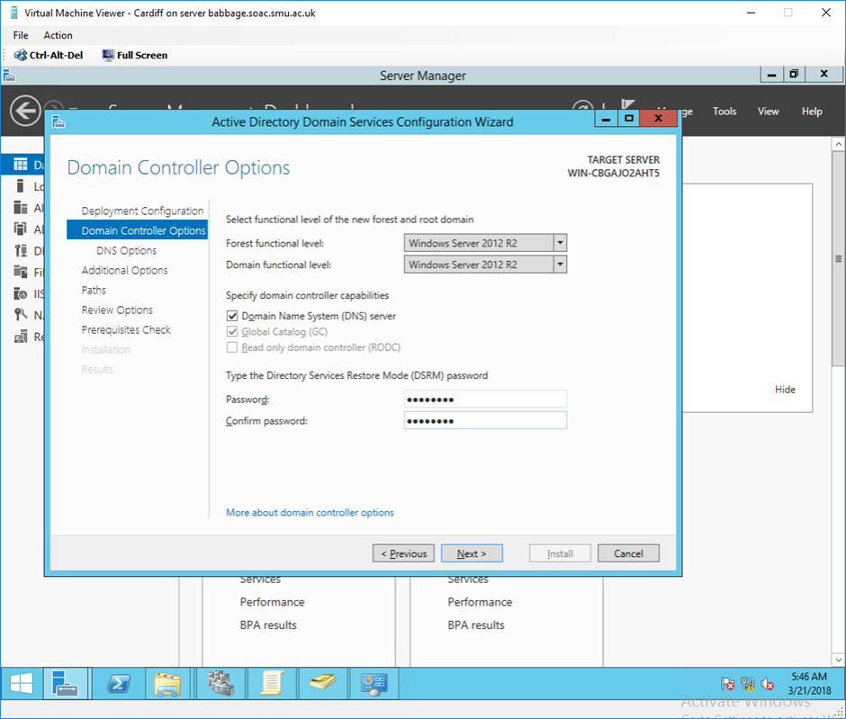
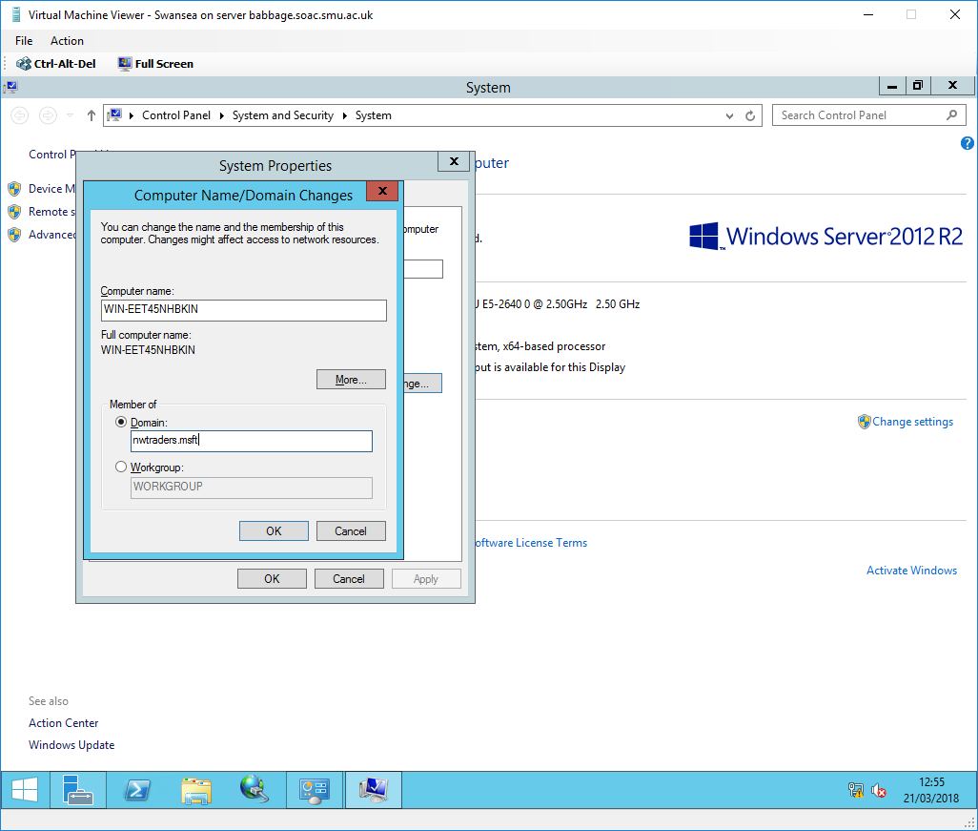
In this part, Swansea and Bridgend will get together to form the basis of the failover cluster nodes. Cardiff will still be a domain controller - one of the rules of the Microsoft Failover Cluster is that the nodes must belong to the same domain, but they themselves cannot become domain controllers.
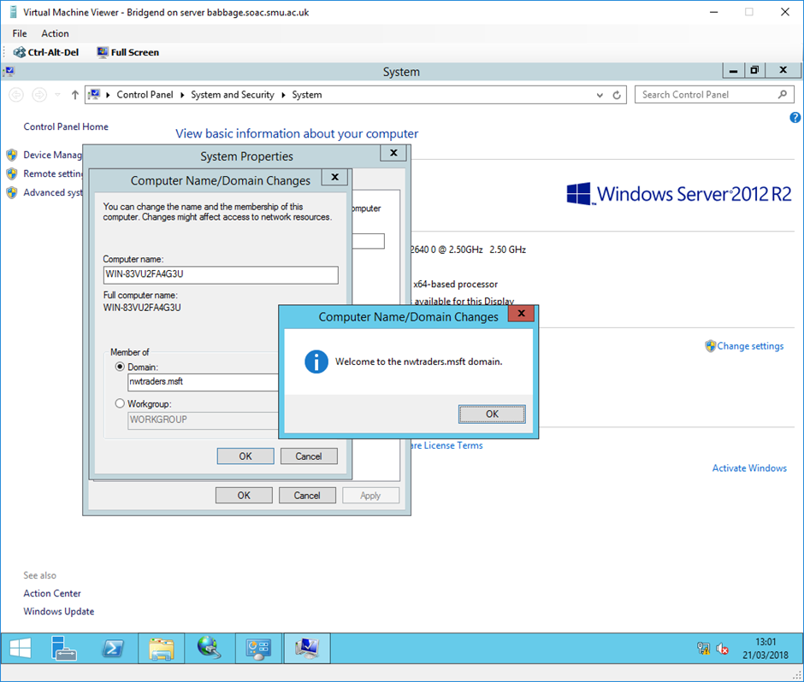
Then the three nodes computer hostnames will be hostname/nwtraders:

Environment details:
- Single iSCSI server Cardiff: IP address: 192.168.11.1
- File server Swansea IP address: 192.168.11.3
- File server Bridgend IP address: 192.168.11.4

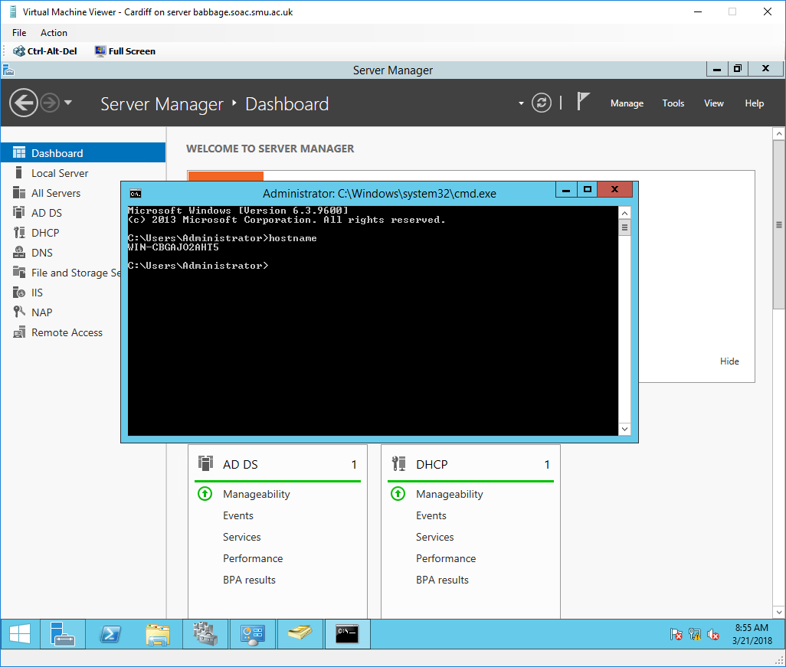

Set up the Disk
Create a new disk for Cardiff
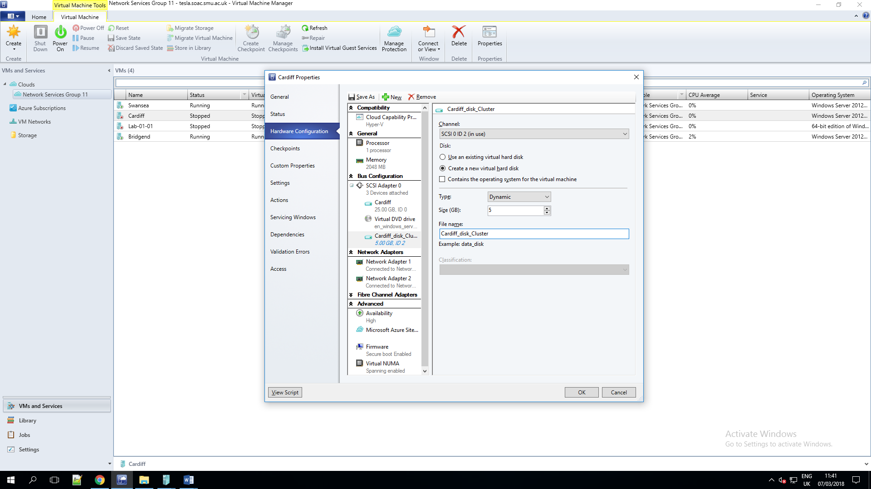
Disk Management is a system utility in Windows that enables you to perform advanced storage tasks. Here are some of the things Disk Management is good for:
To setup a new drive, see Initializing a new drive.
To extend a volume into space that's not already part of a volume on the same drive, see Extend a basic volume.
To shrink a partition, usually so that you can extend a neighboring partition, see Shrink a basic volume.
To change a drive letter or assign a new drive letter, see Change a drive letter[5].
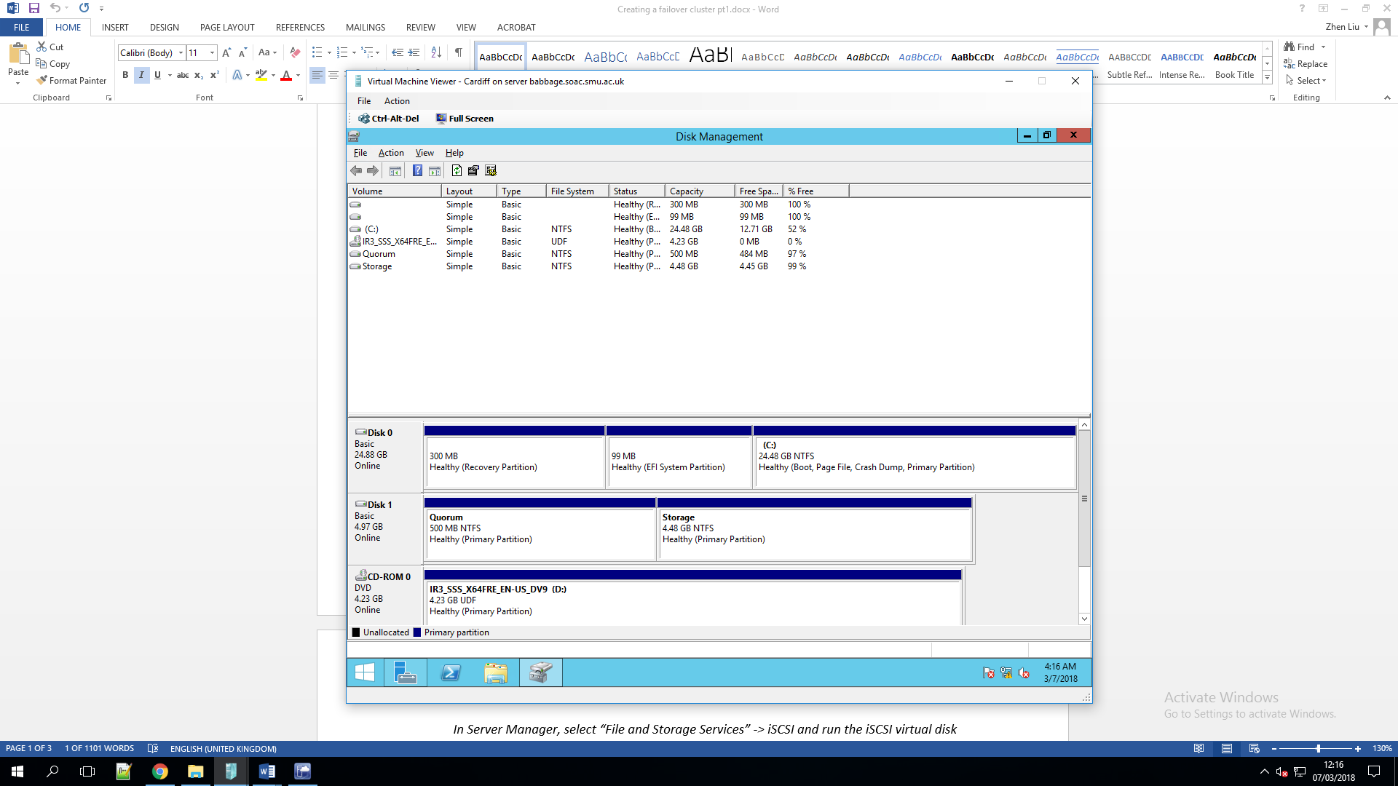
There are two disks in each node quorum and storage. Storage is used to store data and information. The quorum is as follows:
The fault-tolerant technology is to allow the existence of a fault within the system. Based on the redundant design, the system can still operate reliably. Quorum is a fault-tolerant technology that is well represented in Amazon's Dynamo. The Quorum system is a collection system based on a redundant design.
Each quorum is composed of multiple nodes (usually three, and Dynamo defaults to three). The quorum nodes maintain the consistency of data operations through mutual communication and data replication. At the same time, the quorums again use the intersecting nodes to copy the data inside their quorum to all the nodes of other quorums.
The main difference between the various quorum system fault-tolerance technologies is the difference in organization, topology, and execution protocols, and the resulting differences in performance and application areas. Fault-tolerant implementation protocols fall into two main categories: election protocols and mutually exclusive protocols. When some nodes fail or fail, valid data is elected from valid nodes containing faulty nodes quorum through an election protocol, or mutually exclusive protocol is used to obtain valid data from valid quorum nodes that do not contain faults or faulty nodes. The system can still operate reliably.

Heartbeat Network
The quorum which stores the progress and mechanism of the Failover, the heartbeat network refers to how a node is known to be lost in the cluster network. The principle is as follow:
The core of heartbeat consists of two parts, the heartbeat monitoring part and the resource takeover part. Heartbeat monitoring can be performed via network links and serial ports, and it supports redundant links, and they are sent to each other. The message tells the other node of its current status. If the message is not received by the other node within the specified time, the other node is considered to be invalid. At this time, the resource takeover module needs to be started to take over the resources or services running on the other host.
By modifying the configuration file of Heartbeat's software, you can specify which Heartbeat server to use as the primary server, and the other server will automatically become a hot standby server. Then configure Heartbeat on the hot standby server to monitor heartbeat messages from the primary server. If the hot standby server detects the heartbeat from the master server within a specified time, it will initiate the fault escape procedure and obtain the ownership of the related resource service on the master server, and continue to provide services without interruption to the master server, thereby achieving resources and The purpose of serving high availability.

Create iSCSI target
1. To install Windows server iSCSI target open Server Manager and click Add Roles and Features then walkthrough the installation as per the below screenshots

2. After installation is complete successfully we will now configure the iSCSI target server as per the following
- We will have single VHD of 5 VHDs
- Access is allowed to two file server nodes
192.168.11.3
192.168.11.4

- Storage target name is File Server

To complete iSCSI target server the configuration go to Server Manager, click File and Storage Services then follow the screenshots below;
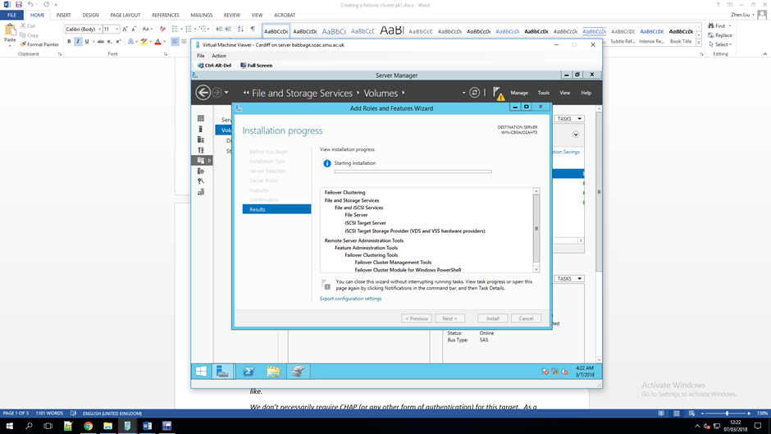
Go to iSCSI Virtual disks and click “Launch the New Virtual Disk wizard to create a virtual disk” and walk through the Virtual Disks and targets creation
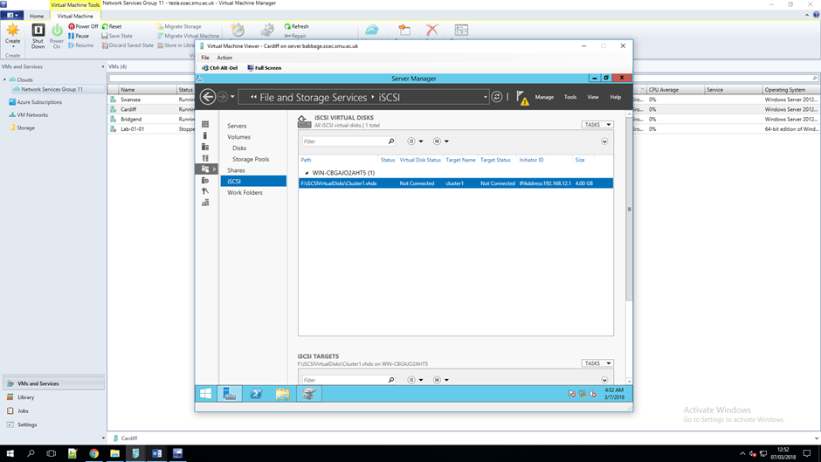
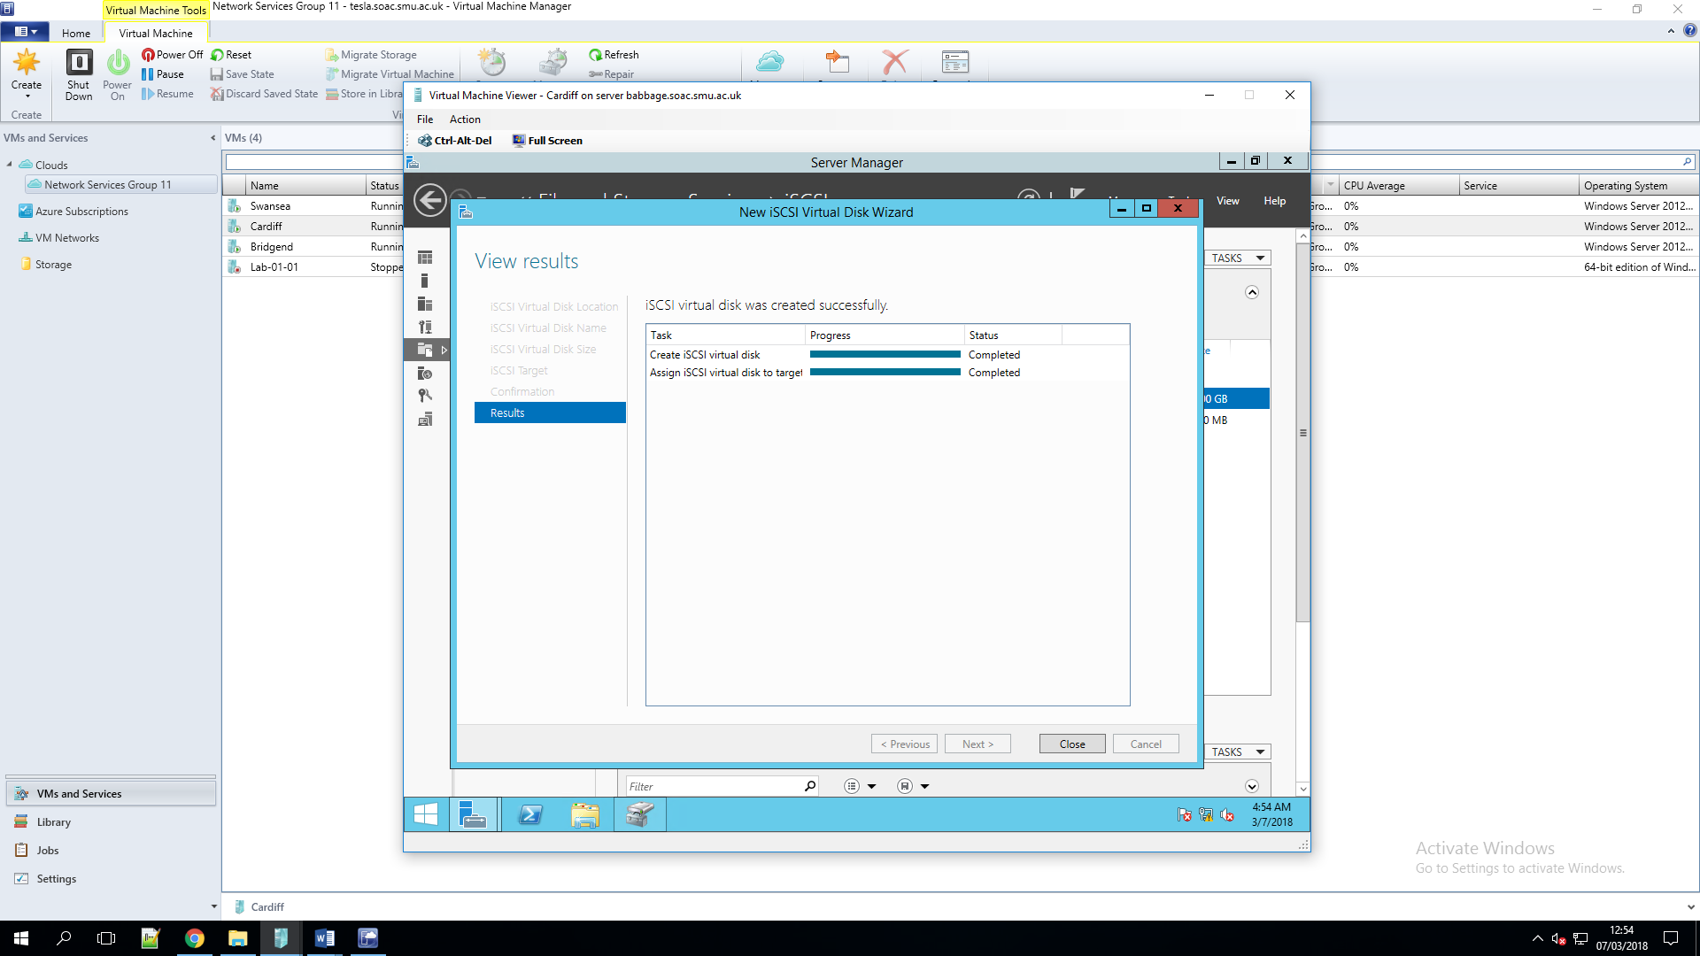
3. To connect File Server nodes to iSCSI target open Server Manager click Tools and select iSCSI Initiator then proceed with the configuration as per the below screenshots
Now we open disk management to make sure that the disk is presented correctly
Repeat step 3 for the second file server node[6].
After doing these tasks, you can test that the corresponding disks of these computers have been shared as the same cluster. By testing, you can write files to any disk, whether it be quorum or storage, and the same files will appear in the disks corresponding to several other nodes.

Configure DHCP
We will now configure DHCP to run on the cluster instead of running on Cardiff. To run services on a cluster, all nodes of the cluster must have the appropriate roles installed. To do this, install DHCP on the appropriate node.
Since Cardiff is not redundant, we will also uninstall DHCP from Cardiff. Make sure you authorize first. If you forget and (strange) often fail, this may cause you some major problems. If this happens, don't worry - we will solve it later.
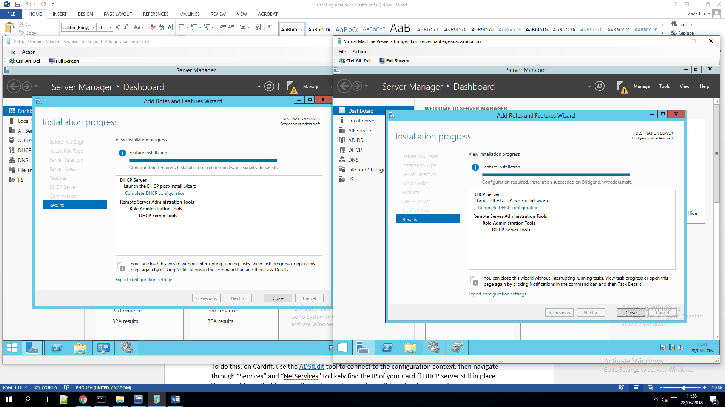
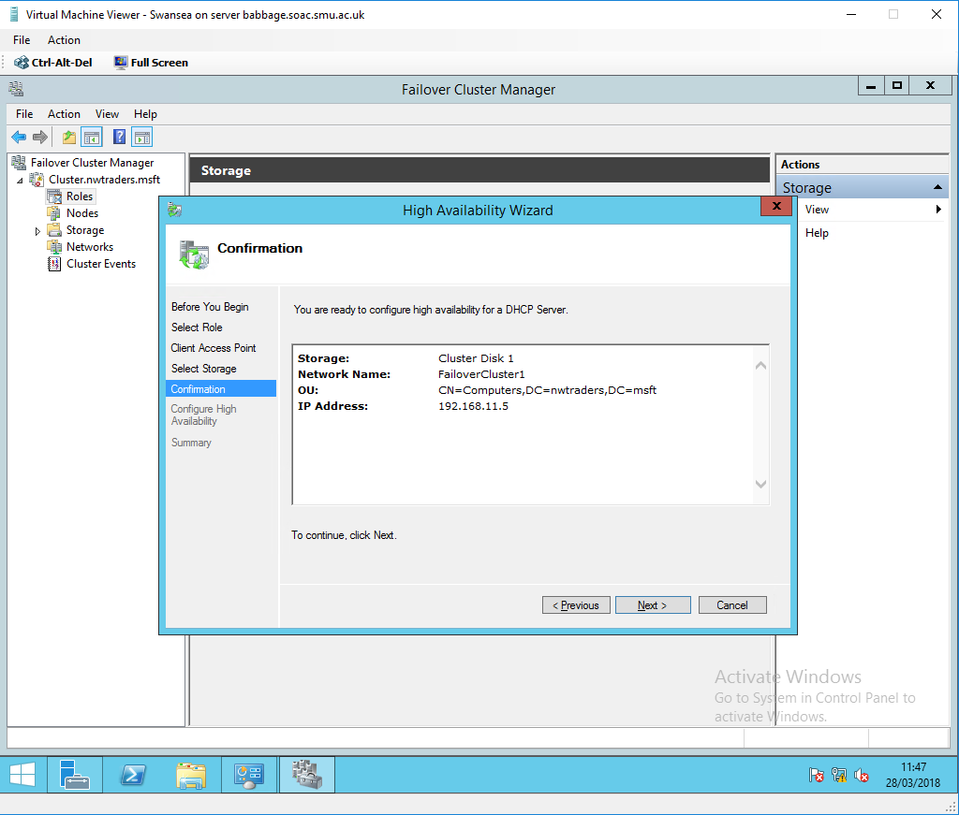

Add a DHCP Role

The live migration process for the virtual machines in the cluster (when the virtual machine is stored on the CSV volume) and the virtual machines outside the cluster (when the virtual machine is stored on the SMB share) is actually the same.

When performing live migration of virtual machines between two computers that do not share the infrastructure, Hyper-V first performs a partial migration of virtual machine storage, as follows:

In most mobile operations, disk reads and writes go to the source virtual hard disk.

As the source virtual hard disk is read and written, the disk contents are copied over the network to the new target virtual hard disk.

After the initial disk copy is complete, disk writes are mirrored to the source and target virtual hard disks, while unfinished disk changes are replicated.

After the source and target virtual hard disks are fully synchronized, live migration of virtual machines is initiated in the same process as real-time migration using shared storage.

Once the live migration completes and the virtual machine runs successfully on the target server, the files on the source server will be deleted[7].
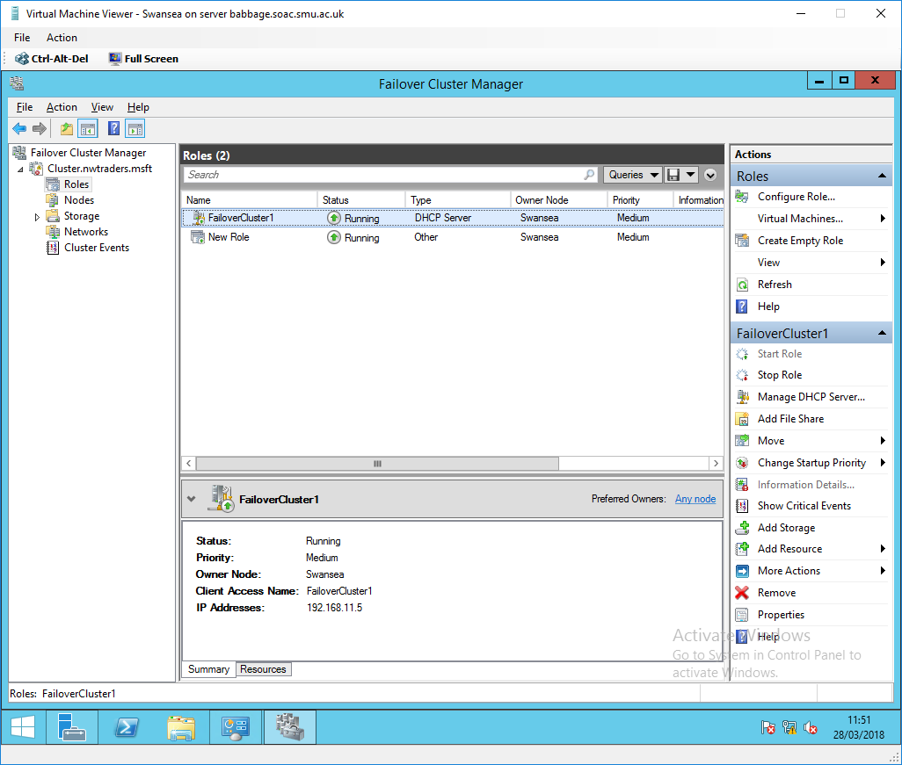
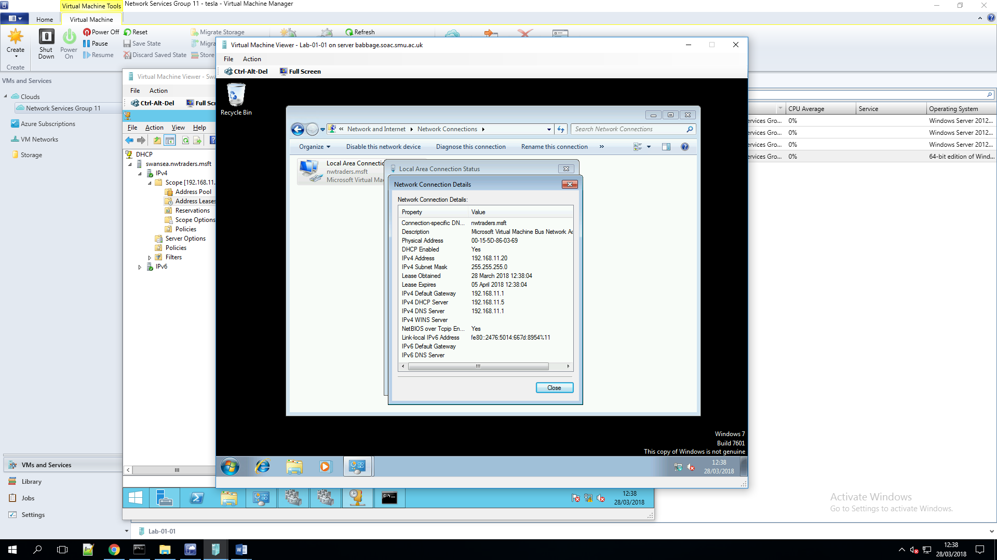

Add failover cluster to each node
After adding the first node server, other node servers need to install the failover cluster function first. After the installation is complete, the first node server can add ta into the cluster.
Add a node server. Right-click the node, click Add Node, and follow the wizard to finish adding the node server. Once added to the cluster, the node server can view the corresponding cluster service on the local machine.

Test failover
Configure the web site under IIS on each node server in turn. For specific implementation details, see IIS Web Site Configuration under Failover Clustering. After installation, the home page of each node server is marked. From the label, it can be seen which node server. When using a client to access the cluster network's virtual IP, you will first see the home page of the current owner of the cluster. For example, if the current owner of the cluster is server001, then when the cluster's virtual IP is accessed, the home page of server001 will appear. Similarly, when the server 001 is down, the failover cluster network will automatically switch to change the current owner to the currently available node server. At this time, the fault has been transferred. For the client, only the network delay has not failed and is inaccessible.
There is no shared storage for this test. All of them are stand-alone storage. And there are more than 3 node servers[8].
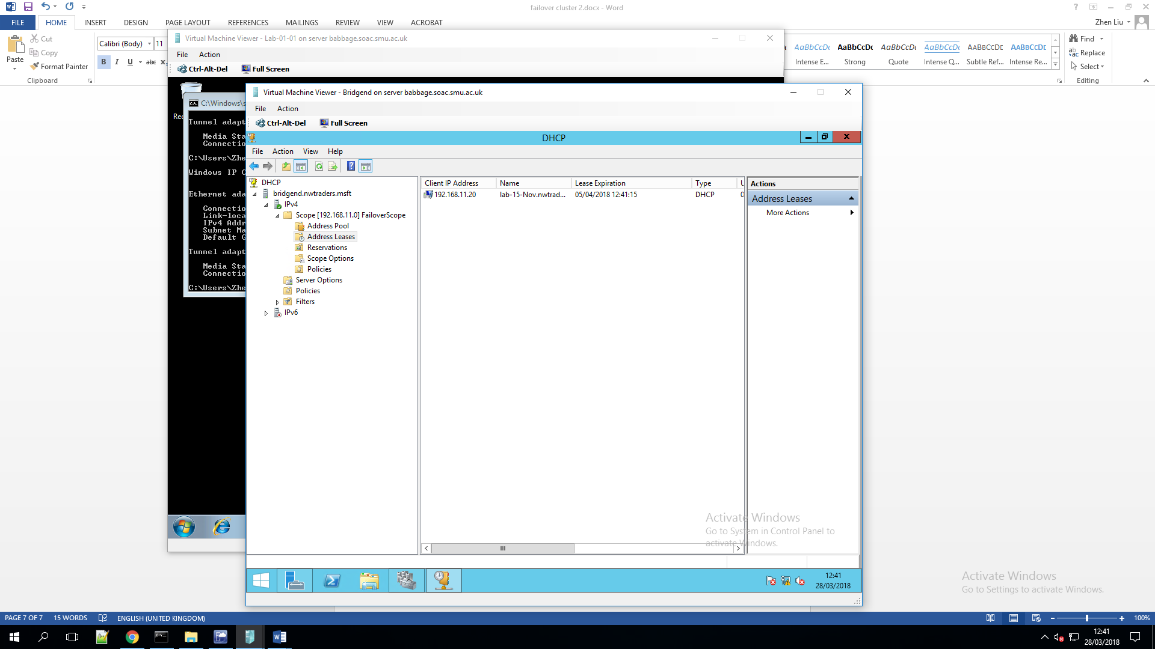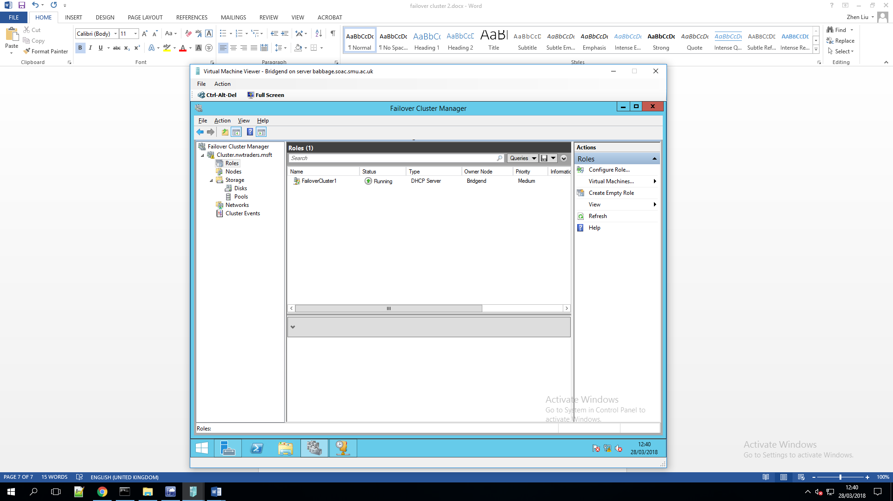

Bibliography
[1] A. R. Condrobimo, B. S. Abbas, and A. Trisetyarso, “DATA MINING TECHNIQUE WITH CLUSTER ANAYSIS USE K-MEANS ALGORITHM FOR LQ45 INDEX ON INDONESIA STOCK EXCHANGE,” pp. 885–888, 2018.
[2] S. Lim, Y. Chong, Q. Ng, and K. Yap, “Failover Mechanism During Upgrading Process for Software-Defined Networking,” no. 304, pp. 591–596, 2018.
[3] K. Benz and T. M. Bohnert, “Impact of pacemaker failover configuration on mean time to recovery for small cloud clusters,” IEEE Int. Conf. Cloud Comput. CLOUD, pp. 384–392, 2014.
[4] “78c15df1f111f18582d05a3b @ wenku.baidu.com.” .
[5] “overview-of-disk-management @ docs.microsoft.com.” .
[6] “8003b214585a2a45010513c9e8789513f3fb2766 @ blogs.technet.microsoft.com.” .
[7] “hh831435(v=ws @ docs.microsoft.com.” .
[8] “41925205 @ blog.csdn.net.” .

