Assignment Title
Croeso Connect 2025: An International Meeting Celebrating Wales’ Cultural Hospitality and Global Connectivity
Module: BMIH6007 - International Meetings Management for the Hotel Industry
Level:Level 6
Student Name:Catalina Coman
Student ID:2238715
Lecturer Name: Kathryn Flynn

AI Declaration:
"I confirm that I have not used any AI tools in the research and creation of this assignment. I confirm that I have not presented any AI-generated materials as my work. I confirm I have copies of my drafts, notes, and other resources I used, which I may be asked to provide in evidence."

Table of Contents
1 Introduction 4
2 The Event Cycle 4
3 Event Concept 6
4 Aim and Objectives of the Meeting/Event 6
5 Event Management 7
6 Event Budget 8
7 Industry Trends / Issues / Impacts 10
8 Situational and Cultural Considerations 10
8.1 Political 11
8.2 Economic 11
8.3 Social 11
8.4 Technological 11
8.5 Environmental 12
8.6 Legal 12
9 Conclusion 12
10 References 14

Introduction
Croeso Connect 2025 is a 3-day event to highlight Welsh hospitality and the nation's place in the global community. The purpose of this event is to reflect "Croeso," which means welcome, by having cultural activities, business meetings and educational events together (Zhylenko et al., 2022). It allows for keynote speeches, cultural activities, exhibitions and networking, which bring together more than 500 delegates from the MICE, cultural diplomacy and business investment fields. The event attracts attention by displaying Welsh culture with original food, music, art and heritage, which makes it a key highlight of Year of Croeso 2025 (McInch and Fleming, 2022).
Croeso Connect 2025 is well-chosen because it directly supports Visit Wales' goals to make Wales more visible internationally and ensure everyone visiting feels included. Because of the growing worldwide interest in events that celebrate culture, this event promotes economic growth and tourism and supports international joint efforts as outlined by the theme "Sense of Place." The event answers stakeholders' requests for improved promotion of Wales' unique culture and hospitality by giving a unique chance to celebrate the region's identity and open new business doors (Pyankova et al., 2022).
The event will occur at the International Convention Centre (ICC) Wales, inside the Celtic Manor Resort in Newport. This place has modern features and flexible areas that can host meetings, exhibitions and cultural events, all using advanced audio and video tech and environmentally friendly methods. International audiences can easily reach the location since it is not far from Cardiff and Bristol airports and nearby accommodations. Croeso Connect 2025’s strategy is to raise Wales’s profile internationally, use cultural activities and build teamwork among various organisations (Fox et al., 2014). This event brings people together to learn about culture as well as to build their professional network which is now popular in the MICE industry and helps the region succeed in its economic and social goals.
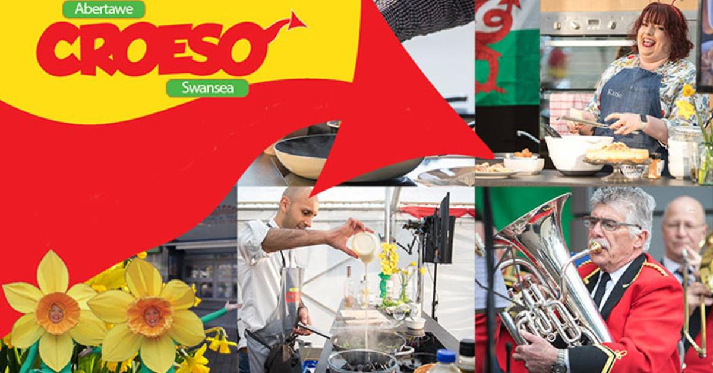
Figure 1 Croeso Connect

The Event Cycle
The EMBOK (Event Management Body of Knowledge) Model covers all elements of event planning in three main phases: Design, Development and Delivery (Bladen, 2012). The Design phase is about developing an idea for the event and clarifying its main goals. During this phase, Croeso Connect 2025 is molded to fit the “Year of Croeso” theme, so it includes both Welsh culture and business and tourism possibilities. In the Development stage, the planners arrange the use of ICC Wales, handle important details and team up with Visit Wales and other local groups. The main task of this stage is to carry out the event and ensure that every detail such as food, cultural shows, exhibitions and networking, goes well.
Croeso Connect 2025 is different because it merges cultural activities with professional networking which is rarely found at other MICE events. This is made possible by including Welsh cultural activities such as watching choir performances, sampling local dishes and visiting places of historical importance which turns it into more than a business event for delegates. Since the event supports Visit Wales’s objectives, it helps to promote Wales as a place for travel and for doing business. With this approach, Croeso Connect 2025 offers something unique, highlighting its efforts to help businesses and showcase the great culture of Wales.
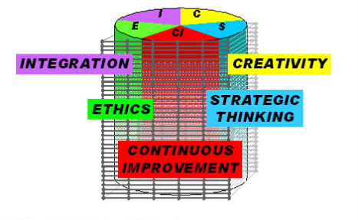
Figure 2EMBOK Core Values

Event Concept
The event makes sure that delegates learn, grow professionally and enjoy cultural activities for three days. The event starts with a welcome reception, where harpists and dancers perform traditional Welsh music to create a culturally lively atmosphere. Influential tourism, culture, and international business speakers will deliver keynotes, and sector-based exhibitions on Welsh arts, crafts, and new businesses will be held (Elshaer and Marzouk, 2019). Delegates can participate in workshops related to cultural tourism development, making events more sustainable and teaming up with other countries in business. The organizers will ensure well-planned networking sessions to help people from different backgrounds make valuable connections.
Catering menus will celebrate Welsh cuisine by including Welsh lamb, different kinds of artisanal cheeses and options for those with plant-based diets, so all guests are included (Healey, 2023). Outside the conference rooms, attendees can go on tours to nearby sites and areas of natural beauty, which help them appreciate Wales' special character. At the venue, a Welsh craft market will sell eco-conscious and locally produced goods to encourage community members and those attending the event to be sustainable (Menon, 2025). In the evening, cultural events will offer a relaxed way to chat and enjoy the Welsh language, art and traditions.
This event idea follows the MICE industry trends, which are now more focused on offering immersive and culturally authentic experiences that enrich professional events. Croeso Connect 2025 satisfies the growing popularity of events that give both business chances and enjoyable cultural moments by including Welsh culture in the food, music, sessions and leisure schedule (Fox et al., 2014). This holistic approach means visitors are more satisfied, and Welsh tourism becomes better known for events and cultural attractions.
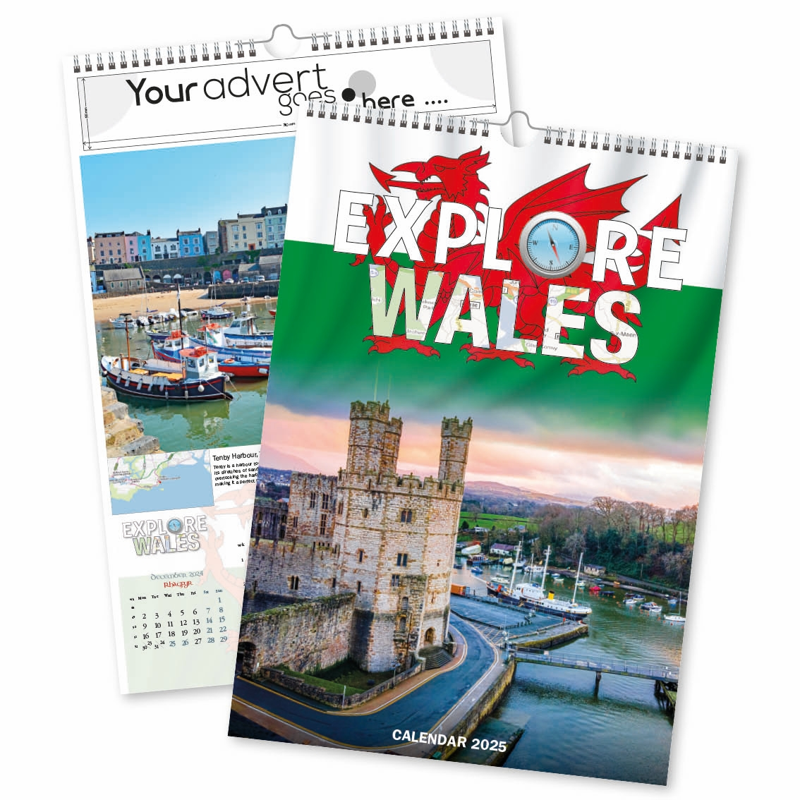

Aim and Objectives of the Meeting/Event
The primary aim of Croeso Connect 2025 is to become the leading international event that connects culture and business, promoting Wales’ hospitality, heritage, and economic potential. Aligned with Visit Wales’ "Year of Croeso" initiative, the event aims to position Wales as a prominent destination for MICE (Meetings, Incentives, Conferences, and Exhibitions) events while fostering meaningful cross-sector relationships. By blending cultural celebration with professional networking, the event will strengthen Wales' global visibility and enhance its economic, social, and cultural landscape. To achieve this aim, the event will work towards the following SMART objectives:
Specific: Attract more than 500 international delegates, primarily from the tourism, culture, education, and business investment sectors, by targeting global MICE professionals.
Measurable: Generate a minimum of £200,000 in revenue through delegate fees, sponsorships, exhibitor contributions, and government support to ensure financial sustainability (Croke et al., 2021).
Achievable: Gather participant feedback post-event to evaluate their understanding and appreciation of Welsh culture, aiming for a satisfaction rate of at least 80%, ensuring that the event meets its cultural and experiential goals (Evans and Williams, 2024).

Event Management
Successful delivery of Croeso Connect 2025 will require a team with diverse skills, including expert event planners capable of managing all aspects of the event. Smooth communication and cultural exchanges depend on having cultural liaisons and multilingual staff. Technical staff will be responsible for the equipment and stage layout and provide simultaneous translation so events are presented flawlessly (Kumar, 2021). Experts in hospitality and catering will ensure that all food is served and that it matches guests' dietary needs, focusing on genuine Welsh dishes.
Resource needs involve handling all logistics at ICC Wales, such as arranging rooms, ensuring security, putting up signs, and handling the flow of visitors. The latest technology will be used for keynote talks, exhibitions, and cultural acts (Bowdin et al., 2023). Proper transportation coordination will make it easy for guests to get to the airport or around the resort, and accommodation choices will make things easy for delegates.
The team will utilise platforms like LinkedIn and MICE industry networks to reach the participants the event attracts. Partnerships with Visit Wales, trade organisations, embassies and diplomatic missions will be used to get business organisations and invite top-level delegates from other countries (Refiloe Julia Lekgau and Tembi Maloney Tichaawa, 2023). The efforts will receive support from content that emphasises the special cultural aspects of the event.
Part of the planning process is carefully organising sessions, performances, and networking events. A proper risk management plan will outline how to handle health, safety, and issues created by disruptions. Inclusivity will be achieved through accessibility plans, which include supporting people with disabilities, providing clear signs, and helping with language (Rogers and Wynn-Moylan, 2022). Properly coordinating stakeholders will help ensure that Visit Wales, local authorities, sponsors, and cultural partners are aligned and understand each other.
All these elements unite to ensure guests have a smooth, professional, and inspiring event that fits the 2025 strategic objectives. Smoothly working teams ensure that operations run well, the culture is preserved, and the event is enjoyable for everyone.

Event Budget
The budget for Croeso Connect 2025 outlines both income and expenditure streams necessary for the event's success. Income is projected to reach £200,000, primarily from delegate fees (£100,000), sponsorships (£50,000), and a grant from Visit Wales (£30,000), and exhibitor fees (£20,000). These income sources are strategically diversified to ensure financial stability.
On the expenditure side, £160,000 is allocated across several key categories. The largest cost is venue hire and equipment at ICC Wales (£60,000), which provides state-of-the-art facilities for the event. Catering, with a focus on traditional Welsh meals, is budgeted at £30,000, ensuring delegates’ dietary needs are met. Staffing costs (£25,000) cover event planners, technical experts, and hospitality staff. Marketing and public relations efforts are allocated £20,000 to attract a global audience. Transport and miscellaneous expenses are planned at £15,000 and £10,000, respectively. Contingency planning ensures flexibility to manage unforeseen costs or additional sponsorships (Consoli et al., 2024).
Table 1 Event Budget
Category | Details | Amount (£)
Income Sources
Delegate Fees (500 delegates x £200) |  | £100,000
Sponsorship (Cultural and Tourism Fields) | Partnerships with Visit Wales and companies supporting the event | £50,000
Visit Wales Grant | Financial assistance for the event | £30,000
Exhibitor Fees | Fees from local and international businesses | £20,000
Total Income |  | £200,000
Expenditure Categories
Venue Hire and Equipment (ICC Wales) | High-quality facilities for plenary sessions, exhibitions, and cultural events | £60,000
Catering (Meals following Welsh traditions) | Food for delegates with special dietary requirements | £30,000
Staffing (Event Planners, Tech Experts, Cultural Liaisons, Hospitality Workers) | Including staff for all operational needs | £25,000
Marketing and Public Relations | Digital and targeted PR to attract the desired audience | £20,000
Transport Support (Airport Transfers, Shuttles) | Transport arrangements for delegates | £15,000
Miscellaneous (Unplanned Needs) | Budget reserved for unforeseen expenses | £10,000
Total Expenditure |  | £160,000
Contingency and Risk Management | Carefully monitored expenses, with additional funds in miscellaneous to handle unforeseen costs. Additional sponsors may be sought if necessary. (Smith, 2012)

Industry Trends / Issues / Impacts
Croeso Connect 2025 has been created in response to the critical trends affecting the MICE (Meetings, Incentives, Conferences and Exhibitions) industry. There is a growing tendency for business events to add cultural elements so that people can enjoy professional and artistic activities together. This matches the Welsh focus of Croeso Connect, allowing delegates to learn about Wales's heritage, arts and food. Sustainability has become very important, and the industry is now adopting green approaches such as less waste, plant-based menus and lower carbon emissions (Samuel et al., 2021). The conference applies these by handing out digital materials, ordering catering that uses plants and local sources and encouraging everyone to recycle and avoid waste everywhere.
Health concerns and the possibility of travel restrictions after the pandemic still make keeping events safe very important. Health and safety are priorities at Croeso Connect 2025, so they will register attendees contactless, have clear hygiene protocols, and have plans ready for disruptions. Also, political or travel issues in some parts of the world can make it harder for people to attend the event (Mair and Smith, 2022). For risk management and marketing, these factors are now considered, especially by highlighting how flexible the company is and how it communicates with delegates.
Organizers also pay close attention to the social and environmental sides of planning the event. The event helps local culture and businesses, supporting community growth and the local economy. Sustainable practices in sourcing and operations are used at the event to help the environment by lowering waste and carbon emissions (Moayerian, McGehee and Stephenson, 2022). Overall, these trends and challenges help guide the organization of Croeso Connect 2025 so that it remains relevant, responsible and able to face future changes in the world.

Situational and Cultural Considerations
The PESTEL framework shows that various outside factors play a major role in planning and delivering Croeso Connect 2025.

Political
Strong political support from Visit Wales makes the event possible by providing financial support, promoting it, and adding legitimacy. Because of this support, tourism policies are followed, and partnerships with organizations like the Newport City Council are formed, providing better infrastructure and assistance (Ormerod and Wood, 2020).

Economic
Significant economic change arises as international travel and business tourism recover after the pandemic. More interest in MICE events and the strong local economy around Newport and Cardiff make it possible to organize an international event (Tendai, 2021). Moreover, links with local firms and support from sponsors provide much-needed money, and the event helps the local economy grow by attracting visitors and fueling sectors like tourism and retail.

Social
Social factors are very important, as the Welsh culture and language define the event. When people speak more than one language and programmes are culturally aware, traditional customs are kept in mind while including viewers’ worldwide (Neuhofer et al., 2024). It also provides ways to include everyone by catering to various diets, mobility, and cultural diversity, ensuring all delegates are comfortable.

Technological
At ICC Wales, the conference is equipped with modern audiovisual technology, promotion is handled through digital marketing on LinkedIn and MICE websites, and attendees receive digital brochures instead of physical ones (Dillette and Ponting, 2020). Such technologies make the event more enjoyable for participants and help reduce paper use, which is good for the environment.

Environmental
The event highlights sustainability by using plant-based menus, minimizing waste, and having no-waste policies. The company tries to buy locally and uses eco-friendly methods that match international efforts to protect the environment (Kontovas et al., 2022).

Legal
Following health, safety, and data protection rules is important, especially after the pandemic (Harfst et al., 2025). Making the event inclusive is essential, so accessibility laws are a significant concern.
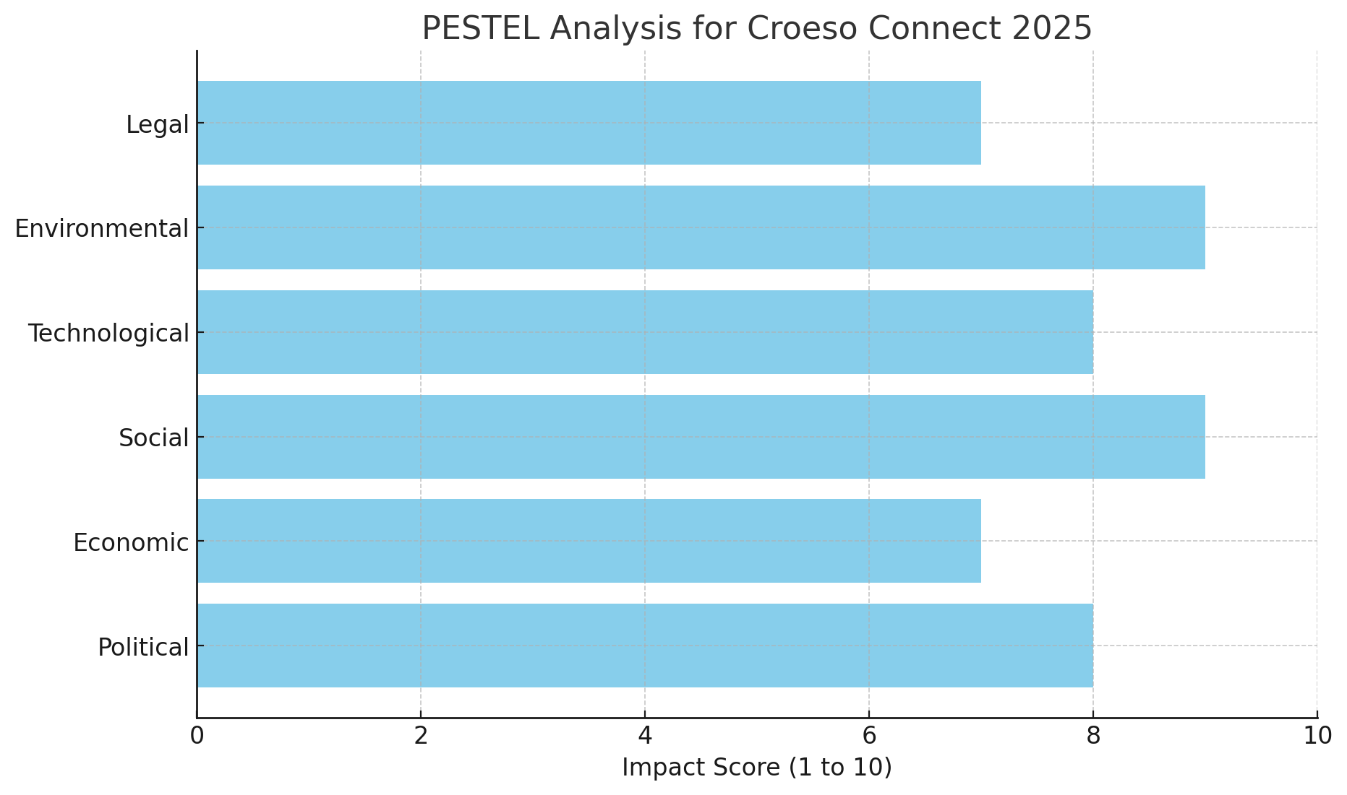
Figure 3 PESTEL Analysis for Croeso Connect 2025

Conclusion
It is concluded that Croeso Connect 2025 is an international event that brings together Wales' cultural heritage, business, and education per the purposes of the Wales' Year of Croeso campaign. Using a comprehensive event cycle model, the organisation plans, carries out and reviews the event systematically. Central aspects of operations are having well-trained staff, managing resources effectively, targeting marketing and planning for risks and access, all organised to ensure a smooth and enjoyable experience. The budget is made sustainable and balanced using financial planning, and different funding sources, such as delegate payments, sponsorships, grants, and exhibitor contributions, support it. The budget is handled with care using plans to prevent any possible overruns.
The event reflects current trends in the MICE industry, such as the desire for culture-based experiences, environmentally friendly practices, and more online activities, as well as responses to concerns like health safety measures due to COVID-19 and uncertain political situations. The analysis points out that the government's support and special cultural features are strong points, and there is room to grow tourism and form partnerships with other countries. By keeping culture in mind, event planners ensure that everyone feels included and that the experience is true to the event's aims, attracting people worldwide.
Croeso Connect 2025 is prepared and positioned to bring significant cultural, economic, and tourism advantages to Wales. It is meant to raise Wales' profile and support the development of valuable connections between different sectors. By planning well and setting clear goals, the event can now be carried out in full detail, which serves as a significant step in Wales' Year of Croeso events and sets a standard for future international gatherings.

References
Bowdin, G., McDonnell, I., Harris, R., O’Toole, W., Allen, J. and Leo Kenneth Jago (2023). Events Management. Routledge. doi:https://doi.org/10.4324/9781003044963.
Croke, R., Dale, H., Dunhill, A., Roberts, A., Unnithan, M., and Williams, J. (2021). Integrating sustainable development and children’s rights: A case study on Wales. Social Sciences, 10(3), 100.
Dillette, A. and Ponting, S.S.-A. (2020). Diffusing innovation in times of disasters: considerations for event management professionals. Journal of Convention & Event Tourism, 22(3), pp.1–24.
Elshaer, A.M. and Marzouk, A.M. (2019). Labor in the Tourism and Hospitality Industry. doi:https://doi.org/10.1201/9780429465093.
Evans, N., and Williams, C. (2024). Globalising Welsh Studies: Decolonising history, heritage, society and culture (p. 336).
Fox, D., Gouthro, M.-B., Morakabati, Y. and Brackstone, J., 2014. Doing events research: from theory to practice. Oxford: Routledge.
Getz, D. and Page, S., 2019. Event studies: theory, research and policy for planned events. 3rd ed. Oxford: Routledge.
Harfst, J., Sandriester, J., Mildeberg, S., Dołzbłasz, S. and Grochowska, A., 2025. Policies on industrial heritage tourism as a tool for sustainable regional development? a Central and Eastern European analysis. Tourism Recreation Research, pp.1-14.
Healey, N.M., 2023. Reinventing international higher education for a socially just, sustainable world. Perspectives: Policy and practice in higher education, 27(4), pp.169-178.
Kontovas, C., Bras, A.A., Chang, C.H., Romano, A., Poo, M.C.P., Wang, J., McCormack, H., Qu, Z., Paraskevadakis, D., Lamb, L. and Yang, Z., 2022. Fostering innovation in the blue economy within the United Kingdom (UK): A stakeholders’ perspective. Ocean & Coastal Management, 224, p.106143.
Kumar, P. (2021). Hospitality and Tourism Information Technology. USF M3 Publishing, LLC. doi:https://doi.org/10.5038/9781732127593.
Mair, J. and Smith, A. (2022). Events and sustainability: why making events more sustainable is not enough. Events and sustainability: why making events more sustainable is not enough, pp.1–17. doi:https://doi.org/10.4324/9781003314295-1.
McInch, A. and Fleming, S., 2022. Sport policy formation and enactment in post-devolution Wales: 1999–2020. International Journal of Sport Policy and Politics, 14(2), pp.225-237.
Menon, N. (2025). The Impact of Recent Global Events and Long-Term Industry Trends. IGI Global eBooks, [online] pp.35–68. doi:https://doi.org/10.4018/979-8-3693- 9760-2.ch002.
Moayerian, N., McGehee, N.G. and Stephenson, M.O. (2022). Community cultural development: Exploring the connections between collective art making, capacity building and sustainable community-based tourism. Annals of Tourism Research, 93, p.103355. doi:https://doi.org/10.1016/j.annals.2022.103355.
Neuhofer, B., Celuch, K. and Rihova, I. (2024). The future of transformative events: an event leaders’ perspective. International journal of contemporary hospitality management, 36(10). doi:https://doi.org/10.1108/ijchm-07-2023-1027.
Ormerod, N. and Wood, E.H. (2020). Regional Event Tourism Funding Policies: A Strategic-Relational Critique of Current Practice. Journal of Travel Research, 60(4), p.004728752091363. doi:https://doi.org/10.1177/0047287520913631.
Pyankova, S., Ergunova, O., Bogomolova, I. and Belyakova, N. (2022). Trends of Integration of MICE-Tourism into Priority Areas of Socio-Economic Development of the Region. Regionalnaya ekonomika. Yug Rossii, (3), pp.16–27. doi:https://doi.org/10.15688/re.volsu.2022.3.2.
Refiloe Julia Lekgau and Tembi Maloney Tichaawa (2023). Dynamic Changes and Recovery in Event Venues: Perspectives from MICE Event Planners and Venue Managers. Studia Periegetica. doi:https://doi.org/10.58683/sp.598.
Rogers, T. and Wynn-Moylan, P., 2022. Conferences and conventions: a global industry. 4th ed. Oxford: Routledge.
Samuel, M., Choi, H., Kang, H. and Lee, M.J. (2021). Sustainable Event Planning: An Exploration of University Conference Centers. Sustainability, 13(13), p.7194. doi:https://doi.org/10.3390/su13137194.
Tendai, C. (2021). A critical assessment of the sectorial development potential of business tourism events. [online] Available at: https://repository.nwu.ac.za/handle/10394/37340.
Zhylenko, K.M., Khalatur, S.M., Pavlenko, O.P. and Pavlenko, O.S. (2022). FORMATION OF MACROECONOMIC INDICATORS UNDER THE INFLUENCE OF MICE-TOURISM. Akademìčnij oglâd, 2(57), pp.249–266. doi:https://doi.org/10.32342/2074-5354-2022-2-57-19.

