Alexander Apps (1806320)
1806320@student.uwtsd.ac.uk
Management Approaches
The National Health Service

BATCHELORS DEGREE ASSIGNMENT
Business Portfolio
Contemporary Approaches to Management
BMSP4002
Davina Evans

-The ‘National Health Service’-
-Introduction-
The NHS a well-known and established Public Sector company, beloved by the populace due to its benevolent stance on free-sustainable health care. It maintains a perennial sense of pride for the British people. The NHS protects? It tries as well as any beloved Public sector company can with a supreme gusto of continual commitment to its patients. A beloved yes, but how many of us know of its organisational functions and the approaches it uses to manage these, how does the organisation gauge its level of satisfaction, are employees aware of its perception and how do NHS managers communicate with employees’ patients and the public. A world changing public sector innovation, produced after massive Geopolitical upheaval (The Second World War), it marked 3 years of hard work for Labour Health minister Aneurin Bevan. Beginning on July 5th, 1948 in Manchester Park Hospital as it was known at the time (NHS, 2016). Many criticise it for the problems it endures at this time, but would we really want, to live without it.

-Management and Organisation-
Any organisation must understand its necessity for management, otherwise a stagnant and useless failure will arise. There are several management options available to both private and public companies, private being profit driven verses, public which is funded by taxes and regards service and efficiency as its primary concerns. Choosing the right style will usually be reflected by the nature of the business itself. The Classical management style targets a company’s structure being able to increase efficiency and is good for redefining the structure of an organisation that needs improvement. But is criticised for its myopic approach to influential social factors that can create morale problems for said company, and further evaluation of empirical research has occluded the so-called good effect of the ‘Classical Management Style’ (Woodward, J. 1980), but positively this way promotes a more systematic vista for managing the company, (Mullins, L. 2016). The ‘Human resources’ direction pays closer attention to behavioural factors in the workplace as well as the outside social influences that depress efficiency and encourages managers to become better evaluators of their employees needs and create a better note of what influences their potential efficacy (Buggy, C. 2015). Lane et al believe that “It is people who unlock the benefits and opportunities of information and communication”, (Lane, T., Et al. 2000), the previous styles have been savaged due to their nature of only observing just the internal milieu of the organisation, but the Systems management direction is designed to resolve both of the previous examples. The Systems approach regards the working organisation as conglomeration of coalescent parts and that any one of these elements can influence and positively and adversely effects all other parts of the organisation structure which encourages managers to observe the environment as a single entity but be aware that it remains part of a larger external habitat it remains a theoretical system due to its concern with many potential impacts but serves well in a capacity where HR or Classical may not work (Bertalanffy, 1951). Lastly Contingency. Contingency works in a capacity of consideration of structure as a major control over any institutions operation where Classical and HR aim to perfect an importance based on standards and don’t focus on a company’s structural formations. The Contingency level of management is an extension of the Systems statement and envisions potential distinctions between dimensional categories of an organisations super-structure, remembering that there is no one premium state of capacity, and the most efficacious manager, is single handily affected by the immediate situations in play (Mullins, L. J. 2016). All of these are expressions of management that have been developed by business overtime, due to specific needs within the workplace. Some of these styles wouldn’t work for the NHS due to their natural limitations, one style will work for one company; another won’t meet a managers or business’s necessary needs.
A Public company like the NHS benefits greatly from a sub-section of the Classical approach to management, due to its organisational nature. Bureaucratic management an element of Classical Management, is the most efficient way of harnessing the NHS’s sustainability, the NHS is publicly funded and accountable to the tax payer so this approach to management is imperative, and if not implemented could incur the wrath of both the public and official patronages; taxes would be wasted and politicians -“Heaven forfend”- held directly accountable for this inefficiency. Ionescu (2018) understands that “Bureaucratic management is dominating the public sector”, by the nature of its development. It produces vital data for management and minimises the needless expenditure of taxes with which this organisation is funded (IBID). A very clearly defined structure with definitive hegemonial echelons, a bureaucratic style is integral to the NHS’s efficiency and necessary direction (Webber, M. 1968). Without a steadfast adherence to this necessary managerial concept an expedient morbidity will ensue. Something that privatisation, currently whelmed in shapeless political and corporate darkness, waits diligently, outside the NHS’s light, ready to exsanguinate her.

-Perception and Communication-

The NHS could be perceived as a national Religion, it affects all our lives largely for the positive. A religion yes, none want its cannibalism (to a private sector ownership), only it’s virtuous ascendance for our needs as a society. Looked upon with envy by American brethren it is a source of worship, a hospital a cathedral, a doctor a priest and the director, pontifex. But it is its good will that most are sub-consciously, in thrall to. NHS Managers are aware of the public’s love for this national institution as are politicians. It has maintained in most people’s mind a highly positive vista since its inception in 1946. But the perception of any organisation will become opaque, unless management adopt a far-sighted vista for the workforce, effectively discovering the stimuli of their flock. A manager can inadvertently influence the mood of the day to day dealings in the environment, the way they view their own job and their subordinates can create an unnecessary bias when viewing the work attitude, nature and essence of a person’s character. McGregor’s Theory supposes this preconditioning of management nature. So, when judging another individual, a manager should conjure a view of their subconscious sentiment and motivation, not just the finality of their perceived behaviour. The belief of a workers, “work level”, can be distressed by the habitat of the job itself (Wexley, Et al. 1972). Perceptual distortions and erroneous conclusions within the working scope can be described by stereotyping, the Halo effect and Rusty Halo effect, perceptual defence, projection of these misunderstandings and the conspicuous anomaly of the branding of unconscious bias (Mullins, L. J. 2016), these must be understood by a manager otherwise a concatenation of missed opportunities for the safe rescue and avoidance of a rudderless department cannot be countered sagaciously. Resulting in high turn around and thoughtless stress, being slowly accreted upon the remaining staff. In an environment like the NHS management must be always up to date on how well their disparate employees are adapting to the work life and load, for the system to flourish correctly.
Problems with Perception and Communication are shown in the diagram beneath.
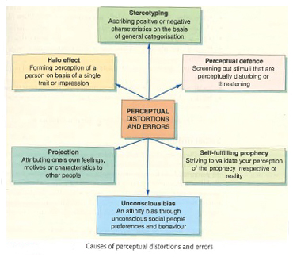

-Organisational Context-

Organised in to a Public sector paradigm, the NHS’s organisational edifice differs greatly from a Private corporation or a Social Enterprise. Private companies have very different management styles compared to Public ones. Social Enterprises have many similarities to a Public Sector and Private Sector functionals. Containing elements of both capitalism and socialism. There are many social enterprises within society. Social care services, recycling and welfare, (ACAS, 2008) to name just a few. Private and Public sector organisations are polarised in nature, are they elated only by the metastasizing propensity for obscene profit creation, or do they offer a great service to the public, funded by our taxes. Private corporations are ones which belong strictly to shareholders or individuals and are responsible for their own governing, fundamentally they are geared prospectively for the making of money (Mullins 2016). Public groups want to ensure a service that will be delivered for the community, owned by the city council or domestic government and financed directly by the treasury. The capacity of Public endeavours is perspicacious and non-profit. “Government Departments” like the DVLA, Armed Forces, Fire Service and the NHS must fulfil a political service for the public. When large groups of individuals engage in a corporate undertaking, stress and conflict can arise from an uninformed belief of another’s favouritism, to being passed over for promotion or bullying simply for the ephemeral satisfaction of ego. Ackroyd and Thompson (1999), are convinced by their definition of ‘Organisational Misbehaviour’ to mean “anything you do at work which you are not supposed to”, very simplistic but gives great clarity to all prescinded ideologies and actions not welcomed in the workplace. Managers will create a strict partition of operational parameters for conductorial acceptability and all the actions of their staff will be judged by these custodial arbiters (IBID). Conflict leads to high levels of inefficacity and will have a negative toll on the working environment. The Advisory, Conciliation and Arbitration Service (ACAS), believes that conflicts are mullioned in to a triumvirate: “Organisational Conflict”, which is engendered by a strike possibly due to continued lack of a pay rises, “Overt Individual Conflict”, where indignities may coalesce over the conditions of work and “Latent Conflict”, where beacons of unpalatability such as discouragement, sullenness and intemperance for whatever reason are effectively justified by a pronounced increase in absence and high frequencies of personnel turnover, brazen drops in efficiency and caustic relationships between staff and management (Podro, S. 2010). All working relationships must maintain a profound sense of good-will, arrogant fractiousness could not be allowed in the NHS due to its patients’ needs. Conflict though, could be managed by the need for good expression, understanding an employee’s achievements and directions, the equitable assignment of resources, procedures designed for the emotional enrichment of staff, Non-monetary incentives, developing better workplace skills and creating an improved, Socio-Technological direction for viewing the social and mental factors, that affect workers. These are just a few ways to manage conflicts. Stress another unnecessary but inevitable factor has quite a multi-dimensional pedigree. York (2001), contends that it is anxiety formed from a person overloaded by too many tasks, the equal prioritisation of demands, contradictory pressures, not understanding the beginning of a process and rarely being given the necessary resources to perform tasks (IBID). Managers can use the Kaizen factor to get an understanding of how to minimise stress on an individual in the department, and effectively communicate with the said individual in a non-hostile manner. An example of these factors is shown in the diagram below.
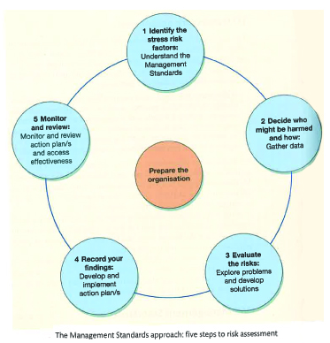

-Motivation and Satisfaction-

In the NHS, motivation is crucial to efficiency, morale and quality of service to the public. Nicholson (1995), posits that “Motivation refers to a dynamic, internal state resulting from the independent and joint influences of personal and situational factors… (it is) an individual state affected by the continuous interplay of personal, social and organisational factors”. Smith (1999) believes that “workers should be scientifically selected and then trained and developed; managers should heartily cooperate with the workers to ensure all the work is being done in accordance with the principles of the science; and there should be almost an equal division of the work and responsibility between the management and the workmen”. Spurring a worker in to action is cousin to the work itself, a manager should notice a person’s contributions and reward them for their proactivity. Over time theories have been developed to understand motivation and satisfaction. Taylor (1911) argued in his theory of scientific management that a science needed to be created to understand all parts of an employee’s work. His belief was to reduce the amount of human participation in all parts of a workforce’s production, which theoretically would reduce erroneous inefficiency and create a strong sense of productive efficacy due to the palpable happiness of the workers, crude but effective and has limitations within certain workplaces due to a possible proselytization. Taylorism, is part of the motivating process for workers in most companies Maslow, though believed differently, that motivation was an ascending pyramid of important factors integral to an individual’s work, being, survival, psychological needs, safety, belonging, love, self-esteem and self-actualisation. Maslow was convinced that a person’s motivation was constructed by the need to fulfil these. But since his theory was published, there has been hardly any available empirical evidence to argue for its meritorious inception (Mullins, 2016). Another theorist was Herzberg who developed a proposition aimed at understanding motivation and workplace satisfaction (Hertzberg, F. Et al. 1959), Hertzberg believed there was a profound link between workplace satisfaction, motivation in said working environment and the composition of the job. Hertzberg hypothesized the ‘Hygiene Factor’, meaning a healthy working ambiance, good money, the security of permanency, appropriate safe work conditions, trustful mangers, a feeling of belonging within the company, all of these compose workplace hygiene. Herzberg’s theory has two criticisms, its mainly limited to unskilled workers and secondly workers will convey positive accounts of their working behaviour due to their own performance. Influenced by Maslow the Theory X and Theory Y direction for motivation was envisioned by Douglas McGregor in 1960, McGregor theorised a proposition for attitudes based on human understandings and workplace demeanour it is formed on a polar belief of nadir vs. zenith (McGregor, D. 1987). Theory X represents the rewards direction, Theory Y involves the assimilation of the workers individualism, intersecting with the company’s objectives forming a precise symbiotic co-dependence, X is highly explorative in nature and needs to be stream lined for management due to its specific focuses and Y is difficult to implement successfully due to its time constraining dilations. A Combination of McGregor’s Theory and Maslow’s would be beneficially entertained by the NHS management section, simply for the fact that these theories focus on the individual within the machine and could potentially buoy morale and vanquish a worker’s melancholy. Functions of Maslow and Herzberg’s theories are shown in the diagrams below.
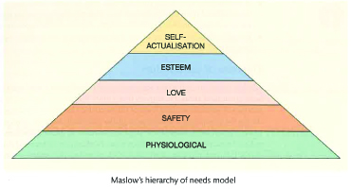

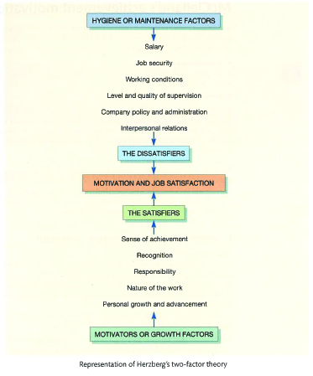

-Conclusion-

While trusting in the Bureaucratic style of Management the NHS can function well, this style, is crucial, to its sustainability, without it only a precipitous floundering would ensue, and this beloved Public company would perish due to the enactment of an imperfect managerial style. Managers are acutely aware of the perennial flourishment of a worker’s motivation and satisfaction, depression in either of these working necessities can be swiftly trounced. Being a Public company, her organisational super structure and direction differ greatly from the Private sector and Social Enterprises, profit is not her motivation, but good service and efficiency are.
Workplace stresses can lead to conflict, and this will be immediately tackled by her managers, due to the nature of her service. A patient’s wellbeing is Sacrosanct, and regular checks need to be in place, through manager and administrator surveillance to correct any perceived indignities from slowly corroding a worker’s august daimonion. The way the public perceive the NHS is as a saviour, her workers see her as a very necessary social edifice with which the populace greatly benefits. A manager can influence the employee’s perception greatly and need to be on guard to ensure that only the quintessence of an effervescent purity of perception and communication is sparklingly maintained within. The NHS has great social responsibilities and all staff members work hard to maintain her gilded lustre and good will, simply through their own force of custodial sustainability. This company is a multi-celled organism and needs constant attention due to its socially precarious balance in our society. Would we want to live without it, the answer is obvious? It has endured the weathering of political and social elements, with more constraints on its budget. But continues to play such a necessary role in our lives, that could a Britain divorced from the NHS still be Britain. Of Course, but it would trundle on, in a more lugubrious manner.
A National Institution. A National Religion. A National Saviour. We need this public company, privatisation would cannibalise its very soul. Simply put, in the NHS…
“We Trust”
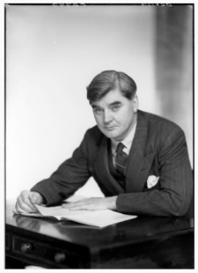
Pictured: Aneurin Bevan. Health Minister in 1945. Primary inceptor and pioneer of the NHS.

Bibliography
ACAS. (2008). Social Enterprises as a new type of employer. Employment Relations Matters(11), 3-5.
Bertalanffy, L. v. (1951). Problems of the General Systems Theory:A new approach to the Unity of Science. Human Biology, pp. Volume 23 Number 4 302-312.
Buggy, C. (2015). Are You Really Listening Professional Manager.
Ionescu, L. (2018). Bureaucratic Management in Public Sector Accounting. In Economics,Management, and Financial Markets (pp. 275-281). Bucharest: Addleton Academic Publishers.
K N Wexley, S. Z. (1972). Importance of Contrast Effects in Employment Interviews. Journal of Applied Psychology, 56, 44 - 45.
Labrow, T. L. (May/June 2000). Learning to Suceed with ICT. British Journal of Administrative Management, 14-15.
Mcgregor, D. (1987). The Human Side of Enterprise. Penguin.
Mullins, L. (2016). Management and Organisational Behaviour.
N Nicholson (Ed), S. R. (1995). Encyclopaedic Dictionary of Organisational Behaviour. Oxford: Blackwell.
NHS. (2016, April 03). About the NHS. Retrieved from NHS: https://www.nhs.uk/using-the-nhs/about-the-nhs/the-nhs/
Podro, S. (2010, March). Riding Out the Storm: Managing Conflict in a Recession and Beyond. ACAS Policy Discussion Paper.
Smith, L. (1999). An Evaluation of Programmes for Staff Motivation in NHS and Hotel Ancillary Staff. Sheffield Hallam University, Facilities Management Graduate Centre. Sheffield: Sheffield Hallam University.
Snyderman, F. H. (1959). The Motivation to Work. (Second, Ed.) Chapman and Hall.
Taylor, F. W. (1911). The Principles of Scientific Management. Harper & Brothers.
Thompson, S. A. (1999). Organisational Misbehaviour. Sage.
Webber, M. (1921). Economy and Society. Totowa, NJ: Beminster Press.
Woodward. (1980). Idustrial Organisation: Theory Practice. (S. Edition, Ed.) Oxford University Press.
York, P. (2001). Getting a Grip on Stress. Management Today, 105.

