Games Architecture and Mechanics Report

Name: Jonathan S. Davies
Student Number: 1707239
Lecturer: Gordon Dickers
Module Code: ACCA5017

Table of Contents
Table of Figures 1
Introduction 2
1. Code Organisation & Commenting 2
2. Game Loop Pattern 2
3. Rates 3
4. Object Loader Integration (.obj) 3
5. Object Loader Integration (.bmp) 4
6. Testing 5
6.1 – File Path 5
6.2 – FPS Test 5
References 6

Table of Figures
Figure 1 - Regions and Code Commenting 2
Figure 2 - The Game Loop 3
Figure 3 - Polygon Changes 4
Figure 4 - BMP Reader 4

Introduction
The aim of this report is to highlight key changes, features, modifications and extensions to the game engine that has been provided. The paper covers a plethora of areas in which these changes have happened, and have been documented, recorded and tested, using screenshots and test tables where necessary.

Code Organisation & Commenting
The first task that was undertaken in the project was to eradicate any unnecessary code and files that were not used throughout. This proved invaluable as the code structure become more recognisable and familiar to the programmer. The use of regions was incorporated to organise code in to blocks that both grouped similar operations and eased the finding and sorting process. Although commenting was provided, much of it was changed in order to reflect the thinking procedure of the operator.
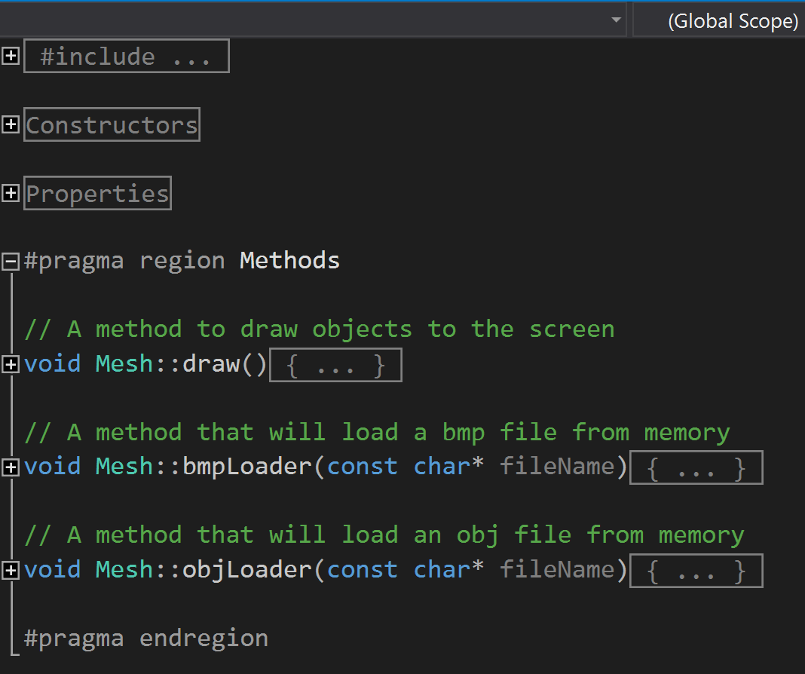
Regions
Figure 1 - Regions and Code Commenting

Game Loop Pattern
The game loop pattern is one of the most extensively used patterns within the gaming industry and can be found in most modern games [1]. The loop effectively cycles through three main stages. Firstly, processing input, which receives all input that is generated by the user and translates it into a mode of communication that can be understood by the program. Secondly, the update process, handles all updating of objects, characters, weather systems and physics, and tactfully takes place just after user input so that it can deal with changes in this too. Last is the rendering component, which takes a snapshot in time, processes it and displays it to the screen. These processes have been highlighted in red in figure 2 below.
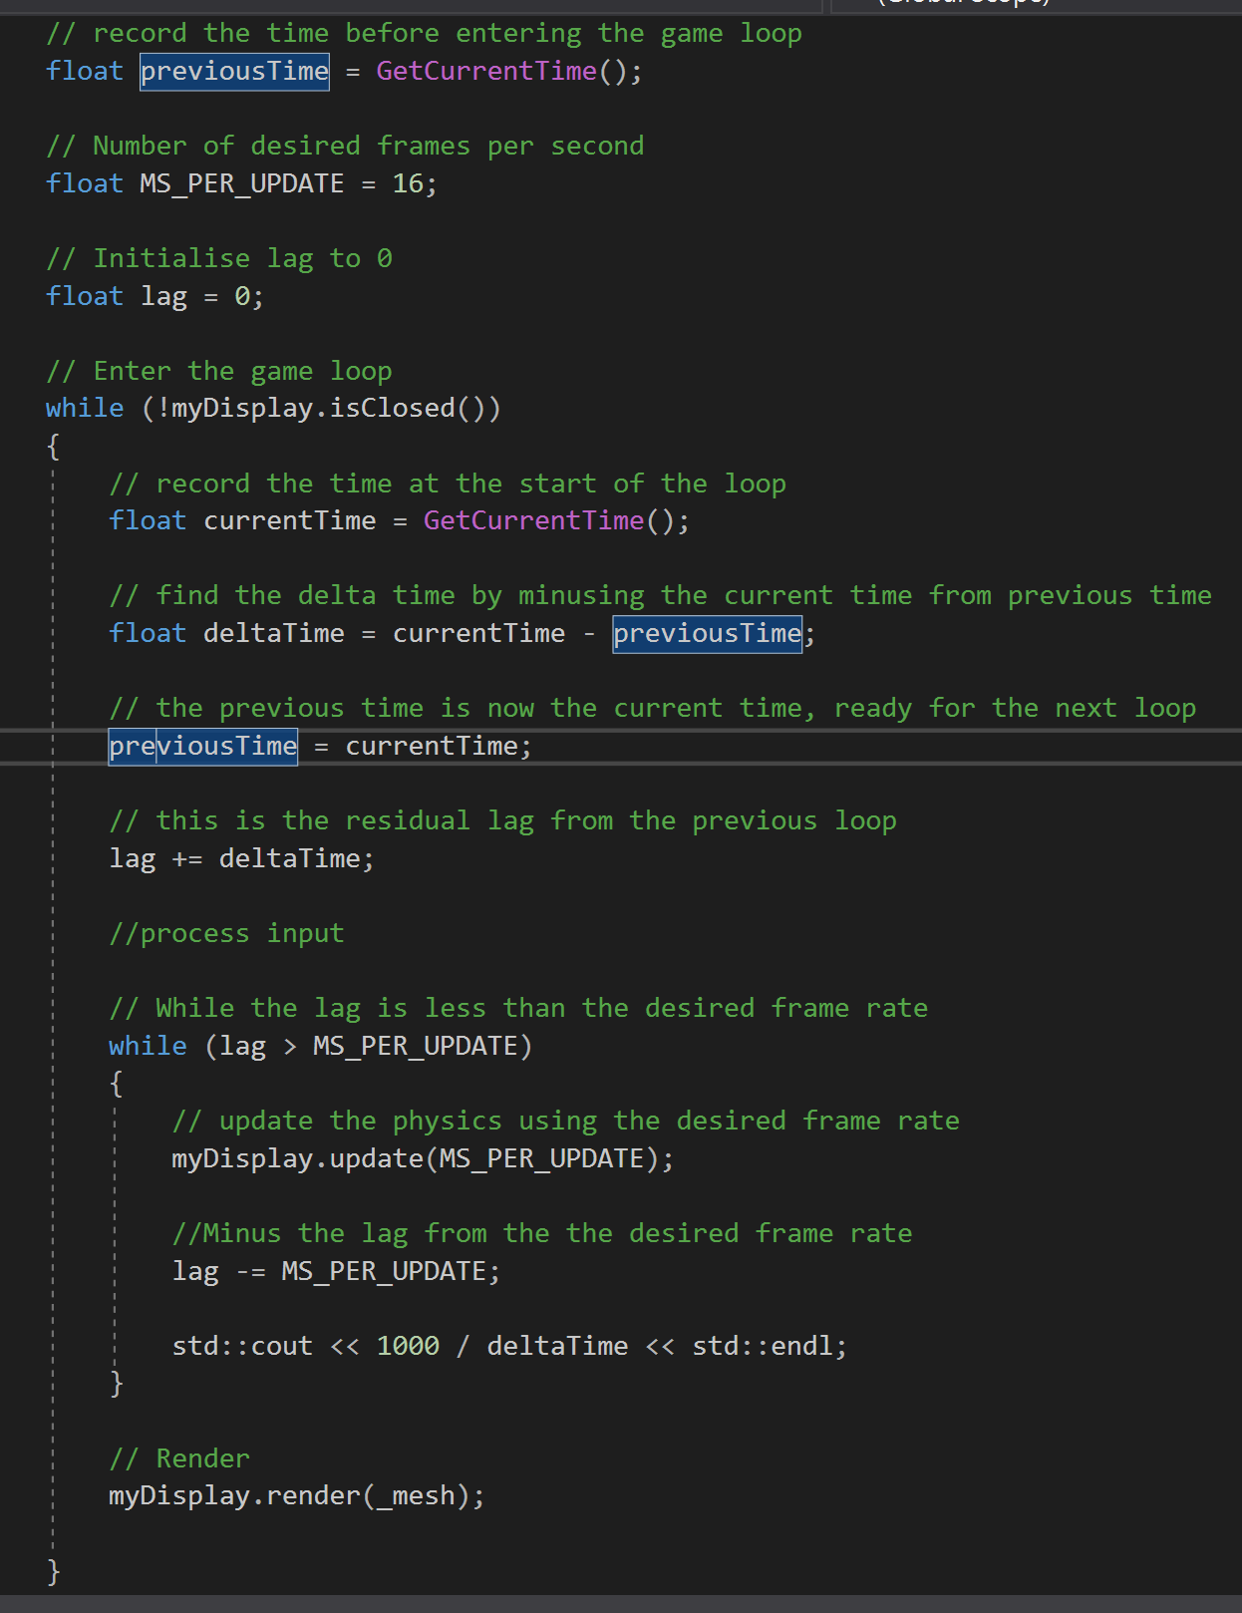
Figure 2 - The Game Loop

Rates
There are two major types of frame rate within a game, fixed and variable. A fixed rate depends on a hard-coded value that will ‘fix’ the speed of events local to a machine. The problem with this method is that if one person has an extremely fast computer, while the other has an extremely slow computer, there is a significant difference in the level of performance of the game between the two machines, possibly providing an unfair advantage to one of the players.
The variable rate uses a clock time that is calculated periodically throughout the program and is then used to find a starting and finishing time, which can in turn be used to discover a delta time (or elapsed time). The latency can also be accounted for and used on the next iteration of the loop to allocate extra work towards different parts of the engine.
Some of the code blocks that represent the variable time step) have been highlighted in yellow above in figure 2 above.

Object Loader Integration (.obj)
An OBJ file reader was modified and integrated into the system via the ‘mesh’ class and will allow the user to scan and store any obj object, with future extensions allows transformations to be made upon them. Much of the OBJ reader was kept in the same way in which it was presented, however small changes were made in the way of variable names, code structure and operations. Most notably was the changing of the polygon reader, which was adapted to not place any undesirable characters in the buffer by adding ‘*’ into the ‘%c’ operation. An example of this can be found in Figure 3 below. The second feature that has been changed allowed the name of the file to be passed in as an argument in the constructor, allowing for clearer code in the source file. The last major feature saw a switch statement added to the constructor allowing the choice of either a BMP or OBJ file to be scanned.
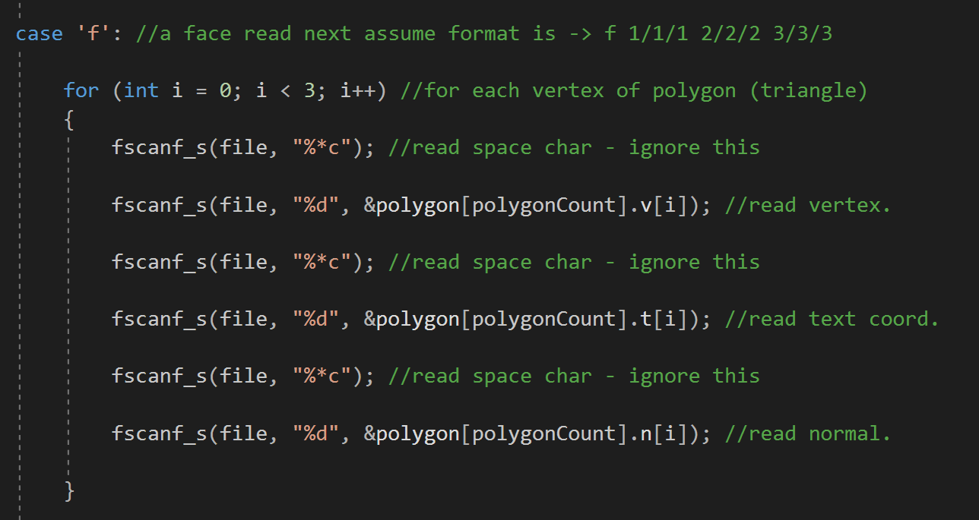
Figure 3 - Polygon Changes

Object Loader Integration (.bmp)
A BMP file reader was also added into the ‘Mesh’ class but offer much simpler functionality that its OBJ counterpart. The diameters are stored in variables which in turn are stored in pointers, upon which the pointers are passed as arguments to a function labelled ‘SOIL_load_image’, which as the name suggests, is part of the SOIL library. Testing on this particular function has been showcased below.
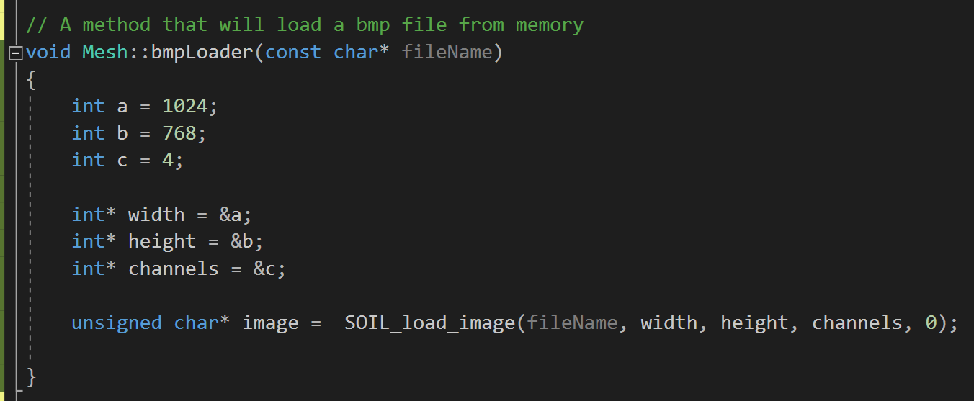
Figure 4 - BMP Reader

Testing

6.1 – File Path
This test aims to verify whether the BMP file is being found and scanned by the SOIL_load_image function. The test will fail if the function returns zero and will pass if it is anything but zero.
Test Number | Test Description | Expected Result | Actual Result | Outcome
1 | Testing if returned value is not zero. | Integer greater than or less than zero. | 154 | Pass
2 | Testing file path of image - Models\\Sample.bmp | Integer greater than or less than zero. | 154 | Pass
3 | Testing incorrect file path - Models\\Sample.bm | Zero. | Zero | Pass

– FPS Test
The next test aims to see the results of a frame rate test.
Test Number | Test Description | Expected Result | Actual Result | Outcome
1 | Testing the frame rate at full GPU capacity | 50-70 FPS | 62.5 FPS | Pass
2 | Testing the frame rate at half GPU capacity | 25-35 FPS | 31.5 FPS | Pass

References

[1] | B. Nystrom, “Game Loop,” in Games Programming Patterns, Genever Benning, 2014, pp. 123-152.

