  Component One:  What are the key skills required when working in the housekeeping team? 750 words (+/- 10%)  Contribution to Overall Module Assessment: 25% | Student No: | Gulam Nawaj (2209347)
 | Module Title: | Operating Hotel Facilities
 | Module Code: | BMIH4006
 | Lecturer: | Kathryn Flynn
It is essential for workers in the housekeeping business to possess a variety of skills in order to carry out their duties in an effective and efficient manner. In the following paragraphs, we will discuss a number of essential abilities that should be had by each and every member of a housekeeping staff.

Attention to Detail: Maintaining the cleanliness, orderliness, and frequently the space's overall appearance is a part of housekeeping that requires careful attention to detail. Because of this, the team responsible for cleaning has to have a strong attention to detail (Chen, 2016). It is possible for an inexperienced eye to miss even the smallest of flaws, such as dust on a picture frame or a single item that has been lost, yet someone with this talent is able to identify and rectify even these issues.

Time Management: Housekeepers often have a lot to do in a short period. Cleaning many rooms, replacing supplies, and resolving unexpected messes or client demands may be required. Time management is crucial. Prioritise tasks, organise routines, and balance speed and quality. This provides high-quality work and quick job completion, maximising client satisfaction (Chen, 2016).

Physical Endurance and Dexterity: Housekeepers must bend, stretch, carry heavy goods, and stand for lengthy durations. In bigger businesses, they may need to act swiftly. To survive the work, you need physical stamina. Dexterity is needed for precise jobs like making beds or cleaning sensitive goods. These physical qualities assist housekeepers do their duties and avoid workplace accidents (Riegel, 2009).

Teamwork: Housekeeping requires a lot of teamwork since there are so many different duties to do. For example, in order to effectively clean a large space or manage a significant project, collaboration is often required. According to O'Fallon and Rutherford (2011), working cohesively with others requires both strong communication skills and the ability to work well with others.

Customer Service: Despite the fact that cleaning staff members often operate behind the scenes, they do on occasion engage in conversation with customers or visitors. In situations like this, having strong abilities in customer service is essential in order to address any requests or complaints in a manner that is both professional and kind (Walker, 2013).

Abilities to Solve Problems: During the course of housekeeping, unanticipated problems may develop, such as a sudden mess or a malfunctioning piece of equipment. The team responsible for housekeeping has to be capable of making choices quickly and finding solutions to issues in an effective manner (Riegel, 2009). This will guarantee that operations run smoothly.

Acquiring Expertise in Cleaning goods and Methods: Acquiring expertise in cleaning goods and methods is one of the most important aspects of housekeeping. This involves having knowledge of which products are appropriate for various surface types and how to utilise those products appropriately (O'Fallon & Rutherford, 2011).

Ability to react: Housekeeping workers must be adaptable since customer wants and requests might change quickly. This requires the capacity to quickly change cleaning plans or routines to handle new jobs or unexpected challenges. Employees must be able to quickly switch tasks. According to Walker (2013), flexibility shows a desire to go above and beyond to fulfil client expectations, improving the customer experience.

Reliability and Integrity: Housekeeping requires dependability and honesty. Housekeepers have access to private places, personal possessions, and valuables. They must do their tasks appropriately and honestly. They must be professional and respect client privacy and property. They must also offer high-quality work on time and show reliability. Employers respect these traits because they help customers trust and feel protected (Chen, 2016).

Organisation: Housekeeper’s supply and maintain cleaning materials, tools, and equipment. Cleaning programmes may be prioritised by urgency or client choice. They may also organise places for efficiency and beauty. Organisational abilities are needed to plan, organise, and execute activities effectively. Such abilities help housekeepers manage their workload, improving productivity and customer satisfaction (Riegel, 2009).

In conclusion, the housekeeping profession requires a wide variety of abilities, ranging from the fundamentals such as attention to detail and physical endurance to the more specialised skills such as understanding of cleaning materials and customer service. The difference between a competent housekeeping staff and a great one may be found in the talents of its members to maintain a high level of service and guarantee complete customer satisfaction.

Word Count | 715

Component Two:
Contribution to Overall Module Assessment: 25%
In this scenario – You have just been promoted to team leader for a floor within the hotel. A guest complains that on their arrival, their room had not been properly cleaned. Create an action plan and answer the following questions.

Problem | Why did it happen? | What are you going to do? | How will you prevent this from happening in the future? | What measures would you introduce to improve team effectiveness?
Room not cleaned properly on guest's arrival. | Due to a hectic schedule or confusion regarding which rooms required cleaning, the room was neglected. | Apologize to the guest and arrange immediate thorough cleaning of the room or, if possible, offer a room change. | Use a reliable room status monitoring system to clean all rooms before visitors arrive. | Team meetings for problem-solving and open communication.
Miscommunication or lack of communication between housekeeping and front desk. | The front desk may have assigned the room to a visitor without knowing it was unclean. | Address the communication issue between the housekeeping and front desk teams. | To instantly update room statuses, improve front desk-housekeeping communication. | Training focuses on customer service, housekeeping, and time management.
Inadequate training for housekeeping staff. | Housekeepers may not have had proper cleaning training. | Implement or enhance training programs to ensure staff understand and adhere to cleaning standards. | Regular and thorough staff training on hygiene and visitor pleasure. | Team incentives and recognition programmes.
Insufficient time allocated for cleaning. | Tight timelines or frequent room turnover may have caused hasty cleaning and a dirty room. | Review and adjust cleaning schedules to ensure sufficient time for each room. | Optimise cleaning schedules and leave buffer time to fully clean each room. | Clear and efficient communication for real-time updates and faster problem-solving.
Lack of quality checks after cleaning. | Post-cleaning inspections may miss cleaning issues. | Introduce regular quality checks and inspections post-cleaning. | Regular quality tests and comments for continual development. | A buddy system or mentoring programme allows less experienced personnel to learn from more experienced staff, boosting team effectiveness.

Component Three:
Contribution to Overall Module Assessment: 50%
Your task is to create and prepare a presentation following the detailed scenario provided below.

As the floor housekeeping manager and given the recent guest complaints you need to put together a basic training presentation for your colleagues within the housekeeping team to get the best out of them, ensure that brand standard is being achieved and that Health and Safety procedures are also being followed.

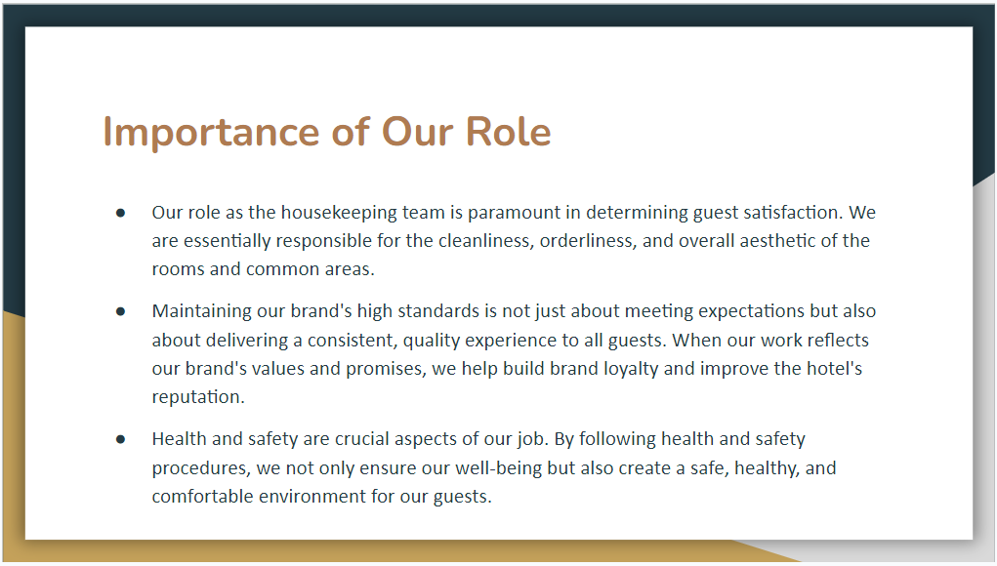

Training Notes:
- Provide examples of how sanitation contributes to the satisfaction of guests. Guests are more likely to have a positive experience, for instance, if their rooms are spotless, fresh, and well-organized upon arrival.
- Highlight the brand's hygiene and presentation standards. Stress the significance of attaining these standards consistently in all duties performed by the janitorial team.
- Provide a concise summary of the health and safety procedures that the team must follow, such as the correct use of cleaning chemicals, the safe management of laundry, and the protocols for reporting hazards or accidents.
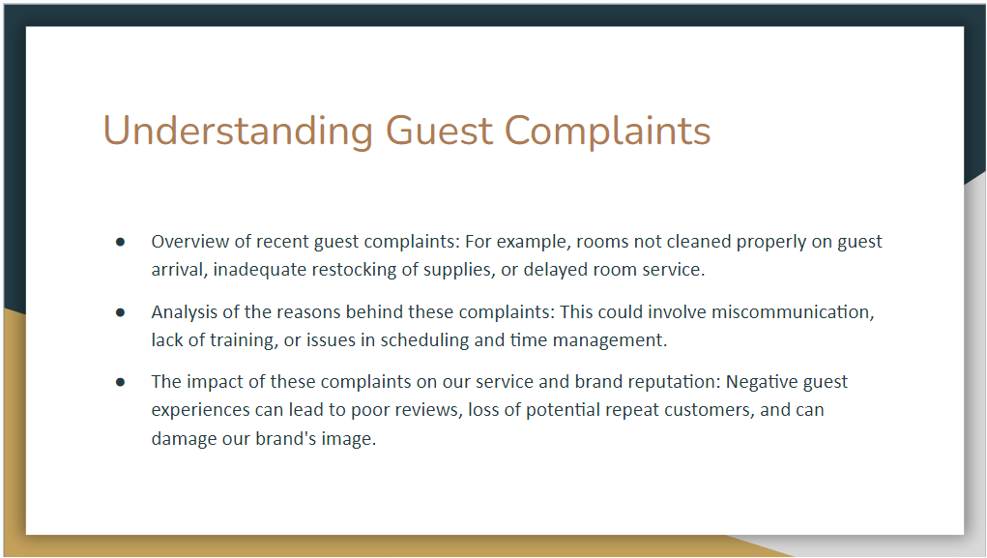

Training Notes:
- Engage team members in a conversation regarding each complaint. Ask them what they believe caused the problem and how it could have been avoided.
- Emphasise the significance of customer satisfaction to our ultimate success.
- Describe how negative reviews can deter prospective visitors and how repairing a damaged brand's reputation can be a lengthy process.
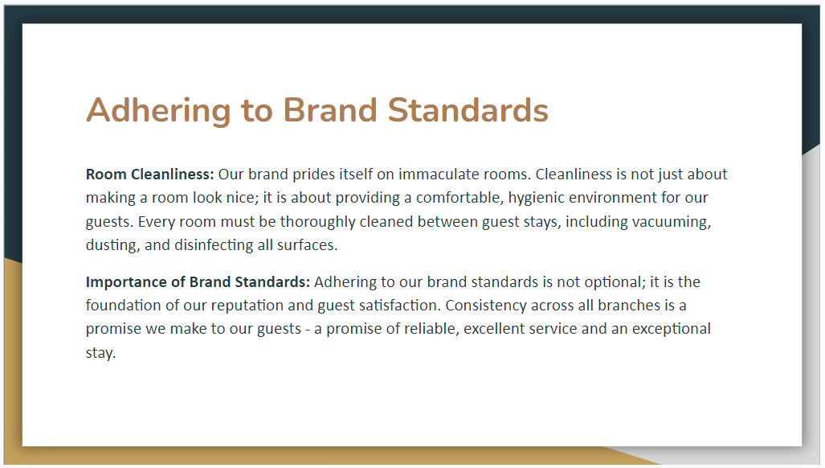

Training Notes:
- Explain the concept of brand consistency and why it is vital to the reputation of our hotel. Guests should expect and receive the same level of quality regardless of which location they choose to visit. Our brand standards are intended to guarantee this level of uniformity.
- Encourage team members who are uncertain about any aspect of these standards to ask inquiries.
- Emphasise each team member's role in sustaining these standards and establishing a positive visitor experience.
- Remind them that their diligence and commitment are essential to the success of our brand.
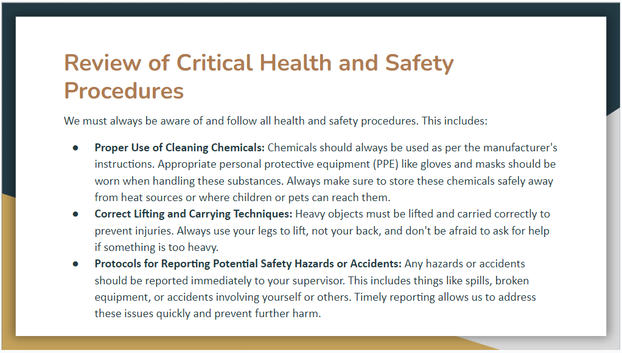

Training Notes:
- Discuss the significance of reporting safety hazards and catastrophes promptly. This enables immediate risk mitigation and incident prevention measures.
- Describe the potential consequences of not adhering to these procedures, such as injury, illness, or even legal ramifications for the hotel, if they are not followed.
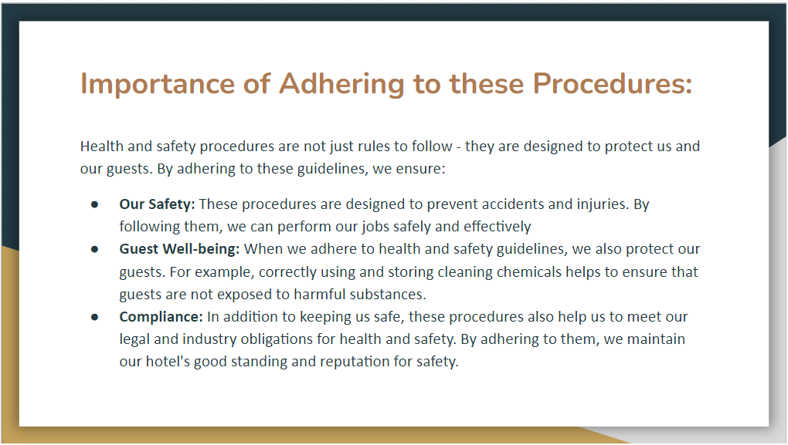

Training Notes:
- Discuss what to do in the event of a chemical leak or if a team member encounters an unreported safety hazard, for instance.
- Encourage team members to ask questions and voice any concerns they might have about health and safety.

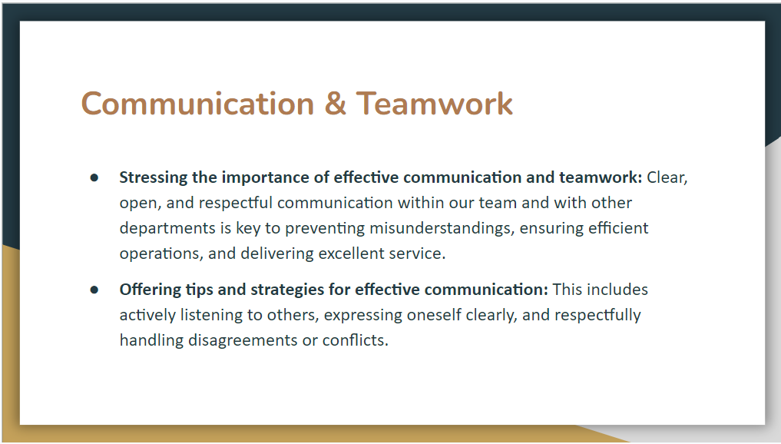

Training Notes:
- Highlight the significance of transparent and open communication.
- Remind team members that each member has an important role and that their contributions are valued.
- Teach effective communication techniques and plain expression
- Explain why respectful conflict resolution is essential.
- Discuss methods for handling disagreements constructively, emphasising the need to focus on the issue rather than the individual.
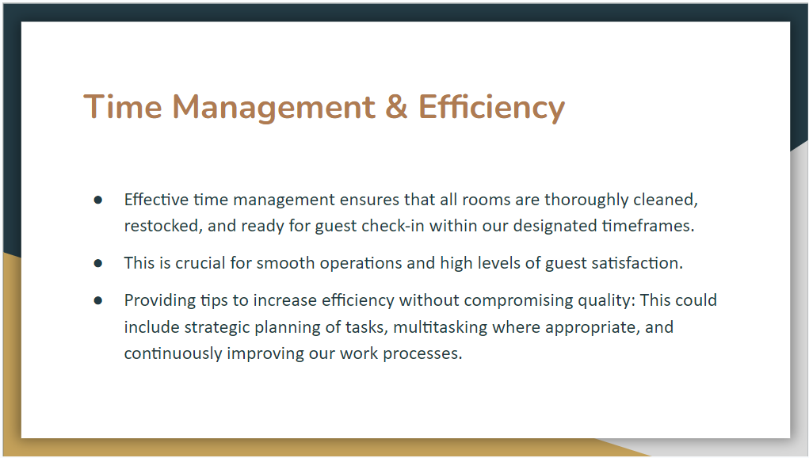

Training Notes:
- Share time management strategies, such as prioritising tasks based on urgency and importance, dividing down larger tasks into manageable chunks, and organising effective work schedules.
- Discuss the concept of "working smart" Explain that efficiency is not about completing tasks as quickly as possible, but rather about completing them more effectively and with fewer resources.
- Encourage team members to share their own ideas and techniques for increasing productivity.
- Discuss the significance of maintaining quality while enhancing efficiency.
- Discuss methods to ensure that our emphasis on efficiency does not compromise our hygiene and guest service standards.
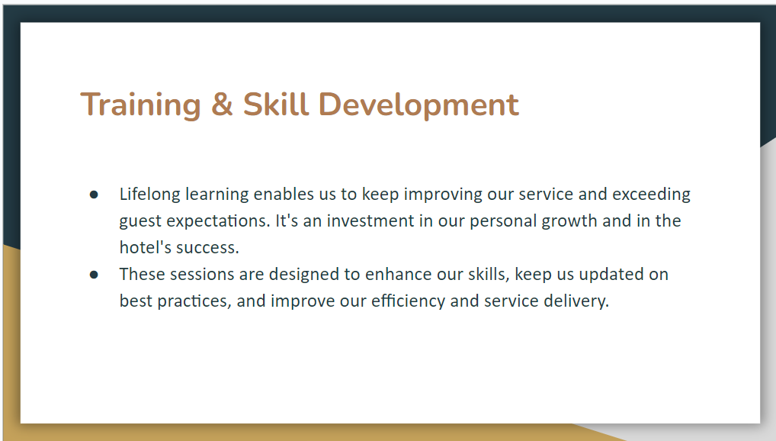

Training Notes:
- Emphasise the significance of assuming responsibility for one's own learning and development.
- Encourage team members to be proactive in their pursuit of learning opportunities and application of new skills and knowledge.
- Describe the impending training sessions and opportunities for skill development that are available to the team.
- Describe the purpose of each session and how it will benefit the team members' responsibilities.
- Discuss how the skills acquired through these training sessions can be utilised to improve service delivery, increase efficiency, and increase visitor satisfaction.
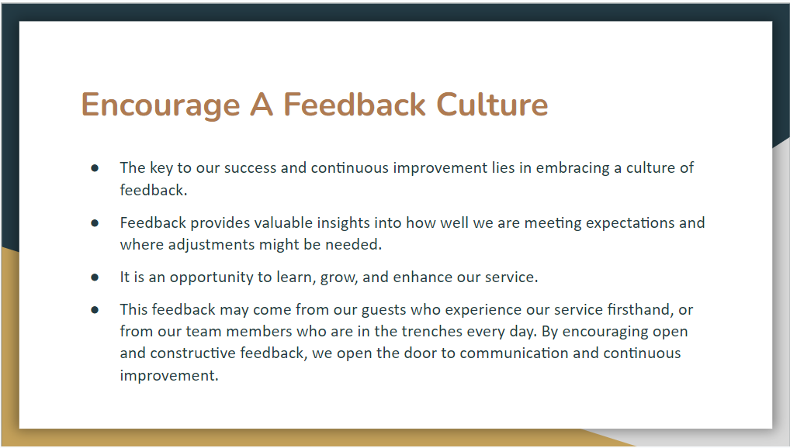

Training Notes:
- Examine the significance of feedback in a professional setting.
- Encourage team members to be receptive to both giving and receiving feedback.
- Discuss methods for providing constructive feedback.
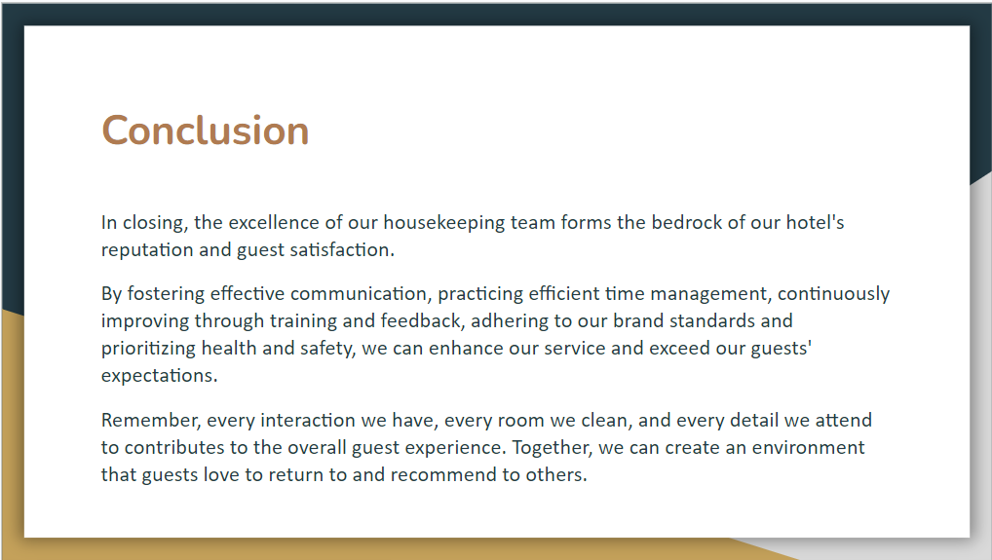

Training Notes:
- Recap the key points covered in the presentation and the next steps that must be taken. Reiterate the significance of each discussed area and its contribution to the overall passenger experience.
- Encourage team members to implement the discussed ideas and strategies in their daily work.
- Express gratitude for the effort and commitment of the team.

References

Bailey, A. & Zampetakis, L.A. (2012). The relationship between the use of management control systems and service quality: Evidence from Greek firms. International Journal of Quality & Reliability Management, 29(8), pp.850-868.
Chen, J.S. (2016). Advancing the concept of tourist satisfaction. Marketing Intelligence & Planning, 34(4), pp.524-5
Kusluvan, S., Kusluvan, Z., Ilhan, I. & Buyruk, L. (2010). The human dimension: A review of human resources management issues in the tourism and hospitality industry. Cornell Hospitality Quarterly, 51(2), pp.171-214.
McCabe, V.S. & Savery, L.K. (2007). The effectiveness of team-building in organisations. Leadership & Organization Development Journal, 28(6), pp.511-526.40.
Riegel, C.D. (2009). Hotel Housekeeping Operations and Management. Oxford: Oxford University Press.
Walker, J.R. (2013). Introduction to Hospitality Management. Pearson.
National Research Council (U.S.). (2001). Musculoskeletal disorders and the workplace: low back and upper extremities. National Academies Press.
Xu, S., Martinez, L.R., Van Hoof, H., Tews, M., Torres, L. and Farfan, K. (2017). The impact of abusive supervision and coworker support on hospitality and tourism frontline employees’ service performance. International Journal of Contemporary Hospitality Management, 29(1), pp.326-342.
UNWTO, World Tourism Organization. (2011). Tourism and job creation. UNWTO World Tourism Barometer, 10(2), pp.1-3.

