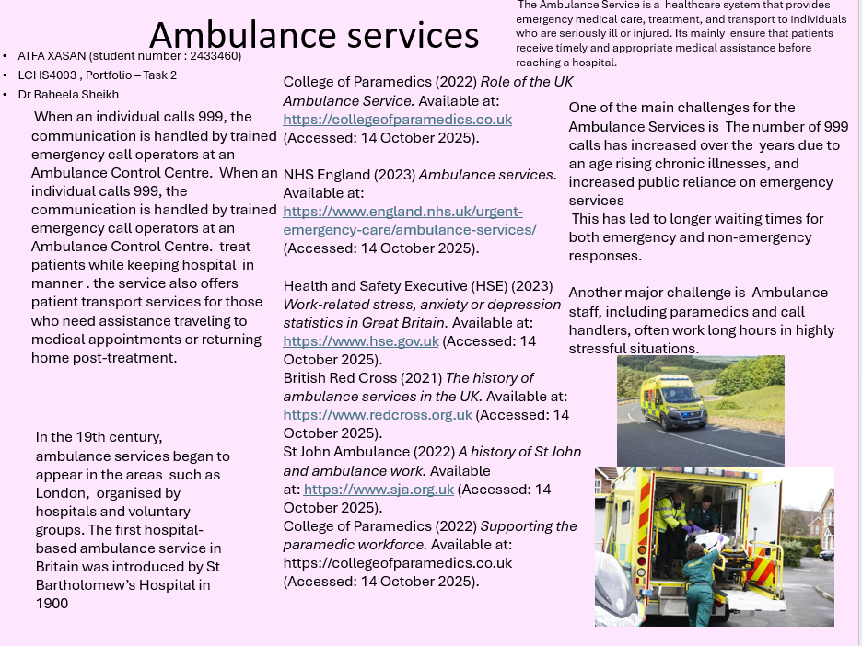

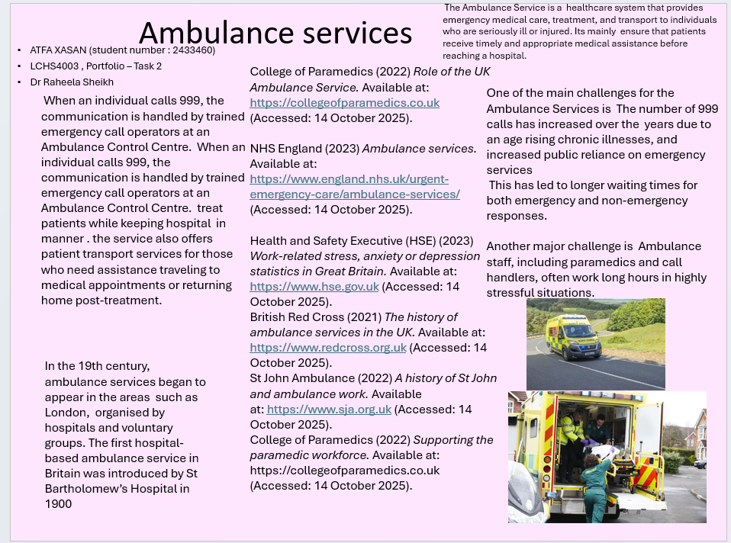
Task 2: A 600-word Essay
The Origins and Current Structure of the National Health Service (NHS)

The National Health Service (NHS) is regarded as one of the most important social achievements in the United Kingdom, providing free healthcare to all citizens at the time of delivery. Founded in 1948, the NHS was created based on the principles of universality, equity, and accessibility, affirming that healthcare should be viewed as a right rather than a privilege. Origins and Historical Context Before 1948, access to healthcare in Britain was irregular and restricted. A considerable number of people could not afford medical care, as most services were provided through private payments or charitable organizations. The Poor Law system and voluntary hospitals offered limited support to those who could not pay, frequently leading to inequalities in health outcomes

On July 5, 1948, the NHS was formally established, inspired by Bevan's vision of a healthcare system based on three fundamental principles: it must serve the needs of all individuals, be provided at no cost at the point of access, and be rooted in clinical expertise. As it approaches future challenges, the NHS must adapt while preserving the founding values that have defined it for over seventy years.

Current Structure and Functioning of the NHS

The modern NHS has experienced significant transformation since its establishment. It currently functions as a devolved system, indicating that health services are managed independently in England, Scotland, Wales, and Northern Ireland. Each nation possesses its own unique policies and priorities, yet all are consistent with the same core values. In England, the NHS is structured around three main elements: NHS England – responsible for overseeing healthcare delivery, budget management, and strategic planning. Integrated Care Systems (ICSs) – regional partnerships that coordinate hospitals, general practitioners, and community services to improve population health. NHS Trusts and Foundation Trusts – organizations that deliver hospital, ambulance, and mental health services directly to patients. The NHS is primarily funded through general taxation, making it one of the largest publicly funded healthcare systems in the world. The NHS faces challenging, and it increases their financial constraints. Workforce have led to longer waiting times for patient and the strain on emergency and mental health services continues to grow. The systems start to improve collaboration it will changes the funding and clear the accountability.

Conclusion
The establishment of the NHS in 1948 represented a pivotal moment in British history, grounded in the conviction that everyone deserves access to healthcare. This development transformed the relationship between the states and its citizens by ensuring that health services were available to all, regarding of income. Although the NHS continues to face challenges such as staff shortages, increased demand and funding pressure, it remains a virtual part of British identity. It enduring strength lies in its commitment to fairness and equality, upholding the belief that healthcare is a universal right and not a privileged.

Reference :

BBC News (2024) NHS funding and workforce challenges explained. Available at: https://www.bbc.co.uk/news/health (Accessed: 14 October 2025).
Beveridge, W. (1942) Social Insurance and Allied Services (The Beveridge Report). London: His Majesty’s Stationery Office.
King’s Fund (2023) Integrated Care Systems: what they are and how they work. Available at: https://www.kingsfund.org.uk (Accessed: 14 October 2025).
NHS England (2023) About the NHS. Available at: https://www.england.nhs.uk (Accessed: 14 October 2025).
Nuffield Trust (2022) The NHS explained: structure, funding and performance. Available at: https://www.nuffieldtrust.org.uk (Accessed: 14 October 2025)

