

MODULE TITLE: CHANGEMAKERS: BUILDING YOUR PERSONAL BRAND FOR SUSTAINABLE EMPLOYMENT
MODULE TUTOR: NOUH ELMITWALLY
MODULE CODE: BMHP5015_BIRM
STUDENT NAME: QASIM HASAN
STUDENT ID: 2410267
ASSIGNMENT: COMPONENT 2 WRITTEN ASSIGNMENT (REPORT)

Table of Contents
- Introduction
- Overview of the Healthcare Assistant Role
- An Assessment of the Skills Necessary for Gaining Employment.
- Assessment of Personal Skills
- Current Qualifications
- Creating an Individual Brand Identity
- Benefits to the Organisation
- Five-Year Action Plan
- Communicating My Skills to Employers
- Conclusion
- References

1: Introduction
Healthcare Assistants (HCAs) are an integral part of multidisciplinary healthcare teams, providing direct patient care while supporting registered nurses and other healthcare professionals. The advertised Healthcare Assistant role at Prometheus Safe and Secure Patient Transport requires employees to support vulnerable patients during transport, provide compassionate care, maintain patient dignity, manage mental health crises, assist with safeguarding, complete accurate documentation, and respond appropriately to emergencies.
This report provides a critical analysis of the traits that are deemed essential to gain employment for the advertised position, assesses personal growth in relation to the person specification, reviews my current qualifications and experience, explores strategies for establishing a professional identity and personal brand, and formulates a five-year action plan aimed at acquiring the competencies essential for successful employment.

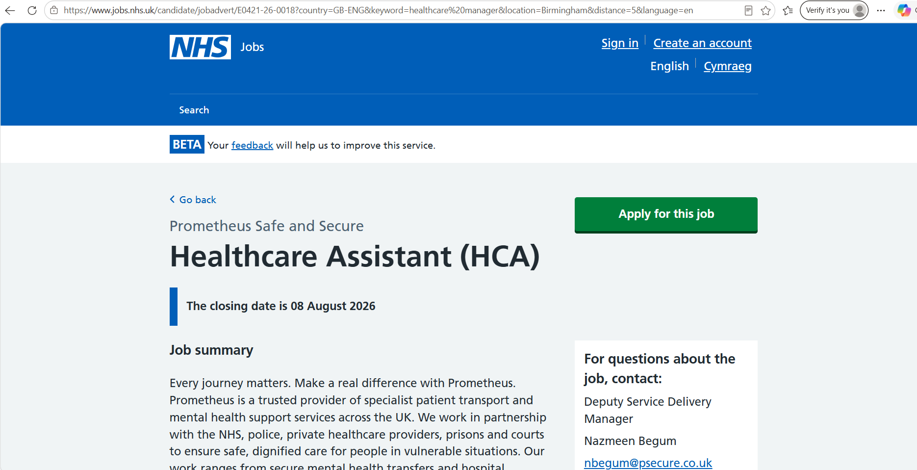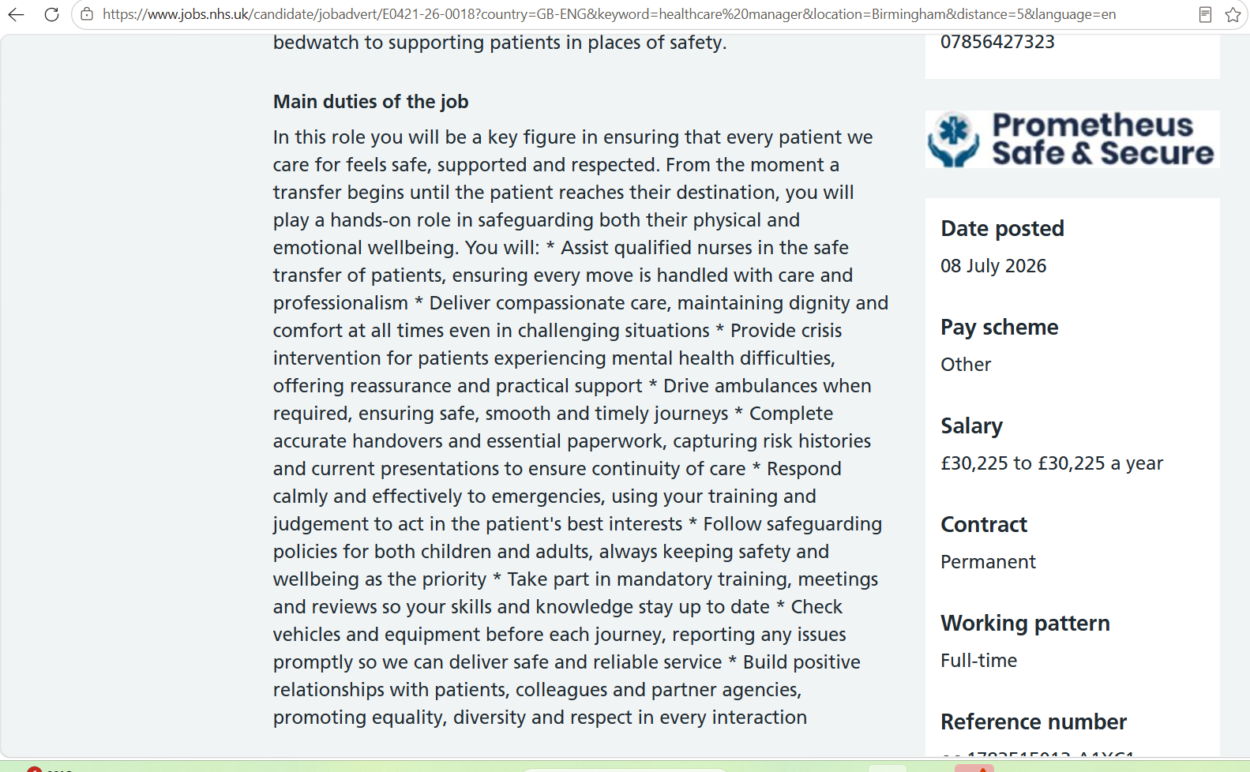

Figure 1:Screen Shots of the Job Advertisement
Healthcare Assistant Vacancy (Prometheus Safe and Secure Patient Transport)
(Source: Prometheus Safe and Secure Patient Transport, 2025)

2: Overview of the Healthcare Assistant Role
The Healthcare Assistant role advertised by Prometheus reflects modern healthcare practice where patient-centred care, multidisciplinary teamwork and safeguarding responsibilities are central to service delivery. Healthcare Assistants provide essential support that contributes significantly to patient safety, quality of care and patient satisfaction (Barker et al., 2016).
These responsibilities align closely with the rules promulgated by concerned agencies and departments (Skills for Care, 2023). The Care Certificate establishes the minimum competencies expected from healthcare support workers, including communication, safeguarding, infection prevention, duty of care and person-centred care.
The role also reflects the principles of the 6Cs of Nursing, introduced by NHS England: “Care, Compassion, Competence, Communication, Courage and Commitment” (NHS England, 2016). These principles underpin compassionate healthcare delivery and encourage healthcare workers to place patients at the centre of every decision.
Unlike many Healthcare Assistant positions, this role includes transporting patients experiencing acute mental health crises. Mental health patients often experience heightened anxiety, confusion, distress or aggressive behaviour during transportation (Price et al., 2018).
The role also requires adherence to safeguarding legislation. Healthcare professionals have a legal duty to recognise and report abuse or neglect involving children or vulnerable adults (Care Quality Commission, 2022)
Another important aspect is accurate documentation and handover. Effective communication between healthcare professionals improves continuity of care while reducing clinical errors. Poor communication remains one of the leading causes of adverse patient safety incidents within healthcare settings (WHO, 2021)..

3: An Assessment of the Skills Necessary for Gaining Employment.
Employability signifies the integration of knowledge, skills, behaviours, and personal attributes that enable an individual to gain and hold a job. (Yorke, 2006)
Healthcare employers are more frequently seeking candidates who have both transferable skills and clinical proficiency.
Communication Skills
Effective communication enhances patient satisfaction, reduces misunderstandings and improves healthcare outcomes (O'Daniel & Rosenstein, 2008).
Patients experiencing mental health crises require calm, clear and empathetic communication. Research demonstrates that compassionate communication significantly reduces patient anxiety and increases trust in healthcare professionals (Silverman et al., 2013).
Teamwork
Effective teamwork contributes to patient safety because information is shared accurately, responsibilities are understood and clinical risks are identified promptly (West et al., 2014).
Compassion and Emotional Intelligence
Compassionate healthcare workers recognise emotional needs while preserving dignity and respect (Sinclair et al., 2016).
“Emotional intelligence, which pertains to the ability to comprehend and manage one's own emotions as well as to identify the emotions of others, is closely related to this idea”. (Goleman, 1998).
4: Assessment of Personal Skills
For the Healthcare Assistant (HCA) role at Prometheus Safe and Secure Patient Transport, I have evaluated my skills using a SWOT analysis and a skills audit, supported by reflection on my current qualifications and experience.

SWOT Analysis
A SWOT analysis is utilised as a strategic framework for assessment “Strengths, Weaknesses, Opportunities and Threats.” It provides a structured approach to identifying personal capabilities and areas for professional growth.
Strengths
One of my greatest strengths is my commitment to providing compassionate and respectful care. These principles are essential for supporting vulnerable patients during transportation and align closely with the values enshrined in the principles of NHS (Department of Health and Social Care, 2021).
I also possess strong interpersonal and communication skills. Effective communication is fundamental to maintaining patient safety, reducing anxiety and ensuring accurate handovers between healthcare professionals (O'Daniel and Rosenstein, 2008).
I recognise the importance of lifelong learning and continuous professional development (CPD), which will enable me to maintain high standards of care throughout my career (Health and Care Professions Council, 2023).

Weaknesses
Although I possess theoretical knowledge, I have limited practical experience in secure patient transport and crisis intervention. Supporting patients experiencing mental health emergencies requires specialised skills in de-escalation, risk assessment and conflict management.
I also recognise that my confidence in emergency situations requires further development. Healthcare assistants must remain calm under pressure while making safe decisions and following clinical protocols
Opportunities
The healthcare sector offers numerous opportunities for professional development. NHS Trusts, Skills for Care and professional organisations provide training programmes covering safeguarding, mental health awareness, first aid, infection prevention and moving and handling. Completing these courses would enhance my employability and prepare me for the responsibilities of the HCA role.

Threats
Healthcare is a challenging field that is often accompanied by emotional strain, workload challenges, and the risk of burnout. Research suggests that those in the healthcare sector regularly encounter psychological stress, particularly when assisting service users who show psychological and physiological symptoms (West et al., 2016)
Skills Audit
Comparing my current abilities with the requirements of the Prometheus Healthcare Assistant role enables me to identify areas where I already meet the person specification and where further development is required.
Required Skill | Current Level | Evidence | Development Required
Communication | Good | University presentations and group work | Improve clinical communication and documentation
Teamwork | Good | Collaborative assignments and projects | Gain multidisciplinary healthcare experience
Compassion | Excellent | Caring attitude and understanding of person-centred care | Continue developing through practice
Time Management | Good | Meeting academic deadlines | Apply skills in fast-paced healthcare settings
Mental Health Support | Basic | Academic knowledge | Undertake Mental Health First Aid training
Safeguarding | Good | University safeguarding training | Update with Level 2/3 safeguarding certification
Emergency Response | Basic | Theoretical understanding | Complete First Aid and Basic Life Support training
Patient Documentation | Basic | Academic experience | Develop practical record-keeping skills
Conflict Resolution | Moderate | Customer service experience (if applicable) | Crisis intervention and de-escalation training
Driving Ambulances | Not yet achieved | Full UK driving licence (if applicable) | Gain experience with patient transport services

5: Current Qualifications
At present, I am studying Health and Social Care, which has provided me with a strong theoretical foundation in healthcare principles, ethics and professional practice
Through academic assignments, I have also developed transferable skills including research, critical thinking, report writing and evidence-based practice. (Melnyk and Fineout-Overholt, 2019).
Reflection on Professional Development
Reflective practice is an essential component of healthcare professionalism. Schön (1983) argues that professionals continuously improve through reflection on their experiences, while Gibbs' Reflective Cycle (1988) provides a structured framework for evaluating performance and identifying learning needs.
6: Creating an Individual Brand Identity
Personal branding refers to the progression to present skills, knowledge and achievements in a way that differentiates an individual from other applicants (Montoya and Vandehey, 2009).
One of the most important aspects of my personal brand is my commitment to compassionate care. Demonstrating a proactive attitude towards learning reassures employers that I will remain competent and deliver evidence-based care throughout my career (Health Education England, 2022).
Developing a Professional Network
Professional networking has become increasingly important within healthcare recruitment. Networking enables individuals to learn from experienced professionals, identify career opportunities, gain mentorship and remain informed about developments within the healthcare sector (Forret and Dougherty, 2004).
LinkedIn
A professional LinkedIn profile with an appropriate photograph, well-written summary and evidence of continuous professional development can strengthen my employability by increasing my visibility to recruiters.
NHS Jobs
Creating an NHS Jobs profile also allows applicants to upload tailored CVs, monitor applications and receive vacancy alerts matching their career interests.
University Careers Service
My university careers service offers valuable employability support including CV reviews and networking events.
Professional Organisations
I have an absolute trust in the fact that work-experience at British Red Cross and others would provide access to additional training opportunities, networking events and current healthcare guidance.
7: Benefits to the Organisation
I possess excellent organisational skills developed through university coursework. Successfully balancing assignments, presentations and examinations has improved my time management, planning and ability to prioritise competing demands.
I demonstrate a strong commitment to lifelong learning. Rather than viewing training as a mandatory requirement, I see continuous professional development as essential for improving patient care and maintaining competence throughout my career.
My Unique Selling Point (USP)
It is important to differentiate one applicant from others. (Kotler and Keller, 2016).
My USP combines three key strengths:
Compassionate Care
I genuinely enjoy supporting others and understand the importance of treating every patient with dignity, kindness and respect.

Positive Attitude Towards Learning
My willingness to learn new skills, attend training and reflect upon practice demonstrates adaptability and resilience.
Professionalism and Reliability
I value punctuality, accountability and ethical behaviour. Employers require Healthcare Assistants who can be trusted to follow policies, maintain confidentiality and consistently deliver safe care.
Critical Reflection
Reflecting on my employability demonstrates that technical knowledge alone is insufficient for securing employment within healthcare. Overall, I believe that my values align closely with the organisational culture described in the job advertisement. By continuing to develop practical experience and professional competence, I will become a strong candidate for this position.
8: Five-Year Action Plan
Year One
During the first year, my priority will be strengthening my theoretical knowledge while developing practical healthcare skills. I intend to complete training in providing support and aid to the people who need them.
I also plan to begin volunteering within a healthcare setting to gain practical experience working with vulnerable individuals.
Year Two
In the second year, I aim to gain more direct patient contact through voluntary or paid healthcare support work. This experience will improve my confidence in communication, teamwork and documentation while exposing me to multidisciplinary healthcare practice.
Year Three
By the third year, I expect to have developed stronger practical competencies through work experience. I will focus on improving my leadership, decision-making and problem-solving skills by accepting additional responsibilities during placements or employment.

Year Four
In the fourth year, I aim to secure a permanent Healthcare Assistant position. During employment, I will continue reflecting on my practice, seeking feedback from supervisors and undertaking mandatory organisational training.
Year Five
Within five years, my goal is to become an experienced Healthcare Assistant recognised for compassionate care, professionalism and excellent communication.
This structured approach reflects the concept of lifelong learning, which is widely recognised as essential within modern healthcare practice (Health Education England, 2022).
Resources Required to Achieve My Career Goals
Successfully achieving the Healthcare Assistant role requires both educational and practical resources.
Formal Education
My under-graduate qualification is suffice to provide the theoretical foundation necessary for understanding healthcare legislation, ethics and professional practice. Continuing my academic studies remains essential.
Professional Training
Additional accredited courses through credible course providers like British Red Cross and NHS Learning Hub will enhance my employability.
Practical Experience
Research consistently demonstrates that practical experience significantly improves employability within healthcare professions (Jackson, 2015).
Mentorship
Receiving guidance from experienced healthcare professionals will accelerate my professional development.
Mentorship has been shown to improve professional competence, confidence and job satisfaction among healthcare workers (West et al., 2014).

9: Communicating My Skills to Potential Employers
Possessing appropriate skills is only one aspect of employability. Candidates must also communicate those skills effectively throughout the recruitment process.
Curriculum Vitae (CV)
My CV should clearly demonstrate my education, profession and skills.
Cover Letter
A personalised cover letter enables applicants to explain why they are interested in the organisation and demonstrate how their skills meet the job requirements.
LinkedIn Profile
Maintaining an active professional profile demonstrates engagement with the healthcare profession.
Professional Portfolio
My portfolio will include certificates, documents and references.
This portfolio can be presented during interviews to demonstrate ongoing professional development.
Interviews
During interviews I will communicate my skills using the STAR technique (Situation, Task, Action and Result), providing examples of occasions when I demonstrated skills required for the job role.
10: Conclusion
This report has critically analysed the employability skills required for the Healthcare Assistant position at Prometheus Safe and Secure Patient Transport and evaluated my current abilities against the employer's requirements. The analysis demonstrates that modern Healthcare Assistants require much more than basic clinical knowledge. The job description highlights the importance of delivering safe and person-centred care. In contemplating my skills, I realise that I have a mix of strengths and weaknesses. The report further explored strategies for building a strong personal brand and professional identity.
Overall, this report has demonstrated that employability within healthcare extends beyond academic qualifications. Continuous learning, self-reflection, professional networking and practical experience are essential for career success.

References:
Barker, H., Buchanan-Barker, P. and Tilley, S. (2016) Psychiatric and Mental Health Nursing: The Craft of Caring. 3rd edition. London: CRC Press.
CQC (2022). Care Quality Commission. [online] https://www.cqc.org.uk/. Available at: https://www.cqc.org.uk/. (Accessed 12 July. 2026)
Department of Health and Social Care (2021) The NHS Constitution for England. London: DHSC.
Forret, M.L. and Dougherty, T.W. (2004) ‘Networking behaviours and career outcomes’, Journal of Organizational Behaviour, 25(3), pp. 419–437.
Gibbs, G. (1988) Learning by Doing: A Guide to Teaching and Learning Methods. Oxford: Oxford Polytechnic.
Goleman, D. (1998) Working with Emotional Intelligence. London: Bloomsbury.
Health and Care Professions Council (2023) Continuing Professional Development Standards. London: HCPC.
Health Education England (2022) Continuing Professional Development Strategy. London: HEE.
Jackson, D. (2015) ‘Employability skill development in work-integrated learning’, Higher Education, Skills and Work-Based Learning, 5(4), pp. 350–357.
Kotler, P. and Keller, K.L. (2016) Marketing Management. 15th edn. Harlow: Pearson.
Melnyk, B.M. and Fineout-Overholt, E. (2019) Evidence-Based Practice in Nursing and Healthcare. 4th edn. Philadelphia: Wolters Kluwer.
NHS England (2016) Leading Change, Adding Value: A Framework for Nursing, Midwifery and Care Staff. London: NHS England.
O'Daniel, M. and Rosenstein, A.H. (2008) ‘Professional communication and team collaboration’, in Hughes, R.G. (ed.) Patient Safety and Quality: An Evidence-Based Handbook for Nurses. Rockville, MD: Agency for Healthcare Research and Quality.
Price, O., Baker, J., Bee, P. and Lovell, K. (2018) ‘Learning and performance outcomes of mental health staff training in de-escalation techniques’, International Journal of Mental Health Nursing, 27(1), pp. 3–15.
Schön, D.A. (1983) The Reflective Practitioner. New York: Basic Books.
Silverman, J., Kurtz, S. and Draper, J. (2013) Skills for Communicating with Patients. 3rd edition. Oxford: Radcliffe Publishing.
Sinclair, S., Norris, J.M., McConnell, S.J., Chochinov, H.M., Hack, T.F., Hagen, N.A., McClement, S. and Bouchal, S.R. (2016) ‘Compassion: a scoping review of the healthcare literature’, BMC Palliative Care, 15(6), pp. 1–16.
Skills for Care (2023) The Care Certificate Standards. Leeds: Skills for Care.
West, C.P., Dyrbye, L.N., Erwin, P.J. and Shanafelt, T.D. (2016) ‘Interventions to prevent and reduce physician burnout’, The Lancet, 388(10057), pp. 2272–2281.
West, M.A., Eckert, R., Collins, B. and Chowla, R. (2014) Caring to Change: How Compassionate Leadership Can Stimulate Innovation in Healthcare. London: The King's Fund.
World Health Organization (2021) Global Patient Safety Action Plan 2021–2030. Geneva: WHO.
Yorke, M. (2006) Employability in Higher Education: What It Is and What It Is Not. York: Higher Education Academy.

