

Business Management
University of Wales Trinity Saint David
Sandra Ghinescu
2118454
Data Handling and Business Intelligence
Assessment 1

Table of Contents
Part 1: Analysis of Hotel Reservation Data Using Microsoft Excel 3
Part 2: Data Analysis and Evaluation 7
Reference List 15

Part 1: Analysis of Hotel Reservation Data Using Microsoft Excel
Abstract
Using Excel's robust features like "IF,” “VLOOKUP," and "PIVOT TABLES," we analysed the course's Hotel Reservation data set and looked at the growth or decline in average hotel reservation prices from 2017 to 2021. By proactively filling in missing numbers and correcting data gaps, preliminary processing using Excel's "IF" tool assured data consistency and correctness. The "PIVOT TABLEs" helped us efficiently summarise the data and determine the typical yearly costs. The price patterns over the last five years were graphically represented by a line chart, showing the ups and downs of the market. Differentiating between periods with price rises and reductions by using colour improved the comprehension of the graphs, making the data more digestible for the stakeholders.
In the end, this study aids hotel operators in setting prices and allocating resources more effectively. It also allows travellers to more accurately budget for their hotel stays in light of recent patterns and average reservation price adjustments. They were able to extract actionable insights from the information by taking use of Excel's flexible functions and visualisations, so the findings of this study will be of use to the ever-evolving hotel sector.
Introduction
Hotel reservation data analysis is crucial in the dynamic hospitality business for seeing patterns, making educated choices, and better serving guests. In this research, we analyse the Moodle Hotel Reservation dataset to see how average hotel reservation costs have changed from 2017 to 2021. Microsoft Excel's powerful and flexible capabilities, such as "IF,” “VLOOKUP," and "PIVOT TABLEs," are put to good use by data analysts like us for anything from initial data cleaning to advanced statistical analysis to graphical representation. Pre-processing data is the bedrock of every trustworthy analysis since it guarantees data uniformity and precision. When there are blanks in our data, we use Excel's "IF" function to deliberately fill them in using zeros or informed guesses based on nearby data points. The "VLOOKUP" function also helps find and fix mistakes, which is crucial for maintaining the accuracy of the dataset. They ensure the integrity of the data used for analysis by verifying its consistency across many sources. Average price changes across years are calculated as a percentage using Excel formulas, allowing us to see overarching patterns in the data. This gives them knowledge for both hotel owners and visitors, since we can see whether average room reservation costs are going up or down from the previous year. Excel's "PIVOT TABLEs" are used to graphically show the results, summarising the data in a way that makes calculating annual average expenses much easier. The average price of a hotel room for a certain time period may be visualised using a line chart, allowing interested parties to track price changes and spot trends. The chart's use of various colours to indicate years with price rises vs years with price decreases improves readability.
Data Pre-processing
There may be periods when room reservation costs are unavailable in the Hotel Reservation dataset. The 'IF' function in Microsoft Excel allows data researchers to locate these gaps and strategically fill them in. Analysts may, for instance, fill in missing numbers with zeros or make educated guesses based on neighbouring data points according to logical criteria inside the ‘IF’ statement. It is possible for the analysis to be skewed by faulty data. Excel’s “IF”, “VLOOKUP” features help data professionals identify and fix errors in the dataset. It's possible for them to check for inconsistencies in data, make comparisons to external references and apply the corrective logic directly inside the functions themselves (Selwyn, 2022). The data must be structured properly to guarantee consistency and facilitate analysis. Analysts may quickly determine the annual average cost by using Excel’s “PIVOT TABLEs” to organise and summarise the data. Analysts may easily examine the yearly average pricing and identify whether there was an increase or decrease throughout the years by establishing a pivot table with ‘Arrival year’ as the row column and 'Average of Average price' as the value field. Pre-processing data is essential because it guarantees a correct and trustworthy dataset, which is the basis for insightful research. Excel tools such as “IF”, “VLOOKUP” and “PIVOT TABLEs” allow data analysts to quickly and easily deal with missing numbers, fix mistakes, and organise data for analysis. These preliminary procedures are crucial for generating reliable and insightful charts, graphs, and diagrams depicting average hotel reservation costs and their trends and patterns from 2017 to 2021.
Data analysis
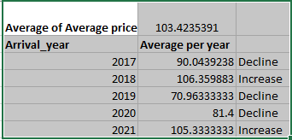
Figure 1: PIVOT Average of average price
(Source: Excel )
According to an examination of the data, average prices have shown considerable variation throughout the years. The 2017 average was 90.0439238 units, which is lower than the long-term average. In 2018, however, the average price rose dramatically to 106.359883 dollars. As a result, 2019 saw a decrease in average price to 70.96333333 units, down from the previous year. In the same vein, the average price fell in 2020, levelling out at 81.4 units. The most recent year of the data set (2021) had a rise in average price to 105.3333333 units, more than the average throughout the whole data set (Bharwani and Mathews, 2021).
The table shows that hotel reservation costs have generally followed a shifting trend throughout the years, with both rises and decreases. Insight into industry tendencies like these may help hotel owners and guests make better business and travel choices like pricing and room selection.
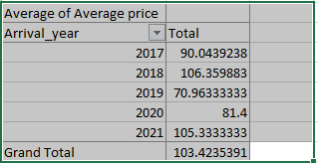
Figure 2: Lookup Average of average price
(Source: Excel)
The supplied Pivot Table shows the average cost of a hotel stay for each visit year, as well as the overall average cost. Over the years, the whole cost average comes out to 103.4235391 dollars.
By looking at the numbers, people can see how much things cost on average per year. Hotel bookings had a considerable price rise from 2017's average of 90.0439238 units to 2018's average of 106.359883 units. The average price fell to 70.96333333 units in 2019 nevertheless, which is a significant decrease from previous years. The average cost increased to 81.4 units by the year 2020. In 2021, the median price finally surpassed the grand total average, rising to 105.3333333 units (Rita et al., 2022).
Calculating average room reservation prices in each year
Using an Excel function, it is possible to calculate the average cost of reserving a hotel room for each year (2027 to 2021) included in the hotel base dataset. It will soon be possible to make the PIVOT yearly cost loading reserve in the PIVOT Table, which will make it much easier to evaluate the data as well as graph the trend over time (Tong-On et al., 2021). Both the PIVOT TABLE and the averageIF function delivered the same information for the years 2017 through 2021.
Visualization Data
For a rapid and clear understanding of the dynamics at play with hotel room rates, this data may be easily visualised in Microsoft Excel. A table is a good example of an appropriate visualisation. From 2017 through 2021, the x-axis shows the years, while the y-axis shows the average price (Rasoolimanesh et al., 2021). The excel table depicts annual price averages, with each data point representing a separate year. The price changes over the period of five years are clearly shown as a straight line connecting the data points. Differentiating between years with an increase and years with a decrease in average price may be made clearer by using various colours. Users may readily see how prices have fluctuated over time using this chart. Consumers can observe at a glance whether periods had higher or less average costs. Stakeholders may learn about the trends in hotel booking rates and use that information to inform choices about pricing, marketing, and resource allocation.
Conclusion
As a conclusion, we can now see clear patterns and trends in the average cost of a hotel reservation from 2017 to 2021 thanks to the examination of the Hotel Reservation dataset conducted using the Excel spreadsheet's functions. Data analysts effectively pre-processed, analysed, and visualised the data using Excel's "IF,” “VLOOKUP," and "PIVOT TABLEs," providing useful insights for hotel owners, industry experts, and visitors. For data to be accurate and trustworthy, pre-processing is an absolute must. Analysts might address gaps in the data set and strategically patch in missing values by using the "IF" function. The "VLOOKUP" tool was also essential in finding and fixing any mistakes, and kept the data clean for future study.
The research showed that hotel booking costs have been on the rise or fall throughout the years. The line chart clearly showed how prices changed over a five-year period, with different years showing distinct price rises and declines. Knowing the state of the market in this way allows hotel operators to set rates with confidence. In addition, "PIVOT TABLEs" facilitated data summarization and yearly average cost calculation. This enabled for a more holistic understanding of the patterns and provided a more complete picture of the data. Analysts were able to help hotel owners and visitors make better decisions by instantly comparing average prices over years utilising a pivot table. Stakeholders were better able to understand the patterns and changes in hotel reservation costs due to the visualisations' clear and succinct portrayal of the data. The use of different colours to indicate rising and falling prices in different years greatly improved the graphs' readability and understandability.

Part 2: Data Analysis and Evaluation
1. 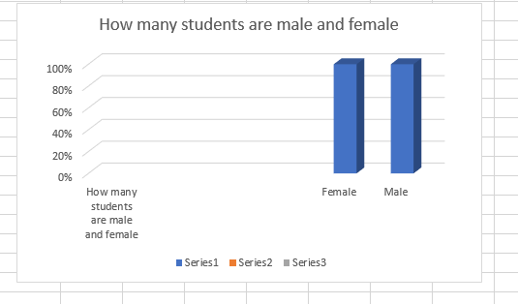
Figure 3: How many students are male and female
(Source: Excel)
In the above data it is calculated and analysed the total survey of 2133 students. The information is also given of their total score in pre and post tests. This information is valid and does qualify for the result that is required to find out how many students are male and female in the school room. The total number of students can be figured out using the CountIf formula. The total number of students in the given data along with their genders by calculating in the proper process it is estimated that a total of 1056 female students are being calculated among the total number of students. The total number of male students is also calculated in the same process making the figure of total 1077. Thus, it can be understood in which process it can be figured out from 2133 students how many are male and female.

2. Number of student qualifies and does not qualify for free lunch

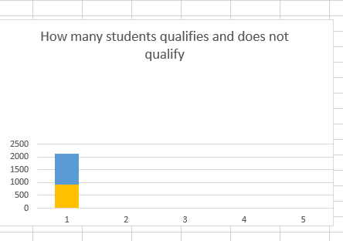
Figure 4: Student qualifies and does not qualify
(Source: Excel)
In the above data it can be understood the total male and female who don't qualify for free or reduced lunch. The above 2133 number of students all are not qualified for free lunch. To distinguish between the students who all are qualified the CountIf formula is needed to show its effort. After using the CountIf formula over the students how many are qualified for lunch and who all are not (Kurniawan et al., 2019). After using the countif formula for free lunch a total number of 918 students have secured free lunch in the time being. The introduction of the countif formula also generated the total number of students who haven't qualified for free or reduced lunch is about 1215 students.
3. Mean and median of students qualified and do not qualify for lunch
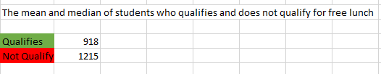
Figure 5: Mean and median of students
(Source: Excel)
In the above data it is estimated that the total mean and median of students who all are qualified for free lunch. The total number of students is 2133. According to the dataset the total mean it is estimated that the total number of students who are qualified are 918. It is calculated that the number of students who qualified for free lunch are about the same proportion along with the total mean and median (Rahmayani et al., 2022). The total number of students who aren’t qualified for free lunch is about 1215. These 1215 not qualified students is directly proportional to the total number of students who haven't qualified for lunch.
4. Mean and median students in their pre and post test score
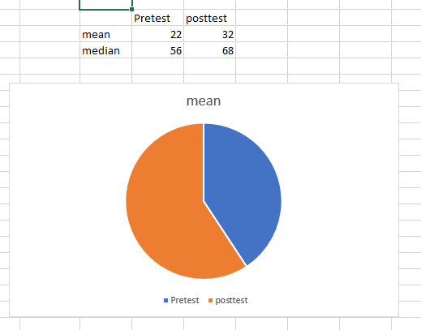

Figure 6: Mean and median students in their pre and post test score
(Source: Excel)
In the above data it is estimated that the number of students with pre and post test scores. During the calculation of pretest of the students in mean mode mode it can be distinguished by using the formula of mean by selecting the cells in the pretest column, thus the mean of pretest is 22. The above selected with the same formula in which it has been made pretest by the same exact formula can be determined as the posttest as 32. In the median mode it is also made with the same formula by using the median formula in which the score is 56 (Ardianti et al., 2020). Thus, in pre test it is explained that 56 means. Thus by using the median formula in posttest it is determined 32. The posttest of the students in median mode by using the formula it is explained the number of median is 32 in posttest.
Clustering
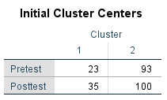
Figure 7: Clustering
(Source: SPSS)
In the above data it is being analysed taking the total of 2133 students it is understood that initial cluster centres should be taken aback. During this Initial Cluster Centres in the pretest it is determined that in the first phase it has been recorded as 23. Thus in the second phase it is recorded as 93. In the above data in the posttest it is understood that the value is 35 in the first phase. In the second posttest it is recorded that a total of 100.
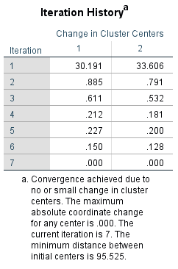
Figure 8: Iteration History
(Source: SPSS)
In this above data it is recorded that the Iteration history in the cluster centres changes in the time being. In the first iteration it is recorded as 30.19 whereas we can see the changes in the second phase determining 33.60. In the second iteration it is determined with .885 and simultaneously in the third is .611. In the fourth iteration it is determined as .212. This in the fifth is .227 and sixth being .150. The changes in the iteration can be described as small changes in cluster centres (Okagbue et al., 2021). The maximum absolute coordinate change of any type of centre is.000. The current iteration is 7 and thus the minimum distance between initial centres is about 95.52.

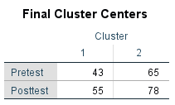
Figure 9: Final Cluster
(Source: SPSS)
In the above data it is experienced that in pretest it is 43 whereas in the first cluster centre it was about 23. So, it can be determined that during the final pretest it has increased by 20. In the second half of the pretest it is recorded with 65. In the posttest it is determined that the final cluster centres is 55, which has increased from the first by 20. In the second phase of the initial posttest it is recorded 78, which has decreased by 28.
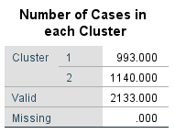
Figure 10: Number of cases in each cluster
(Source: SPSS)

Therefore, the number of cases in each cluster is determined by using the SPSS process. In cluster 1 it is recorded as a total of 993 students and in the second and final; cluster it is determined as 1140 students. SWo, therefore it is determined that a total number of students adding with each cluster forming in 1 and 2 are 2133 students. So, there are 2133 valid students in the cluster and none are missing. So, it is finalised with 0 missing students in the cluster.
6. The extract useful insight and patterns from datasets also understand text, contemporary business use powerful techniques like techniques like data mining. Below, it will go through five common methods.
Data Mining Methods
Decision Trees
Classification: This technique allows for predictive modelling and effective data classification by dividing information into specified groups based on particular properties. It may be used for a variety of things, such as filtering out unwanted messages, diagnosing illnesses, and categorising clients.
Clustering: Clustering organises data into groups of items with shared characteristics, revealing hidden trends and relationships. It has applications in areas like pattern identification, anomaly detection as well as market segmentation.
Association Rule Mining: As a result of using this method, several fascinating correlations and patterns between the dataset’s variables have been uncovered. It is often used in systems for suggestions and grocery planning analyses.
Regression Analysis: It helps with trend research and forecasting since it makes connections between variables and forecasts numbers based on additional factors.
Anomaly Detection: The approach is crucial for spotting fraud, network intrusions, and mistakes since it zeroes in on unusual occurrences.
Time Series Analysis: Insightful choices may be made with the help of this technique, which forecasts future developments based on existing patterns in the data.
Text Mining Methods
Text Preprocessing: It is impossible to begin Text Data Mining without first preprocessing the text. Data cleansing and transformation in text mining entails getting rid of blanks, stop words, and other formatting. In order to prepare text for further analysis, several methods, such as encoding and stemming, are used.
Sentiment Analysis: The idea of a technique called “sentiment analysis” is to ascertain the underlying mood of a piece of written content. For organisations, this method is invaluable for collecting and analysing customer feedback, public perception, and brand impression to inform data-driven choices that enhance the quality of products and services offered to clients.
Topic Modeling: Using Topic Modelling, one may pull out the most important themes and ideas from a set of documents. This method is useful for content analysis and management since it allows for the systematic organisation of massive amounts of material and the identification of recurrent themes.
Named Entity Recognition (NER): Named Entity Recognition (NER) refers to the process of extracting and organising information about nouns (such people's names, places, businesses, and dates) from text. This method is helpful for mining unstructured text for hidden insights.
Text Classification: One important use of text mining data is text classification, which involves sorting documents into categories it has been already thought of. Among the many applications of this method is improved data organisation and retrieval via its usage in sentiment analysis, filtering out spam, and document organisation.
Text Clustering: Clustering texts by their shared characteristics facilitates the management and examination of massive text collections. It is useful for discovering interconnections and patterns in textual information.
7.

Aspect | SPSS | Excel
Data Analysis Capabilities | SPSS was developed for the express purpose of doing statistical research and modelling. It offers sophisticated methods for analysing large datasets, such as regression analysis, clustering, and component analysis. | Excel has some rudimentary statistical features, but it can nott match what SPSS can do. The standard deviation, median, and mean can be calculated, but it lacks more advanced statistical techniques.
An Actual Benefit (Instance) | SPSS is well-suited for studies in social sciences because it enables researchers to do complex regression analysis to uncover correlations among multiple factors in a large dataset. | If then have a limited dataset and need to get the mean as well as the median of before and post-test scores, then can do so fast with Excel.
Data Visualization | SPSS’s robust charting and graphing capabilities simplify otherwise difficult statistical findings. | Although Excel has certain charting features, they may be less robust and flexible than SPSS's options.

Reference List
Ardianti, S., Sulisworo, D., Pramudya, Y. and Raharjo, W., 2020. The impact of the use of STEM education approach on the blended learning to improve student’s critical thinking skills. Universal Journal of Educational Research, 8(3), pp.24-32.https://pdfs.semanticscholar.org/fd7e/2a74b3e17abf610c8a96701d9ed854fd2602.pdf
Ardianti, S., Sulisworo, D., Pramudya, Y. and Raharjo, W., 2020. The impact of the use of STEM education approach on the blended learning to improve student’s critical thinking skills. Universal Journal of Educational Research, 8(3), pp.24-32.https://pdfs.semanticscholar.org/fd7e/2a74b3e17abf610c8a96701d9ed854fd2602.pdf
Bharwani, S. and Mathews, D., 2021. Post-pandemic pressures to pivot: tech transformations in luxury hotels. Worldwide Hospitality and Tourism Themes, 13(5), pp.569-583.https://www.emerald.com/insight/content/doi/10.1108/WHATT-05-2021-0072/full/html
Dexter, F., Ledolter, J., Epstein, R.H. and Loftus, R.W., 2020. Importance of operating room case scheduling on analyses of observed reductions in surgical site infections from the purchase and installation of capital equipment in operating rooms. American journal of infection control, 48(5), pp.566-572.https://www.sciencedirect.com/science/article/pii/S0196655319307631
Kurniawan, D.A., Astalini, A., Darmaji, D. and Melsayanti, R., 2019. Students' Attitude towards Natural Sciences. International Journal of Evaluation and Research in Education, 8(3), pp.455-460.https://files.eric.ed.gov/fulltext/EJ1232323.pdf
Okagbue, H.I., Oguntunde, P.E., Obasi, E.C. and Akhmetshin, E.M., 2021. Trends and usage pattern of SPSS and Minitab Software in Scientific research. In Journal of Physics: Conference Series (Vol. 1734, No. 1, p. 012017). IOP Publishing.https://dl.acm.org/doi/abs/10.1145/3456529.3456541
Rahmayani, O., Ardi, S. and Nofrialdi, R., 2022. The Effect of Utilization of Social Media Instagram@ Nanarfshop on Buying Interest of Fisipol Students University Ekasakti Padang. Journal of Law, Politic and Humanities, 2(2), pp.85-94.https://dinastires.org/index.php/JLPH/article/download/89/82
Rasoolimanesh, S.M., Wang, M., Mikulić, J. and Kunasekaran, P., 2021. A critical review of moderation analysis in tourism and hospitality research toward robust guidelines. International Journal of Contemporary Hospitality Management, 33(12), pp.4311-4333.https://www.researchgate.net/profile/S-Mostafa-Rasoolimanesh/publication/354693182_A_Critical_Review_of_Moderation_Analysis_in_Tourism_and_Hospitality_Research_Towards_Robust_Guidelines/links/6147e1b8a3df59440b9b9ebc/A-Critical-Review-of-Moderation-Analysis-in-Tourism-and-Hospitality-Research-Towards-Robust-Guidelines.pdf
Rita, P., Ramos, R., Borges-Tiago, M.T. and Rodrigues, D., 2022. Impact of the rating system on sentiment and tone of voice: A Booking. com and TripAdvisor comparison study. International Journal of Hospitality Management, 104, p.103245.https://www.sciencedirect.com/science/article/pii/S0278431922001074
Selwyn, N., 2022. ‘Just playing around with Excel and pivot tables’-the realities of data-driven schooling. Research Papers in Education, 37(1), pp.95-114.https://www.tandfonline.com/doi/abs/10.1080/02671522.2020.1812107
Tong-On, P., Siripipatthanakul, S. and Phayaphrom, B., 2021. The implementation of business intelligence using data analytics and its effects towards on performance in the hotel industry in Thailand. International Journal of Behavioral Analytics, 1(2).https://ijbmcjournals.org/wp-content/uploads/2021/09/ijba-vol-1_2_9_2021.pdf

