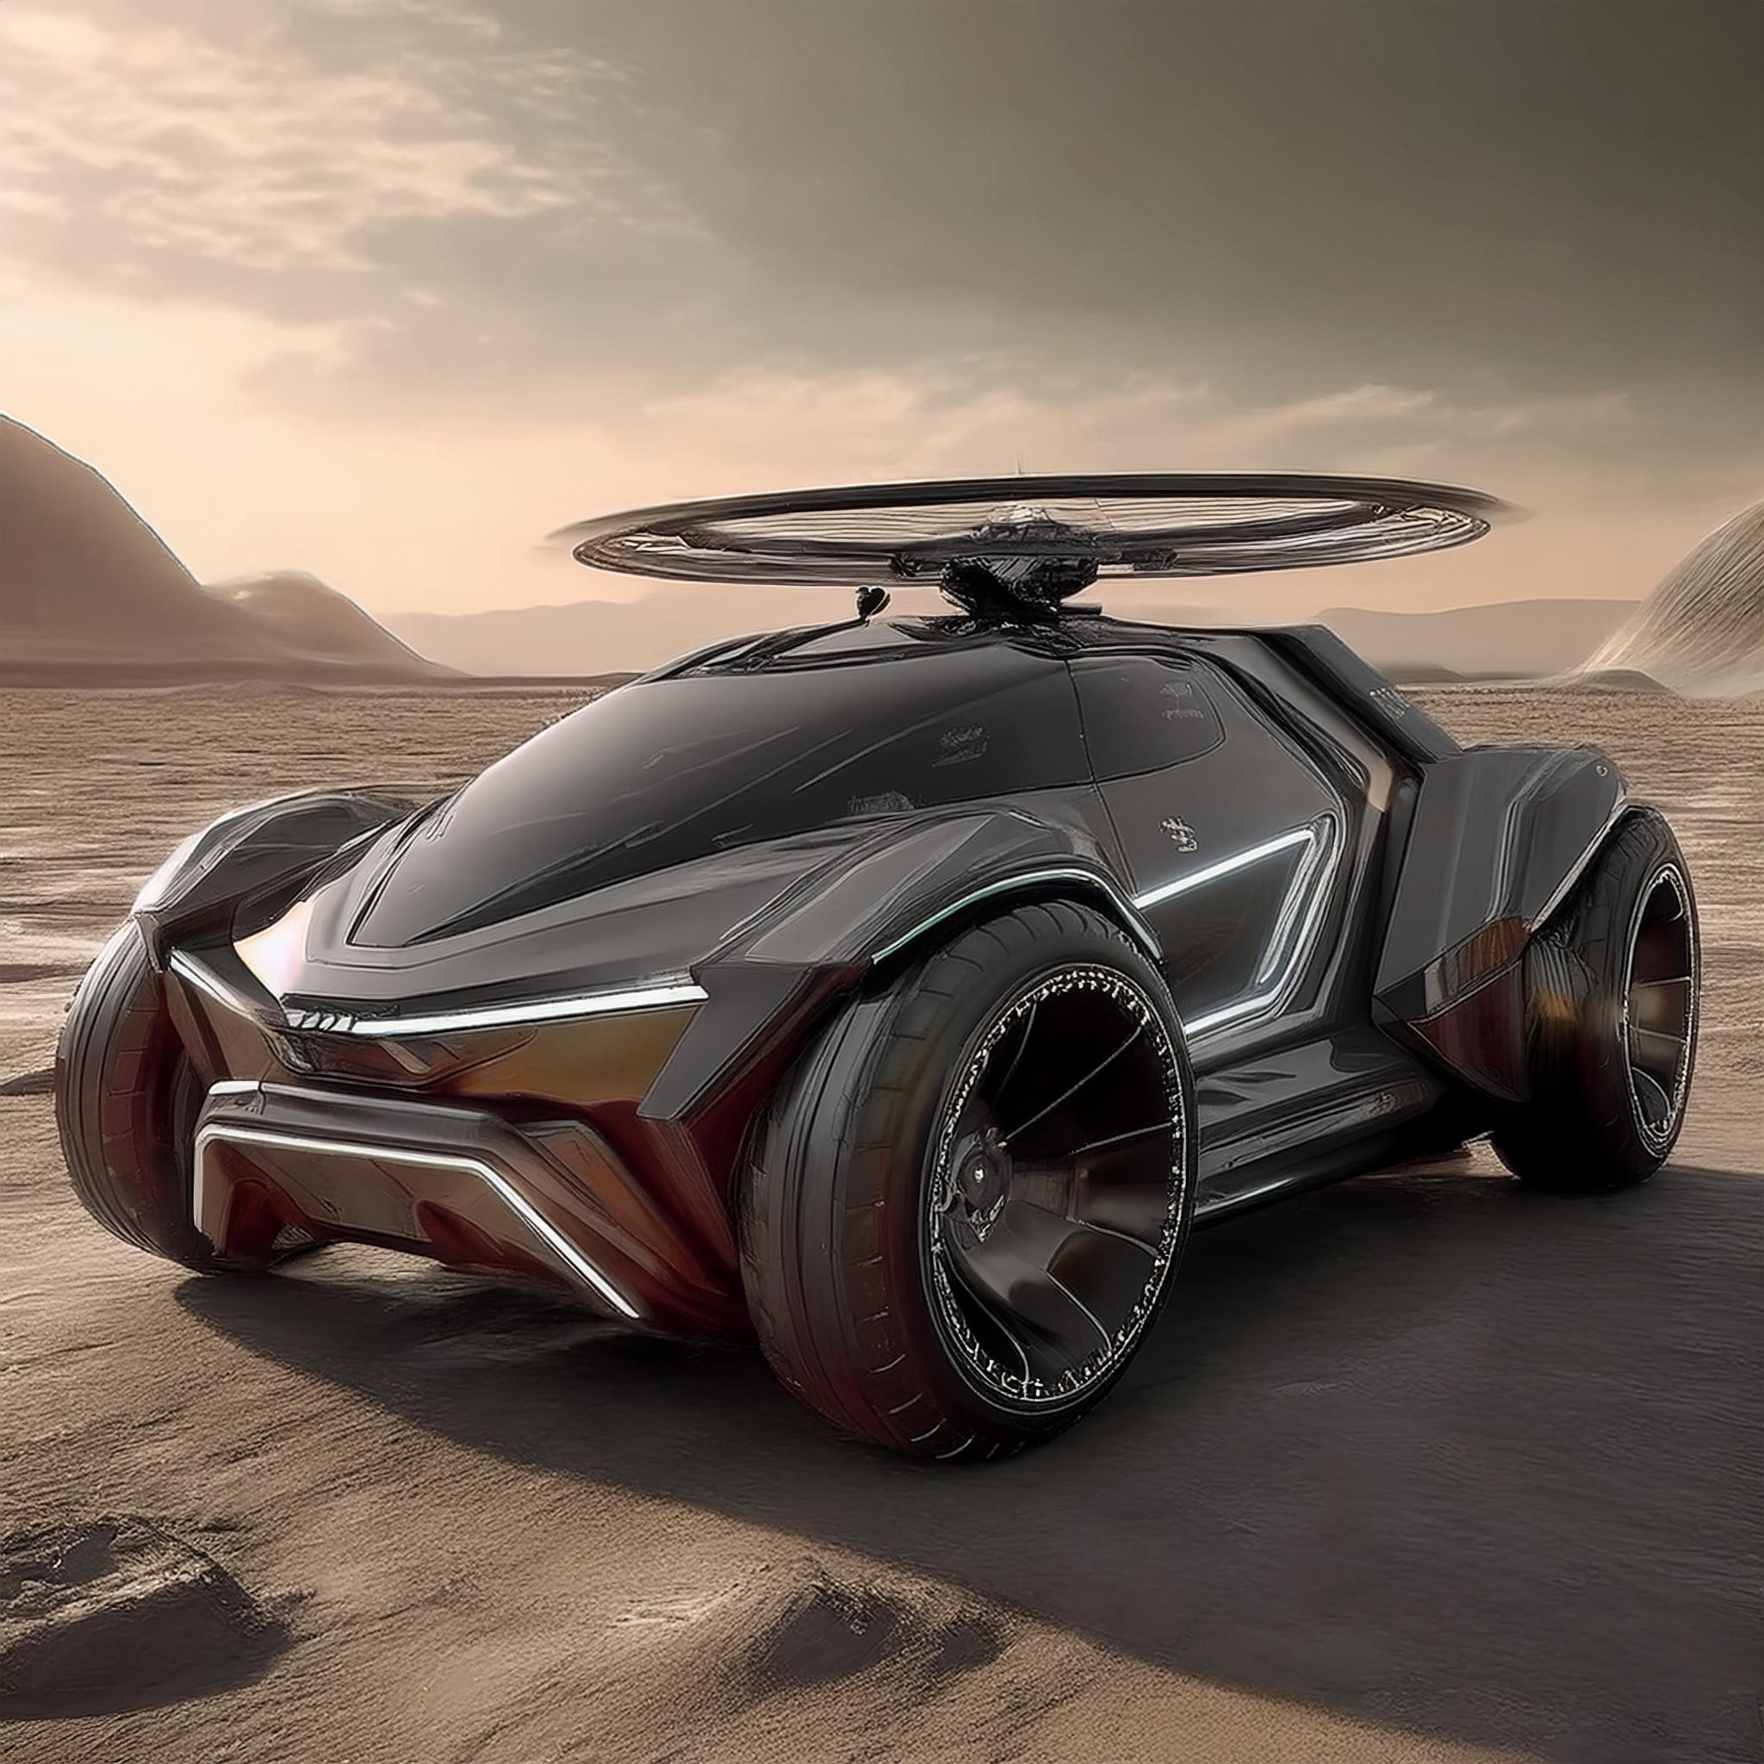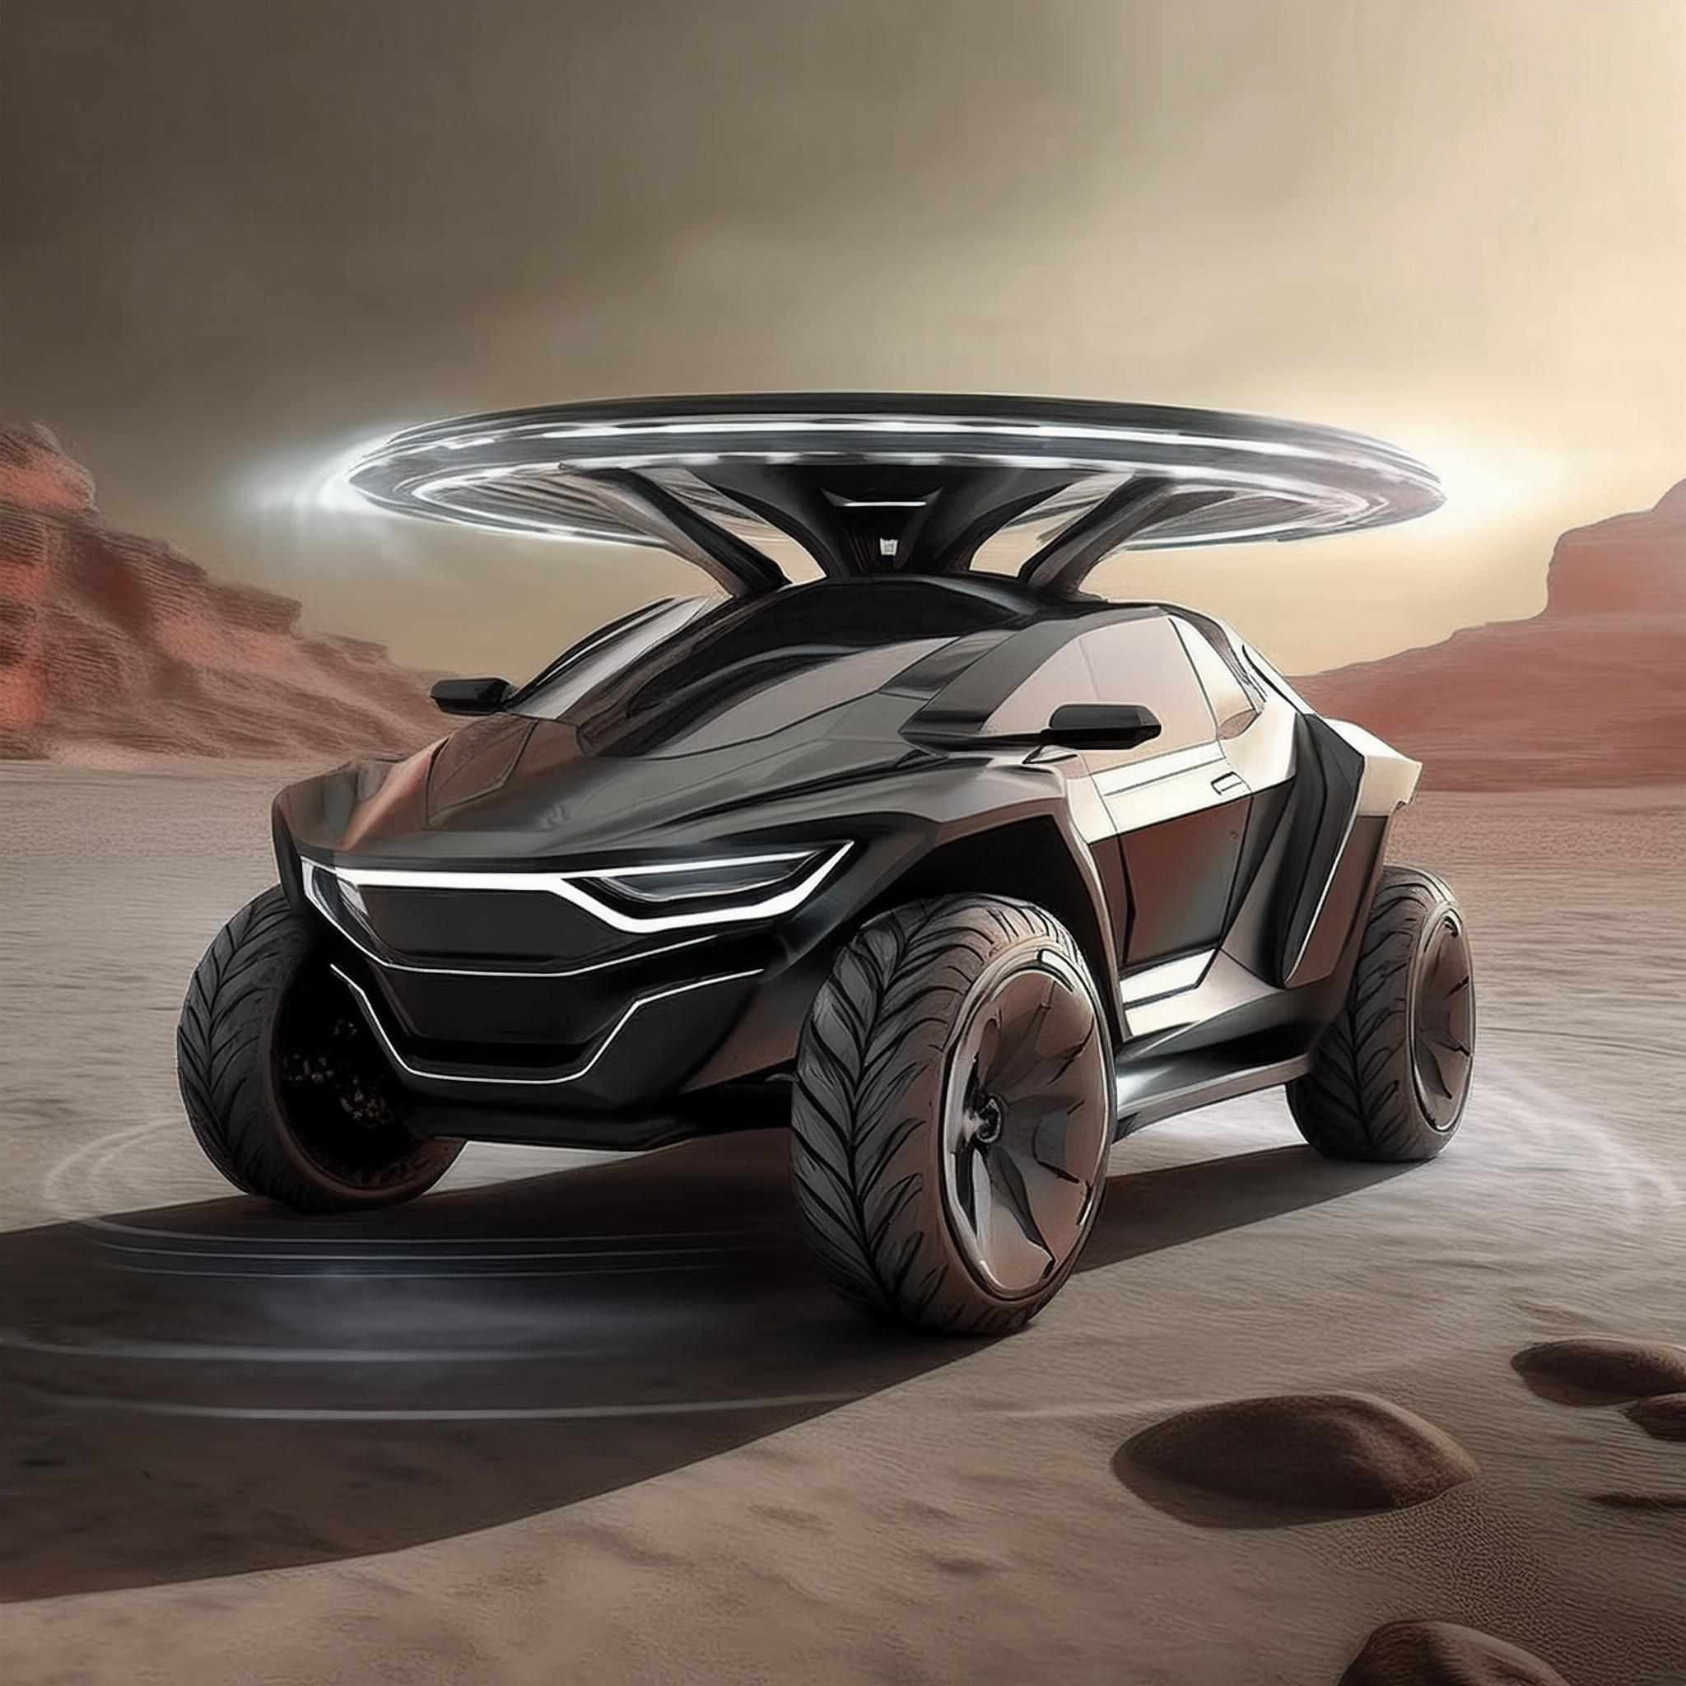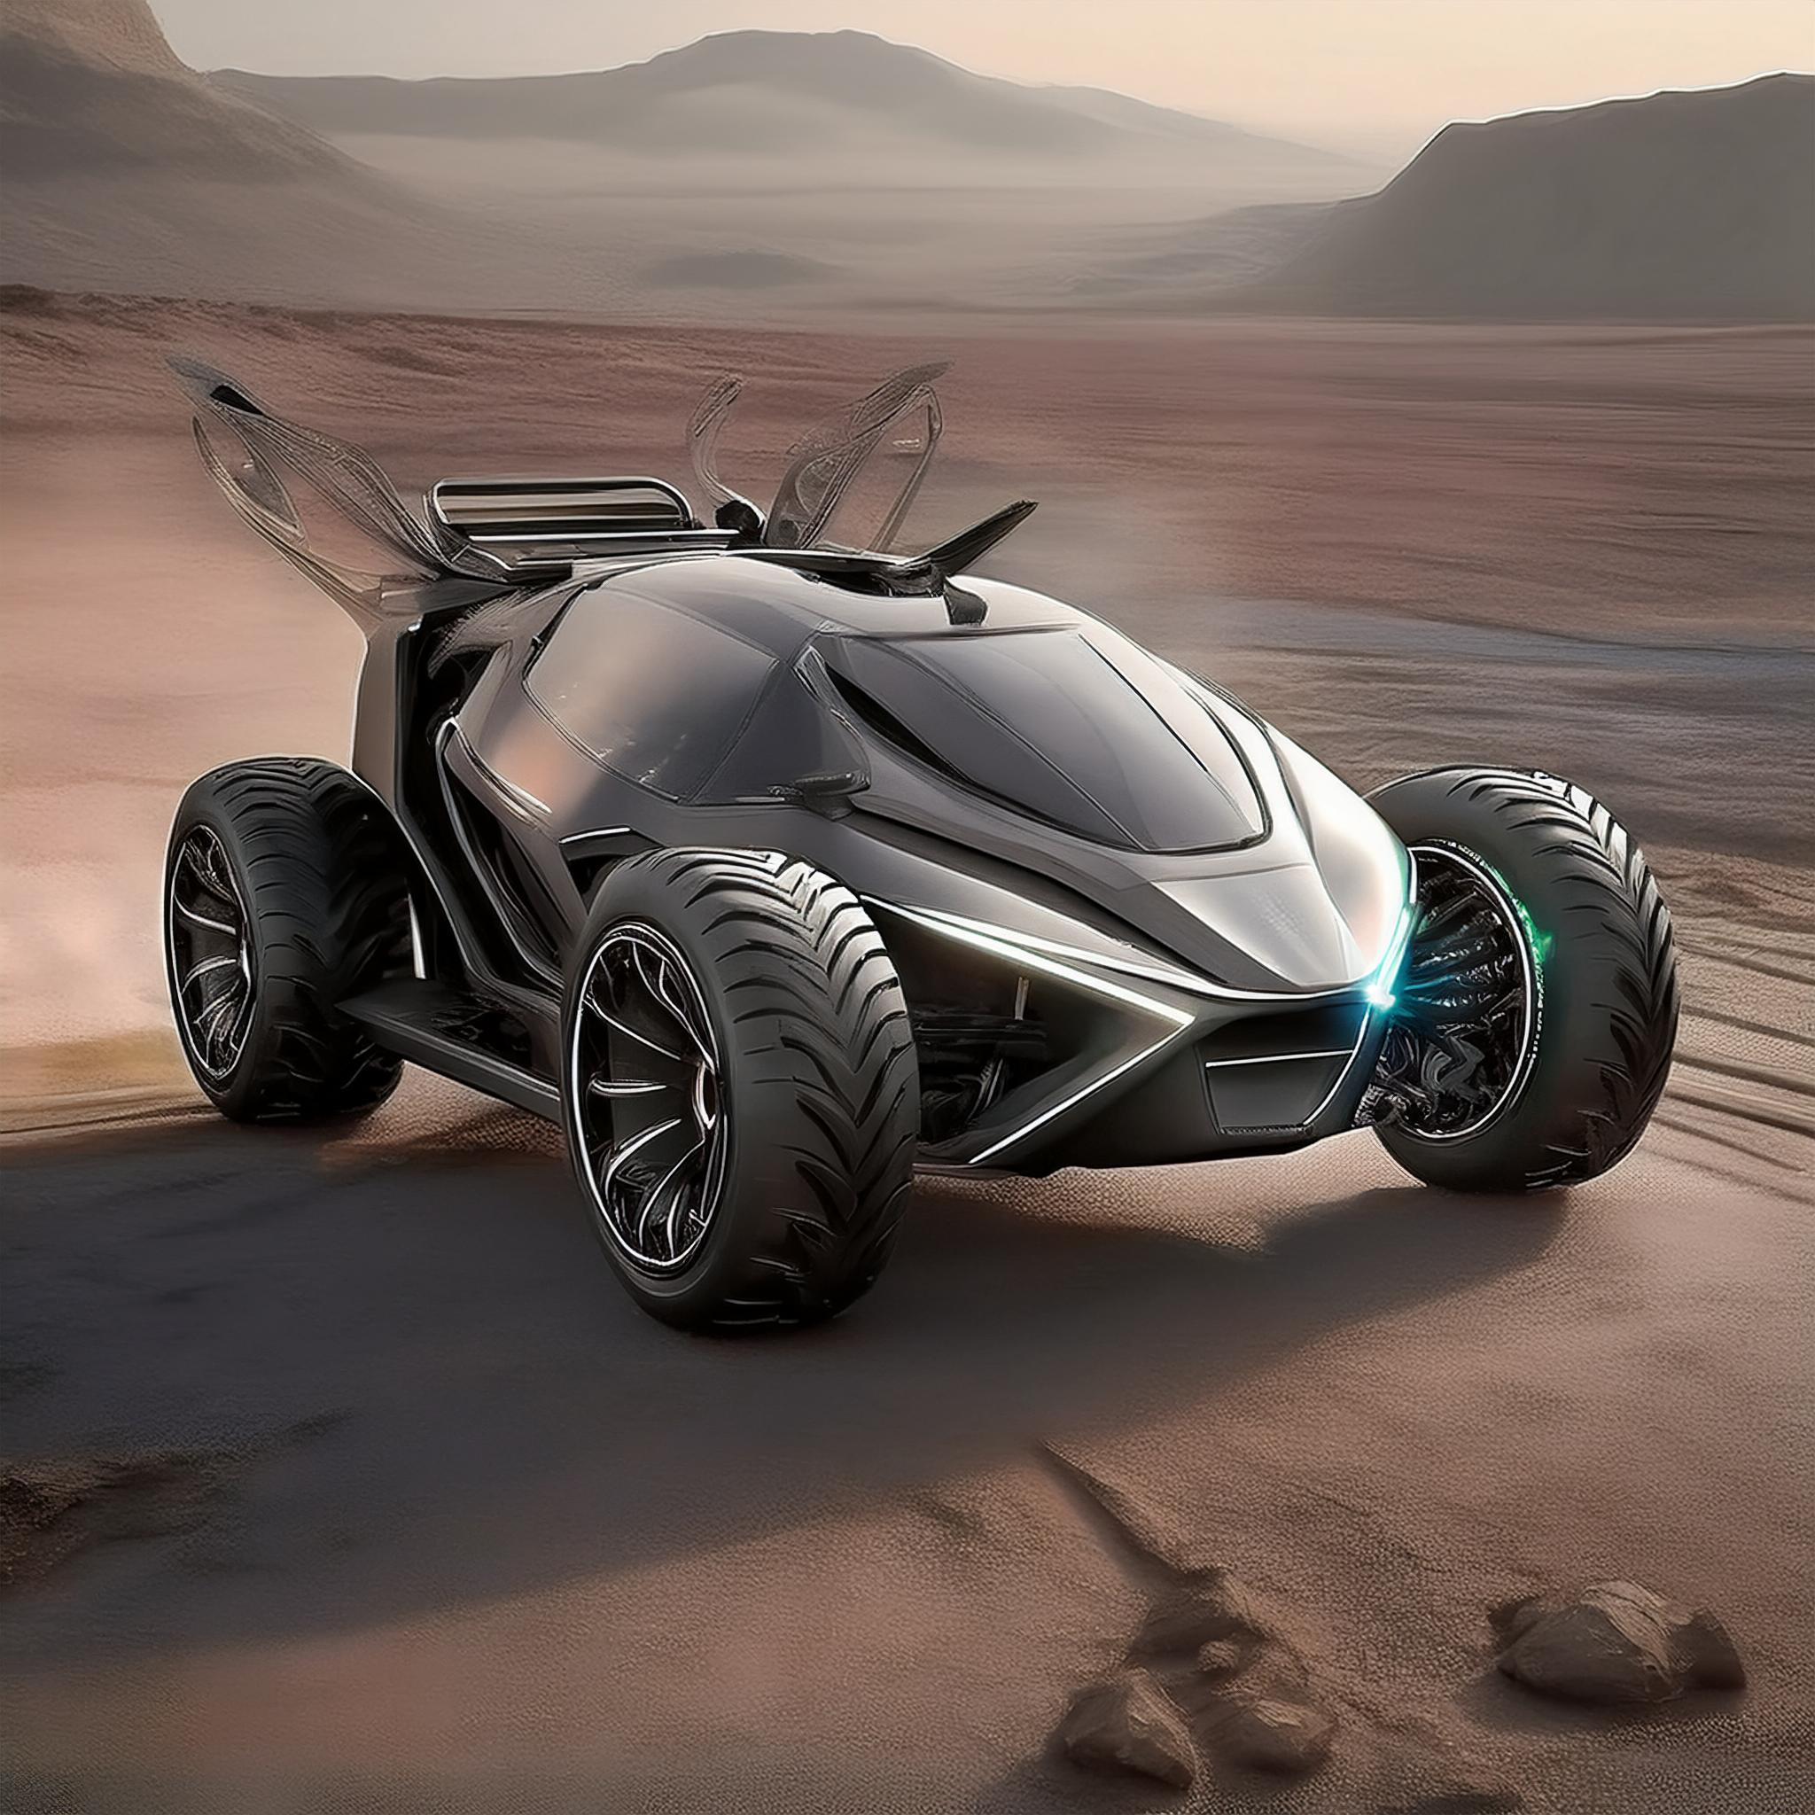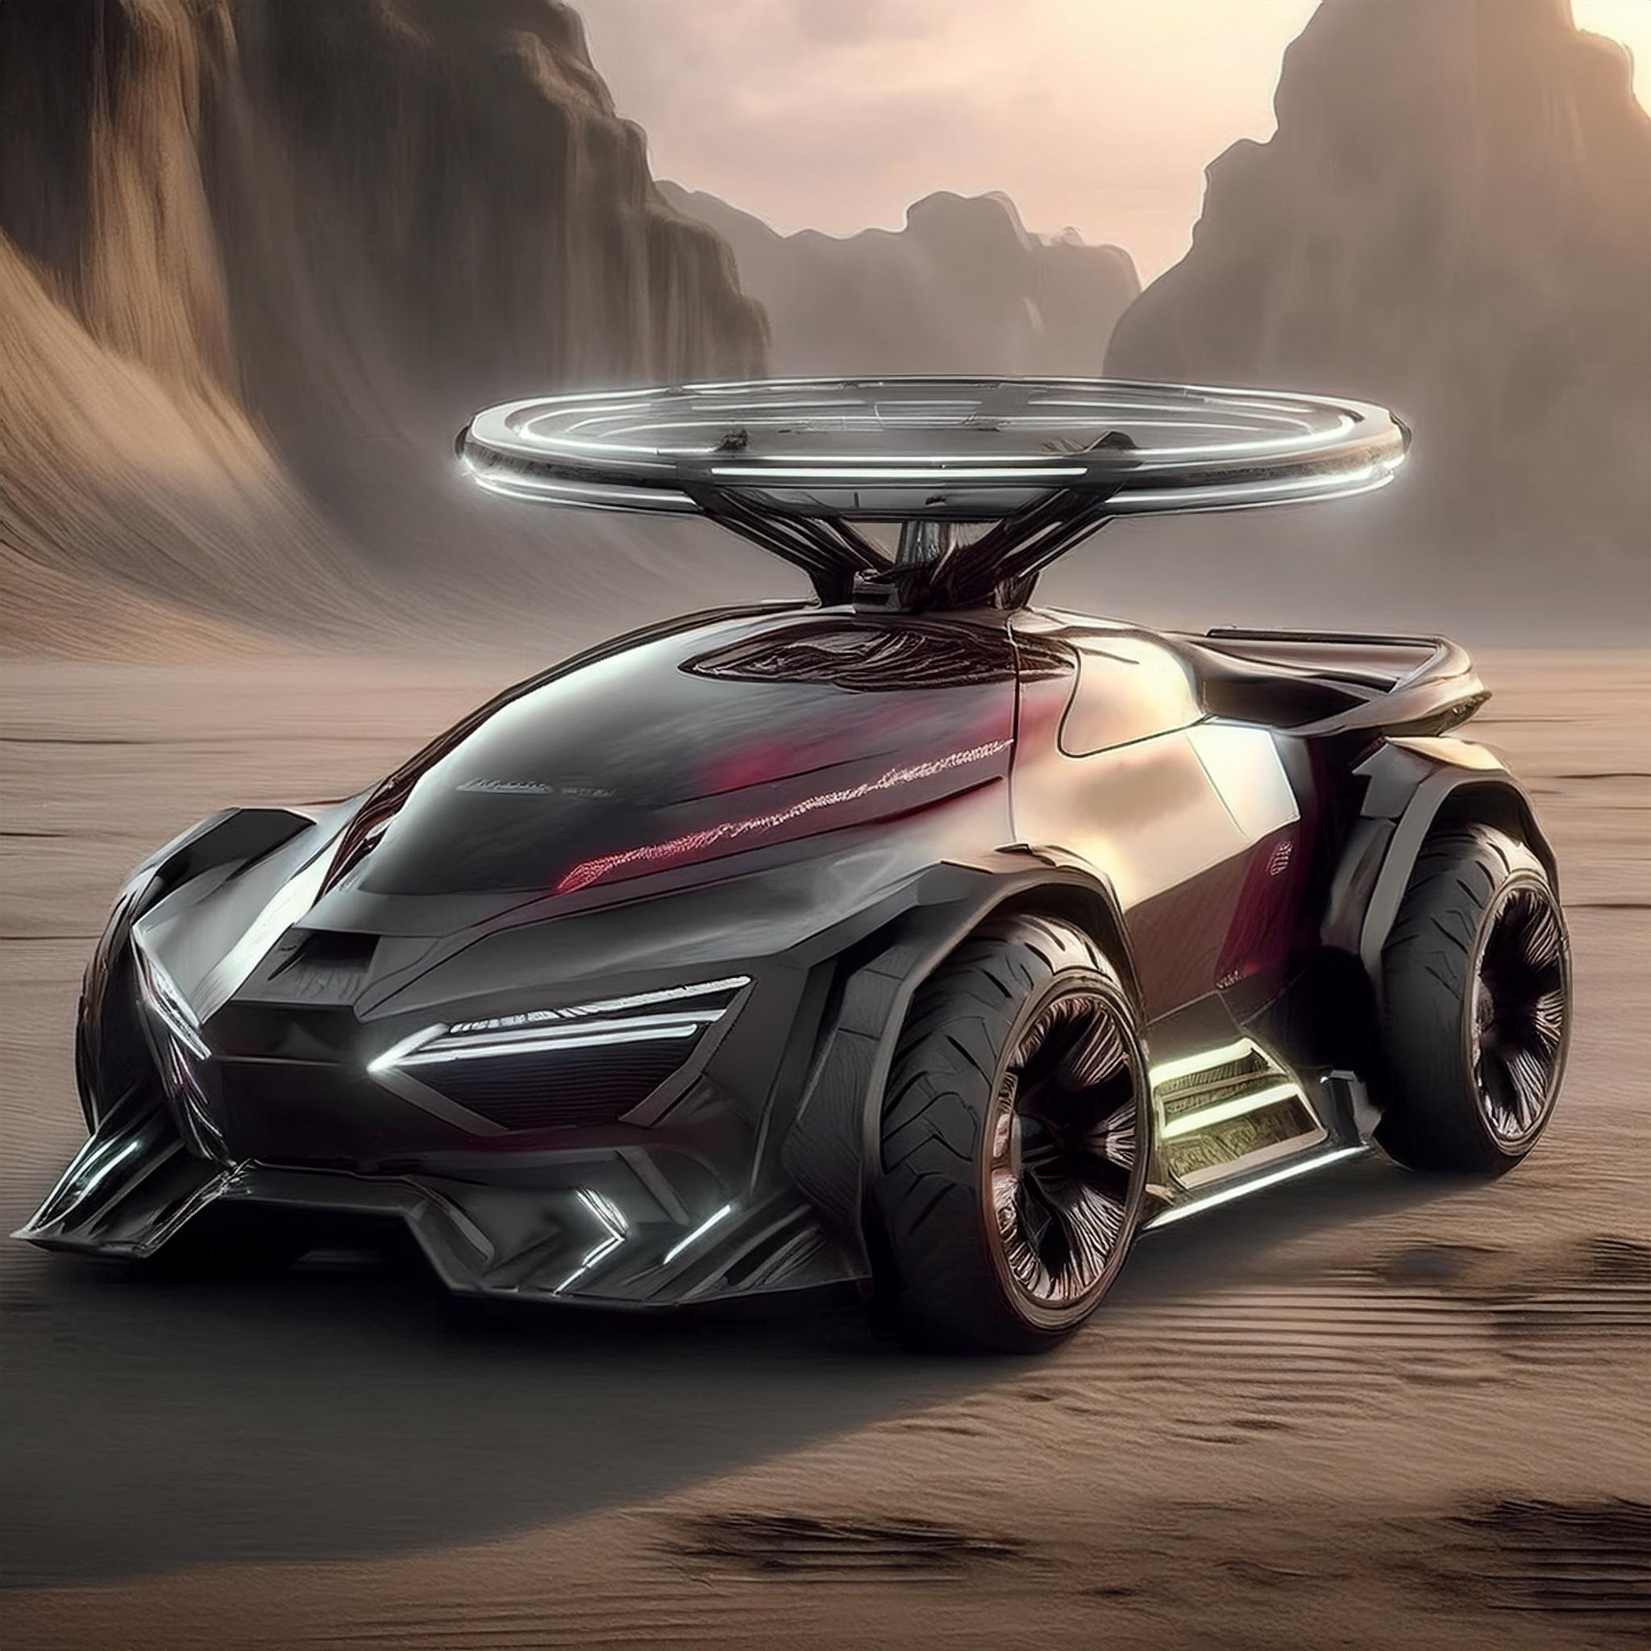

Magnetohydrodynamic Dynamic Texture + Vertical Takeoff and Landing Rotor Chimera + Aurora Gradient Breathing Light + Quantum Totem Laser Etching

Atvs for Mars colonization in 2050

