Global Ethics
Assignment 2 When in Rome, do as the Romans do
Useful structure
Do not copy, cut and paste because Turnitin will identify a similarity match and you will be penalised. Instead use this document as a guide.
I think it is useful for you to start with the premise – what works in a company’s home country can fail in a country with different standards of ethical conduct so how do we deal with this ?
Advancements in globalisation and technology have led to the dangerous assumption that the world is becoming increasingly more homogenous. Theodore Levitt (1983) states, "The products and methods of the industrialized world playa single tune for all of the world, and all the world eagerly dances to it" (p. 2).
When it comes to shaping ethical behavior, companies must be guided by three principles.
- Respect for core human values, which determine the absolute moral threshold for all business activities.
- Respect for local traditions.
- The belief that context matters when deciding what is right and what is wrong.
At the other end of the spectrum from cultural relativism is ethical imperialism, which directs people to do everywhere exactly as they do at home. Again, an understandably appealing approach but one that is clearly inadequate. Consider the large U.S. computer-products company that in 1993 introduced a course on sexual harassment in its Saudi Arabian facility. Under the banner of global consistency, instructors used the same approach to train Saudi Arabian managers that they had used with U.S. managers: the participants were asked to discuss a case in which a manager makes sexually explicit remarks to a new female employee over drinks in a bar. The instructors failed to consider how the exercise would work in a culture with strict conventions governing relationships between men and women. As a result, the training sessions were ludicrous. They baffled and offended the Saudi participants, and the message to avoid coercion and sexual discrimination was lost.
When we leave home and cross our nation’s boundaries, moral clarity often blurs. Without a backdrop of shared attitudes, and without familiar laws and judicial procedures that define standards of ethical conduct, certainty is elusive.
Should a company invest in a foreign country where civil and political rights are violated?
Should a company go along with a host country’s discriminatory employment practices?
If companies in developed countries shift facilities to developing nations that lack strict environmental and health regulations, or if those companies choose to fill management and other top-level positions in a host nation with people from the home country, whose standards should prevail?
Executive Summary
This should outline the whole of your report. It is standardised;
- This report provides an analysis and evaluation of
- The case study or the product or the service is
- Methods of analysis include evaluation and application of X AND Y AND Z theories and or concepts
- The report finds that the current is positive or negative ???
- The major areas of weakness require further investigation and remedial action by management
- Recommendations discussed include

Introduction
While globalisation remains a fluid concept (Akaka & Alden, 2010),the globalisation imperative (Ram, 2009) epitomises the competitive pressure and market opportunities offered by an increasingly global consumer demand (Arnould & Thompson, 2005; Cleveland & Laroche,2007; Muñiz & O'Guinn, 2001), accelerating the emergence of a homogenous global consumer culture (Alden, Steenkamp, & Batra,1999), and the need for businesses to optimise their market performance, including economies of scale, on a global basis (Kotabe & Helsen, 2014).
Introduce your case study or product or service
Possible topics;
Sweatshops – would the Rana Plaza Building collapse in Bangladesh happen in Britain or Belgium ?
Social media - breaching of personal privacy and user data leakage. Using the cultural relativism framework and CSR model by Carroll to analyse how Facebook used or abused business ethics when providing UK and US services.
MacDonalds and its transformation into a global entity because of its ‘respect’ or manipulation for cultural relativism. Every country in which it operates has some type of ethnicity reflected in the menu. McDonald's is perhaps judged unfairly, as the mere mention of its name conjures up cultural imperialism. Though McDonald's may be everywhere, it at least adheres to some principles of individual cultures, which makes it successful everywhere it goes.
Dumping of waste – if you have read the Donaldson resources you will have seenthat some European tanneries and pharmaceutical companies were looking for cheap waste-dumping sites. They approached virtually every country on Africa’s west coast from Morocco to the Congo. Nigeria agreed to take highly toxic polychlorinated biphenyls. Unprotected local workers, wearing thongs and shorts, unloaded barrels of PCBs and placed them near a residential area. Neither the residents nor the workers knew that the barrels contained toxic waste.
Background to the case study or product or service
Methods I recommend the two models used in this report are the cultural relativism perspective and the Carrol’s CSR pyramid
Cultural relativism and sweatshops, social media, MacDonalds, dumping of waste, OR YOUR CHOICE –
Cultural relativism indicates the existence of different moral codes in different cultures, and these moral codes determine the moral correctness or wrongness within the specific culture (O’Regan and MacDonald, 2007).
Remember how we looked at globalisation permits outsourcing in developing countries, where labour is cheaper and low costs in terms of environmental and employee safeguards/protections
Managerial responses to the incident using the Carroll’s CSR pyramid
The CSR pyramid is used in this report analyse to which level the managerial teams in both companies have fulfilled according to the pyramid.
Organisations should engage on all four levels of Carroll’s pyramid of corporate social responsibility
- Southwest Airlines’ triple bottom line (Performance, People, and Planet) approach
- H-E-B grocers’ disaster relief efforts during and after Hurricane Harvey
- Patagonia’s giving its entire $10 million tax cut in 2019 to help mitigate climate change

FC Barcelona example of CSR pyramid/FC Barcelona as a socially responsible organisation THIS IS SIMPLY AN EXAMPLE OF CSR APPLIED TO THE ORGANISATION OF FC BARCELONA

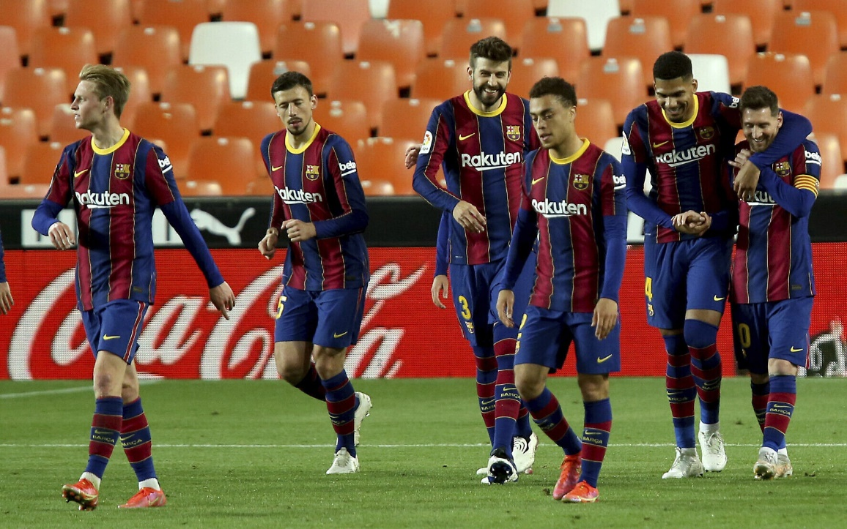

FC Barcelona has been a world-class club for many years. It regularly participates in the Champions League games and has been a 5-times victor. The club dates back to 1899 when Hans Gamper, a Swiss, gathered a group of 12 male football players in Catalonia and founded an association: Football Club Barcelona (Fútbol Club Barcelona). Even then, the distinctive features of the club were forming: Catalan identity, democracy, multiple sports and universality. More than one hundred years later, on its official website, one finds the very similar characteristics of FC Barcelona: Catalanism, universality, and democracy. However, the fourth value has changed—social commitment has replaced multiple sports. This change indicates that social responsibility has become one of the pillars of FC Barcelona’s activity. Through its CSR activities, the “Catalan Pride” shows that the motto “More than a club” is not just a slogan but a commitment to the local and global community. Due to the specific nature of activities of the football clubs, the CSR initiatives will differ depending on the stakeholders and the interests and initiatives. The internal stakeholders of a sports club include all its employees (players, sports and medical staff, administrative employees), owners, shareholders, investors and trade unions. External stakeholders include customers, competitors, creditors, suppliers (e.g.: companies providing equipment for footballers), TV stations, local and international sports institutions, local and national authorities, the local community (Filizöz & Fisneb, 2011, p. 1410; Skrzypek, 2015, p. 194), universities, media, courts and other entities constituting the organisation’s environment (Sznajder, 2013, p. 197), and—as the so-called silent stakeholder (Jastrzębska, 2015, pp. 49–51)—the natural environment. In FC Barcelona, a participatory democracy model is used, combining membership with club ownership, which is why one of the most important stakeholder groups are club members known as socios. They are part of the council of delegates and have a real influence on club management. They have the right to choose the club’s president and board as well as to verify whether decisions taken by the board are in accordance with the applicable statute, they also have the right to vote on charitable activities of the FC Barcelona Foundation (Hamil, Walters & Watson, 2011, p. 154). As of June 30, 2017, the socios group comprises members, of whom as many as 132,748 live in Catalonia. Men dominate among club members (74%), women constitute 26% of the population. The statistics do not distinguish children, but almost 9,000 members are persons under 5 years of age (FC Barcelona, Report 2016/2017 [hereinafter referred to as Report 2016/2017], p. 110).
One can see that being socio of FC Barcelona is in many cases a family tradition and proof of a true membership in the club. FC Barcelona’s activities in the field of corporate social responsibility in the framework of a system corresponding to Carroll’s CSR pyramid are presented below. It should be emphasised that this division is conventional, as individual activities can often be qualified to more than one dimension. The main entity enabling ethical and philanthropic activities on behalf of FC Barcelona is the Barca Foundation established in 1994, thanks to which over one million children around the world have already received assistance in the framework of a variety of programmes.
Conclusions and recommendations
ESSENTIALLY – International companies that operate overseas must take into account the impact that expressing their political views has on the social environments they do business in. This requires a moral awareness, moral sensitivity, moral imagination and sometimes moral courage on the part of companies. And it requires a balance, being able to understand that there are different competing tensions and goals that have to be addressed at the same time
Corporate social responsibilities (CSR) are becoming increasingly important in today’s globalised business world. Companies should care about their stakeholders’ interests but at the same time, they should place more emphasis on other areas apart from solely profits making. Most people used to think that businesses are taking advantages from consumers. Nonetheless, nowadays stakeholders are not only concern about profits; they are more interested in company regarding various economic, environmental, ethical, governance, and social aspects, since these factors significantly affect the fate of the company in long term. Research has proven that there is a competitive advantage for corporations that have a higher reputation and are more socially responsible in their CSR program. Many multinational companies such as Starbucks, the BodyShop, and Microsoft, establish well-developed code of conduct; they also strive to achieve some social missions in order to do businesses ethically, minimize negative environmental impacts, raise public attention on certain issues, raise funds and donations, increase employees’ job satisfaction, and more.

Reference list

