Marketing Management
Assessment 1

Student Name: Simran Kaur Virdi
Student ID: 2220720

Table of Contents
Introduction 3
Background of Tesco 3
Concept of Communication 3
Diagram and a brief explanation of a communication model 4
Integrated Marketing Communications 6
New promotional strategies of Tesco to raise awareness of the brand 7
Definition of branding and brand equity 8
Keller's Brand Equity Model and its different stages 9
Keller’s brand equity model application in marketing 9
Include the advantages and disadvantages of Keller’s Brand Equity model 11
Discuss the customer journey and customer touchpoints for the organisation 11
Explain the Total Engagement Model and how it could be related to Tesco 14
Recommendations of new touchpoints 15
Conclusion 15
References 17

Introduction
A well-structured and rigorously enforced marketing management is vital for mobilizing a specific company towards success. It depends on the productive regulation of various aspects that reflect the potential of influencing the management procedure. Therefore, this report analyses the communication for marketing on the backdrop of Tesco, accompanied by a detailed discussion on the promotional strategies and branding. The report also puts forward a detailed explanation of a communication model. The study would further evaluate Keller's brand equity model while exploring the customer journey and client touchpoints in Tesco. The report ends with a thorough investigation of the total engagement model and its relation to Tesco. In a nutshell, the report would be evaluating various elements that contribute to the success of an organisation in the market with a detailed analysis based on one of the dominant UK-based retail chains, that is, Tesco.

Background of Tesco
Tesco is one the most influential retail chains in the UK with its headquarters in Welwyn Garden City. Founded in 1919, the retail brand has been able to establish a solid position in the market with its vast and diversified product line. This can be inferred from the fact that the brand has accumulated £61.3 billion as statutory revenue as of 2022 while its operating profit amounted to £2,560 million reflecting the corporation’s dominance in the British retail industry (tescoplc.com, 2023). The company has been continuously investing in modifying its marketing strategy while ensuring the use of unique methods of interacting and communicating with its clients and prospective buyers. The market share of Tesco in the United Kingdom has been 27.3% as of 2022 which indicates the company’s method of marketing and addressing its customers that have resulted in such a positive share in the market (assosia.com, 2023).

Concept of Communication
Communication is a method that includes the transmission and procurement of information and knowledge. It can be either verbal or non-verbal accompanied by the adoption of audio, visual, graphical or infographics to disseminate or acquire information and data (Schoneveld et al. 2021). Communication can take several forms and be used by a variety of sources to facilitate the process of exchanging information. Such a process can be either a one-way or two-way procedure depending upon the kind of communication that has taken place between the sender and receiver. In the business domain, communication plays a crucial role in exchanging information and facilitating the effective transmission of actionable data. Cohesion among the key elements of communication ensures meticulous enforcement of the process whereas the lack of allegiance to the significant ingredients of communication reflects the scope of miscommunication that not only affects the purpose and need of such information exchange but also shifts the process towards technology-backed and regulated communication.

Diagram and a brief explanation of a communication model
There are several communication models out of which, the Schramm Model has been identified as the feasible one for this report. This is a holistic and cyclical method including all the necessary ingredients for successful communication. According to this theory, communication is based on three key elements, that is, source (the sender), message (the information that is transmitted) and destination (the receiver of the transmitted information). This model indicates that communication is a two-way procedure involving the exchange of knowledge and message between the sender and the receiver (Atapattu et al. 2020). The main ingredients of a communication process are- the sender, encoder, decoder, interpreter, feedback, medium and noise.

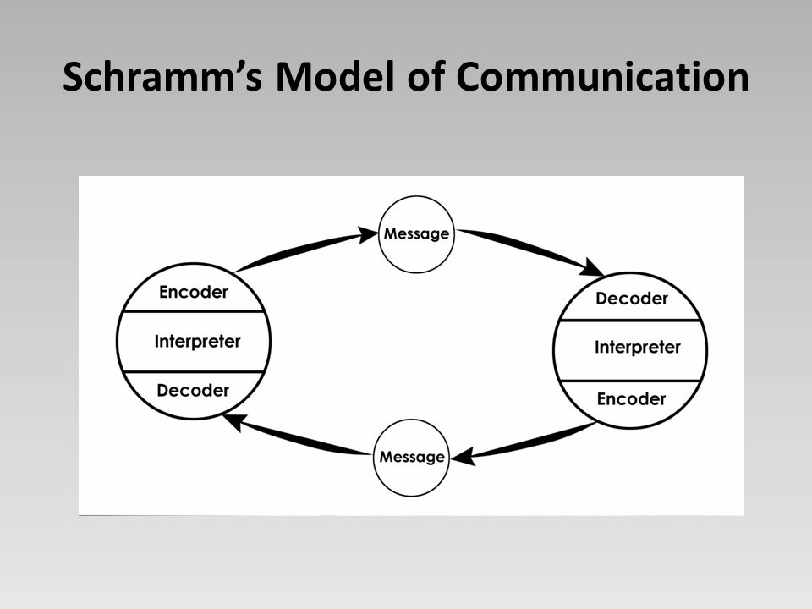
Figure 1: Schramm’s Model of Communication
Source: [slideplayer, 2023]

This theory highlights the reversal of roles between the sender of the information and the receiver (Frean, 2022). According to this concept, the information transmitter is known as the sender whereas the individual transforming the message into comprehensible codes is the encoder. This is because it is necessary to analyse and put into use the precise words that must reflect the information the sender intends to convey. The decoder is the individual or source who receives the coded information and turns it into an interpretable message because while receiving information, it is crucial to utilise cognitive and behavioural capacities to successfully know and understand what has been conveyed to us (Zhang and Wang, 2020). Interpreter on the other hand generally refers to the source or individual who comprehends and evaluates a message that is then moved forward to be received by the concerned destination source. However, the kind of interpretation depends on the cognitive capacity of a person due to the distinct point of view and distinguished process of comprehending complex information that gives rise to the scope of misinterpretation. The process is reversed when the receiver provides feedback on the received information which is usually a reaction or response to the concerned message (deVries et al. 2019). In a communication process under the Schramm Model, a medium is a channel through which the transmission of information happens which can be either telephonic, virtual or visual mediums. Noise is the disturbance that is generally observed during the transmission process. Such noise is also witnessed when the aimed objective of the information accompanied by the intended meaning of the receiving source reflects a distinct difference This model is not based on traditional communication techniques but has been framed based on the observed utilisation and enforced methods of technology.

The significance of this model is that it reveals that situations are unpredictable and with effective communication, a conflict or dispute can be solved (Karthikeyan and Malathi, 2022). It indicates that circumstances and information are perceived by different people in distinct ways that ultimately decide whether the communication has been successful in conveying the embedded message or not which plays a vital role in business. In this theory, redundancy contributes to refining information or data and modifies the original status of the message. This model is not only cyclical but also encourages the vitality of feedback in various domains that utilise communication.

Integrated Marketing Communications
Integrated marketing communication is the strategic procedure that is being crafted to ensure the information that is being transmitted is received by the prospective client accompanied by the communicative assurance that the commodities and services offered by the company are aligned with the individual’s interests, needs and demands and reflects stability under changing times (online.purdue.edu, 2023). This type of communication facilitates the promotional apparatus to efficiently perform together which is followed by the specific phases through which such a communication campaign is enforced by the concerned organisations.
The first stage involves the meticulous identification of the prospective market followed by the process of chalking down the objectives in relation to the campaign (Elrod and Fortenberry, 2020). A firm also drafts a rigorously analysed budget that not only serves the cost-saving purpose but also enables the company to accomplish its business objectives efficiently on the basis of which the promotional or product mix is determined. Integrated marketing communication’s last phase involves the evaluation phase where the result is predicted. Therefore such a strategy reflects a comprehensive and holistic technique of mobilising a campaign to success for an enterprise.
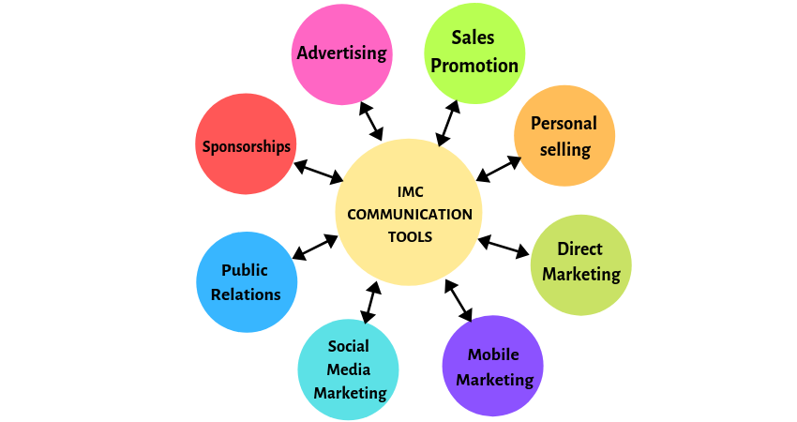

Figure 2: Integrated Marketing Communication Tools
[Source: hitechnectar, 2019]

New promotional strategies of Tesco to raise awareness of the brand
Due to the increasing competition in the market, it is essential to enhance brand awareness to survive the pressure exerted by emerging companies and the increasing influence of the existing ones. In this context, it has to be noticed that in the case of the online delivery facility for groceries, Tesco in the UK has a brand awareness of 96% as of 2022 reflecting that the company has become a household name in the British market (statista.com, 2022). However, even such an impactful company might lose its ground due to the increasing competition in the market that demands the expansion of Tesco’s client base. Companies looking forward to increasing the consumer base must meticulously identify and understand the preferences and needs of the clients (Verhoef et al. 2021). Therefore, Tesco might procure an effective insight regarding the kind of products or services that the customers want by efficiently monitoring media activities, enforcing the use of advanced technology-backed tracking systems to identify customer behaviour and procuring information on the current trends and the products sold by the competitors. This would help Tesco in understanding the inclination of prospective clients while obtaining vital information regarding market tendencies and the product mix offered by the companies that are potential competitors of Tesco in the UK.

Apart from monitoring the trends and behaviours reflected by the consumers in the market, it is also essential to pull the customers towards the brand (Lehnert et al. 2021). In the 21st century, such a process requires the rigorous utilisation of social media platforms with curated content, high-quality graphics, and unique audio-enabled advertisement that reflects the entire product and the brand’s vision in one single picture (Roma and Aloini, 2019). Therefore Tesco needs to invest in research and development to conduct market research regarding the type of graphics that catch human attention fast while refining and crafting its contents in accordance with the preferences reflected by the clients. This must be followed by the use of social media marketing and influencer marketing to pull British customers towards the retail chain. Due to the increased potential of the social media platforms to generate short advertisements, Tesco might also consider using unconventional and attractive jingles to leave a long-lasting impact on the audience that has the potential to act as the catalyst in mobilising the viewers towards purchasing the brand’s products in future.

Definition of branding and brand equity
Brand equity refers to the yielded premium by an enterprise or a brand of a specific service or commodity in contrast to any service or goods offered by the competitors of the concerned brand in a similar market. In this context, it has to be noticed that the term ‘brand equity’ is generally utilised for commodities which are distinct by the virtue of different manufacturing companies as well as the observed contrast in production procedure but reflect similar or identical ‘product value’ (Romanello et al. 2020). It contains three key ingredients which include the consumers’ perspective regarding the product accompanied by the positive or negative impact of such a perception on the evolving value. It has been observed that brand equity is considered to be high when it receives positive impacts on the consumers’ perceptions whereas negative viewpoints of the customers concerning the brand result in ‘low brand equity’. Therefore, it might be inferred that the brand equity of a specific commodity relies on the kind of reaction it receives from the clients in the market that together determines the brand value of the company that is offering such products in the market (Ebrahim, 2020). It has been observed that Tesco enjoys high brand equity due to the decreased rate of production accompanied by high product standards.

Keller's Brand Equity Model and its different stages
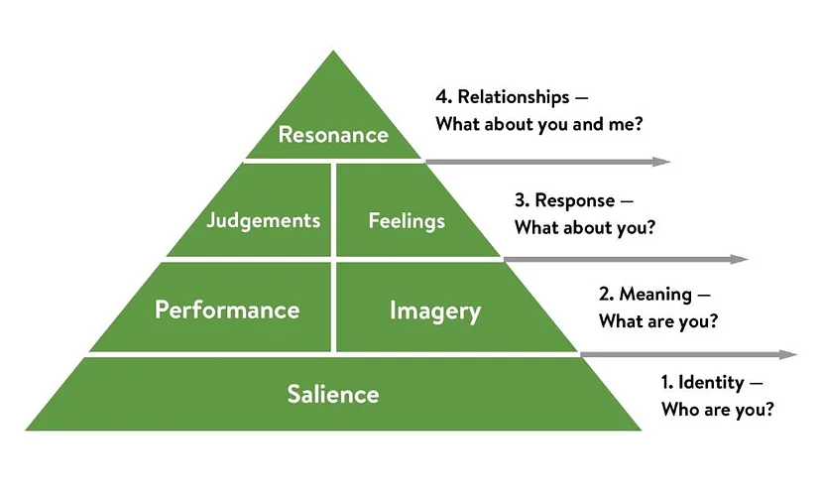
Figure 3: The Keller’s brand equity model
(Source: medium, 2019)
Keller’s Brand equity model is an effective framework that depicts the journey between the customer relationship with the business organisation. This particular model has 6 significant aspects which are salience, performance, imagery, judgements, feelings as well as resonance. All these elements help in understanding the perspective of the customers regarding the brand which further helps in improving operations to accelerate the profit margin and revenue in the long run (Stukalina and Pavlyuk, 2021). It also helps in getting the idea of brand recognition rate in the marketplace and accordingly can improve the techniques to have a competitive advantage in the highly competitive and ever-changing business market.

Keller’s brand equity model application in marketing
In accordance with the standpoint of Zollo et al. (2020), Brand equity can be depicted as the value of a particular business organisation among the customers. Keller’s Brand equity model includes 6 adequate characteristics which help in promoting the brand among potential consumers to increase the volume of sales. This initiative further helps in accelerating the profit margin as well as revenue to build a stable financial statement for the company which assists in sustaining itself as well as developing an effective brand image in the highly competitive Global Business market.
Salience is the first characteristic of the aforementioned brand equity model which helps in providing awareness regarding the particular brand and its products and services to the potential customers to grab their attention (Borirakcharoenkit et al. 2022). A company can attain the attention of the mass audience by including appropriate segmentation. Making an appropriate brand identity in the cluttered business marketplace can be highly beneficial for the brand to sustain itself. appropriate brand identity avails in getting Global recognition which further helps in rising the sales volume by increasing the customer base. Tesco always tries to grab the attention of the potential customers by providing a wide range of products at a reasonable price point because segmenting the audience according to the demographic segmentation, the organization strategies this pricing approach.
Performance and imagery are the next factors of Kellers’ brand equity model which assist in deciding which services and processes are needed to be incorporated into the business to increase the value proposition as well as accelerate the growth. it is necessary for a business organisation to create a meaningful image along with performance in the business market to gain the trust of potential customers (Ebrahim, 2020). Along with the uniqueness and design, it is necessary to have adequate performance of the customer services as well as reliability and transparency in the customer policies to achieve the trust of the buyers which results in loyal customers in the long run. Innovative and creative products along with services can be significantly attractive in this competitive and ever-changing demand market because these days people are more likely to prefer innovative commodities that have significant usefulness in day-to-day life. Tesco has introduced self-service in store where an individual can choose their own products and check-out utilizing various advanced technological gadgets and software.
Judgements and feelings are the most useful assessment factors for brand responses. This provides an adequate Idea regarding the perspective and feelings of the customers regarding the products and services as well as about the brand. It is necessary for a company to evaluate the remarks and reviews of the customers in order to enhance the growth rate by including various operations as well as appropriate marketing strategies. Customers at the most precious assets of any business enterprise so it is crucial to consider their feedback and work accordingly to scale up the business as well as increase the profit margin by enhancing the sales figure. Utilising the feedback mechanism, Tesco gathers the feedback and reviews of the customers and evaluates them appropriately to understand the customer perspectives.
Resonance is the last element of the forenamed framework which depicts the loyalty quotient as well as the engagement rate of the customers with the particular brand (Çınar, 2020). This aspect is totally based on the psychological state of the customers so this initiative is quite difficult. The brand needs to incorporate some emotional attachment such as corporate social responsibilities or nostalgic factors to gain the customer's attention adequately.

Include the advantages and disadvantages of Keller’s Brand Equity model
The main advantage of Keller’s brand equity model is it helps in identifying the measures that are needed to be integrated and implemented by a business organisation in order to create a strong and effective impression on potential customers. It helps in impacting the feeling and perspectives of potential consumers by shaping the approaches of a brand. On the other hand, the main disadvantage of this particular brand equity model is it does not take into account the other stakeholders of the company, especially the suppliers and manufacturers who hold a significant position in shaping the brand.

Discuss the customer journey and customer touchpoints for the organisation
As per the viewpoint of Uvet, (2020), it can be commented that the customer journey map is a vital aspect for every business enterprise because analysing and assessing the customer journey map of a business organisation can significantly comprehend the demands as well as interests of the audience who are potential customers of the company. As per the report of the evaluation the company can significantly integrate essential ideas and procedures to produce those products and services as per the demand to accelerate the growth and profitability by increasing the volume of sales. Providing the customers with appropriate products and services as per their expectations can significantly enhance the satisfaction which will further influence the retention rate as well as the word-of-mouth marketing. This initiative significantly enhances the brand equity and awareness in the competitive market.
Tesco is considered one of the most profound retail organisations in the United Kingdom that provides a wide range of products at an affordable price range so the organisation has a huge amount of customers. The customer journey map includes 3 significant procedures which are pre-purchase, purchase and post-purchase Because there are significant activities take place during all these three stages (Shiratori et al. 2021).
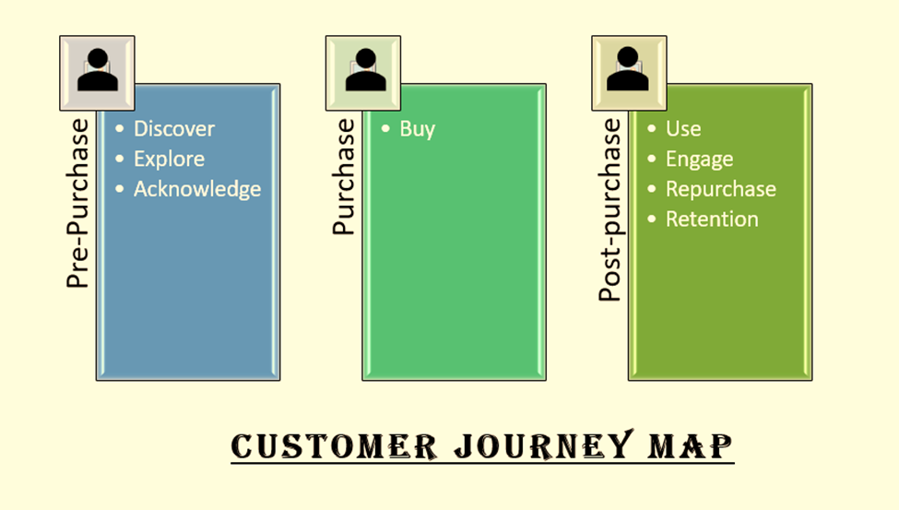
Figure 4: Customer Journey Map
(Source: self-created)
From the opinion of Wang et al. (2019), the touch points can be described as the contact approaches with which a company can communicate with the customers regarding queries as well as issues associated with the problems and services to resolve them adequately. There are various significant touch points that are utilised by Tesco such as social media platforms, websites, magazines, newspapers and so on to reach potential customers.
Strengths and Weaknesses of Customer Journey Map
The advantage of evaluating a customer journey map is it facilitated a company with an in-depth insight into the interest and demand of the potential customers along with the problem at areas that are needed to be rectified by the company to amplify the growth (Alvarez et al. 2020).
The main weakness of the journey map is it takes a huge amount of effort and time to develop a customer journey map because every individual has a different perspective regarding purchasing.
Stages of the customer journey map

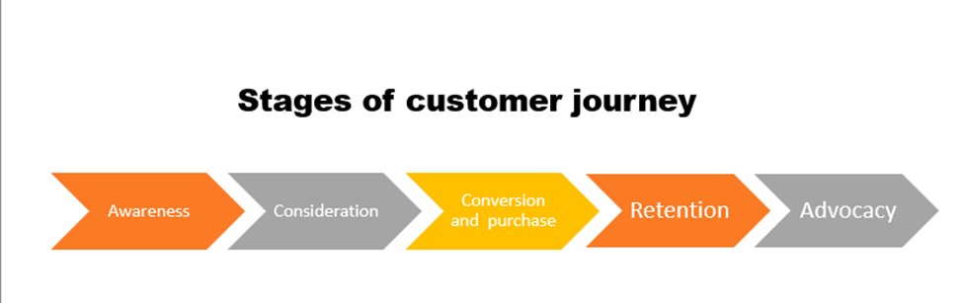
Figure 5: Stages of Customer Journey Map
(Source: self-created)
The customer journey of Tesco Includes 6 effective phases which are “ awareness”, “ consideration”, “ conversion and purchase”, “ retention” as well as “ advocacy”.
In the awareness phase, the individual gets to know about the products and services of the particular organisation along with detailed information regarding the brand (Grewal and Sridhar, 2021). For this particular study, the individual is going to gain an effective amount of knowledge regarding Tesco and its products are services. After this, during the consideration stage, the individual compares the services and products along with the prize points with other business organisations for better deals And services. In the conversion as well as purchase phase, the person decides to purchase products on services from a particular brand, according to the study from Tesco. Afterwards, the customer uses the products and services which leads to retention. after the retention stage, the consumer chooses to recommend other individuals to purchase products or services from Tesco which facilitates the company with a sales increase as well as brand equity.

Explain the Total Engagement Model and how it could be related to Tesco
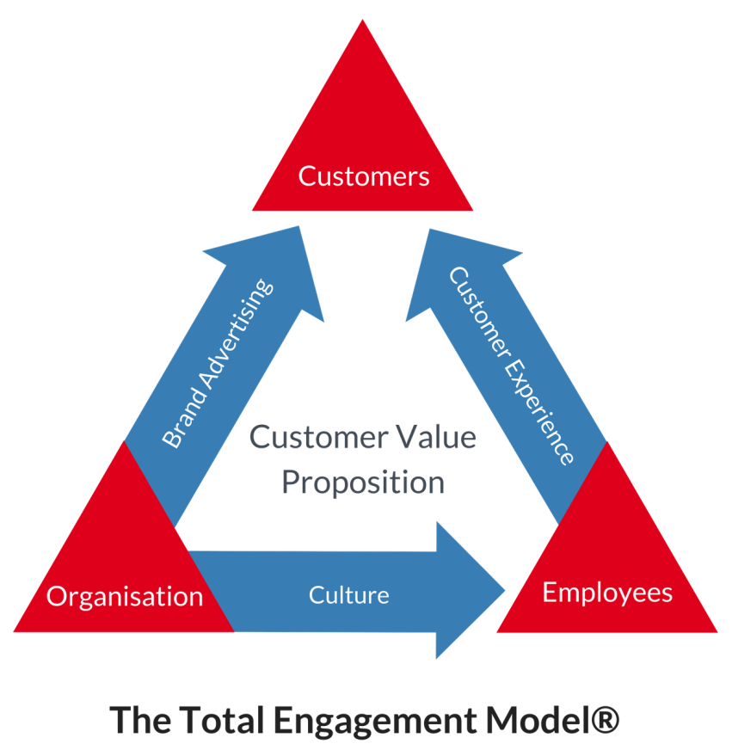
Figure 5: The total engagement model
(Source: engagedstrategy, 2023)
Customer and employee engagement are necessary for a business organisation to increase the profit and revenue margins by accelerating the sales volume to a certain level. The total engagement model frames out all the operations related to engagement among the working professionals, customers and the organisation regarding brand awareness, culture, customer experience as well as a value proposition (Bergel and Brock, 2019).
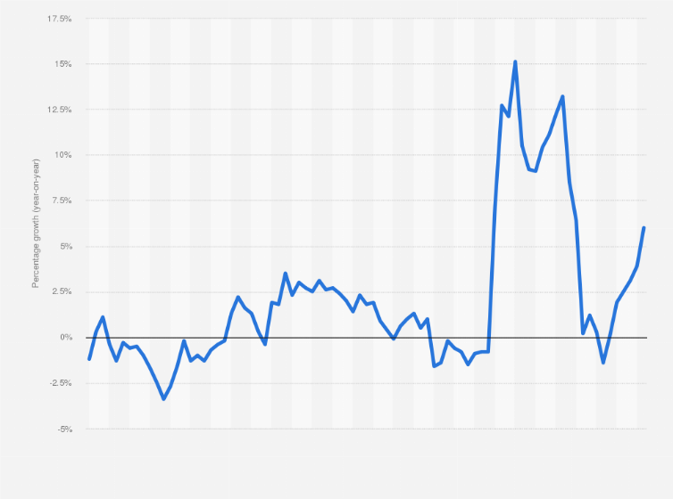
Figure 6: Sales increase of Tesco
(Source: statista, 2023)
The increasing sales of Tesco is depicting the enhancement of customer engagement as well as engagement of the working professionals who have helped in amplifying operational productivity. From the above-mentioned figure, it can be seen that the sales volume of the company is increasing day by day and in 2022, the revenue of the company is 6134.4 crores GBP (tesco.com, 2023).

Recommendations of new touchpoints
Tesco can use other touch points like Billboard as well as adequate social media websites such as Instagram as well as Tik Tok to contact the customers and reserve their matters with appropriate solutions (Akter et al. 2019). Utilising magazines can be beneficial to put forward the discounts and offers to the customers also.

Conclusion
Marketing is one of the most essential operations that are needed to be taken into account by every business organisation in order to scale up the business and get recognition across the globe. Moreover, marketing helps in accelerating the performance of the company by attaining more potential customers to increase the volume of sales. This initiative further influences the profit margin as well as revenue generation amount to a certain extinction in the long run. Appropriate marketing strategy not only helps in attaining customers but also assists in the conversion process of being a buyer to a loyal customer. In the assignment, extensive analysis has been conducted regarding the various marketing approaches and their importance in the context of the profound retail business organisation, Tesco. Communication concepts along with marketing techniques and promotional strategies of Tesco have been evaluated in this study with the help of various effective frameworks.

References
Ai, X., Jiang, Z., Hu, K., Chandrasekaran, S. and Wang, Y., (2020). Integrating a cross-reference list and customer journey map to improve industrial design teaching and learning in “project-oriented design based learning”. Sustainability, 12(11), p.4672.
Akter, S., Hossain, M.I., Lu, S., Aditya, S., Hossain, T.M.T. and Kattiyapornpong, U., (2019). Does service quality perception in omnichannel retailing matter? A systematic review and agenda for future research. Exploring omnichannel retailing: common expectations and diverse realities, pp.71-97.
Alvarez, J., Léger, P.M., Fredette, M., Chen, S.L., Maunier, B. and Senecal, S., (2020). An enriched customer journey map: how to construct and visualize a global portrait of both lived and perceived users’ experiences?. Designs, 4(3), p.29.
Alvarez, J., Léger, P.M., Fredette, M., Chen, S.L., Maunier, B. and Senecal, S., (2020). An enriched customer journey map: how to construct and visualize a global portrait of both lived and perceived users’ experiences?. Designs, 4(3), p.29.
assosia.com, (2023). Tesco supermarket share, Available at: https://www.assosia.com/uk-supermarkets-market-share-2022. [Accessed on: 05.03.2023]
Atapattu, S., Fan, R., Dharmawansa, P., Wang, G., Evans, J. and Tsiftsis, T.A., (2020). Reconfigurable intelligent surface assisted two–way communications: Performance analysis and optimization. IEEE Transactions on Communications, 68(10), pp.6552-6567.
Bergel, M. and Brock, C., (2019). Visitors’ loyalty and price perceptions: The role of customer engagement. The Service Industries Journal, 39(7-8), pp.575-589.
Bernard, G. and Andritsos, P., (2019). Contextual and behavioral customer journey discovery using a genetic approach. In Advances in Databases and Information Systems: 23rd European Conference, ADBIS 2019, Bled, Slovenia, September 8–11, 2019, Proceedings 23 (pp. 251-266). Springer International Publishing.
Borirakcharoenkit, P., Sukhabot, S., Rinthaisong, I. and Soonsan, N., (2022). The effect of brand equity on investor loyalty in online securities trading using the Technology Acceptance Model. Journal of Eastern European and Central Asian Research (JEECAR), 9(2), pp.295-308.
Çınar, K., (2020). Customer Based Brand Equity Models in Hotel Industry: A Literature Review. Strategic Innovative Marketing and Tourism: 8th ICSIMAT, Northern Aegean, Greece, 2019, pp.281-288.
de Vries, M.J., Land-Zandstra, A.M. and Smeets, I., (2019). Citizen scientists’ preferences for communication of scientific output: a literature review. Citizen Science: Theory and Practice, 4(1), p.2.
delighted.com, (2023). [Available at: https://delighted.com/blog/guide-to-customer-journey-mapping]. [Accessed on: 10.03.2023]
Ebrahim, R.S., (2020). The role of trust in understanding the impact of social media marketing on brand equity and brand loyalty. Journal of Relationship Marketing, 19(4), pp.287-308.
Ebrahim, R.S., (2020). The role of trust in understanding the impact of social media marketing on brand equity and brand loyalty. Journal of Relationship Marketing, 19(4), pp.287-308.
Elrod, J.K. and Fortenberry, J.L., (2020). Integrated marketing communications: a strategic priority in health and medicine. BMC Health Services Research, 20(1), pp.1-5.
engagedstrategy.com, (2023). [Available at: https://www.engagedstrategy.com.au/home/total-engagement-model-round/] [Accessed on: 10.03.2023]
Frean, J., (2022). Comprehension across disciplines: A practical framework for reading research. Literacy, 56(4), pp.299-310.
Grewal, R. and Sridhar, S., (2021). Commentary: Toward formalizing social influence structures in business-to-business customer journeys. Journal of Marketing, 85(1), pp.98-102.
hitechnectar.com, (2019). Integrated Marketing Communication Tools, Available at: https://www.hitechnectar.com/wp-content/uploads/2019/06/IMC-COMMUNICATION-TOOLS-7.png. [Accessed on: 05.03.2023]
Karthikeyan, S. and Malathi, S., (2022). Study Of Conflict Resolution Skills Among Aspiring Teachers In The Digital Era. Journal of Positive School Psychology, pp.843-853.
Lehnert, K., Goupil, S. and Brand, P., (2021). Content and the customer: inbound ad strategies gain traction. Journal of Business Strategy, 42(1), pp.3-12.
Ludwiczak, A., (2021). Using customer journey mapping to improve public services: A critical analysis of the literature. Management, 25(2), pp.22-35.
medium.com, (2019). [Available at: https://medium.com/@keatonhawker/kellers-brand-equity-model-what-it-is-how-to-use-it-84e42d562299] [Accessed on: 10.03.2023]
online.purdue.edu, (2023). Integrated marketing communication, Available at: https://online.purdue.edu/blog/communication/what-is-integrated-marketing-communication-imc. [Accessed on: 05.03.2023]
Roma, P. and Aloini, D., (2019). How does brand-related user-generated content differ across social media? Evidence reloaded. Journal of Business Research, 96, pp.322-339.
Romanello, D.L., Freire, O., Quevedo-Silva, F. and Santos, E.B.A., (2020). Brand equity and brand value: proposition and validation of a model. REMark, 19(3), p.496.
Schoneveld, L., Othmani, A. and Abdelkawy, H., (2021). Leveraging recent advances in deep learning for audio-visual emotion recognition. Pattern Recognition Letters, 146, pp.1-7.
Shiratori, E.K.A., Trevisan, A.H. and Mascarenhas, J., (2021). The customer journey in a product-service system business model. Procedia CIRP, 100, pp.313-318.
Shiratori, E.K.A., Trevisan, A.H. and Mascarenhas, J., (2021). The customer journey in a product-service system business model. Procedia CIRP, 100, pp.313-318.
slideplayer.com, (2023). Schramm Model of Communication, Available at: https://slideplayer.com/slide/9483638/29/images/15/Schramm%E2%80%99s+Model+of+Communication.jpg. [Accessed on: 05.03.2023]
statista.com, (2022). Tesco brand awareness in the UK, Available at: https://www.statista.com/forecasts/1304375/tesco-online-grocery-delivery-brand-profile-in-the-united-kingdom. [Accessed on: 02.03.2023]
statista.com, (2023). [Available at: https://www.statista.com/statistics/386598/tesco-sales-percentage-change-great-britain-uk/] [Accessed on: 10.03.2023]
Stukalina, Y. and Pavlyuk, D., (2021). Using customer-based brand equity model in the higher education context: simulating the current university’s brand. Business, Management and Economics Engineering, 19(2), pp.272-288.
tescoplc.com, (2023). Tesco facts, Available at: https://www.tescoplc.com/about/key-facts/. [Accessed on: 05.03.2023]
Uvet, H., (2020). Importance of logistics service quality in customer satisfaction: An empirical study. Operations and Supply Chain Management: An International Journal, 13(1), pp.1-10.
Verhoef, P.C., Broekhuizen, T., Bart, Y., Bhattacharya, A., Dong, J.Q., Fabian, N. and Haenlein, M., (2021). Digital transformation: A multidisciplinary reflection and research agenda. Journal of business research, 122, pp.889-901.
Wang, W., Wei, T., Zhang, Y. and Wang, Y., (2019). A method of intelligent product design cue construction based on customer touchpoint correlation analysis and positive creativity theory. Advances in Mechanical Engineering, 11(1), p.1687814018819347.
Zhang, P., Li, C. and Wang, C., (2020). Viscode: Embedding information in visualization images using encoder-decoder network. IEEE Transactions on Visualization and Computer Graphics, 27(2), pp.326-336.
Zollo, L., Filieri, R., Rialti, R. and Yoon, S., (2020). Unpacking the relationship between social media marketing and brand equity: The mediating role of consumers’ benefits and experience. Journal of Business research, 117, pp.256-267.

