Report: Using Psychological Theories to Support Adults Aged 65+ with Dementia in a Care Home

Introduction
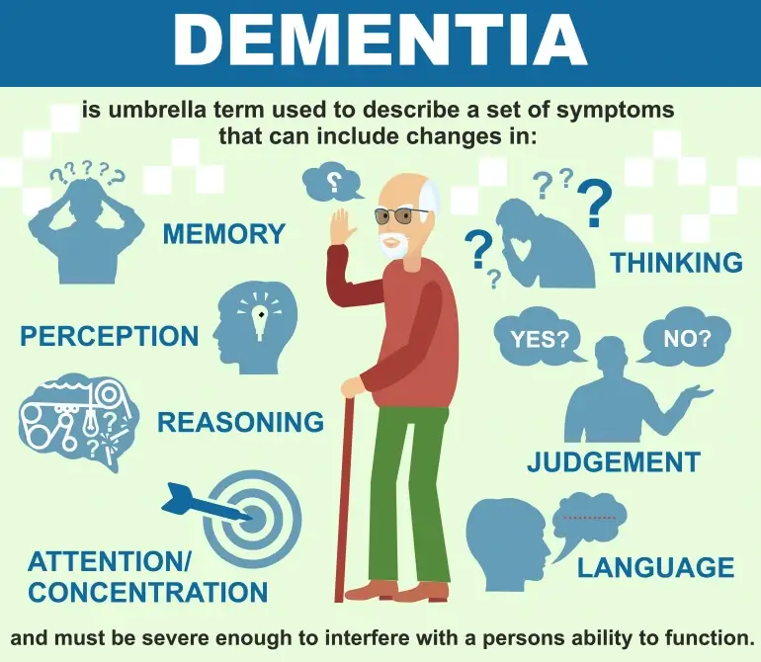

As people grow older, they often experience changes in their physical and mental health. For adults aged 65 and over, one of the most common challenges is dementia, which affects memory, thinking, and behaviour. Many older adults live in dementia care homes where health and social care professionals work every day to support them. Understanding psychological theories can help staff provide better care, improve communication, and create a safer and more supportive environment.

This report explains how psychological theories can be used when working with older adults who have dementia. It focuses on two theories: Erikson’s Psychosocial Theory and Person-Centred Care Theory. The report shows how these theories can be applied in a dementia care home, using practical examples, and also discusses some challenges that staff may face.

1. Context: Dementia Care Homes

Dementia care homes are settings where older adults receive long-term support because they can no longer manage safely at home. Many residents may experience memory loss, confusion, changes in personality, depression, anxiety, or problems with communication.

Staff play an important role in everyday tasks such as helping residents eat, communicate, wash, socialise, or stay safe. Psychological theories are useful because they help staff understand why residents behave in certain ways, especially when they become confused, distressed, or withdrawn. By understanding the psychological needs of older adults, staff can offer care that is more respectful and effective.

2. Detailed Overview of Two Psychological Theories


a) Erikson’s Psychosocial Theory – Stage 8: Integrity vs Despair

Erik Erikson believed that people go through eight stages of psychosocial development throughout their lives. The final stage, called Integrity vs Despair, happens in older age (around 65+). At this point, people look back on their life and think about whether they are satisfied with how they lived. If they feel proud and content, they experience integrity. If they feel regret, guilt, or sadness, they may experience despair.

For older adults with dementia, this stage becomes even more important because they may struggle with memory and identity. Some residents might feel confused about who they are, or they may remember their past but misunderstand the present. This can affect their emotional wellbeing.

Erikson’s theory helps professionals understand that older adults need support to feel valued and respected, even when their abilities change. Small things like listening to their stories, involving them in decisions, or encouraging familiar routines can help them feel more positive and safe.

b) Person-Centred Care Theory (Kitwood, 1997)
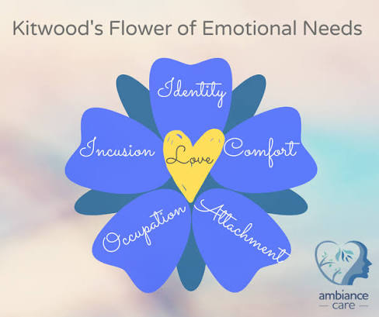

Tom Kitwood developed the Person-Centred Care approach specifically for people with dementia. The theory focuses on the idea that every person has their own personality, history, preferences, and emotional needs. Even when someone has dementia, their identity and dignity should be respected.

Kitwood argued that dementia is not only a biological condition but also influenced by the environment and how people are treated. When staff treat a person kindly, listen to them, and meet their emotional needs, the person is more likely to feel calm and valued. When they feel ignored or rushed, they may become distressed or confused.

Person-centred care encourages professionals to:
- See the person, not just the illness
- Learn about their past and interests
- Communicate in a way they understand
- Provide activities that match their abilities
- Create a safe and comforting environment

This theory is widely used in dementia care homes and helps staff offer support that is respectful and personalised.

3. Application in the Health and Social Care Context
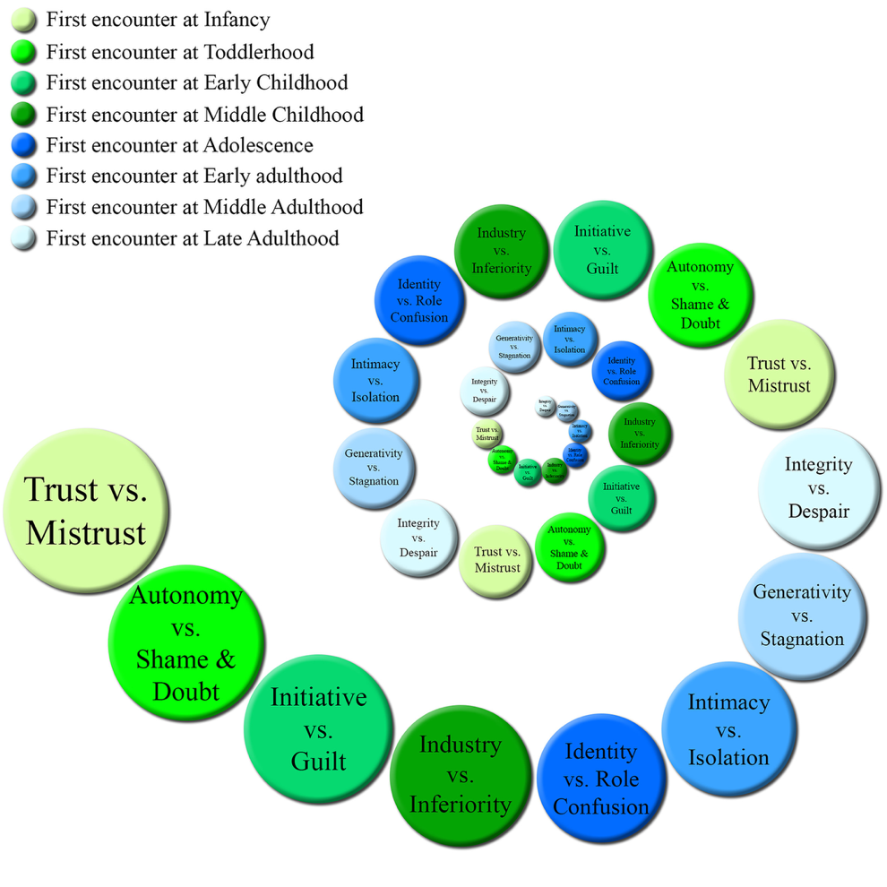

a) Applying Erikson’s Theory in Dementia Care Homes

Erikson’s theory helps staff understand the emotional needs of older adults. Many residents may feel fear or sadness because they have lost independence or because they cannot remember important parts of their lives. Staff can use this theory in several ways:

Practical example 1: Life story work
Staff can create “life story books” with photos, memories, and important events from the resident’s life. These books help residents feel connected to who they are and support them in maintaining a sense of identity.

Practical example 2: Reminiscence therapy
Talking about past memories, old songs, or childhood stories can help residents feel joy and pride. Even if they cannot remember recent events, long-term memories are often stronger.

Practical example 3: Supporting dignity
Simple actions like knocking before entering a room or asking for consent before providing personal care help residents feel respected. This supports the “integrity” part of Erikson’s theory.

Challenges in Applying Erikson’s Theory

Sometimes residents with advanced dementia may not understand conversations about their past or may become distressed when they cannot remember something. Staff may also struggle with time pressures and may not always have enough time to engage in long conversations.

Strategies
- Break activities into short sessions
- Use visual aids like photos or familiar objects
- Keep communication simple and calm
- Provide staff training on dementia-friendly communication

b) Applying Person-Centred Care Theory in Dementia Care Homes

Kitwood’s theory is particularly useful because dementia affects every resident differently. Staff should adapt care plans to each person’s needs.

Practical example 1: Individual care plans
Each resident should have a personal profile including their likes, dislikes, hobbies, fears, and daily routine. For example, if a resident prefers quiet mornings, staff can schedule activities later in the day.

Practical example 2: Communication techniques
Person-centred care encourages using short sentences, eye contact, a calm tone, and non-verbal gestures. Staff should avoid arguing or correcting the resident forcefully, because this can increase anxiety.

Practical example 3: Meaningful activities
Activities should match a resident’s ability. For example:
- Folding towels for someone who used to enjoy housework
- Listening to favourite music
- Light gardening
- Touch therapy or hand massages

These activities help residents feel included and valued.

Challenges in Applying Person-Centred Care
- Heavy workloads may limit the time staff can spend with each resident
- Lack of training in dementia communication
- Different staff may offer inconsistent care
- Relatives may have unrealistic expectations

Strategies
- Regular staff training
- Better staff-to-resident ratios
- Using “key worker” systems so each resident has a main carer
- Encouraging families to share background information

Conclusion

Psychological theories are very helpful in understanding the needs of older adults living with dementia. Erikson’s Psychosocial Theory helps professionals support the emotional wellbeing of residents by respecting their identity and acknowledging their life experiences. Person-Centred Care theory encourages staff to see each resident as an individual with unique preferences and needs.

When these theories are applied in a dementia care home, they can improve communication, reduce distress, and create a more positive environment. Although challenges such as time pressure and lack of training exist, using practical strategies can help staff provide care that is more compassionate and effective.

References
Barker, M. (2022) Understanding Dementia Care, London: Sage.

Brooker, D. (2007) Person-Centred Dementia Care: Making Services Better, London: Jessica Kingsley Publishers.

Erikson, E.H. (1995) Childhood and Society, London: Vintage.

Kitwood, T. (1997) Dementia Reconsidered: The Person Comes First, Buckingham: Open University Press.

Woods, B. and Clare, L. (2015) ‘Psychological therapies in dementia care’, British Journal of Psychiatry, 207(4), pp. 1–6.

Yektatalab, S. et al. (2018) ‘Effect of reminiscence therapy on older adults with dementia’, Journal of Gerontological Nursing, 44(3), pp. 23–31.

