Kate peters library & community hwb

feasibility study 2023-2024

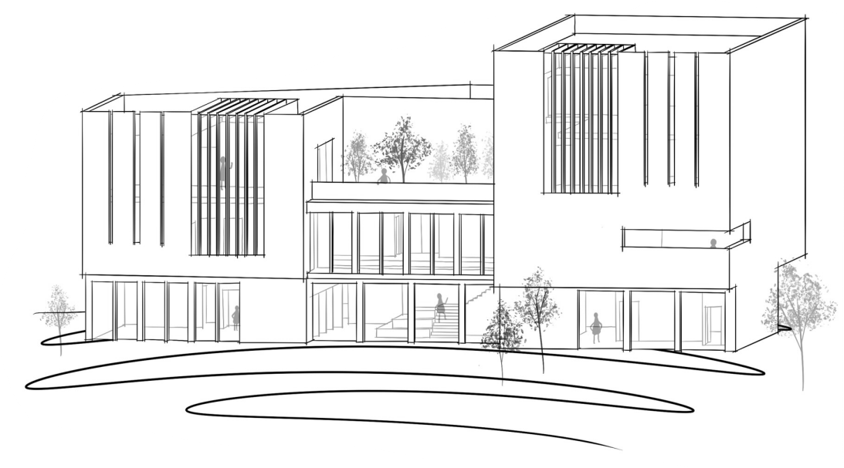
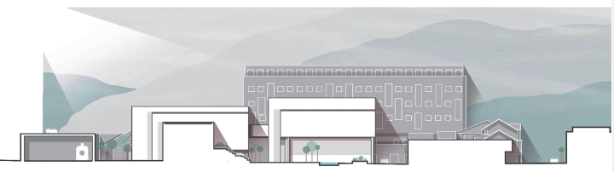

Contents
5.4 HIGHWAYS IMPLICATIONS OF DEVELOPMENT 3
5.6 USES OF SURROUNDING DEVELOPMENT 3
5.7 CONSTRAINTS ON SIZE/HEIGHT & RIGHTS OF WAY COVENANTS 4
5.10 CONTRACTORS SITE COMPOUND AND ACCESS 4
5.11 PARTY WALL ACT 4
6 ACCOMODATION REQUIREMENTS 4
6.3 SERVICE REQUIREMENTS – ABNORMAL LOADINGS IT SUITES D&t MACHINARY 5
6.4 EXTERNAL WORKS 5
6.5 EQUIPMENT FIXED/LOOSE FURNITURE 6
6.6 FURNISHINGS 6
6.7 CUSTOMER SUPPLIED EQUIPMENT 6
6.11 FLEXIBILITY OF USE 6
8. ESTIMATES 7
8.1 CAPITAL COSTS 7
8.2 WORKS TO BE UNDERTAKEN BY CONTRACTOR 9
8.3 MAINTENANCE COSTS 9
8.4 WHOLE LIFE COSTS 9
8.5 FEES 10
8.6 VAT EXCLUDED 10
8.7 NOTES AND EXCLUSIONS 10

5.4 HIGHWAYS IMPLICATIONS OF DEVELOPMENT

LUKAS MOLNAR RIIS
The site will be able to utilise existing roads surrounding the site with the possibility of a one-way road system around site at earlier stages, but throughout all stages of the project there should be a way of getting around site. As the current site is an existing carpark(s) there is a good access point on the current roundabout coming from a highway, with no low bridges HGV’s will be able to gain entry into site, the site however should use specific hours where HGV’s and deliveries can be made as residents will not want loud noise from large vehicles very early in the day or in the late afternoon. Another site entrance could be introduced at the southern side of the site closer to main roads. There is a through road which is used for access for the church located at the Northern side of the site. This needs to be maintained so a one road system could be introduced here using traffic management, I would also suggest widening the road to allow another point of access to the site and the possibility of a lay down area for materials on this tight space site.
Site parking should not be a problem when the first phase is being built (South stage) as the site is currently a car park so this can be used in phases and moved around with the site set up if needed. But once the project moves into the second stage (Northern stage) the site parking will have to be moved off site as there will be little room for a parking area other than on built roads along the kerb line. Site parking offsite will have cost implications primarily paying for parking or organising with local bodies, and secondarily access to site is not as easy. This will affect programme as more time is spent getting on to site and in turn affect costs.

5.6 USES OF SURROUNDING DEVELOPMENT

LUKAS MOLNAR RIIS
Surrounding areas are taken up by primarily a retail area, with clothing, food and other types of shops. It is a town centre so primarily a retail, as we move further out from the site there are petrol stations, theatres, bus and train stations and merchants’ dealers. There is a main road running adjacent to the site which goes through the town centre and over a fly over towards Port Talbot bus station. Above shops are possibly apartments so a slightly residential area. North of the site is the current Port Talbot library. The street over from the row of shops is a job centre and some banks. All this being said there should be no cost implications.

5.7 CONSTRAINTS ON SIZE/HEIGHT & RIGHTS OF WAY COVENANTS

LUKAS MOLNAR RIIS
N/A. No low-lying bridges to block access into site. The through road on the left-hand side of the site needs to be worked, this will have to be approved by the local council prior to works commencing and any changes being made.

5.10 CONTRACTORS SITE COMPOUND AND ACCESS

LUKAS MOLNAR RIIS
The project should be worked in phases with the site compound and site parking located in one area of the site whilst the other side is being worked. Once there is no room for a cabin set up for a site compound, built buildings with no internal finishes should be used as a site compound for site office, canteen and toilets. Toilets and a washroom could still be possibly used in cabins outside of constructed areas.

5.11 PARTY WALL ACT

LUKAS MOLNAR RIIS
Other than slight alterations to roads which currently connect public roads to the existing car park there will be no affect on surrounding areas ground level infrastructure. Higher buildings than the existing row of shops will have an effect on the aesthetics of the area but will not affect in a negative way. The addition of the library in this area could increase the amount of traffic and possibly foot traffic in the area. If anything the affect on the surrounding properties will be positive as there is more chance of library users to use surrounding shops as they are closer to them after or before using the libraries services.
In relation to the party wall act. Other than works on the development for this project and some alterations to roads on the left hand side, there should be no problems here in terms of affecting existing walls and structures.

6 ACCOMODATION REQUIREMENTS
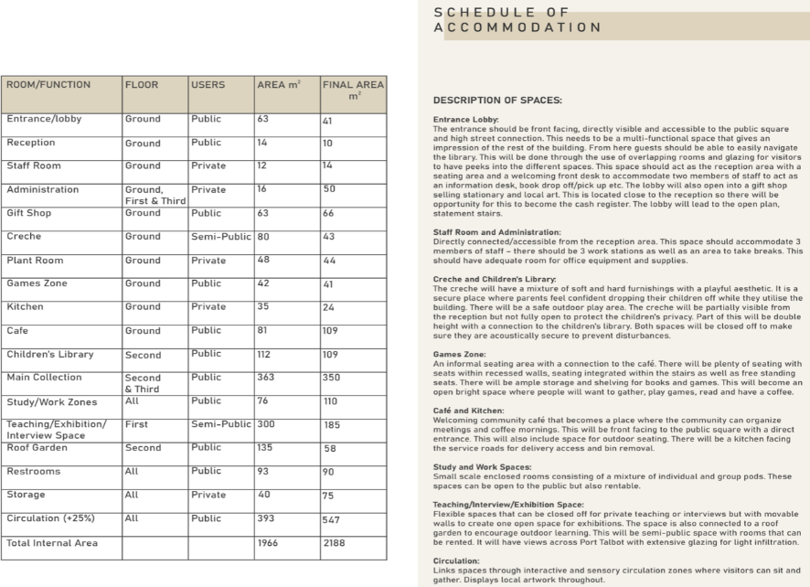

6.3 SERVICE REQUIREMENTS – ABNORMAL LOADINGS IT SUITES D&t MACHINARY

LUKAS MOLNAR RIIS
There will be significant IT requirements for IT suites within the library for computers and numerous printers. Internal lighting will be a big factor also as the building is larger in size so this will have to accommodate this.
Following consultation with the mechanical and electrical teams, we can see the requirements needed for a building with the purpose the library has will be above average and a lot of electricity and heating specifically will be needed. To make the building more energy efficient the correct insulation method needs to be used, this could have an increased cost implication but there are options there to mitigate this. The building needs to be as airtight as possible, again there are options to mitigate this having a big impact on costs which is worst case scenario, but again modern methods can help to mitigate this where possible.

6.4 EXTERNAL WORKS

LUKAS MOLNAR RIIS
The externals will have to include lighting columns for dark hours. Footpaths with hard landscape products either paving or tarmac or another hard surface. To meet BREEAM requirements a certain number of species of planting and grassing will have to be included. And as well as requirements for the aesthetics of the development, it will need aspects of soft landscaping such as grass, trees and shrub planting to bring the surrounding areas together. Arboriculture reports will have to be compiled in early stages of the project. Soils brought in for soft landscape areas will need to be tested to make sure the pH and chemical make up is suitable for the area and planting schedule, which in turn should suit the acceptable plants for conditions in Port Talbot. The external works are to UK norms so there is nothing major that can affect the cost too much in comparison to similar projects, this is not an outstanding area of the works. However to aid in the logistics of the overall site certain areas should be included in the library package to allow a phased handover for the southern side of the site. This will allow use of buildings whiles the Northern side of the site is being constructed.

6.5 EQUIPMENT FIXED/LOOSE FURNITURE

LUKAS MOLNAR RIIS
The library will need technology such as PC’s, laptops, mice and printers. Desks, chairs and tables will be required for users of the library. We will also need bookstands and books purchased. Varying designs of furniture will be required for different types of areas. Some areas will be for studying and reading, some will be more so for relaxing. This is standard for a library so poses no problems in terms of making the project feasible to carry out or not.

6.6 FURNISHINGS

LUKAS MOLNAR RIIS
As above.

6.7 CUSTOMER SUPPLIED EQUIPMENT

LUKAS MOLNAR RIIS
N/A – Possibility of books to be supplied from original Port Talbot library, this will be raised with the council.

6.11 FLEXIBILITY OF USE

LUKAS MOLNAR RIIS
The library hub will be used for studying and carrying out work on computers and writing using the desk spaces. There will be areas which are more relaxed as well as areas which are quieter, quiet rooms can be introduced to combat this so the quiet and louder areas don’t affect each other. Introduction of soundproof rooms will affect cost to accommodate everyone who needs to use the library at all times. This is because certain materials and soundproofing of room edges etc. will add to cost and are usually high in price to ensure the quality is there to guarantee they will carry out their purpose.
Other uses of the library will be for people to socialise and catch up in a nice environment. As well as working on work like essays, people can use the library for arts and creativity, the library will need funding for resources for this if it wants to be promoted in this way. The public can use the library to eat in between anything they are doing. Again this will need different types of areas that are more social and relaxed.
Concern – Logistics on site are tight so the use of a crane could be beneficial for site progress but will have primary costs to install and hire for a duration of time. Looking at having a crane on site for minimum amount of time will reduce the costs needed. Worst case scenario the crane needs to be present on site at all times for the project an additional £200,00.00 will need to allowed for, for just the crane hire alone.

8. ESTIMATES

8.1 CAPITAL COSTS

LUKAS MOLNAR RIIS
The land and building have already been purchased by the investor so are exclusive of this estimate. There are no demolitions as there are no existing buildings to take down but there will be some breaking out of existing tarmac that is currently on the ground in the car park.

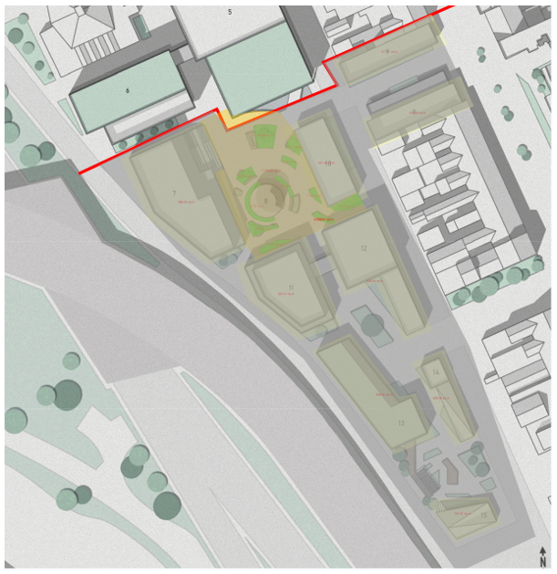
Above shows the area in grey that will need tarmac broken out. Breaking out of the tarmac will come at a rate of £22.38/m2 for 8597m2, so £192,400.86, rounded up to £200k.
The access road for the church and the rear of some shops will need to be altered to maintain access to the church and create a temporary access for site, with worst case scenario a lay down area, an allowance of £50,000.00 needs to be made for this.
Our construction manager has made a point that the best course of action for the whole project would be to half the works into two stages. For this to happen as the library is to be built first we would have to carry out the foundations for all the buildings in our stage of the works. The measure with the library area taken out as this is included below is 3286.12m2 and at a rate (From Spon’s adjusted for our project’s time and location) of £427.15/m2, this means the foundations which will be piling would cost £,436,527.35. This will be rounded to £1.5 million.

8.2 WORKS TO BE UNDERTAKEN BY CONTRACTOR

LUKAS MOLNAR RIIS
Using Spon’s pricing book’s £/m2 and current location and timing of the project factors, an estimate for the building has been calculated as below;
Building cost including preliminaries and a 10% contingency allowance: £9.7 million
- Furniture: £49k
- Hard and soft landscaping: £98k
- External lighting: £30k
- Allowance for use of crane: £200k
- Building cost estimate of £10,077,00.00
- Design risk allowance at 5% £503,850.00
- Overall building cost estimate of £10,580,850.00
Say £10.6 million. This allows for a worst-case scenario so a saving could be achieved if the construction of the project is successfully run.
We recommend that the surround external landscape areas are included in this section of works to allow access to users following completion of the first phase of the overall project.

8.3 MAINTENANCE COSTS

LUKAS MOLNAR RIIS
Maintenance costs estimated at 1% of the project value per year so £106,000.00.

8.4 WHOLE LIFE COSTS

LUKAS MOLNAR RIIS
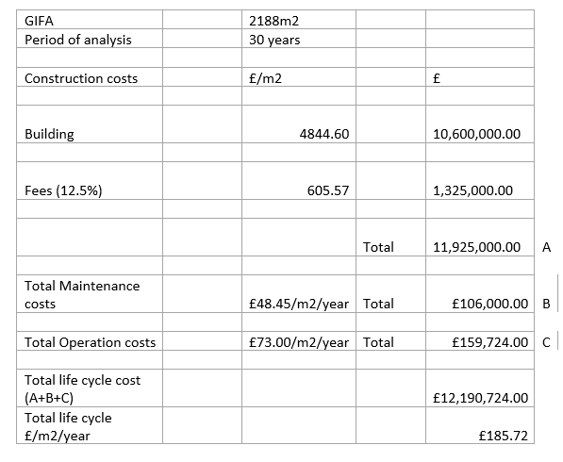

8.5 FEES

LUKAS MOLNAR RIIS
QS, Architect anyone working for the client
RICS Standard fees are estimated at 12.5% for construction costs which are £10,600,000.00 so the 12.5% fees would be £1,325,000.00

8.6 VAT EXCLUDED

LUKAS MOLNAR RIIS
Subtotal exclusive of VAT £12,031,000.00 add £1,750,000.00 capital costs. So a total of £13,781,000.00.
This will be rounded up to £13.8 million exclusive of VAT.

8.7 NOTES AND EXCLUSIONS

LUKAS MOLNAR RIIS
estimates are approximate only; base date; site conditions; planning/ building regulation fees; specialist site investigation costs; exclusion of loose furniture, equipment/computers
Estimates are based on Spon’s altered figures for the project’s location and programme dates. Any prices not available from Spon’s pricing books are estimates based on industry standards.

Existing site is currently used as a car park with some good access points especially with an existing road alteration. Site investigations for contaminated ground etc. are not included. Loose furniture and IT equipment has been included in the cost estimate as this is a key part of this building.
We have had a flood report carried out, pending the results of this the worst case scenario is that buildings are to be lifted. As we do not yet know if this is needed this is not included in the cost estimate.
Where there are higher or lower rates used to arrive at the cost estimate in most parts we have opted with the higher rate, this is due to the sustainability requirements of the project, with making areas as airtight or options for higher quality insulation etc. this is because the materials used and these construction methods usually come at a higher price.
All calculations are available upon request if in some case this is needed.
Recommendations
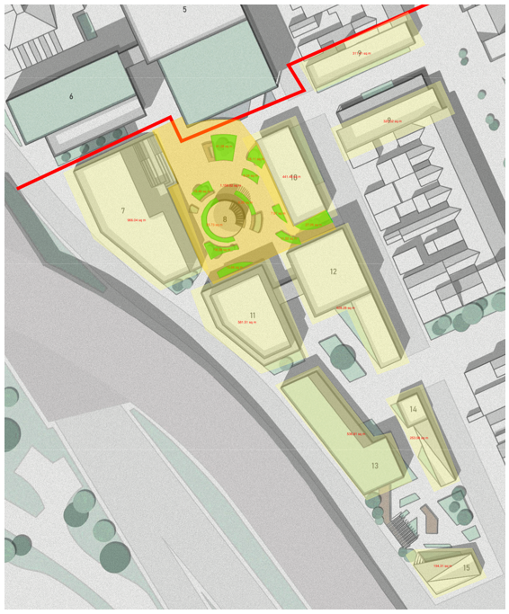

Just for reference to cost estimates, the above screenshot shows the split between Phase 1 and Phase 2, foundation measures, and the landscaping area in the courtyard that has been priced, both soft and hard. This way if the 2 phases method is used for the overall scheme access to the library can be allowed following first handover.

