Managing People
Module code: LCBB5004
Assessment 1
Student name: Lucian Mirica
Student ID: 2013041
Lecturer: Tanja Nathan

Table of Contents
Introduction 1
A Case in favour of Flexible working in relation to diversity and inclusion in the workplace 1
What is Flexible working condition 1
The promotion of diversity and inclusion in a workplace 3
How Flexible working can promote diversity and inclusion in a workplace 3
How Human resources can promote diversity and inclusion through flexible working 4
A Case against Flexible working concerning inequality at work 5
What are the pitfalls of flexible working 5
How flexible working can increase the inequality in the workplace 7
How Human resources can address the concerns related to inequality due to flexible working 8
Conclusion 9
References 10

Table of Figures
Figure 1: Flexible working practices in the UK 2
Figure 2: Employee diversity at Lush cosmetics 4
Figure 3: Employee response to flexible and remote working conditions 6
Figure 4: Employer perspective of flexible work settings 7
Figure 5: Flexible working condition initiators 8

Introduction
This report is focused on the flexible working conditions in various organisations that have become very popular these days. Flexible working condition refers to altering or modifying the time, place or contents of work according to the needs of employers, employees or the organisation in general (Joyce, 2020). This has become an even more common phenomenon since the COVID-19 pandemic required social distancing and ensuring minimum physical contact. There are opinions both in support of and against such flexible working systems, which will be analysed in this study. How flexible working can promote diversity and inclusion in a workplace will be explained in a case and the role of human resources will also be described. On the other hand, a case on how flexible working might create inequality in the workplace as well as the role of human resources in handling such possible issues will be identified and explained. For a more realistic perspective, several examples of Lush cosmetics, a British cosmetics retailer will be used (Bom, 2019).

A Case in favour of Flexible working in relation to diversity and inclusion in the workplace

What is a Flexible working condition
A flexible working system can be considered a contemporary approach where employees are offered a schedule-based work arrangement with higher chances of freedom. There are many kinds of flexible working systems in an organisation, some refer to flexible timing of work, and some refer to the flexibility in work responsibility or even the freedom to choose the place of work according to the needs of the employers or employees (Elbing, Gadon and Gordon, 2020). This flexible working system has become a great support for organisations during the pandemic because now the employees can fulfil their duties without needing to be present physically at the workplace. The concept of remote working and work-from-home are gaining more popularity and the organisations are also trying their best to ensure the appropriate implementation of these systems (Forbes, 2020).

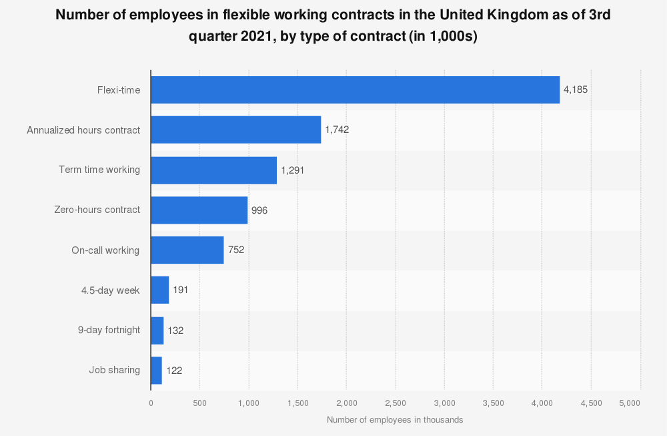
Figure 1: Flexible working practices in the UK
Source: (Staista, 2022).
The figure given above shows how many people have started adopting a flexible working system in the UK as well as the various kinds of flexible working systems. The most popular form is flexi-time, which is the flexibility of job hours for the employees. Many organisations are using such work processes these days and Lush cosmetics is also one of those.
The flexible working system has aided the companies greatly in being able to maintain their workflow without needing their employees to risk their health and being present at the workplace. It has also widened the talent pool as global recruitment has become easier for organisations to practice. The global business has also been able to be kept afloat due to such remote working opportunities. This is something that many companies had been practising for a long time even before the pandemic in limited quantity. The outsourcing of talent increased innovation, and lower costs required for employee management are some of the reasons that the companies are adopting such practices (Xiang, 2021). Now most companies, including Lush cosmetics are making sure they have a necessary device to support an online working system, a specific line of authority to handle overseas workers and balancing the quantity of flexibility with employee accountability to their work.

The promotion of diversity and inclusion in a workplace
Diversity and inclusion are practised in companies for both better brand image and increase favourability as an employer. Lush cosmetics practices diversity and inclusion in the company by taking various kinds of steps and measures (Roberson, 2021). Lush cosmetics has a Belonging, Inclusion and Diversity (BID) Advisory Board through which it promotes honest and open dialogues among the staff of various levels. There are product training and innovation opportunities for employees to be more aware of the need for diversity and inclusion as well. There are also anti-racism training campaigns that focus on teaching employees about what entails systematic racism and how to identify subtle signs of racism. They are also taught ways to practice cultural empathy, compassion and communication to be better allies and accomplices in the fight for anti-racism. There are also strong anti-racism and anti-discrimination policies in Lush cosmetics that ensures taking proper actions against any employee displaying such behaviours (McColl, Ritch and Hamilton, 2021). Lush believes that such practices can only be successful if it is carried out as a core part of company culture, not a process or campaign. The company also has digital cultural hubs for employees to join in and feel included in every aspect. These are some of the ways through which an organisation ensures the practice of inclusion and diversity in a workplace.

How Flexible working can promote diversity and inclusion in a workplace
Flexible working has made the practice of diversity and inclusion in a work much easier. It is because of such work settings that employees can now be more aware of the practices related to diversity and inclusion through mandatory orientation programs on these aspects. Lush cosmetics has been practising remote working, flexitime and other kinds of flexible working practices a lot, and it is also reflected in the way the employee charts show how there is a great variety of employees working for the company.
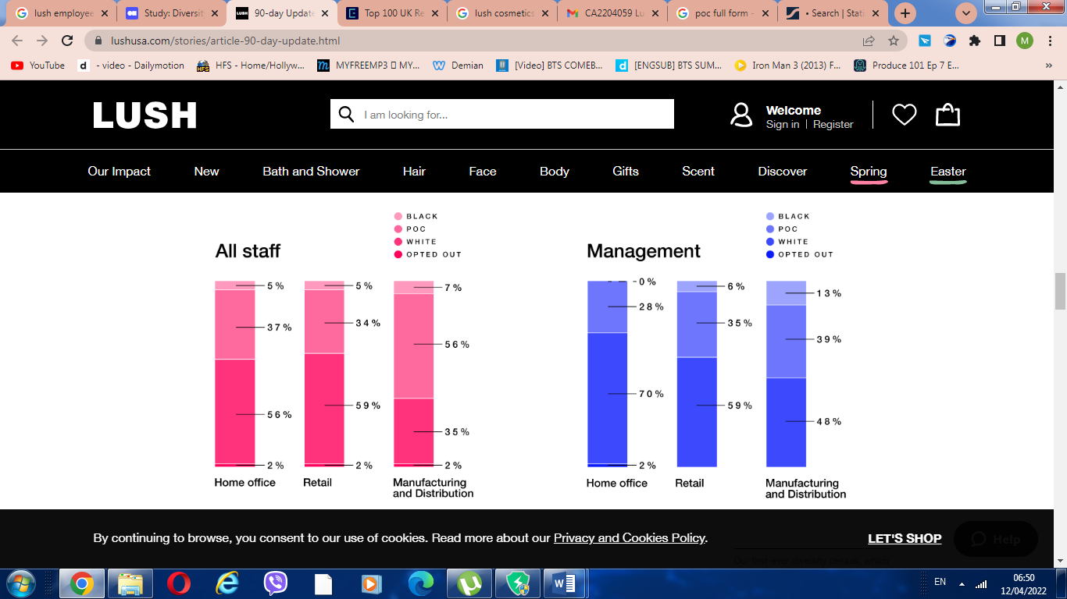
Figure 2: Employee diversity at Lush cosmetics
Source: (Gill-Simmen, 2021).
As the company no longer need employees to be physically present for their work the whole time, they can select global talent with a wide diversity of employees from all over the world. So more and more diversity has been attained in both management positions and the rest of the positions. It has also created more ways for ensuring a balance between male and female staff as previously many female employees failed to conduct their work properly due to long working hours, unfavourable departure times and work-life balance issues, but now many females can work from home or can adjust the timetable according to their needs; thus creating more scope for inclusion.

How Human resources can promote diversity and inclusion through flexible working
Human resource is a very important part of any organisation and it can be utilised to promote diversity and inclusion in a workplace through the use of flexible working in many ways (Kew, 2016). Some of how it can do so are given below:
Global recruitment and selection opportunities
The flexible work system has made it possible for companies to be able to attract, select and retain talent from all over the world. As the work hours can be adjusted, the companies can now employ people from any side of the world as long as they have to work online and don't need to be present physically at the workplace. This has led to more variety of people applying for a job and getting selected instead of choosing from only one home country and one nationality. The recruitment and selection committees now make sure that people from different backgrounds are being given chance for employment in the organisation (Lewis, 2020).
More flexible and worldwide career and succession planning
Career and succession planning is another human resource function that can help in promoting diversity and inclusion in the workplace through utilising flexible working. The top-level executives now plan the succession in a way that will make sure that people from various backgrounds are being considered for future leadership roles. It can include the opportunity through expatriation in future or even through the online remote working of the employee (Torrington, 2016). As there is flexible timing, the programs offered for career planning and development are also designed in a way that will be mostly online and employees can choose to go through those anytime they want.
Increased employee engagement and creativity
Employee engagement and communication have also increased because of the flexible working practices. People do not need to keep sitting at a desk at work and think of ideas now; they can stay at home and explore various innovative options while doing their regular chores. As people from various backgrounds can now work together due to this online setting, the people can be more free and relaxed regarding generating ideas.

A Case against Flexible working concerning inequality at work

What are the pitfalls of flexible working
Flexible working is considered one of the main reasons for survival for many businesses all over the world. Even though this is deemed as a very positive change in workplaces, there are also many issues related to this work process. The flexible working system also causes many kinds of problems for the employees, employers and the organisations in general. When asked about the perspective related to flexible working at Lush cosmetics, the employees have a highly diverse response range.
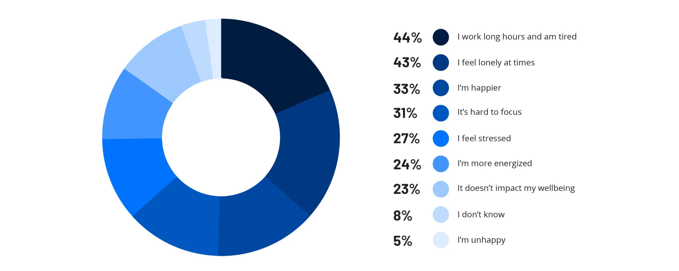
Figure 3: Employee response to flexible and remote working conditions
Source: (Janssen and Nachreiner, 2019).
As the figure given above shows, a huge portion of employees feels tired because of flexible working as they feel like they are working even longer hours and fail to divide their time between personal and professional use. It also makes employees feel lonely as they cannot be with their co-workers and have to do all the work from home online. Some employees are happy but a lot also find it hard to focus in the environment of their home instead of the workplace and it also makes them procrastinate more. And this is not only difficult for the employees but the employers as well. The employers have pointed out several issues they have to face due to working in a flexible setting and which impacts their employee management a lot.

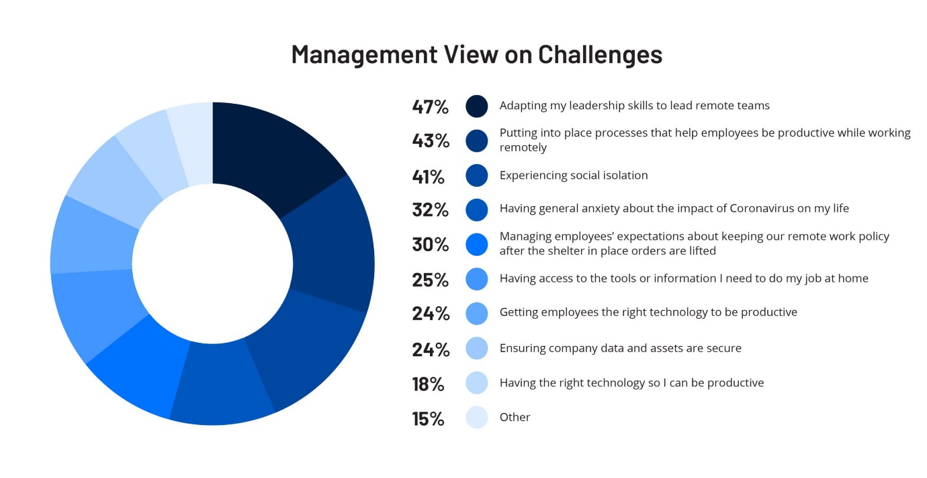
Figure 4: Employer perspective of flexible work settings
Source: (Brewster, Mayne and Tregaskis, 2020).
The figure shows various issues that employers and management face due to employing and handling flexible workers. The workers are more difficult to lead and the companies struggle with providing employees with the necessary tools and devices to carry out their work from home. It also causes social isolation and it is also difficult to protect the company data as many things are often transferred online with not much security.

How flexible working can increase the inequality at the workplace
Most organisations these days strive to attain equality among employers, whether it is based on gender, age or race. The employees are required to be given fair and equal chances regardless of this background information. This not only has a direct role in employee performance and productivity, but it also helps organisations in practising fair working policies and become better employers. Even though flexible working is considered a phenomenon that is helping organisations in becoming global, retaining diverse talent and being more creative; it is also paving way for more inequality in the workplace. For example, it has been noted that the employees attending the workplace physically are being paid more while the ones working from home are suffering from salary cuts. But in many cases, the employees are not the ones choosing to work from home, it is rather assigned by the company itself (Chung and Van der Lippe, 2020).
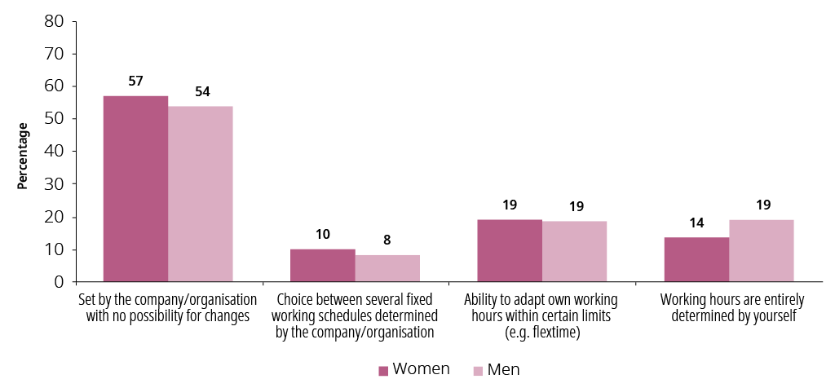
Figure 5: Flexible working condition initiators
Source: (Radcliffe and Cassell, 2021).
The females often greatly suffer because of this, as they have more need to work from home to handle their duties towards their families as well. Also, the retention of global talent through a flexible working system can be another issue because as flexible work is increasing, foreign employees are finding it harder to physically fly or travel to the office due to risks and regulations. But as a result, they are being paid much less than the local employees. Such issues are resulting in inequality in the workplace because of the flexible working system.

How Human resources can address the concerns related to inequality due to flexible working
Human resources can highly help in handling the identified issues at a workplace through taking appropriate measures and various functions. Some of those will be provided below:
Implementing a fair performance appraisal system
One of the main things that an organisation can do in this regard is to design and implement a fair performance appraisal system for employees that will assess them equally regardless of their backgrounds. There should be separate appraisal systems for the physical and remote workers, as well as the hybrid and flexible ones. Gender or ethnicity should not be considered here, but the fact that how much they can fulfil their goals and how their performance is based on their job responsibilities and targets.

Ensuring equality in recruitment practices
Equality should be considered as one of the core values of the company that will be closely embedded in the company culture, not just an idea to maintain. The employees and employers need to be aware of the possible inequality and work to eliminate that. When employers are required to be fair and just during the recruitment process itself, there should be more equality in the workplace. The candidates should be selected based on their talent and the nature of work, not their nationality or gender.
Practising equality in employee rewards and compensation
Rewards and benefits are very important for employee motivation in human resources (Armstrong and Taylor, 2020). When rewarding or compensating the employees, the employers need to practice equality by offering the same incentives for people in the same position. Just because a worker is attending physically, it doesn't testify to their efficiency that depends on the fulfilment of targets and the result of various other appraisal methods. The compensation policies should also include specific criteria with no regard to the cultural or demographic background of an employee. The company must ensure that ethnic minorities of women are not falling victim due to unequal reward or compensation policies.

Conclusion
This study has presented both cases in favour of and against the flexible working system in organisations with the help of relevant examples of Lush cosmetics. It can be concluded that flexible working helps greatly in the case of diversity and inclusion in various organisations and the human resource plays a great role in promoting that through conducting various functions appropriately. On the other hand, there are also chances that flexible working might lead up to inequality in a workplace, but that can also be handled using various human resource measures so that the employees can be treated fairly and equally. The study shows how flexible working conditions have changed the way of business in drastic ways and must be handled appropriately to ensure that it is being utilised properly and the risks of it harming the company or its employees are being minimised.

References
Armstrong, M. and Taylor, S. (2020). Armstrong’s handbook of human resource management practice. 15 th Ed. Kogan Page Publishers.
Bom, S., Jorge, J., Ribeiro, H.M. and Marto, J. (2019). A step forward on sustainability in the cosmetics industry: A review. Journal of Cleaner Production, 225, pp.270-290.
Brewster, C., Mayne, L. and Tregaskis, O. (2020). Flexible working in Europe. Journal of World Business, 32(2), pp.133-151.
Chung, H. and Van der Lippe, T. (2020). Flexible working, work–life balance, and gender equality: Introduction. Social Indicators Research, 151(2), pp.365-381.
Elbing, A.O., Gadon, H. and Gordon, J.R. (2020). Flexible working hours: It's about time. Harvard Business Review, 52(1).
Forbes, S., Birkett, H., Evans, L., Chung, H. and Whiteman, J. (2020). Managing employees during the COVID-19 pandemic: Flexible working and the future of work.
Gill-Simmen, L., MacInnis, D.J., Eisingerich, A.B. and Whan Park, C. (2021). Brand-self connections and brand prominence as drivers of employee brand attachment. AMS review, 8(3), pp.128-146.
Janssen, D. and Nachreiner, F. (2019). Health and psychosocial effects of flexible working hours. Revista de saude publica, 38, pp.11-18.
Joyce, K., Pabayo, R., Critchley, J.A. and Bambra, C. (2020). Flexible working conditions and their effects on employee health and wellbeing. Cochrane database of systematic reviews, (2).
Kew, J. and Stredwick, J. (2016). Human Resource Management in a Business Context. 3 rd Ed, CIPD.
Lewis, S. (2020). Flexible working arrangements: Implementation, outcomes, and management. International review of industrial and organizational psychology, 18, pp.1-28.
McColl, J., Ritch, E.L. and Hamilton, J. (2021). Brand purpose and ‘woke’branding campaigns. In New Perspectives on Critical Marketing and Consumer Society. Emerald Publishing Limited.
Radcliffe, L.S. and Cassell, C. (2021). Flexible working, work–family conflict, and maternal gatekeeping: The daily experiences of dual‐earner couples. Journal of Occupational and Organizational Psychology, 88(4), pp.835-855.
Roberson, Q.M. (2021). Disentangling the meanings of diversity and inclusion in organizations. Group & Organization Management, 31(2), pp.212-236.
Statista. (2022). Flexible working in the UK 2021, by type | Statista. [online] Available at: <https://www.statista.com/statistics/415888/number-of-employees-flexible-working-contracts-uk-by-type/> [Accessed 14 April 2022].
Torrington, D., Hall, L., Atkinson, C. and Taylor, S. (2016). Human Resource Management. 10 th Ed, Pearson.
Xiang, N., Whitehouse, G., Tomaszewski, W. and Martin, B. (2021). The benefits and penalties of formal and informal flexible working-time arrangements. The International Journal of Human Resource Management, pp.1-22.

