Surveying

Module Code – M4X013417

Student – Ellis Jones (1708692)

Assignment 1 – Levelling at the University of Wales SA1 Campus

Contents

Introduction/Scenario

Task 1

Equipment used and Procedures

Sketch and 1st Diagram of Area Measured

Field Book 1 (Line of Collimation Method)

Factors that could affect the accuracy of a levelling exercise

Task 2

Field Book 2 (Fly Level)

Sketch and 2nd Diagram of Area Measured

Bibliography

Introduction/Scenario

The SA1 Swansea Waterfront development is the new home for Yr Athrofa, the Institute of Education, the Faculty of Architecture, Computing and Engineering, the Construction Wales Innovation Centre, as well as housing a new library.

Plans by the University of Wales Trinity Saint David to create a vibrant student and staff Gymnastics Centre closer to the new library building come 2020. You have been appointed by UWTSD to carry out a basic levelling on the proposed site so as to find the difference in elevation and calculate the reduced levels of various points on the proposed site using the Collimation method and rise and fall method.

The proposed site can be seen in the photograph below

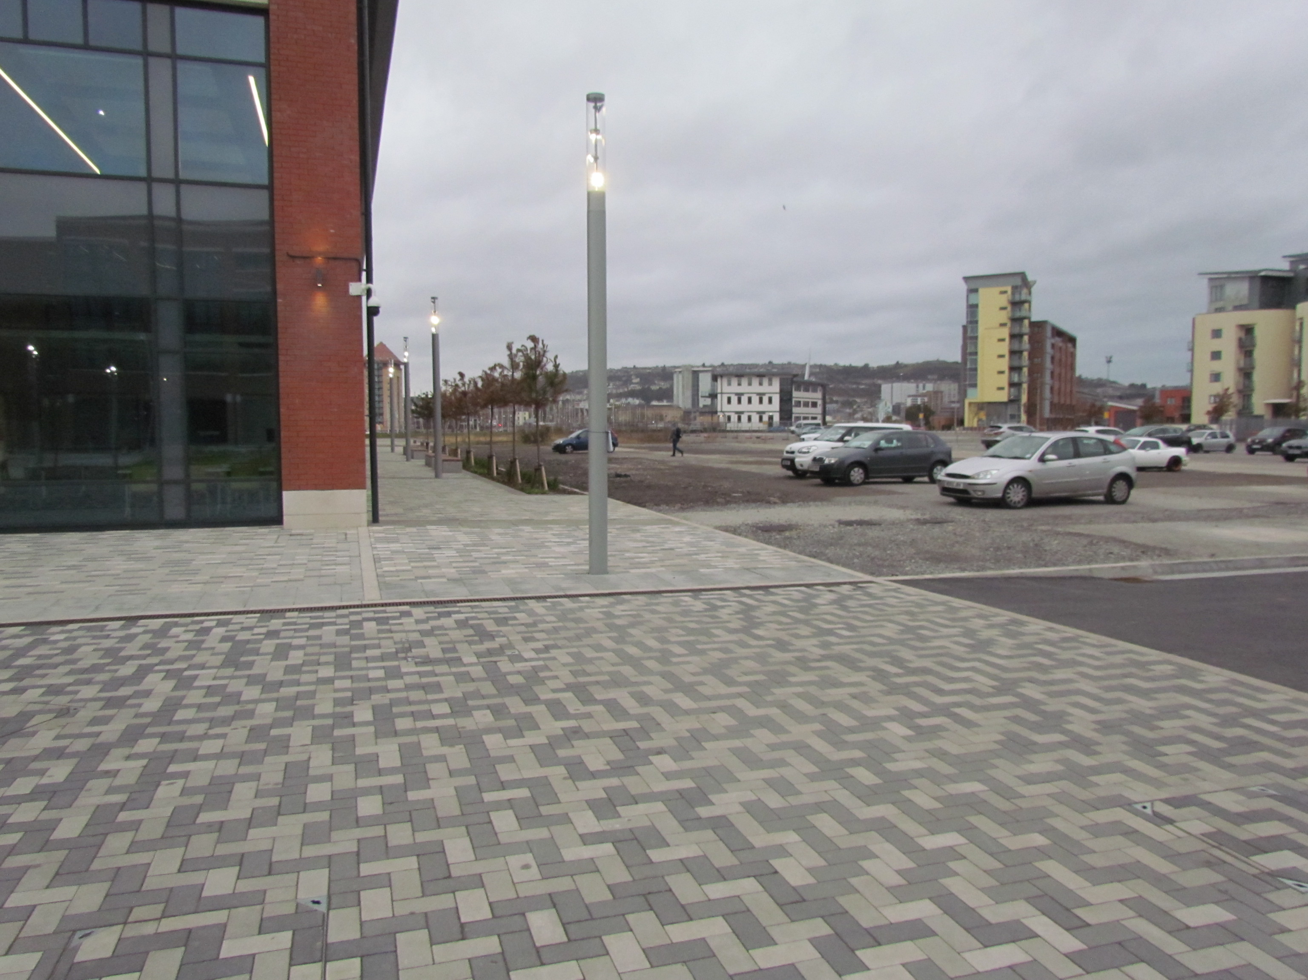

Before undertaking our investigation, we ensured we were familiar with key terms of levelling such as datum and reduced level. We were then each given our own reduced level.

“Datum is the point or surface with respect to which levels of other points or planes are calculated. The levels of various points taken as heights above the datum surface are known as reduced levels”
(S, Bhavikatti, 2010)

My individual reduced level was 1089m.
Task 1

- Identify the basic equipment’s used and explain the procedure adopted in setting out during your fieldwork at singleton park

Our investigation was carried out at the University of Wales car park. Our aim from the investigation was to measure the difference in height between two points of the car park for future construction of a Gymnastics building.

Before we left the classroom and collected our measuring instruments, we first ensured we had the correct health and safety procedures in place as we would be working near traffic. Each of us put on hi-visibility vests and collected our field books. Within these field books, we recorded the findings our investigation and so we ensured we also had a pen handy. As it was an overcast day but dry, we did not feel the need for an umbrella. We may have found it useful to use marking paint to easily distinguish each station that we needed to take recordings from, however, on this occasion, we did not use any marking paint.

Before undertaking our investigation, it was vital we had the correct equipment in place to ensure our readings were as accurate as possible. Firstly, we ensured our tripod was set up correctly in preparation for our levelling instrument. This instrument is commonly known as a “Dumpy Level” and can be seen in the photo below.

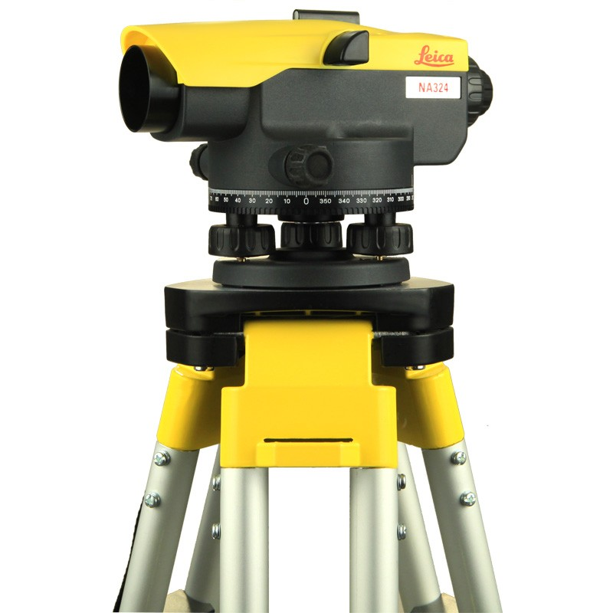

Dumpy Level” (https://www.sccssurvey.co.uk/leica-na332-automatic-level.html Date Accessed 23/1/19)

We ensured all screws and hinges of the tripod were screwed tight to minimise unwanted movement. To ensure maximum accuracy in future, the use of a plumb bob could be useful. This helps determine that the tripod has been set up in the correct location, over a datum marker.

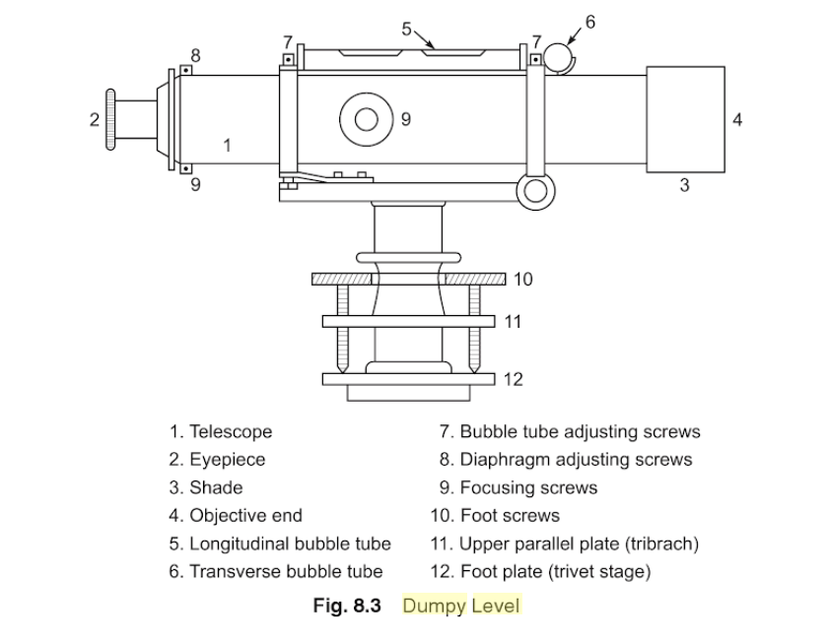
(Bhavikatti, S, 2010)

The above diagram from the book “Surveying and Levelling” summarises each component of the dumpy level. We utilised the eye piece to view the levelling staff in the distance. In order to achieve maximum accuracy, there is what’s known as a diaphragm in front of this eye piece. This diaphragm creates a crosshair so that surveyors can pinpoint the exact measurement on the staff. Once the tripod was erected, we then removed our levelling instrument from its padded box and placed the level on top of the tripod.

We then ensured the instrument was level by utilising the “bubble tube” on the side of the instrument, as displayed in the image on the right.
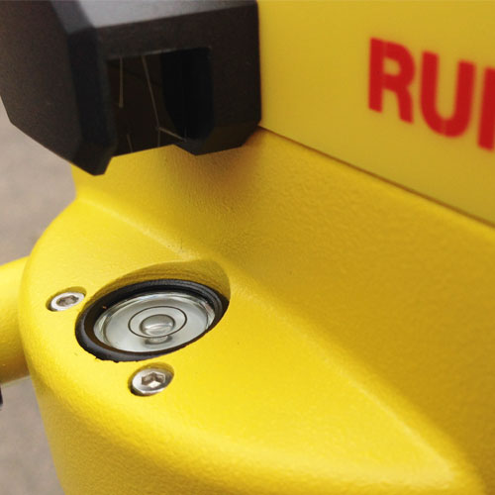

(http://www.merlinlazer.com/Runner-24-Automatic-Optical-Level---Level-Only Date Accessed 23/1/19)
We turned the foot screws in opposite directions until the bubble was in the centre to ensure it was level.

“The four levelling screws are worked in opposite pairs to position the bubble at the vial center. The bubble follows the directional movement of the left thumb”
(Brinker, R, 2013)

We then adjusted the eyepiece until it was in focus to ensure we had clear vision of the levelling staff. It was also vital that when we were transporting our level, it was not swung about and carried in a vertical position. This ensures the maintenance of the Dumpy Levels calibration.

We used a conventional levelling staff to take our readings. The levelling staff, along with the automatic level, enabled us to determine the difference in height across differ points of the University Car Park. In future, it may be useful to use a level to ensure that our levelling staff is kept straight throughout our investigation to ensure our readings are accurate. Before leaving the class room, we ensured that we familiarised ourselves with the different readings on a staff.

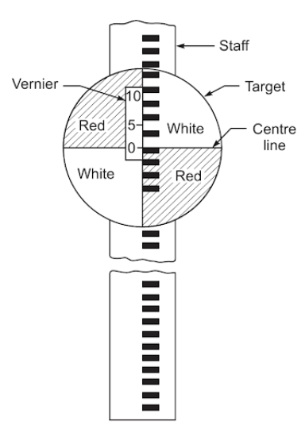
(S, Bhavikatti, 2010)

To the left is an example of the staff used during the investigation. As we had three people manning the level with one man in charge of holding the staff, we conversed with each other to ensure we all agreed on the reading that the level was giving us. Readings were then logged into our log books, featuring back sights, intermediate sights and fore sights.

Once we returned to the classroom, we then began to work out the height of collimation and the various different levels across the stations.

- Carry out a basic levelling to determine the difference in elevation and calculate the reduced levels of various points as shown in the site map provided by using the line of collimation method and the rise and fall method.

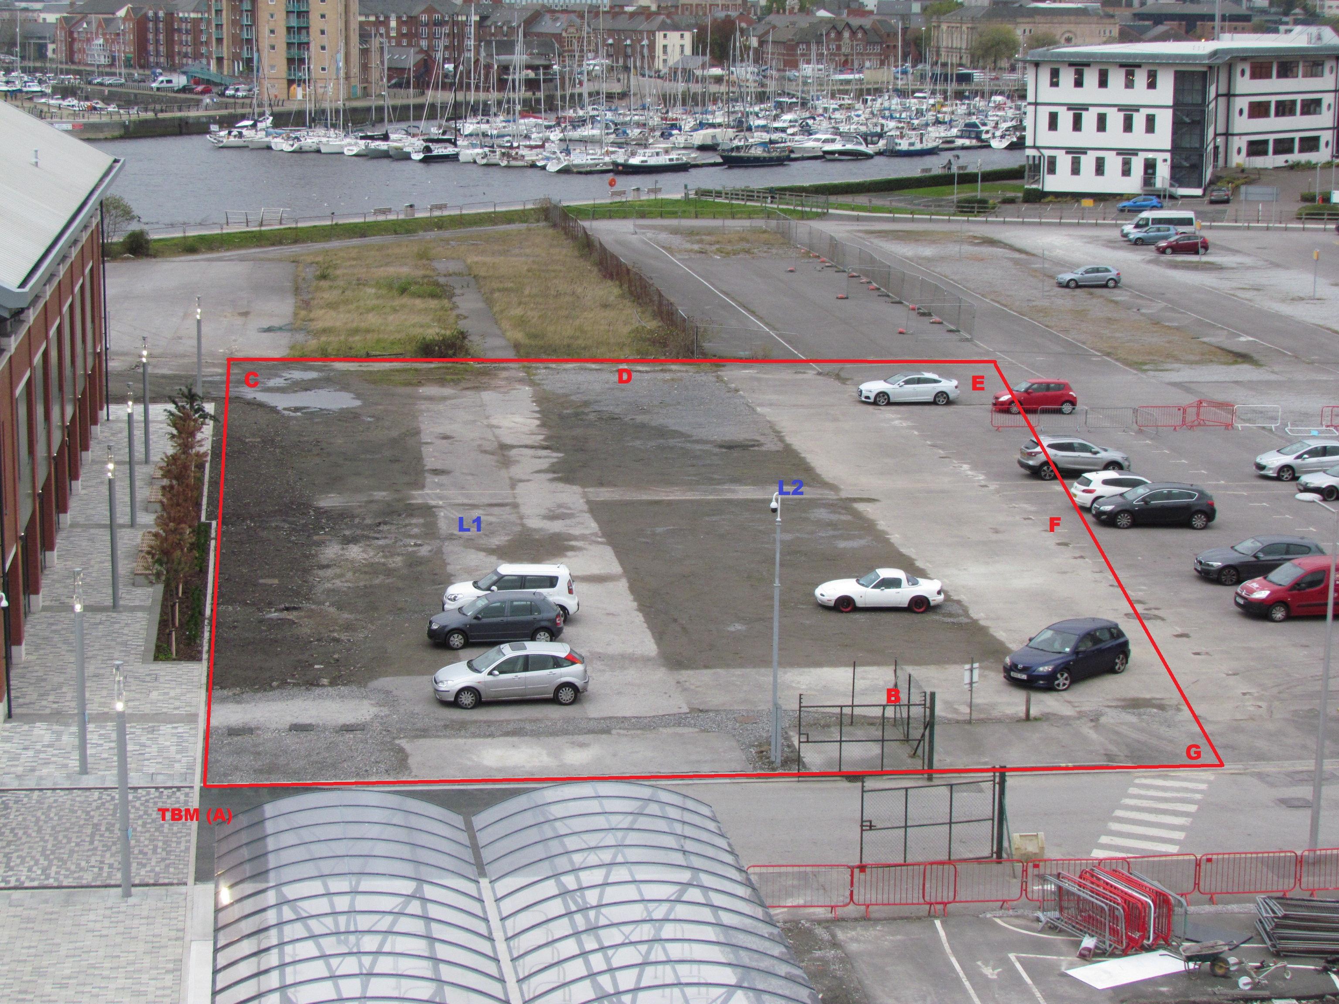
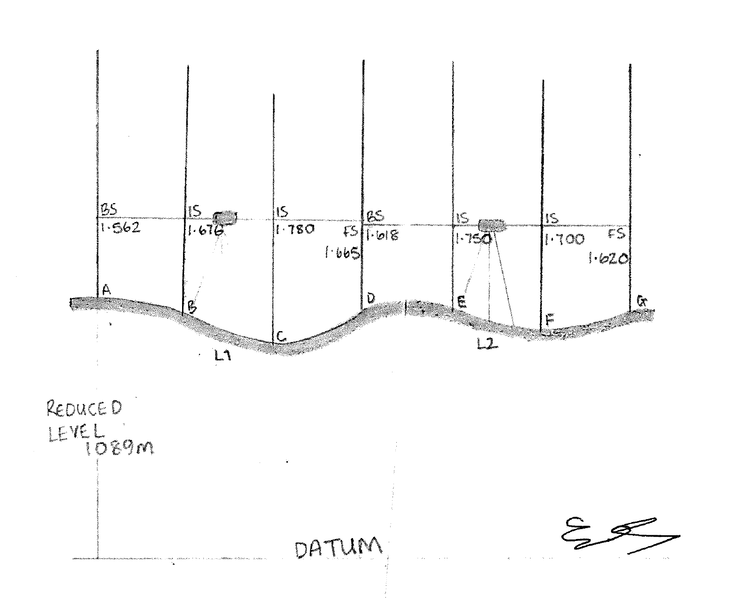

Hand drawn (not to scale)

- Book your readings in a field book provided

Site | University of Wales, SA1- Car Park
Weather | Overcast/Windy/ 10°c
Date/Time | 4th November 2018 – 1.30pm
Surveyor | Ellis Jones
Surveyor | Phil Abdullah
Surveyor | Greg Thompson
Surveyor | Dan
BACKSIGHT | INTERMEDIATE | FORESIGHT | HEIGHT of COLL. | REDUCED LEVEL | REMARKS
1.6 |  |  | 1090.6 | 1089.0 | A
 | 1.7 |  |  | 1088.9 | B
 | 1.8 |  |  | 1088.8 | C
1.6 |  | 1.7 | 1090.5 | 1088.9 | D
 | 1.8 |  |  | 1088.8 | E
 | 1.7 |  |  | 1087.1 | F
 |  | 1.6 |  | 1088.9 | G
 |  | Check
Difference between BS and FS |  |  | Difference between first and last RL
Backsights | 3.2 |  | 1088.9 | Last
Foresights | 3.3 |  | 1089.0 | First
Difference | -0.1 |  | -0.1 | Difference

- State 6 factors that could affect the accuracy of a levelling exercise apart from a collimation error in the instrument

There are many factors that could affect the accuracy of an investigation. Firstly, human error can have an adverse effect on the accuracy of measurements taken. Some examples of human error would be not holding the staff up straight, inability to read the staff measurements correctly, straying away from the allocated measurement points, lack of concentration and also a major factor – lack of experience. Should investigators not receive the adequate training in how to carry out the test, it’s likely they will struggle with tasks such as setting up the equipment properly and taking readings, leading to carelessness. Human error could also result in readings being taken incorrectly. This would have an adverse effect on the accuracy of the results. Miscommunication between group members could also result in poor accuracy of readings. If both members manning the level don’t consult on the reading and one person relays the wrong information to the member in charge of the log book, the wrong measurement could be recorded.

“These errors are purely due to the mistakes. They are quite large, they can be avoided by following good surveying practice by taking precautions and readings”
(Uren, J, Price, W, 2010)

Another factor could be the many obstacles surrounding the site. There were many parked cars and also a fair amount of human traffic. This may have affected visibility due to cars being in the line of sight of the level.

Another factor to take into account would be the weather. Poor visibility would mean that it would be harder to take readings. Luckily, it was a clear day when the investigation was carried out. There were however, high winds. Although the importance of holding the staff still was stressed pre-investigation, the high winds may have had a negative effect on how still the staff was held, thus reading to incorrect information logged. Defective equipment would also have an adverse effect on the accuracy of readings taken. For example, a tri-pod that has been incorrectly set up or a staff that’s base has become worn.

“The stability of tripods should be checked before any fieldwork commences by testing to see if the tripod head is secure, that the metal shoes at the base of each leg are not loose and that, once extended, the legs can be tightened sufficiently”
(Uren, J, et al 2010)

Linked to the stability of the tripod, uneven terrain could also have an effect on the accuracy of readings taken. Surfaces such as earth/mud could be crumbled and vary massively depending on whether the person undertaking the investigation decides to remove the material on the surface. This would also be the case with gravelled terrain where the layers of stone can vary massively. This factor applies to both the tripod and the height of both could be affected.

“When the instrument is set up on soft ground and bituminous surfaces on hot days, an effect often overlooked is that the tripod legs may sink into the ground or rise slightly whilst readings are vbeing taken. This alters the height of collimation.”
(Uren, J et al 2010)

Another factor to take into account would be the curvature of the earth. “When the distance of sight is long, the curvature of the earth may affect the staff reading”
(Basak, 2014)

Task 2

- Carry out a fly level to calculate the reduced levels of various points by H.I method.

- Book your readings in a field book provide

Site | University of Wales Campus, SA1
Weather | Overcast/Windy/ 10°c
Date | 21/11/2018
Surveyor | Ellis Jones
Surveyor | Gregory Thompson
Surveyor | Phillip Abdullah
Surveyor | Dan
BACKSIGHT | INTERMEDIATE | FORESIGHT | HEIGHT of COLL. | REDUCED LEVEL | REMARKS
1.608 |  |  | 1090.608 | 1089 | A
1.462 |  | 1.693 | 1090.377 | 1088.915 | A2
 |  | 1.878 |  | 1088.499 | B
Check |  |  | Difference between first and last RL
3.07 | Backsight |  | 1088.499 | Last
3.571 | Foresight |  | 1089 | First
0.501 | Difference |  | 0.501 | Difference

- Draw a rough sketch of the fieldwork mapping out your stations from Station A (TBM) to B

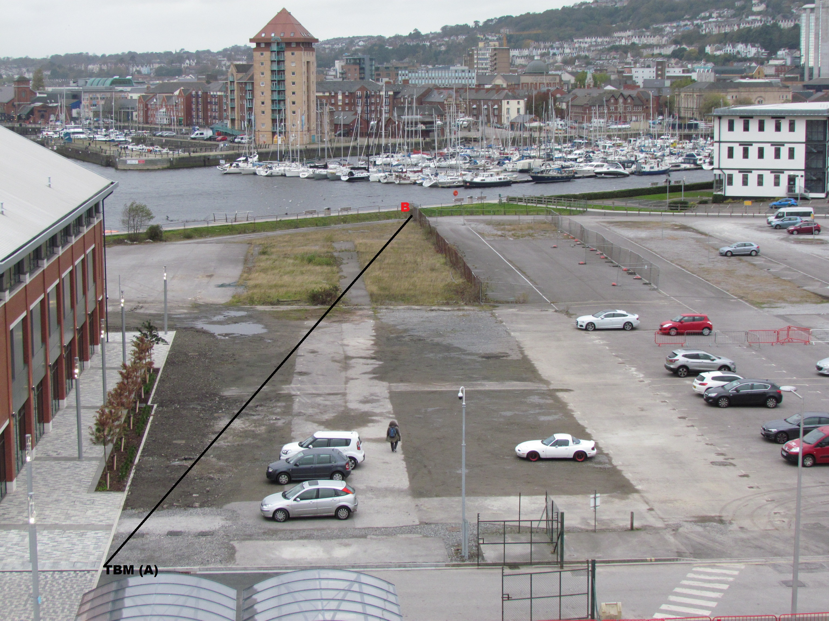
L2
A2
L1

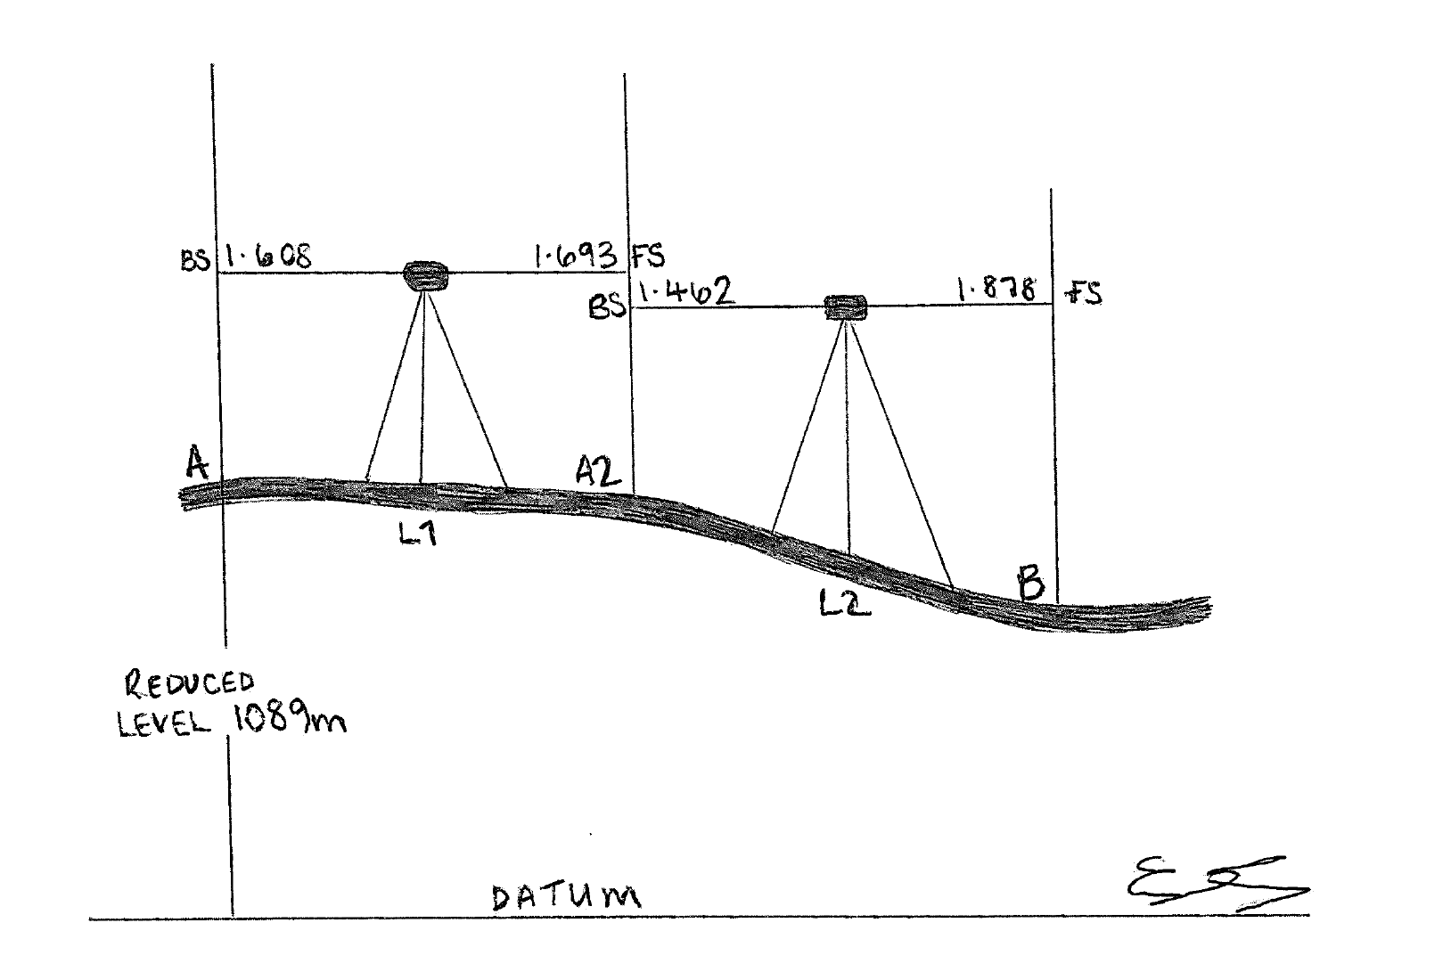

(Hand drawn, not to scale)

Bibliography

Books

S, Bhavikatti (2010). Surveying and Levelling. .: I.K International. 174-179.

Brinker, R (2013). The Surveying Handbook. .: Springer . 189-190.

Uren , J, Price, W, (2010). Surveying for Engineers. .: Macmillan International. 54-56.

Basak (2014). Surveying & Levelling. India: McGraw. 197.

Websites (for photographs only)

https://www.sccssurvey.co.uk/leica-na332-automatic-level.html Date Accessed 23/1/19)

(http://www.merlinlazer.com/Runner-24-Automatic-Optical-Level---Level-Only Date Accessed 23/1/19)

