Module Title:
MANAGING IN COMPLEX ENVIRONMENTS: STRATEGIES, INSIGHTS AND SOLUTIONS
Module Code: LCDB7002

Assignment Title: Consultancy Report: Managing an Ageing Nursing Workforce: Ireland Healthcare System
Lecturer’s Name: Professor Amare Desta
Student Number: 1712816
Student Name: Margaret Kyakunda

Managing an Ageing Nursing workforce Report: Ireland Healthcare System.

Recommendations of Managing an Ageing Nursing Workforce

September 2020

Evidence based report

Table of Contents
Executive Summary 4-5
Introduction 6-8
Aims of the Report 5
Analysis 9-
- External Environment for Irish Healthcare System 10
- Political 11
- Economic 11
- Social 12
- Technological 12-13
- Legal 12-13
- Inter Environment 13
- Demand Analysis 14
- Gap Analysis 14-15
Key issues facing Irish Healthcare System 16
- An Ageing nursing workforce 16
- Emigration of Irish Nurses 17
- Retention of older nurses 18
- Shortage of nursing workforce 19
- Age discrimination 20
- Multi-generation Team 20-21
- Change in workforce attitudes to work 22
- Cultural/language differences 23
Benefits of an ageing nursing workforce 23-25
Recommendations 26-34
Conclusion 35-39
References 40-41

Executive Summary
This report aims to present facts and arguments to the Irish healthcare system HR and board members considering the changing demographics and the trends in the Irish labour market.
HR must align its strategies on diversity with business objectives. Janice R w Joplin, and Catherine S. Daus (1993-2005).
The purpose of the report is to examine the challenges faced by HR on how to manage an ageing nursing workforce in the Irish Health Service. Then recommend the appropriate people’s management strategies for age diversity to ensure the National Health Service builds a sustainable partnership with its stakeholders and ensure a stable workforce for the future
The report draws attention to a shift in demographics as the traditionalists are ageing and working beyond retirement age, the birth rates have gone down. (Towers Perrin, 2005),

According to Buerhaus et al. (2000), in the next twenty years, age will determine the size of the healthcare nursing workforce.
The population is as living longer and are putting pressure on the public health service, which must meet both challenges to give exceptional service to its ageing clients as well as its older workforce. The impact of an ageing population has created shortages in skilled labour (specialist nurses), and gaps in knowledge. Irish public healthcare system (HSE) is experiencing an ageing nursing workforce, plus a staff shortage as many are nearing retirement age. (AARP,2002,2003) in addressing the issue of an ageing workforce, the Irish healthcare system (HSE), is drawing attention to its experienced and knowledgeable workforce, to gain a competitive advantage as more mature employees are opting to stay and work past retirement age.

Ireland Public Health Service needs to identify the needs of the older workforce based on:
- Flexible working for older nurses as the long and night shifts affects this group, revise the scheduling practices in place to accommodate the changing needs. Whenever possible nurses over 50 should be offered alternative working arrangements by monitoring the situation.
- Acknowledge and capitalise on expertise and talent.
- Improve succession planning in the workforce
- Health and wellbeing, better care for older nurses.
- Individual support for retirement planning
- Recruit locally and internationally to bridge the nurse shortage gap
- Incentives for older nurses to stay in an organisation
- Return to practice courses

Introduction
The report draws attention to the issues of an ageing workforce to the board members of the Irish healthcare system (HSE) and human resource management (HRM) that failure to address these issues will affect the future workforce.
The following are some of the key issues the board of directors and HR should be aware of:
- Any form of direct or indirect age discrimination is unlawful.
- a global nursing shortage has created a competitive environment for talent retention and recruitment of skilled workers. (CIPD 2009).
- Irish public healthcare system, over-reliance on recruitment of migrant nurses will not solve to fill the gap.
- The older workforce is an untapped source of labour. Instead of recruiting migrant nurses, they should concentrate on local recruitment to fill the gap.
- People are comfortable working long past retirement age is the workplace conditions are right.
- Retirement is by choice unless in exceptional circumstances.
- The long-term strategy plans forecasted during the 2008 economic downturn must be revised.
The report is about the challenges the Irish healthcare system is facing in around the area of managing an ageing nursing workforce. It has been written by the author into the awareness of the current complex issue of the and ageing nursing workforce, and make recommendations to the board, on how to retain its asset and make better use of older workers.
The Irish healthcare system (HSE) employs 34% of the Irish population are nurses. Due to the cuts on health care made during 2011 saw a decline in the nurse workforce which led the healthcare system relying on an ageing nursing workforce. (Wells & White 2014). An ageing workforce is not a problem faced by Ireland alone, but a global issue, USA estimated that 50% of the workforce is over 50, UK, 34% of the workforce employed by the National Health Service (NHS) and Japan over 50. (Wells & Norman 2009), these figures signify a challenge for contemporary HR.
There is an increase in an ageing population around the world, and this demographic shift is shaping the labour markets in many economies. As set out in Fig.1 by the year 2028, older people in Northern Ireland will surpass the number of children, by 2023, 30% of the population will be 65 and grow by 50% by 2061.

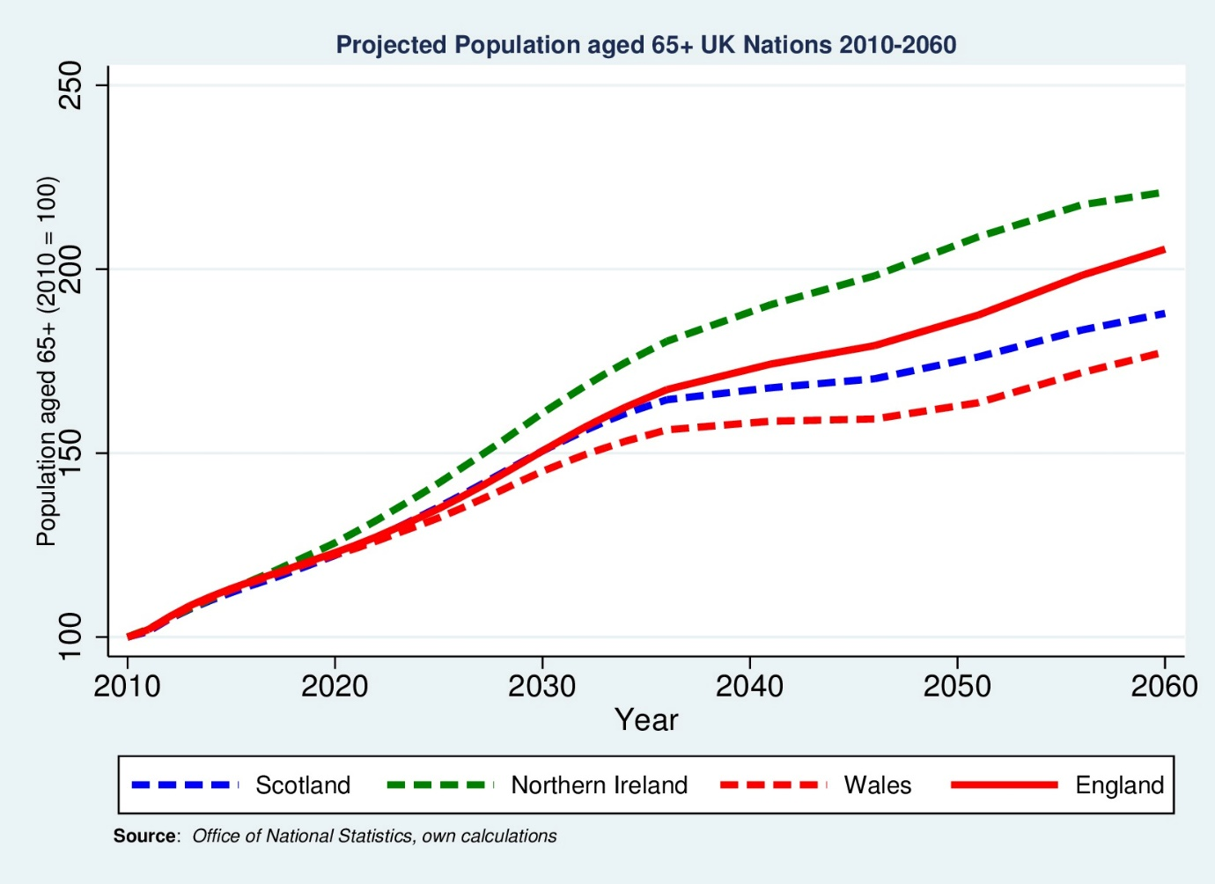
Fig.1 Source Office of National Statistics
Another aim of the report is to draw attention to the board members on how to implement and revise age diversity strategies in the areas of managing and retaining its mature workers as this impact the HR strategies on age diversity.
The report used the following to achieve its objectives
- Contemporary issues regarding an ageing nursing workforce in Ireland Public Health Services.
- The benefits and challenges of managing and retaining an ageing nursing workforce.
- Best fit, contingency theory approach and Generic Foresight Model used to help Ireland Healthcare Service develop age diversity strategies.

Analysis
Irish healthcare system (HSE) HR, can use the foresight framework for strategic environmental scanning to get gather information, analyse what is happening around the organisation make sense of the issues that are impacting the workforce and interpret what is really happening or what future prospects. By identifying the trend analysis and interpret then HR can decide on the best strategy as strategy decisions are based primarily on interpreting information about the past and present and will help in designing different methods for Ireland PHS, to successfully manage, attract and retain older nurses
Due to the rapid change in the external and internal environment, especially the change in people’s attitudes to work that is working past the retirement age has created a need for HR look at this pressing issue in more detail and to devise new ways to manage an ageing nursing workforce. (Harvey & Bowen, 1996) cited Agarwala, T. (2002). By using the contingency view, HR practices have to align with the interpretation of the environment ( external and Internal) and draw the best strategy that is unique to the Irish health service system(HSE).Porter 1980 argued for any organisation to have a competitive advantage the business competitive strategy has to align with human resource policies. Redman & Wilkinson, 2006, p.33. in view of this argument Ireland HR practices regarding the age diversity is to be competitive and have a robust retention strategy when it comes to retaining its ageing workforce as its prone to nursing leaving and migrating to green pastures making sure it retains its knowledge intensive and skilled workforce. For the Irish healthcare system (HSE), to take advantage, is to have robust retention strategies for its skilled nursing workforce. Especially in times of immigration visa caps on migrant workers and Britain leaving the EU.
Ireland public health service should implement the Generic Foresight Model when designing a strategy to fit what is happening at present. Ireland public health service, by understanding what is happening consideration as it recruits from Europe)., the HR practices should include systems that influence organisational inclusion, whereby re-engineering business processes will change organisation culture as true inclusion will drive organisational performance.
The foresight framework should help HR in understanding the political, technological, social, personal factors to understand the forces that lead to Irish nurses leave the workforce and choose best fit strategy to retain its skilled nursing workforce.
External Environment for Irish Healthcare System
Demographic changes and equal opportunities in the workplace have ignited debates on why managing diversity in the workplace is vital to employee performance. The Healthcare relies on understanding the changes in demographics and public values. The shifting demographic trends are shaping the development of managing diversity strategies which HR has to embed in any workforce planning decisions and it is not only in Ireland but around the world.
HR should liaise with board members as they are key in supporting the progress and sustain business performance on issues:
- The implications of managing an ageing workforce for workforce sustainability
- Present picture on where the Irish healthcare system standard on an age profile workforce profile, and its talent.
- Present current retention strategy and need for change to address current trend, on talent and skills
- Address how knowledge transfer is being used.
Political Factors
Brexit has had a major impact on Ireland nursing workforce as it relies heavily on migrant nurses. The lack of personnel will further deepen the ongoing shortage of nurses In the Irish health care system when the nurses go in retirement.
Additional risks have been created by Brexit for both short and long term. Due to labour mobility reduction caused by uncertainty, more EU nurses left their roles and returned to their home country.
Economic Factors
The 2008 crisis led to many difficulties for Ireland healthcare service system, the lack of resources and economic regulation of the health service was under pressure. The health care sector employees almost 31.2% of nurses and it is this profession that was impacted by cost cutting which led to many nurses leaving, and destabilising the nursing labour market, leading to severe shortages which have extended further than expected. HR resource must consider the long- and short-term declines on the supply and demand of nurses and be able to manage strategically through these economic cycles. If management and HR don’t keep up with currents trends in the labour markets, will lead to making misinformed workforce downsizing and very expensive and unreversible, therefore the foresight framework should be implemented before any decision by HR Ireland healthcare system is still struggling to attract back the nursing workforce; therefore,

Social Factors
Ireland is no exception it is witnessing a rapid change in the population; people are living longer, and ageing rapidly putting pressure on the health care system as both the patients and the workforce are part of the ageing group. HR to understand the needs of its ageing nurse workforce and have a retention strategy and invest and motivate nurses to stay longer at work and offer their expertise. The Irish healthcare system needs to find creative ways and best practices, reinforce a culture with is supportive to its workforce, raise age diversity awareness, redesign the jobs and due to the physical nature of the job introduce an ergonomic workplace. (McIntosh et al. (2010).
Technological Factors
Advance in technology is changing the way we work, and the nursing profession due to its physical nature will ease the work of nurses. Nurses spend a great amount of time trying to learn how to use the integration electronic needed to do the job well. The introduction of technology and training can make a difference in nursing.
The Irish healthcare system should invest in technology as it will be an asset in motivating and engaging the workforce without them working around the clock to keep a
motivated workforce, management must differentiate between, flexible working, remote working, and work /life balance.
Legal Factors
The Nurses and Midwives Act 2011 governs the work of NMBI and sets out the legal framework in conjunction with the European Union. The nursing body must stick to the rules when it comes to labour mobility must comply with, including the freedom of movement of healthcare professionals with a member of healthcare professional within. Age discrimination
HR must comply with the Age discrimination Act, (Northern Ireland) 2006 and work towards elimination of t discriminate on grounds of age. Therefore, Ireland public health service has the duty to promote equality of opportunity and positive action in the workplace. Many older nurses have addressed the concern of being discriminated at work due to age. HR has to commit to elimination of direct and indirect age discrimination when dealing with an ageing nursing workforce in areas of recruitment, selection and retirement, offer equal training and development to all age groups at work , terms and conditions of employment, working environment, access to employment related benefits, redundance and post-employment situation.
There is no single fixed retirement age for employees. Employers set retirement age in the contract of employment. The revised Equality act 2015 has been amendment since January 2016 to include that employers may set mandatory retirement age provided it is objectively
Internal issues relating to an ageing nursing workforce in Ireland.
Managing an ageing workforce is an internal issue and below is a SWOT analysis of the Ireland public service to understand the internal issues relating to an ageing workforce. Employers attitudes and polices on how they perceive an ageing workforce will be affected by their perception of threats and opportunities in the labour market.
Findings in the case study addresses the age diversity as a concern for human resource managers who must enforce and commit to the existing legislation on age discrimination and try harder to eliminate it from the organisation. Successful, workforce planning must be an ongoing activity for the HR department, especially when it comes to an ageing workforce. A long-term forecasting process is needed, to understand why mature workers make early exits and how the health service is going to build a future workforce and when and where to tap for existing talent.
Demand Analysis /demand model
By using the demand analysis model, internal analysis involves the future health service needs tanking in consideration an ageing nursing workforce, and the external business issues for better strategic planning. For example, address the social issue of the ageing population and how it is going to deal with the dual complex issues of ageing workforce and an increase in older patients (ageing population).
Gap Analysis.
HR use of the gap analysis to discover the existing gaps in the current and future workforce needs, helps HR plan and think of the retention, recruiting, training and development strategy in case a gap is uncovered. For example, the current short-term strategy, used by Ireland health service is the use agency nurses to fill the immediate gaps of staff shortage covering sick leave and absenteeism caused by other factors. But they are still facing immediate gaps to feel specialist vacancies as they arise thus impacting productivity and competitive advantage. Below are some of the threats facing the healthcare service.
- Ageing workforce
- impending retirement of key consultant staff
- shrinking size of the talent pool
- Fewer young people leaving education and creating a skill gap
- recruiting internationally immigration caps on talent
- Indirect age discrimination in the recruitment process
- Retain of staff
- Emigration nurses
- Sup optimal succession planning
- Sub optimal self-promotion

Key issues facing Irish Health System
An ageing nursing workforce.
The report identified an ageing nursing workforce in the Irish healthcare system (HSE), and estimate of 65% are above 50, and many of whom started retiring in 2010, making under-staffing a main challenge for HSE, and a need for ways for nurse retention strategy to address the problems. (Health Service Executive, HSE,2017).
The trend of an ageing workforce is across the health service. Taking into account of the above statistics, this is a reality that the health service must address, by interpreting what is happening in the environment they operate in, with an ageing nursing workforce the need for workforce planning with strategies fit needs of the health service take into consideration for the future workforce which will comprise of millennials replacing the older workforce to care for the patients. (Buchan et al. 2018). (Fig. 2 & 3. Illustrates age profile)
Fig.2. Workforce Age Profile in Ireland’s healthcare
Fig.2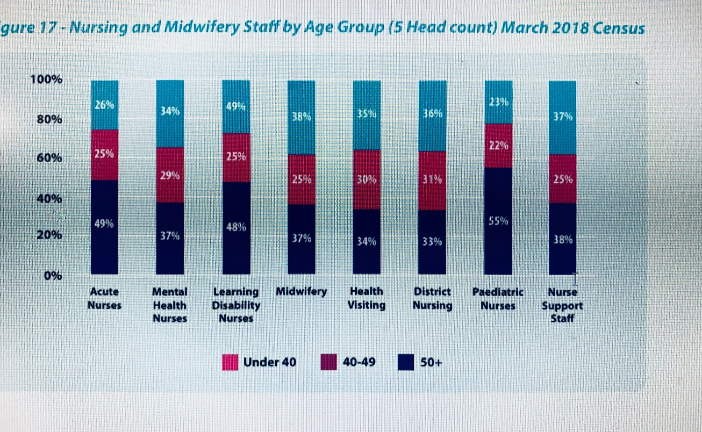
In comparison with the UK Nursing workforce (see figure 3). below the same issue is global witnessing more people are working past retirement age.

Fig. 3
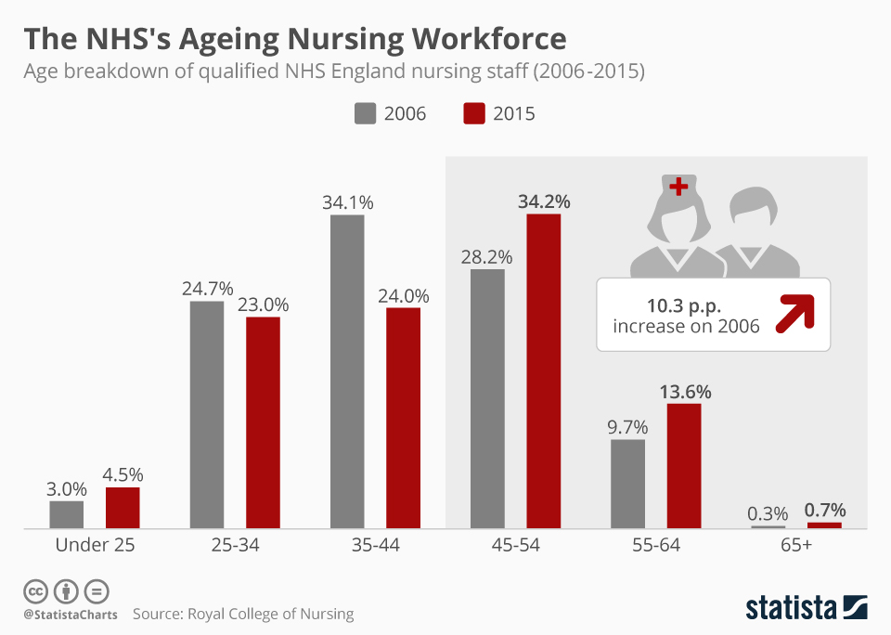
Emigration of Irish nurses.
Local Markets key source of workforce supply
evidence in the case study shows that most Irish nurses emigrate to in search for better working conditions and pay. To overcome this challenge, the Irish nurses should implement. effective workforce planning to meet existing and future HR and service needs
Another issue is Irish public health service heavy reliance on non -Eu nurse immigration. The Irish healthcare system opted for this strategy to recruit from abroad as a short-term strategy to fill the gaps left by ageing nurses and to cover sickness -absenteeism. HR should focus on attracting local nurses and reach out to rural Ireland to recruit on a national scale to fill the gap and cut costs.
A survey on Irish nurses indicated 78% of nurses graduating intend to leave the health service in future. (Irish Nursing and Midwifery Organisation (INMO)) (see Fig. Fig 4.)
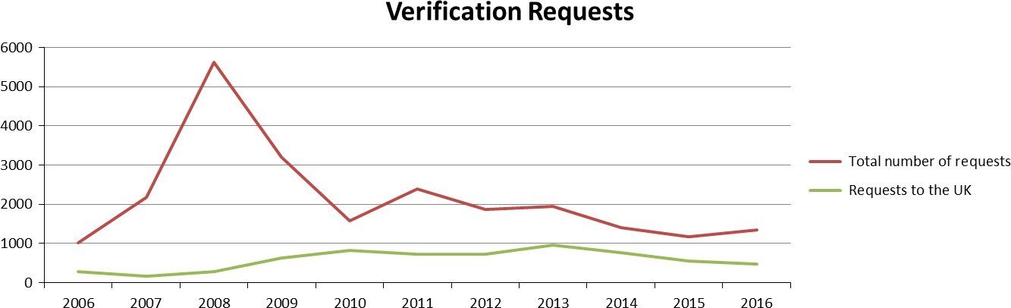
Fig. 4. Source: Case study on an ageing nursing workforce in Ireland.
The above problem, couple with old nurses feeling unappreciated and alienate, these barriers to older nursing and migrant nurses should be addressed urgently, to stop frustration and negative response. HR professions implementing a strategy base on the Equity theory, taking into consideration that individuals are motivated by fairness. If the Irish nursing workforce perception on equity of the workplace or profession is high then the more motivated they will be and stay instead of migrating, but currently the nursing perception of an unfair environment, is demotivating leading to leaving for a better place where they will be appreciated thus impacting Ireland health service with loss of skills, knowledge and staff shortage. HR should use the Kanter’s (1993) theory of structural empowerment theory when managing ageing nursing workforce especially as the case study points out that the nurses feel alienated and not included in decision making or recognised for the work they do.

Retention of older nurses in the health service
HRM is faced with the issue of how to balance individualism (fulfilment) and at the same time meet organisational goals. To create an inclusive organisation, HR must work on reversing the culture on the myth surrounding age. By implementing and commit to the existing regulation on managing diversity in the workplace, equality will them be released through awareness. CIPD’S 2014 report Managing an Age Diversity points out that HR in organisations do not have a sort of strategy for older workers, something that must be on top of their agenda.
Retaining the older nursing workforce can help Ireland public health service, address potential issues such as skills shortages, inability to meet customer needs and production targets due to the ageing workforce. However, the biggest challenge to the health service is retaining and manage an ageing workforce in the workplace.

The management of the future workforce is more and goes beyond a good salary, and comprehensive benefits program. HR must understand an ageing workforce and taking consideration an individual wellbeing, personal training and development, a change in the culture of the organisation, restructure the workplace, and acknowledge and appreciate the old workforce, otherwise nursing shortage is future gaps threaten the health service than funding issues.
Shortage of nursing workforce
Nurse workforce shortage is still a major challenge to HSE despite an 8% increase since 2008. There is a significant shortfall in the number of nurses available to take up vacant posts. Global shortage of registered nurses and this impacts on Northern Ireland. The growing demand and changing service needs with a corresponding increase in workforce knowledge, skills, and expertise. The evidence in the development of innovative new roles such as advances nurse practitioners and consultants’ nurses have advanced autonomous practice and embedded strong clinical leadership. Fig 4 shows that over 32% of the nursing workforce are over the age of 50, this clearly has significant implications for workforce planning and reinforces the need to raise the number of undergraduate places over the next five years and not to only address current vacancies but potential retirements. The figure shows a challenge for the public health service to improve staff shortages to meet demand of the growing population of Northern Ireland.
Age discrimination in employment
Age discrimination is very common in a workplace and can affected any age group, but its more felt with the older age group as evidence shows more than one in 4 employees over the age of 50 say that they have experienced it. Despite the discrimination policy implemented in the Irish public health service. age discrimination still exists leading to unconscious bias leading to intergeneration conflict. legislating against discrimination by employers on the grounds of age, for anyone age 16 or over is prohibited, an amendment in Equality Act 2015, included protection against age discrimination, whereby employers can set a mandatory retirement age, provided it is objectively justified
Multi-generation Teams
Today’s workforce is multigenerational, traditionalists, boomers, Gen X, Y& Z, and the emerging Gen Wireless are in one team. A challenge to the management as the mature nurses, feel discriminated against due to age when it comes to some aspects of working, training and career development. Managers must find ways for multi-generations to work together as a team learning from each other, is the way to prepare for the future workforce. Management must create awareness of intergeneration working. By tailoring and monitoring of age policies and practices will help the health service to reap the potential productivity and innovation and avoid potential conflicts and avoid age discrimination
For multi generations to work together is the way to prepare for the future workforce. Management must create awareness on intergeneration working. By tailoring and monitoring of age policies and practices will help the health service to reap the potential productivity and innovation and avoid potential conflicts and avoid age discrimination
Most organisations when recruiting use the economic based theory that suggest that older employees are paid high wages and are less productive. (Medoff and Abraham, 1980). Therefore, the wage productivity gap is a motivator for organisations to reduce older workforce, the theory provides a backbone of to the alleged employers age selectivity when hiring and firing, though there is no empirical evidence for this, in the health service the indirect discrimination can be identified in the recruitment process.

Employers are continually using years of experience as a selection criterion in recruitment and this disadvantages young workers. Recruitment ages are set more than 6 months below retirement age. This traditional way of recruitment must be revised as different generations have different views and attitudes to employment.
Long incremental pay scales are an issue in the social care, though it is being looked at and being eliminated.

The change in workforce attitudes to work
In the past most organisation have strategized using the Z theory of motivation. “Theory Z suggests that large complex organisations are human systems, and their effectiveness depends on the quality of humanism used”. employees had a lifetime employment contract, assuming that since job is for life more output is expected from all employee. The contemporary issues manager and organisation are facing is the employee attitude to work and values has changed drastically. The traditional way of life is not applicable in today’s rapid change in the external environment. The complexity of the issue is how to manage by recognising that your workforce has interests outside the workplace. there is need to change due to demands of the workforce. The services Ireland health service provides to its citizens has to change as the needs are different from the citizens who grew up with the system. Management must reconfigure the core objectives of the health service. Employees are asking for more flexibility and not a life contract, they are demanding to work less hours as it suits their needs.
Cultural/language differences
The older and new nurses joining the workforce feel a sense of alienation, which brings on the debate of cultural competency on the over reliance and intensive recruitment of foreign nurses. On whether they have the capability of carrying their profession in an environment which is very different to their social norms, rules, or expectations plus language barriers, (Wells & Norman2009). HR professionals need to make the migrant workers feel welcome by assimilating them into the Irish culture of nursing as adjusting to a new environment takes time and to prevent error when providing care.

Benefits of retaining an ageing workforce
Knowledge transfer
Irish public healthcare system has one of the most experienced employees and have much more to offer to the health service in terms of skills, expertise and knowledge ( doctors, consultants, nurses, social workers, no-medical staff). As they age in the profession, the older nursing generation should not be a problem to the service but rather as a benefit to the organisation due skills, experience, and knowledge they will be a good asset to the service if managed well becoming role models and supervisors for the new recruits especially their junior counterparts
Multigeneration team working benefits the organisation as older workers share and transfer existing skills and r experience and know to the younger generate, and the mature workers can also learn new skills. By becoming mentors to new recruits brings about a positive e productivity level. p.3: Penna 2008, p.3. HR must come up with proactive initiatives to build a future workforce by focusing on retaining nurses longer in the workforce.
Flexibility
The need for flexible working by nurses was reflected in the study as it found some of the nurses are migrant workers and needed more flexibility in their contracts due to family responsibilities as most leave their families abroad. The demand for flexible working had a response from management as they released the benefit of retaining its workforce.
Older workers prefer to work flexible hours during the phased retirement period. This is a benefit to the health service and the employees, whereby the organisation retains critical skills at a reduced cost.
There are different pathways in and out of the nursing profession over 50 years of age these are
- Nurses on career break and return in employment in the Irish healthcare system.
- Retired nurse who comeback after retirement on flexible terms as evident during the current pandemic (COVID-19).
- Nurses who are currently employment and staying longer past retirement.
The above points show the different ways nurses enter leave, remain, and currently working in the health service. The distinction between the last two of these categories are subjective but is intended to rest on the attitudes and intentions of the individual. The main point of the diagram is to show that there is still room for older workers or those that have left the service to return and continue working, whether they have been on sabbatical leave or return after retired or when the health service needs them especially in these unprecedented times we are living in older workers who are retired are being called back to offer the service
The public health service being the largest employer, one of its peoples management strategy should be on how to manage the ageing workforce, especially focusing on how to keep old workers in the workforce and for the case of the Ireland which has a professional and specialist workforce, where losing staff is very costly. With nearly one in every two nurses across Ireland Is aged 45 or over. Despite having one of the most ethnically diverse workforces in the public sector, there are long-standing inequalities issues in the Irish public health workforce.

Recommendations.
HR and management should consider the following actions to implement good Age diversity management based on the needs of an ageing nursing workforce. The following recommendations were put forward for consideration by the Irish healthcare system board and
Implement a Retention strategy for an ageing nursing workforce.
HR in order to keep up with the changing nature of the workforce in terms of managing an ageing workforce, should adopt age profiling which will allow for a clear took at the organisations workforce now, in the future and at an organisation, departmental or team level, the purpose of this is to be able to predict trend in the labour markets, and be able to identify the areas where there may be a higher likelihood of retirement requests in the future and when you need to consider retirement conversations, help in planning retirements, how you recruit or retain staff, workforce planning and highlight pattens and trends across the workforce
Annual awards to recognise staff for 50 plus hard work and achieved should be introduced to motivate staff, and value them as an asset to the organisation. as research has shown that mature nurses feel unappreciated for hard work leading to exiting the health service. Due to the nursing shortage, competition in the nursing profession is fierce and Ireland has seen many of its nurses migrating, therefore Ireland (HSE), needs to understand, the needs of its workforce.
Redman & Wilkinson, 2006, p.307. Another way forward is the culture of inclusion recognising that certain groups within the organisations feel left out or unwelcome. HR should understand that diversity in isolation is no longer a sufficient goal, inclusion must be part of the organisational overall strategy.
Recognition, reward, and appreciation is very vital in retention strategy and should be practiced in the healthcare by nursing leadership, this will improve and create a healthy working environment.
Another retention strategy should involve empowering older nurses, by giving them autonomy and greater control in balancing their lives to increase motivation, satisfaction, and retention of nurses.
Implement Knowledge management strategy to Prevent knowledge loss.
For an effective managing diversity management, HR should take lead in committing to avail the available talent and how It is going to be utilized and aligned to the organisational objectives. An awareness by HR that knowledge is typically high tacit, as knowledge possessed by key individuals in this case the mature nurses and they are an asset to the health service. A knowledge management strategy to motivate the nurses.
Losing experienced nurses will potentially result in a skill mix imbalance in some areas of the health service as it is struggling to fill specialist posts. As younger nurses enter the profession, the challenges will relate to part time working, whereby developing mentoring or coaching programmes between the younger workforce and the older workforce.
The public health service will benefit in attracting older nurses, which results into a consultancy type role within your organisation for strategic and longer – term projects. The health service should harness years of expertise, and decades of older workers working through the ranks at each level. They will know what fails, success and the lessons they have learned from each stage as they progressed within the organisation. Packed with all this knowledge and experience in the old workforce is something a few younger workers can bring to the interview table therefore organisations have to be aware of the physical and mental health needs of the older worker and how they differ from the younger workforce.
Furthermore, HR should implement knowledge based initiatives including knowledge sharing among workers especially now HR and line management are dealing with a multi generation team , this will make the health service to stay competitive by protecting and retaining its knowledge base and manage it well otherwise neglecting the greying workforce will have some negative consequences for organisational performance.
Implementing cultural awareness and integration workshops
HR should revise and commit to cultural awareness programmes, by introducing cultural workshops for migrant workers to get a glimpse of what is expected in the new work settings the do and don’ts in the nursing profession. This will be a good time for the migrant nurses who felt discriminated, to get time to adapt to a new working culture.
Introduce cultural, Age awareness, equality workshops during orientation week for all new nurses in the workforce to understand the culture of the organisation, is expected in the new work setting.

Implement competitive Pay Scales
Another recommendation for Ireland HR should focus on motivation by offering competitive salary packages as in the primary concern for most nurses. With a good package nurses will stay and work longer for the health service instead of leaving (Scarborough’s (199)
Redman & Wilkinson, 2006, p.416. Management should revise the pay and reward policy which supports recruitment and retention, and pay rises must be targeted toward specialist nursing posts which are hard to fill, though financial incentives alone do not guarantee or solve nursing shortage but things like lifelong awards, loan write offs should be considered. HR should also benchmark with other countries pay scale for nurses to reduce nurse migration due to better PayScale, UK, USA, Canada, and Dubai being the top countries where nurses from Ireland relocate as they feel appreciated.
Implement s Retirement and Redundancy transition assisted programs
Ireland HSE management should introduce programmes of phased retirement so that the older employee prepares for life after work which should be based on individual circumstances. It is not only beneficial to the employer but also a wish for many nurses to stay on longer. (Kim & Feldman, 2000), this gives change for many nurses to either leave employment at retirement age but return on a part-time basis or progressively with from work or withdraw.
Indirect discrimination always occurs when an employer chooses part- time workers for redundancy using age as category and many them are older workers the redundancy policy does not directly or indirectly discriminate against older workers. The introduction of Introducing awareness programmes for nurses nearing retirement and over 50s, by informing them about retirement policy, financial counselling, benefit for offering flexibility to the ageing nurse workforce is to allow them time to consider phase retirement as an encouragement to work longer. Either way the organisation choses to set the retirement age, it should be based on individual capability and contribution, and personal preference, not on age.
Implement wellbeing strategies by Redesigning Workplace infrastructure
HR must accommodate their older nursing workforce wellbeing, creating a working environment which is safe and support the work of nurses. The case study highlighted one of the reasons for staff shortage by ageing nurses was work environment. To retain older workers, HR can involve ergonomic changes for older nurses as the profession is physically demanding. Older nurses fill burnout on 12hr shift in unfavourable working environment. (Noe et al., 2017). Therefore, by redesigning the workplace, adjusting, the tools used by nurses would increase productivity levels and good working conditions as many nurses from the case study reasons for leaving was bad working conditions.

Health service have to implement a policy of over 50’s to report to Occupational health and recommendation be taken in account for example to offer ergonomic furniture and redesign tasks which are repetitive work or strain from long hours at work. Due to the physical aspects of the job the existing technology equipment to reduce pain, to be fully utilised. Benefit for this is to reduce low productivity, stress, and sickness absences.

Implement Work-life balance policy
Another recommendation for HR action plan is to co-produce a regional work-life balance for the nurses and offer flexibility for older nurses. HR must recognise the needs of the ageing nursing workforce especially those with dependant relative/ caring responsibilities, while balancing the requirements of the service.
Recommend clarity about flexibility around hours and shifts where older nurses need leadership rigidity in shift scheduling. Nurses are on rota for 12-hour shifts, for older nurses some flexibility is needed due to the negative impact of 12-hour shift which causes fatigue, leading to medical errors as patient complains and dissatisfaction. (Stimpfel et al. 2012, Geiger-Brown & Trinkoff 2010). Enforce part-time and job sharing to become a targeted at older nurses, who find working night shifts as they age and poor scheduling challenging leading to poor productivity levels.
Emphasis for flexible working should be included in job advertisements that don’t necessary attract older applicants per se, it should be for all ages, and assure the old worker that this is something given and part of the company culture. In addition, managers should seek to develop and implement personal development plans that are flexible tailored to the individual nurse, particularly with regard to further education and training opportunities (Andrews et al. 2005; Armstrong Stassen et al. 2014; Mion et al. 2006; Moseley et al. 2008).
Succession planning.
Monitoring age diversity and potential skill shortages by implementing age and skills audits. In making decisions and strategies HR should use age as a category even though it may pose some dangers of indirect discrimination.
By rolling out of exit interviews for all nurses leaving the health service, this will help in monitoring and feed into workforce planning process and decision making. By identifying the gaps will allow HR to organise mentoring programmes in time and prepare the future workforce for the benefit of the organisations.
Consider the impact on patient care when older nurses leave the healthcare service. Young nurses are going to find themselves pushed into roles at short notice without or with little experience Hatcher et al. (2006). The Benners model should be used as a framework by nursing leadership in how to pass on skills and knowledge to the young nurses. The recommendation is that nurse manages mentor the incoming manager to ease slowly in the as the new role. . Trepanier and Crenshaw (pp. 980–985).
Focus on Reskilling older workers and investing in nursing education programmes
HR practices for older workers, should offer training and development a due to rapid changes in technology and a driven technologically driven workforce. The older workers skills will not match to the current changing environment, it is up HR to play a key role in devoting human capital especially older nurses.
Further recommendation on training and development for older nurses can be effective above 55 plus and beyond. Management should make sure to engage and encourage the older a group to take part in the training.
Engage with older nurses and get to know their needs for personal development, career opportunities, age diversity training, this allows the older nurses to rate their organisation efforts in implementing of best practices in managing an ageing workforce.
One of the tools HR can use to change behaviour of the workforce is recruitment and selection. Recruitment and selection strategies must be developed based on the unique needs of the organisation and not use generalised strategies.
Staff Shortage
- Emphasis should be put on the role played by Health care assistants in the health service – offer a pathway into nursing profession by paying for their education and training
- Encourage Health Care Assistants (HCA) role into a support function to help nurses and be mentored by nurse into the role
- Introduce mature apprenticeships into nursing for those non nursing professions and those returning to nursing.
- Implement effective workforce planning to meet existing and future HR and service needs
- Introduce mature apprenticeships into nursing for those non nursing professions and those returning to nursing.
Implement effective workforce planning to meet existing and future HR and service needs
Implement Transparent age management policy
Training for line managers as older nurses find themselves being managed by young manager. The lack of age awareness by line managers to handle the ageing workforce, understand different perspectives and needs of different age groups in the team and dispel any myths about age across the organisation workforce. education training for all, should be fair and equitable who are sometimes presented with informal and unpredictable discussions regarding coming retirement should have proper training to equip…
A multigeneration team will require management to educate the workforce on age diversity issues and:
- monitor staff wellbeing as ageing health issues present themselves
- Practice early intervention, one to one discussion, planning and offer support where needed when asked and offer support.
- Introduce individual sessions and help staff near retirement to make plans or mid-career to plan future careers, and discussion would be around consideration of flexible working, retirement so that they can make informed decisions.
- Recruitment should focus on a mixture of candidates to balance the teams for successful working.
- Address the stereotyping of older workers as many feels undervalued and discriminated against because of age. Considerations of age awareness training for the world organisation.
- Introduce one day management training programmes on inclusion and raise age awareness, to understand different perspectives and needs of different age groups in the team and dispel any myths about age across the organisation workforce.

Conclusion
The recommendations for HR to implement a strategy that will contribute to deep and wide transformation of health and social care in Northern Ireland by establishing long term, suitable sensible approach to meeting the demands of the workforce. HSE has a long commitment to diversity management
Compared with other sectors, the health service is doing well and better prepared for the Age regulations and the issue with the PHS to manage this complex issue is to revise the existing people’s management strategy on age diversity an make a better use of an age diverse workforce plus its mind sent on the /local, global/international recruitment and retention strategy.
The National Health Service in general have a positive attitude towards the older workforce and allow employee flexibility for example in choosing their retirement dates and staying on past their retirement age, than employers in other sectors in the United Kingdom. Despite this positive picture however several unfair practices are still evident in the NHS and these need to be reviewed and renegotiated to comply with the regulations, unless a clear and proportionate business benefit can be demonstrated.

Ireland public health service needs to fully commit to age diversity strategy, by retaining its talent and professional skilled nursing workforce in order to stay competitive and wade off other health sectors from different countries to poach its workforce as the benefits the older workforce brings:
- Talent and experience that the older employees bring wealth of experience to the organisation can serve as mentors or consultants and assist younger employees and in return feel valued.
- An age diverse workplace is healthy for an organisation as the multigeneration teams learn from each other, share knowledge, bring new ideas, creative and improved problem solving
- Older workforce is loyal and less likely to leave and more attracted to stay on longer past retirement age
- Nursing profession being duty of cares it brings joy to the patients if they are being treated with someone with experience.
Taking that into consideration and can conclude that managing an ageing nursing workforce will benefit the health sector, as it will lower costs, retain talent. But the main obstacles Ireland public health is facing is the issue of over reliance on migrant nurses, many nurses are leaving Ireland for better pay and working conditions and discrimination. Therefore, for Ireland public health service to build a more sustainable nursing workforce, it must redesign the recruitment and selection strategy, Age diversity strategy and apply different HR approaches which are best fit for the health service. One approach will not be able to address a multigeneration team, a mixture of HR strategies must be implemented in accordance with each challenge as it arises.
Timeline
Management and HR should adopt an evidence -based approach in the first phase the KPIs should include a mixture of quantitative and qualitative evidence such as workforce surveys across the multi generation workforce and find out vacancy rate, leaving rate, agency staff costs/spend, age diversity awareness.
This strategy therefore needs to be flexible. That is why I propose three consecutive action plans over the life of the strategy, for:
- 2020-2023
- 2024-2026
- 2026-2028
The proposal for a three year action plan is to allow for formal review of progress, where by the HCS will take into account of the global, national and local developments ( PESTEL) In order to have a clear path of cumulative action for achieve the objectives:
Short term retention strategies
- Strategy to address immediate nurse shortages. Agency and bank staff are filling most of the vacancies to relieve work related stress cause by understaffing. More younger nurses are leaving the health service creating more chaos.
- Action to improve retention and Have a robust international nursing recruitment campaign. The restrictive immigration policy compounded by Brexit, regulatory hurdles, and lack of national coordination, should be addressed immediately to ease the workforce challenges facing the health service.
- Emphasis on the psychosocial on older nurses and more focus on recognition of achievements and expertise of older nurses
- Support new ways of working
- Empower nurses
- Flexible roles to be offered to nurses over 55plus
- Workplace adjustments to limit the negative impact of shift work
- Training and development should be on a one to one basis.
- Attract local/nation with national and local campaign talent:
- Age audit and succession planning.
- Ageing strategy awareness
- Attract and retain younger employees (millennials and Gen Z

Long term, retention strategies
The long-term plan should be five to ten-year plan to keep pace with both the demographics and population in boosting recruitment for more nurses:

- international nursing recruitment though is a short-term solution, it is not a long-term fix and due to ethical concerns about taking trained workers from developing countries with different nursing ethics.
- Partner with Universities, and colleges to encourage students to consider a nursing pathway and in the long run more qualified nurses will lessen Ireland dependence on migrant nurses and cut costs.
- In the past 2 years has seen a decline in application for nursing places at university due to the loss of bursaries and young people leaving school. More funding should be put into education to increase nurses and reduce shortage.
- Increase in pre-registration nursing and midwifery places
- Address race and gender inequalities in pay and progression of older nurses and in general.
- Increase the post registration training budge
- Cut spending
- Retention strategy to stop, migration of Irish Nurses
- Review the pay structure
- Cust overspending on agency nurses to solve the short-term issues.

References
Agarwala, T. (2002). Human Resource Management: The Emerging Trends. Indian Journal of Industrial Relations, 37(3), 315-331. Retrieved July 7, 2020, www.jstor.org/stable/27767793/
Chartered Institute of Personnel and Development (2011b) Employee outlook: Focus on managing an ageing workforce [online]. Survey report. London: CIPD. Available at: http://www.cipd.co.uk/ [Accessed 25 August 2020]
Penna & Chartered Institute of Personnel and Development. (2008) Gen up: how the four generations work [online]. London: Penna. Available at: http://www.penna.com/research/Detail/Gen-UpHow-the-four-generations-/ [Accessed 20August 2020]
Redman, and Wilkinson P. (2006); Contemporary Human Resource Management: Text and Cases, 2ND ed. Prentice Hall
https://www.hrmonline.com.au/mature-age-workers/manage-challenges-ageing-/ [Accessed 20 August 2020]
workforce/https://www.health-ni.gov.uk/sites/default/files/publications/health/hsc-workforce-strategy-2016.pdf/ [Accessed 11 August 2020]
https://www.nielsen.com/ie/en/insights/article/2014/ireland-s-aging-population// [Accessed 25 August 2020]
https://www.independent.ie/irish-news/ageing-population-trend-revealed-29232247.html/ [Accessed 25 August 2020]
https://www.shrm.org/hr-today/trends-and-forecasting/research-and Professional.pdf
https://www.cipd.co.uk/knowledge/work/trends/ageing-workforce-report/ [Accessed 25 August 2020]
https://www.hrzone.com/engage/employees/the-ageing-workforce-four-approaches-for-hr/ [Accessed 25 August 2020]

https://data.oireachtas.ie/ie/oireachtas/committee/dail/32/joint_committee_on_health/submiss/ [Accessed 12 July 2020]
ions/2019/2019-11-13_opening-statement-phil-ni-sheaghdha-general-secretary-irish-nurses-and-midwives-organisation-inmo_en.pdf/ [Accessed 25 August 2020]
https://www.agediversity.org/wpcontent/uploads/2018/09/5754managingageingworkforceweb.pdf/ [Accessed 25 August 2020]
https://www.cso.ie/en/releasesandpublications/er/rpp/regionalpopulationprojections2016-2031// [Accessed 25 August 2020]

