2021/22
Industrial Process Operations and Control

Assignment 1 - Measurement systems and controller tuning techniques
Lewis Curtis
Student FEEDBACK FORM

This section details the extent to which the assessment criteria are demonstrated by you, which in turn determines your mark. The marks available for each category of skill are shown. Lecturers will use the space provided to comment on the achievement of the task(s), including those areas in which you have performed well and areas that would benefit from development/improvement.

Generic Assessment Criteria | Marks available | Marks awarded
1. Engagement with Literature Skills
 | 10
2. Knowledge and Understanding Skills
 | 20
3. Cognitive and Intellectual Skills
 | 20
4. Practical Application Skills
 | 40
5. Transferable Skills for Life and Professional Practice
 | 10

Assessment Mark  (Assessment marks are subject to ratification at the Exam Board. These comments and marks are to give feedback on module work and are for guidance only until they are confirmed. ) | Late Submission Penalties  (tick if appropriate) |  | %
 | Up to 1 week late (40% Max) |  | %
 | Over 1 week late (0%) |  | %

Contents page
Introduction | Page 2
Task A1 | Page 2
Task A2 | Page 4
Task B1 | Page 5
Task B2 | Page 9
Task C | Page 12
References | Page 15

Introduction
In this assignment, I will be discussing a control system for a selected industrial process and assessing an appropriate control strategy which will be used as part of an operating procedure to an industrial process. I will also be explaining both methods for tuning a three-term controller as well as showing how these are used in a practical setting.
Part A. Industrial Measuring Systems
A1: Explain the elements required to provide an effective control system over a selected (typical) industrial process. Include in your answer an overview of the industrial process operation, the sensors’ principle of operation and any advantages and disadvantages with respect to the operating environment.
In the engineering industry, there are many different processes and equipment that work together to ensure the smooth and safe running of site and plant. These different processes range in terms of how vital they are but it is very important to keep control of them. A big part of the refining industry is the storage of product, whether it is coming into the refinery or being shipped out. The most common method of storage is by large tanks of different shapes depending on the product inside. It is very important to keep control of the level of these tanks and to do that, an effective control system must be used.
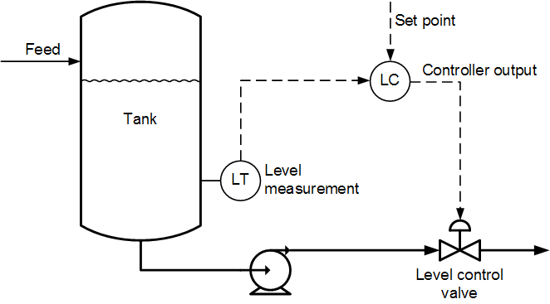
The basic control system of a storage tank would ultimately monitor the level of the tank and when it reaches its high-level alarm, open certain valves and turn on certain pumps to lower the level of the tank. On the other hand, if the level is too low, the control system must react and increase the level of the tank if product is available. To achieve this the control system must have many different components and sensors.
The image above shows how a level sensor (LT) will constantly be monitoring the level of the tank. A selected set point will be inputted to the level controller (LC) and when the level sensor reads the set point, the level controller will send a signal to the level control valve which will open. It will also send a signal to the pump, turning it on and allowing the product to flow out of the tank through the control valve.
A common type of level sensor that is used is a float level sensor. This will consist of a magnetic float which will rise and fall with the level of the fluid inside the tank. The sensor will also have a magnetic switch that will activate once the float has reached a specific set point level. This switch will send a signal to the level controller which will then open the level control valve. The level sensor will act as the measurement element in the control system.
The Level controller is where the set point is inputted. This will act as the comparison element to the system as it will detect when the level inside the tank reaches the set point. Once the set point (maximum level alarm) has been reached, it will send a signal to the control valve to open.
The level control valve is controlled by the level control and the level sensor but in some cases, it may have a manual override in case the other systems fail as this will allow you to manually open the valve. The valve is the correction element in the control system as it is able to lower/control the level of fluid inside the tank. When the level hits the set point, a signal will be sent to the control valve causing it to open. The percentage that you want the valve to open could be set in certain controllers. Once the low-level alarm is hit, the controller should signal the control valve to fully close.
The advantages to this control system are that it is closed loop, meaning that personnel will not be required to manually adjust the level in the tanks. Another advantage is that it is a simple control system and doesn’t contain too many elements which lowers the risk of failure. Some disadvantages may include that when one element of the system fails, it will have an effect on the whole control system. To eliminate this, a bypass could be put over the valve to use if the system does fail.

A2: Assess and select an appropriate control strategy for an operating procedure to an industrial process. Examples should include continuous control, batch control and sequential control. Include in your answer any advantages and disadvantages with respect to your chosen control process.
In the refining industry, there is constantly product being imported and exported. This product is commonly stored in tanks, and it is vital that the control systems in the tanks continuously keep the product coming in and out.
When applying control systems to an industrial process, it is also just as important to implement and control strategy. This strategy can be followed to efficiently complete the specific process.
In the case of product moving in and out of tanks, with the control system used in task A1, I think the correct control strategy to use would be continuous control. This strategy would allow the control system to monitor the tank level at all times, opening and closing the level control valve to alter the level in the tanks. With the continuous monitoring and control of the fluid level of the tanks, I think that this is the most efficient way of allowing product to enter and leave the refinery. The one downside to this strategy is that it may be stopped if some elements of the control system fail. If they do fail, then the monitoring and control of the fluid level in the tanks will not be continuous.
Another strategy that could be used for this industrial process is batch control. This would allow the tank to fill up in one batch before being released from the tank. This method could work for the control of tank level, but I think that it wouldn’t be as efficient as the continuous strategy as you would need to wait for the tank to reach its maximum level, then empty before filling up again whereas with continuous control, the tank will never be completely full or empty but will have a steady level.
One other strategy used in industry is sequential control. This is where the control and measurements are taken in a specific sequence. The sequence will depend on the application or equipment that is being controlled.

Part B. Industrial Control Systems
Exercise B1 - Tuning a PID controller using the ultimate cycle tuning method.
In this exercise you will be using the ultimate cycle method to tune a three-term controller. The TSC process simulation software will be used for this exercise. Initial conditions are: Proportional Gain = 2.0, Integral Time Constant = 0, Derivative Constant = 0.
I firstly set the set point to 25%, the proportional gain to 2 and the control actions to 0. These initial figures are shown in the image below.

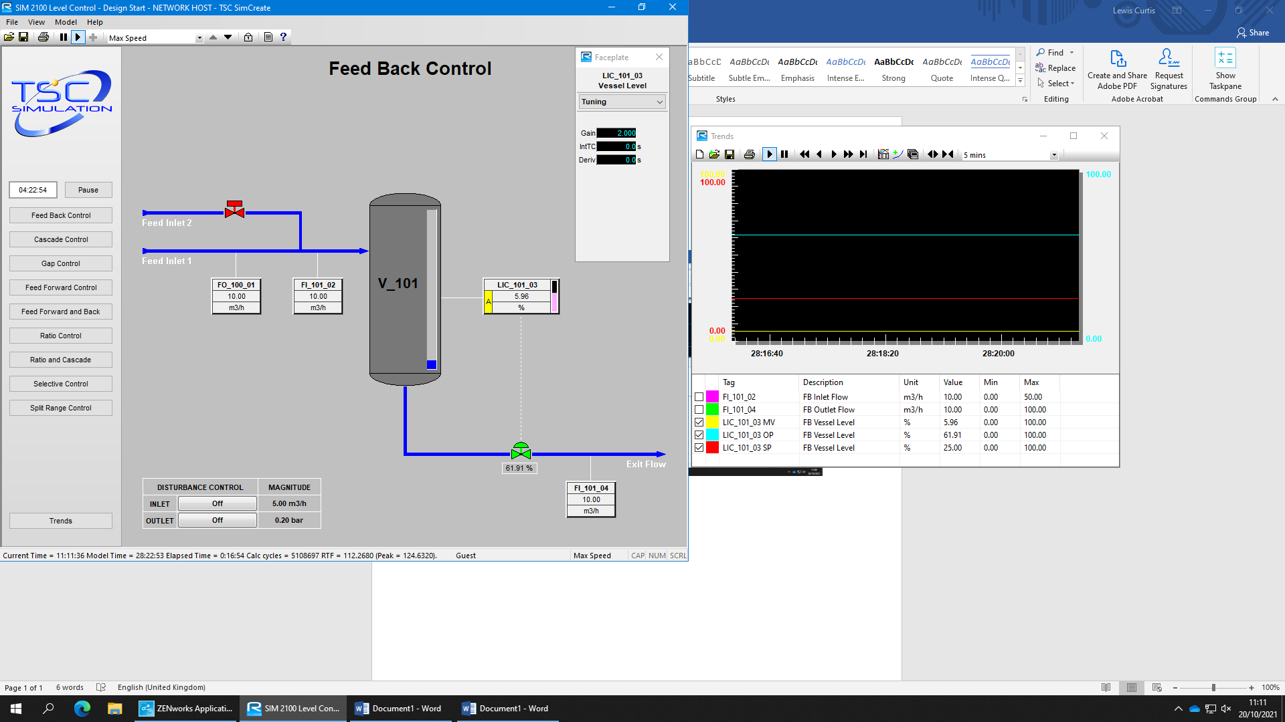

The set point was increased to 40%. This showed a slight percentage increase of both LIC_101_03 MV (yellow line) and LIC_101_03 SP (red line). This is shown in the screenshot below
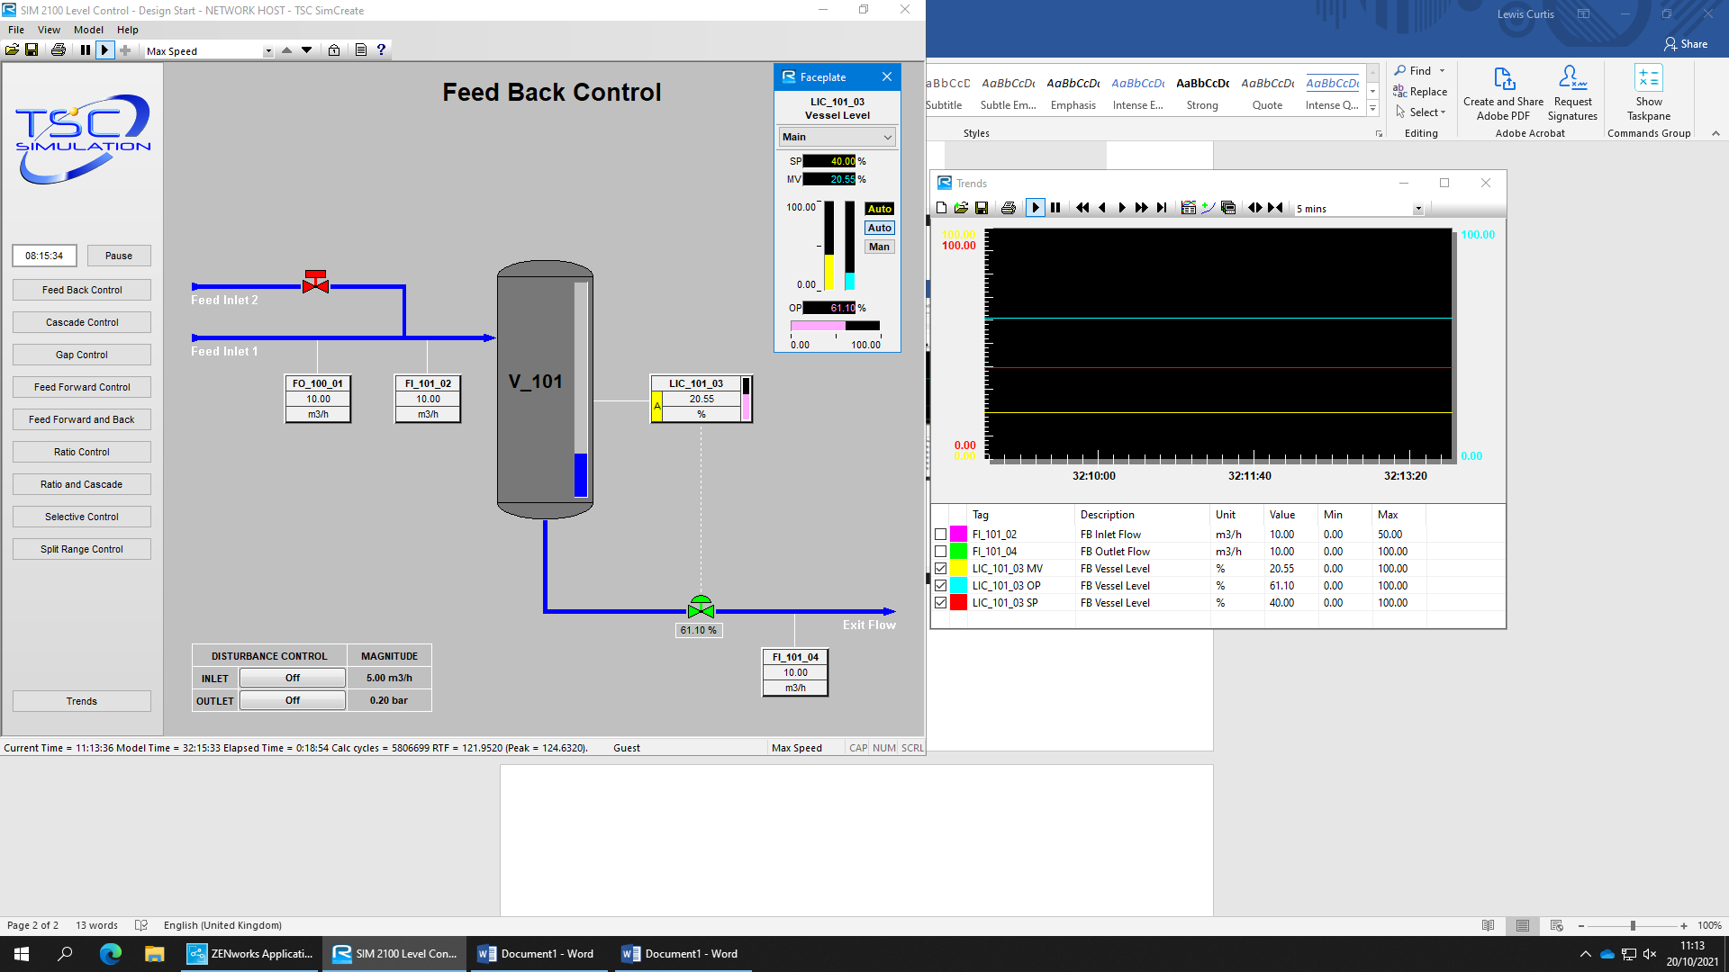

Next, I returned the set point to 25% and increased the gain to 5K_{u}. This is shown in the screenshot below.
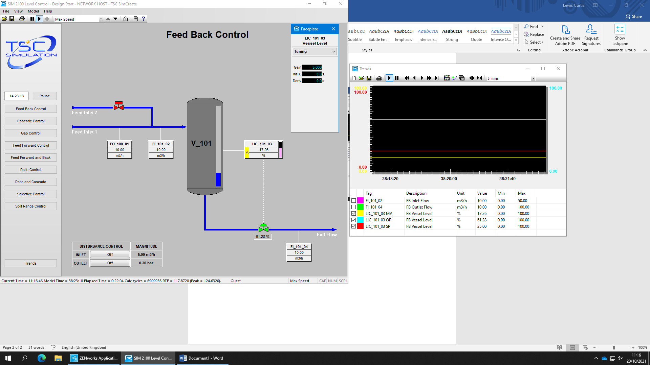

After slightly increasing gain, I found sustained oscillatory behaviour which does not increase or decrease in amplitude achieved at gain 7.65K_{u} and set point 25%
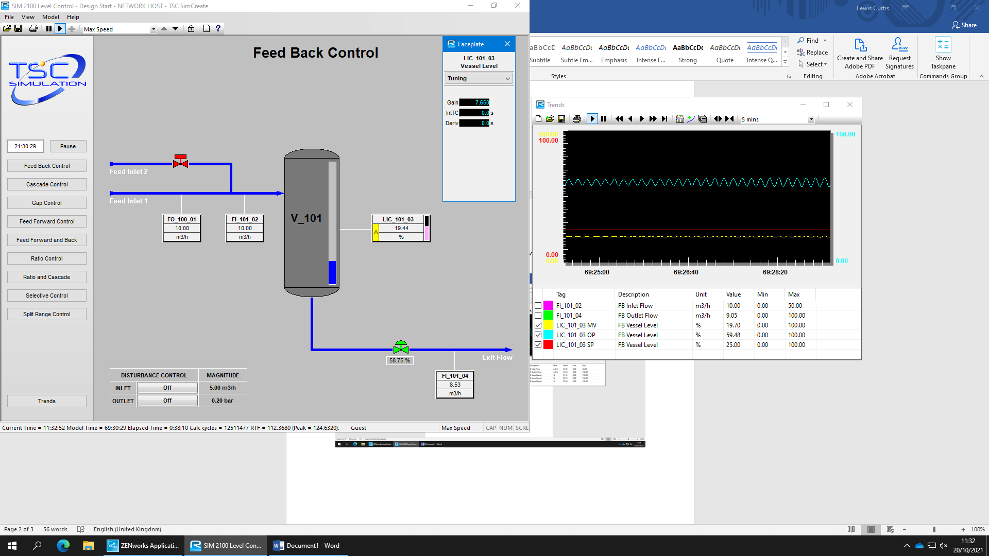

T_{u} = 10 as peak-to-peak difference is 10 seconds (80:41:14 / 80:41:24)
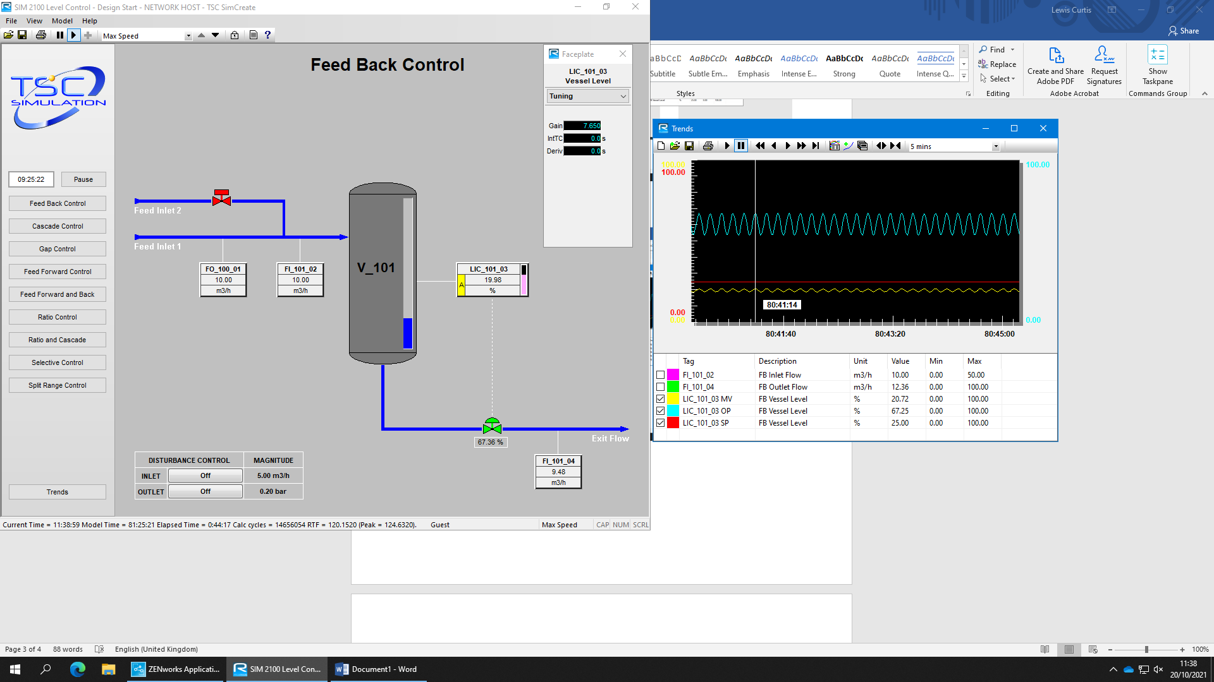
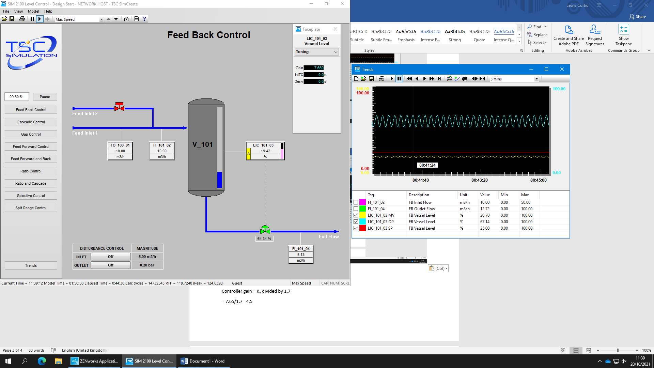
Controller gain = K_{u} divided by 1.7
= 7.65/1.7= 4.5
Integral (T_{i}) = T_{u} divided by 2
= 10 / 2 = 5
Derivative (T_{d}) = T_{u} divided by 8
= 10/8 = 1.25
I applied my calculated values to PID setting for level control system. The screenshot below shows that the controller had been successfully tuned.
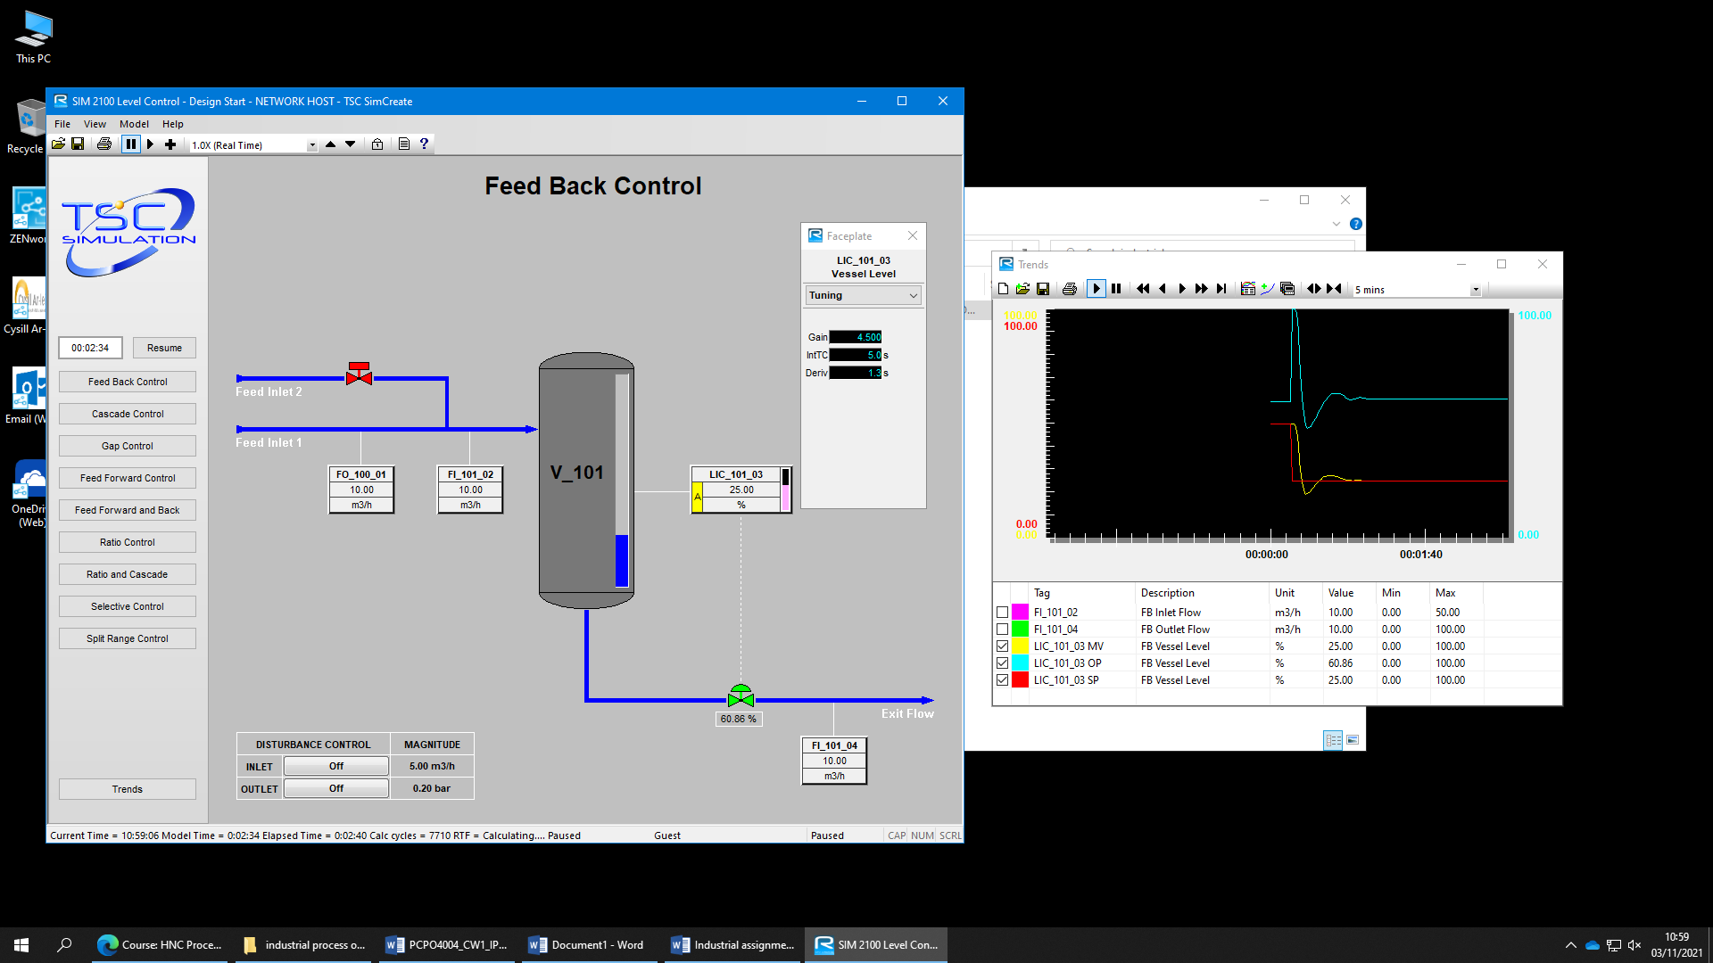

The graph in the screenshot above shows how the controller has been successfully tuned as the yellow line (LIC_101_03 MV) eventually evens out and ends up in line with the red line (LIC_101_03 SP). The graph does show a slight undershoot below the red line followed by an even smaller overshoot before the yellow line levels out.

Exercise B2 - Tuning a PID controller using the reaction curve tuning method.
In this exercise you will be using the reactive curve method to tune a three-term controller.
The TSC process simulation software will be used for this exercise.
Initial conditions: Proportional Gain = 2.5, Integral Time Constant = 0, Derivative Constant = 0.

The Controller was firstly set to auto and normal operating conditions are set (Proportional Gain = 2.5, Integral Time Constant = 0, Derivative Constant = 0.). The initial settings inputted onto the controller are shown in the image below.
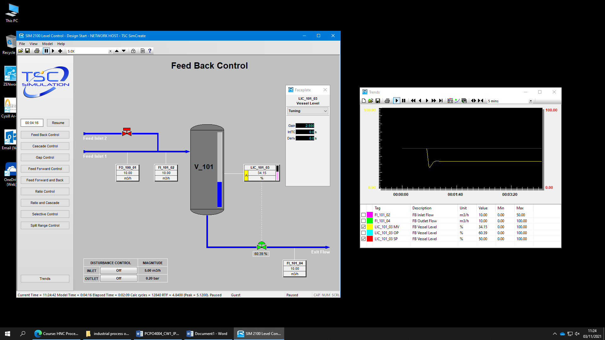

I then applied a small step change (+15 set point) to the controller output. This showed a sudden percentage increase of both LIC_101_03 SP and LIC_101_03 MV. This change is shown on the graph on the image below.
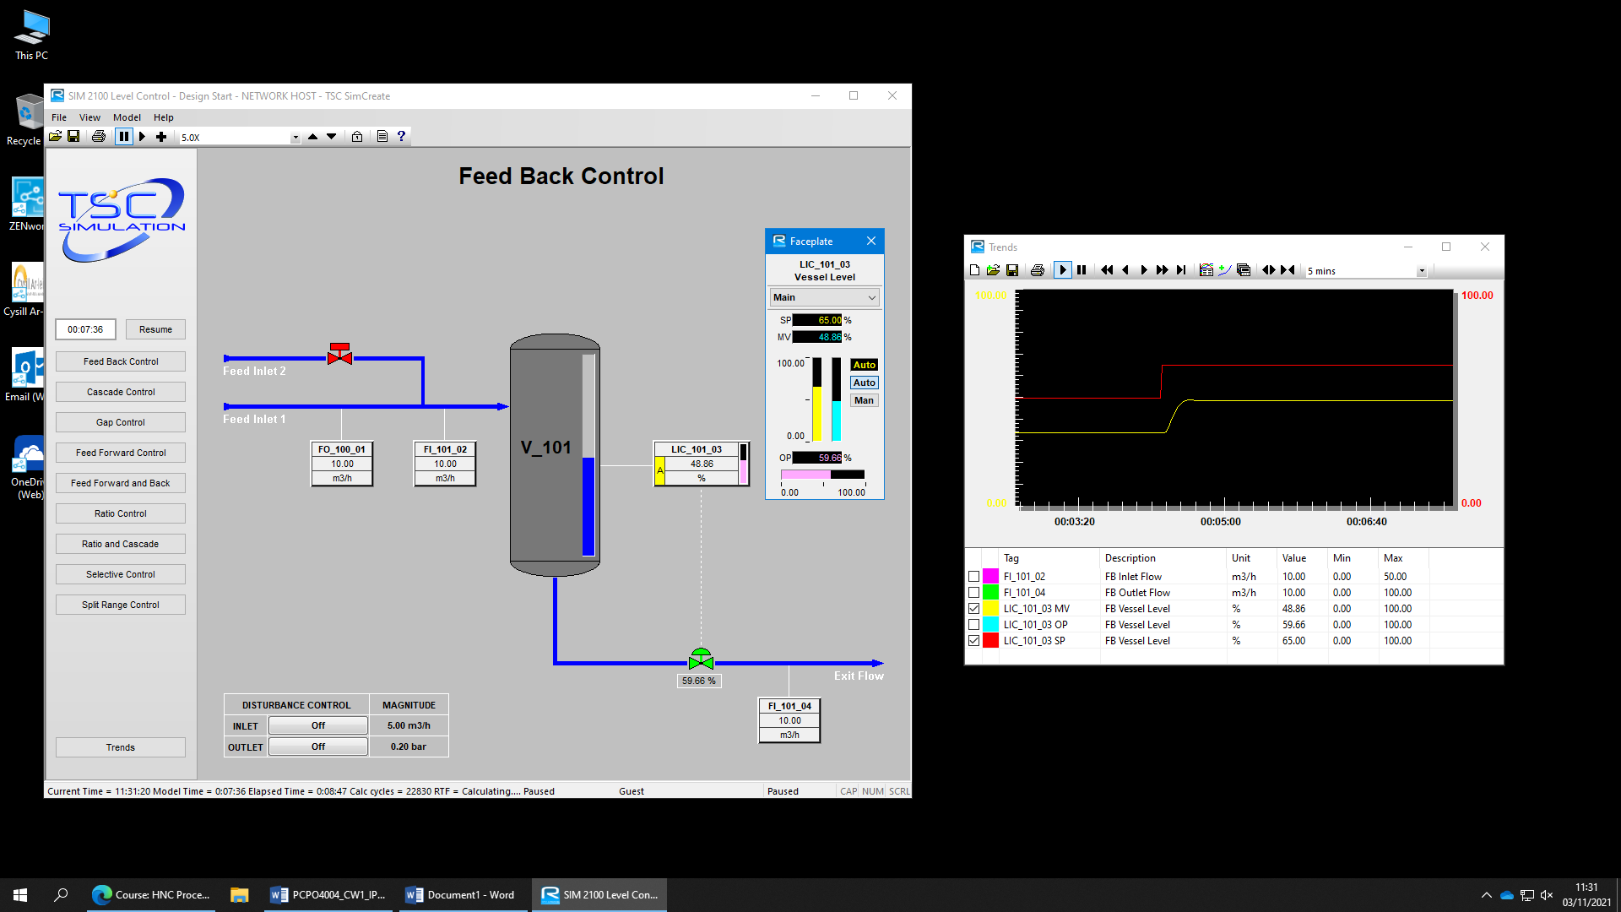

∆U
ND
D

Control Type | PID
Controller Gain | 1.2(Δu ÷ ND)
Integral (Ti) | D ÷ 0.5
Derivative (Td) | D ÷ 2
The effective time delay (D) is approximately 7 seconds. This was the time measured between the application of the step change and the point where the maximum slope intersects the plant initial response point.
ND is approximately 6.
∆U is approximately 14.
Controller gain = 1.2x(14/6) = 2.8
Integral (Ti) = 7/0.5 = 14
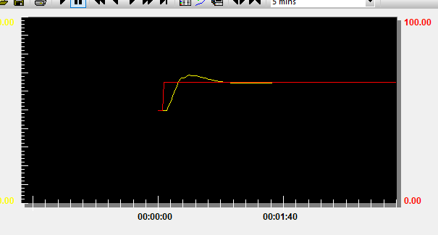
Derivative (Td) = 7/2 = 3.5
The graph above shows the controller with the new values inputted. This shows that the controller had been successfully tuned as the yellow line (LIC_101_03 MV) had risen and levelled out. It shows that it had slightly overshot but quickly levelled out.

Part C Control systems evaluation
Examine, compare and contrast the ultimate cycle and reaction curve methods used to tune the three-term controller, in particular on issues associated with the following:
•Techniques to achieve controller PID values.
•Application of the final values and system response.
•Key characteristics such as rise time, overshoot, steady state error.
Ultimate cycle and reaction curve are two methods commonly used to tune a three-term controller. Both methods are good ways of doing so and come with their own advantages and disadvantages.
Both the ultimate cycle method and the reaction curve method were published by J.G. Ziegler and N.B. Nichols in 1942. The ultimate cycle method is for a closed loop whilst the reaction curve method is for an open loop. In the previous task, I used both of these methods to tune a virtual controller on the TSC software. Both methods worked well but showed multiple differences in the way that they came to tuning the controller.
The first major difference in these two methods that I noticed is when I firstly increased the set points of both methods, the red and yellow lines of the ultimate cycle had a sudden percentage increase with both lines rising. This had a similar effect on the reaction curve method, but this showed more of a slow curve reaction to the set point change.
From looking at both trend graphs given by the controller, it is clear that the ultimate cycle method, which firstly has an oscillating pattern, is more unstable than the slow increasing reaction curve method. This is also shown when both controllers are finally tuned as the ultimate cycle method first undershoots, then overshoots before levelling out whilst the reaction curve method has a very small overshoot before levelling out.
When I made my final calculations and inputted them into the controllers, they both gave a firstly different, then a clear response to one another. The difference being that when the newly calculated results were inputted, the yellow line of the ultimate cycle method rapidly decreases. Once it begins to increase again, it shows a very similar pattern to the ultimate cycle curve where it gives a slight overshoot before levelling out. Neither of the graphs showed a steady state error which is an advantage to both methods.
When looking at both methods, it is clear that the oscillating pattern of the ultimate cycle method shows a much more unstable, but quick to react, method of tuning a controller which will be more suited for applications where a quick response is needed, such as flow and temperature control systems, and cannot be used for unstable processes. The reaction curve method, with its slow reacting curve, shown by the time delay (7 seconds in my example in the previous task), will be more suitable for slower acting processes where an instant reaction isn’t needed, such as large storage tanks and large temperature control systems.
Even though the ultimate cycle method is a faster reacting method, it may take slightly longer to perform the method. This is because you will need to keep increasing the set point until the plant exhibits sustained oscillatory behaviour which does not increase or decrease in amplitude whereas, in the reaction curve method, the steps are followed, and a direct reaction is given without having to constantly change factors such as the set point.
In conclusion, I think that both of these methods are good and are not overly difficult to perform when following the correct procedure. They have multiple differences which suite them better for different applications but when used for the correct application, both methods should give good results. The main benefit to both of these methods is that they can be used for such a wide range of industrial control systems and for either an open loop system or closed loop system.

References
- Process Industry Forum. (unknown). Level Control Selection Guidelines. Available: https://www.processindustryforum.com/article/level-control-selection-guidelines. Last accessed 02/2022.
- Alexander Wiegand. (2013). How Liquid Level Sensors Work. Available: http://www.tc-fluidcontrol.com/about-us/blog-posts/how-liquid-level-sensors-work/#:~:text=Some%20types%20of%20liquid%20level,reed%20magnetic%20switch%20is%20activated.. Last accessed 02/2022.
- Jacques Smuts. (2010). Ziegler-Nichols Closed-Loop Tuning Method. Available: https://blog.opticontrols.com/archives/131. Last accessed 02/2022.

