

Strategic Management (LCMB7003)

Strategic Analysis of Volvo Company

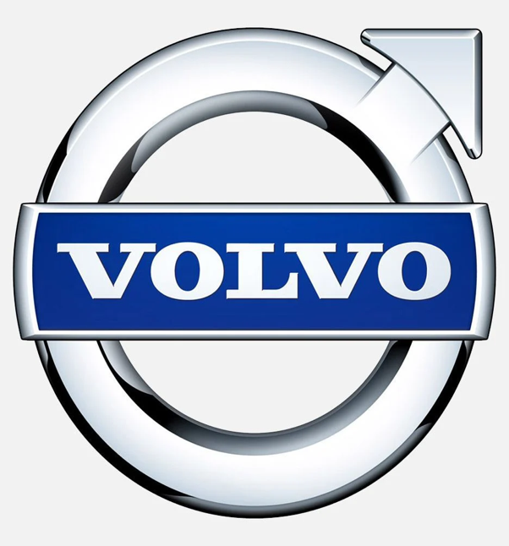

Student name: Vladimir Rebrik
Student Number: 1914780
Lecturer: Gladius Kulothungan
Word count: 5739
Submission Date: 01.09.2023

Table of Contents

Table of Contents....................................................................................................2
1. Introduction..........................................................................................................3
2. Volvo Cars background.......................................................................................3
3. Volvo Cars Mission and Objectives.....................................................................3
4. Macro-Environment Analysis of Sweden.............................................................4
5. Micro-Environment Analysis................................................................................4
6. Internal Analysis..................................................................................................7
7. Volvo Car's strategic resources and capabilities.................................................7
8. Strategies to Sustain Competitive Advantage....................................................17
9. Growth Strategies..............................................................................................18
10. Corporate Social Responsibility.......................................................................19
11. Conclusion and Recommendations..................................................................20
12. References........................................................................................................21
13. Appendix...........................................................................................................25

Introduction
As part of the UWTSD MBA Strategic Management module, this report aims to comprehensively analyse Volvo Cars' case study and the strategic management processes implemented to achieve the company's goals. Volvo Cars have faced challenges in recent years, such as increasing competition, rising costs of materials and developing new technologies, and instability in the supply chains. To stay competitive, Volvo Cars has made several strategic changes, including focusing on electrification, autonomous driving, and connectivity. This report will analyse Volvo Cars' strategic management and how it adds value to its products and receives competitive advantages over its rivals. It will first provide a brief overview of the company's background, current situation, mission, objectives, strategic resources, and capabilities. The report will evaluate internal and external environments and factors to identify the company's potential opportunities and challenges. To accomplish this, the report's author will explain and apply various strategic management concepts and tools, such as PESTEL analysis, SWOT analysis, Porter's Five Forces, Ansoff Matrix, and others. In the final section, the author will provide conclusions and recommendations.
Volvo Cars background
Automobile manufacturer Volvo Cars, located in Gothenburg, was previously a part of AB Volvo until 1999, when it was sold to the Ford Motor Company. It has been owned by the Chinese Geely Holding Group since 2010. Despite this change in ownership, AB Volvo and Volvo Cars still share the Volvo logo.
The history of Sweden's most significant car company dates back to 14 April 1927. The era of Volvo's safety dominance began in 1957 when the 120 Amazon model appeared on the roads of Sweden and fitted a three-point safety belt. Since then, the company has become famous for improving its active and passive safety features. It has a long list of safety innovations implemented over the years to mass-produce cars (MarketLine, 2013). As of December 2022, Volvo Cars employed around 43,200 full-time employees. Volvo Cars' production plants are situated in Gothenburg, Ghent (Belgium), South Carolina (US), Chengdu, Taizhou, and Daqing (China). The company owns research and design centres in Gothenburg, Camarillo (US), and Shanghai (China). Today, Volvo Car is a highly respected and globally recognised car brand, with sales to customers in more than 100 countries. For 2022, Volvo Car Group recorded an operating profit of 22.3 billion SEK and revenue amounted to 330.1 billion SEK, up 17 per cent compared to the previous year. At the same time, global sales reached 615,121 cars (Volvocars, 2022).
Volvo Cars Mission and Objectives
"For a better future. We want to provide you with the freedom to move in a personal, sustainable, and safe way," - the official Volvo website claims (Volvo Cars, 2021). Volvo Cars' mission is to simplify life and make it more convenient and safer. To achieve this mission, Volvo Cars has established the following objectives:
• to achieve climate neutrality by 2040.
• to become a circular business by the same year.
• to establish Volvo Cars as a leader in ethical and responsible business practices.
The company prioritises safety, sustainability, and social responsibility as the three pillars to help create a better future for everyone (Volvocars.com, 2022).
Macro-Environment Analysis of Sweden. PESTEL Analysis
Companies often analyse their external and internal environments to identify opportunities and set goals to gather valuable information. The PEST framework is helpful and adaptable for understanding changes within a broader context. It categorises influential factors into political, economic, social, and technological categories, allowing enterprises to identify potential threats and opportunities. Furthermore, by adding legal and environmental factors, PEST can be expanded to PESTLE analysis, which assists businesses in assessing factors such as laws and regulations governing businesses, climate change, natural disasters, and resource depletion (Rugman,2012).
According to the PESTEL Analysis of Sweden conducted by the author, see Appendix A,
Sweden is a highly conducive environment for Volvo Cars to thrive. The political system is stable and predictable, ensuring Volvo Cars can operate without any or minimum disruptions. Furthermore, Sweden has a strong economy with low unemployment rates and a highly skilled workforce. This helps create a supportive culture that promotes innovation and creativity, increasing productivity and competitiveness for Volvo Cars. The Swedish government's focus on environmental protection aligns with Volvo Cars' commitment to sustainability, making it easy to operate in an eco-friendly and socially responsible manner.
Overall, combining these positive factors gives Volvo Cars a competitive edge in the automotive industry, enabling the company to remain a leading player in the market and industry.
Micro-Environment Analysis
Strategic micro-environment analysis is the process of evaluating factors that directly impact an organisation's competitiveness. This includes comprehending customers' requirements and competitors' strengths and weaknesses, maintaining healthy relationships with suppliers, selecting the proper distribution channels, and complying with government regulations. Understanding these factors assists organisations to develop strategies to achieve their strategic goals (Thompson et al., 2019).
Industry Life Cycle Model
The Industry Life Cycle Model explains an industry's five stages - introduction, growth, shakeout, maturity, and decline. Only a few competitors are in the introduction stage, and the product or service is new. In the growth stage, the industry expands rapidly, and new rivals enter the market. In the shakeout stage, weaker rivals are forced out of the market. The maturity stage of the industry is marked as saturated with little growth. Finally, the decline stage is when the demand for the product or service decreases, and some rivals exit the market (Porter, 1980).
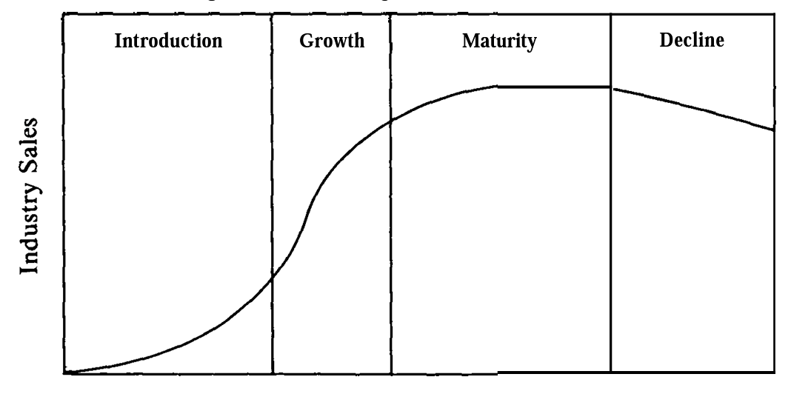
Figure 1. Stages of the Life Cycle (Porter, 1980).
In the author of this report's opinion, Volvo Cars products are in the maturity stage of the automotive industry life cycle, facing competition from other premium brands such as BMW, Mercedes-Benz, and Audi. While the industry is experiencing a gradual growth rate, here are some of the factors driving the maturity of the Volvo Cars industry life cycle: technological advances, globalisation, and ecological concerns. Despite these challenges, Volvo Cars has a strong brand reputation, a focus on safety and innovation, and a global presence. The industry's future is uncertain due to unique challenges, such as the shift to electric vehicles and autonomous driving.
Porter's Industry Five Forces Analysis
An industry's competitive landscape and potential future changes can be analysed by using Porter's five forces. These forces include rivalry among existing competitors, the threat of new entrants, the threat of substitute products or services, the bargaining power of suppliers, and the bargaining power of buyers. By analysing these factors, businesses can make informed decisions such as introducing new products or services, improving efficiency, differentiating current offerings from competitors, improving quality, and targeting specific niches (Rugman,2012).
Scandinavia automotive Industry Porters five Forces analysis
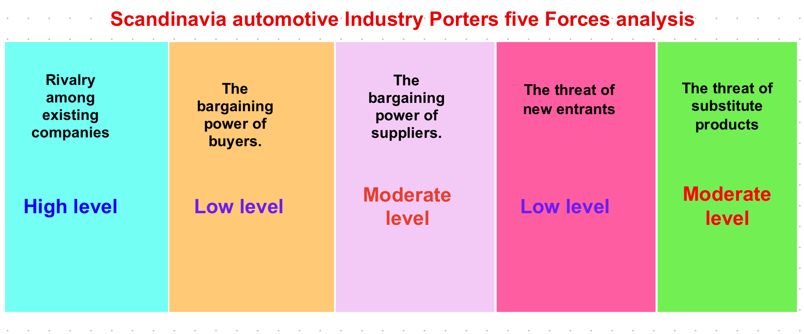
Figure 2. Scandinavia Automotive Industry Porter's Five Forces analysis
Rivalry among existing companies. High level.
Competition in the automotive industry is intense as companies vie for customers through pricing and non-pricing strategies. High exit barriers increase competition, and offering extended warranties or service agreements with new cars is common. Differentiation exists in the industry, but some companies service multiple segments. Lower electricity costs in Sweden give Scandinavian manufacturers an advantage and increase their profitability; overall, the degree of rivalry in the industry is substantial.
The bargaining power of buyers. Low level
Car dealerships act as middlemen between manufacturers and consumers, limiting buyer power through exclusive contracts. Product differentiation is limited, and environmental concerns are increasing the popularity of hybrid and electric cars. Tariffs on imported steel and aluminium have increased costs for manufacturers, eventually not benefiting consumers. Buyer power is limited, with potential forward integration by key industry players. Overall, buyer power in the auto manufacturing industry is weak.
The bargaining power of suppliers. Moderate level
The number of potential suppliers In the automotive industry is high, which limits the power of suppliers. However, switching costs are high due to the significant initial investment required for designing and specifying parts. The threat of suppliers integrating is unlikely. Supplier power is reduced due to low differentiation of raw materials, but the requirement for high-quality materials can increase it. Import tariffs and fluctuating prices of primary raw materials can impact the power of suppliers. The upstream competitive landscape is fragmented, but consolidation trends in the steel industry could increase supplier power. Overall, supplier power is moderate.
The threat of new entrants. Low level.
The Scandinavian automotive industry prioritises brand strength, and reputation is highly valued, making it difficult for new players to enter due to high fixed costs and economies of scale. This industry is semi-differentiated, requiring significant research, development, and manufacturing investments.
The presence of established players diversifying into electric vehicles limits the threat of new entrants. Although self-driving technology is seeing growth in the industry, the threat of new entrants is weak overall.
The threat of substitute products. Moderate level.
Substitutes for the automotive industry include used cars, car sharing, and finance packages for new vehicles. During economic downturns, dealerships sell more used cars, which can threaten manufacturers. Scrapple schemes can incentivise customers to buy new vehicles, reducing the threat of used cars. There are several alternative modes of transportation, such as public transportation, bicycles, and motorcycles. However, cars remain the most popular mode of transportation for many people, and overall, the threat of substitutes to the automotive industry is moderate (MarketLine, 2023).
Internal Analysis
Volvo Car's strategic resources and capabilities

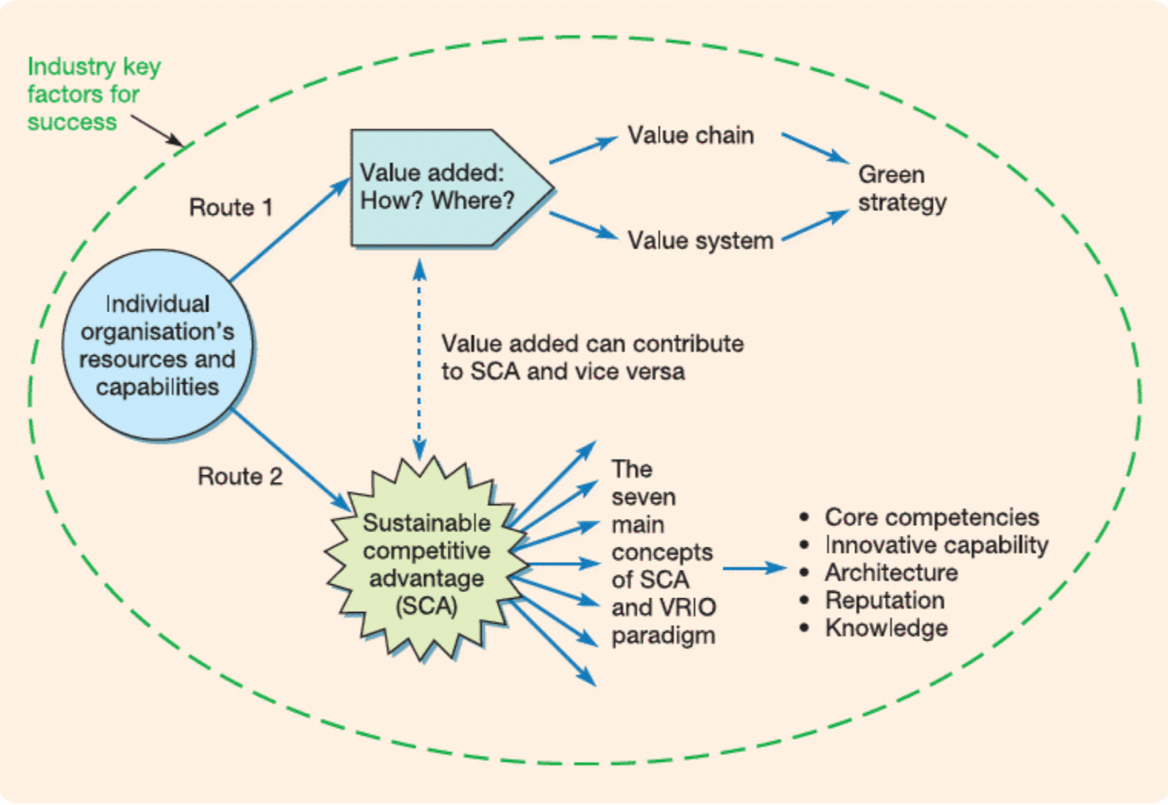
Figure 3. Analysing resources and capabilities (Lynch, 2018).
Analysing an organisation's resources and capabilities involves examining and understanding two key issues. The first is how resources can generate superior profits and provide optimal services, known as the value-added strategy. The second issue is which resources and capabilities offer an organisation a competitive advantage and how they can be improved over time. Therefore, the resource and capabilities analysis focuses on two parallel and interconnected routes: the value-added explores how a company adds value to its inputs, and the other is a sustainable competitive advantage, identifying unique resources that enable the organisation to compete (Lynch, 2018). Organisations can possess three categories of resources and capabilities: tangible resources, such as property, infrastructure, and equipment; intangible resources, such as brand name, technology, and patents; and organisational capabilities, including leadership, routines, management, and workforce skills. Organisations must effectively utilise and share these resources to create value, connect various parts and departments, and coordinate activities.
Volvo Cars Tangible Resources
Volvo Cars has three global headquarters: Torslanda, Gothenburg in Sweden, Mahwah in the USA, and Shanghai in China. They also have regional offices in Europe, the Middle East, and Africa. Volvo Cars operates five production facilities globally. The largest plant in Gothenburg, Sweden, produces various vehicles, including the XC90, XC60, and S90 (Volvocars, 2021). The Ghent plant in Belgium produces the XC40 and S60 models. The S60 and XC90 are also manufactured specifically for the North American market in Charleston, South Carolina, USA. The Chengdu factory in China produces various models for the Chinese market, such as the S90, XC60, and XC90. The second plant in China in Daqing specialises in making the S60 and XC40 for the Chinese market (Volvocars, 2021). Additionally, Volvo Cars will open a new production plant in Kosice, Slovakia, in 2024, focusing only on electric vehicle production (Volvocars, 2023).
Volvo Car's intangible resources
Strong brand image
Volvo Cars is a well-known and respected brand in the automotive industry, with a strong reputation for safety, reliability, and environmental sustainability. The company's focus on safety innovation has resulted in consistently high vehicle safety rankings; according to a 2022 survey by Brand Finance, Volvo Cars was the world's 10th most valuable car brand. Volvo Cars' strong brand reputation helps it attract new customers, command premium prices, and build its loyal customer base (Brandirectory, 2023).
Advanced technology
Volvo Car is a renowned brand in the automotive industry for its original advanced safety technologies. Some of the safety features offered by Volvo include City Safety, Blind Spot Information System, Pilot Assist, Run-off Road Mitigation, and Cross Traffic Alert. By utilising radar, cameras, powerful computer hardware and software and navigation systems, these technologies detect potential collisions, keep the car centred in its lane, prevent run-off, detect vehicles in blind spots, and warn drivers of crossing vehicles when reversing. With these safety features, Volvo is consistently ranked among the safest cars on the road (Volvo Cars, 2021).
Original own patents and developments
Volvo has 8583 unique patent families globally, with 21341 total patents; 10965 are still active as of 2022. Volvo Cars has patented several innovative technologies that have become standard in the automotive industry. These include the three-point seatbelt, now used almost in any vehicle, a side-impact protection system to ensure passenger safety in collisions, and a pedestrian airbag to protect pedestrians in car accidents. Additionally, Volvo has patented a hybrid powertrain that combines gasoline and electric power, which improves fuel efficiency. Although still in development, a self-driving vehicle patent has the potential to revolutionise the way people travel.
Volvo Cars' patents are a valuable asset for the company. They help to protect the company's intellectual property and give it a competitive advantage in the automotive industry. The company's patents also contribute to the safety and sustainability of its vehicles.

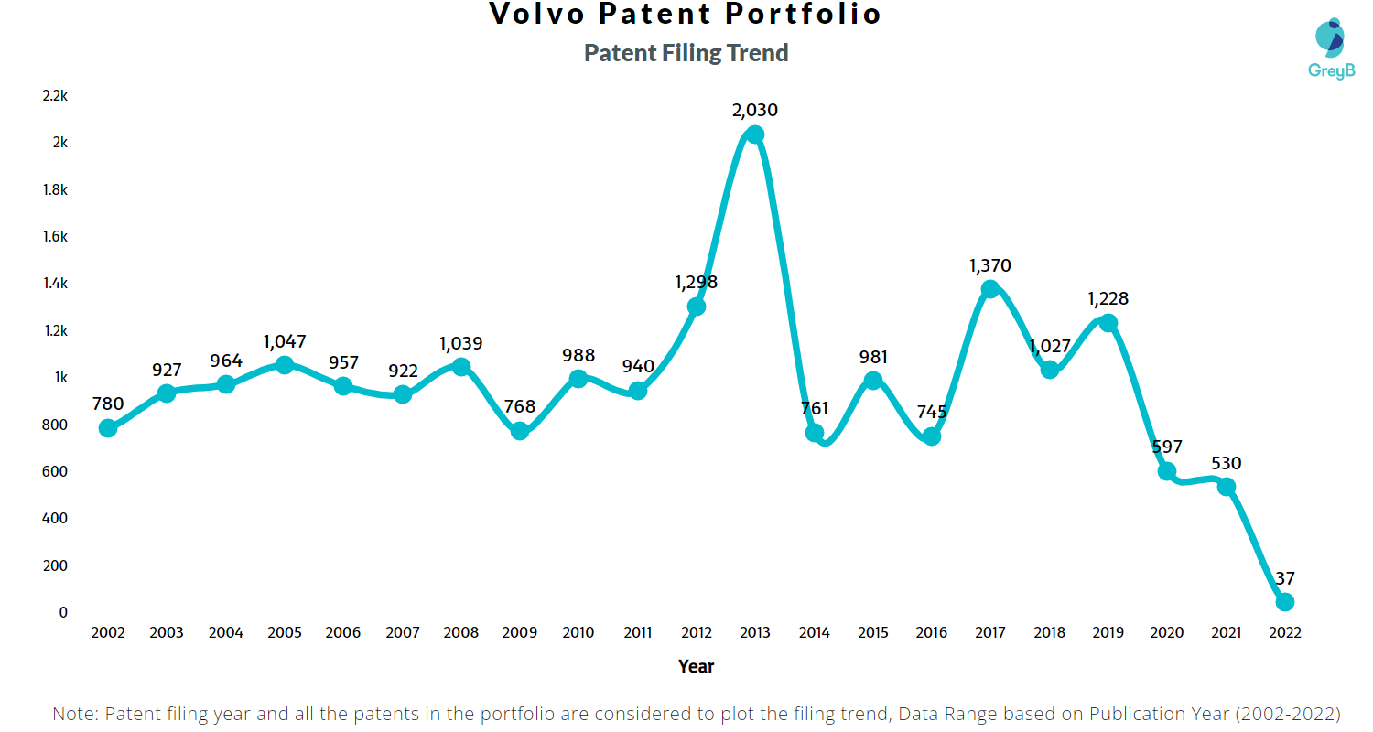
Figure 4. Numbers and trends of Volvo patents portfolio
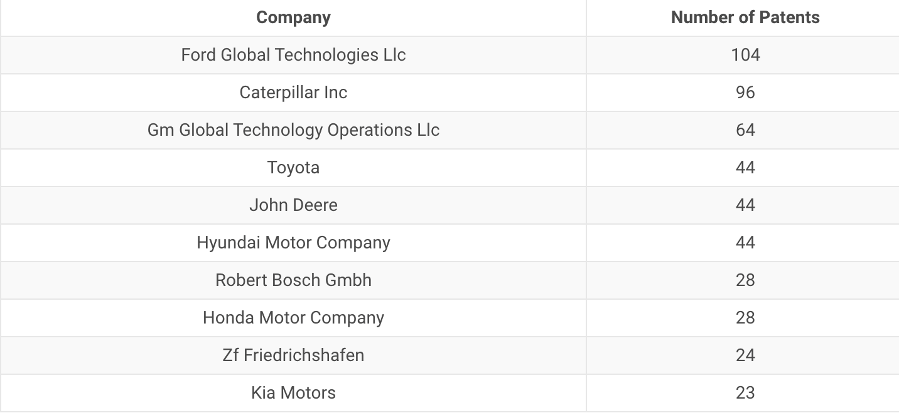
Figure 5. displays some of the enterprises using Volvo's patented technologies.

The patents owned by Volvo Cars are a critical asset for the company, protect the company's intellectual property and give a competitive advantage in the automotive industry. Moreover, these patents contribute to the safety and sustainability of the company's vehicles (Insights; Gate, 2022).
Volvo Cars organisational capabilities
People and Culture
Volvo Cars is driven by its core values of safety, passion, togetherness, and care. The company prioritising safety at all levels encourages education, collaboration and teamwork and strives to create a sustainable future. The Volvo employees are enthusiastic and passionate about making the safest, most reliable, and environmentally friendly cars globally. These values have helped Volvo Cars create a desirable workplace and produce some of the world's most respected automobiles (Volvogroup.com, 2023).
Sales and marketing capabilities
﻿Volvo Cars boasts a strong global sales and marketing network, with over 2,300 dealers in more than 100 countries. The company prioritises investing in new marketing channels, such as online sales and subscription services. Volvo Cars utilises data-driven and personalised marketing, social media, and content marketing and strives to enhance its sales and marketing capabilities. The company is committed to continuous innovation to stay ahead of its rivals and expand its business (Volvocars, 2020).
Digital and software capabilities
Volvo Cars heavily invests in digital technologies, including AI, to improve safety features, personalise the driving experience, and collect extensive data from its cars. The company equips its vehicles with in-car connectivity, software updates over the air, and autonomous driving technology. Volvo will release its safest-ever line of vehicles with enhanced software and hardware levels and real-time data from customer cars. The company collects data from millions of kilometres driven by Volvo drivers worldwide to validate autonomous driving features and continuously improve safety features. Customers can share data to help Volvo Cars improve safety levels. Volvo Cars invests in a data factory with over 200 Pebibytes of data, and AI capabilities can crunch data at record times. The forthcoming fully electric flagship SUV will have top industry-leading safety technology as standard, including LiDAR sensors and an autonomous driving computer powered by NVIDIA DRIVE Orin™ (Volvocars, 2021).
Value Chain Analysis
For businesses to stay ahead of their rivals, it is critical to maintain a competitive advantage, which involves achieving cost leadership, differentiation, or a combination of both to create more value than the costs incurred. Value chain analysis helps management identify an enterprise's strengths and weaknesses in creating, moving, selling, and servicing its products. Creating value is a step-by-step process highlighting the resources and capabilities that improve efficiency and effectiveness. Primary activities are basic, such as making and moving products, while support activities provide the necessary infrastructure for the company. Both are essential to an organisation's success (Daniels, 2019).
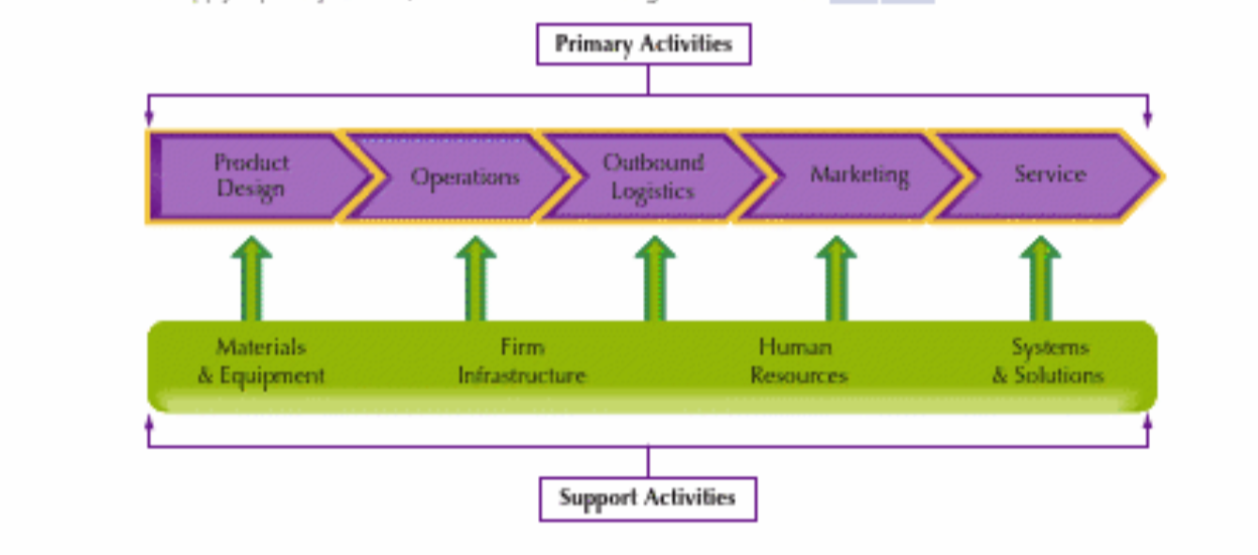
Figure 6. Visualising the Value Chain (Daniels, 2019).
Primary activities
One of Volvo Cars company strategies is to differentiate from rivals and add value to products by using primary activities of the value chain, which include:
Inbound logistics
• Volvo Cars prefers only high-quality raw materials, such as high-quality steel, aluminium, magnesium, plastics, and electronics, to ensure safety, durability, and improved vehicle performance. High-quality raw materials provide enhanced safety, increased durability, better performance, and reduced environmental impact.
• Since Geely acquired Volvo Cars in 2010, the company's inbound logistics have changed. Volvo Cars has increased its focus on China, invested in innovative technologies like blockchain and artificial intelligence, increased collaboration with suppliers, and prioritised sustainability.
Operations
Volvo's flexible assembly lines support multiple car models and have succeeded at their Torslanda, Sweden plant. Siemens Product Lifecycle Management Software Inc.'s Teamcenter and Tecnomatix process-development software help achieve the company's manufacturing flexibility. Tecnomatix also enables Volvo to transfer much manufacturing knowledge to its Chinese operations. The software features several tools, such as Process Simulate and Robcad, which let Volvo manage, plan, and simulate production processes (Assembly in Action: Process Planning Improves Volvo's Manufacturing Flexibility, 2012).
Outbound logistics
Volvo Cars makes its vehicles accessible to customers worldwide through its network of dealerships and retailers. To set itself apart, Volvo focuses on outbound logistics, including improving shipping methods to minimise product damage, ensuring timely delivery, offering flexible delivery options, and streamlining order-processing procedures. For example, Volvo Car UK has launched a new platform, Volvo Cars Selekt Direct, allowing customers to buy new and approved used cars online 24/7. All vehicles come with a 12-month Volvo Selekt warranty and UK-wide delivery. Volvo plans to sell all new electric models online and have most UK sales online by 2025, while retailers will handle servicing, maintenance, and repairs (Williams, 2022).
Service
Volvo Cars provides a wide range of after-sales services, such as maintenance, repair, and parts, ensuring a longer vehicle lifespan. Volvo stands out from other car manufacturers by providing exceptional service quality, dependable technical assistance, and prompt repair and maintenance services. One of Volvo Cars' unique offerings is the Bumper Program, which allows customers to split the cost of their service, repairs, or accessories into affordable monthly payments with 0% interest. UK customers can spread the instalments evenly from £60 to £5,000 and arrange up to 9 instalments depending on the total cost. To apply for the program, customers must mention "Bumper" and "0% interest" to a service team member (Volvocars, 2023).
Secondary Activities
Information systems
Volvo Cars uses a range of information systems to support its day-to-day operations. These systems include Enterprise resource planning (ERP), Customer relationship management (CRM), Product lifecycle management (PLM), Manufacturing execution system (MES), telematics, and infotainment systems. With their help, Volvo can effectively manage its essential business processes, customer communications, product development, manufacturing operations, vehicle performance, and driver experiences. Volvo Cars is dedicated to continuously investing in new technologies and advancements and improving its operations to ensure its customers' highest level of safety (Volvo Cars, 2022).
Human resource management
Volvo Cars has unique human resource management practices focusing on diversity, inclusion, employee development, sustainability, and staff well-being. Specific programs include:
- Unconscious bias training.
- Mentorship programs.
- Formal and informal training.
- Telecommuting options.
- Carpooling encouragement.
- Accessible electric vehicle charging stations.
- On-site fitness facilities.
- Flexible work arrangements.
- Employee assistance programs.
The company continually seeks ways to create environments where employees can grow professionally. For example, according to Chief People Officer Hanna Fager, Volvo Cars strategically aligns with an electric vehicle future by upscaling and reskilling its workforce while attracting new talent. HR is crucial in this transition, providing leaders and workers with new frameworks, policies, and training. Volvo Cars has changed its organisational structure, separating combustion engines into a separate entity to become fully electric by 2030. The company is also committed to collaborating with union representatives to ensure fairness for both employees and the company's long-term strategy (HBS Working Knowledge, 2023).
VRIO Analysis of Distinctive Resources and Capabilities
The VRIO framework is a strategic management tool to assess an organisation's resources and capabilities. It comprises four essential elements: Value, Rarity, Imitability, and Organization, which means a resource or capability that is valuable, rare, inimitable, and organised can provide a sustainable competitive advantage, allowing an organisation to outperform its rivals over the long term (Barney, 1991).
VRIO analysis of Volvo Cars:
Value
• Strong brand reputation for safety and reliability
Volvo Cars' distinguished standing for safety and reliability is a competitive advantage in the premium automobile market, where safety is paramount.
• Advanced safety technology: Volvo Cars is leading in advanced safety technologies with the incorporation of features like automatic emergency braking, lane departure warning, and blind spot monitoring, giving them a competitive edge in the market.
• Innovative design: Volvo Cars is known for innovative and cutting-edge design, their sleek and elegant looks. This design aesthetic has enabled the company to broaden its appeal and attract diverse customers.
Rarity
• Strong brand reputation for safety and reliability: This resource is rare because Volvo Cars' has spent many decades building its reputation for safety, which is hard to replicate.
• Strong dealer network: Volvo Cars has a rare and exceptional dealer network, providing excellent customer service compared to many other brands.
• Advanced safety technology: Volvo Cars' advanced safety technology is original, authentic, and rare. Other companies are starting to develop similar technologies, but Volvo Cars is still ahead of the curve.
• Innovative design: Volvo Cars' design innovation is exceptional; despite being copied by other car companies, Volvo Cars remains at the forefront of this area.
Inimitability
• Strong brand reputation for safety and reliability: Volvo Cars' brand is hard to copy due to its long-standing safety commitment. Other carmakers can try to copy Volvo Cars' safety features, but they cannot replicate the same level of trust consumers have in the Volvo brand.
• Advanced safety technology: Volvo Cars' safety technology is hard to copy; their expert engineers constantly develop new features, so competitors cannot keep up.
• Innovative design: Volvo Cars' unique designs are challenging to replicate. Their talented designers constantly generate fresh and exciting ideas while keeping traditional company lines. Other brands may copy some features but cannot match their creativity.
• Strong dealer network: Volvo Cars has a long history and relationships with its dealers, so others cannot easily replicate the same level of customer service.
Organisational Exploitation
• Strong brand reputation for safety and reliability: Volvo Cars can effectively exploit its strong brand reputation by using it to market its cars. The company's ads often highlight its safety features, which attract customers looking for a safe vehicle.
• Advanced safety technology: Volvo Cars can exploit its advanced safety technology by offering its safety features as standard on all of its cars, which helps to differentiate its products from its rivals.
• Innovative design: Volvo Cars exploits the innovative design
of its stylish and unique car to attract customers. The company's cars are often featured in popular fashion magazines and other publications, increasing their visibility.
• Strong dealer network: Volvo Cars can exploit its strong dealer network by providing excellent customer service where the dealers are always willing to go the extra mile for customers, almost guaranteeing Volvo customer loyalty.
Volvo Cars possess a range of resources and capabilities that are valuable, rare, and difficult to replicate by other carmakers, which provide the company with a competitive edge in the premium car market. However, Volvo Cars must continue investing in innovation and enhancing its brand reputation to maintain its advantage.
SWOT Analysis of Volvo Cars Company
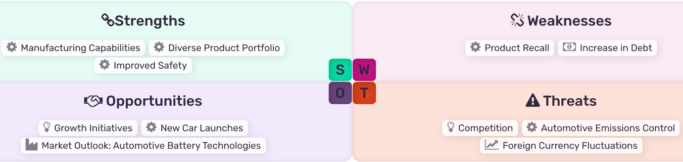
Figure 7. SWOT Analysis of Volvo Cars Company (MarketLine, 2023).

Strengths
• Manufacturing Capabilities
Volvo Car has efficient manufacturing capabilities with plants in China, Belgium, and Sweden. It added a new plant in South Carolina and, in the building process, a new factory in Slovakia, producing top-rated models such as S90 and XC60 globally.
• Diverse Product Portfolio
The company offers models in three categories: Electric, Hybrids and Mild Hybrids. In pure electric, the company provides SUVs and a crossover electric car. The company gives SUVs, state cars, and sedan plug-in hybrids in its hybrid category. Through its mild hybrids, Volvo Cars provides SUVs and Estate category cars. The company also offers special vehicles for Protection, Diplomatic and Police and Emergencies.
• Improved Safety
The company is known for creating some of the safest cars in the world by utilizing cutting-edge secure space technology and a combination of intelligent, innovative, and established safety features. For example, Volvo employs Lidar and advanced autonomous driving technology for unsupervised driving. The company also has a driver understanding system that detects distracted, sleepy, or intoxicated drivers, reducing speed or stopping the car. Additionally, they have created a driver understanding system capable of detecting drivers who are distracted, sleepy, or under the influence of alcohol or drugs and automatically reduce speed or stop the vehicle.
Weaknesses
• Product Recall
The company could be adversely affected due to product recalls, which could reduce the customer's confidence. In January 2023, the company identified specific 2023 car models due to a software issue linked to a broken control module. The recall affects 106,691 vehicles globally, which could affect the Volvo brand image and reduce sales if it cannot rectify this and satisfy its customers.
• Increase in Debt
Volvo Cars reported an increase in debt in FY2022 by 8.5% to SEK35,155 million, which could impact operations and make it difficult to raise funds. High debt levels may hinder strategic plans and leave the company vulnerable to economic and industry changes.
Opportunities
• Growth Initiatives
In 2023, Volvo Cars partnered with Wrisk to offer seamless insurance services. They signed an agreement with Tesla to allow its electric vehicles to use the Supercharger network, enhancing the user experience for customers. These initiatives aim to accelerate the company's growth perspectives.
• New Car Launches
Volvo Cars continuously launches new products to meet customer needs and keep up with market trends. In July 2023, the company launched the Volvo EX30 in North America, a versatile car with ample space. In June 2023, the company announced the launch of an electric vehicle, which enables customisation.
• Automotive Battery Technologies
The global automotive battery market is expected to grow to 119.9 million units by 2026 due to global political instability, dependence on oil, competition, and increasing carbon emissions. Rising gasoline prices have increased demand for electric and hybrid vehicles, which can result in a higher need for advanced automotive batteries, such as lithium-ion batteries, from which Volvo Cars will benefit.
Threats
• Competition
Volvo Car is in a highly competitive market with significant players like Volkswagen, Ford, and Toyota. Innovation, quality, pricing, reliability, safety, fuel economy, environmental impact, customer service, and financing terms are all factors in the competition. The highly competitive and pricing pressure can negatively affect Volvo's operating results and financial position.
• Foreign Currency Fluctuations
With operations in over 100 countries across the Americas, Europe, and Asia, Volvo Car faces the risk of unfavourable changes in forex rates, which can increase the company's expenses and affect the company's revenue generation in a particular region or market.
• Automotive Emissions Control
The UN ECE regulates emissions in Europe, and the EC imposes emission control requirements on vehicles sold in EU member states. Tax incentives can be given to manufacturers for meeting emission standards earlier. New European standards focus on reducing diesel emissions, which may increase costs and promote new technologies; the US has emission control requirements, including testing and recalling non-compliant vehicles, that can also impact Volvo Cars (MarketLine, 2023).
Strategies to Sustain Competitive Advantage
Strategies to sustain competitive advantage are a business's actions to maintain its competitive edge, including innovation, differentiation, focus, cost leadership, technology, branding, customer service, and partnerships (Barney, 1991).
Volvo Cars has several strategies in place to sustain its competitive advantage, which include:
• Focusing on safety,
• Investing in sustainability,
• Differentiation by combining safety, luxury, and sustainability.
• Investing in branding.
Here is an example of Volvo's strategy - focusing on customer safety. Ford Motor Company acquired Volvo Cars in 1999 and invested significantly in research and development (R&D) to develop advanced driver assistance systems (ADAS), including features such as adaptive cruise control, lane departure warning, blind spot monitoring, and automatic emergency braking, all designed to improve driver safety and convenience.
According to a SWOT analysis conducted by the author, being a part of Chinese Geely, Volvo Cars has shifted its focus from traditional cars to connected vehicles and autonomous driving technology in recent years. Volvo Cars again invested massively in (R&D) to develop and implement these new technologies.
It is evident that over time, despite being a part of totally different companies, Volvo Cars continues to be committed to the same strategy, differentiated from its rivals - primarily focusing on customer safety.
Porter's generic strategy framework
Also, using Porter's generic strategies framework helps identify Volvo Cars' competitive advantage. Porter's generic strategies are three business-level strategies that can help enterprises achieve competitive advantage: cost leadership, differentiation, and focus. It can be combined to create hybrid strategies. The decision of which strategy to adopt depends on factors, including the industry, the organisation's resources, and the demands of its customers (Porter, 1980).
Volvo Cars strategies to sustain its competitive advantage by Porter's generic strategies are:
• Cost leadership
Volvo Cars aims for cost leadership by reducing production costs through investments in new manufacturing technologies and streamlined operations, including China.
• Differentiation: Volvo Cars differentiates itself by offering unique products and services focused on safety, sustainability, and uniqueness of design and services.
• Focus: Volvo Cars chose a focus strategy by targeting specific market segments: the luxury car and SUV markets, with a strong focus on electric and hybrid vehicles.
Utilising these strategies, Volvo Cars has been able to sustain its competitive advantage for decades in the automotive industry and is well-positioned to continue to succeed in the years to come.
Volvo Cars Growth Strategies
The Ansoff Matrix is a strategic tool that helps enterprises identify, evaluate, and choose growth strategies: market penetration, product development, market development, and diversification (Ansoff, 1957).
Volvo Cars has used a variety of Ansoff Matrix strategies over the years. Here are some examples:
• Market penetration
Volvo Cars uses market penetration strategies to increase its sales and grow in existing markets. For example, the company launches marketing campaigns to promote its new electric and hybrid cars to existing customers. It increases brand awareness by running advertising campaigns and sponsoring sporting events such as Volvo Car Golf Scandinavian Mixed 2023.
• Market development: Volvo Cars uses market development strategies to expand into new markets. For example, the company has opened new dealerships in emerging markets such as China, now its largest market, and India. For that purpose, Volvo has also launched localized marketing campaigns to attract customers in these markets.
• Product development: Volvo Cars has used product development strategies to introduce new products to its existing customers. For example, the company has launched several new models, including the XC90 SUV and the S90 sedan, after developing their electric and hybrid versions. Volvo has also introduced new features and technologies to its existing models, like advanced safety and connectivity features.
• Diversification: Volvo has used diversification strategies to enter new businesses. For example, Volvo created Polestar to enter the electric vehicle market, establish one more premium brand, and become more flexible in exploring and developing new technologies and designs different from classic Volvos. The brand has been a success so far, with its first car, the Polestar 2, receiving positive feedback, and Polestar launched several new models, including the luxury electric SUV Polestar 3 (Polestar UK, 2023).
Corporate Social Responsibility
Global enterprises are responsible for prioritising ethical business practices through Corporate Social Responsibility (CSR) initiatives, which go beyond merely maximising profits and require businesses to align their policies with moral standards while respecting the rights of all stakeholders. Furthermore, CSR emphasises shared responsibility for social and environmental problems, ensuring companies operate sustainably and ethically (Maurice,2022).
Volvo Cars is committed to Corporate Social Responsibility (CSR) and aims to achieve it through three pillars: sustainability, ethical business practices, and societal engagement. The company's CSR initiatives include creating, developing, and manufacturing electric and hybrid vehicle programs utilising recycled materials, reducing water consumption, investing in renewable energy, promoting diversity and inclusion, supporting safety initiatives, and making charitable donations. Volvo Cars is a founding member of the Drive Sustainability network and has been awarded a Bronze in the 2021 Corporate Sustainability Assessment by S&P Global. As one example of Volvo Cars' social ethics programme to support this commitment, the elements of the program can be summarised as Prevent, Detect and Manage.
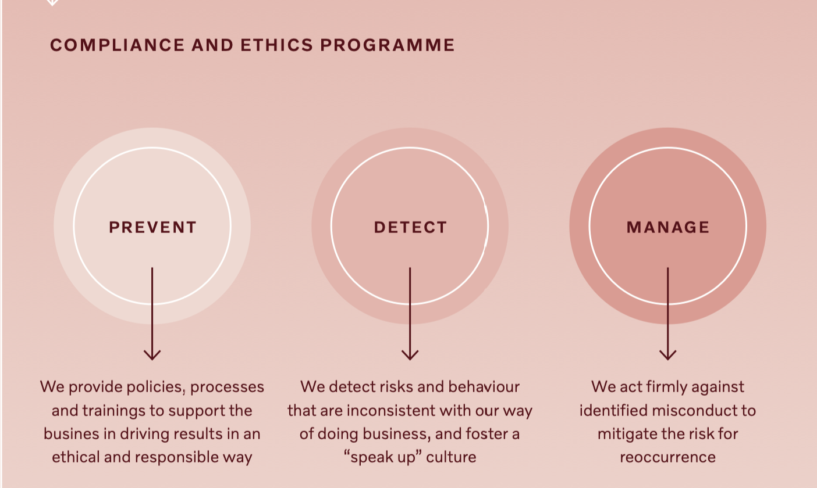
Figure 8. Volvo Car's Compliance and Ethics Program (Volvo Car Group, 2022).
Volvo Car Group has a Global Compliance Committee overseeing compliance cases and programs. The Compliance and Ethics Program at Volvo Cars prevents, detects, and manages misconduct. Preventing involves employee training. Detecting is about audits and policy monitoring. Managing misconduct involves disciplinary action against those responsible, corrective measures, and victim compensation. Volvo's Compliance and Ethics Program is designed to conduct business ethically and responsibly (Volvo Car Group, 2022).
Conclusion and Recommendations
According to this report analysis and findings, Volvo Cars has made significant positive strategic changes in recent years after becoming a part of Chinese Geely. Volvo Cars received substantial investments and advanced technology from its parent company; however, despite these changes, the company has remained true to the values of its Swedish heritage, prioritising driver safety, vehicle quality, and the traditional design of Volvos. The report shows that Volvo Cars mainly focuses on electrification, autonomous driving, and connectivity to keep and gain its competitive advantages. It has also invested in new space technology assisting with radars and location futures and increased its customer base by creating its fully electric sub-brand, Polestar. These changes have helped Volvo Cars to improve its financial performance and gain market share. However, Volvo Cars still faces several challenges. The company is still relatively small compared to its German premium competitors and faces increasing competition from Chinese automakers.
After conducting an in-depth analysis, the report author recommends the following actions for Volvo Cars:
• Volvo Cars should concentrate on developing electrification, autonomous driving, and connectivity technologies. These three game-changing technologies will likely define the automotive industry's future.
• Volvo Cars must increase hi-tech research and development investments to keep ahead of its rivals.
• Volvo Cars should expand its reach into emerging markets, such as China and India since it is experiencing the fastest automotive industry growth.
• Volvo Cars should expand partnering with parent Geely company to share resources and knowledge to help reduce costs and speed up the development of new technologies.
If Volvo Cars implement these recommendations successfully, the author believes it will be well-equipped to keep growing and prosper.

References:

Assembly in Action: Process Planning Improves Volvo's Manufacturing Flexibility (2012) ASSEMBLY. Available at: https://www.assemblymag.com/articles/90051-assembly-in-action--process-planning-improves-volvo-s-manufacturing-flexibility (Accessed: 10 August 2023).

Barney, J. B. (1991) 'Firm Resources and Sustained Competitive Advantage', Journal of Management, 17(1), pp. 99–120.

Brandirectory. (2023). Top Automobile Brands for 2022. [online] Available at: https://brandirectory.com/rankings/automobiles/table [Accessed 9 Aug. 2023].

CEICdata (2023). Sweden National Government Debt. [online] Ceicdata.com. Available at: https://www.ceicdata.com/en/indicator/sweden/national-government-debt#:~:text=Sweden%20National%20Government%20Debt%20reached,Mar%201999%20to%20Dec%202022. [Accessed 27 Aug. 2023].

Daniels, J.D. (2019) International business: environments & operations. Sixteenth edition, global edition. Harlow, England: Pearson.

HBS Working Knowledge. (2023). Podcast Details. [online] Available at: https://hbswk.hbs.edu/Pages/podcast-details.aspx?episode=27308586 [Accessed 20 August 2023].

Insights; Gate. (2022). Volvo Patents - Key Insights and Stats. [online] Available at: https://insights.greyb.com/volvo-patents/ [Accessed 9 Aug. 2023].

Kinacentrum. (2023). From a China strategy to no strategy: Exploring the diversity of European approaches. [online] Available at: https://kinacentrum.se/en/publications/from-a-china-strategy-to-no-strategy-at-all-exploring-the-diversity-of-european-approaches/ [Accessed 18 Aug. 2023].

Lynch, R.L. (2018) Strategic management. Eighth edition. Harlow, England : Pearson.
MarketLine (2013).

Volvo: The safest car in the world. [online] Available at: https://advantage-marketline-com.ezproxy.uwtsd.ac.uk/Analysis/details/volvo-the-safest-car-in-the-world-27010 [Accessed 05 August 2023].

MarketLine (2023). Macroeconomic Outlook Report: Sweden. [online] Available at: https://advantage-marketline-com.ezproxy.uwtsd.ac.uk/Analysis/ViewasPDF/sweden-macroeconomic-outlook-report-61330 [Accessed 6 Aug. 2023].

MarketLine (2023). Scandinavia - Automotive Manufacturing. [online] Available at: https://advantage-marketline-com.ezproxy.uwtsd.ac.uk/Analysis/ViewasPDF/scandinavia-automotive-manufacturing-173619 [Accessed 18 Aug. 2023].

MarketLine (2023). Volvo Car AB - Profile Volvo Car AB | MarketLine Intelligence Center. [online] Available at: https://new-marketline-com.ezproxy.uwtsd.ac.uk/Company/Profile/volvo-car-corporation?swot [Accessed 20 Aug. 2023].

Maurice, L. C. S. (2022) Corporate Social Responsibility: The Co-Responsibility of Business Along Global Supply Chains.

Porter, M. E. (1980) Competitive strategy: Techniques for analysing industries and competitors. New York: Free Press.

Rugman, A.M. (2012) International business. 6th ed. Harlow, England: Pearson.‌
Thompson, A. et al. (2019) Crafting & executing strategy: Concepts and cases. 22nd edn. Columbus, OH, USA: McGraw-Hill Education.

Volvo Car Group. (2022). Volvo Car Group Annual and Sustainability Report 2022. Gothenburg, Sweden: Volvo Car Group.

Volvo Cars. (2021). Safety - Highlights | Volvo Cars. [online] Available at: https://www.volvocars.com/lb/v/safety/highlights [Accessed 9 Aug. 2023].
Volvo Cars. (2021). We are a brand for people who care about other people |Volvo Cars. [online] Available at: https://www.volvocars.com/intl/v/discover#:~:text=From%20the%20very%20outset%20Volvo,personal%2C%20sustainable%20and%20safe%20way. [Accessed 6 August 2023].

‌Volvo Cars. (2022). Our story | Volvo Cars. [online] Available at: https://www.volvocars.com/intl/v/our-story#:~:text=Leading%20new%20technology&text=We're%20developing%20our%2 [Accessed 20 August 2023].

‌Volvocars (2013). Volvo Car Group starts series production of the Volvo S60L at Chengdu manufacturing plant. [online] Available at: https://www.media.volvocars.com/global/en-gb/media/photos/135425/volvo-car-group-starts-series-production-of-the-volvo-s60l-at-chengdu-manufacturing-plant1 [Accessed 9 Aug. 2023].

Volvocars (2021). Volvo Cars manufacturing plant in Daqing, China. [online] Available at: https://www.media.volvocars.com/global/en-gb/media/photos/280039/volvo-cars-manufacturing-plant-in-daqing-china?preview=true&t=2c298f8a-d8e1-47e7-8aab-f018c0cc11ea [Accessed 9 Aug. 2023].

Volvocars (2021). Volvo Cars to harness real-time data from customer cars to set new safety standards. [online] Available at: https://www.media.volvocars.com/global/en-gb/media/pressreleases/283544/volvo-cars-to-harness-real-time-data-from-customer-cars-to-set-new-safety-standards [Accessed 11 Aug. 2023].

Volvocars (2022). Volvo Cars report full-year 2022 results – accelerating strategic journey and navigating challenges. [online] Available at: https://www.media.volvocars.com/global/en-gb/media/pressreleases/308861/volvo-cars-reports-full-year-2022-results-accelerating-strategic-journey-and-navigating-challenges [Accessed 05 August 2023].

Volvocars (2022). Volvo Cars report third-quarter results – despite multiple headwinds, demand continued to be robust. [online] Available at: https://www.media.volvocars.com/global/en-gb/media/pressreleases/305399/volvo-cars-reports-third-quarter-results-despite-multiple-headwinds-demand-continued-to-be-robust [Accessed 6 August 2023].

Volvocars (2023). 0% finance - Bumper. [online] Available at: https://www.volvocars.com/uk/l/service/0-percent-interest/ [Accessed 13 August 2023].
‌Volvocars (2023). Available at: https://www.volvocars.com/intl/news/innovation/Halo-Slovakia-welcoming-a-new-electric-only-manufacturing-plant/ [Accessed 9 Aug. 2023].

Volvocars.(2020). This is Volvo. [online] Available at: https://www.media.volvocars.com/global/en-gb/corporate/this-is-volvo [Accessed 11 Aug. 2023].

Volvogroup. (2023). Volvo Work Culture. [online] Available at: https://www.volvogroup.com/en/careers/work-culture.html [Accessed 11 Aug. 2023].

‌Williams, J. (2022) Volvo launches a new online portal to sell used cars directly to customers, Car Dealer Magazine. Available at: https://cardealermagazine.co.uk/publish/volvo-launches-new-online-portal-to-sell-used-cars-directly-to-customers/253966 (Accessed: 13 August 2023).

‌‌

Appendix:

PESTEL Analysis of Sweden

Political
Positive
• Political stability.
Sweden's political stability, prolonged history of peaceful governance, democratic system, and transparency are well-known. In 2022, the Council of Europe's Congress of Local and Regional Authorities recognised their efficient local self-government. The World Bank ranked Sweden in the 97.6 percentile for political stability and absence of violence parameter in 2021, while the OECD reported an increase in trust in government from 63.4% to 68.8% in 2022.
Challenges
• Immigration challenges
In response to a statement by the Danish anti-immigration party, Stram Kurs, planning to burn a copy of the Quran, an enraged mob caused chaos in the Swedish town of Linköping. The Swedish prime minister declared integration of immigrants had failed and led to the creation of parallel communities, fuelling gang violence in the country. Immigration rules were changed in June 2022, and in January 2023, an international campaign was launched to discourage migrants from relocating to the country and inform migrants about Sweden's requirements.
• The deteriorated relationship with China
Sweden's approach to China has significantly shifted in the past five years, and Sweden's new government aims to reduce its unilateral dependence on China. Challenges also include the imprisonment of a Swedish book publisher, Gui Minhaj, concerns about Chinese investments in critical infrastructure, and potential security risks, so Swedish and Chinese companies are hesitant to invest in each other's countries (Kinacentrum, 2023).
Economic
Positive
• Strong labour market
Sweden has a flexible labour market with a highly educated and skilled workforce, strong protections, and a relatively low unemployment rate. According to MarketLine, despite the energy crisis and supply chain disruptions, unemployment decreased to 7.5% in 2022 from 8.8% in 2021and employment increased by 0.9% in March 2023 due to high labour demand. Older employees until age 69 are encouraged to remain in the workforce, with tax reductions and an increased age limit raised to 66 for receiving old-age pensions (MarketLine, 2023).
Challenges
• High level of inflationary pressure
Inflation in Sweden increased to 8.4% in 2022 due to the Russian-Ukraine war and the lockdown in China, which caused supply chain disruptions and raised prices, leading to a drop in domestic demand and slowed economic growth. The Central Bank of Sweden raised the interest rate six times, which affected investment sentiment.
• High level of government debt
Sweden's National Government Debt reached 188.0 USD billions in Dec 2022, equivalent to 32.2% of the country's GDP, the lowest level since 2019. However, it is still higher than the European Union (EU) average (CEICdata, 2023).
Social
Positive
• Advanced model universal social security system
In Sweden, there is a well-developed social welfare system, with social expenditure at 23.7% of GDP in 2022, which is higher than the OECD (Organisation for Economic Cooperation and Development) average. The state pension age will be connected to life expectancy in 2026, favouring the pension system. The income pension system had a surplus of $128.6 b in 2022.
Challenges
• Ageing population
Sweden's ageing population is increasing, resulting from a declining birth rate and increased life expectancy. By 2030, older people (65 and over) will comprise 21.3% of the total population, while the working-age population (15-64 years old) will decrease to 61.9%. Without the implementation of new reforms, there is a risk that social programs for older people may become unsustainable, affecting the financial sustainability of Sweden's social welfare measures.
• Preference of leisure over work
Sweden's culture prioritises quality of life and personal well-being, focusing on leisure time for relaxation and hobbies. The average annual work hours per employee in 2021 was 1,444, much lower than the OECD average of 1,716 hours, due to a preference for part-time arrangements and a reluctance to work long hours, which has led to labour shortages and additional inflation risks (MarketLine, 2023).
Technological

Positive
• Strong digital infrastructure
Sweden has a highly advanced digital infrastructure, among the best globally. The value of Sweden's start-up ecosystem almost doubled in a year, reaching €239 billion in 2022. In January 2023, the government launched a €1 billion Digital Transformation Infrastructure Plan to promote digitalisation across critical sectors like education, transportation, healthcare, and national security.
Challenges
• Rising cyberattacks
Cyberattacks, including attacks on the a-Kassa unemployment system in December 2022, have targeted Sweden. The Swedish Security Service (Sapo) warned of increased Russian intelligence activity and the possibility of sabotage, disinformation campaigns, and the use of violent extremists in February 2023. Scandinavian airline SAS also suffered a massive cyber-attack this year, affecting their app and website and leading to leaked customer confidential information.
Legal
Positive
• An efficient legal system
Sweden has a highly efficient and strong legal system. According to the 2022 Rule of Law Index by the World Justice Project, the country ranked fourth out of 140 countries with a score of 0.86. Sweden performed exceptionally well in various areas, including the absence of corruption, open government, security, regulatory enforcement, and civil and criminal justice.
Challenges
• High FDI restrictions
Sweden has the EU's highest FDI (Foreign direct investment) restrictions, increasing barriers and limiting new companies and job opportunities. OECD's index indicates Sweden has a 0.06 out of 1 for openness, higher than other EU countries.
Environmental
Positive
• Growing source of renewable energy
Sweden's renewable energy usage is increasing steadily. By 2022, the grid-connected solar power capacity had doubled to 1GW compared to the previous year (503.4MW). For example, in March 2023, only one Eco Energy World Limited sold a 42MWdc solar PV project to a large Swedish solar and wind developer, producing 41 GWh of clean and sustainable energy annually.
Challenges
• Increasing deforestation
According to the Global Forest Watch, Sweden lost 333 kha of natural forest in 2021, or 19% since 2001, due to deforestation. The country recorded 5,618 VIIRS (Visible Infrared Imaging Radiometer Suite fire alerts from June 3, 2019, to May 30, 2022, a worrying tendency that needs to be addressed (MarketLine, 2023).

