MARKETING FUNDAMENTALS
CARNIVAL CORPORATION & PLC
BLOGS
Assessment 1 Blogging to communicate
Student name: Sava Mantchev
Student number:2028706
Lecturer name: Tushara Balendran
Module code: LCBB4004
Submission date:06/01/2022

- A GREAT SUCCESS - COSTA FIRENZE DEBUT IN DUBAI
The first cruise in Costa city within the Arabian Gulf begins once the ship opens the new city Harbor Cruise Terminal at a spectacular ceremony. The Costa city Itinerary offers a special tour to require guests to the Italian tent at aggregation 2020 city, supported by Costa Cruises as a Gold Sponsor.
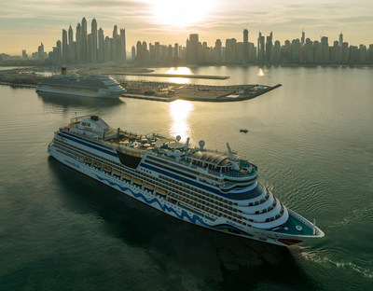
The Dubai Harbor Cruise Terminal project is part of a strategic partnership between Carnival Corporation & plc, the world's largest cruise line, and Shamal Holding, which aims to transform Dubai into a leading maritime tourism hub in the region. As the first dedicated dual-terminal cruise port in the region, Dubai Harbor Cruise Terminal can handle two large cruise ships simultaneously. Located in the heart of modern Dubai, this world-class complex covers over 120,000 square meters and includes two purpose-built terminal buildings that provide safe, comfortable and hassle-free pickup and drop-off for passengers and crew.
Excellences of savoir-faire
Covering an area of ​​3,500 sq m, the Italian Pavilion is renowned for its three large "buildings" that are covered with a food waste canopy and form the tricolour of the largest Italian flag in the world. The theme that runs through the pavilion is "Beauty unites people," where beauty is regarded as a factor that can unite multidisciplinary knowledge and skills of the past, present and future. Costa Cruises is one amongst the excellences of address gift within the Italian tent, taking part in a number one role within the sustainability-themed forums within the transport and business enterprise sectors, a section during which Costa Cruises is at the forefront and a pioneer. At the tip of the visit, participants within the circuit of Costa`s Italian tent are guests of Bvlgari for novel cuisine expertise.

- NEW RELEASE - SUMMER 2023 EARLY BOOKINGS STARTED FOR AIDA VOYAGES
The wait for the cruise lovers is over. On December 16, 2021, it is released that AIDA vacation plans for the amazing summer trip can be booked from April 2023 to October 2023 for the most beautiful AIDA cruises to experience the most amazing and exciting locations of Europe. The guests will be able to experience the breathtaking locations and scenery of Iceland and Norway in the Northern part of Europe. The guests will get a chance to enjoy the Mediterranean lifestyle from the western to the eastern they will visit the charming city and dreamy bays. With a little more time, you can discover a wide variety of cities and islands in the western Mediterranean at AID Stella in 10 or 11 days.
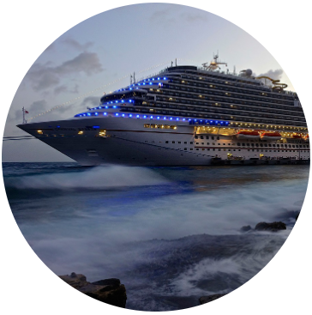
Advantages for early bookers
If you book early at the Premium AIDA rate, individuals get a discount of up to 300€ that is an early bird plus a discount for the departure of 2023 summer if you book your journey by 2022, November 30th. Allocations are limited and apply to the first and second person in the cabin. A further benefit of AIDA PREMIUM pricing is the choice of the cabin of your choice, 2 bottles of mineral water per day and a 250MB internet package. Travel can also be booked at AIDA Premium All Inclusive rates. In addition to the premium rate service, it includes the widest range of AIDA drink packages and a flat rate on social media for the entire trip. With the new AIDA Winter assure, AIDA Cruises will offer guests additional flexibility and safety for all new bookings from December 9, 2021, to March 31, 2022, until the start of the trip.

- THE FUN ONES – NEW MARKETING CAMPAIGN
The cruise line Carnival has launched a new campaign for marketing the organisation's cruise services name The Fun Ones; it celebrates the spirits of the guest of the organisation Carnival. This is to how they chose the unique bond and the fun with the fellow cruisers who are there to enjoy the experience shamelessly true to them. This campaign welcomed everyone in an atmosphere that attracts approximately 6 million guests every year. The organisation has used the taglines such as the fun ones plan for no plans and choose the vacation as fun as you are.
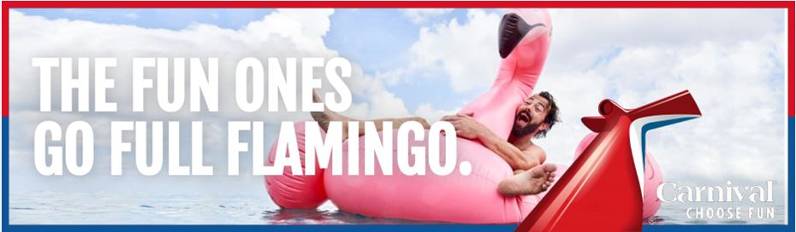
This message is delivered in out-of-home elements along with 15-, 30- and 60-second commercials airing in key markets such as Los Angeles, Dallas, Atlanta, Tampa, Houston and Orlando on television, radio, as well as national digital properties including YouTube and Hulu to view one of the spots. We all enjoy our lives, the people we want to be with, or the way we want to be a brand or product marketing for Carnival Cruise Line. When consumers see new places, they are encouraged to find "fun places" in their lives and enjoy them together on a carnival cruise.

- UNDERSTRUCK – NEW MARKETING CAMPAIGN
Carnival Cruise Line announces FUNDER STRUCK a new marketing campaign that will help create greater joy and enjoyment that you can experience together on Carnival Cruise Line.
Based on Carnival's brand name platform ChooseFun, the company is introducing the all-new word Funderstruck. To explain the unique emotions individuals experience when choosing the fun of a carnival. Funderstruck celebrates what travellers want and what the carnival is accurately designed.
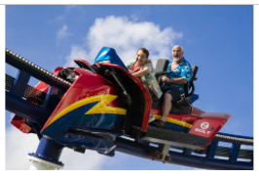
Carnival ends this year with a winning takeover of the hotel industry after the whole industry in the United States was suspended for 16 months. Carnival returned 19 of the 22 ships based in the United States. Most of the guests are on all cruise lines. With the idea that through 2022, the entire US fleet and all 10-year homeports will receive two more ships in March to increase wharf capacity in time for Carnival 50th in 2022. That's the calendar increasing pandemic levels. In some locations, guests enjoy a lot of funder truck experiences that the Carnival must present. Ride BOLT, the first roller coaster in the ocean. Don't be shy and enjoy delicious chocolate ice cream with other passengers who are overjoyed and share their joy of being together again.
The campaign created by Anomaly is an additional room for the brand's Choose Fun campaign launched in 2018. All salaried media and adding up elements were created by the plan and supported by PR consulting.

- BUSINESS UPDATE - CARNIVAL CORPORATION & PLC
Carnival Corporation and PLC's President and the CEO stated the organisation will begin an outage early in the epidemic, but the fleet on hold, correctly size the organisation and steadily resume the continuing hospitality at the two world-leading travel brands Costa and AIDA in Italy. Until then, it will make a complete round. In German. Accelerated sales of inefficient vessels. This allows you to leverage the backlog of reduced capacity to structurally reduce your cost base while retaining cash-generating assets. The firm is taking optimistic action to become a slimmer and more efficient company that manages our balance sheet, reduces our ability to position ourselves to survive this turmoil, and strengthens the organisation’s position as an industry leader increase.
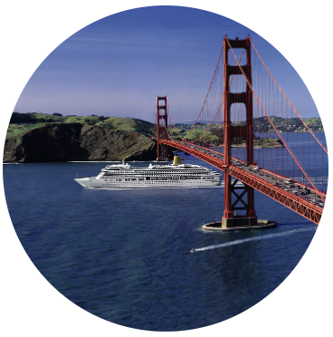
Health and safety regulation: Protocols after COVID-19
Costa and AIDA are working with international and national health authorities and medical professionals to expand a complete health and hygiene protocol to ensure a safe and healthy return to cruise holidays. Both brands provide guests with detailed information on comprehensive protocols provided by the individual countries of their respective brands and modelled on the guidelines for land health and mitigation approved by the Italian flag state. The procedure will be updated based on evolving scientific and medical knowledge of improvement approaches.

- CARNIVAL CORPORATION & PLC – AIDA PROMISE FOR FLEXIBLE NAD SAFE TRAVEL THIS WINTER
AIDA cruises are taking the guests to the best places to experience the best destination cruise trip. Turning from the winter blues to the sun the winter program of the organisation is aimed to visit the guests to beautiful destinations. Sunbathers look ahead to the endless sandy beaches of the Caribbean Sea. It can also be unusual and exciting on Orient cruises. The Mediterranean and Canary Islands routes assure spring-like temperatures and exclusive holiday knowledge. Winter recreation is huge at AIDA, which also has an ice rink. From Hamburg, the ship anchors in main cities in Western Europe on a 7-day cruise.
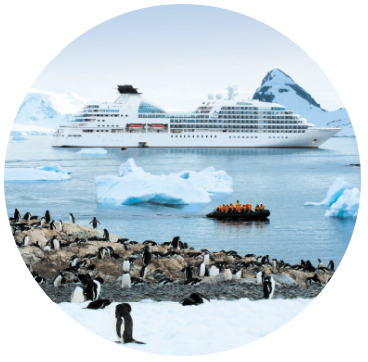
With the new AIDA Winter assure, AIDA Cruises will offer guests additional flexibility and safety for all new bookings from December 9, 2021, to March 31, 2022, until the start of the trip. All AIDA rates have the option to change both. Individuals can use one journey day and one journey route free of charge up to 40 days before leaving.
With the development of AIDA's health and protection concept, visitors can relax and take pleasure in a safe holiday. All AIDA cruises are operated with an adjusted traveller capacity. In addition to Vaccine Protection Regulations and extra COVID-19 pre-arrival testing, inclusive precautions include usual in-flight health examinations and extensive AHA regulations. A medical centre equipped with the latest COVID-19 testing equipment guarantees comprehensive care 24 hours a day.

REFERENCES
Beck, J., Harvey, J., Kaylen, K., Sala, C., Urban, M., Vermeulen, P., Wilken, N., Xie, W., Iliescu, D. and Mital, P. (2021). Carnival Optimizes Revenue and Inventory Across Heterogeneous Cruise Line Brands. INFORMS Journal on Applied Analytics, 51(1), pp.26-41.
Carnival Corporation & plc. (2021). News Releases | Carnival Corporation & plc. [online] Available at: <https://www.carnivalcorp.com/media-center/news-releases?page=2> [Accessed 17 December 2021].
Carnival Corporation & plc. (2021). The new AIDA Winter Promise for safe and flexible travel | Carnival Corporation & plc. [online] Available at: <https://www.carnivalcorp.com/news-releases/news-release-details/new-aida-winter-promise-safe-and-flexible-travel> [Accessed 17 December 2021].
Luzón, M.J. (2017). Connecting genres and languages in online scholarly communication: An analysis of research group blogs. Written communication, 34(4), pp.441-471.
Santiago, M. and Correia, R. (2018). Service recovery influence on consumer's complaint intention to obtain benefits. The case of the cruise ship industry. In 32nd International Business Information Management Association Conference (pp. 2160-2175). International Business Information Management Association.
Verbeek, D. (2018). Carnival Corporation: The Challenges of Cutting Costs While Maintaining Quality and Customer Satisfaction. Council of Supply Chain Management Professionals Cases.

