Fundamentals of Electrical and Electric Systems Assignment

Jake Comer

Due Date: 10/7/23

Introduction
This assignment is set out to show a level of understanding from the online weeklong course titled ‘Fundamentals of Electrical and Electronic systems’. This assignment has a two separate tasks with different sections that are required to be completed to showcase the understanding of the teachings of this subject module. The results will be shown in the required formats such as tables, graphs, and screenshots from the suitable simulation software. The tasks are meant to challenge the knowledge after the teachings of these lectures and to test the understanding of some of the theorems showcased in the module.

Task 1
Background Information
Theovin’s Theorem
Theovin’s theorem can be explained in simple terms as a method that can be used to simplify a complex circuit, such as simplifying a circuit with many resistors in a parelell circuit and replacing them with a single resistance and load resistor in a series circuit with a power source. This theorem is particularly useful for DC power sourced circuits. To be able to complete this theorem the Equivalent Resistance and the Equivalent Volatage is needed to be found out.
Maximum Power Transfer Theorem
This theorem claims that the source can deliver maximum power to load if the load resistance is equal to the source resistance [1]. This theorem is applicable to both AC and DC powered circuits. It claims that if the load resistor in the circuit of task 1 is the same as the source resistance then that is when the power from the source will be at it’s maximum. This theorem is applied in a Theovin Equivalent Circuit which is shown in Figure 4 and is used during running of the simulation software too.
Calculations
The way of understanding how resistance can be calculated is by understanding and differentiating which resistors are in a series circuit and which resistors are in a parallel circuit.
In a series circuit the total resistance can be worked out as
R1+R2+R3…etc.
However, in a parallel circuit the resistors have to be calculated as
$\frac{R}{1}+\frac{R}{2}+\frac{R}{3}+\frac{R}{4}….$Etc.
The following calculation are going to show how the theovin’s equivalent was calculated before using the simulation software.
The resistances that were given in the brief was that R1 = 1kΩ, R2 = 10kΩ, R3 = 12kΩ
So to try and simplify the circuit given to back up the claims of the two previous theorems, it was needed to be able to calculate the resistors together so that there was only one that could be put in a series circuit. First the two resistors in parallel would needed to be calculated which were R1 AND R2.
$\frac{1}{Rt}=\frac{1}{1000}+\frac{1}{100}$ = 0.0011
Then the next step of the calculation is to put it in brackets and times it by the power of negative 1 so the equation then looks like this
$Rt={(0.0011)}^{-1}$= 909.09
Now the R1 and R2 calculation of 909.09 would then fit in a series circuit with R3 and then they can be added together, leaving the resistance at 12.909kΩ

Results
In this section it will show the results table with the data that was collected. In this section the data collected from the Theovin’s Equivalent Circuit for each time the RL was increased (by 1kΩ at a time) and the power reading from the DC ammeter was then recorded in the table.
This table was used to establish the power in Watts of the circuit. This was done using the formula to work out the power which was
$$P=I_{L}^{2}R_{L}$$
The recordings of data are detailed in each column and then a graph of the recordings will follow after the table to show to correlation between the resistance and power recorded data.

Resistance (KΩ) | Current (mA) | Power (mW)
1 | 1.31 | 1.72
2 | 1.22 | 2.97
3 | 1.14 | 3.9
4 | 1.08 | 4.7
5 | 1.02 | 5.2
6 | 0.96 | 5.53
7 | 0.91 | 5.8
8 | 0.87 | 6.1
9 | 0.83 | 6.2
10 | 0.79 | 6.24
11 | 0.76 | 6.35
12 | 0.73 | 6.39
12.7 | 0.71 | 6.4
12.8 | 0.71 | 6.45
12.9 | 0.71 | 6.5
13 | 0.7 | 6.37
13.1 | 0.7 | 6.42
13.2 | 0.7 | 6.47
14 | 0.68 | 6.47
15 | 0.65 | 6.34
16 | 0.63 | 6.35
17 | 0.61 | 6.33
18 | 0.59 | 6.27
19 | 0.57 | 6.17
20 | 0.55 | 6.05

Method
This section is going to detail how the initial values given from Figure 1 of the original circuit that was given in the assignment brief were used to then be able to create a circuit to be able to extract data for the above table in the results sections.
At the start of task 1 figure 1 was given as well as the values of R1, R2, and R3. Which were: R1 = 1KΩ R2 = 10KΩ R3 = 12KΩ V=20V
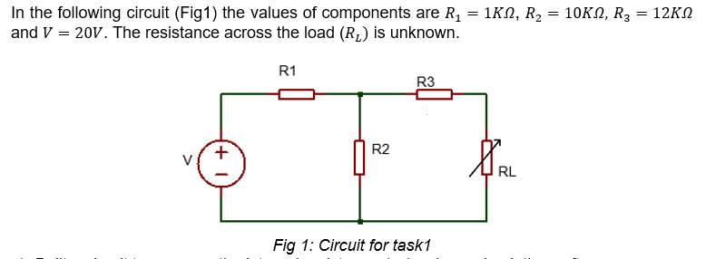
Section a of Task 1 was to build a circuit to measure the internal resistance (Rs) using a simulation software. Proteus was used to gather the data needed to work out the Rs.
Firstly, the DC source of power was taken out of the circuit and was replaced with an ohmmeter to be able to measure the equivalent resistance of the circuit (12.909KΩ). This can be seen in Figure 2 below. By using Theovin’s resistance from the theorem then the equivalence resistance can then be used for the Rth in the Theovin’s equivalent circuit.

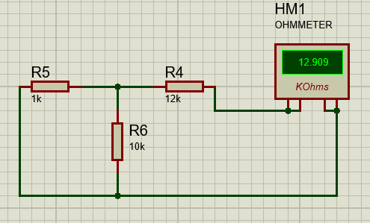
Figure 2
Then the RL was taken from the circuit and was replaced by a DC Voltmeter. This was to create an open circuit which could then be used to measure the current. This is shown in Figure 3 as well as the current reading which is 18.2V. This reading of 18.2V will then be used in the Theovin’s equivalent circuit as the Vth reading.
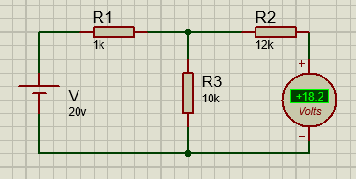
Figure 3

Using the data gathered from Figure 2 and Figure 3 the Theovin’s equivalent circuit can be created to be able to gather the data needed to complete the Task 1 section B section. The circuit that was set up is shown in Figure 4 below. This was used and the RL was changed by 1k at a time apart from around the peak to be able gain more precise data of said peak. The DC ammeter had to be changed to measurements in miliamps, this was due to the current being small and therefore having the ammeter to this setting would collect more accurate data.
The resistance for ‘R7’ is calculated above in the background section under the calculations heading which explains how the total of 12.909kΩ was able to be gathered.

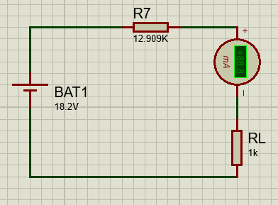
Figure 4

Discussion
From cross examining both the calculations that were completed earlier in this report and comparing the data collected, to the results gathered from the software simulations. We can say that the resistance and voltage that was predicted from the calculations were the same results gathered from the software simulation. This therefore shows that the theorems are accurate and also so is the software simulation too.
This task also shows that the claim made by the Maximum Power Transfer Theorem (states in the background information section) is true as when looking at the results of the graph there is an obvious peak around 12.7kΩ to 13.3kΩ as this is when the load resistance and the source resistance are equal or close to being equal. This therefore, backs up the claim through strong evidence in the graph and also in the calculations performed as well to provide further evidence to the Maximum Power Transfer’s claim.

Task 2
Background Information
In task 2 the brief provides a picture of circuit that included an oscilloscope, a signal generator, a resistor, a capacitor, and an inductor. A circuit with these devices all connected is called a resonant circuit and in this case would be called a RLC Circuit. Due to the first letter of each component. The oscilloscope is used to display the voltage signals as wave forms and shows the variation of voltage over time [1]. The signal generator is used to produce a AC current to run through the circuit which can then be viewed using the oscilloscope, in this task it was used to count peak to peak with the wave forms that were created from the alternating current.

Results

Method
This task was conducted by having to run the simulation and then changing the dials to alter the readings to be able to acquire the data that was needed to find the peak to peak, which could then be used to fill in the table. The following figures will be screenshots of the software tools with a brief description of what they are and what they change.
In the figure below, is the same circuit that was given in the assignment brief, it was tasked to recreate this assignment brief in a simulation software. The software that was chosen and used was Proteus and the software was able to create an identical circuit with the same numerical figures for each component, just as was in the assignment brief.
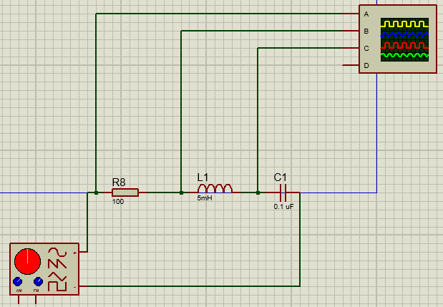

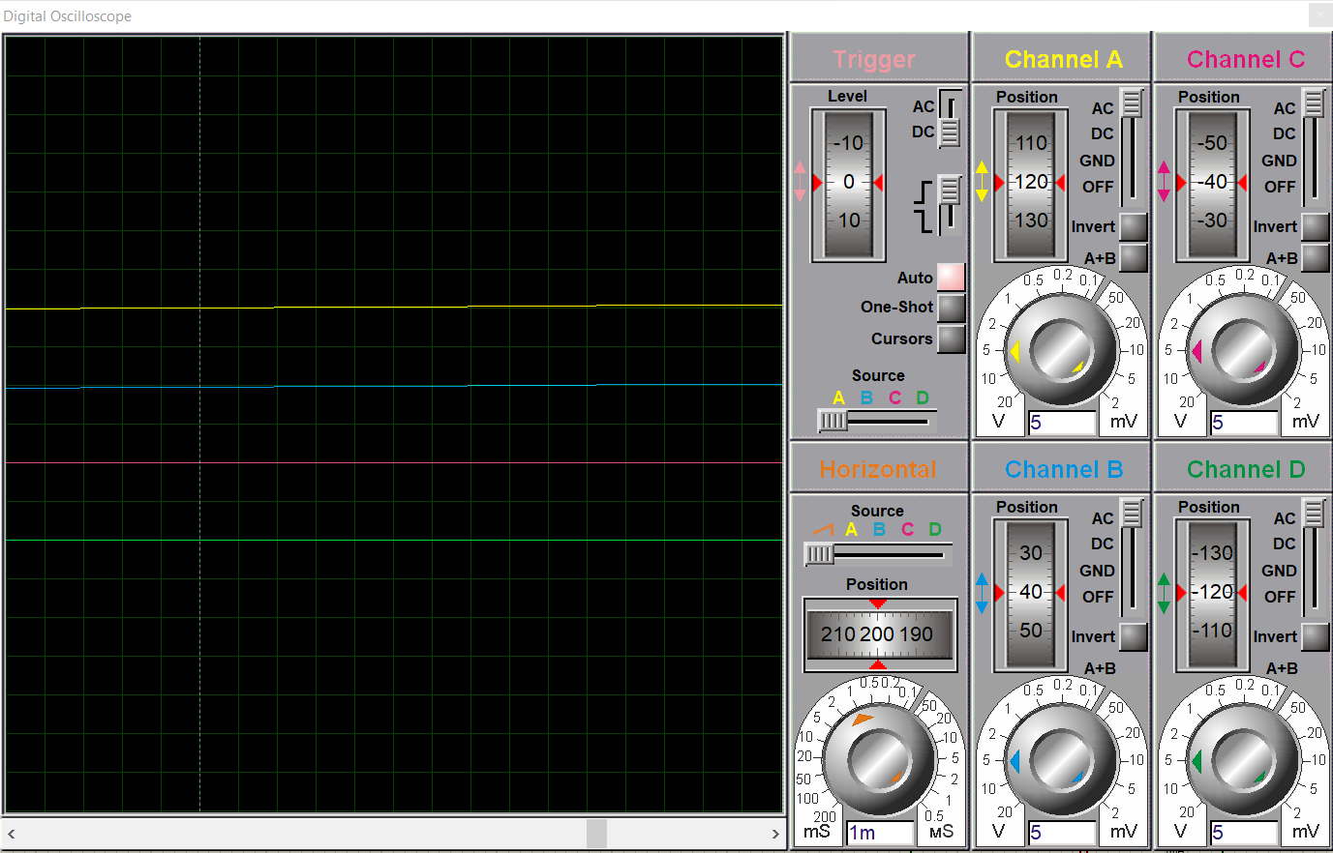
Figure 5
In figure 5 above is the oscilloscope work face which is where the frequencies can be measured. Through using this work face, it was possible to gain data of the peak to peaks as it was possible to gain the information from one peak and then again from the next peak, due to the power source being an alternating current which creates the wave flow.
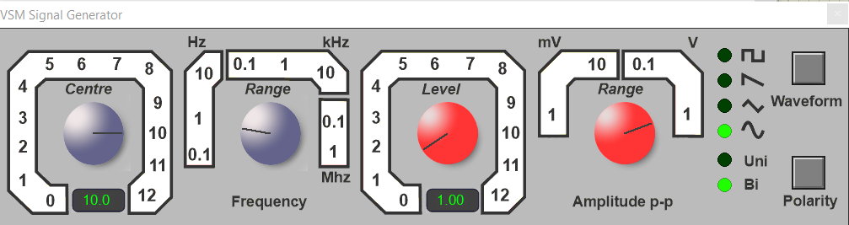
Figure 6
Figure 6, above, is a picture of the work face of the signal generator, this is the control panel for the range of voltage and frequencies for the peak to peak measurements.
Discussion
This task’s aim was to gain data of the Vr, Vc, and Vl at a range of frequencies which was completed and the data gathered was then put into a table. A graph was acquired from the data collected and shows a highlighted data collection around the peak. This shows that the simulation software was able to complete the tasks as required.
There is a high probability that user error can lead to the data collected being wrong, as there was no other way to find out the peak but to use the computer mouse. This isn’t desirable for the simulation software as if there was a unit measurement of the peak to peak then it would make the data more accurate as there wouldn’t be room for operator error, which could have potentially happened in this task.
Overall Conclusion (Both Tasks)
In conclusion, the tasks were able to be completed using the knowledge gained from the lectures taught on the different theorems to use to complete the tasks that were given in the assignment brief. Both of the tasks were able to be completed with accurate data being collected, to back up the theorems claims.
The first task resulted in the same answer of 12.909kΩ being calculated in both the simulation software and also in the calculations shown in the background information section of task 1. The same can be said for task 2 where the theorems claims have been backed up by the software’s simulation. This is therefore a big positive of both the theorems used and the simulations software.
However, a disadvantage of using the software simulations is that one mistake can then lead to gathering completely wrong data. This is a disadvantage of the software due to if the operator of the software was to make an error they would receive the wrong results.
Another disadvantage of the software is that it isn’t very user friendly. This is a disadvantage due to the operator becoming confused due to not having enough knowledge on how to use the software and then choosing the wrong resistor, power source etc. and can then end up with receiving the wrong data and results.
Overall, looking back on the points made and the conclusive evidence and data created, to support the calculations and equations of the theorems that were used over the duration of this assignment. It is clear that the tasks completed were successful and the simulation software that was used to determine the claims was a success and created accurate and reliable data to be used. It would be sensible and suitable to carry on using this simulation software in the future to determine whether the claims made by different theorems were true, or not.

