

Student name: Nasreen begum
Student ID:2008171

Module name: Introduction to Health and Social Care (LCHS4003),
Module code: LCHS4003
Lecturer name

Content page

Element 1 page 1

Element 2 page 2
Key Facts
🏠 Care at home
👩‍⚕️ Provided by trained carers
📋 Personalised care plans
🎯 Focus on independence
Care at home helps people live independently with dignity
Challenges
- Staff shortages
- Not enough care workers
- High workload
- Funding issues
- Not fully free
- Limited council budgets

🏠 Care at home
👩‍⚕️ Provided by trained carers
📋 Personalised care plans
🎯 Focus on independence

Brief History and who provides these services
- Before 1948: Care provided by families
- 1948: NHS introduced
- 1960s–70s: Home help services begin
- 1990: Community Care Act → care at home increases
- Today: Key part of UK social care Local councils
- Private care agencies
- Charities
All services are regulated to ensure safety and quality.
What Are Domiciliary Care Services?
Domiciliary care, also known as home care, supports people in their own homes instead of hospitals or care homes. It helps older adults, people with disabilities, and those recovering from illness to remain independent.
The main aim is to provide safe, personalised care while allowing people to stay in familiar surroundings.
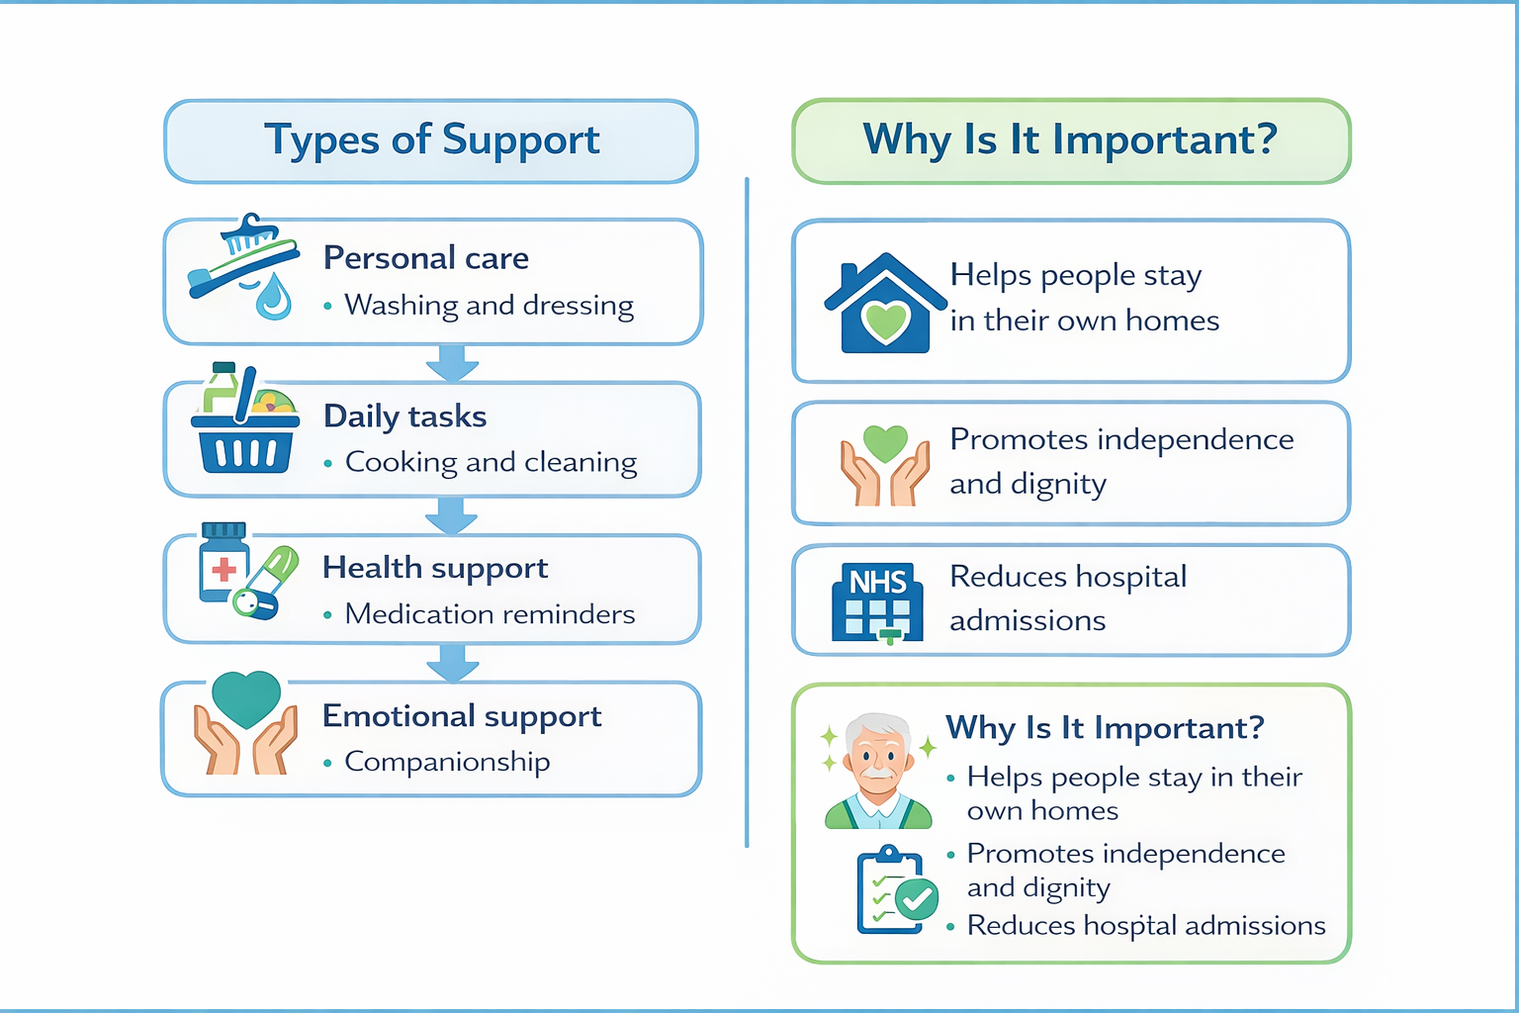

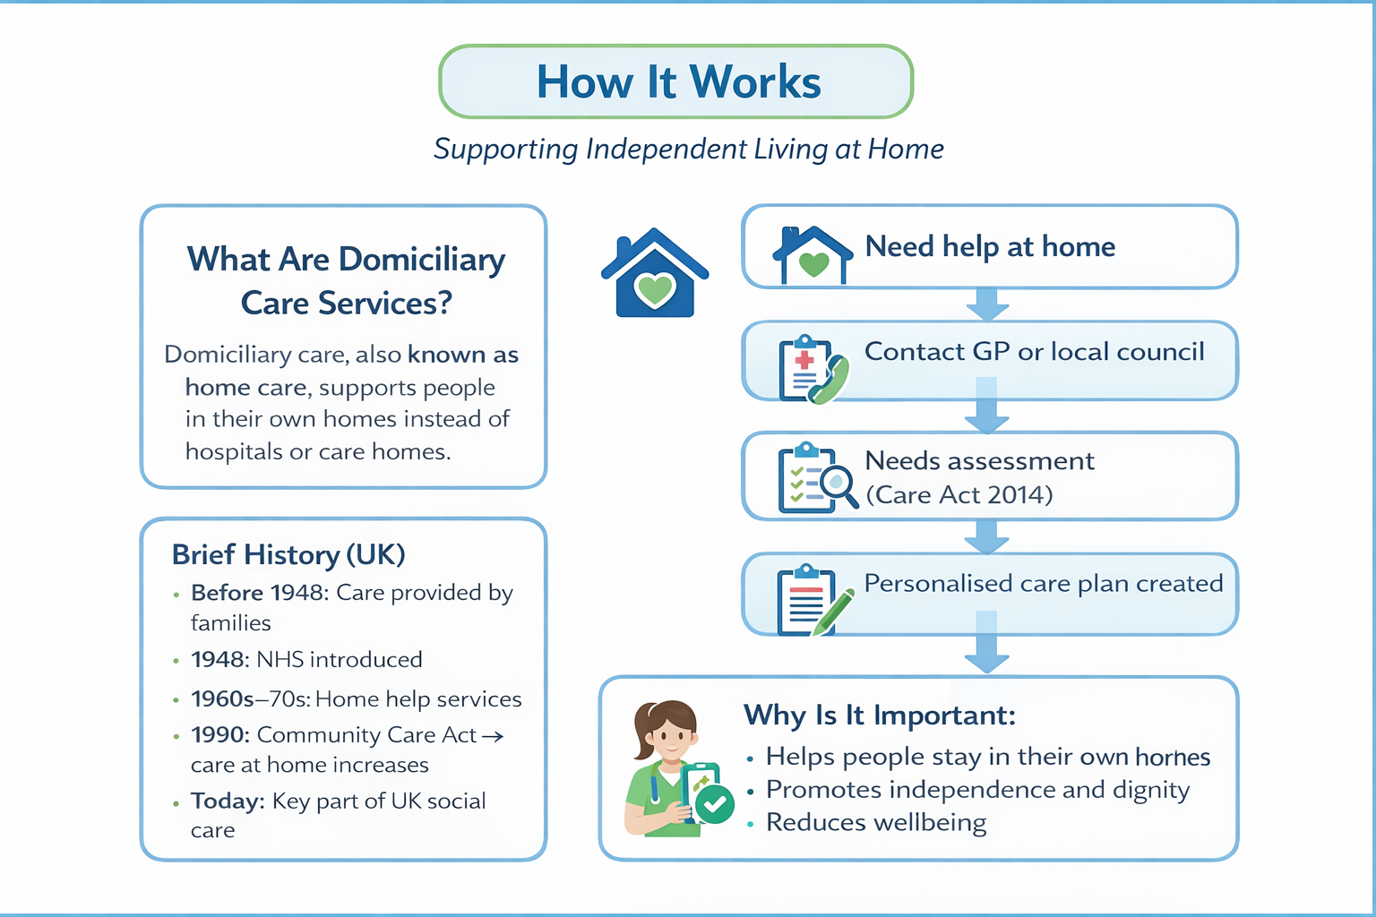
Domiciliary Care Services in the UK
Supporting Independent Living at Home
Nasreen Begum, Introduction to Health and Social Care (LCHS4003), 2008171@student.uwtsd.ac.uk

Element 2

Domiciliary Care Services in the UK

Domiciliary care services are an important part of the UK’s health and social care system. They provide support to individuals in their own homes, helping them to remain independent while receiving the care they need. These services are particularly important for older adults, people with disabilities, and those recovering from illness.

The development of domiciliary care services in the UK is closely linked to wider changes in healthcare and social policy. Before the mid-20th century, most care was provided informally by family members or charitable organisations. At that time, there was very limited government involvement, and many individuals struggled without structured support.

A major turning point came with the introduction of the National Health Service in 1948, which made healthcare free at the point of use (NHS, 2022). However, social care services such as domiciliary care remained separate and were managed by local authorities. As the population began to age, the need for more organised and accessible support became increasingly clear.

During the 1960s and 1970s, local councils began to introduce home help services, mainly aimed at supporting older people. Although these services were relatively basic, they represented an important step towards formal domiciliary care provision. A more significant shift occurred with the introduction of the NHS and Community Care Act 1990, which promoted the idea of “care in the community” (Glasby, 2017). This policy encouraged a move away from long-term institutional care and supported individuals in remaining in their own homes wherever possible.

In the present day, domiciliary care services operate under the Care Act 2014, which sets out how local authorities should assess and meet individuals’ care needs (Department of Health and Social Care, 2014). Services are delivered through a combination of local councils, private providers, and voluntary organisations. In England, they are regulated by the Care Quality Commission, which ensures that services meet required standards of safety and quality (CQC, 2023).

One of the main strengths of domiciliary care is its person-centred approach. Care is tailored to the specific needs and preferences of each individual, which helps promote independence and dignity. Support may include assistance with personal care, household tasks, and emotional wellbeing. Receiving care at home also allows individuals to remain in familiar surroundings, which can have a positive impact on mental health and overall wellbeing.

However, there are several challenges affecting how effectively these services operate. One major issue is the shortage of care workers. The role can be physically and emotionally demanding, and relatively low pay can make it difficult to recruit and retain staff. As a result, some services may struggle to meet demand, which can lead to reduced quality of care and increased pressure on existing workers (Skills for Care, 2023).

Another challenge is funding. Unlike healthcare provided by the NHS, social care is not free for everyone. Many individuals are required to contribute towards the cost of their care, depending on their financial situation. In addition, local authorities often face budget constraints, which can limit the availability of services and create inequalities in access (The King’s Fund, 2022).

Despite these challenges, domiciliary care services play a vital role in enhancing the quality of life for service users. They enable individuals to maintain independence, dignity, and control over their daily lives while remaining in their own homes. Furthermore, these services help reduce the need for hospital admissions and residential care, which benefits the wider healthcare system.

In conclusion, domiciliary care services in the UK have developed from informal support systems into a structured and essential part of modern social care. Shaped by key policies and changing social attitudes, they continue to play a crucial role in supporting individuals to live independently. While challenges such as workforce shortages and funding pressures remain, the importance of these services in improving quality of life is clear.

Reference:
Care Quality Commission (CQC) (2023) About us. Available at: https://www.cqc.org.uk

Department of Health and Social Care (2014) Care Act 2014. London: HMSO.

Glasby, J. (2017) Understanding Health and Social Care. 3rd ed. Bristol: Policy Press.

NHS (2022) The history of the NHS. Available at: https://www.nhs.uk

Skills for Care (2023) The state of the adult social care sector. Available at: https://www.skillsforcare.org.uk

The King’s Fund (2022) Social care funding and reform in England. Available at: https://www.kingsfund.org.uk
References

