BMSW4002
Effective Team Work and Communication

Effective Team Work and Communication Assessment 1

Module Leader: Lloyd Beharry
Student Name: Mariyana Rusafova
Student Number: 2131037

Table of Contents

1. Introduction 3
2. Models of Communication 3
2.1 Shannon-Weaver’s Model of Communication 3
2.2 Schramm’s Model of Communication 4
2.3 Berlo’s Model of Communication 5
3. Communication Skills 6
3.1 Verbal Communication 7
3.2 Non-Verbal Skills 7
3.3 Listening Skills 7
4. Disadvantages of Modern Technology in Communication 8
5. Conclusion 9
6. References 10
7. Appendix 11

1. Introduction
Knowledge is transmitted from one person to another through communication. Communication is the process of disseminating information to individuals inside and outside of an institution through strategies that foster mutual respect and trust. In the workplace, where it fosters job satisfaction, participation, efficiency, and career progression, communicating is particularly important. Additionally, better teamwork and collaboration depend on communication (Duck and McMahan, 2014). Communicating effectively at work eventually helps people, teams, and enterprises achieve better results. But, a variety of communication impediments, such as linguistic barriers, psychological concerns, institutional barriers, cultural issues, physical barriers etc. might affect the message (Duck and McMahan, 2014). All of these obstacles cause poor communication, which may cause a lot of stress at work, connections to fall apart, worker scepticism, low employee morale, absenteeism, and low participation, all of which eventually lower productivity.

2. Models of Communication
Communication models are conceptual depictions of the system that show how it operates. These models may not always accurately capture the diversity of human interaction and may even promote narrow-minded stereotyping. Below, some of the many communication model kinds will be covered.

2.1 Shannon-Weaver’s Model of Communication
The linear structure of Shannon and Weaver's model of communication is supported by five key factors (Cobley and Schulz, 2013). When a user submits a query, the source randomly chooses a message from a list of possible answers. The message is converted into a pulse and sent to the recipient across the contact channel. Because it is in charge of deciphering the received data and turning it back into communication, the receiver may be viewed as a reverse transmitter. The intended receiver of the communication is then informed. Additional noise is introduced into the signal each time a packet of data is sent through a network (Thompson, 2011). This noise may be internal or external. The effect of the message might be influenced by internal or external noise.
Based on the case study of Maria and Pedro, this method may be utilised to ascertain why Pedro interpreted Maria's remarks incorrectly. Pedro operates in a construction area with a lot of background noise, so he misinterpreted Maria's mention of chicken as a remark to the kitchen. They were unable to hear and comprehend the actual content due to the background noise.
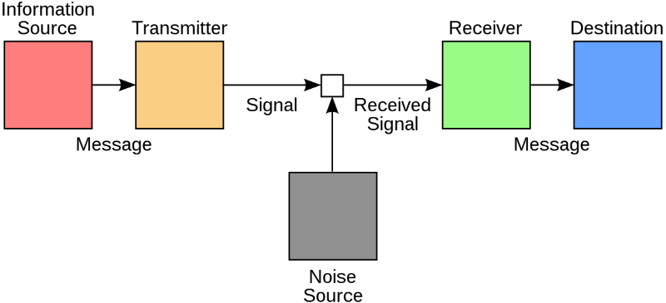
Fig: Shannon and Weaver Model (Kobiruzzaman, 2021)
Instead of just repeating what people believe they heard and questioning whether it is true, the proper method for avoiding misunderstandings is to ask questions to clear up any misunderstandings.
Fig: Implementing Shannon and Weaver Model in the case study (Source: Author)
Workplace example: A coworker called Jack at my workplace once asked Monika (another coworker) for certain files at my place of employment. Monika was conversing with customers when he asked for the documents. Additionally, Monika misread and sent Jack the erroneous papers as a result of the commotion surrounding her. Jack's work was affected in a few ways by this. The right communication may have prevented this incident.

2.2 Schramm’s Model of Communication
Wilbur Schramm came to the conclusion that decoding and encoding occur simultaneously on both ends while extending Shannon and Weaver's theory (Mcluhan and Mcluhan, 2011). As a consequence, he came up with a system that had bidirectional interaction between the inputting principle and output results. Additionally, he defined what he was talking about using the phrase knowledge domain. A transmitter and receiver interact with one another through a medium, according to a communication model created by Schramm (Mcluhan and Mcluhan, 2011). The information is stored and communicated by using appropriate verbal and visual signals. The receiver will contact the sender to confirm delivery after the information has been decoded. Schramm discussed expertise, interruption, and ambient noise in the closed-loop system (Mcluhan and Mcluhan, 2011).

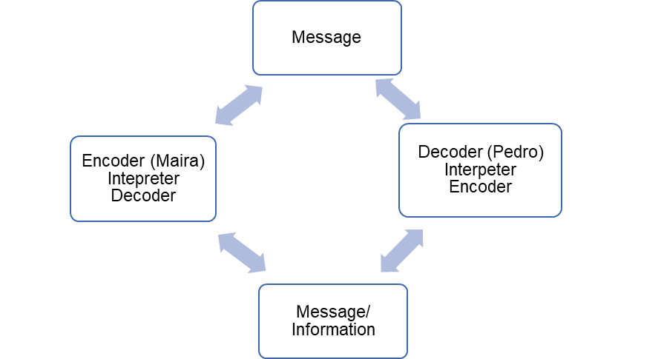
Fig: Implementing Schramm Communication Model (Mcluhan and Mcluhan, 2011)
If Maria had been able to help Pedro comprehend the entire statement by inquiring or cross-checking, the issue may have been avoided. If Maria and Pedro had been talking back and forth, this framework may have been used to interpret what Maria was attempting to convey to him. Asking Pedro if he understood the proper information may have prevented the problem.
Workplace example: The management team of the firm where I work got together to discuss the prospects of the business in the future. The other project managers supported David's suggestion, which was made by the management, increase sales as a way to enhance the outcomes. However, he used the input from each person's knowledge to ensure that everyone grasped the concept by exchanging information and ensuring that everyone was on the same page.

2.3 Berlo’s Model of Communication
The origin, communication, medium, and receiver are the four elements that make up Berlo's model (Cobley and Schulz, 2013). A distinctive feature of Berlo is its systematic analysis of the key factors influencing message clarity (Cobley and Schulz, 2013). Which are:
1. Source: The source is influenced by the caller's style of communication, character, and social network.
2. Message: A message is made consisting of text, design, and code.
3. Channel: The perceptions of listening, vision, feeling, tasting, and scent are all components of the channel.
4. Recipient: The receiver's personality, past experiences, and social network are all facets of them.
The professor tried to tell the people that his house was on fire, but they could not understand his language. The professor and the villagers' case study demonstrates the professor's challenges in explaining what was going on to the villagers owing to his use of unfamiliar language due to their limited exposure to modern culture and weak communication capacities. The professor could have been able to avoid the unfortunate situation he ran into if he had been able to converse with the locals.
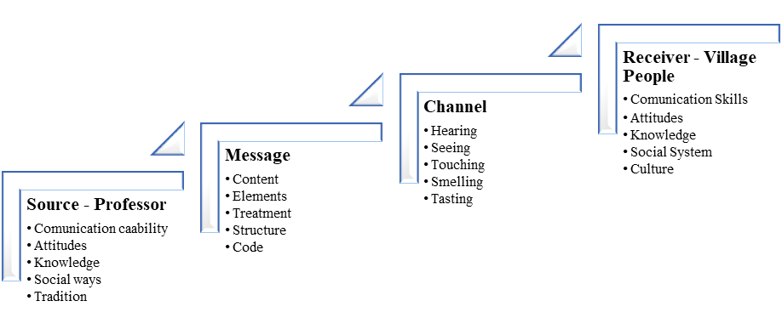
Fig: Implementing Berlo's Model of communication (Sabbagh, 2010)
Workplace example: At my workplace, I once gave an assignment to a young employee who had just started working there. Despite the fact that I was speaking to him in business jargon, he was unable to understand what I was asking of him and eventually failed to finish the task. This was brought on by the disparity in expertise and communication style. If I had spoken to him in a way that I knew, it might not have happened.

3. Communication Skills
One of the most basic abilities in life is the capacity for effective and straightforward communication. The exchange of concepts and knowledge that aids in comprehension is referred to as communication (Ellis, 2003). Effective communication abilities are helpful in many facets of life, such as personal and professional connections.

3.1 Verbal Communication
Competency with words is required whenever two people communicate information verbally, they are engaging in verbal communication (Ellis, 2003). Thus, it encompasses both spoken and textual interaction. It can also apply to any conversation. What is stated and how it is received are the fundamental elements of oral communication. Effective communication requires three key elements: the words individuals use, how they present their ideas, and the effects they have in nonverbal circumstances (Quintanilla and Wahl, 2016). These factors all have an impact on the message's delivery and the takeaways for the target audience.
In the case study of Barry and Communication Barriers, it can be observed that Barry was unable to convey the messages properly to the employees of the restaurant. This has been due to the difference in cultural and ethnic backgrounds. The lack of a common language made it difficult for Barry to communicate and so the aspect of verbal communication have to be changed (Quintanilla and Wahl, 2016).

3.2 Non-Verbal Skills
Effective communication, the creation of making links, and the maintenance of strong relationships are all made possible by the use of nonverbal cues (Rocci and de Saussure, 2016). A better understanding of this type of involvement could result in more solid interpersonal connections. Because of this, even the same nonverbal signals may imply very different things to different people, especially when ethnic variations are taken into account. Just as their existence serves as a way of nonverbal communication, the lack of such nonverbal signs can also be noteworthy. The body interacts with others through changes in posture, eye movements, limb motions, and facial gestures (Sabbagh, 2010). This may be covert or overt, and occasionally even contradicting. Because they are always present and frequently hard to fake, nonverbal cues are better representations of a person's real feelings. By practising postures and gestures during the conversation, they can be developed (Rocci and de Saussure, 2016).
The case study of A Day with the Chief shows the importance of non-verbal communication and how important it is to understand certain aspects while talking to any other person.

3.3 Listening Skills
An essential communication skill, listening is especially necessary for a professional setting when it is important to appreciate others' thoughts and perspectives (Thompson, 2011). Every organisation relies heavily on its leaders' ability to hear and comprehend the perspectives of its employees to govern and flourish. A good listener and speaker can comprehend what other people are expressing and respond accordingly (Thompson, 2011).
Active listening is the process of being ready to listen, paying attention to the verbal and nonverbal cues being used, and then responding appropriately to demonstrate that people are paying attention to what is being said (Davenport Sypher et al., 1973). This kind of listening shows that the audience and speaker are on the same page.
Empathic listening is indeed the skill of paying close attention to and responding to other people's opinions when they are speaking (Thompson, 2011). Establishing an intimate attachment with the other individual and seeing commonalities in experiences are both necessary for listening compassionately.

4. Disadvantages of Modern Technology in Communication
Modern technology has changed the way people communicate with one another in the present era. Though there are many advantages of modern technology in the sector of communication, there are several disadvantages of modern technology as well. Some of the disadvantages of modern technology include identity theft, cyberbullying, social interaction etc (Cantoni and Danowski, 2015).
Communication has been developed through the use of modern technology and almost all people around the world are connected through some kind of network. The Identity of the people has very easily available to others and it is very easy to copy one identity and use it for various purposes (Cantoni and Danowski, 2015). This has given the rise to different types of crimes and breaches of data. On social media sites, it is also observed that people communicate with other people impersonating another one and taking advantage of stolen identities.
Another type of disadvantage that is observed in modern technology communication is cyberbullying. Cyberbullying can be observed in social media sites where people bully a person in the online world and it decreases the self-esteem of the person and also causes depression and loneliness (Quintanilla and Wahl, 2016). Cyberbullying is very common nowadays as most people, especially the younger generation are connected online and face different types of opinions (Quintanilla and Wahl, 2016). Due to the freedom of speech on social media sites, people get the chance to bully one another in cyberspace. The governments of countries have taken different types of measures to decrease cyberbullying and also social media organisations have taken steps to reduce these as well.
Social interaction is decreasing due to the use of modern technology and social media sites, as the interaction between people has been digitalized and face-to-face communication has decreased to a great extent. Too much time spent on mobile phones and laptops has also impacted the health of the new generation as they are facing different types of mental and physical issues like reduced eyesight and depression (Duck and McMahan, 2014). These could be mitigated if the social interaction between people could be increased by reducing the use of modern technology for communication in the social aspect.

5. Conclusion
Obstacles to communication have a big role in how an organisation operates and how individuals go about their daily lives, but they can be overcome by using various models and strategies. Several things, including communication problems or improved comprehension, might affect someone's capacity. Therefore, removing barriers to communication is beneficial. Miscommunications and a lack of knowledge of the circumstances may result from communication failure. The case studies demonstrate how misunderstandings may lead to problems in a variety of businesses. It is possible to establish communication with people using the communication models. These skills help one communicate more successfully in both social and business contexts.

6. References
Cantoni, L. and Danowski, J. A. (eds) (2015) Communication and Technology. DE GRUYTER.
Cobley, P. and Schulz, P. J. (2013) Theories and models of communication. Berlin, Germany: De Gruyter Mouton.
Davenport Sypher, B., Bostrom, R. N. and Seibert, H. (1973) ‘Listening, communication abilities, and success at work’, The Journal of Business Communication, 26(4), pp. 293–303.
Duck, S. and McMahan, D. T. (2014) Communication in everyday life: A survey of communication. 2nd edn. Christchurch, New Zealand: Sage Publications.
Ellis, R. (2003) Communication skills: Stepladders to success for the professional. Intellect.
Kobiruzzaman, M. M. (2021) Shannon and Weaver Model of Communication Explanation & examples, Newsmoor. Newsmoor- Best Online Learning Platform. Available at: https://newsmoor.com/shannon-and-weaver-model-of-communication-explanation-examples/ (Accessed: 31 December 2022).
Mcluhan, E. and Mcluhan, M. (2011) Theories of Communication. Peter Lang Publishing.
Quintanilla, K. M. and Wahl, S. T. (2016) Business and professional communication: KEYS for workplace excellence. 3rd edn. Thousand Oaks, CA, USA: SAGE Publications.
Rocci, A. and de Saussure, L. (eds) (2016) Verbal Communication. 1st edn. Berlin, Germany: De Gruyter Mouton.
Sabbagh, S. (2010) Oral Presentation Skills and Non Verbal Communication Techniques. VDM Verlag.
Thompson, N. (2011) Effective communication: A guide for the people professions. 2nd edn. Basingstoke: Macmillan Education.

7. Appendix
Class Activities


