AC 1.1
Evidence-based practice (EBP) involves the gathering and critical analysing of facts and data to make reliable informed decisions (Young, 2022). Deriving from Sackett et al’s (1996, pp. 71) definition of evidence-based medicine as ‘the conscientious, explicit, and judicious use of current best evidence in making decisions’, EBP is the method of appraising multiple sources of information to solve a problem (CIPD, 2019). This process is laid out in a six-step model more commonly known as the Six A’s of EBP: Asking, Aquiring, Appraising, Aggregating, Applying and Assessing (Barends, Rousseau and Briner, 2014). When conducting EBP, four main sources of evidence should be considered: scientific research, organisational data, practitioners experience and stakeholder concerns (Barends, Rousseau and Briner, 2014).
EBP can be applied by both people professionals in an organisation and also leaders and senior management in an array of business areas to make better informed decisions. For example, HR professionals can promote the use of practices of EBP to managers in the recruitment and selection of new employees, such as structured interview processes and specifically designed assignments, to maximise organisational talent (Carless, 2009). Implementing new HRM systems, such as performance management, can benefit from reviewing relevant literature, organisational data, practitioner opinions and stakeholder feedback to ensure the system meets the needs of the organisation and the users (Waters, 2017; Young, 2022). Lastly, EBP can help organisations investigate employee engagement, from speaking to stakeholders to gathering engagement data, and identify outcomes for improving engagement and thus, improving customer service (myHRfuture, 2019).

AC 1.2
Utilising data, or people analytics, in the process of decision-making aids in solving issues of importance to the organisation, thus, generating more value (Mohdzaini, 2022). Furthermore, data becomes a key building block in workforce planning, projecting the future challenges a workforce may face, allowing senior management to adapt and plan proactively (Mercer, 2015). Data analytics allows for the closer examination of a range of people management matters including employee engagement, culture, recruitment and productivity, and enables people professionals to effect change in these areas (Leatherbarrow and Fletcher, 2019; Baska, 2018). Data-driven approaches to diversity and inclusion can uncover structural inequality amongst different demographics in organisations and identify key actions to take in order to implement fair practices, eliminate variations and detect any necessary unconscious bias training (Jefferey, 2019; Kennedy, 2019).
Accurate data should be timely in order to react to the needs of the organisation and make quick, effective decisions (Makoff-Clark, 2018). Inaccurate data results in inaccurate decisions which can impact both business performance and stakeholder and employee confidence levels in HR and senior management’s ability to make informed decisions that benefit the organisation (Marson, 2022). For example, without accurate and up to date data on all employees’ performance levels, skills and experience, an organisation would be unable to craft an internal talent strategy (Woods, 2010). that Data protection laws and regulations protect employees from the misuse of their information; if the use of their data is non-compliant, organisations put themselves at risk of legal and financial ramifications (Ayling and Suff, 2022; Morris, 2020).

AC 1.3
Quantitative data is objective, measurable and statistical, used to track units of
measurement over periods of time; qualitative data, on the other hand, is an interpretation of
subjective information or observations (Mohdzaini, 2022). HR information systems can provide measurable data on the workforce that people professionals can utilise in their decision-making and future forecasting including metrics such as turnover, recruitment, retention, engagement and absence (Finneman, 2017). This data can be utilised to answer organisational questions such as how small or large a workforce should be or how to drive performance or business results (CIPD, 2013; Finneman, 2017). Employee engagement, in particular, can be measured through both sets of data; through quantitative measurements such as retention rates and employee satisfaction scoring systems and qualitative measurements such as surveys, focus groups, and exit interviews (Mistry, 2022).
Internal feedback systems can engage with employees, asking for their opinions regarding
their engagement, performance and advocacy of the business, measurably tracking these
key indicators and illustrating a larger picture of an organisation’s health, culture or
productivity (CIPD, 2013). However, Macchi Silva and Ribera (2021) proposed a dual
approach to performance appraisals; quantitative data for statistical analysis of performance
and qualitative data for constructive suggestions for employee development. Both
quantitative and qualitative data can be used to examine absence rates; accurate statistics
of sickness days can be measured in a sickness absence system paired with employee
feedback or surveys can identify possible trends or unaddressed reasons for absence (Dale,
2019).

AC 1.6
Policies and procedures, when applied effectively and consistently, have a significant impact on organisational decision-making. By setting out the organisation’s approach to various employment issues, policies provide guidelines for managers that ensure a consistency to the decisions made when resolving different situations (Armstrong and Taylor, 2020). For example, talent management policies contribute to decisions made regarding recruitment and workforce planning (Armstrong and Taylor, 2020). Policies with clear and established procedures will prevent time wasted on uncertainty and minimise unnecessary costs or administrative work (Lakhotia, 2018). Decisions are made confidently, promptly and in accordance with the business strategy (George, 2022).
Defining the employer-employee relationship and the behaviours and attitudes accepted in the organisation in policies and practices informs the employees’ decisions on how to behave and what is expected of them in their role (Torrington et al, 2020; Armstrong and Taylor, 2020). By utilising a set policy or procedure in order to make a decision, managers and people professionals ensure a consistency and transparency to an organisation’s decision-making process and prevents managerial bias (George, 2022; Aquinas, 2009). Furthermore, an organisation’s policies and procedures are tailored in line with legal obligations and ensures that decisions made conform to the various laws and legislation organisations are bound by (Aquinas, 2009; Lakhotia, 2018).

AC 2.1
People professionals invest in the people of their organisation through their policies and processes, including performance management, training and benefit systems, thus gaining further understanding into how their employees create value and, in addition, maintaining that value-creation (Burke, 2016). On a daily basis, people professionals create value for employees, managers and the wider organisation through their routine tasks and processes such as providing advice and solutions, administrative work, recruitment and furthering motivation and development (Personnel Today, 2012). People professionals’ role in employee relations, including wellbeing, employee voice, learning and development and engagement, ensures that the roles employees play in an organisation bring value, that employees feel a sense of purpose and the human capital of the organisation is maximised to its full potential (Mallick, 2021).
Adopting a long-term focus for value-creation will not only engage and motivate the existing workforce but should also attract high-quality candidates and retain them through monetary means, namely wages, and non-monetary systems, such as development and reward (Goedhart and Koller, 2020). One aspect of this long-term focus, Henisz, Koller and Nuttall (2019) suggest, is a strong environmental, social and governance (ESG) framework that creates value for not only internal shareholders but the wider community and external stakeholders. Ulrich and Dulebohn (2015) proposed that people professionals should be adopting an ‘outside/in’ approach to value; not only creating value internally for their employees but ensuring the services the organisation provides aligns with the external expectations of customers, investors and the wider external community.

AC 2.2

In order to be more customer-focused, we must first, as both a HR department and as an organisation, understand what the customer wants, needs and expects from the delivery of our products and services (CIPD, 2022). Understanding the customer experience allows us to identify where the business strategy does, and does not, align with that experience and what areas of development should be focused on (Blackburn, 2011). Customer feedback through reviews, surveys and focus groups would allow us to find out first-hand about the customer’s perceptions and experiences of the organisation; furthermore, sharing this feedback with key players in customer service engages them in developing a more customer-focused approach (Gibson, 2017). Additionally, this feedback can enable us to identify potential training opportunities for improving employees’ customer service skills (Blackburn, 2011).

Standards are the agreed way something is done and, according to Bond (2022), ‘provide a reliable basis for organisations and people to share the same expectations about a product or service.’ By setting standards for various HR strategic matters such as workforce planning, recruitment and training, we can measure key organisational metrics such as engagement, productivity and retention, providing key insights into our human capital (Dufrane, 2022). For example, standards could be set in our recruitment process such as job descriptions, cost-per-hire and candidate evaluation, as per the guidance suggested by the International Organization for Standardization (ISO) (Boler, 2016). We can also adopt a standards-driven approach in our legal obligations, implementing national and international standards into our organisation’s ethos, ensuring compliance and preventing liability (Bond, 2022).

Word Count = 1,458

AC 1.4

 |  | Age | Age | Age | Age | Age | Age | Age
 | Total in each  department | 16 -25 | 26 - 35 | 36 - 45 | 46 - 55 | 56 - 65 | 66 - 75 | 76 - 80
Department C | 172 | 18.6% | 6.9% | 18.6% | 15.6% | 29.6% | 9.8% | 0.5%
Department D | 90 | 0 | 2.2% | 4.4% | 10% | 22.2% | 61.1% | 0

AC 1.5

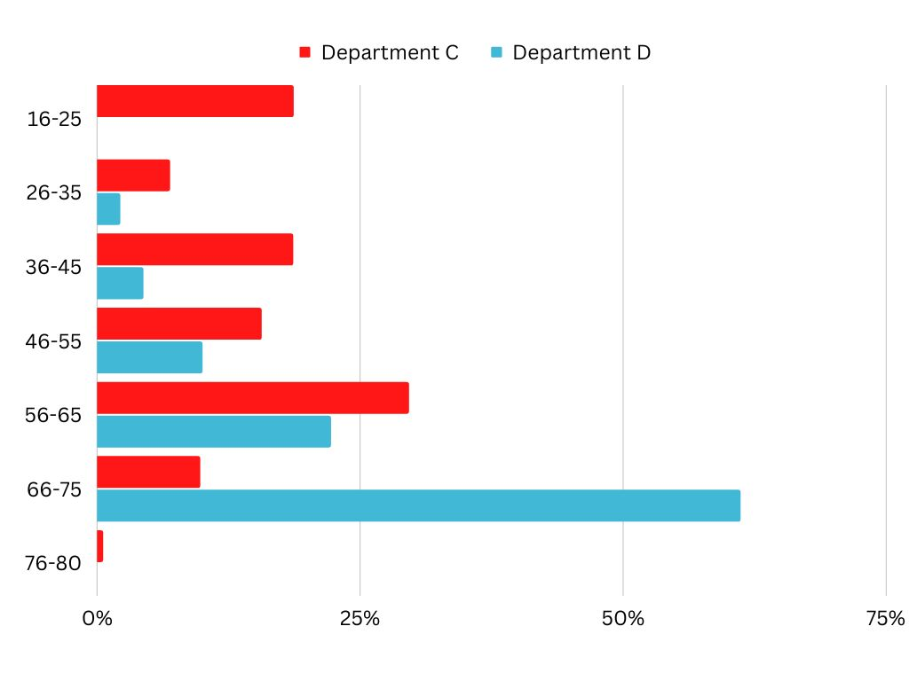

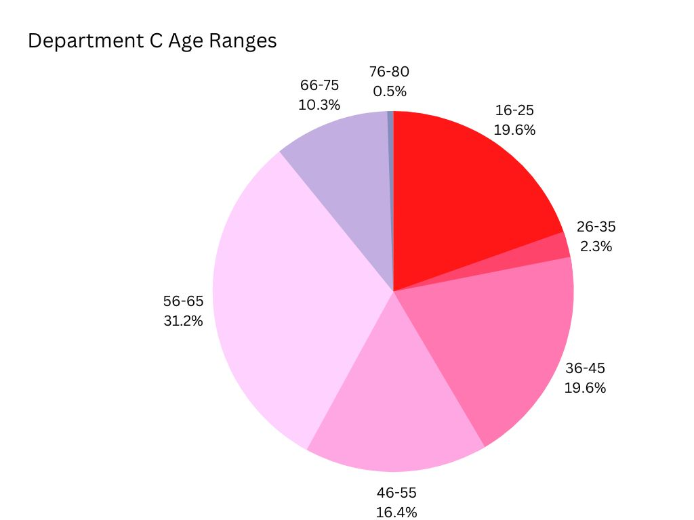
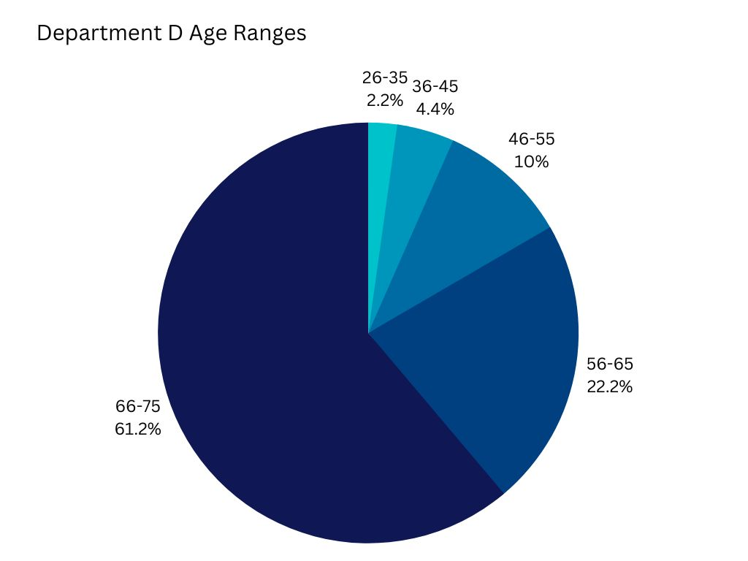
Department C benefits from a fairly age-diverse team which can improve knowledge-sharing, innovation, customer service and problem-solving (CIPD, 2014). Department D, however, has a disproportionate number of over-50 workers compared to under-50. A large portion of both Department C and D’s teams are over 50 years of age. Retirement ages continue to steadily rise and employers are seeing an ‘appetite’ in their over-50 workers to work longer (Roper, 2016; Muller-Heyndyk, 2018). This could potentially be initially viewed as a disadvantage; an older workforce are considered to be less flexible, unenthusiastic and obstinate (Bersin and Chamorro-Premuzic, 2019). However, in converse, retaining this age demographic of the workforce is vital both in terms of enhancing the skillset of our workforce and ensuring a diverse workforce can meet the needs of an equally diverse market (Roper, 2016). Continuing to have career conversations with our older employees and offering support in relation to their wellbeing, such as using the occupational health service and making reasonable adjustments to their work-life, and their financial considerations, such as pension guidance and phased retirement options, will enable them to continue their role as capably and efficiently as possible (McCartney, 2022; Barton, 2011). However, we should reconsider our recruitment strategy in terms of targeting younger talent, particularly when considering Department D’s succession planning in case of potential retirements (Barton, 2011).
This is acutely exemplified by the complete lack of 16-25-year olds in Department D. The recruitment of young people is fundamental to ensuring both the diversity and the future of our workforce (CIPD, 2012). Young people’s flexibility, adaptability, tech-savviness and enthusiasm, to name a few of the skills they would bring to the organisation, would benefit us both in terms of cost and in our ability to serve our customers successfully (Wright, 2021; CIPD, 2012). Offering entry-level job opportunities, apprenticeships or internships, engaging with schools and colleges, and using relevant communication channels such as social media are a number of suggestions for ways for us to engage with this particular demographic (NHS Employers, 2022; CIPD, 2012). In the short term, redeploying a portion of Department C’s 16-25-year-old employees to Department D could provide that department with an opportunity to innovate and avoid stagnation. Furthermore, we could utilise the older employees in Department D by placing them in leadership or mentoring roles with the 16-25-year olds, developing next generation leaders and passing on organisational knowledge (Carruthers, 2022).
Department C’s total of employees in the department almost doubles the number in Department D which presents both potential advantages and challenges. Smaller teams are able to collaborate more effectively and are more engaged due to recognition of their individual efforts (Jackson, 2020; Morgan, 2015). Large teams could be prone to communication or decision-making issues and members of the team could drop productivity due to the lack of ownership in a larger group, also known as ‘social loafing’ (Potter, 2020). This can be addressed with the implementation of effective internal communication channels and clarity of roles and responsibilities (West, 2019). Again, there is the potential to redeploy a section of Department C’s workforce to Department D to alleviate possible understaffing or re-distribute workload.
Word Count = 520

References
Armstrong, M. and Taylor, S. (2020) Armstrong’s handbook of human resource management practice. 15th edn. London: Kogan Page.

Aquinas, P (2009) Human Resources Management Principles and Practices. New Delhi: VIKAS.

Ayling, L. and Suff, R. (2022) Data protection and GDPR in the workplace. Available at: https://www.cipd.co.uk/knowledge/fundamentals/emp-law/data-protection/factsheet#gref Accessed: 15 January 2023).

Barends, E., Rousseau, D. and Briner, R. (2014) Evidence-Based Management: The Basic Principles. Amsterdam: Center for Evidence-Based Management. Available at: https://www.cebma.org/wp-content/uploads/Evidence-Based-Practice-The-Basic-Principles.pdf (Accessed: 31 January 2023).
Barton, T. (2011) Planning ahead for an ageing workforce. Available at: https://employeebenefits.co.uk/issues/august-2011/planning-ahead-for-an-ageing-workforce/ (Accessed: 4 January 2023).

Baska, M. (2018) Six ways analytics will future-proof HR. Available at: https://www.peoplemanagement.co.uk/article/1744727/six-ways-analytics-future-proof-hr#_ga=2.84945497.138459327.1674989542-2122259706.1646996593

Bersin, J. and Chamorro-Premuzic, T. (2019) The Case for Hiring Older Workers. Available at: https://hbr.org/2019/09/the-case-for-hiring-older-workers (Accessed: 6 January 2023).
Blackburn, A. (2011) Can HR add value to the customer experience? Available at: https://www.hrmagazine.co.uk/content/features/can-hr-add-value-to-the-customer-experience/ (Accessed: 22 January 2023).
Boler, J. (2015) Human Resources Management Standards Improve the Bottom Line. Available at: https://www.theauditoronline.com/human-resource-management-standards-improve-the-bottom-line/ (Accessed: 23 January 2023).
Bond, H. (2022) HR and Standards. Available at: https://www.cipd.co.uk/knowledge/strategy/hr/standards-factsheet#gref (Accessed: 24 January 2023).
Burke, E. (2016) People and the creation of value. Available at: https://www.cipd.co.uk/Images/people-and-the-creation-of-value_tcm18-19955.pdf (Accessed: 16 January 2023).
Carless, S. (2009) ‘Psychological testing for selection purposes: a guide to evidence-based practice for human resource professionals’, The International Journal of Human Resource Management, 20:12, pp. 2517-2532. Available at: 10.1080/09585190903363821
Carruthers, R. (2022) The Critical Role of Senior Employees in L&D: Mentoring the Next Generation. Available at: https://www.spiceworks.com/hr/learning-development/guest-article/the-critical-role-of-senior-employees-in-ld-mentoring-the-next-generation/ (Accessed: 8 January 2023).
CIPD. (2012) The business case for employer investment in young people. London: Chartered Institute of Personnel Development. Available at: https://www.cipd.co.uk/Images/the-business-case-for-employer-investment-in-young-people_2012_tcm18-10294.pdf (Accessed: 8 January 2023).

CIPD. (2013) Analytics: how HR can influence strategy through data [Podcast]. 3 April. Available at: https://www.cipd.co.uk/podcasts/hr-analytics-influence-strategy-through-data#gref (Accessed: 15 January 2023).

CIPD. (2014) Managing an age-diverse workforce. London: Chartered Institute of Personnel Development. Available at: https://www.cipd.co.uk/Images/managing-an-age-diverse-workforce_2014_tcm18-10838.PDF (Accessed: 8 January 2023).
CIPD. (2019) Evidence-based practice for HR: beyond fads and fiction [Podcast]. 7 May. Available at: https://www.cipd.co.uk/podcasts/evidence-based-HR#gref (Accessed: 15 January 2023).
CIPD. (2022) Commercial drive. Available at: https://peopleprofession.cipd.org/profession-map/core-behaviours/commercial-drive#gref (Accessed: 23 January 2023).

Dale, G. (2019) Absence data: how to use staff sickness absence data. Available at: https://www.myhrtoolkit.com/blog/absence-data (Accessed: 22 January 2023).

Dufrane, A. (2022) How Standards Are Essential to Strategic HR. Available at: https://www.hrci.org/community/blogs-and-announcements/hr-leads-business-blog/hr-leads-business/2022/02/14/how-standards-are-essential-to-strategic-hr (Accessed: 24 January 2023).
George, S. (2022) HR policies. Available at: https://www.cipd.co.uk/knowledge/fundamentals/people/hr/policies-factsheet#gref (Accessed: 1 February 2023).
Gibson, G. (2017) Taking a customer-focused approach to HR service delivery. Available at: https://www.linkedin.com/pulse/taking-customer-focused-approach-hr-service-delivery-gerry-gibson/?trk=public_profile_article_view (Accessed: 23 January 2023).
Goedhart, M. and Koller, T. (2020) The value of value creation. Available at: https://www.mckinsey.com/capabilities/strategy-and-corporate-finance/our-insights/the-value-of-value-creation (Accessed: 17 January 2023).

Henisz, W., Koller, T. and Nuttall, R. (2019) Five ways that ESG creates value. Available at: https://www.mckinsey.com/capabilities/strategy-and-corporate-finance/our-insights/five-ways-that-esg-creates-value (Accessed: 4 February 2023).

Jackson, B. (2020) Smaller connected teams work better for businesses. Available at: https://www.hrmagazine.co.uk/content/news/smaller-connected-teams-work-better-for-businesses/ (Accessed: 6 January 2023).

Jeffery, R. (2019) Amazing insights you can learn from people analytics. Available at: https://www.peoplemanagement.co.uk/article/1742168/amazing-insights-learn-from-people-analytics (Accessed: 22 January 2023).

Kennedy, E. (2020) ‘Can data drive racial equity?’, MIT Sloan Management Review, 3. Available at: https://sloanreview.mit.edu/article/can-data-drive-racial-equity/

Lakhotia, S. (2018) Why HR Policies Are Prerequisites to Organizational Excellence. Available at: https://www.entrepreneur.com/en-au/growth-strategies/heres-why-companies-need-to-create-better-hr-policies/324335 (Accessed: 2 February 2023).

Leatherbarrow, C. and Fletcher, J. (2019) Introduction to human resource management: a guide to HR in practice. 4th edn. London: Kogan Page

Macchi Silva, V. and Ribeiro, J. (2021) ‘A discussion on using quantitative or qualitative data for assessment of individual competencies’, Personnel Review, 50(6), pp. 1460-1478. Available at: https://doi.org/10.1108/PR-08-2019-0444

Makoff-Clark, A. (2018) Only half of organisations using people data to make business decisions, CIPD report finds. Available at: https://www.peoplemanagement.co.uk/article/1746764/half-of-organisations-using-people-data (Accessed: 21 January 2023).

Mallick, A. (2021) The Role of Human Resources (HR) as Value Creator. Available at: https://sightsinplus.com/hottopic/value/the-role-of-human-resources-hr-as-value-creator/ (Accessed: 4 February 2023).

Marson, L. (2022) 4 reasons HR must clean its people analytics data. Available at: https://www.techtarget.com/searchhrsoftware/tip/4-reasons-HR-must-clean-its-people-analytics-data (Accessed: 21 January 2023).

McCartney, C. (2022) Age and employment. Available at: https://www.cipd.co.uk/knowledge/fundamentals/emp-law/age-discrimination/factsheet (Accessed: 4 January 2023).

Mercer. (2015) A Workforce Tsunami is Approaching: How You Can Be Prepared and Manage Workforce Risks. London: Mercer Limited. Available at: https://www.mercer.pt/content/dam/mercer/attachments/global/Talent/human-capital-agenda/anthology-2016/a-workforce-tsunami-is-approaching-how-you-can-be-prepared-and-manage-workforce-risks-2016-mercer.PDF?mkt_tok=eyJpIjoiWVRrNE1EbGxNRFl3WlRReSIsInQiOiJFUmtRWWZqaVcycjY5NVlaNmJ5Y1ZCZzlxM3lkdFBIblZxc2ozRFJlTW9pUE5rMTliSHVacnhrcmtOVmxsSHZMRjdsTnEwWjNQSTJEbnozSkN1S0o3Zk9RblwvM2xQakVZWGV1emVjQjAzYW89In0%3D

Mistry, P. (2022) Why Employee Engagement Is About More Than Just Metrics. Available at:

https://www.thehrdigest.com/why-employee-engagement-is-about-more-than-just-metrics/ (Accessed: 28 January 2023).

Mohdzaini, H. (2022) People Analytics. Available at: https://www.cipd.co.uk/knowledge/strategy/analytics/factsheet#gref (Accessed: 14 January 2023).

Morgan, J. (2015) Why Smaller Teams Are Better Than Larger Ones. Available at: https://www.forbes.com/sites/jacobmorgan/2015/04/15/why-smaller-teams-are-better-than-larger-ones/?sh=1cba0d121e68 (Accessed: 6 January 2023).

Morris, E. (2020) Why Accurate HR Data Is Vital for Companies Operating in a Crisis. Available at: https://datafloq.com/read/why-accurate-hr-data-is-vital-companies-operating-crisis/ (Accessed: 14 January 2023).

Muller-Heyndyk, R. (2018) Over-50s plan to work longer. Available at: https://www.hrmagazine.co.uk/content/news/over-50s-plan-to-work-longer (Accessed: 9 January 2023).

myHRfuture. (2019) HOW TO MAKE HR MORE EVIDENCE BASED - Edward Houghton, CIPD. 21 May. Available at: https://www.youtube.com/watch?v=zlhTsfnWLvo (Accessed: 22 January 2023).

NHS Employers. (2022) Recruit and retain young people toolkit. Available at: https://www.nhsemployers.org/publications/recruit-and-retain-young-people-toolkit (Accessed: 4 January 2023).

Personnel Today. (2012) How can HR prove it really adds value? Available at: https://www.personneltoday.com/hr/how-can-hr-prove-it-really-adds-value/ (Accessed: 4 February 2023).

Potter, J. (2020) The Ideal Team Size At Work May Be Smaller Than You Think. Available at: https://www.forbes.com/sites/jaimepotter/2020/04/27/the-ideal-team-size-at-work-may-be-smaller-than-you-think/?sh=13c393c0630a (Accessed: 6 January 2023).
Roper, J. (2016) The HR challenges of an ageing workforce. Available at: https://www.hrmagazine.co.uk/content/features/the-hr-challenges-of-an-ageing-workforce/ (Accessed: 6 January 2023).
Sackett, D., Rosenberg, W., Gray, J., et al. (1996) ‘Evidence based medicine: what it is and what it isn't: it's about integrating individual clinical expertise and the best external evidence’, BMJ, 312, pp. 71-72. Available at: http://dx.doi.org/10.1136/bmj.312.7023.71
Torrington, D., Hall, L., Atkinson, C. and Taylor, S. (2020) Human resource management. 11th edn. London: Pearson Education Limited.

Ulrich D. and Dulebohn, J. (2015) ‘Are we there yet? What’s next for HR?’, Human Resource Management Review, 25(2), pp. 188-204. Available at: https://doi.org/10.1016/j.hrmr.2015.01.004 (Accessed: 5 February 2023).

Waters, S. (2017) Make Better Decisions with Evidence-Based HR. Available at: https://www.shrm.org/hr-today/news/hr-magazine/1217/pages/make-better-decisions-with-evidence-based-hr.aspx (Accessed: 21 January 2023).
West, M. (2019) Does team size matter? Available at: https://www.affinaod.com/article/does-team-size-matter/ (Accessed: 6 January 2023).

Woods, D. (2010) HR teams don’t have access to the data they need to make important decisions. Available at: https://www.hrmagazine.co.uk/content/news/hr-teams-dont-have-access-to-the-data-they-need-to-make-important-decisions (Accessed: 14 January 2023).

Wright, H. (2021) Why hiring young talent creates opportunities for innovation. Available at: https://www.hrmagazine.co.uk/content/comment/why-hiring-young-talent-creates-opportunities-for-innovation (Accessed: 6 January 2023).
Young, J. (2022) Evidence-based practice for effective decision-making. Available at: https://www.cipd.co.uk/knowledge/strategy/analytics/evidence-based-practice-factsheet#gref (Accessed: 14 January 2023).

