Data Warehousing & Data Mining
Component 1
Yasser El Ouafai Ouafa (2320925)

Abstract
This report outlines the proposed solution to streamline NHS England's data warehousing to integrate, analyse and report healthcare data. It clarifies the difference between OLTP systems and Data Warehouses, describes an appropriate DW architecture and creates an appropriate schema – Star – to support business intelligence. The ETL process is also described in the report, along with discussions about the data quality and governance, and identification of possible data marts and source systems. This solution enables implementations of dashboards in Tableau Public 2026.1 and will make information-sharing easier, more efficient, and more effective in making actions more evidence-based.

Contents
Abstract 1
Introduction 3
Task 1 4
1.1 OLTP vs Data Warehouse 4
1.2 Data Warehouse Architecture and ETL 5
1.3 Data Marts for Management Decision-Making 6
1.4 OLTP Normalisation vs Data Warehouse Dimensional Modelling 7
Task 2 8
2.1 Source System Identification 8
2.2 Star Schema Design 9
2.3 Data Marts and Schema 11
2.4 ETL Plan 11
2.5 Data Quality and Governance 12
Conclusion 12
REFERENCES 13

Introduction
Patient, clinical, workforce and financial data is produced in great volumes throughout the NHS England's operations across multiple systems. Though these systems can assist with regular healthcare operations, they are unable to offer a complete perspective on how an organisation is doing. A data warehouse can solve this problem by storing data from various sources in one database for various reports and analyses. The objective of this report is to create a data warehousing solution for NHS England to include ETL processes, dimensional modelling, star schemas and data marts. The solution further enables both Tableau Software clients and Tableau Public 2026.1 to build dashboards to help senior management track progress, more efficiently schedule resources and make data-driven decisions.

Task 1

1.1 OLTP vs Data Warehouse
Currently NHS England are using a range of Online Transaction Processing (OLTP) systems such as Electronic Patient Record (EPR), Patient Administration System (PAS), workforce management systems and financial systems. Their role in working with large amounts of transactions is to process them quickly and accurately, for use in everyday healthcare operation. Patient admissions, appointments, treatments, staff schedules and financial transactions, for instance, are all processed in real time by OLTP systems. Their main goal is to achieve operational efficiency and data integrity, not for long-term analysis.

The data warehouse is for another purpose. It does not assist in day-to-day functions, but instead brings together historic information from various data sources to a single point for analysis and decision making. The data that is stored in a warehouse is 'mixed up', cleaned and structured to give a 'flat and consistent picture' of NHS performance. This allows the management to see trends, compare geography and to uncover performance problems that might not be apparent from individual OLTP systems.

There would be great benefits to the NHS England from their investment of a data warehouse. Clearly see the patient flow, occupancy, staff utilization, cost of treatment and various quality metrics throughout various hospitals & regions by senior leaders. The warehouse will facilitate the analysis of past and up to-date data in order to implement evidence-based decision-making within the warehouse. A data warehouse can be distinguished from an OLTP in that it is primarily used for complex analytical queries and reporting, as opposed to single transactions. NHS England would therefore more effectively meet its targets of cutting waiting times, applying better resources, facilitating the monitoring of targets and improving the outcomes for patients using data-driven decision making.

1.2 Data Warehouse Architecture and ETL
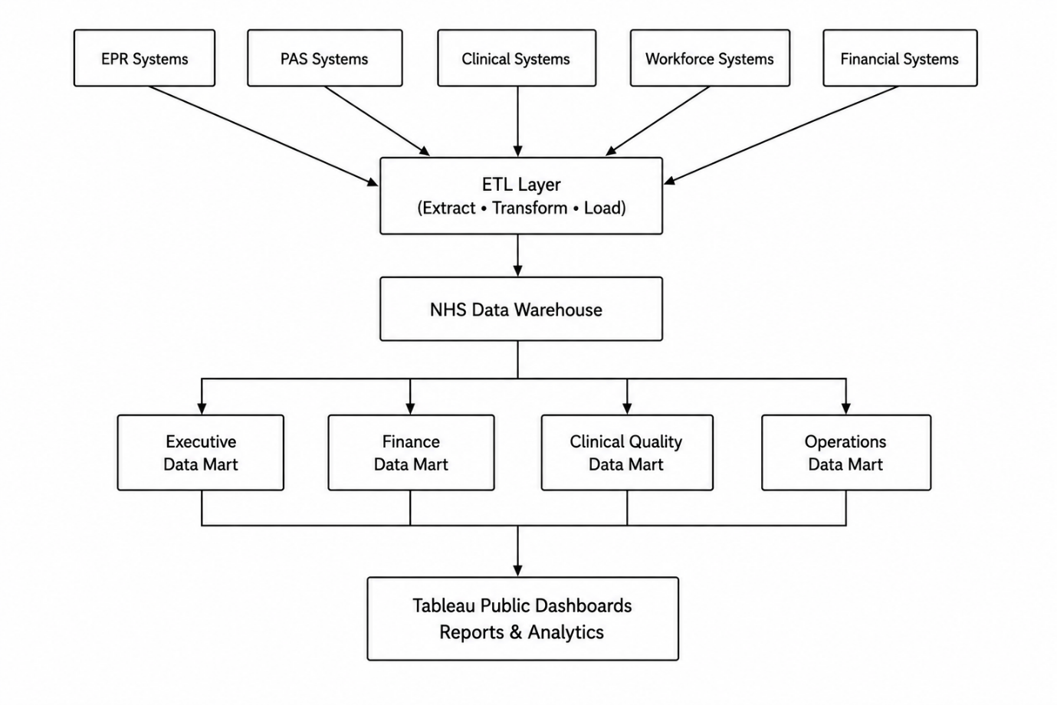
Figure 1: Proposed NHS England Data Warehouse Architecture

NHS England operates a number of operational systems for managing patient information, clinical activity, staffing and financial information. These systems can help with the day to day running of the healthcare industry but they aren't comprehensive enough to give a regional or hospital-wide picture of performance. To tackle this, it is recommended to have a central data warehouse to house data from various sources in a common place to be used for reports and analyses.

The proposed architecture (see Figure 1), includes four major components: the source systems, an ETL (Extract, Transform and Load) process, a Data warehouse and Data marts for departments. The sources of information mainly are Electronic Patient Records (EPR), Patient Administration Systems (PAS), clinical systems, platforms for workforce management and financial systems. The systems produce information like number of patients and visits, diagnoses with their approval, treatments granted and received by patients, and information about staffing, budgets, and the costs of the healthcare system.

The ETL process extracts important information from each of the operational systems, cleanses the data by removing duplicate records, fixes errors and standardises data records into various formats (e.g. ICD-10 diagnosis codes), and then loads the cleaned data records into the central data warehouse. This will guarantee that the information is accurate, consistent and appropriate for analysis.

There are several data marts such as Executive, Finance, Clinical Quality and Operations that are part of the data warehouse. These offer customized info for various administration teams and may be associated to Tableau Public 2026.1 dashboards for reporting and performance tracking.

The ETL process tends to take place outside of the working hours, so that NHS England can engage with the clinical service without impacting on the day-to-day clinical and administrative running of the service. This way, while delivering reliable reporting, it does not affect the performance of the present operational systems.

1.3 Data Marts for Management Decision-Making
A data mart is a specialized data warehouse for a particular area of the business who have specific reporting requirements. The NHS England senior leadership team needs different kinds of information to help with their work in regards to operational, financial and clinical decision making. A single data mart will provide each department with relevant information, while the data is kept consistent across all these data marts in the data warehouse.

The Executive Data Mart will support the Chief Executive, including providing him/her with key performance indicators (KPIs) such as waiting times; bed occupancy; and workforce capacity and patient outcome. The performance insights allow for senior management tracking performance by region, trends and informed decision making when making resource allocation decisions. These can be displayed in a clear and interactive manner using a dashboard with Tableau Public 2026.1.

The Finance Data Mart would help the Finance Director to keep data for treatment costs, National tariffs, Departmental expense, budgets, cost per treatment episode. This enables financial managers to keep track of expenditure, determine whether there are any overspend areas and, consequently, enable long term finance planning improvements.

The Medical Director would benefit from the Clinical Quality Data Mart, which would enable him or her to analyse patient satisfaction, patient safety incidents, treatment effectiveness, mortality indicators and readmission rates. This information enables healthcare managers to track the quality of the services they provide, assess the effectiveness of clinical care, and continually improve the quality.

Through its provision of dedicated data marts for executive, financial and clinical reporting, NHS England can enable decision makers to access accurate, timely and relevant information for better healthcare management and report on it more efficiently.

1.4 OLTP Normalisation vs Data Warehouse Dimensional Modelling
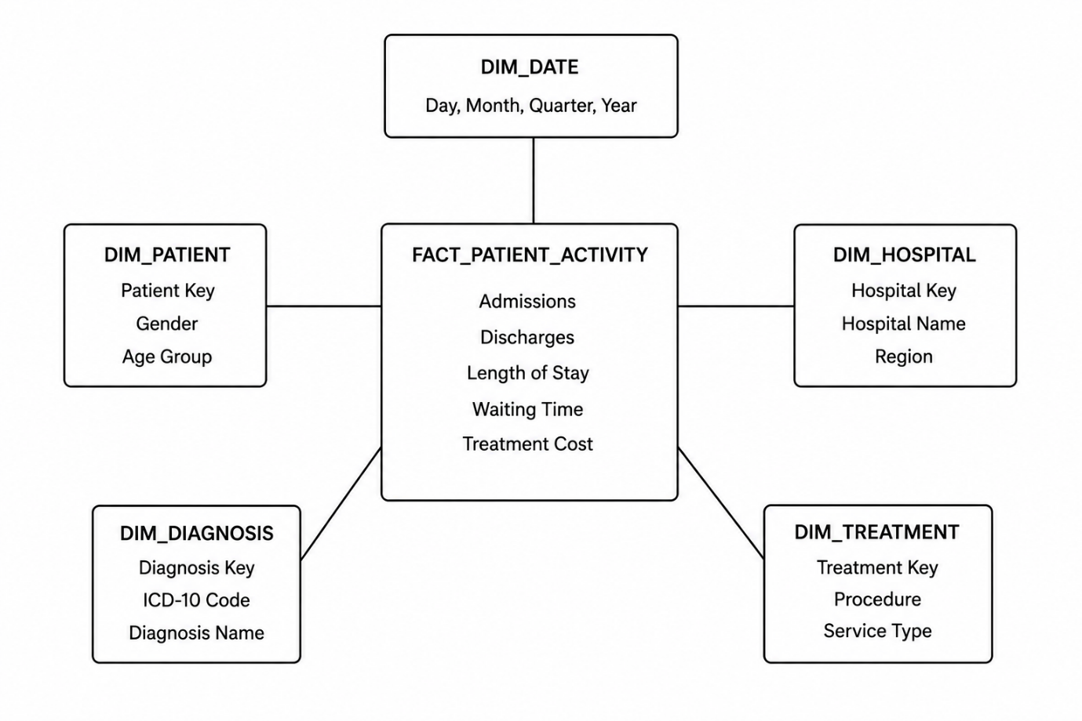
Figure 2: Proposed NHS Patient Activity Star Schema

NHS England operational systems, such as electronic patient records (EPR) and patient administration systems (PAS), are often developed based on normalised databases. A normalized Database organises the data into different related tables to help minimise duplication and data integrity. Because this design allows for quick insert, update and delete operations necessary for the day-to-day operations of healthcare systems, it is suitable for Online Transaction Processing (OLTP).

A data ware house is a collections of reports and analytical process. It employs a dimensional modeling style. The most prevalent type of dimensional model is the star schema, which is made up of a fact table with one or more dimension tables connected to it. This helps to come up with complex queries and boost reporting performance.

The proposed NHS England star schema (shown in Figure 2) has FACT_PATIENTS as its fact table. It records information that can be measured like admissions, discharges, length of stay, treatment costs etc. Boxes of descriptive information, surrounding dimension tables, include patient demographics, hospital information, dates, diagnoses and service types. These dimensions enable health care activity analysis from various viewpoints.

A star schema offers superior query processing performance and simpler usage for business intelligence, compared to extremely normal OLTP databases. It also integrates seamlessly with Tableau Public 2026.1, allowing users to quickly and easily build dashboards, conduct trend analysis and make informed decisions based on facts throughout NHS England.

Task 2

2.1 Source System Identification
The planned implementation of NHS England's data warehouse will bring together information from inward and outward sources to offer a comprehensive view of the performance of healthcare. Examples of internal data sources are: Electronic Patient Records (EPR), Patient Administration Systems (PAS), clinical systems, Workforce Management Platforms and Financial Systems. Patient demographic details, admissions, diagnoses, treatments, staff info, budgets and health care expenditure are all provided by these systems. Other systems that contribute data to quality and performance include readmission rates, mortality indicators and patient satisfaction.

External information sources may include data from ONS population data sources, public health data sources and national regulatory reporting information. Nested together, these sources will provide NHS England with the ability to track performance of care, detect trends and inform learning and strategic planning based on evidence throughout the organisation.

2.2 Star Schema Design
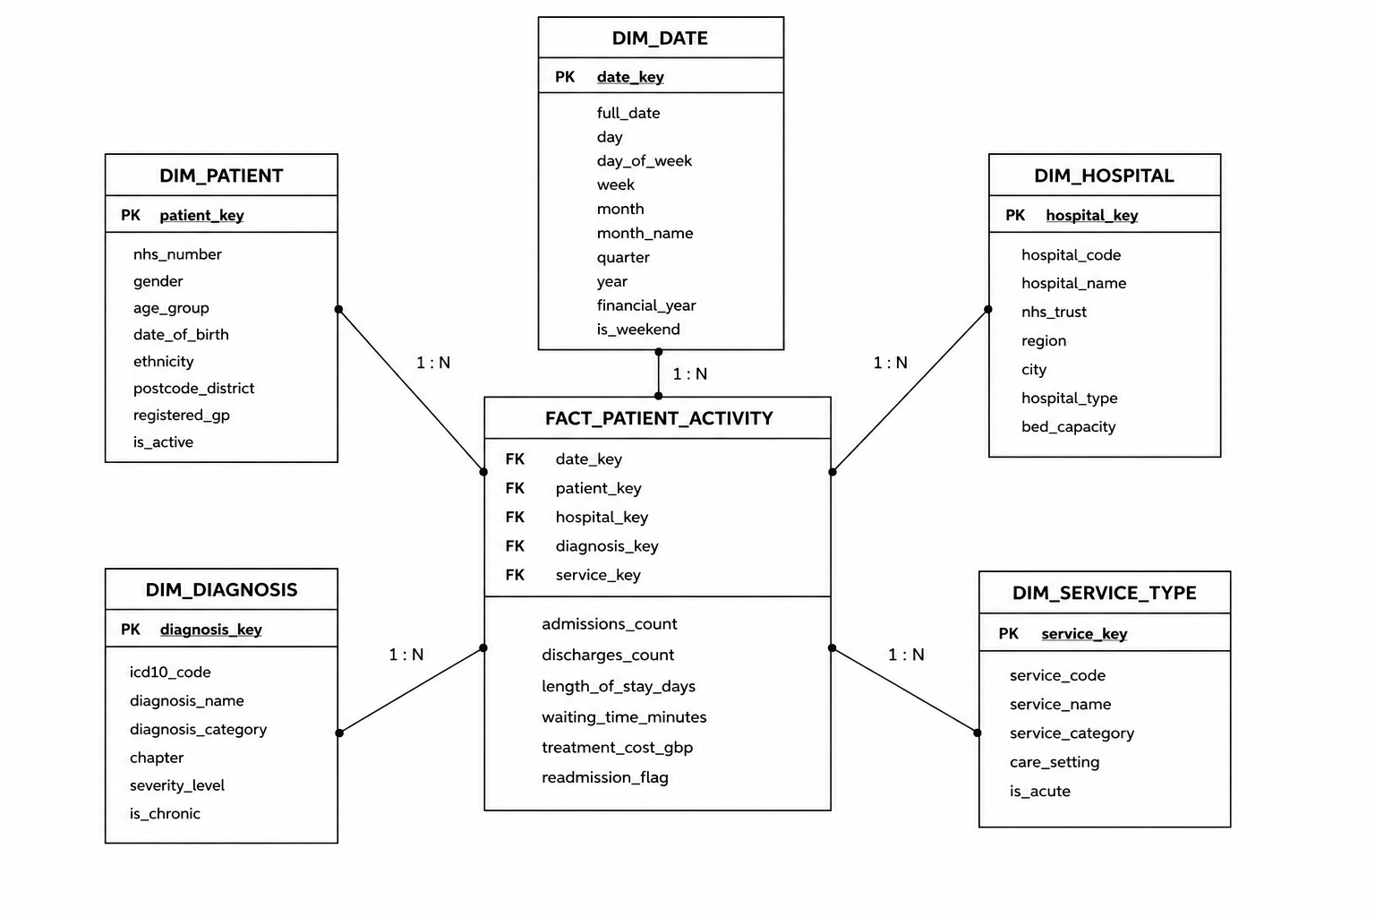

NHS England has a need for a semantic model of data which can enable analytical reporting and business intelligence. The star schema has been chosen as this will offer a simple structure, have favourable performance for queries and will be utilized to work with visualisation programs, like Tableau Public 2026.1. The design is a dimensional design in which a fact table in the middle is surrounded by dimension tables that contain the descriptive information for reporting and analysis. The proposed design is shown in Figure 3.

The central FACT_PATIENT_ACTIVITY table contains measurable health care data from health care delivery during the care experience. This comprises of admissions, discharges, length of stay, waiting times, treatment costs and readmission indicators. These "numeric" values can be added up and analysed to track healthcare performance at the hospital, region and temporal levels.

Master data that is stored in the DIM_PATIENT table would include NHS number, age range, gender, ethnicity, postcode district and registered GP. The information stored separately means that it does not get duplicated and healthcare activity can be analysed among different demographic groups.

A time dimension will be used for reporting purposes and the DIM_DATE table is the time dimension. It contains both day, week, month, quarter and year attributes, enabling NHS England to compare performance across time intervals, look at any patterns which emerge seasonally, and measure the volume of services required over time.

The DIM_HOSPITAL table contains details on the healthcare providers such as name of the hospital, NHS Trust, region, type of hospital and bed capacity. This allows assessments of the quality of care provided by hospitals and comparison between them, helps control performance at the regional level and identifies capacity gaps and operational bottlenecks.

The DIM_DIAGNOSIS table contains clinical information based on ICD-10 diagnosis codes. This dimension could be used to help medical condition trends to be monitored by NHS England, help in the evaluation of medical outcomes and in understanding the demand for various health services by medical condition.

The DIM_SERVICE_TYPE table represents metadata, describing the type of healthcare service delivered, such as acute care, community care, outpatient services and mental health services. Having a dedicated dimension for service classifications assures uniformity of reporting organization-wide.

The FACT_PATIENT_ACTIVITY table also supports aggregate reporting because its measures, including admissions, discharges, treatment costs and length of stay, can be summarised by date, hospital, diagnosis and service type to produce monthly performance indicators. This enables NHS England to monitor trends, evaluate organisational performance and provide senior management with meaningful business intelligence without requiring additional fact tables.

Overall, the proposed star schema provides a scalable and efficient data warehouse design that integrates operational, clinical and performance data. It facilitates rapid analytical requests, simplifies reporting and helps NHS England to make well-informed choices by using Tableau Public 2026.1 dashboards.

2.3 Data Marts and Schema
The enterprise data warehouse needs to be segmented into specific data marts that can deliver data to departments to support decision making throughout NHS England. Every data mart has the data relevant to a particular business functional area and is consistent through the central data warehouse.

The Finance Data Mart will assist the Finance Director by storing: treatment costs, treatment budgets, expenditure, national tariffs and cost per patient episode. It leverages the data in the FACT_PATIENT_ACTIVITY table as well as the DIM_HOSPITAL, DIM_DATE and DIM_SERVICE_TYPE dimensions. This will allow for financial monitoring, budget control and cost analysis.

Analysis of admissions/discharges, waiting times, bed utilization and patient flow, are all powered by the Operations Data Mart for the Chief Executive and operational managers. It brings together FACT_PATIENT_ACTIVITY with DIM_DATE, DIM_HOSPITAL and DIM_PATIENT to pinpoint any occupation gaps and enhance resource management.

The Clinical Quality Data Mart includes data on diagnoses, patient outcomes, readmission rates, mortality indicators and patient satisfaction and is designed to assist the Medical Director in performing analysis. It combines FACT_PATIENT_ACTIVITY with information on the diagnoses (DIM_DIAGNOSIS), patient (DIM_PATIENT), date (DIM_DATE) and service type (DIM_SERVICE_TYPE) to help audit clinical point and evaluate service improvements.

Dedicating data to finance, ops and clinical quality data marts mean that NHS England can offer quick response times for reporting, better decision making, and better access to relevant, consistent and reliable data to each department.

2.4 ETL Plan
The ETL (Extract, Transform and Load) process will load data into the data warehouse from the NHS England operation systems. Data will be captured in a variety of systems during the Extract stage, including Electronic Patient Records (EPR), Patient Administration Systems (PAS), clinical systems, workforce management platforms and financial systems. These come from and include patient information, admissions, diagnoses, treatments, staffing information and financial records.

In the Transform stage, results will be cleaned and standardised by eliminating redundant data, drawing out the spelling of names and addresses, checking, and assigning consistent formats (including ICD-10 diagnosis code standardization). The name of the hospital, the type of service and the region identifier will also be harmonised to ensure uniformity of the data.

Finally, in the Load stage the transformed data will be moved to the central data warehouse and to the relevant data marts. This will give NHS England accurate, reliable and consistent data to report, analyse and create Tableau Public 2026.1 dashboards.

2.5 Data Quality and Governance
Data quality and governance are essential to ensure reliable healthcare analytics. The data must be cleaned and standardised throughout the ETL which also identifies any errors and/or repeated data. NHS England need to ensure it has accurate, complete and consistent data in all systems. Good governance should entail adherence to the UK GDPR, access control and audit trails based on user roles to safeguard patient-sensitive information. Data quality checks will be carried out regularly in order to assure that reportation and decision making is sound and accurate.

Conclusion
This report has suggested an approach to the data warehousing design for NHS England to help unify, store and analyse healthcare information. A data warehouse is a collection of data that are centralized to aid reporting, trend analysis and decision-making, whereas present OLTP systems exist. The proposed architecture entails multiple operational systems providing data to each other via an ETL approach, and that dimensionally using a star schema. Specific data marts are created for executive reporting, financial reporting and clinical reporting for quicker and efficient data access to different departments and teams. Tableau Public 2026.1 adds to the solution by offering interactive dashboards that enable performance monitoring and fact-based choices. With robust data quality, governance, and compliance (UK GDPR) in place, NHS England will have accurate reporting and will achieve greater efficiencies, resource planning, and patient outcomes throughout the organization.

REFERENCES
[1] W. H. Inmon, Building the Data Warehouse, 5th ed. Indianapolis, IN, USA: Wiley, 2005.
[2] R. Kimball and M. Ross, The Data Warehouse Toolkit: The Definitive Guide to Dimensional Modeling, 3rd ed. Hoboken, NJ, USA: John Wiley & Sons, 2013.
[3] T. Connolly and C. Begg, Database Systems: A Practical Approach to Design, Implementation, and Management, 6th ed. Harlow, UK: Pearson Education, 2015.
[4] P. Vassiliadis, “A Survey of Extract–Transform–Load Technology,” International Journal of Data Warehousing and Mining, vol. 5, no. 3, pp. 1–27, 2009.
[5] C. J. Date, An Introduction to Database Systems, 8th ed. Boston, MA, USA: Pearson, 2004.
[6] NHS England, “Transformation Directorate,” NHS England, 2025. [Online]. Available: https://www.england.nhs.uk/transformation/. [Accessed: Jun. 2026].
[7] NHS England, “NHS Data Model and Dictionary,” NHS England, 2025. [Online]. Available: https://www.datadictionary.nhs.uk/. [Accessed: Jun. 2026].
[8] Information Commissioner’s Office (ICO), “Guide to UK GDPR,” ICO, 2025. [Online]. Available: https://ico.org.uk. [Accessed: Jun. 2026].
[9] M. Golfarelli and S. Rizzi, Data Warehouse Design: Modern Principles and Methodologies. New York, NY, USA: McGraw-Hill, 2009.
[10] R. Kimball, M. Ross, W. Thornthwaite, J. Mundy and B. Becker, The Data Warehouse Lifecycle Toolkit, 2nd ed. Indianapolis, IN, USA: Wiley, 2008.

