Anthony Jacques
1806571
Joanna Walsh

PROFESSIONAL CAREER DEVELOPMENT

Executive Summary
In this report, it has been highlighted about the personal development plan along with self evaluation it has also focused about the personal analysis with the help of SWOT and Johari Window Analysis. In this report, the discussion has also been about the motivational factors as well as personal career life line. Further discussion has been completed with the help of reflective model. It has also highlighted about the knowledge of the world of employment. It also has the discussion about the identification of personal potential skills with the help of SMART objectives along with the aspirations and future ambition in the career field. A personal development plan has also been highlighted in this study with force field analysis.

Table of Contents
1. Introduction 4
2. Self Evaluation 4
2.1. Lifeline 4
2.2. SWOT 5
2.3. Learning style 7
2.4. Johari Window 8
2.5. Motivation 9
3. Reflective Model 10
4. Understanding world of employment 10
5. Smart Objectives 11
5.1. Own potential review 12
5.2. Aspiration as well as ambition 13
6. Personal Development Plan (PDP) 14
6.1. Force Field Analysis 14
6.2. Action Plan 15
7. Conclusion 15
Reference List 16
Appendices: 18
Appendix 1: Honey and Mumford Learning Style 18
Appendix 2: Skills Audit 19
Appendix 3: Personal Development Action Plan 20

1. Introduction
In this world of dynamic everyone is in search of a better livelihood and in search of that different form of development has been initiated by following strategies known as career development plan. In this perspective decision has been granted based on the career objectives in both academic as well as professional life. This report states of vindictive career development as well as lifeline along with the professional development plan to showcase my skills that I imbibed and the skills that require immediate development to pursue a sustainable career ahead. In addition to that I will forecast an extensive view of world employment as well as self-evaluation review to get a clear picture of my own career.

2.Self-Evaluation

2.1. Lifeline
Lifeline is the basic structural format that I have experienced in my past years. As opined by Potvin et al. (2016), lifeline brings a subjective review of own career that brings a reliable knowledge on skills being possessed. My own lifeline states of the incident that I have passed as well as experienced previously to get a clear perspective of career life. I have completed my school education at the age of 19 and after that I have completed my graduation at the age of 22. After that I joined John Lewis as sales marketing representative and served the company for 4 long years. I have focused on providing my best to the development of the company John Lewis in order to develop myself in the sales career for sustainable period. After three year service I have been promoted as a junior assistant sales manager and served the company. This particular incident of promotion became a turning point of my life. I have joined night classes of post-graduation at the age of 27 to enhance my academic career that can also bring significant changes in my professional career. My lifeline has laid a significant perspective in my further career growth with utmost academic knowledge to get a prevalent form of career developer. My whole lifeline can be visualized as well as represented by a graph given below.
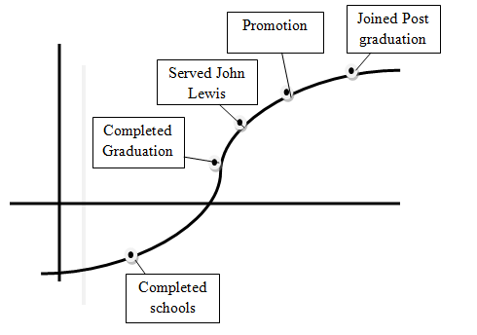
Figure 1: Lifeline graph

2.2. SWOT
Swot is an analytical tool that specifies of analyzing personal strengths and weaknesses as well as threats and opportunities in own career role. As suggested by Rangkuti (2015), analysis of owns strength help to understand as well as opportunity brings possible advantage of using opportunities in every aspect.
Strength  - Handling of critical situation  - Effective communication  - Honesty as well as punctuality  - Professional experience  - Social responsibility  - Professional training  - Decision making and endurance  - Handling excessive work pressure | Weakness  - Laciness in time management  - Laciness in recent trends and knowledge  - High competition with the new talent
Opportunity  - Innovative form of training and workshop  - Post graduation course  - Experience in sales  - Communication skills | Threats  - High rate of competition  - Laziness as well as derailment  - Time dealing
Table 1: Personal SWOT
Prime strength of mine is of handling critical situation in every perspective as well as situation. As a sales marketing representative I have been dealing with various forms of stakeholders and faced certain critical situation that I handled with calmness to handle such situation. Communication is one of the key skills that I have in me and has helped me to attain a sustainable position in my academic career as well as professional career. I have communicated my teachers with topics that I have not understood in my academic career. Attributes such as honesty as well as punctuality has added value to my career development in both academic as well as professional career in John Lewis. Based on the views of Peacock (2017), honesty brings an ultimate win to an individual what the situation the individual face in life.
I have maintained honesty as well as punctuality from my academic life and in professional life also that helped me to gain a selective form of life dealing from every perception. In addition to that I have served John Lewis for 5 long years and still serving and have gained promotion that states of my own experience in sales field. Moreover I have certain form of social responsibility towards the society that instigates me to serve for the betterment of the society. Lastly I have high endurance capacity as well as capability to handle high work pressure that caters to the demand of the company I work in.
Though I have enabled as well as established my career in sales section of John Lewis I have certain form of weakness that require immediate venture to make my career life more smooth as well as hassle free. I have lacked in managing time and have many times failed to accomplish my task as per the deadline provided by my hierarchy. Such incidents have hampered my self confidence level as well as become an instance of shame for me. Moreover, I have lacked in current academic knowledge and perception that withdraws me from handling new form of projects in my company. Moreover, recent innovative technology handling by the technically enriched candidates that is absent in me has left me less effective for certain form of projects.
I have joined the post graduation course that will be an opportunity for me to gain more knowledge for incorporating them in my career field. Moreover, sales experience and training provided by John Lewis is also brings a high level of opportunity for me to gain more perspective in my career growth. On the other hand, communication being one of my strength has become one of my opportunity sections for me. However, more educated personnel and more experienced person can be a major area of threat for me. Derailment as well as laziness is factors that sometimes I feel can be a major threat perspective for my career development. As previously mentioned managing time is one of my weaknesses that have also become a threat to my smooth career growth.

2.3. Learning style
Learning style is the method of which an individual can makes potential to acquire as well as gain knowledge and skills to cater to a bright future an individual prevails in (An and Carr, 2017). Learning style is different from a different perspective and generally do not match with each other. This is a model where an individual enhances their capabilities in view of developing their condition in life perspective.
Importance of learning style
Learning style is different for different people as it deals with various forms of perspective it deals with (Rogowsky et al. 2015). Learning style helps an individual to understand the basic form of own development in convenient manner and in a lucid form. Moreover it deals with the basic form of understanding ones need of improvement at various stage (Vasileva-Stojanovska et al. 2015). In addition to that understanding individual career growth and their achievement along with their skill improvement will be an effective form of business development in making a seasonal perception of understanding one's improvement.
Types of Learning style and own learning style
Learning style has different perspective of usage as well as have various forms of learning have been sorted in this area. There are mainly two types of learning style one is VARK and other one is Honey and Mumford Learning (Vasileva-Stojanovska et al. 2015). According to Honey and Mumford learning style there are four perspective nature as well as behaviour that helps to understand the basic form of quality that I perceive. As per the question I marked I have activist as well as reflector type of behaviour as I like to deal with work and take swift action accordingly without depending on other theories as well as behaviour. My target remain of task accomplishment whatever the consequence may be (Refer to appendix 1).

2.4. Johari Window
Johari Window is a model that brings an effective establishment of communication among various people at certain place with the help of understanding own as well as other members (Saxena, 2015). This analytical tool has been used to analyze the basic form of dealing with individual with the others in certain perspective. In this model there are four quadrants where the two traits mentioned is known to an individual, whereas the other two is unknown to the same (Gamayanto et al. 2019). This model relates to information reveller among the sender as well as the receiver along with the feedback provided by the group it deals with. This particular model is one of the significant role players to understand my strength that is known to me as well as other and strength known to me but unknown to others also (Tran, 2016). Moreover, it also helps to identify my skills known to others but unknown to me along with the information about me not known by any person in this world. The four quadrants are known as Open Self and Blind Self as well as Hidden Self and Unknown Self.
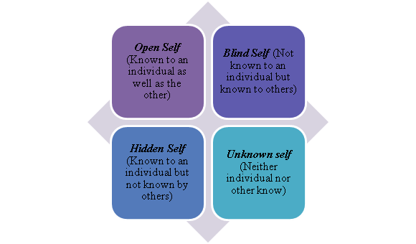
Figure 2: Johari Window
(Source: Saxena, 2015)
Johari window has helped me to analyze myself and bring out the certain skills that have been unknown to me as well as some being unknown to the attributes of my work environment. In Open self I have my honesty and loyalty as well as punctuality and potential worker as all of these skills are known by me as well as my other working colleges in John Lewis. On the other hand I perceive certain skills that are unknown to me but others knew and in this section I have to welcome my unknowing skills in my own knowledge area to extend my Open self area much bigger than blind shelf area. In the present context, I cover the same area both in Open self as well as in Blind self and to extend my open self I have started to survey out my hidden skills known to others. I have pertained certain questions regarding me to my office colleges to get analysis in view of bringing out the hidden skills in me. Moreover, I asked them verbally about my working style and their opinion that has helped me to identify such skills in a short period. In Hidden self I possess certain skills that I have full knowledge but others do not have. For example in John Lewis a problem arose particularly with my college sitting beside me of system hardware creating problem. I dealt with that particular problem and solved it quickly as I have done courses on hardware during my college life. This hardware rectifying skills are unknown to others that came in front of them that became a positive aspect for me. I am trying to reveal such skills more to make it open to all for my performance analysis. On the other hand, I believe that there are some specific skills that are unknown to all, including me. In view of revealing such aspects of skills I have tried to answer my own questions generated from my curiosity and answered them accordingly to satisfy the needs of mine as well as other in working environment.

Open Self | Blind Self
Loyalty and honesty as well as punctuality | Not Known
Hidden self | Unknown self
Hardware repairing | Not Known
Table 2: Johari Window Analysis
(Source: Gamayanto et al. 2019)

2.5. Motivation
Motivation is the basic form of attributes that instigate a person to provide wide performance perspective in reliable manner. As suggested by Herzberg (2017), motivation has played a prime role in introducing new era of sustainable manipulation. In this perspective I have been a self motivator where I perceived of getting better position in my life aspect. Moreover, I have been motivated by my colleagues as well as family members in every perspective.

3. Reflective Model
I have gone through various changes of my life that have left positive as well as negative effective for certain period. This whole lifeline has been plotted in a graph that states of having a reliable work culture I deal in. Moreover, I have gained experience for about 5 years in sales department and in this form of dynamic world I have been acting in John Lewis sales department. I have established a good communication with my subordinate employee in John Lewis that has lead me to make them more motivated and a coordinated form of work environment.

4. Understanding world of employment
As opined by Zyskowski et al. (2015), in the employment world some particular rules as well as regulations for hiring employees in any type of a company. The primary understanding is to create a recruitment team firstly whose main objectives is to identify correct suitable employees for the work by maintaining all policies as well as regulations and rules of the enterprise about hiring of the employee. However, the employer of the organisation guides the recruitments regarding the requirements as well as expectations of the company from their employees for obtaining organisational goals (Bates et al. 2018). Thus, the government has specified some rules for the company which is strictly needed to be followed by them while hiring any employees.
As per the rules of Equality Act of 2010, every company must hire their staff without making any bias decision about colour as well as caste, culture and religions. Thus, the employer of the enterprise should track the entire process of hiring very efficiently as well as effectively. The correct employees should be selected by following fair as well as extensive methods (gov.uk, 2015). Apart from Equality Act, there are also other legislation has been ruled by the government for the organisation. The other legislations are Human Right Act of 1988, which is needed to be followed by the organisation by treating all their employees with respect (libertyhumanrights.org.uk, 2019). Employment Act 2002, under this act the employee needs to follow all the policies of their company (legislation.gov.uk, 2019). National Minimum Wage act of 1988, in this act the employer should minimum amount of salary to their employees (legislation.gov.uk, 2019). Employment Relations Act of 2004, as per the rules of this act the employment of the organisation should not offer which are not appropriate for the employee’s job role (legislation.gov.uk, 2019).

5. Smart Objectives
As mentioned by Ibrahim et al. (2018), the objectives of SMART are the concepts which help to understand whether the expected target is achievable or not. The four criteria of the SMART are the Specific as well as Measurable, Achievable, Relevant and Time target. Thus, the target skill and objectives which I have aim are explained through SMART. However, with the help of SMART, I have clearly explained about the future goals which are to become a successful sales manager.
Skills | Specific | Measurable | Achievable | Relevant | Time
Managing critical situations | I am able to handle difficult situations efficiently by providing appropriate solutions. | I wanted to develop these skills for my future challenging situations. | This goal is achievable as I have experience of working in a difficult as well as challenging environment. | This is relevant as I wanted to become a sales manager and as sales I have to deal with various difficult situations. | I want to achieve this goal of mine within 4 months.
Effective Communication | I want to communicate with my customers effectively | I wanted to improve my communication skills more effectively. | This target is already achievable as I have experience communicating with people. | It is relevant as in case I become sales manager I have to communicate with many people. | I wanted to gain this aim within 2 months
Ability to take quick decision | I have the quality to take fast decision for any problems. | I wanted to develop this skills more efficiently as well as effectively for taking more prompt decision as a sales manager in the future | It is achievable as a sales marketing representative have taken quick decision which is important for the situations. | It is relevant as in the future I wanted to become sales manager for which I have to take quick decision for solving my teams problems. | I wanted to get this target within 3 Months.
Table 3: SMART objectives Analysis
(Source: Ibrahim et al. 2018)

5.1. Own potential review
The abilities as well as skills which I have mainly is pointed out my potential as a professional which can be identified as I have the potentiality of managing any difficult situations very efficiently as well as effectively. I also have the potentiality of communicating with people efficiently as I have worked as sales marketing representative where, on a daily basis as I have to communicate with different kinds of people. I also have identified that I remain honest with the people as well as I am very punctual towards my work. I have some working professional experiences as I am working as a sales marketing representative as I also have done jobs after my graduation. I have also taken some professional training as a sales marketing representative at the initial period of my career. I can also able to take fast decision regarding any problem faced during work. However, most of the time, I have taken quick decision for solving my job related issues. This quick decision potentiality has been helping me to handle difficult situations and for that I have got appreciations from my senior management as well as supervisors. My effective communication skills has supported my organisation to achieve new customers which has helped them to improve their profitability and I also have got rewards for my performance which have motivated me.

5.2. Aspiration as well as ambition
As stated by Greenan (2016), each individual person in their life requires having some particular as without having any ambition as well as goal; people cannot get achieved in their life as well as in their professional field. Thus, after reviewing my potential skills as I have observed that I wanted to become a sales manager in the future. After completing my graduation I started working as a sales marketing representative in the John Wills organisation. However, I wanted to develop my professional career by becoming sales manager as I have gained a lot of experience from my current profession. However, for becoming a sales manager I have to work hard to develop my knowledge to work effectively as well as efficiently in order to become a successful sales manager in the future which is my current ambition in my life. Hence, my goals can be divided into three categories-
Short Term: my short term goal is to achieve more knowledge as well as skills as a sales manager for managing my team and customers effectively.
Middle term: my middle term target is that I wanted to become Sales manager of John Wills Company.
Long Term: my long term goal is to improve my career path with the help of this organisation or any company in the future.

6. Personal Development Plan (PDP)
As per the view of Greenan (2016), PDP is the method of establishing an action plan on the basis of values as well as awareness, reflection, planning and goal setting for personal improvement within the context of self improvement as well as career and educational development.

6.1. Force Field Analysis
As argued by Zyskowski et al. (2015), FFA (Force Field analysis) is a concept which helps to look at the forces which are helping to moving forward towards the targeted goals or restricting the movement. It helps to have a discussion about the future plan for achieving the targeted goal. However, it also describes about the limitations and challenges for the changes (Shrivastavaet al. 2017).
Factors driving the changes
I wanted to develop my time management skills as in the future I wanted to become a sales manager. I also wanted to my knowledge about current business trends as well as qualities required for becoming a successful sales manager in my present company. I have to develop my skills as well as knowledge for gaining my targeted position as well as remain in the competitive advantage with the new increasing talented people in my workplace. My communication is quite good but I wanted to improve this skill more effectively for communicating with my employees after becoming sales manager successfully. I also wanted to gain more experience in the selling process in order to guide my team in the future more efficiently. I also wanted to do post graduation courses on the sales manager for fulfilling my future goals of becoming a sales manager in the company.
Factors affecting the changes
While improving my skills and knowledge, it can be beneficial for me to achieve my target, but it has also some challenges as well as limitations for achieving it. One of the weaknesses of mine is to manage time effectively which can become a big problem for me to balance my both work as well as for my further training for sales manager. However, apart from time managing challenge, it also becomes difficult to communicate with other people with other people of different languages while doing the training session. The lack of communication can restricted me to understand other people while communicating with them while doing training for becoming a sales manager in the future.

6.2. Action Plan
(Refer to Appendix 3)

7. Conclusion
In the entire study, it has been concluded that in order to become a successful sales manager, it is necessary to have some potential skills like efficient communication skills as well as ability to handle any challenging circumstances and quick decision taking ability. In this study, analysis of my skills has been portrayed with the help of SMART. It also contains SWOT Analysis along with Johari window of mine in which my strengths as well as weaknesses, opportunities and threats has been mentioned. However, with the help of Johari window analysis my open space as well as blind self, hidden area and unknown area has been discussed which has helped me to understand my talent more efficiently. Furthermore, with the help of SWOT I have gained clear knowledge about my strengths, weaknesses as well as opportunities and threats for improving myself for my future career. My personal improvement plan will help me to improve my lacking skills for achieving my goal of becoming a sales manager. My personal improvement plan has been shown in this study for helping me to understand time requirement for developing my weaknesses in the future. My interest in developing my career by becoming a sales manager in the future has motivated me to improve my lacking knowledge as well as skills.

Reference List
An, D. and Carr, M., (2017). Learning styles theory fails to explain learning and achievement: Recommendations for alternative approaches. Personality and Individual Differences, 116, pp.410-416.
Bates, L., Hayes, H., Walker, S. and Marchesi, K., (2018). From Employability to Employment: A Professional Skills Development Course in a Three-Year Bachelor Program. International Journal of Work-Integrated Learning, 19(4), pp.413-423.
Gamayanto, I., Christian, H., Wibowo, S. and Purnamasari, D., (2019). Developing “Leadership Intelligence (CI2) Framework” Inside Social Media to Develop An Ethical Leader using the Johari Window Method. Indonesian Journal of Information Systems, 1(2), pp.119-132.
gov.uk, (2015). Equality Act 2010: guidance. Available at: https://www.gov.uk/guidance/equality-act-2010-guidance [Accessed on 18 August 2019]
Greenan, P., (2016). Personal development plans: insights from a case based approach. Journal of Workplace Learning, 28(5), pp.322-334.
Herzberg, F., (2017). Motivation to work. Pp 1-3UK: Routledge.
Ibrahim, M., El-Zaart, A. and Adams, C., (2018). Smart sustainable cities roadmap: Readiness for transformation towards urban sustainability. Sustainable cities and society, 37, pp.530-540.
legislation.gov.uk, (2019). Employment Act 2002. Available at: http://www.legislation.gov.uk/ukpga/2002/22/contents [Accessed on 18 August 2019]
legislation.gov.uk, (2019). Employment Relations Act of 2004. Available at:http://www.legislation.gov.uk [Accessed on 18 August 2019]
legislation.gov.uk, (2019). National Minimum Wage Act 1998. Available at: http://www.legislation.gov.uk/ukpga/1998/39/contents [Accessed on 18 August 2019]
libertyhumanrights.org.uk, (2019). The Human Rights Act. Available at:https://www.libertyhumanrights.org.uk/human-rights/human-rights-act [Accessed on 18 August 2019]
Peacock, M., (2017). Trust, Truth, and Transparency: Why Hard Facts and Corporate Honesty Matter. In Mastering Business for Strategic Communicators: Insights and Advice from the C-suite of Leading Brands (pp. 151-157). Emerald Publishing Limited.
Potvin, S., Charbonneau, G., Juster, R.P., Purdon, S. and Tourjman, S.V., (2016). Self-evaluation and objective assessment of cognition in major depression and attention deficit disorder: Implications for clinical practice. Comprehensive psychiatry, 70, pp.53-64.
Rangkuti, F., (2015). Personal SWOT analysis. Gramedia Pustaka Utama.
Rogowsky, B.A., Calhoun, B.M. and Tallal, P., (2015). Matching learning style to instructional method: Effects on comprehension. Journal of educational psychology, 107(1), p.64.
Saxena, P., (2015). Johari Window: An effective model for improving interpersonal communication and managerial effectiveness. SIT Journal of Management, 5(2), pp.134-146.
Shrivastava, S.R., Shrivastava, P.S. and Ramasamy, J., (2017). Force field analysis: An effective tool in qualitative research. Journal of Current Research in Scientific Medicine, 3(2), p.139.
Tran, B., (2016). Communication: The Role of the Johari Window on Effective Leadership Communication in Multinational Corporations. In Handbook of research on effective communication, leadership, and conflict resolution (pp. 405-429). IGI Global.
Vasileva-Stojanovska, T., Malinovski, T., Vasileva, M., Jovevski, D. and Trajkovik, V., (2015). Impact of satisfaction, personality and learning style on educational outcomes in a blended learning environment. Learning and Individual Differences, 38, pp.127-135.
Zyskowski, K., Morris, M.R., Bigham, J.P., Gray, M.L. and Kane, S.K., (2015), February. Accessible crowdwork?: Understanding the value in and challenge of microtask employment for people with disabilities. In Proceedings of the 18th ACM Conference on Computer Supported Cooperative Work & Social Computing (pp. 1682-1693). ACM.

Appendices:

Appendix 1: Honey and Mumford Learning Style
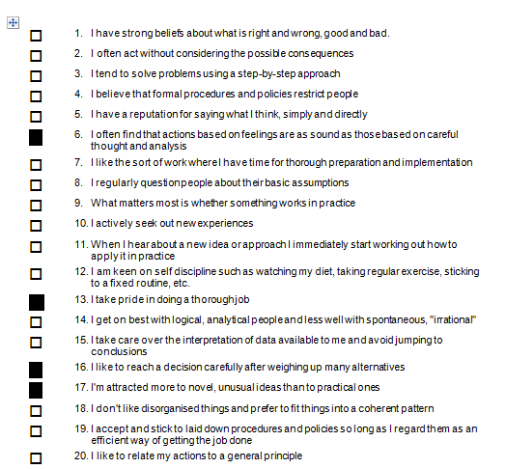

Appendix 2: Skills Audit
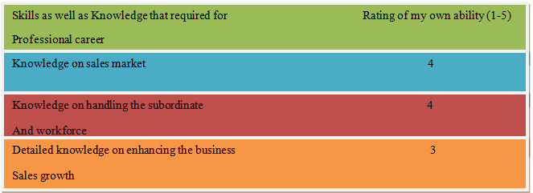
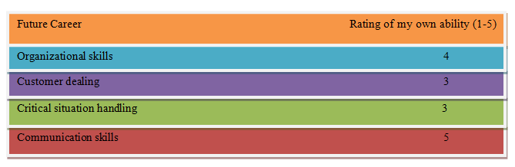
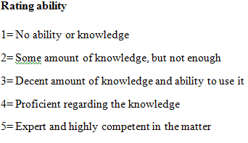

Appendix 3: Personal Development Action Plan
Skills | Description | Resources | Time required
Time Management | It allows finishing worked within a short period of time. | - Prioritize work  - Task scheduling  - Setting up deadlines | It requires 4 months
Recent Trend and Knowledge | Trends are necessary as it provides a proper direction to the people. Knowledge about management is essential for making us successful. | - Mobile technology  - Training session | It needs 3 months
Communication | It is necessary as it can help to conduct basic functions in the workplace by leading as well as controlling people. | - Active listening skills  - Provide practical decisions  - Treat everyone equally | It needs 2 months

