Name | Student Number | Date | Lecturer’s Name | Your score
IANINA MARIA PANAITE | 2434312 | 30.06.2025 | DANIEL JENKIN SMITH | To be filled by the marker  ___/40
You will have 90 minutes to complete this assessment. It is divided into three sections: note-taking, paraphrasing and writing a paragraph.
---------------------------------------------------------------------------------------------------------------------
1. Take diagrammatic notes from the passage below using the space provided:

The university experience is not just about subject knowledge, but also about developing skills that will equip you for your future life. For starters, it's impossible to graduate without a range of people skills under your belt. You'll meet new people from different backgrounds. You'll also interact with lecturers, tutors and university staff almost daily. Another life lesson that university teaches you is taking responsibility for yourself, your own schedule and learning. A lot of university study is self-directed - it's up to you to plan and organise your work, juggle multiple projects and manage deadlines – you will need to develop self-motivation if you want to succeed. Let’s not forget learning how to overcome obstacles; whether academic, work-related or personal, you'll face your fair share of hurdles as a student, but you will develop resourcefulness and resilience in the process. If you were a bit unorganised before you went to university, you won't be by the time you leave. To successfully navigate student life you'll need to handle a variety of study, work, social and personal commitments and the only way to do this is with organisation and time management. Finally, university provides plenty of opportunities to work on and boost your confidence: you'll work in groups, deliver presentations, complete assessments and maybe even become a class representative.
Adapted from: https://www.prospects.ac.uk/applying-for-university/university-life/7-life-skills-youll-learn-at-university

Space for

your notes (max 1
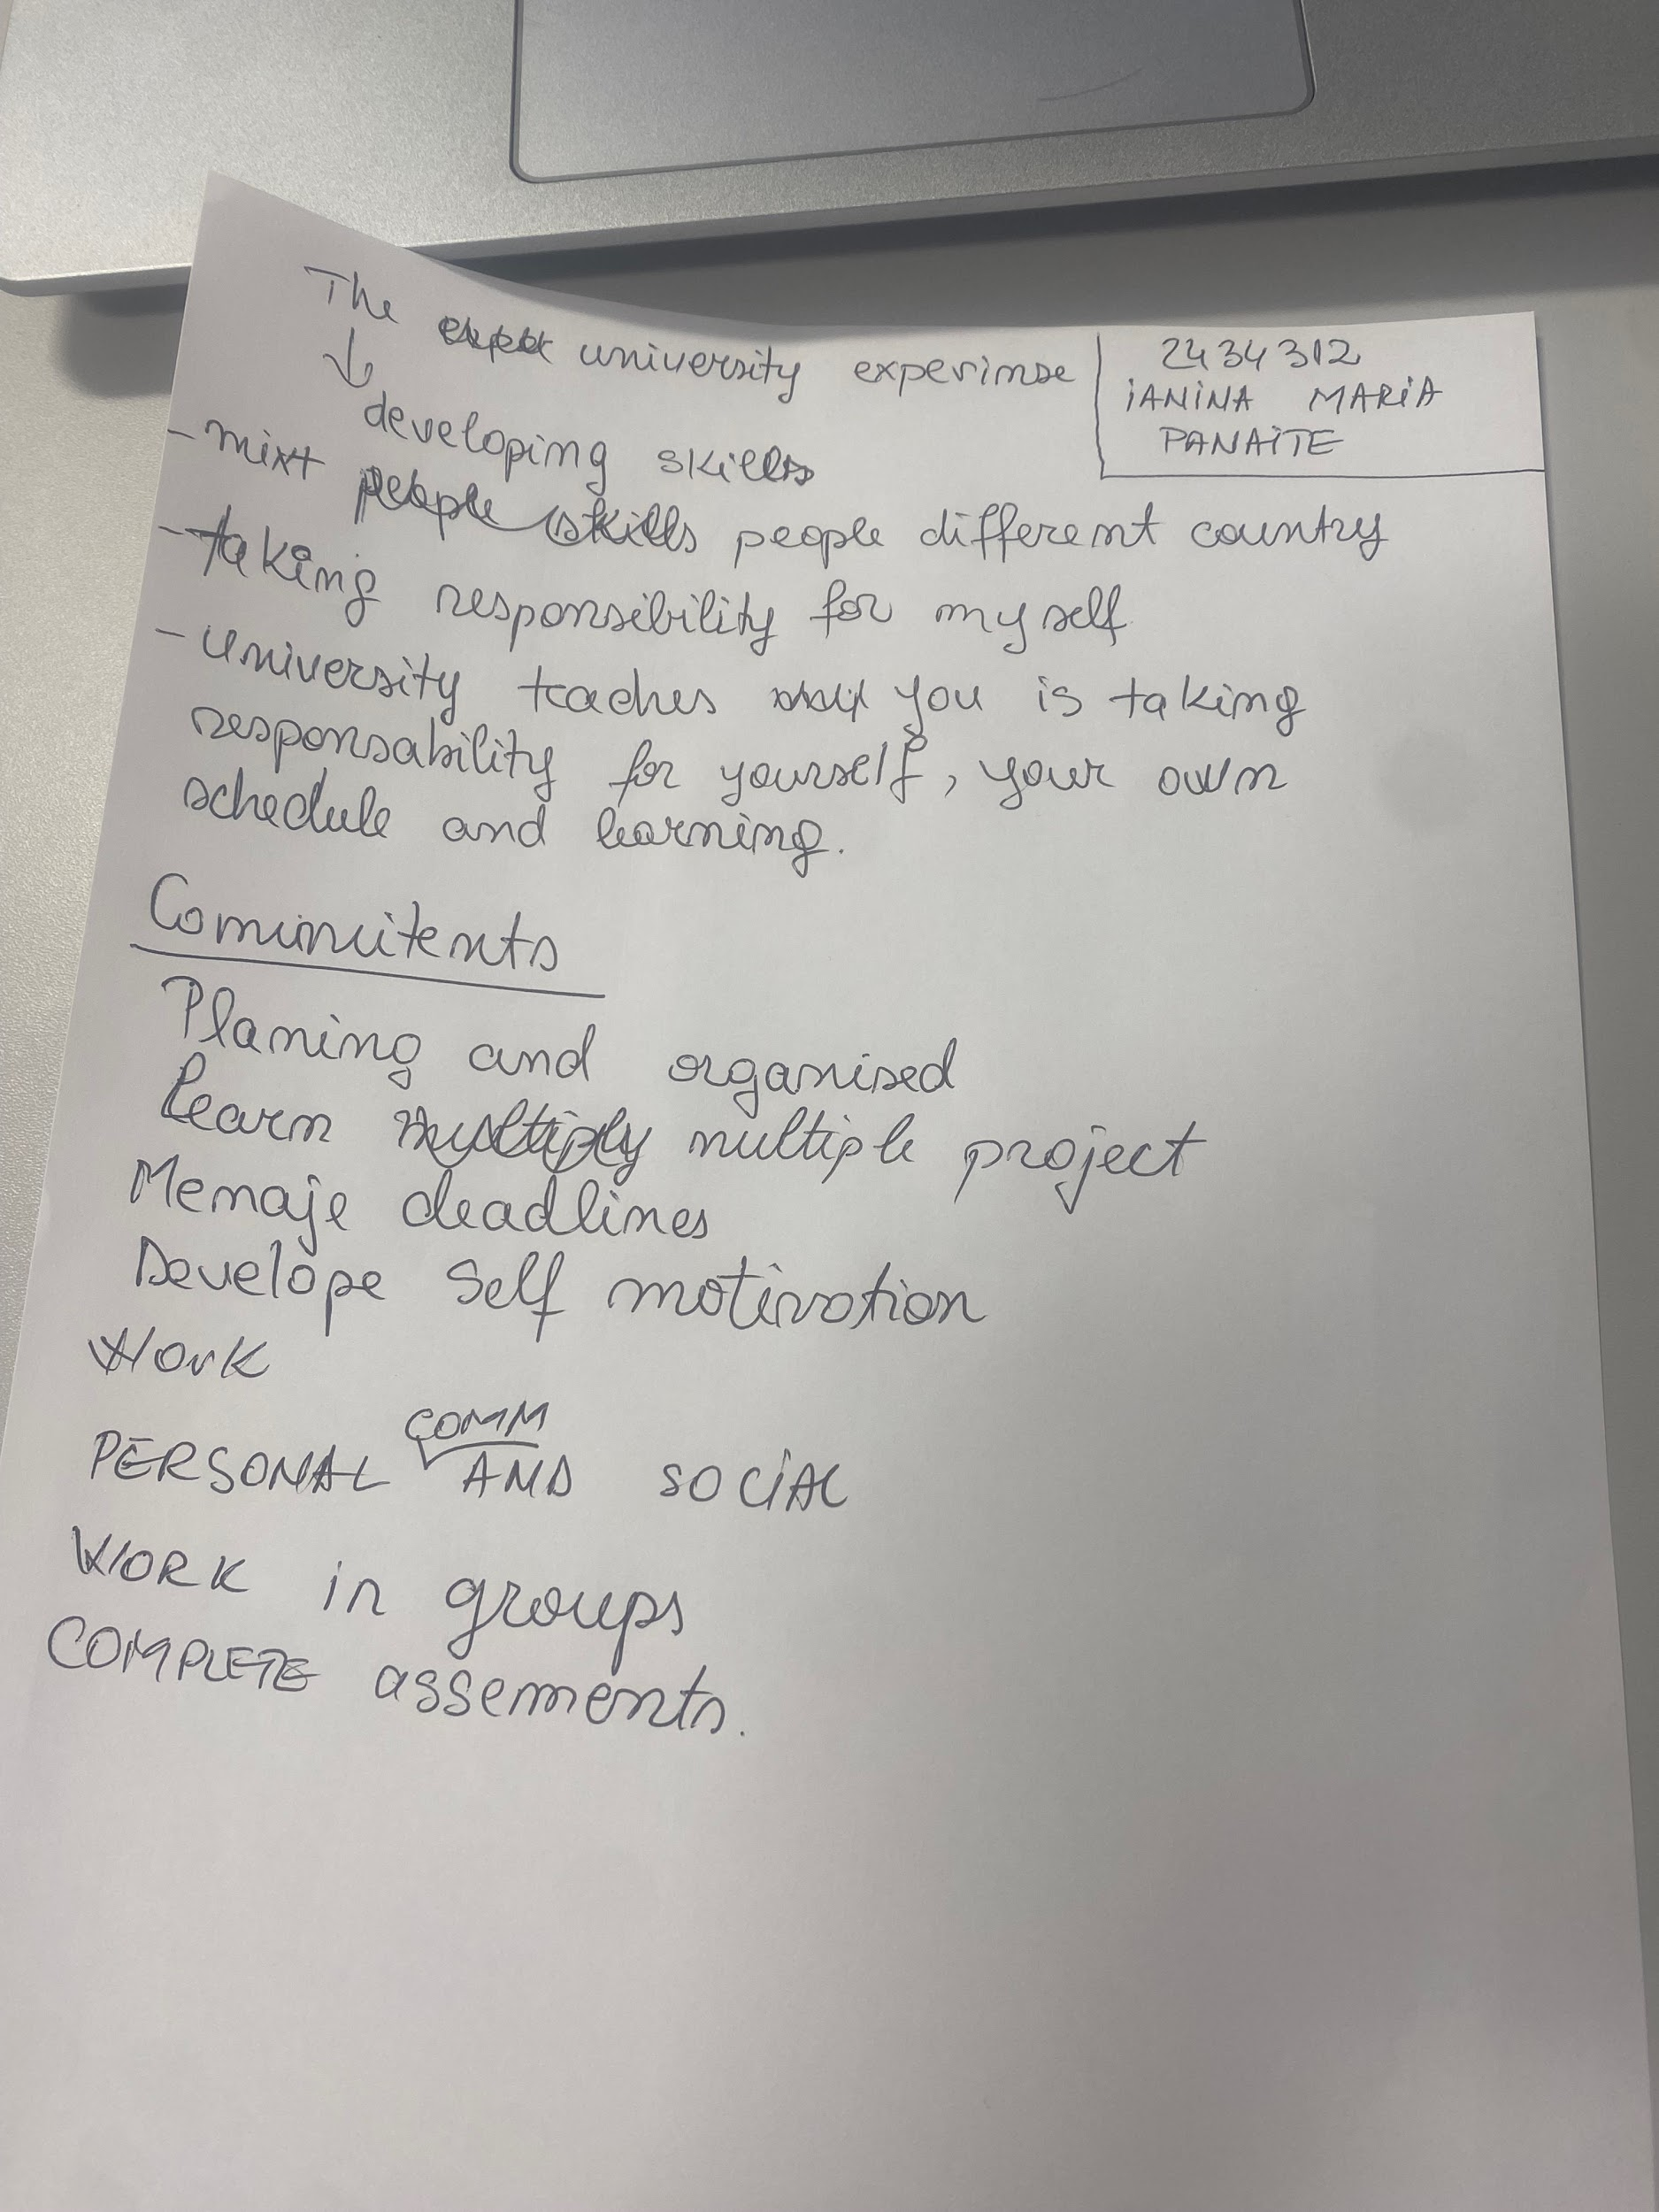
2 marks

2. Paraphrase the following sentences (max 3 marks for each, max 12 marks in total):

a) To successfully navigate student life you will need to handle a variety commitments.
_______________________________________________________________________________________Successfully navigate life will managing a mixture of study, work, social and executive responsibilities.

b) You will need to develop self-motivation if you want to succeed at university. _______________________________________________________________________________________Because you’ll interact with people from different background and communicate regular with lectures, tutors and staff. Students need to plan, organise, and manage deadlines on their own.

c) Many students find it challenging to manage stress during assessment periods. ______________________________________________________________________________________
In good time management and organisation skills can help reduce pressure and improve performance.

d) Frequent reading can help you become a more effective communicator.

_______________________________________________________________________________________
Learning and improving your communication skills, will help you finding different writing styles, dictionary and means of expressing ideas clearly.

3. Write a well-structured paragraph (8 sentences) on the following topic:

Effective time management techniques for university students

Your paragraph must be written in full sentences (no bullet points) and in an academic style.

(max 16 marks in total)

_______________________________________________________________________________________________
I’m using the Pomodoro Technique to help me focus and manage my time better. It works by breaking study or work time into small, 25-minute sessions called Pomodoros.During each Pomodoro, I focus only on one task without any distractions. After the timer rings, I take a short 5-minute break to relax. Once I complete four Pomodoros, I take a longer break of 15 to 30 minutes to rest more deeply.

This method helps me stay focused and avoid feeling tired or stressed. Knowing that a break is always coming soon makes it easier to keep going, even when the task is hard. It also helps me use my time wisely and not waste it on distractions. The Pomodoro Technique keeps me motivated, improves my concentration, and helps me get more done in less time. It’s a simple but powerful way to study and work better.

