  Proper care staff shortage crisis | Madalina Stanga (2118508)  Course: Problem solving and decision-making Lecturer: Nicholas Worthington

ABSTRACT

This report aims to analyse the causes of healthcare professionals’ shortage within Proper Care, an adult social care institution within the NHS. In order to identify the causes a SWOT analysis was used, followed by a PESTLE analysis and a Fishbone diagram. In order to evaluate the solutions proposed based on the identified causes a Decision-Making Grid was used along with a PMI and a SMART analysis. Lastly, a Key Performance Indicator was used for potential future monitoring of the solutions’ effectiveness.

Table of Contents
ABSTRACT 1
INTRODUCTION 2
THE ISSUE 2
SWOT ANALYSIS- HEALTHCARE CAREER 2
THE FACTORS LEADING TO THE ISSUE 3
PESTLE ANALYSIS 3
FISHBONE DIAGRAM 4
SOLUTIONS PROPOSAL 5
DECISION MAKING GRID(DMG) 6
PMI 7
SMART ANALYSIS 7
IMPLEMENTATION OF THE SOLUTIONS 8
CONCLUSION 9
REFERENCE LIST 10
APPENDIX 1. 13
APPENDIX 2. 13

INTRODUCTION

NHS was established by the British government on 5 July 1948. Free medical care was offered to the entire population for the first time in any Western society. A further characteristic of this comprehensive system was that it was not based on an insurance principle, where entitlement followed contributions, but rather on a system that provided universal access to essential services (Delamothe, 2008). Over time NHS became a critical source of economic opportunities for local people, as it employs more than 1.6 million individuals in the UK and offers more than 350 options of careers. However, in recent years the number of vacancies kept increasing. As a result, now England is experiencing its worst workforce crisis in history, with a shortage of 12,000 hospital doctors and over 50,000 nurses and midwives (Reed, 2022).
The adult social care sector is also being greatly affected by the NHS staff shortage. A total of 110,000 positions are available in adult social care, with one out of ten social workers and one out of eleven care workers positions being vacant. Approximately 5,000 nursing vacancies are also available in adult social care, which has a 12 percent vacancy rate. Proper Care is an institution within the social care sector that is directly affected by the chronic staff shortage. This situation is threatening the quality of the services provided and finding a solution is imperative. The aim of this report is to identify the causes that led to this situation and to propose solutions based on those factors.

THE ISSUE
The healthcare professional’s shortage that Proper care is facing is due to the lack of interest towards the profession and the inability of retaining employees caused by work conditions.

SWOT ANALYSIS- HEALTHCARE CAREER
In order to assess the reasons behind the lack of interest towards healthcare professions a SWOT analysis is provided in APPENDIX 1. A SWOT analysis aims to identify the strengths, weaknesses, opportunities and threats of a matter. In this specific situation the strengths of having a healthcare career are strongly bonded to moral fulfilment and social status (Miller, 2019). The weaknesses are represented by much more palpable factors such as pay and pay rises below inflation rate, the big responsibilities and stress that healthcare professionals are facing but also additional stress due to bullying among co-workers (Reed, 2022). Literature relates that 20 to 25% of nurses had experienced bullying, mainly from colleagues and superiors (Wilson, 2016, pp. 303-306). The opportunities offered by working within the NHS are mostly related to training and career development. The continuous professional development (CPD) program offers great opportunities for professional growth through volunteering opportunities, training, workshops and digital learning (Continuing professional development (CPD), 2022). Moreover, the threats are represented by external factors such as litigation, which represents a real source of anxiety and stress for healthcare professionals stress at work has a significant psychological impact on primary care workers. Two out of five healthcare professionals have resigned or considered resigning because of workplace stress (Mind, 2016). Another threat is represented by COVID-19 outbreaks which are another anxiety and depression factor in healthcare protection. Studies have found that 40 to 45% of frontline nurses experienced anxiety and depression during the COVID-19 outbreaks (Hu et al., 2020, p.100424).

THE FACTORS LEADING TO THE ISSUE

PESTLE ANALYSIS
An examination of the external factors affecting the staff shortage at Proper Care was conducted based on the PESTLE analysis in the context of this report and it can be found in APPENDIX 2. These external factors were categorized as political (P), economic (E), social (S), technological (T), legal (L), and environmental (E). PESTLE analysis helps organizations to maximize business development opportunities and minimize threats by providing a strategic framework for understanding external influences on their business (PESTLE Analysis | Factsheets | CIPD, 2021).
The political factors affecting the staff shortage at Proper Care were identified as
- Government policies and Brexit
NHS England changed its charges for hospital treatment for migrants, visitors, and former residents in April 2015. In an attempt to increase the cost of entry for those from outside the European Economic Area (EEA), an immigration health charge (or 'surcharge') has been introduced. Patients presenting to NHS bodies must now be checked against flags placed on their patient records to identify their residency status, while the Home Office must be informed if debts are incurred by them so that they can issue a bill. There are, however, a number of problems with the sharing of information among departments for immigration enforcement purposes. Achieving a balance between confidentiality and disclosure is challenging for practitioners, especially since a large portion of NHS employees are immigrants themselves. It may have significant impacts on morale and their on-going contribution to the NHS if health care workers are constantly reminded that migrants are a burden on the United Kingdom. The NHS has been experiencing a dramatic drop in the number of foreign staff after Brexit, as EU staff left in large numbers, while the number of registrations declined by more than half (Baker, 2018),(Hiam, Steele and McKee, 2018, pp. 107-117),(Noel, 2017).
- Corruption levels
Literature suggests that NHS management exhibits too much collective ego protection and protecting its image, resulting in distortion of its ability to address problems and learn from them. Denial and hiding from reality are traits that are exhibited by organizations and individuals within them (Pope and Burnes, 2013).
The economic factors affecting the staff shortage at Proper Care were identified as:
- Wages and Inflation
Health care professionals received a 3% pay raise in 2021 after a 1% pay increase was initially proposed. There was a consensus among observers that this was a great victory. Yet, with inflation at 9.0%, this raise appears more like a cut than an increase (Readers’ poll: do NHS staff deserve a pay rise of more than 3 per cent, 2021).

- Work visas
People with a job offer in an eligible occupation, who speak English, can apply for a health and care visa. For applicants to be eligible for the visa, they must earn at least £25,600 a year, unless they are entering a shortage occupation like nursing or medicine. However, this visa is not open to social workers even though there is a desperate need for this profession as well (Rimmer, 2020)

The social factors affecting the staff shortage at Proper Care were identified as:
- Aging population
The number of people deceasing before the age of 65 has decreased from 48 per cent when the NHS was established in 1948 to 14 per cent today. In the past three decades, the number of people over 85 has doubled, and life expectancy at 65 has increased to 21 years for women and 19 years for men (Oliver et al., 2014). This situation is increasing the number of vulnerable individuals that need care while decreasing the number of people that could undertake healthcare positions.

The technological factors affecting the staff shortage at Proper Care were identified as:
- New machinery
There is no silver bullet for the pressures affecting the NHS, but technological advances offer significant opportunities to improve health care. Even though we are just beginning to realize the true potential of genomics and precision medicine, there are some really exciting developments underway. In recent years, patients have embraced new technology and increasingly expected it to be used to support their health care (Castle-Clarke, 2018).
The legal factors affecting the staff shortage at Proper Care overlap in some proportion the political ones, regarding work visas their conditions for foreign potential employees.
The environmental factors affecting the staff shortage at Proper Care were identified as:
- Ecological policy
The Greener NHS Programme is working towards reducing the carbon footprint of the NHS, with a goal of reaching a net carbon zero. With everyone being concerned about the environment and the condition in which we will leave the planet for future generations, this programme is likely to attract sympathy among potential employees (Greener NHS, 2022).

FISHBONE DIAGRAM
The Fishbone diagram, created in 1965 by Kaoru Ishikawa is typically used to evaluate causes (people, machine, method, material, measurement, environment)of particular issues, assisting managers to reveal the indicators of any business concern (How to Use the Fishbone Tool for Root Cause Analysis, 2022). A fishbone diagram was realised on the matter of staff shortage at Proper Care, and it can be found in APPENDIX 3.
The problems related to the category “People” were identified as : retirement, graduation rates and absenteeism
According to Jones-Berry, (2021) 1 in 3 undergraduate nursing students are dropped out in 2020, with a worrying attrition rate of 33%. Consecutively, nursers who were registered before 1995 are able to retire at age 55 and the vast majority is deciding to do so (NHS Pensions factsheet template V1, 2022). A third of the existing nurses are due to retire in the next 4 years creating a worrying scenario for the NHS ( Marangozov, 2016). On the other hand, the absenteeism rate is relatively high, especially during the winter season as it can be observed in Figure 1 (nhs.uk/ data-and-information, 2021).

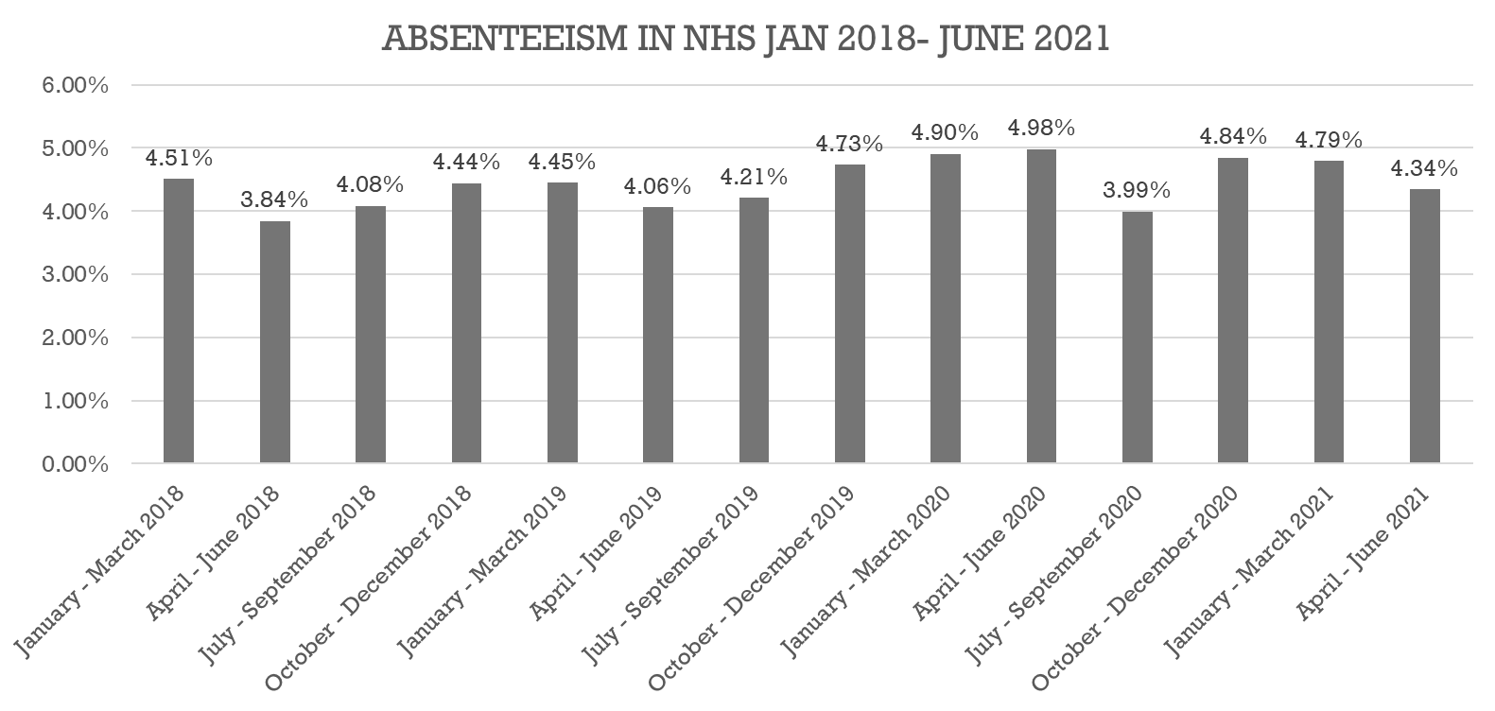
Figure 1. (nhs.uk/ data-and-information, 2021)
The problem related to the category “People” was identified as : removing the NHS bursaries for most students- A centrally commissioned model for funding nursing in England was removed by the English Government in 2017, therefore discouraging students to apply for such degrees out of fear of financial debt (Submission-to-SLSC-NHS-Bursary, 2017).
The problem related to the category “Materials” was identified as: Limited supplies- According to Product Availability, (2022), is not out of the ordinary for the NHS supply chain to run out of some products causing inconveniences and additional stress to the staff.
The problem related to the category “measurement” was identified as: ratio doctors per patients- According to NHS medical staffing data analysis, (2021) England has the second lowest number of doctors per 1000 inhabitants in Europe, with only 2.9. On comparison Germany has 4.47 doctors per 1000 patients. Looking at these statistics doctors that are professing in England have to work harder in order to complete their duties, due to having more patients to treat.

SOLUTIONS PROPOSAL
Looking at the numerous issues identified 4 solutions were proposed in order to minimise the number of vacancies at Proper Care and can be found in Figure 2.
Problem | Solution
Limited supplies | Expanding the chain of suppliers
Early retirement* | Financial education for medical staff*
Removing the NHS bursaries for students | Partnership with medical faculties
Low wages | Performance bonuses
Figure 2.
*-early retirement results in a smaller pension

DECISION MAKING GRID(DMG)
DMG is an analytic tool used for decision making in order to clarify the options, reduce the decision-making time and fatigue and increase objectivity (How To Make a Decision Grid in 7 Simple Steps, 2022). All the solutions proposed for reducing the vacancies at Proper Care have been put on a DMG as it can be observed in Figure 3.
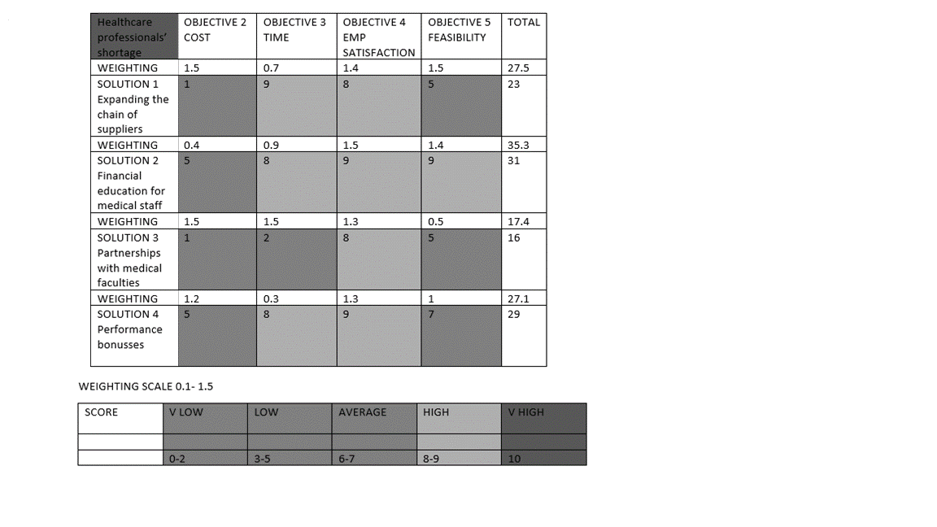
Figure 3.
After performing the necessary calculations, the last solution didn’t obtain a high enough total for being taken into consideration on the further evaluation of the solutions.

PMI
Figure 4 represents a PMI analysis of the remaining 3 solutions from the Grid matrix, which is weighting the pluses, minuses and interesting points regarding the solutions by offering or deducting points on a scale from 1 to 5 depending on the positive effects on Proper Care staff shortage.
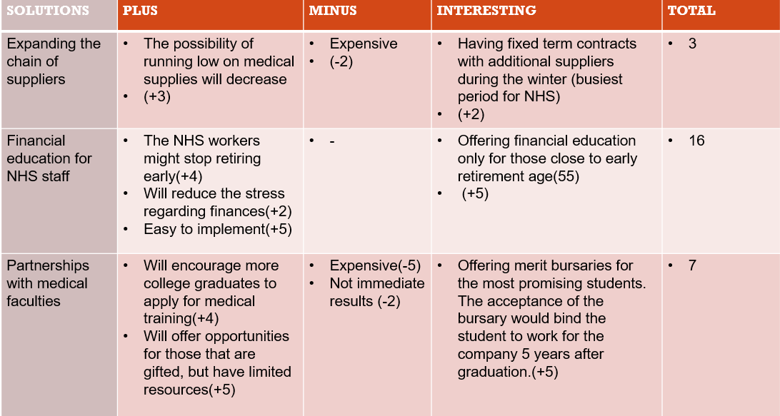
Figure 4.

SMART ANALYSIS
A smart analysis was also conducted for these solutions in order to help organise track and accomplish them as presented in Figure 5.
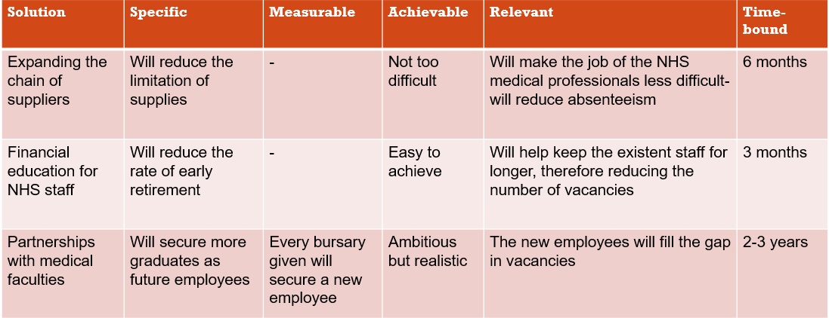
Figure 5.

IMPLEMENTATION OF THE SOLUTIONS
Figure 6, presented below offers some insight into how these solutions can potentially be implemented.
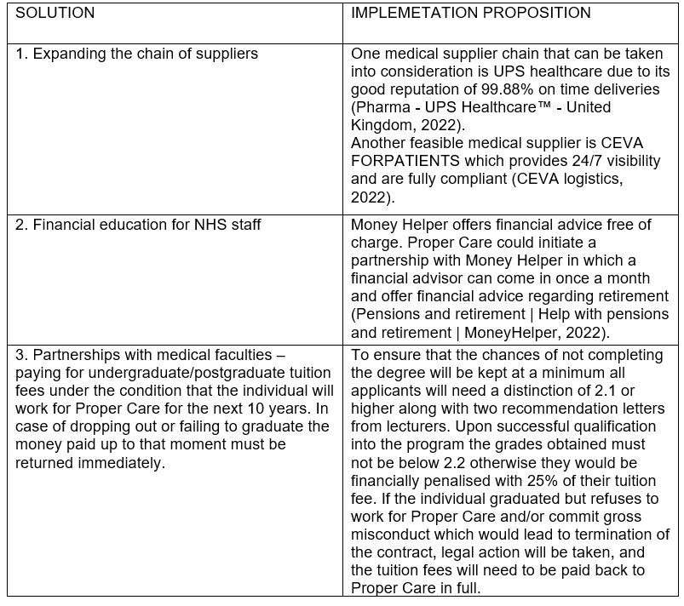
Figure 6.
A Key Performance Indicator (KPI) was also realised in order to offer a guideline in how these solutions should affect the vacancy rate at Proper Care 3 years after implementation.
The KPI is presented in Figure 7.

SOLUTIONS | YEAR | VACANCY RATE REDUCTION WITHIN THE NHS  CURRENT VACCANCY RATE=8.3
Financial education for NHS staff | 1 | 7.5
 | 2 | 7.2
 | 3 | 6.8
Partnerships with medical faculties | 1 | 8.3
 | 2 | 7.7
 | 3 | 7.1
Expanding the chain of suppliers | 1 | 7.6
 | 2 | 7.5
 | 3 | 7.2
Figure 7. (nhs.uk/ data-and-information, 2021)

CONCLUSION
Proper care just like every institution within the NHS is facing a major issue regarding staff shortages which needs to be addressed promptly and carefully in order to avoid a tragic future. Is hoped that the right implementation of these solutions will ease the process of reducing staff shortages.

REFERENCE LIST
- Baker, C., 2018. NHS staff from overseas: statistics. London: House of Commons Library.
- Castle-Clarke, S., 2018. What will new technology mean for the NHS and its patients?.
- CEVA. 2022. CEVA logistics. [online] Available at: <https://www.cevalogistics.com/en/for-patients/?utm_source=Google&utm_medium=CPC&utm_campaign=Search-Healthcare-UK&gclid=CjwKCAjwrZOXBhACEiwA0EoRDzHIzMx43VFiS6lz946TqhqwNCjhKJ6tTM6PpsgFvvsR_fdlyWQwkxoCgs4QAvD_BwE> [Accessed 30 July 2022].
- CIPD. 2021. PESTLE Analysis | Factsheets | CIPD. [online] Available at: <https://www.cipd.co.uk/knowledge/strategy/organisational-development/pestle-analysis-factsheet#gref> [Accessed 7 July 2022].
- Cms.gov. 2022. How to Use the Fishbone Tool for Root Cause Analysis. [online] Available at: <https://www.cms.gov/medicare/provider-enrollment-and-certification/qapi/downloads/fishbonerevised.pdf> [Accessed 28 July 2022]
- Delamothe, T., 2008. Founding principles. [online] National Library of Medicine. Available at: <https://www.ncbi.nlm.nih.gov/pmc/articles/PMC2405823/> [Accessed 7 July 2022].
- England.nhs.uk. 2022. Greener NHS. [online] Available at: <https://www.england.nhs.uk/greenernhs/> [Accessed 30 July 2022].
- Health Careers. 2022. Continuing professional development (CPD). [online] Available at: <https://www.healthcareers.nhs.uk/career-planning/career-planning/developing-your-health-career/developing-your-health-career/continuing-professional-development-cpd/continuing> [Accessed 29 July 2022].
- Hiam, L., Steele, S. and McKee, M., 2018. Creating a ‘hostile environment for migrants’: the British government’s use of health service data to restrict immigration is a very bad idea. Health Economics, Policy and Law, 13(2), pp.107-117.
- Hu, D., Kong, Y., Li, W., Han, Q., Zhang, X., Zhu, L.X., Wan, S.W., Liu, Z., Shen, Q., Yang, J. and He, H.G., 2020. Frontline nurses’ burnout, anxiety, depression, and fear statuses and their associated factors during the COVID-19 outbreak in Wuhan, China: A large-scale cross-sectional study. EClinicalMedicine, 24, p.100424
- Indeed Career Guide. 2022. How To Make a Decision Grid in 7 Simple Steps. [online] Available at: <https://www.indeed.com/career-advice/career-development/decision-grid> [Accessed 30 July 2022].
- Jones-Berry, S., 2021. Quitting before they qualify: what’s behind the spike in nursing students dropping out?. [online] Rcni.com. Available at: <https://rcni.com/nursing-standard/newsroom/analysis/quitting-they-qualify-whats-behind-spike-nursing-students-dropping-out-177551#:~:text=The%20latest%20annual%20Nursing%20Standard,their%20studies%20on%20time%2C%202020.> [Accessed 30 July 2022].
- MaPS. 2022. Pensions and retirement | Help with pensions and retirement | MoneyHelper. [online] Available at: <https://www.moneyhelper.org.uk/en/pensions-and-retirement> [Accessed 30 July 2022].
- Marangozov, R., 2016. A third of nurses due to retire in the next 10 years. Who is going to plug the gap? | Institute for Employment Studies (IES). [online] A third of nurses due to retire in the next 10 years. Who is going to plug the gap? | Institute for Employment Studies (IES). Available at: <https://www.employment-studies.co.uk/news/third-nurses-due-retire-next-10-years-who-going-plug-gap> [Accessed 30 July 2022].
- Miller, C.L., 2019. A Career in Nursing: Calling or Choice?. Journal of Christian Nursing, 36(4), pp.236-237.
- Mind. 2016. Mind finds ‘Worrying’ levels of stress among primary care staff. [online] Available at: <https://www.mind.org.uk/news-campaigns/news/mind-finds-worrying-levels-of-stress-among-primary-care-staff/#:~:text=The%20psychological%20impact%20of%20work,considering%20resigning%20from%20their%20jobs.> [Accessed 3 July 2022]
- NHS Digital. 2021. NHS Sickness Absence Rates - NHS Digital. [online] Available at: <https://digital.nhs.uk/data-and-information/publications/statistical/nhs-sickness-absence-rates> [Accessed 24 July 2022].
- NHS Digital. 2022. NHS Vacancy Statistics (and previous NHS Vacancies Survey) - NHS Digital. [online] Available at: <https://digital.nhs.uk/data-and-information/publications/statistical/nhs-vacancies-survey> [Accessed 26 July 2022].
- NHS supply chain. 2022. Product Availability. [online] Available at: <https://www.supplychain.nhs.uk/ordering/product-availability/> [Accessed 29 July 2022].
- Nhsbsa.nhs.uk. 2022. NHS Pensions factsheet template V1. [online] Available at: <https://www.nhsbsa.nhs.uk/sites/default/files/2022-03/Special%20Class%20status%20%2895%20only%29%20employer%20factsheet-20220305-%28V1%29.pdf> [Accessed 30 July 2022].
- Noel, G., 2017. Letter from NHS Digital to Dr Sarah Wollaston MP 2017. [online] NHS Digital. Available at: <https://www.parliament.uk/globalassets/documents/commons-committees/Health/Correspondence/2016-17/Correspondence-Memorandum-Understanding-NHS-Digital-Home-Office-Department-Health-data-sharing.pdf> [Accessed 29 July 2022].
- Oliver, D., Foot, C. and Humphries, R., 2014. Making our health and care systems fit for an ageing population. London: UK: King's Fund.
- Pope, R. and Burnes, B., 2013. A model of organisational dysfunction in the NHS. Journal of health organization and management.
- Reed, J., 2022. NHS in England facing worst staffing crisis in history, MPs warn. [online] BBC News. Available at: <https://www.bbc.co.uk/news/health-62267282> [Accessed 27 July 2022].
- Rimmer, A., 2020. Government faces backlash after care workers are excluded from fast-track visas.
- The British Medical Association is the trade union and professional body for doctors in the UK. 2021. NHS medical staffing data analysis. [online] Available at: <https://www.bma.org.uk/advice-and-support/nhs-delivery-and-workforce/workforce/nhs-medical-staffing-data-analysis> [Accessed 28 July 2022].
- Thetimes.co.uk. 2021. Readers’ poll: do NHS staff deserve a pay rise of more than 3 per cent?. [online] Available at: <https://www.thetimes.co.uk/article/readers-poll-do-nhs-staff-deserve-a-pay-rise-of-more-than-3-per-cent-b8rh6hw0l> [Accessed 29 July 2022].
- UNISON. 2017. Submission-to-SLSC-NHS-Bursary. [online] Available at: <https://www.parliament.uk/globalassets/documents/lords-committees/Secondary-Legislation-Scrutiny-Committee/UNISON-Submission-to-SLSC-NHS-Bursary-SI-114-17022017.pdf> [Accessed 30 July 2022].
- Ups.com. 2022. Pharma - UPS Healthcare™ - United Kingdom. [online] Available at: <https://www.ups.com/gb/en/healthcare/solutions/pharma.page?> [Accessed 30 July 2022].
- Wilson, J.L., 2016. An exploration of bullying behaviours in nursing: a review of the literature. British Journal of Nursing, 25(6), pp.303-306.

APPENDIX 1.
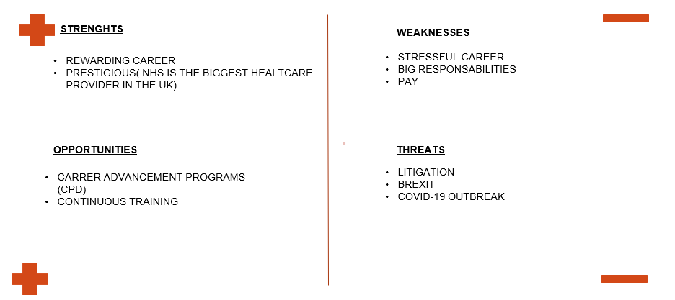

APPENDIX 2. 

