Kenneth Perry (2222109)

Fundamentals of electric and electronic systems -ACDA4018

Contents
Introduction 2
Theory 2
Materials 4
Procedure (Task One) 5
Procedure (Task two) 8
Results 9
Results 11
Conclusion 11
References 12

Introduction

The purpose of this report is to demonstrate a working understanding of the content delivered throughout the module.
Utilising Proteus software and supporting theoretical input, the objective was to complete two tasks.
The first task was to create a DC series circuit using values provided within the assignment specification, measure and collect theoretical values for internal resistance.
Task two was to collect resonant frequency in an AC circuit using values given with the assignment specification.
For the first task, internal resistance was recorded by finding the maximum power value from the software simulation and comparing the values with calculations done theoretically.
The second task included the use of a virtual oscilloscope to measure the peak values, which allowed the resonant frequency to be calculated.

Theory

Electricity is described as energy transfer by movement of electrons. Electrical energy, like all forms of energy can not be created or destroyed, it can only be transferred from one form to another.
There are two forms of Electrical Energy, Direct Current (DC) and Alternating Current (AC).
Electrical current is the flow of charged particles, or specifically in the case of AC and DC, the flow of electrons. According to Karl K. Berggren, professor of electrical engineering at MIT, the fundamental difference between AC and DC is the direction of flow. DC is constant and moves in one direction. “A simple way to visualize the difference is that, when graphed, a DC current looks like a flat line, whereas the flow of AC on a graph makes a sinusoid or wave-like pattern,” says Berggren. “This is because AC changes over time in an oscillating repetition — the up curve indicates the current flowing in a positive direction and the down curve signifies the alternate cycle where the current moves in a negative direction. This back and forth is what gives AC its name.” [1]
AC and DC can be distinguished by looking at devices used. In a bedside lamp, AC current is used because the source (plug) came from far away, and the wave-like motion of the current makes it an efficient traveller. Contrary to this, to use a handheld flashlight (torch), DC power is being used. The battery contained within the device has both positive and negative terminals, and the electrical charge moves in one steady direction (straight line). [1]

An electric circuit is formed when a conductive path is created to allow electric charge to continuously move. This continuous movement of electric charge through the conductors of a circuit is called a current, and it is often referred to in terms of “flow,” just like the flow of a liquid through a hollow pipe.
The force motivating charge carriers to “flow” in a circuit is called voltage. Voltage is a specific measure of potential energy that is always relative between two points.
Current tends to move through the conductors with some degree of friction, or opposition to motion. This opposition to motion is more properly called resistance. The amount of current in a circuit depends on the amount of voltage and the amount of resistance in the circuit to oppose current flow.
Just like voltage, resistance is a quantity relative between two points. For this reason, the quantities of voltage and resistance are often stated as being “between” or “across” two points in a circuit. [2]

An inductor is an electronic component consisting of a coil of wire with an electric current running through it, creating a magnetic field. The unit for inductance is the henry (H), named after Joseph Henry, an American physicist who discovered inductance independently at about the same time as English physicist Michael Faraday. One henry is the amount of inductance that is required to induce 1 volt of electromotive force (the electrical pressure from an energy source) when the current is changing at 1 ampere per second. [3]

Capacitance is the ability of a device to store electric charge, and as such, the electronic component that stores electric charge is called a capacitor. [3] Capacitance is measured in Farads (F).

Electrical power is the rate that power can be transferred into another energy form i.e., heat, kinetic, chemical, potential etc. Electrical power is measured in Watts (W).

Thevenin’s Theorem states ;‘The current which flows in any branch of a network is the same as that which would flow in the branch if it were connected across a source of electrical energy, the e.m.f. of which is equal to the potential difference which would appear across the branch if it were open-circuited, and the internal impedance of which is equal to the impedance which appears across the open-circuited branch terminals when all sources are replaced by their internal impedances.’’ [4]

Materials

In order to design and simulate both AC and DC series circuits, software named Proteus Professional 8 was used. This software allows the user to virtually create circuits using a variety of components.
Proteus was developed by Labcenter Electronics, it is a type of software that a user can create different electronic circuits with all required components. It is widely used due to its simplicity and user-friendly interface.
It allows a user to easily create circuits incorporating schematics, PCB and microprocessor simulation.[5]

Procedure (Task One)

Using values listed below, the circuit was created on Proteus design software.

Component | Value
Resistor 1 | 1 Kohm
Resistor 2 | 10 Kohm
Resistor 3 | 12 Kohm
Load Resistor | 1-20 Kohm
Voltage Source | 20 Volts

The original circuit was created on Proteus design software as seen in Figure 1.
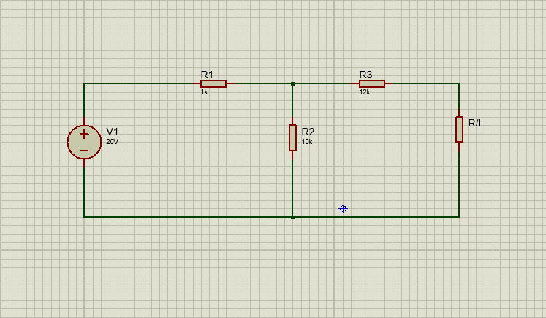
Fig 1.

To find maximum power, the load resistor must be removed from the circuit and replaced with a DC voltmeter.
The revised circuit is shown in Figure 2.
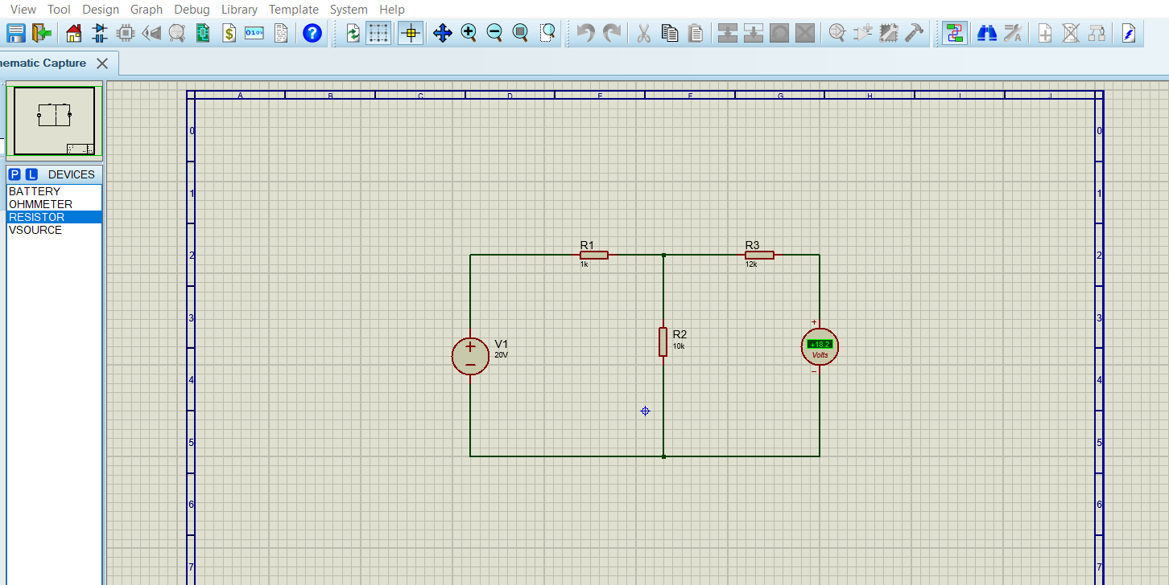
Fig 2.
The simulation is then run through Proteus design software and a value will be displayed on the voltmeter; this value is recorded as Vth.
The equivalent resistance (Rth) was then documented by removing the DC Voltmeter and placing an ohmmeter into the circuit. As seen in Figure 3. Once this has been completed, the value displayed on the ohmmeter is recorded as Rth.

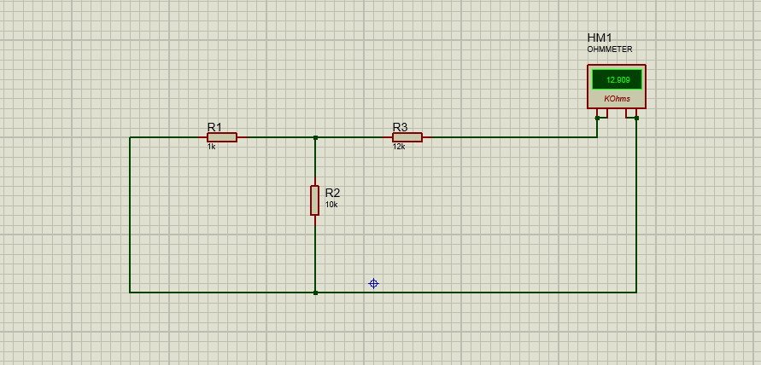
Fig 3.

To find the load resistors current, using both Thevenin’s resistance and voltage values, a new circuit (Thevenin’s equivalent circuit) is created. If resistance is displayed as “MAX” on the ohmmeter, the settings should be changed to kilo ohms.
The Thevenin’s circuit includes the Rth and Vth values already collected, and the load resistor is returned to the circuit. The value of the load resistor is equal to the equivalent resistance (Vth = RL)

Figure 4 shows the revised circuit including values for Vth, Rth, and also the Ammeter reading to show the current flowing through the circuit and load resistor value.
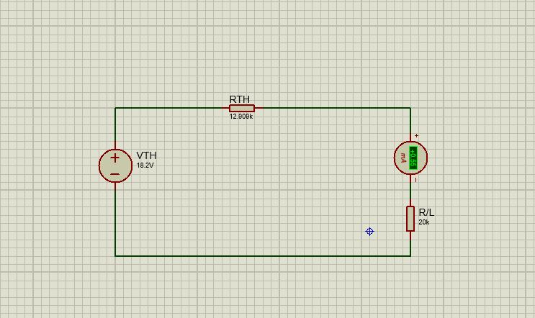
Fig 4.

Once the finalised circuit had been assembled, the value of the variable resistor was changed and alternated ranging from 1 Kohm and 20 Kohm and the subsequent results were recorded.
The maximum power was then calculated using $P=I_{L}^{2}R_{L}$
Results were illustrated in the form of a graph.
Finally, the internal resistance was calculated in theory for comparison.

Procedure (Task two)

For the second task, it was tasked to create an AC circuit on the design software Proteus as shown in Figure 5. Once this had been completed, a variety of components with values were supplied with the assignment specification as shown.
Components | Values
Resistor | 100Ω
Inductor | 5mH
Capacitor | 0.1µF
Signal Generator | 10V at 1KHz -20KHZ
Oscillator | /

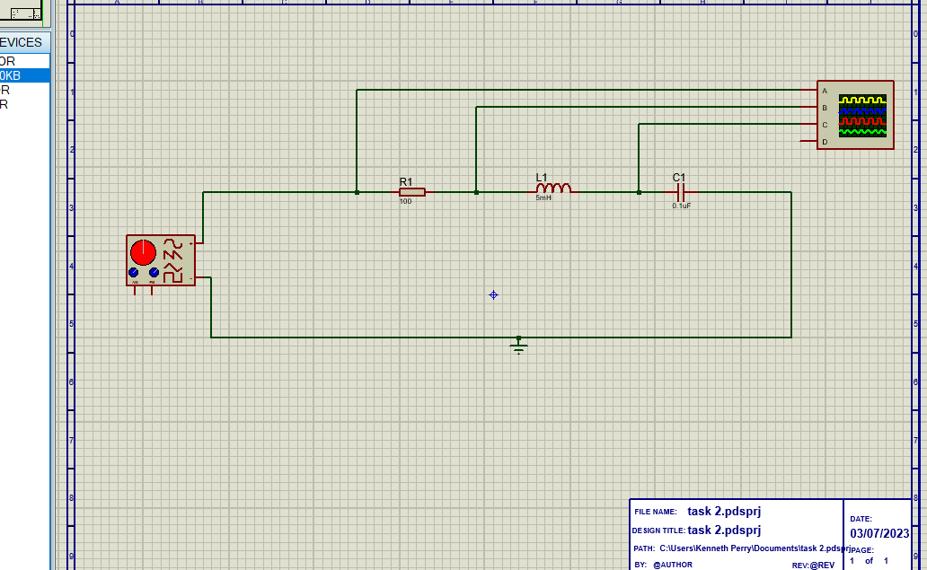
Fig.5

The signal generator was set at an initial voltage of 10v and frequency of 1KHz. This displayed waves from each component in the circuit on the oscillator, each with its individual value. The waves are shown also in Figure 5.
The peak-to-peak values were recorded by means of adding both the peak and the trough of the wave together.
The procedure was repeated for several signals up to 20KHz and values for VC, VR and VL were recorded.
Once these values were logged on a spreadsheet and latterly a graph, the resonant frequency could be identified and compared with the theoretical calculations carried out.

Results

Task one

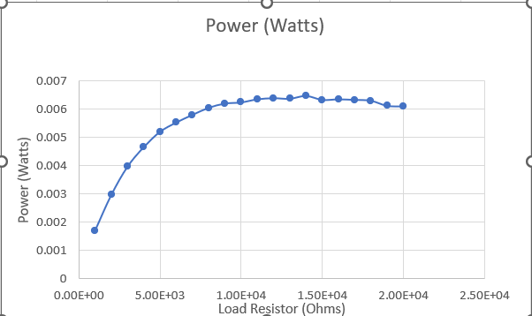
Fig 6
With reference to the graph as shown in Figure 6, a steady increase in resistance results in a power increase.
To evaluate this further, calculations were done for comparison. Using ohms law, Vth was calculated. Values were, Voltage source 20V, divided by resistors R1 and R2 values. This resulted in a value of 0.001819 Amps. This was then multiplied by 10,000 (ohms) which produced a value of 18.19V. As the simulation gave a value of 18.2V, this showed a discrepancy of 0.01V. Rth was then calculated by working out Req which resulted in 909.09 (ohms). The value of R3 was then added (12 Kohms), this generated a value of 12909.09 ohms, comparing to the simulation which gave a value of 12909, showing a difference of 0.09 ohms. As illustrated in figures 7 and 8.
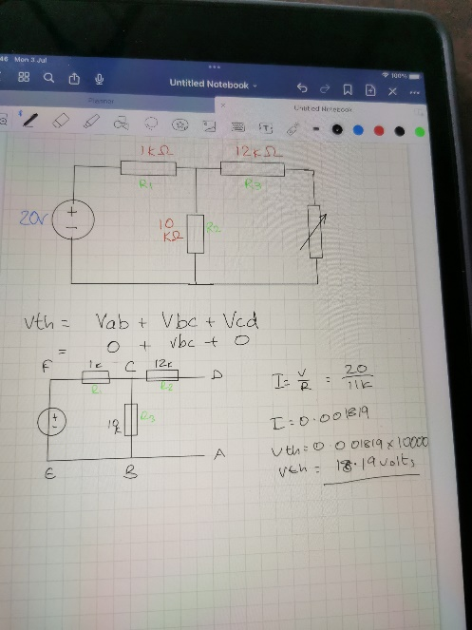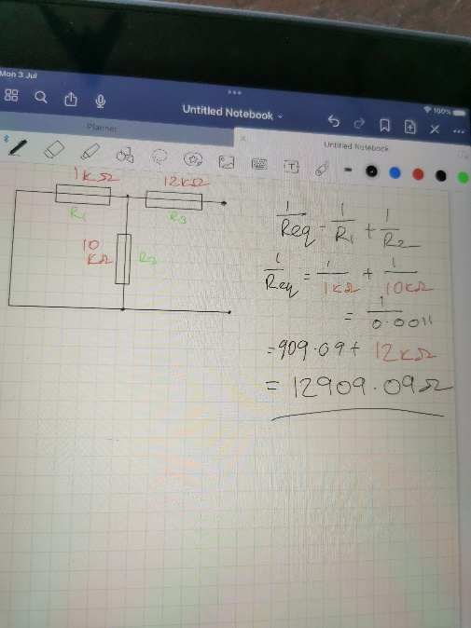
Fig 7 & 8.

To calculate Maximum Power Transfer the formula resistor load must equal resistor threshold. The resistor load for this circuit is 12909.09 ohms, the formula P=IL²RL is used. To calculate current load, $\frac{Vth }{Rth+RL }$ is used. This generated a solution of 6.41 x 10⁻³ Watts, demonstrating a difference of 0.0006 watts from the theoretical calculations which resulted 6.47 x 10⁻³ Watts. Theoretical calculations are shown in Figure 9.
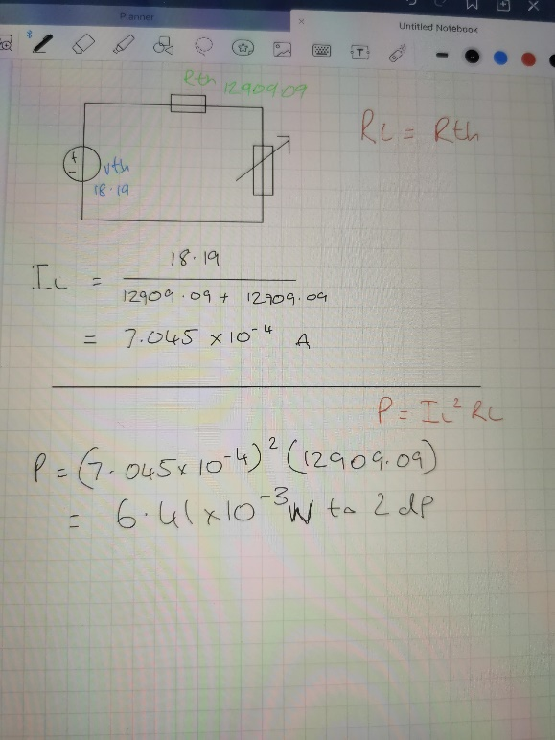
Fig. 9

Results

Task two
The results from task two are displayed in the form of a graph as shown in figure 10.
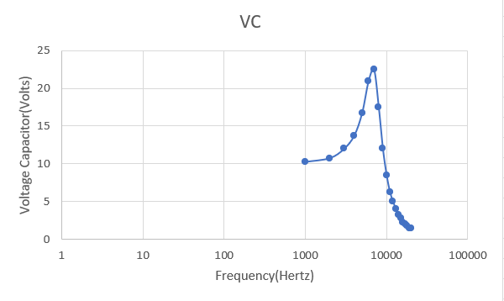
Fig. 10
To demonstrate Resonance in a series circuit, The resonant frequency must be applied ( $\frac{1}{\left(2π\right)√LC}$)

Conclusion

In conclusion for the first task, the discrepancies that exist between the simulated and theoretical values of the circuit can be explained by the fact that all components can be manufactured by different companies and hence may be made to different specifications although these differences may be marginal, it could be enough to result in inaccuracies. Another possibility is that proteus design software rounded up the figures to one decimal place in order to keep values concise.

References

[1] | E. Earley, “What’s the difference between AC and DC?,” MIT School of Engineering, 17 September 2013. [Online]. Available: https://engineering.mit.edu/engage/ask-an-engineer/whats-the-difference-between-ac-and-dc/. [Accessed 03 07 2023].
[2] | “Ohm’s Law - How Voltage, Current, and Resistance Relate,” All about circuits, [Online]. Available: https://www.allaboutcircuits.com/textbook/direct-current/chpt-2/voltage-current-resistance-relate/. [Accessed 3 July 2023].
[3] | J. Lucas, “Electricity Basics: Resistance, Inductance and Capacitance,” Live Science, 16 January 2019. [Online]. Available: https://www.livescience.com/53875-resistors-capacitors-inductors.html. [Accessed 3 July 2023].
[4] | J. Bird, in Electrical Circuit Theory and Technology, New York, Routlege, 2014, p. 782.
[5] | “Proteus 8 overview,” Get into PC, 1 12 2017. [Online]. Available: https://getintopc.com/softwares/electronics/proteus-8-free-download/. [Accessed 3 July 2023].

