

Logistics and Supply Chain Management
Title: Critical Evaluation of Supply Chain Vulnerability and Resilience

Author: David Whitmore
Email: David.Whitmore@vale.com
Number: 01792 841331
Address:
Vale Europe Limited,
Clydach Refinery,
Clydach,
Swansea,
SA6 5QR



- Introduction

The management of risk is not a new concept as we have witnessed when insurance companies impose a higher premium for taking on a riskier customer such as a young driver, or when a bank charges a higher interest rate on a “high risk” loan. However, in recent decades we have seen risk management become more prominent in all areas of a business. In the global business world in which we live, economic, political, social, technological and environmental factors are in a state of constant flux and as suggested by Hunt (2001) “both the number of risks and their potential consequences will continue to grow”. Therefore, to be successful a modern business must identify, assess, mitigate and if possible manage the risks that can present themselves as a result, because as Handy (1999) says “Risk management is not a separate activity to management”. These risks are never more apparent than within the management of the supply chain, Christopher (2010) describes the supply chain as “the network of organisations that are linked through the upstream and downstream relationships in the different processes and activities that produce value in the form of product and services in the hands of the ultimate customer”. The process of supply chain management is well illustrated in figure 1 below.
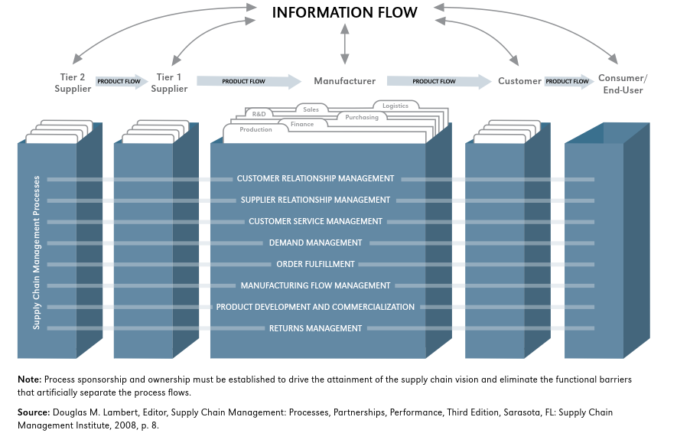

Most senior management are aware that there is a risk to their supply chains and although they recognise the importance of not being exposed they do not have the expertise or resources necessary to effectively address this critical area. The problem is also compounded by the pressures on management to drive Lean methodologies and Just-In-Time operations which themselves have added increased risk, especially when there are many links in a supply chain as the risks are transmitted through the chain meaning a small undesired event at one link can have a major impact for the others (Waters, 2011).
The management of risk within a supply chain, which are now on a global scale for most companies can be complex. It is not unusual for a supply chain to include different countries, climates and cultures, therefore exposing it to new risks and making it more vulnerable, particularly to what have become known as Black Swan events – a problem that comes as a surprise and can have a catastrophic impact.
For this paper, I will be evaluating the McDonalds supply chain and discussing how the company that has managed its risks with relative success having consistently been awarded a top 10 spot in Gartner's Supply Chain Top 25 over the last decade.

- Supply Chain Risk
As previously mentioned there are 4 key stages to managing the risks within the supply chain.
- Risk Identification
- Assess the risk
- Mitigate the risk
- Manage the risk
Risks to the supply chain are anything that have the potential to affect the smooth, normal flow of materials, goods and information (including money) between the linked processes (Peck, 2006). The problem with this is clear, the potential risks are diverse and complex and seemingly endless in number so an effective strategy is required to comprehensively identify them.
For the above reasons companies that have limited experience in risk management and do not source external expert help will undoubtedly hit difficulties with identifying the inherent risk in their supply chain. Dittmann (2014) specifies in his research the top 10 risks to a supply chain. Companies that are not so familiar with SCRM can use the information in figure 1 below as a starting point.
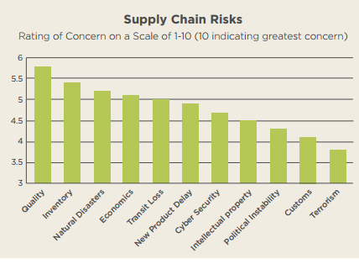
Figure 1: Supply chain risk, scale-rating on concern (Dittmann, 2014).
The aim of the risk identification process is to compile a risk register. As discussed, it is not feasible to list every potential risk so the most significant will be captured in the register. The collating of this data is a key activity and there are numerous proven systems for doing so. However most of the options follow the same initial process:
- Define the overall supply chain process
- Divide it into its distinct operations
- Systematically evaluate the details of each operation
- Identify the risk in each operation
- Capture the most significant risk in the register

Numerous formal tools have been developed for the risk identification stage. Some of them work on the above, by analyzing the processes, others analyze historical events or collate opinions.
Listed below are some of the more common tools (Waters, 2011):
- Consultants: This option is better suited to large and global companies. Experts can use their experience and dedicated software to more precisely identify the risk potential for the company and give advice on how to mitigate them.
- Internal Teams and Brainstorming: This option is probably the main tool used for risk identification. In this method, a diverse group of managers will analyse the different operations/processes to identify risky areas in a judgment-free environment and record in a format such as the one shown in Figure 2. These meeting can also involve the other companies in the supply chain (networking). Their inclusion is key to achieving the integration of the risk management in the supply chain. A PESTLE analysis is an effective tool to be used with this option.
- Checklists made available to all personnel to allow them to identify risks at any time. The checklist can then be collated for one designated team to evaluate each of these risks and the ideal mitigation responses for the relevant ones.
- Cause-and-effect diagrams: this approach starts with the identification of events that could go wrong, such as late delivery, capacity problems and production disruption. After that, the company should identify the possible risks that would cause these events.

On their research for General Motors, Elkins et al. (2004) used the below brainstorming technique to identify an enormous amount of risks by dividing them in four main groups, Financial, Hazard, Strategic and Operational Risks.

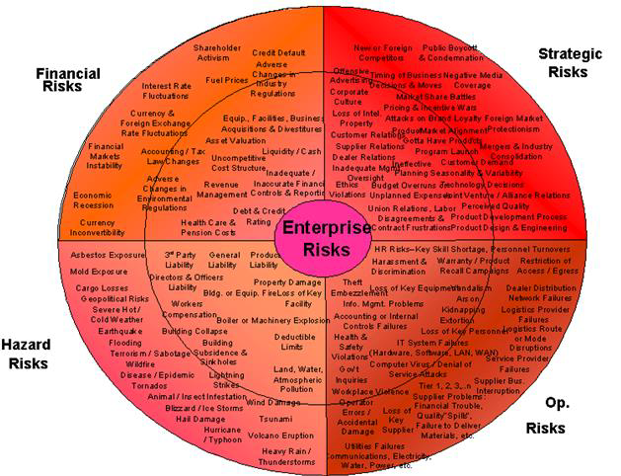
Figure 2: Potential risks on the supply chain (Elkins et al. 2004)

PESTLE Analysis for McDonalds:
POLITICAL
For a global operator, political factors are a major variable and when it comes to operations, variability inherently brings risk. Each country will have its own laws, regulations (food, accounting, business) taxes and trade agreements. McDonalds and its products will have to conform to the political business environment of its host country and this can be particularly difficult in nations who are heavily regulated. A governments policy towards tax, trade and even public health can have a major impact on McDonalds sales and profits globally as they have recently experienced with some governments increasing taxes or even banning some their ingredients.

ECONOMICAL
Due to being a global brand McDonalds are impacted by economic factors on an international, national and local scale. McDonalds success is reliant on a stable economy with low unemployment and increased disposable income (McDonalds 2017a) Economic unrest such as the 2008 recession and more recently Brexit pose a high risk to McDonalds as certain parts of their supply chain will be under threat, the costs of raw materials is likely to rise and customers will revert to the purchase of only items they deem a necessity.
SOCIAL
There are many social factors that pose a significant risk to McDonalds with the main ones being the change in social trends and lifestyles which are being driven by the media, particularly the obesity epidemic and the push for healthier choices. This global drive against obesity has resulted in a global decline in sales for fast food and beverage companies. There have also been several negative documentaries such as “Fast Food Nation” and “Super-Size Me” that have questioned the quality of its ingredients and the sustainability of its supply chain. Also, the changing demographics of customers mean that McDonalds needs to meet the changing demands in taste, nutrition and cost.
Such trends pose a risk to the popularity of the brand and any significant change in the customers preference or taste can have a big impact on the profits of McDonalds’ business.

TECHNOLOGICAL
The importance of technology in business is growing exponentially. McDonalds rely heavily on it for production, packaging, distribution, sales, marketing and customer service/interaction. Technology increases the brands popularity, power and performance. Therefore, areas of technological risk such as cyber security breaches, data theft, compatibility issues and obsolescence are a major concern as companies have a high reliance but limited redundancy for when things go wrong.
LEGAL
As briefly discussed in the political section, the legal framework of a country can have a significant impact on well McDonalds can do business there. Asian countries, particularly China and India are difficult markets for foreign organisation such as McDonalds to operate due to the red tape and bureaucracy. Employment law can be a cost risk, rates of pay, holiday and sick pay can increase cost but could also reduce recruitment costs. Zero hour contracts can be employed in some countries which are particularly useful for McDonalds as they provide a more flexible work force for its 24-hour operations
ENVIRONMENTAL / ECOLOGICAL
There are increasing demands on an organisation such as McDonalds to operate an environmentally friendly and sustainable supply chain. This is not just a trend and global governments are focusing legislation and initiatives around environmental protection. The risk for McDonalds in this area are more reputational than its legislative liability.
Natural disaster, extreme weather conditions and other events caused by acute climate change pose a major threat to the McDonalds supply chain. These unpredictable events can incapacitate the operations of their tier one suppliers - A heatwave could reduce the yield of an agricultural supplier, a flood could close a key transport route, any such event will have an effect on the speed, quality and cost of its supply chain.

Risk Mitigation and Supply Chain Resilience.
With the risks identified, assessed and prioritized a decision must then be made on the level of detail each risk deserves. The company should carefully consider the importance of each risk and the level of resources that will be required to mitigate them and define the most appropriate way of dealing with these risks (Vilko, 2012, p. 47-48).

Berg (2012, p 86-87) presents the most traditional ways of mitigating risks:
• Avoid the risk: not undertaking an activity or operation that might cause the risk.
• Reduce the likelihood of the event: companies are often able to review the risky spots and through preventive maintenance and quality assurance they can reduce the likelihood of risky events. One example is increasing stocks for the materials with varying demand.
• Reduce the impact: Although many events cannot be influenced by the company (such as the Brexit), managers are still able to reduce the negative impact and its influence on the company. One example is that by reducing the lead time of deliveries from suppliers, companies can reduce the consequence of material shortage. Contingency plans are also another possibility. The preparation of protocols and actions to manage a situation before it occurs can prevent managers from making mistakes and save precious time when responding these events.
• Transfer the risk: In this option, risks are transferred from one organization to another. One major company can use its influence and put the other smaller partners under pressure for undertaking these risks. Another traditional way of transferring risks is insurance. Insurance can be very beneficial for the company in some scenarios where the likelihood of an event is very small, but the impacts are too serious to be ignored and, the company prefers to face uncertainty with a small additional cost.
• Accept and ignore the risk: In this scenario, the expected value from the risk must be considerably smaller than the resources needed for mitigation actions. The company should wait and, if the event does occur, they can formulate a response to it.

Resilience is the ability of a supply chain to resist disruptions and to recover operational capability after possible disruptions occur. Supply chains vary significantly in complexity and size, but the actions taken by companies to prevent risky events have many similarities. Waters (2001, p. 198-200) states that an organization should start the process of creating a resilient supply chain internally by understanding the concept of SCRM, followed by taking a strategic view of SCRM and by starting this first analyse within the organization. This means that the company should have already installed and working properly the SCRM before taking further and more complex steps, such as increasing the integration, collaboration and creating agility within the supply chain.
To alleviate the risk of disruption to a key supplier McDonalds will form a close partnership, working together on risk management and promoting the visibility of internal procedures and financial health not just on each other but also any sub-suppliers
It all comes down to visibility and risk management. You need visibility into their financial health, the operating procedures and any sub-suppliers that they use to service your purchases. While it’s hard to anticipate when a supplier may go out of business, or face a serious production problem – it’s not impossible if you have the right data.
McDonald’s have multiple back-up sources of supply. If a problem occurs within their supply chain they have pre-qualified reliable suppliers in a position to assume production. They also have a diverse, multi-national supplier base and logistics network. If they encounter an issue in one area they have a contingency in place in another. Their critical supplies are divided up between multiple suppliers, thus reducing the responsibility and risk on each source.
McDonalds avoid menu disruptions by ensuring they have multiple sources of supply for key products and that those suppliers are ready to fill in for the main supplier should a disruption occur.
Having key suppliers to bid through an e-sourcing system allows the McDonald procurement team to analyse other suppliers and their products and costs. This enables them to react faster to an interruption helping them ensure the downstream supply chain remains unaffected
They have designed their supply chain using a proactive integrated approach of Supply Chain Management. By introducing suppliers and processes that can speed up the flow of goods the risk to the entire chain is reduced.
They have developed parallel paths as suggested by Waters (2011), which give the supply chain an alternative route around potential problems. Where possible they will avoid a global supplier and make the supply chain as short as practical by using local organisations.
Investing in supplier relationships is also helpful, as your suppliers will be more apt to give you an appropriate substitute in the event of a crisis if you have cultivated a long-term relationship with them, and have earned their trust through open and honest communication.

Conclusion.
The aim of supply chain management is to ensure the efficient flow of materials along the supply chain resulting in in a product/service that gives a high level of customer satisfaction at the lowest possible cost.
As discussed some of the larger organisations such as McDonalds have excelled in supply chain risk management but overall its application is somewhat inconsistent.
Supply Chain Management is constantly changing and the supply chain questions being asked today have dramatically shifted from what was being asked 10 years ago. Speed of service, quality and cleanliness have been replaced with questions on product source, sustainability, animal welfare and environmental standards, but McDonalds have acknowledged, listened and acted accordingly to their customers questions. Their significant investment in the key areas discussed in this paper have allowed them to grow their business volume-wise by over 50% in the last 5 years, with their restaurants producing double the volume they were built for.

5.0 References

- Burke, J. Gerard & Carrilo, E. Janice & Vakharia, J. Asoo. 2006. Single versus multiple supplier sourcing strategies. ScienceDirect- European Journal of Operation Research.
- Christopher, M. (2010) Logistics and supply chain management. 4th edn, Financial Times, Prentice Hall, Harlow.
- Dittmann, J.P. (2014). Managing Risk in the Global Supply chain. A report by

the Supply chain Management Faculty at the University of Tennessee.
- Elkins, D et al (2004). Potential risks on the Supply chain. Identifying and Assessing Supply chain Risk.
- Handy, C. (1999). Beyond Certainty, Harvard Business School Press, Boston, MA.
- Hunt, B. (2001). Vol 1. Issue Of The Moment, Managing Risk. Concepts ed J Pickford, Pearson Education, Harlow.
- Peck, H. (2003) Creating Resilient Supply Chains: A Practical Guide, School of Management
- Cranfield University, Cranfield, Bedford.
- Peck, H. (2004). Resilience: Surviving the Unthinkable. Logistics Manager, March, pp 16-18
- Stemmler, L. (2006). Risk In The Supply Chain. Global Logistics, 5th edn, ed D Waters, Kogan Page, London.
- Waters, D. (2011). Supply Chain Risk Management: Vulnerability and Resiliecne in Logistics, 2nd edn.

